White Matter Fiber Segmentation Using DTI Atlas Probability Maps

The images below represent individually segmented DTI fiber tracts. Probability maps for each average DTI atlas fiber were created, overlaid on the average T1 image, and manually edited in Amira using the techniques described in “DTI Fiber Segmentation Methods”.

Summary of examples in this document:

Fiber Name | Fiber Number (In DTI Atlas) | Fiber Numbers (Segmented) | Number of Parts | Page
Fornix (Fx) | 102 | 1020-1023 | 2 | 1
Cingulum (CgC) | 104 | 1040-1043 | 3 | 2
Cingulum (CgH) | 106 | 1060-1062 | 2 | 2
Corticospinal tract (CST) | 108 | 1080-1083 | 3 | 3
Anterior thalamic radiation (ATR) | 110 | 1100-1102 | 2 | 3
Uncinate (Unc) | 116 | 1160-1162 | 2 | 4
Inferior longitudinal fasciculus (ILF) | 118 | 1180-1185 | 2 and 3 | 4
Inferior frontal occipital fasciculus (IFO) | 120 | 1200-1205 | 2 and 3 | 5
Forceps major (F-maj) | 121 | 1210-1217 | 2, 3, and 4 | 5
Forceps minor (F-min) | 122 | 1220-1227 | 2, 3, and 4 | 6
Corpus callosum (CC) | 123 | 1230-1236, and 1240-1248 | 2, 4, and 8 | 6
Superior longitudinal fasciculus (SLF) | 134 | 1340-1345 | 2 and 3 | 7

Fornix, 2-part (fiber 102)

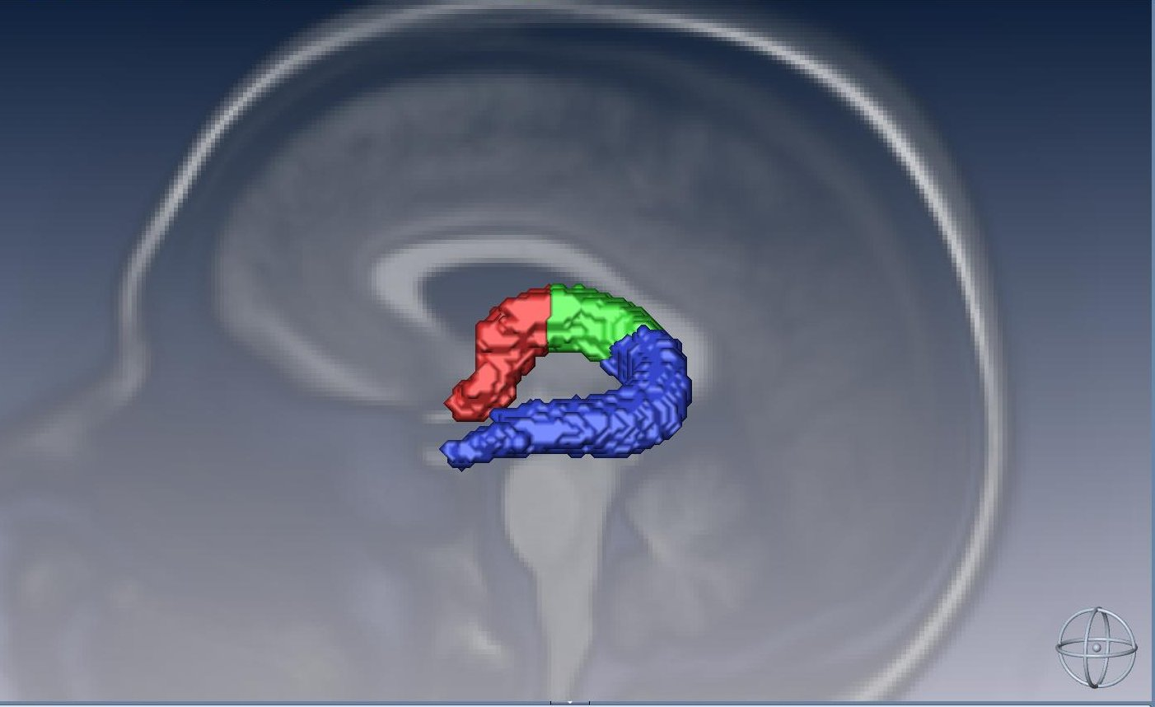

Fiber Number | Fiber Name | Fiber Part | Notes
1020 | L Fx | All | No edits
1021 | L Fx lat | Lateral | Contains hippocampal area (not included as a part)
1022 | L Fx mid | Middle | 2-part version
1023 | L Fx ant-med | Anterior medial | 2-part version
Cingulum, 3-part (fiber 104)

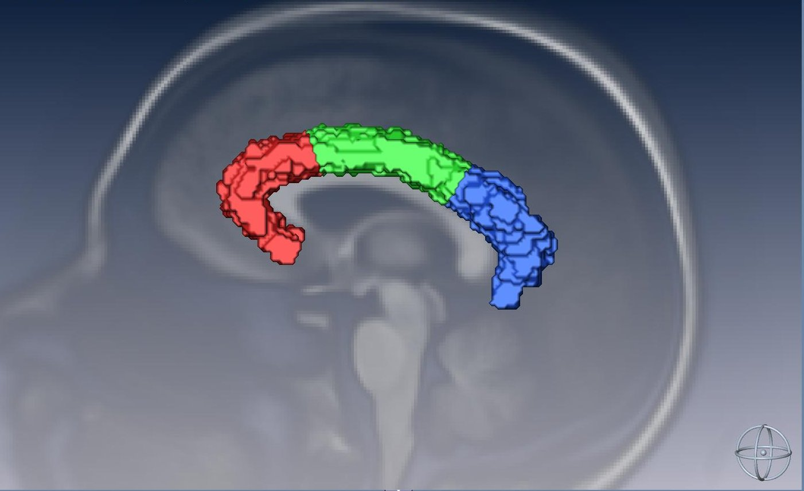

Fiber Number | Fiber Name | Fiber Part | Notes
1040 | L CgC | All corrected | Removed patch of voxels in superior/posterior region
1041 | L CgC ant | Anterior | 3-part version
1042 | L CgC mid | Middle | 3-part version
1043 | L CgC post | Posterior | 3-part version

Cingulum, parahippocampal part, 2-part (fiber 106)

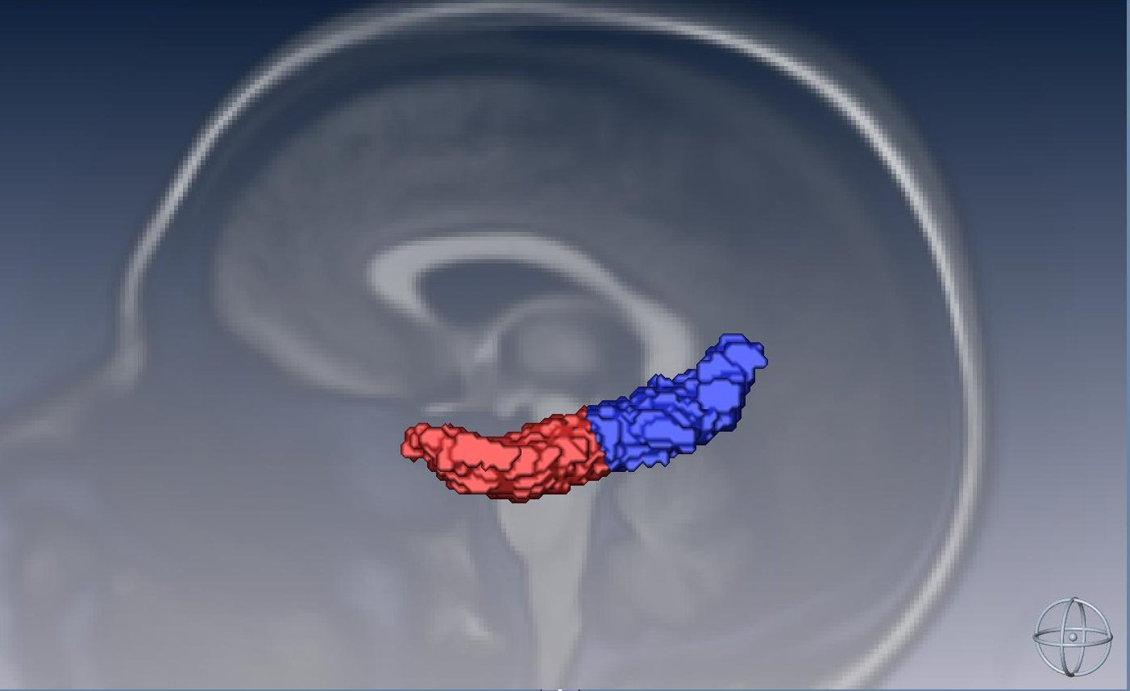

Fiber Number | Fiber Name | Fiber Part | Notes
1060 | L CgH | All corrected | Removed contralateral voxels
1061 | L CgH ant | Anterior | 2-part version
1062 | L CgH post | Posterior | 2-part version
Corticospinal tract, 3-part (fiber 108)

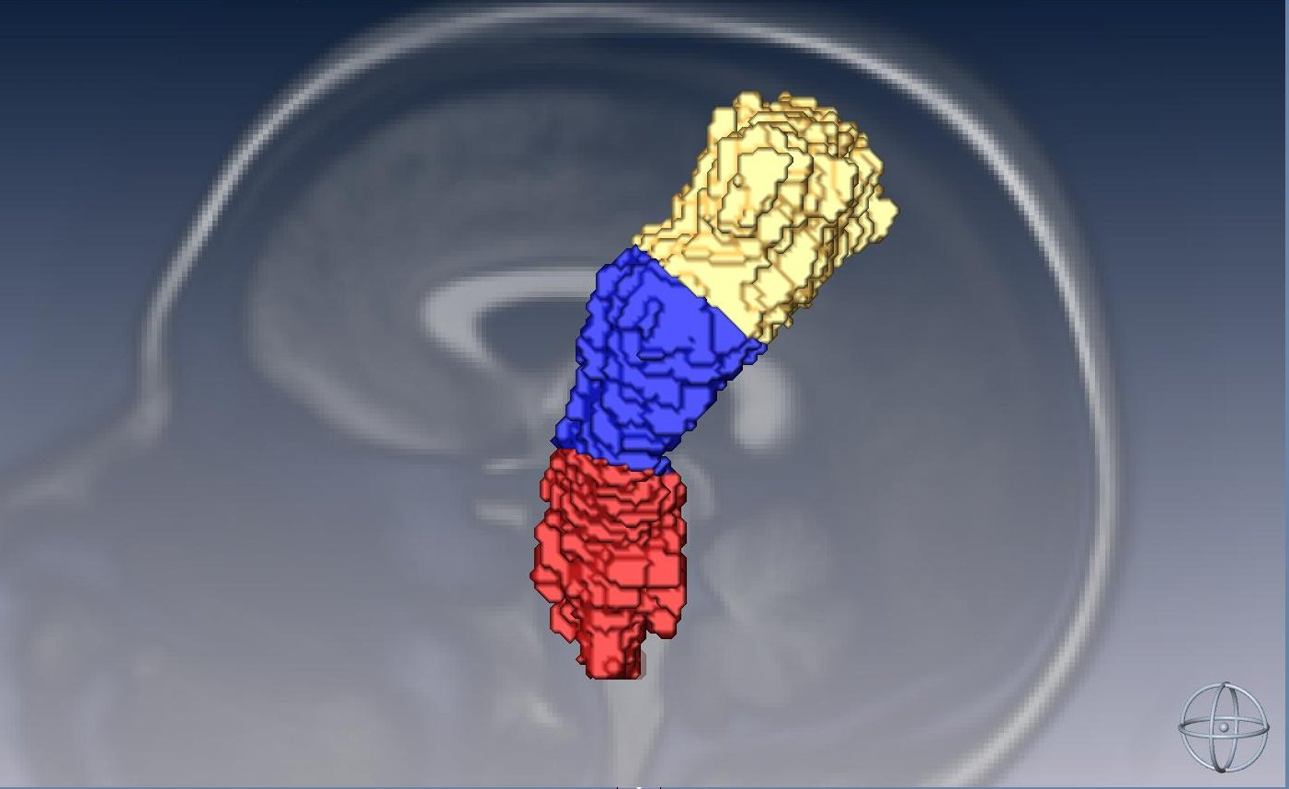

Fiber Number | Fiber Name | Fiber Part | Notes
1080 | L CST | All corrected | Removed pre-central voxels
1081 | L CST sup | Superior | 3-part version
1082 | L CST mid | Middle | 3-part version
1083 | L CST inf | Inferior | 3-part version

Anterior thalamic radiation, 2-part (fiber 110)

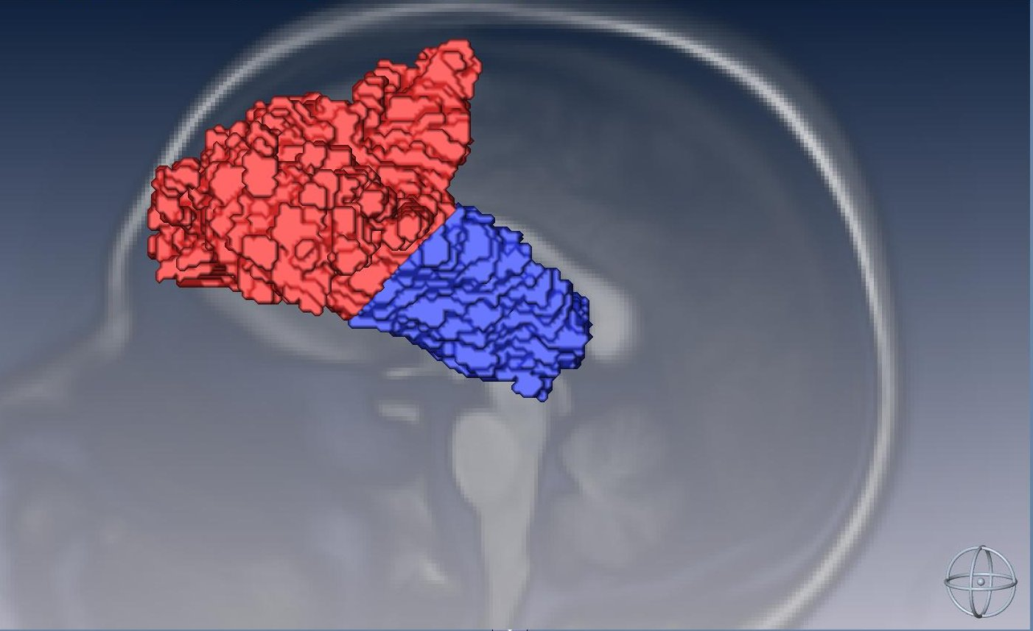

Fiber Number | Fiber Name | Fiber Part | Notes
1100 | L ATR | All | No edits
1101 | L ATR ant | Anterior | 2-part version
1102 | L ATR post | Posterior | 2-part version
Uncinate, 2-part (fiber 116)

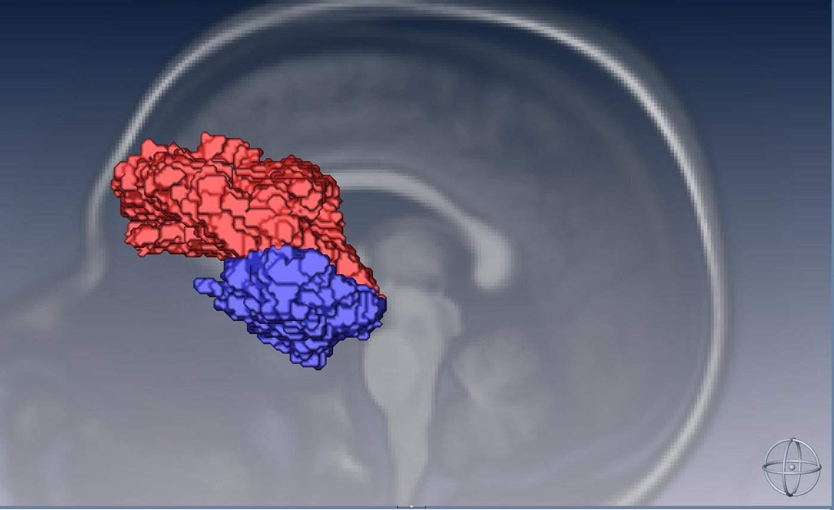

Fiber Number | Fiber Name | Fiber Part | Notes
1150 | R Unc | All | No edits
1151 | R Unc front | Frontal | 2-part version
1152 | R Unc temp | Temporal | 2-part version
1160 | L Unc | All | No edits
1161 | L Unc front | Frontal | 2-part version
1162 | L Unc temp | Temporal | 2-part version

Inferior longitudinal fasciculus, 2-part and 3-part (fiber 118)

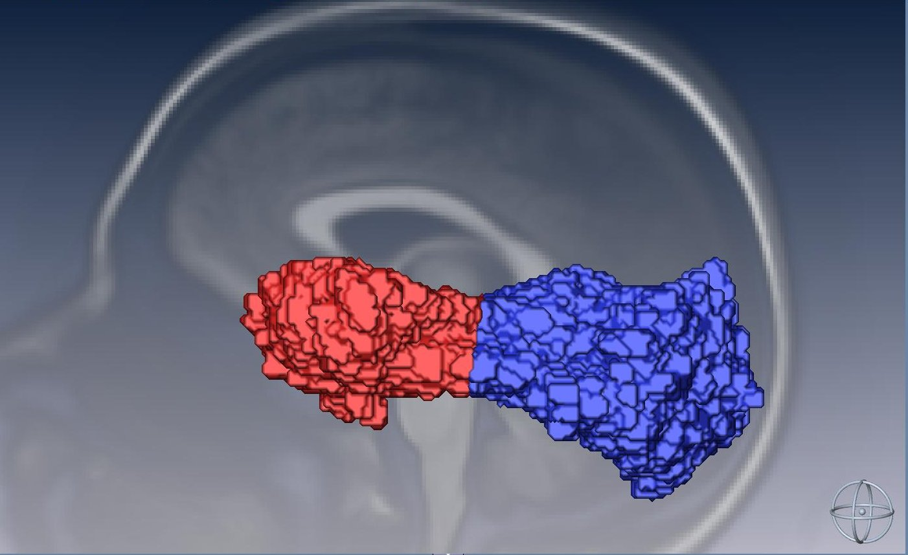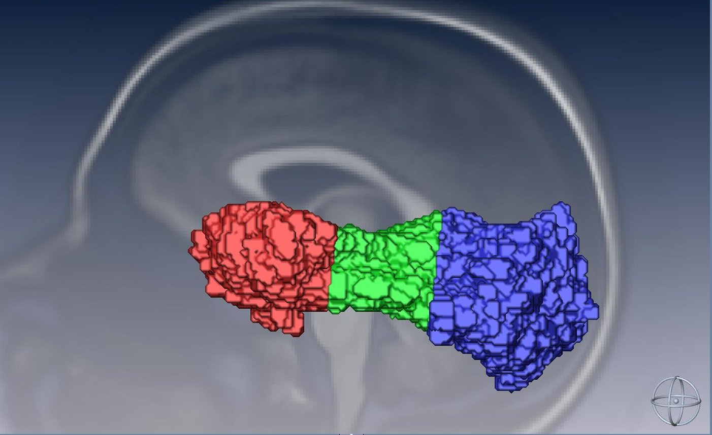

Fiber Number | Fiber Name | Fiber Part | Notes
1180 | L ILF | All | No edits
1181 | L ILF ant | Anterior | 2-part version
1182 | L ILF post | Posterior | 2-part version
1183 | L ILF ant | Anterior | 3-part version
1184 | L ILF mid | Middle | 3-part version
1185 | L ILF post | Posterior | 3-part version
Inferior frontal occipital fasciculus, 2-part and 3-part (fiber 120)

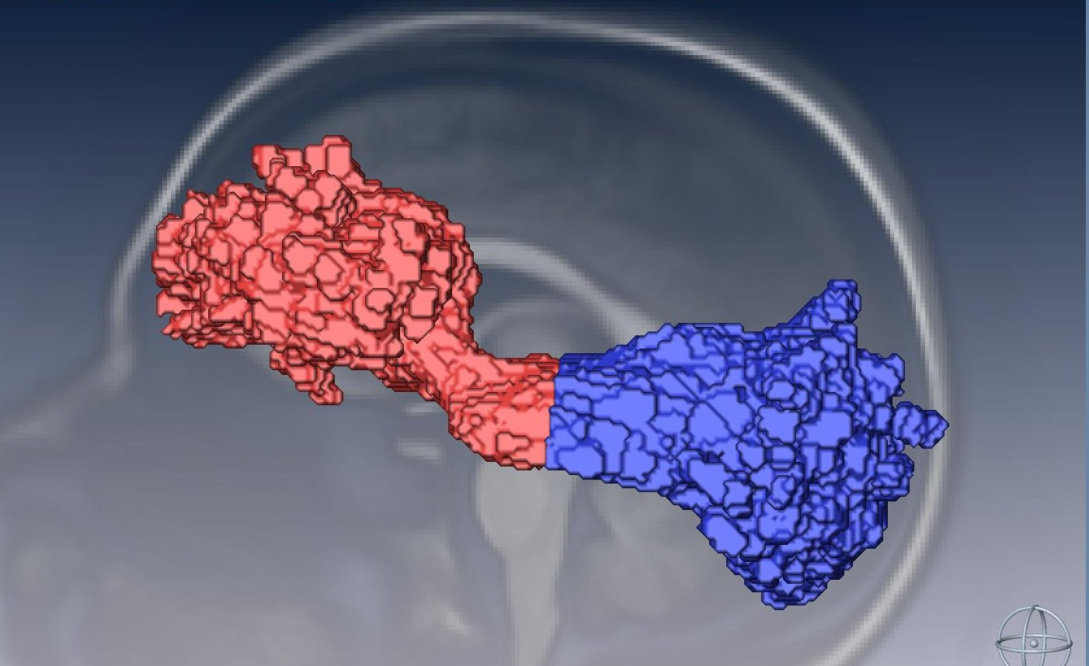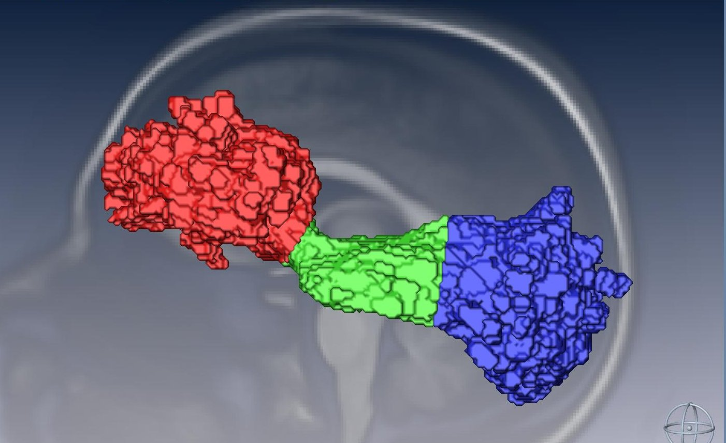

Fiber Number | Fiber Name | Fiber Part | Notes
1200 | L IFO | All | No edits
1201 | L IFO ant | Anterior | 2-part version
1202 | L IFO post | Posterior | 2-part version
1203 | L IFO ant | Anterior | 3-part version
1204 | L IFO mid | Middle | 3-part version
1205 | L IFO post | Posterior | 3-part version

Forceps major, 2-part, 3-part, and 4-part (fiber 121)

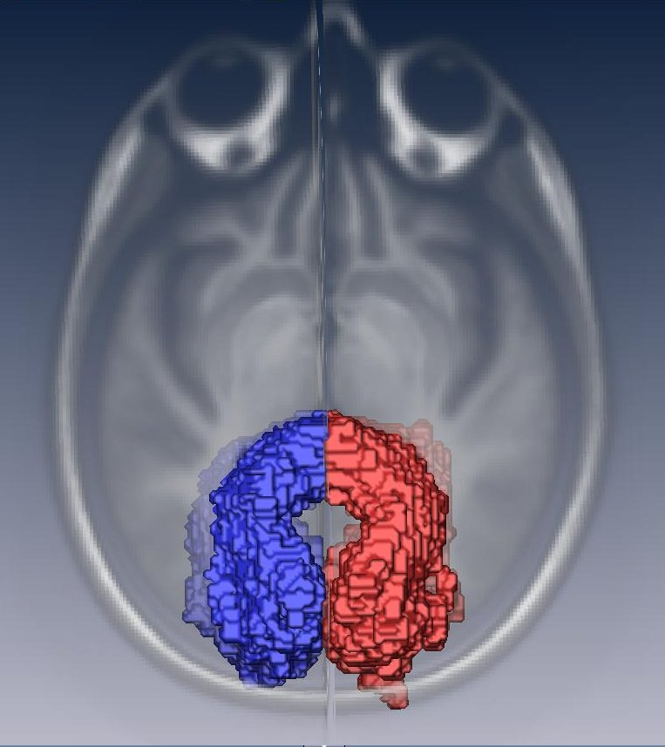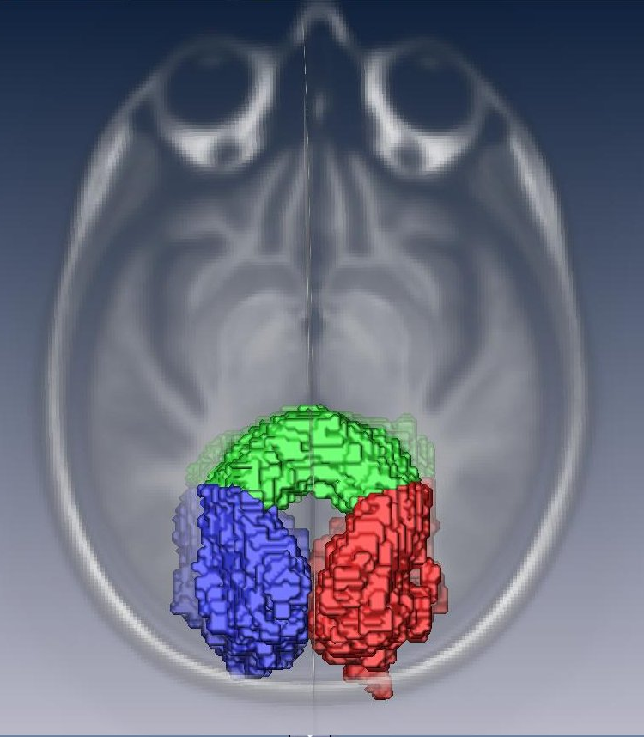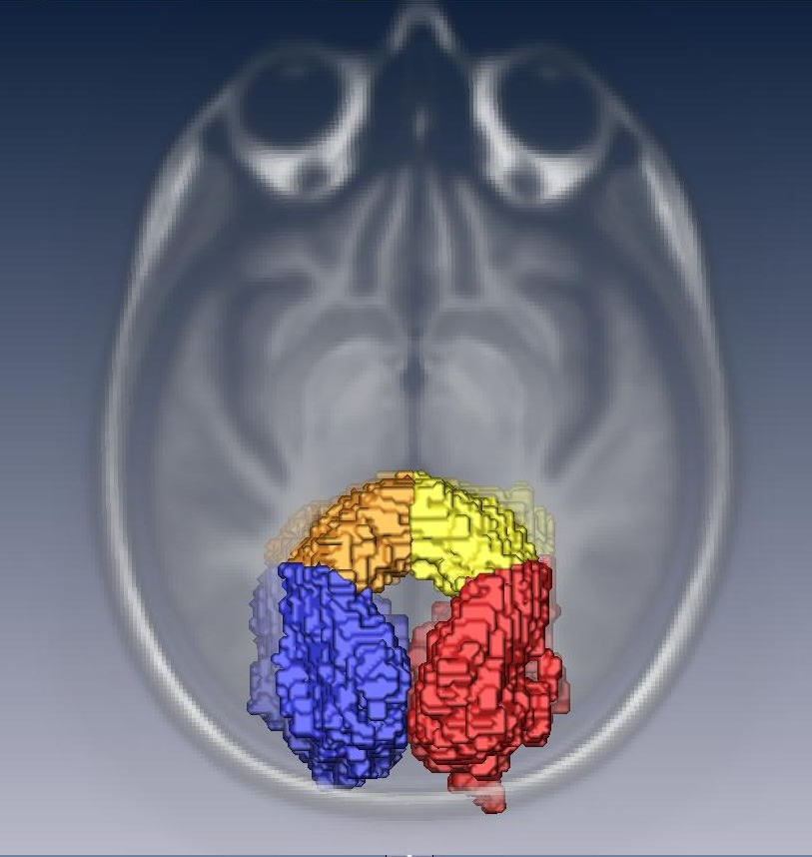

Fiber Number | Fiber Name | Fiber Part | Notes
1210 | F-major | All corrected | Removed voxels representing non F-major fibers
1211 | F-major R | Right | 2-part version
1212 | F-major L | Left | 2-part version
1213 | F-major R | Right | 3-part version (also ¼ of 4-part version)
1214 | F-major mid | Middle | 3-part version
1215 | F-major L | Left | 3-part version (also ¼ of 4-part version)
1216 | F-major mid R | Middle right | 4-part version
1217 | F-major mid L | Middle left | 4-part version

Forceps minor, 2-part, 3-part, and 4-part (fiber 122)

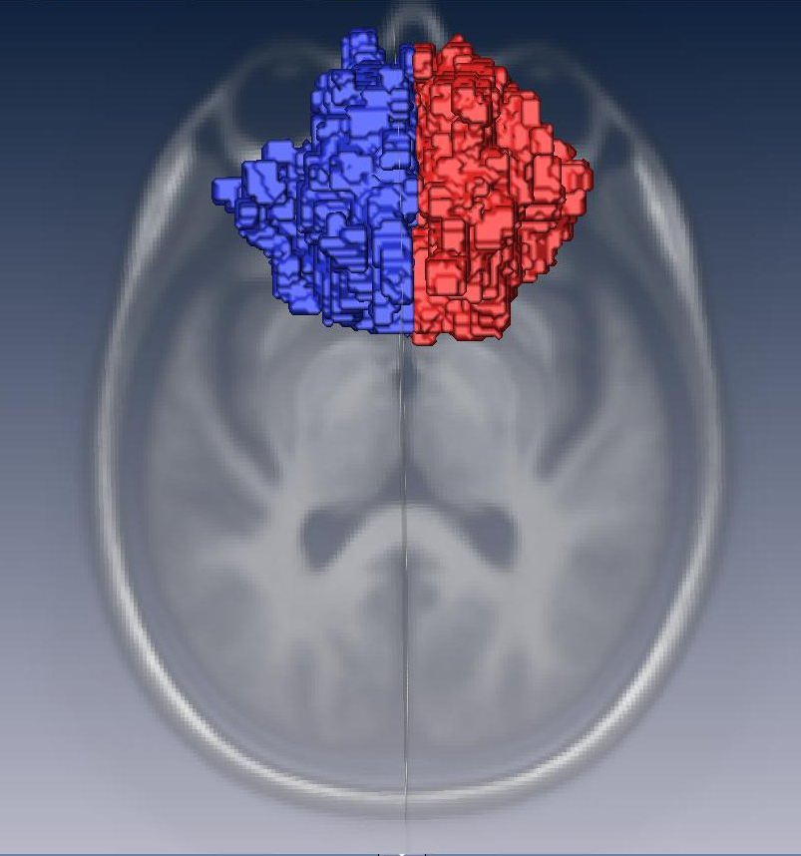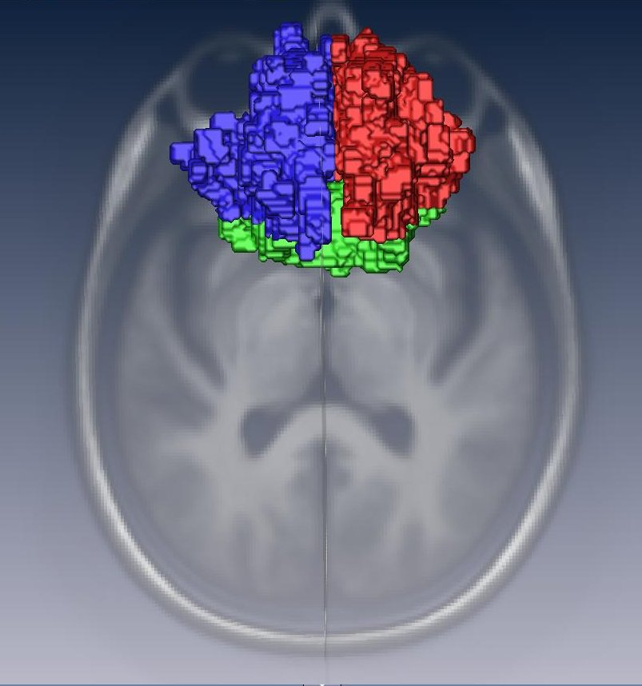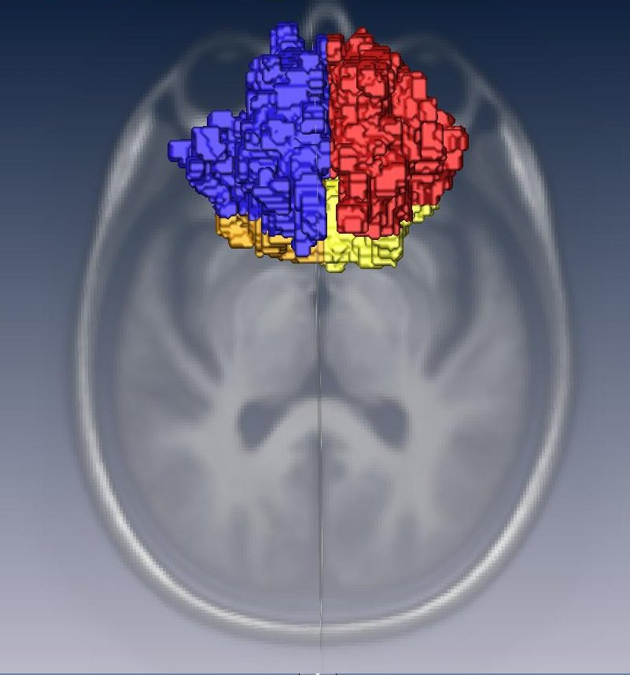

Fiber Number | Fiber Name | Fiber Part | Notes
1220 | F-minor | All corrected | Removed voxels representing non F-minor fibers
1221 | F-minor R | Right | 2-part version
1222 | F-minor L | Left | 2-part version
1223 | F-major R | Right | 3-part version (also ¼ of 4-part version)
1224 | F-major mid | Middle | 3-part version
1225 | F-major L | Left | 3-part version (also ¼ of 4-part version)
1226 | F-major mid R | Middle right | 4-part version
1227 | F-major mid L | Middle left | 4-part version

Corpus callosum, 2-part, 4-part, and 8-part (fiber 123)

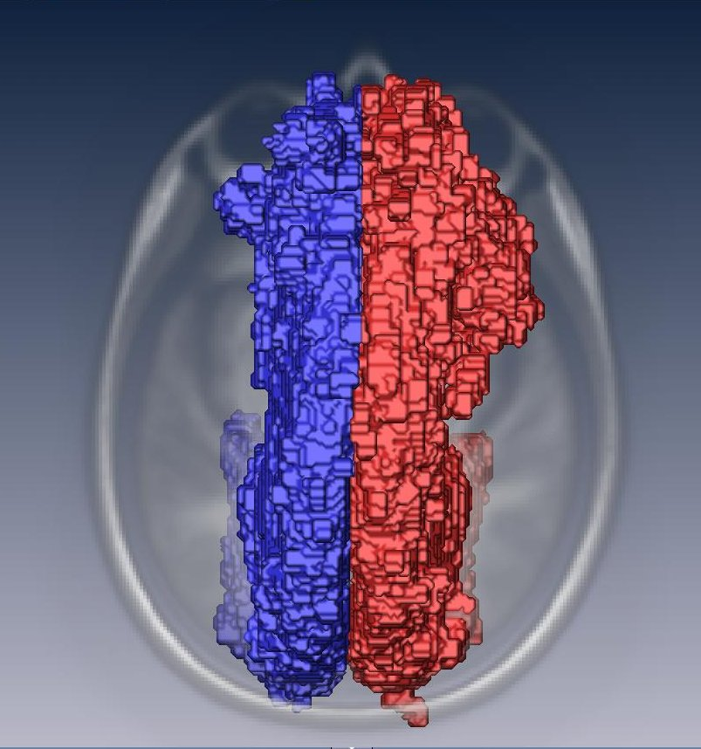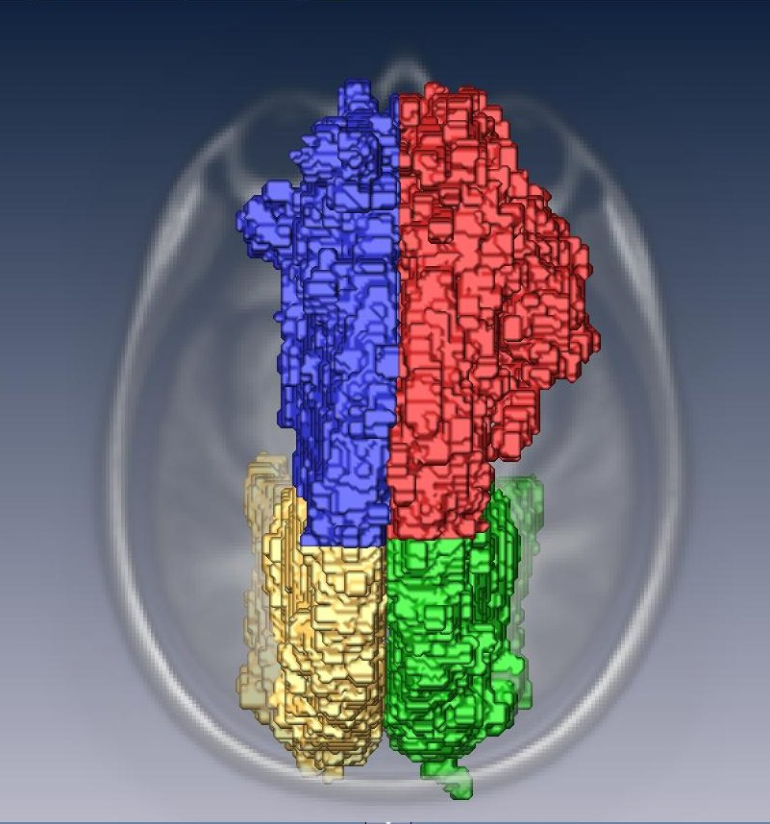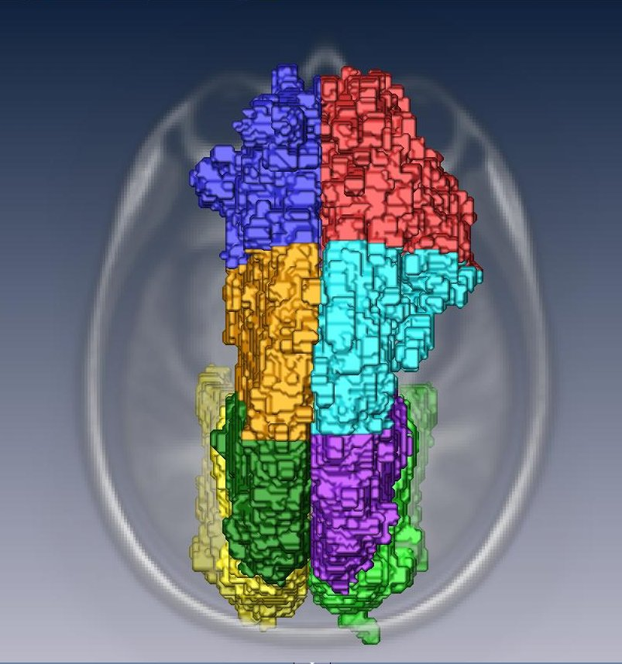

Fiber Number | Fiber Name | Fiber Part | Notes
1230 | CC | All | No edits
1231 | CC R | Right | 2-part version
1232 | CC L | Left | 2-part version
1233 | CC ant R | Anterior right | 4-part version
1234 | CC ant L | Anterior left | 4-part version
1235 | CC post R | Posterior right | 4-part version
1236 | CC post L | Posterior left | 4-part version
1240 | CC | All | No edits (duplicate of fiber 1230, CC)
1241 | CC ant R | Anterior right | 8-part version
1242 | CC ant L | Anterior left | 8-part version
1243 | CC mid-ant R | Middle anterior R | 8-part version
1244 | CC mid-ant L | Middle anterior L | 8-part version
1245 | CC mid-post R | Middle posterior R | 8-part version
1246 | CC mid-post L | Middle posterior L | 8-part version
1247 | CC post R | Posterior right | 8-part version
1248 | CC post L | Posterior left | 8-part version
Superior longitudinal fasciculus, 2-part and 3-part (fiber 134)

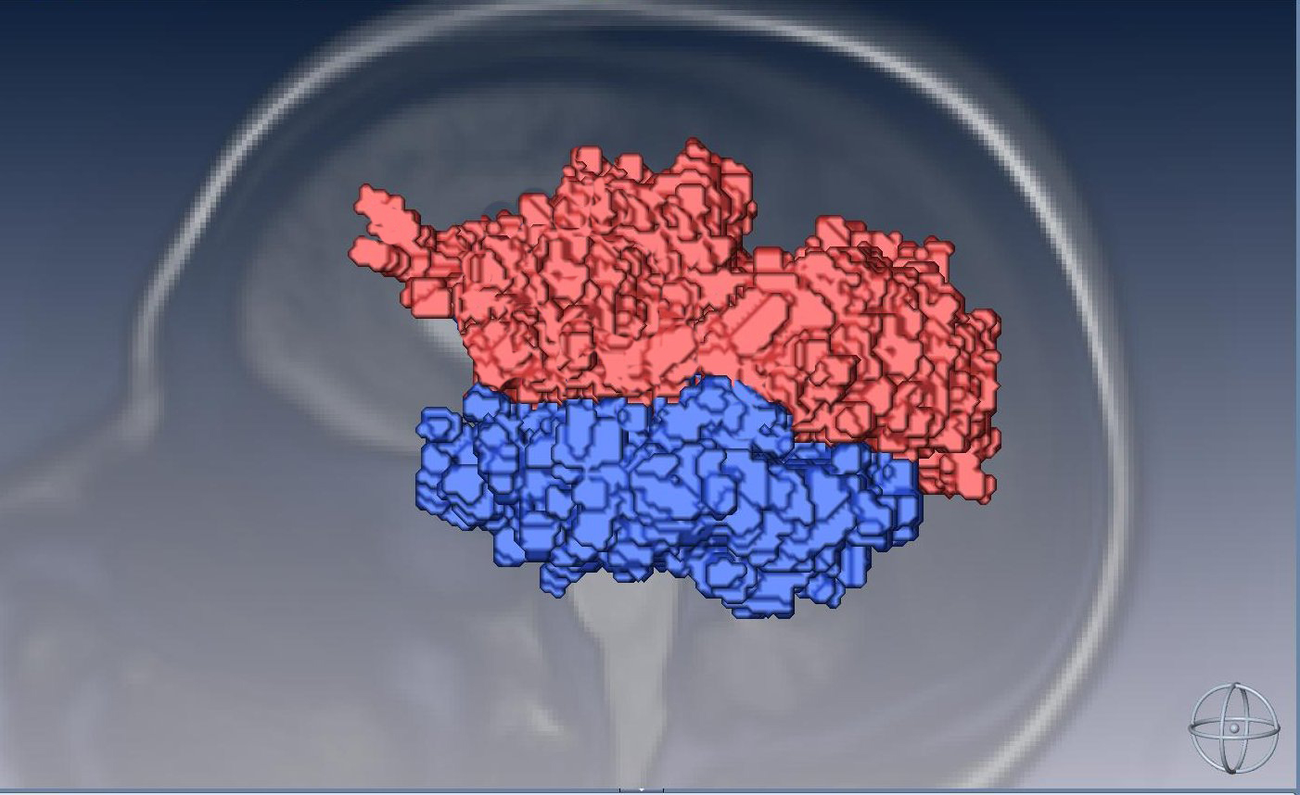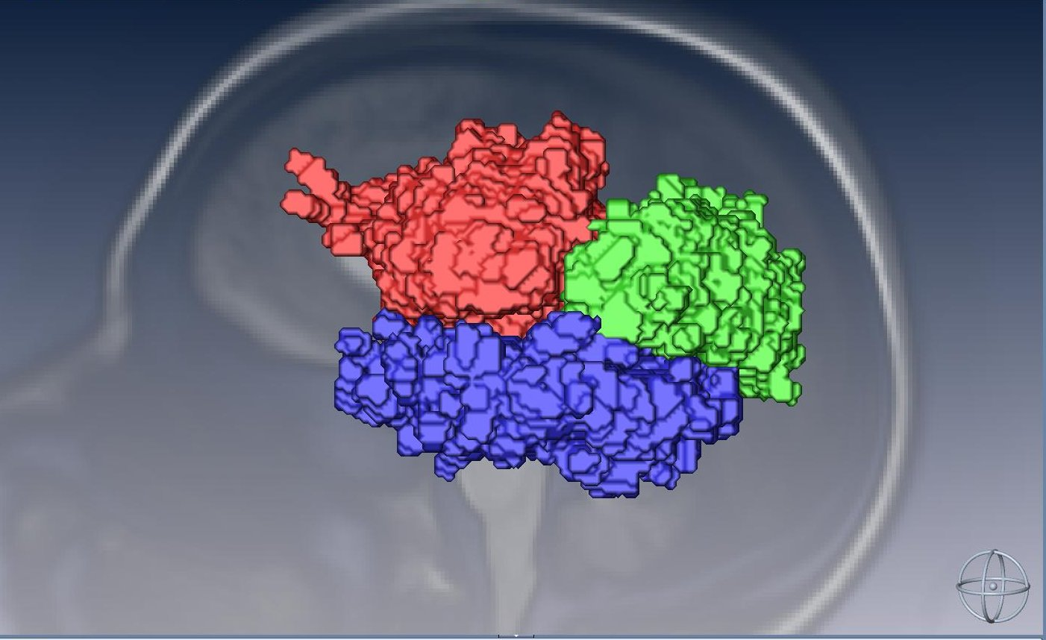

Fiber Number | Fiber Name | Fiber Part | Notes
1340 | L SLF | All | No edits
1341 | L tSLF | Temporal | Duplicate of fiber 1360 (R tSLF)
1342 | L pSLF | Parietal | Duplicate of fiber 1380 (R pSLF)
1343 | L SLF tstem | Temporal stem | 3-part version
1344 | L SLF pstem | Parietal stem | 3-part version
1345 | L SLF fstem | Frontal stem | 3-part version
1360 | L tSLF | All | No edits (use fiber 1341 in place of 1360)
1380 | L pSLF | All | No edits (use fiber 1342 in place of 1380)

