Nama Tim: Bunda Ramah

Sanity Check

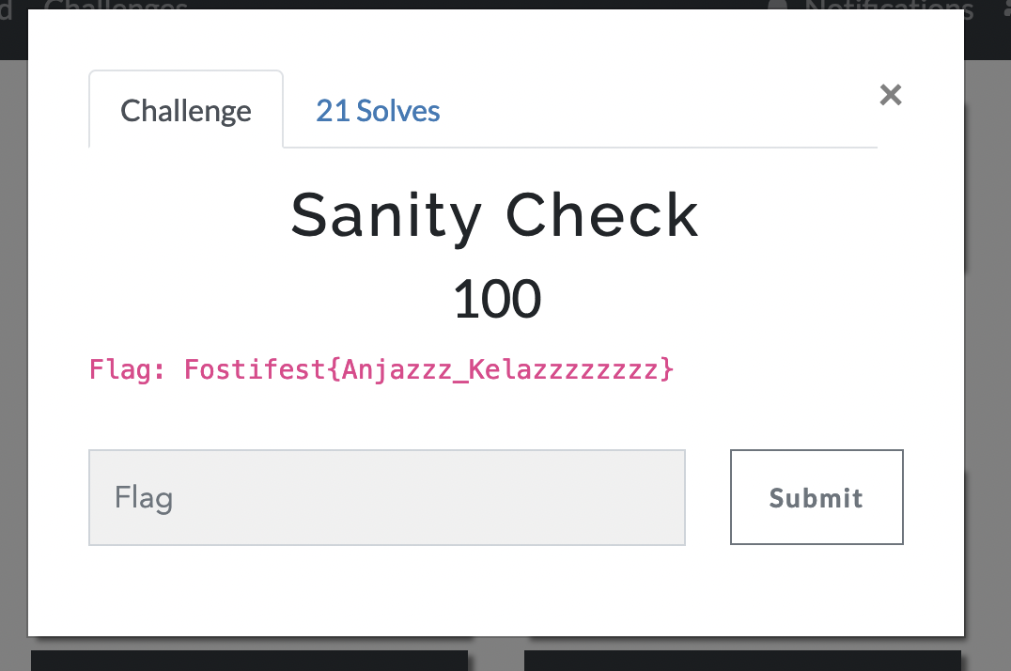

Flag: Fostifest{Anjazzz_Kelazzzzzzzz}

Fosti Server Password

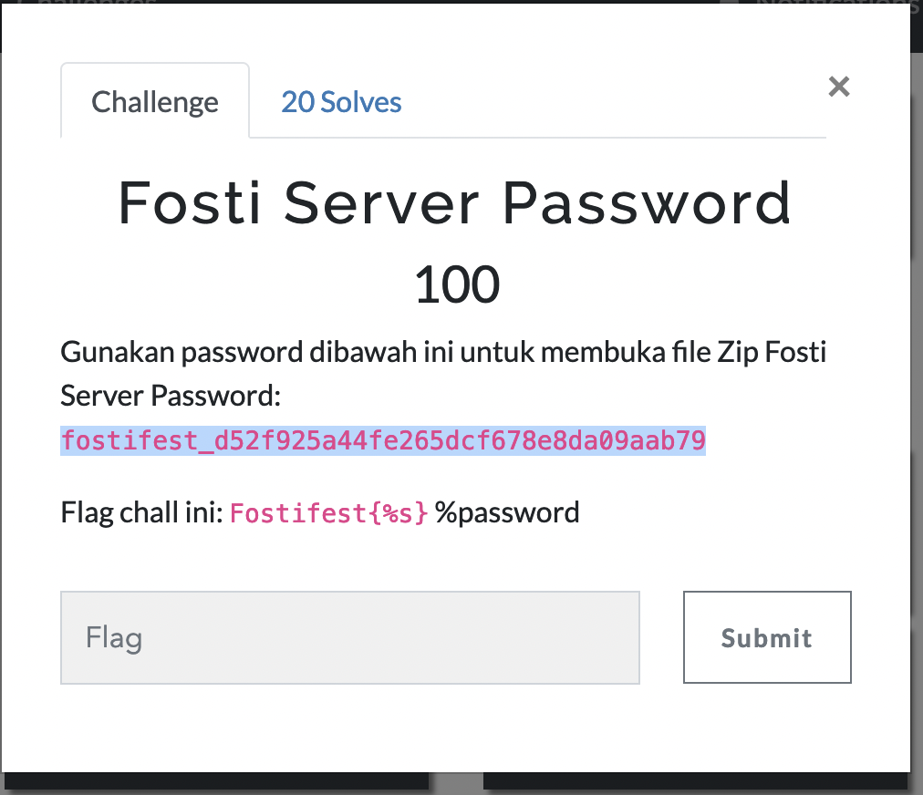

Flag: Fostifest{fostifest_d52f925a44fe265dcf678e8da09aab79}

Fostjail

