Study- Project preparation: Site Map, Wireframe, mood board, and grids here.

I chose a website that is a business but from a artist. She was a artist and then created a shop form her art.

This is also something I am interested in doing.

**Site Map diagram**

From the Top:

|  |  |  |  |  |  |
| --- | --- | --- | --- | --- | --- |
| |  |  | | --- | --- | | Shop Info | Product links/blog /clearance/rewards |  |  |  | | --- | --- | | Login | Liked items, search and cart |   **Logo** | |
| **Shop now but announcement/ Promotion page section!**   |  | | --- | | **Image of promotion/announcement** | | |
| **Best sellers**   |  |  |  |  |  | | --- | --- | --- | --- | --- | | Scrolls/arrows | Product image | Product image | Product image | Scroll/arrows | | |
| **Shop category highlight**   |  |  |  |  | | --- | --- | --- | --- | | Additional Shop information for age 21 and over | Product image   |  |  | | --- | --- | | Information regarding 21 and over shop details | Link | | | |
| **Back in Stock Items**   |  |  |  |  |  | | --- | --- | --- | --- | --- | | Scrolls/arrows | Product image | Product image | Product image | Scroll/arrows | | |
| **Shop category highlight**   |  |  |  |  | | --- | --- | --- | --- | | Another Shop Category | Product image   |  |  | | --- | --- | | Information regarding category | Link | | | |
| **Shop Item highlight ( Valentines)**   |  |  |  |  | | --- | --- | --- | --- | | Another Shop Category | Product image   |  |  | | --- | --- | | Information regarding category | Link | | | |
| **Shop Item Category (Phone Cases)**   |  |  |  |  |  | | --- | --- | --- | --- | --- | | Scrolls/arrows | Product image | Product image | Product image | Scroll/arrows | | |
| **Item images**   |  |  |  |  |  | | --- | --- | --- | --- | --- | | Product Image | Product Image | Product Image | Product Image | Product Image | | |
| |  | | --- | | Customer Case  Faq  Contact us  Return center | | Enter our dimension/ Your Email | |  |  | | --- | | Company  Our story  Press  Affiliate  Student discount  Careers  Give $20. Get $20 |  |  | | --- | | Facebook, Twitter, Instagram, pintrest links |   Privacy Policy, Terms plus Condition, Copyright Valfre 2021 |
| Help button |

**Mood Board:**

Fun, cute and artsy. Valfre started out as an artist and started using her designs to create, planners, stickers, prints etc.

Colors: Bright, pink, blue, red! COLORFUL and bright.

Style: 70s vibe text, retro feel with a modern flare.

Lots of images but not cluttered, broken into sections.

Original drawings and or images of products

Social media access as well as blog.

Wire frame Diagram

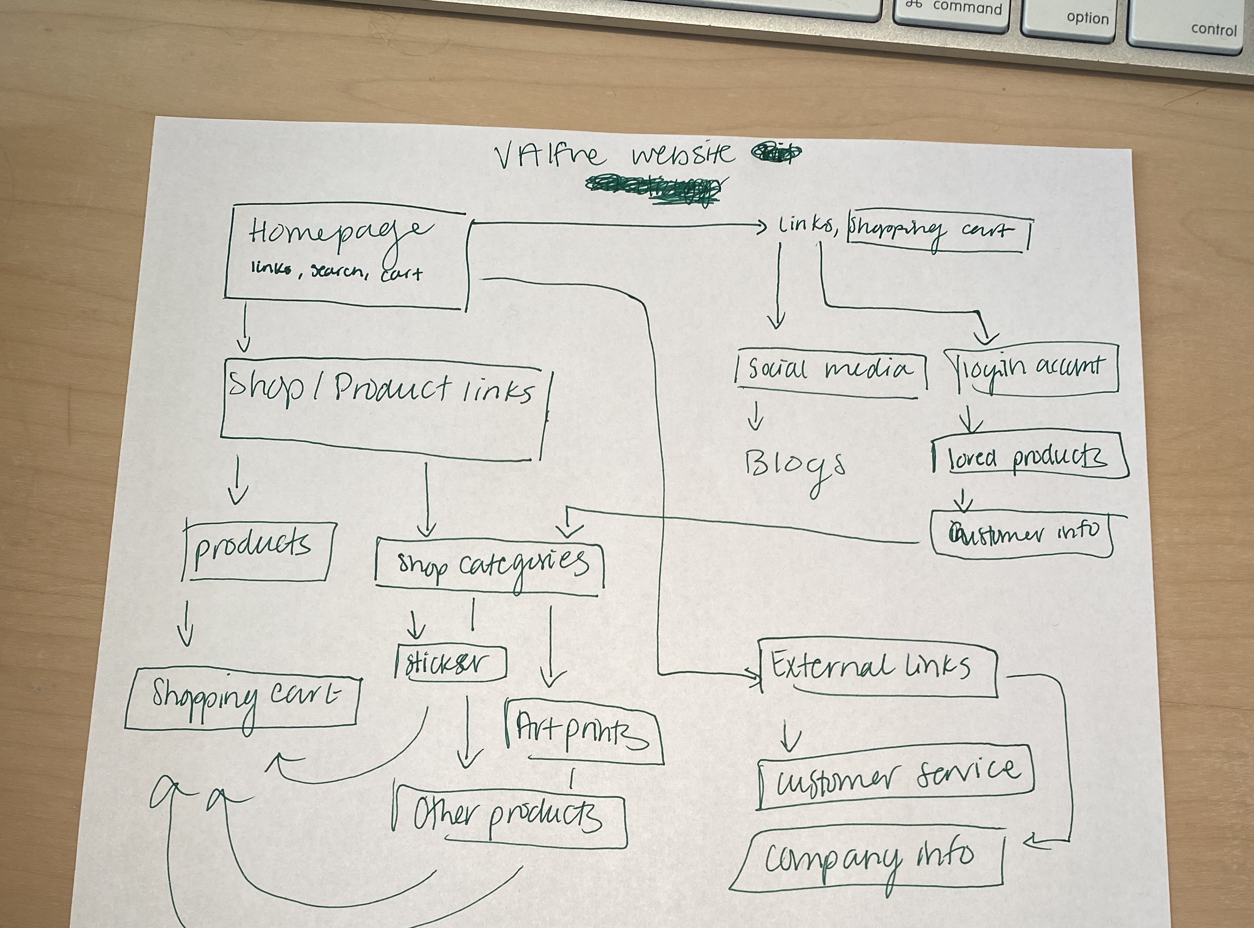

Her website, Highlights her art/style with the layout, typography as well as colors and images. Her HTML set up plus her CSS really work well together. The shop is easily accessible and each link brings you to another link. Each product shows additional products that are similar or “suggested” for the viewer.