SRM Institute of Science and Technology
School of Computing — VIII Semester
21CSP401L / 21CSP402L — Major Project

Architecture Document
High-Level & Low-Level Design with Description

Field | Details
Project Title | SDN-Inspired Seizure Detection & Assistive Control
Student Name | Ekanika Shah
Register No. | RA2211003010633
Department | School of Computing
Guide | Dr. K. Kishore Anthuvan Sahayraj
Review | Second Review
Date | 7 March 2026

1. Introduction
This document describes the high-level and low-level architecture of the SDN-Inspired Seizure Detection and Assistive Control system. The system applies Software-Defined Networking (SDN) principles to epileptic seizure detection using EEG signals, mapping SDN architectural concepts formally onto a three-tier clinical pipeline.

Architecture pattern selected: Event-Driven Architecture. Each EEG window triggers an event that flows upward through the data plane, control plane, and northbound API layer. The system is modular — each layer operates independently. This property, called control-plane portability, is one of the system's core novel contributions.

2. Application Architecture

2.1 Architecture Pattern — Event-Driven
The system uses an Event-Driven Architecture with three layers directly corresponding to the three planes of a Software-Defined Network:

Layer | SDN Equivalent | Responsibility in This System
Data Plane | Packet forwarding | EEG signal ingestion, windowing, feature extraction
Control Plane | Routing logic / controller | ML-based risk scoring + flow-table rule engine
Northbound API | Application interface | Browser dashboard, REST endpoints, device triggers

2.2 High-Level Architecture Diagram
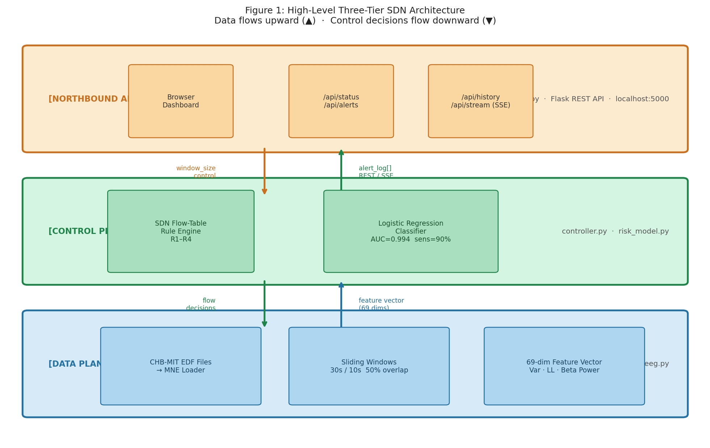
Figure 1: High-Level Three-Tier SDN Architecture. Data flows upward (▲); control decisions flow downward (▼).

2.3 SDN Concept Mapping
Formal mapping of SDN networking concepts to system components — the foundation of the architectural contribution:

SDN Concept | This System Component | Implementation File
Data Plane | EEG signal processing & feature extraction | feature_engineering.py
Control Plane | Logistic Regression risk classifier | risk_model.py
SDN Controller | Programmable flow-table rule engine | controller.py
Flow Table | Clinical decision rules R1–R4 | controller.py — FLOW_TABLE dict
QoS | Window size: 30 s → 10 s when risk rises | feature_engineering.py + controller.py
Northbound API | Browser dashboard — live risk & alert output | dashboard.py
Southbound API | Feature vector channel to classifier | run_pipeline.py
Control-Plane Portability | Rules change without retraining the model | FLOW_TABLE dict in controller.py

3. Microservices / Event-Driven Components
The system is structured as loosely coupled modules communicating through defined interfaces — consistent with an Event-Driven microservices design:

Module | File | Trigger Event | Output Event | Interface Type
EEG Loader | load_eeg.py | File path provided | MNE Raw object | Function call
Feature Eng. | feature_engineering.py | MNE Raw available | X.npy, y.npy | NumPy file / memory
Risk Model | risk_model.py | Features ready | Risk score 0.0–1.0 | Python object
SDN Controller | controller.py | Risk score received | Status + log entry | Python dict
Northbound API | dashboard.py | alert_log[] updated | JSON / SSE stream | HTTP REST + SSE
Pipeline | run_pipeline.py | CLI command received | Full demo launched | CLI + function calls

4. Low-Level Design

4.1 Component Diagram
Component | Input | Output | Technology
EDF Loader | Path to .edf file | MNE Raw object | MNE 1.8.0
Window Slicer | MNE Raw, window size | List of time windows | NumPy
Label Annotator | Window + seizure times | Label 0 (inter) / 1 (ictal) | CHB-MIT summary.txt
Feature Extractor | Window (23×N samples) | 69-dim feature vector | NumPy FFT
StandardScaler | Feature matrix X | Scaled X | scikit-learn
LR Classifier | Scaled feature vector | Risk score (0.0–1.0) | scikit-learn LogisticRegression
SDN Controller | Risk score + timestamp | Status + window_size | Python dict rules
Flask Server | alert_log[] list | JSON REST + SSE | Flask 3.x
Browser UI | JSON from /api/* | Live dashboard | Chart.js, HTML/JS/CSS

4.2 Sequence Diagram — Single Window Processing
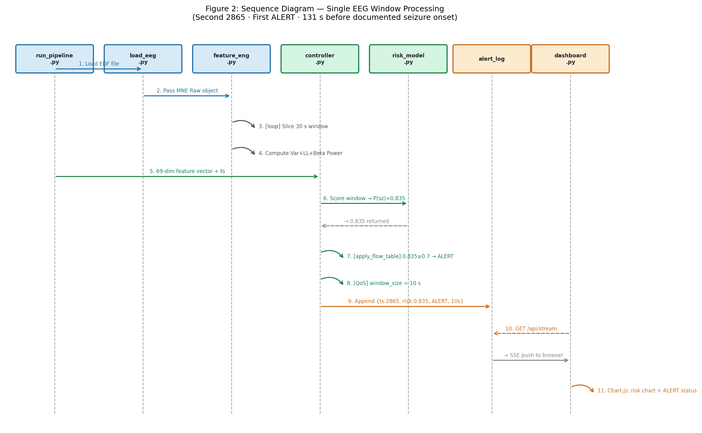
Figure 2: UML Sequence Diagram — Single EEG Window Processing (second 2865; first ALERT detected 131 s before documented seizure onset).

4.3 Data Flow Diagram (DFD)
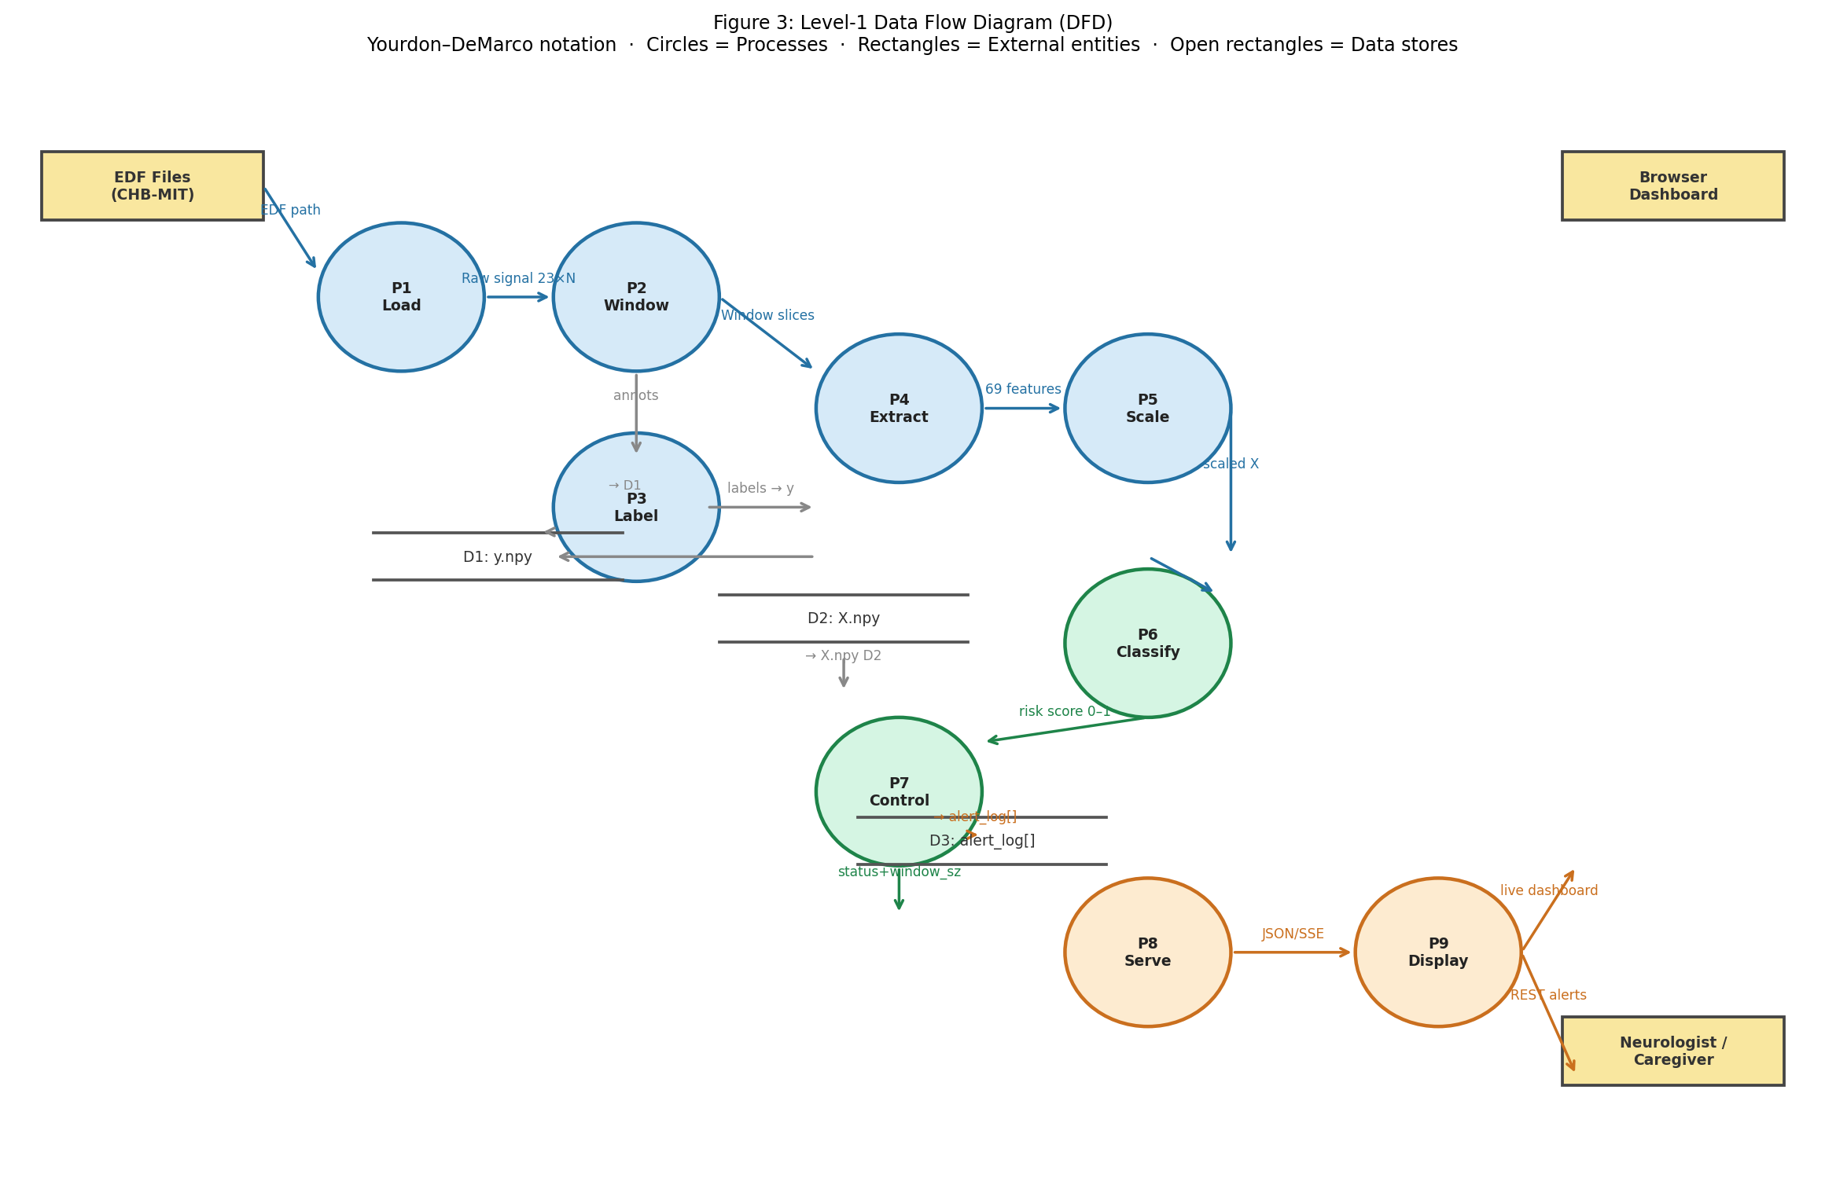
Figure 3: Level-1 Data Flow Diagram (Yourdon–DeMarco notation). Circles = Processes; Rectangles = External entities; Open rectangles = Data stores.

4.4 Use Case Diagram
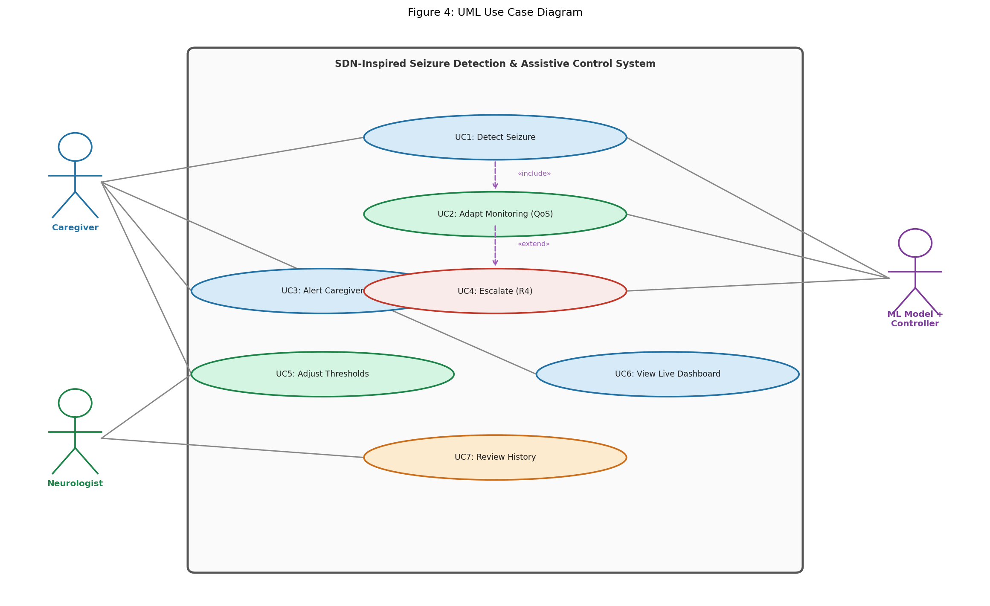
Figure 4: UML Use Case Diagram.

5. Database Design

5.1 ER Diagram / Data Schema
No persistent database is used. All state is in-memory during the session. Primary data structures:

Entity | Type | Fields / Description
Feature Matrix X | NumPy array (717×69) | 69 float features per window. Saved to data/X.npy
Label Vector y | NumPy array (717,) | 0=interictal, 1=ictal. Saved to data/y.npy
Alert Log Entry | Python dict | timestamp:float, risk_score:float, status:str, window_size:int
FLOW_TABLE | Python dict | Maps status → (low_thresh, high_thresh). Clinician-configurable.
WINDOW_SIZE | Python dict | SAFE:30, CAUTION:10, ALERT:10, ESCALATE:10 (seconds)

5.2 Data Exchange Contract
Exchange | From → To | Format | Frequency
Feature vector | Data Plane → Control Plane | NumPy array (69,) | Every 15 seconds (50% overlap)
Risk score | Model → Controller | float32 (0.0–1.0) | Every window
Alert log entry | Controller → Flask API | Python dict | Every window
/api/status | Flask → Browser | JSON | Polled every 500 ms
/api/stream | Flask → Browser | SSE (text/stream) | Pushed every 100 ms
/api/alerts | Flask → Browser / Neurologist | JSON array | On demand (GET)

5.3 Datasets
Dataset Property | Details
Name | CHB-MIT Scalp EEG Database
Source | PhysioNet — physionet.org/content/chbmit
Patient | chb01 — paediatric patient, 23 channels, 256 Hz
Files used | chb01_01.edf (baseline), chb01_03.edf (seizure), chb01_04.edf (seizure)
Total windows | 717 (239 per file × 3 files)
Class balance | 9 ictal (1.3%) vs 708 interictal (98.7%)
Annotations | chb01-summary.txt — seizure onset/offset times by neurologists

5.4 Mode of Data Exchange
Interface | Mode | Notes
Data Plane → Control Plane | Function call (in-memory) | Feature vector passed directly as NumPy array
Control Plane → Northbound | Shared list (alert_log[]) | Flask reads list written by controller thread
Northbound API → Browser | HTTP REST + SSE | JSON via GET endpoints; live stream via EventSource
EDF files → Data Plane | File I/O (MNE loader) | Local disk, European Data Format
X.npy / y.npy | File I/O (NumPy) | Persisted to disk between feature extraction and training

6. Legends
Term | Meaning
Data Plane | Bottom tier — raw EEG processing. No decisions made here.
Control Plane | Middle tier — ML classifier + SDN controller rule engine.
Northbound API | Top tier — interface for caregivers, neurologists, and devices.
Southbound API | Feature vector channel from data plane to classifier.
Flow Table | Programmable rules mapping risk score to clinical action.
QoS | Window shrinks 30 s → 10 s when risk rises — mirrors SDN bandwidth reallocation.
Control-Plane Portability | Rules update without retraining the ML model.
SAFE | risk < 0.4. Normal monitoring. 30 s window.
CAUTION | risk 0.4–0.7. Caregiver alerted. 10 s window (QoS active).
ALERT | risk ≥ 0.7. Seizure detected. Emergency contact notified.
ESCALATE | 3× ALERT. Sustained seizure. Neurologist notified.
SSE | Server-Sent Events — one-way real-time push from Flask to browser.
AUC-ROC | Area Under ROC Curve. 0.5=random, 1.0=perfect.
FPR/hr | False Positive Rate per Hour — false alarms per monitoring hour.
Ictal | During a seizure. Label = 1.
Interictal | Between seizures. Label = 0.
CHB-MIT | Boston Children's Hospital EEG database on PhysioNet.
EDF | European Data Format — standard EEG file format.
→ (arrow) | Data flows from left component to right component.
▲ / ▼ | Upward = toward northbound API. Downward = controller decisions.

