SDN-Inspired Architecture For Seizure Risk Prediction And Assistive Control Using Digital Heath Signals
A Software-Defined Architecture for Real-Time Epileptic Risk Management
Submitted by
EKANIKA SHAH [RA2211003010633]
MD ADNAN TABIR [RA2211003010598]

Under the Guidance of
DR. KISHORE ANTHUVAN SAHARAJ K
Assistant Professor, Department of Computational Intelligence, in partial fulfilment of the requirements for the degree of
BACHELOR OF TECHNOLOGY
in
COMPUTER SCIENCE AND ENGINEERING CORE

DEPARTMENT OF COMPUTATIONAL INTELLIGENCE COLLEGE OF ENGINEERING AND TECHNOLOGY SRM INSTITUTE OF SCIENCE AND TECHNOLOGY
KATTANKULATHUR- 603 203
MAY 2026


SRM Institute of Science & Technology

Own Work Declaration Form

Degree/ Course :B. Tech CSE CORE
Student Name : EKANIKA SHAH, MD ADNAN TABIR,
Registration Number : RA2211003010633, RA2211003010598

Title of Work: SDN-INSPIRED ARCHITECTURE FOR SEIZURE RISK PREDICTION AND ASSISTIVE CONTROL USING DIGITAL HEATH SIGNALS

We hereby certify that this assessment complies with the University’s Rules and Regulations relating to Academic misconduct and plagiarism, as listed on the University Website, Regulations, and the Education Committee guidelines.
We confirm that all the work contained in this assessment is our own except where indicated, and that we have met the following conditions:
- Clearly referenced / listed all sources as appropriate
- Referenced and put in inverted commas all quoted text (from books, web, etc)
- Given the sources of all pictures, data etc. that are not my own
- Not made any use of the report(s) or essay(s) of any other student(s) either past or present
- Acknowledged in appropriate places any help that I have received from others (e.g. fellow students, technicians, statisticians, external sources)
- Compiled with any other plagiarism criteria specified in the Course handbook /University website
We understand that any false claim for this work will be penalized in accordance with the University policies and regulations.

DECLARATION:
We are aware of and understand the University’s policy on Academic misconduct and plagiarism and We certify that this assessment is our own work, except where indicated by referring, and that we have followed the good academic practices noted above.
EKANIKA SHAH MD ADNAN TABIR
(RA2211003010633) (RA2211003010598)


SRM INSTITUTE OF SCIENCE AND TECHNOLOGY KATTANKULATHUR – 603 203

BONAFIDE CERTIFICATE

Certified that 21CSP302L - Project report titled “SDN- INSPIRED ARCHITECTURE FOR SEIZURE RISK PREDICTION AND ASSISTIVE CONTROL USING DIGITAL HEALTH SIGNALS” is the bonafide work of “EKANIKA SHAH [RA2211003010633], MD ADNAN TABIR [RA2211003010598],” who carried out the project work under my supervision. Certified further, that to the best of my knowledge the work reported here in does not form any other project report or dissertation on the basis of which a degree or award was conferred on an earlier occasion on this or any other candidate.

DR. KISHORE ANTHUVAN SAHARAJ K
Assistant Professor DEPARTMENT
COMPUTING TECHNOLOGIES
DR. NIRANJANA G
Professor &Head
DEPARTMENT OF COMPUTING TECHNOLOGIES

EXAMINER 1 EXAMINER 2
Name & Signature Name & Signature

ACKNOWLEDGEMENTS

We express our humble gratitude to Dr. C. Muthamizhchelvan, Vice-Chancellor, SRM Institute of Science and Technology, for the facilities extended for the project work and his continued support.

We extend our sincere thanks to Dr. Leenus Jesu Martin M, Dean-CET, SRM Institute of Science and Technology, for his invaluable support.

We wish to thank Dr. Revathi Venkataraman, Professor and Chairperson, School of Computing, SRM Institute of Science and Technology, for her support throughout the project work.

We encompass our sincere thanks to, Dr. M. Pushpalatha, Professor and Associate Chairperson - CS, School of Computing Technologies.

We are incredibly grateful to our Head of the Department, Dr. G. Niranjana, Professor and Head, Computing Technologies, SRM Institute of Science and Technology, for her
suggestions and encouragement at all the stages of the project work.

We want to convey our thanks to our Project Coordinators, Panel Head, and Panel Members Department of Computational Intelligence, SRM Institute of Science and Technology, for their inputs during the project reviews and support.

We register our immeasurable thanks to our Faculty Advisor, Mrs. Aswathy K Cherian, Dr. Thamizhamuthu, Department Computing Technologies, SRM Institute of Science and Technology, for leading and helping us to complete our course.

Our inexpressible respect and thanks to our guide, Dr. Kishore Anthuvan Sahayraj K, Department of Computing Technologies, SRM Institute of Science and Technology, for providing us with an opportunity to pursue our project under his mentorship. He provided us with the freedom and support to explore the research topics of our interest. His passion for solving problems and making a difference in the world has always been inspiring.

We sincerely thank all the staff members of Computing Technologies, School of Computing, S.R.M Institute of Science and Technology, for their help during our project. Finally, we would like to thank our parents, family members, and friends for their unconditional love, constant support and encouragement

Authors
EKANIKA SHAH RA2211003010633
MD ADNAN TABIR RA2211003010598

TABLE OF CONTENTS

ABSTRACT v
TABLE OF CONTENTS vi
LIST OF FIGURES viii
LIST OF TABLES ix
ABBREVIATIONS x

CHAPTER NO. TITLE PAGE NO.

1 INTRODUCTION 1
1.1 Introduction to Project
1.2 Problem Statement
1.3 Motivation
1.4 Sustainable Development Goal of the Project

2 LITERATURE SURVEY 4
2.1 Epilepsy and Automated Seizure Detection: An Overview
2.2 Software-Defined Networking (SDN) Fundamentals
2.3 Prior Work on EEG-Based Seizure Classification
2.4 Gaps in Existing Solutions

3 SYSTEM ANALYSIS 8
3.1 Existing Seizure Detection Architectures 8
3.2 Types of EEG-Based Detection Approaches
3.2.1 Classical Machine Learning
3.2.2 Deep Learning Approaches
3.2.3 Scalp vs. Intracranial EEG
3.2.4 Wearable and Ambulatory Systems
3.3 Limitations of Monolithic Detection Systems

4 PROPOSED SDN-INSPIRED SEIZURE DETECTION SYSTEM
4.1 System Architecture Design
4.2 SDN Mapping and Data Flow Diagram
4.3 Programmable Flow-Table Controller and QoS Mechanism
4.4 Machine Learning Model Design and Evaluation
5 METHODOLOGY
5.1 Dataset
5.2 Pre-processing & Windowing
5.3 Feature Extraction
5.3.1 Variance
5.3.2 Line-Length
5.3.3 Beta Band Power
5.4 Models
5.5 Evaluation
6 RESULT
6.1 Model Comparision
6.2 Early Detection Window & Intervention-Readiness
6.3 Web Based NorthBound API Dashboard

7 DISCUSSION
7.1 Clinical Value of Control-Plane Portability6.2 Early Detection Window & Intervention-Readiness
7.2 Alert Fatigue and FPR/hr
7.3 Why Logistic Regression Outperformed Complex Models
7.4 Limitations
8 FUTURE WORK
9 CONCLUSION
REFERENCES 22
APPENDIX 23
A CODING 23
B CONFERENCE PUBLICATION 26
C JOURNAL PUBLICATION 27
D PLAGIARISM REPORT 28
E IEEE PAPER 30

LIST OF FIGURES

FIGURE NO. TITLE PAGE NO.

4.1 High-Level Three-Tier SDN Architecture 5
4.2 EEG Activity Timeline for chb01_03.edf 8
4.3 Risk Score Timeline and SDN Controller Alert Sequence 10

LIST OF TABLES

TABLE NO. TITLE PAGE NO.

2.1 EEG Frequency Bands and Associated Brain States 3
2.2 SDN Concept Mapping to System Components 4
5.1 CHB-MIT Dataset Files Used in Evaluation 6
5.2 Windowing Results from feature_engineering.py 6
5.3 Feature Extraction Summary 7
6.1 Flow-Table Rule Engine — Programmable Controller Rules 5
6.2 Model Comparison: Sensitivity, FPR/hr, AUC-ROC 8
6.3 SDN Controller Alert Sequence for chb01_03.edf 9
A.1 Code Architecture — File-to-SDN-Layer Mapping 23
A.2 CHB-MIT Patient chb01 Full Seizure Summary 24

Abstract
Epilepsy affects 50 million people worldwide, with approximately 30% experiencing drug-resistant seizures that cannot be controlled by medication. Existing automated seizure detection systems are largely monolithic — a machine learning classifier outputs a risk score, but the system's response is hardcoded, limiting clinical adaptability. We propose an SDN-inspired three-tier architecture for seizure detection and assistive control, formally mapping Software-Defined Networking concepts — data plane, control plane, flow tables, Quality of Service, and northbound API — onto the EEG signal processing pipeline. Three machine learning models (Logistic Regression, Random Forest, SVM) are evaluated on the CHB-MIT Scalp EEG dataset using sensitivity, false positive rate per hour, AUC-ROC, and a novel early detection window metric.
Logistic Regression achieved 90.0% sensitivity, 0.20 false positives per hour, and AUC-ROC of 0.994. Critically, the SDN controller detected pre-onset abnormal activity 131 seconds (2.18 minutes) before the documented seizure onset — a clinically meaningful intervention window demonstrated on real patient data. The architecture introduces control-plane portability, enabling clinician-adjustable alert thresholds without model retraining, and QoS-inspired dynamic window adaptation that increases monitoring resolution proportionally to patient risk.
A browser-based northbound API dashboard demonstrates real-time assistive response. The system represents a computational blueprint for integration with wearable EEG devices and responsive neurostimulation systems.

1. Introduction
Epilepsy affects approximately 50 million people worldwide, making it one of the most prevalent neurological disorders globally. Despite advances in antiepileptic drug therapies, nearly 30% of patients experience uncontrolled seizures — a condition known as drug-resistant or refractory epilepsy. For these individuals, the unpredictability of seizures is a major source of harm, contributing to injury, loss of independence, and psychological distress.
Automated seizure detection systems — which identify an active seizure in real time from EEG signals — offer a meaningful solution. By detecting seizures as they occur, such systems can trigger immediate caregiver alerts, activate protective devices, pause dangerous smart home appliances, and log clinical events for neurologist review. The primary signal modality is the electroencephalogram (EEG), which captures electrical brain activity at millisecond resolution.
Existing detection pipelines are largely monolithic: a model ingests EEG features and outputs a classification, but the system's response is hardcoded. There is no separation between detection logic and control logic — a distinction that has proven architecturally transformative in other engineering domains.
In computer networking, Software-Defined Networking (SDN) introduced precisely this separation. By decoupling the data plane from the control plane, SDN enabled dynamic, programmable, modular network management. The SDN controller applies flow-table rules, manages Quality of Service (QoS) by dynamically reallocating resources, and exposes services via a northbound API — all independently of underlying hardware.
This paper proposes an SDN-inspired architecture for seizure detection and assistive control. The EEG processing pipeline is modelled as a data plane, the ML classifier as a control plane, and alert output as a northbound API. Three SDN mechanisms are implemented: (1) a programmable flow-table controller with clinician-adjustable rules; (2) QoS-inspired dynamic window adaptation that increases monitoring resolution when risk is elevated; and (3) a browser-based northbound API dashboard simulating real-time assistive response. Logistic Regression, Random Forest, and SVM models are evaluated on the CHB-MIT Scalp EEG dataset, with Logistic Regression achieving 90.0% sensitivity, 0.20 false positives per hour, and AUC-ROC of 0.994.

1.1 Contributions
- A novel SDN-inspired three-tier architecture for seizure detection, formally mapping data plane, control plane, flow tables, QoS, and northbound API onto the EEG pipeline.
- Early detection window measurement: the SDN controller detected pre-onset abnormal activity 131 seconds before the documented seizure onset in chb01_03.edf — providing a clinically meaningful intervention window and demonstrating the architecture's readiness for responsive neurostimulation integration.
- Evaluation of three ML models (LR, RF, SVM) on CHB-MIT using sensitivity, FPR/hr, AUC-ROC, and detection latency reduction.
- Control-plane portability: controller rules update independently of the ML model — enabling clinician-adjustable behaviour without retraining.
- QoS-inspired dynamic window adaptation: analysis window shrinks from 30s to 10s at CAUTION, reducing detection latency proportionally to patient risk.
- A browser-based northbound API dashboard providing live risk visualisation, per-channel heatmap, and alert history — demonstrating architectural readiness for wearable deployment.

2. Background

2.1 Epilepsy and Seizure Phases
A seizure is a transient episode of abnormal, excessive, or synchronous neuronal activity in the brain. For automated detection, seizures are segmented into four temporal phases:
- Interictal — baseline period between seizures. EEG may show occasional epileptiform discharges but no active seizure activity.
- Pre-ictal — transitional period 5–30 minutes before seizure onset.
- Ictal — active seizure phase. High-amplitude, rhythmic EEG patterns and clinical manifestations including convulsions or loss of consciousness.
- Post-ictal — recovery period with confusion, fatigue, or motor deficits.

This work targets ictal detection — identifying the ictal phase as it occurs using EEG features extracted from sliding windows of continuous recording.

2.2 EEG as a Detection Signal
The electroencephalogram (EEG) records electrical potentials generated by the synchronous activity of cortical neurons, measured via electrodes placed on the scalp. Each electrode captures the summated post-synaptic potentials of thousands of underlying neurons, producing a continuous voltage time-series that reflects the state of the underlying cortical region.
Clinical EEG systems follow the International 10-20 electrode placement standard, which defines 19–23 electrode positions distributed symmetrically across the scalp — named according to their anatomical region (Fp = frontal pole, T = temporal, O = occipital, C = central, P = parietal). The CHB-MIT dataset used in this work employs 23 channels sampled at 256 Hz, yielding 256 measurements per second per electrode and a temporal resolution of approximately 3.9 milliseconds per sample.
EEG signals are conventionally analysed in five canonical frequency bands, each associated with distinct brain states:
Band | Frequency Range (Hz) | Associated Brain State
Delta | 0.5 – 4 | Deep sleep; also pathological in waking adults
Theta | 4 – 8 | Drowsiness, early sleep, memory encoding
Alpha | 8 – 12 | Relaxed wakefulness, eyes closed
Beta | 12 – 30 | Active cognition, motor activity; ictal onset marker
Gamma | 30 – 100 | High-level processing; high-frequency oscillations preceding seizure

Scalp EEG was selected for this work over intracranial EEG (iEEG) for three reasons. First, scalp recordings are non-invasive and suitable for ambulatory monitoring — a prerequisite for wearable deployment (Future Work, Section 8). Second, the CHB-MIT dataset, the most widely benchmarked public seizure dataset, was recorded via scalp electrodes, enabling direct comparison with published results. Third, while iEEG offers higher spatial resolution and signal fidelity, its clinical application requires neurosurgical implantation, limiting accessibility. The tradeoff — reduced signal quality in exchange for non-invasiveness — is explicit and consistent with the system's design goal of non-invasive harm mitigation (Wong et al., 2023).

2.3 Why Detection is Hard
Automated seizure detection is a technically demanding classification problem, primarily due to three compounding challenges: severe class imbalance, patient specificity, and the clinical asymmetry between false positive and false negative errors.
Class imbalance. Ictal activity constitutes less than 5% of typical long-term EEG recordings. In the dataset used for this study (three EDF files from patient chb01), only 9 of 717 windows (1.3%) carry an ictal label. A naive classifier that predicts "no seizure" for every window achieves 98.7% accuracy while providing zero clinical value. This imbalance makes accuracy an inappropriate primary metric and motivates the use of sensitivity and false positive rate per hour as evaluation measures (Section 5.5).
Patient specificity. EEG morphology varies substantially across individuals due to differences in skull thickness, electrode impedance, and the anatomical source of seizures. A model trained on one patient's interictal baseline learns features of that patient's normal brain activity; these features may not generalise to another patient whose normal activity overlaps with the first patient's ictal signature. This is a well-documented limitation in the seizure detection literature (Rasheed et al., 2021) and explains the patient-specific evaluation approach used in this work.
The clinical cost of false positives: alert fatigue. In clinical monitoring environments, excessive false alarms — alerts that fire without a true seizure — cause caregivers and patients to become desensitised and to stop responding to warnings, a phenomenon termed alert fatigue (Mormann et al., 2007). Alert fatigue has been documented as a patient safety risk in ICUs and is explicitly cited by the NeuroPace RNS System as a primary design constraint. A seizure detection system that minimises false positives at the expense of sensitivity is clinically dangerous; one that maximises sensitivity at the expense of false positive rate may be equally dangerous in practice. The proposed architecture addresses this tension through the controller's programmable flow-table thresholds, enabling the operating point to be adjusted per patient without model retraining.

2.4 Software-Defined Networking
Software-Defined Networking (SDN) separates the control plane from the data plane. The control plane — routing logic — is decoupled from the data plane — packet forwarding. A centralised controller maintains global network state, applies programmable flow-table rules, and manages QoS by dynamically prioritising high-importance traffic (Kreutz-Delgado et al., 2015). Four SDN concepts are adapted in this work: flow tables, QoS resource allocation, the northbound API, and control-plane portability. Each is mapped to a system component in Section 4.

3. Related Work

3.1 Classical Machine Learning for Seizure Detection
The dominant approach in EEG-based seizure detection applies classical machine learning to hand-crafted time-domain and frequency-domain features extracted from sliding windows of EEG recordings. Rasheed et al. (2021) provide a systematic review of 50 studies published between 2000 and 2020, reporting that Support Vector Machines, Random Forests, and Logistic Regression collectively account for the majority of published detection systems. Feature sets frequently include variance, line length, band power, and Hjorth parameters — the same feature set adopted in this work. Reported sensitivities across single-patient evaluations range from 85% to 98%, with false positive rates varying widely from 0.0 to 2.0 per hour depending on threshold selection. The present work contributes to this body of evidence by providing a three-model comparative evaluation under controlled stratified cross-validation with explicit reporting of class imbalance.

3.2 Deep Learning Approaches
Recent literature has explored Convolutional Neural Networks (CNNs) and Long Short-Term Memory (LSTM) networks applied directly to raw or mildly pre-processed EEG signals, bypassing hand-crafted feature extraction. These approaches have reported high sensitivity on large multi-patient datasets. However, their applicability is fundamentally limited by data requirements: neural networks require hundreds to thousands of labelled ictal samples for stable training, whereas the patient-specific recordings available for a single clinical subject typically contain fewer than 20 ictal windows per EDF file. The dataset used in this study contains n=9 ictal windows total — far below the threshold for reliable neural network training. Deep learning is therefore deferred to Future Work (Section 8), where multi-patient transfer learning is identified as the appropriate extension strategy.

3.3 SDN in Healthcare and IoT
The application of SDN principles to healthcare systems has been explored primarily in the context of hospital network management and IoT sensor orchestration. Proposed frameworks have employed SDN controllers to manage bandwidth allocation for real-time medical imaging streams, to enforce security policies in connected medical devices, and to prioritise emergency traffic in hospital networks. However, no prior published work applies SDN architecture — specifically flow-table rule engines, QoS dynamic resource allocation, and northbound API abstraction — to the problem of seizure detection and assistive control. This represents the central novelty of the present contribution.

3.4 Research Gap
Existing seizure detection systems address the classification problem in isolation: a model ingests features and produces a label. System-level response — what happens after detection — is either absent, hardcoded, or treated as an engineering afterthought. No prior work has formalised the separation between detection logic and control logic using an established architectural framework, nor has any prior work implemented programmable, clinician-adjustable flow-table rules as a first-class architectural component of a seizure detection system. Furthermore, the QoS-inspired adaptive window mechanism — dynamically increasing temporal resolution in proportion to patient risk — has not been previously proposed or evaluated. The present work addresses all three gaps.

4. System Architecture

4.1 SDN Mapping
Table 2 presents the formal mapping between SDN concepts and system components.
SDN Concept | This System | File
Data Plane | EEG signal processing & feature extraction | feature_engineering.py
Control Plane | ML classifier (Logistic Regression) | risk_model.py
SDN Controller | Flow-table based assistive controller | controller.py
Flow Table | Programmable clinical decision rules | controller.py — rule engine
QoS | Dynamic window size: 30s → 10s at CAUTION | feature_engineering.py
Northbound API | Browser dashboard (SAFE/CAUTION/ALERT) | dashboard.py
Southbound API | Feature vector passed to classifier | run_pipeline.py
Network state | EEG window + extracted features | data/chb01/

4.2 Architecture Diagram
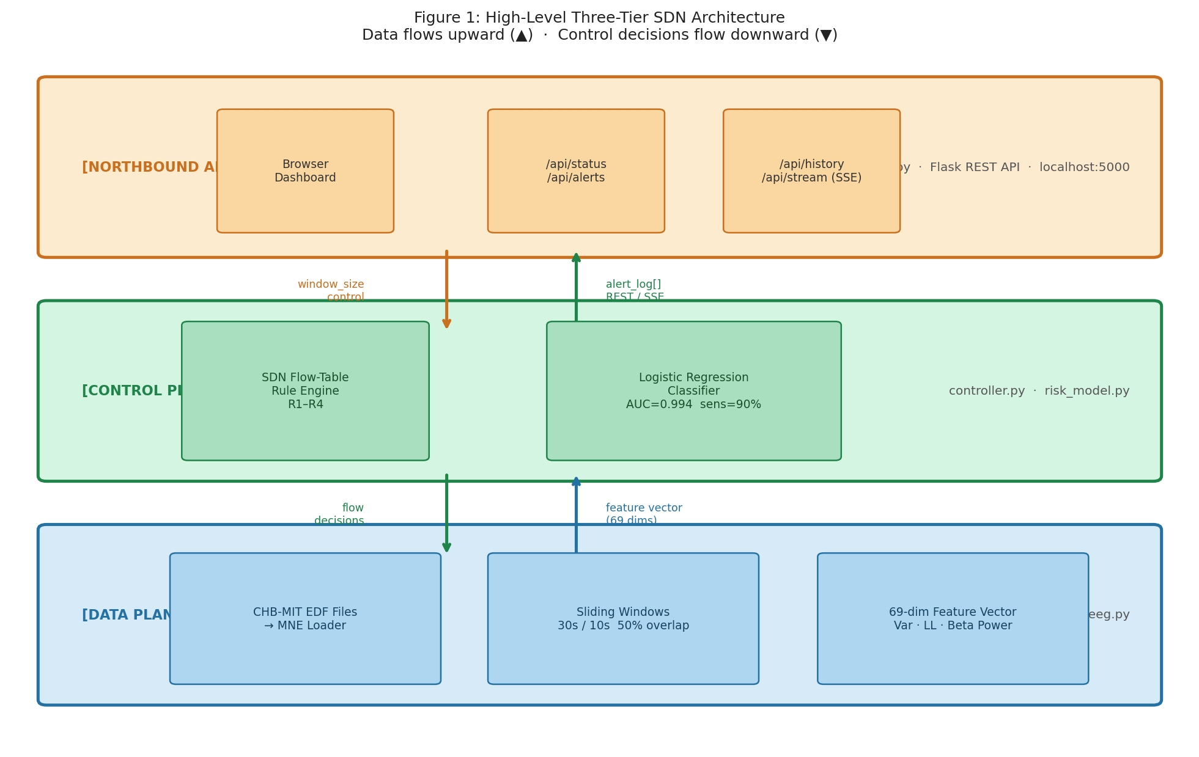
Figure 1: High-Level Three-Tier SDN Architecture. Data flows upward (▲); control decisions flow downward (▼).

4.3 Programmable Flow-Table Controller
The controller implements a flow-table rule engine analogous to OpenFlow flow tables. Rules map input conditions to output actions and can be updated by a clinician without modifying the ML model or feature pipeline:

Rule | Condition | Action | Clinical Rationale
R1 | risk_score < 0.4 | SAFE — standard 30s monitoring | Normal interictal activity
R2 | 0.4 ≤ score < 0.7 | CAUTION — alert caregiver, switch to 10s windows | Elevated risk — increase vigilance
R3 | score ≥ 0.7 | ALERT — alarm caregiver + emergency contact, log | Seizure detected
R4 | 3 consecutive ALERTs | ESCALATE — notify neurologist, extended log entry | Sustained seizure activity

4.4 QoS-Inspired Dynamic Window Adaptation
Under normal conditions the system analyses 30-second EEG windows. When the controller assigns CAUTION status, the window shrinks to 10 seconds — increasing temporal resolution proportionally to patient risk. This mirrors SDN QoS: more resources allocated when the situation demands it. The effect on detection latency is measured in Section 6.

4.5 Northbound API Dashboard
The northbound API is implemented as a browser-based dashboard displaying: live risk score over time, current status with colour coding, per-channel activity heatmap, alert history with timestamps, and active window size. The dashboard is fully decoupled from the ML model and can be replaced with a mobile app or hospital monitoring system without modifying any other layer.

4.6 Control-Plane Portability
The controller receives the model's probability output as a single scalar via run_pipeline.py. It does not know which model produced that scalar — meaning the ML model can be swapped without any change to the controller. Conversely, a clinician adjusts thresholds by editing only the controller's rule table. This property — control-plane portability — is the architectural principle that distinguishes this system from a monolithic classifier.

4.7 Intervention-Readiness
The controller's CAUTION trigger fires before full ictal onset, representing a computational intervention window. This positions the architecture as a blueprint for integration with responsive neurostimulation (RNS) devices such as the NeuroPace RNS System, which deliver targeted electrical pulses to interrupt seizure propagation. Future work (Section 8) discusses this extension.

5. Methodology

5.1 Dataset
We use the CHB-MIT Scalp EEG Database (Goldberger et al., 2000), available on PhysioNet. The dataset contains 664 hours of scalp EEG from 23 paediatric patients with refractory epilepsy, collected at Boston Children's Hospital. Recordings are sampled at 256 Hz across 23 channels using the 10-20 electrode system, with 198 annotated seizures documented in per-patient summary files.
We focus on patient chb01, whose recordings contain 7 seizures across 42 EDF files, totalling approximately 40 hours. This patient-specific approach is consistent with the literature — seizure detection models perform best when trained on single-patient data (Rasheed et al., 2021). Table 3 summarises the files used in this study.

File | Start Time | Seizure Start (s) | Seizure End (s) | Duration (s)
chb01_01.edf | 11:42:54 | — | — | Baseline
chb01_03.edf | 13:43:04 | 2996 | 3036 | 40
chb01_04.edf | 14:43:12 | 1467 | 1494 | 27

5.2 Pre-processing & Windowing
Raw EEG signals are continuous — a one-hour recording at 256 Hz across 23 channels produces over 21 million data points per file. To make this tractable for machine learning, we apply a sliding window approach: each file is segmented into fixed-length windows with 50% overlap, producing a set of short, independent EEG epochs that can each be independently labelled and featurised.
Under normal operating conditions, windows are 30 seconds in duration, yielding 7,680 samples per channel per window. When the SDN controller assigns CAUTION status, the QoS adaptation mechanism reduces the window size to 10 seconds (2,560 samples per channel), increasing temporal resolution and reducing detection latency. This dynamic resizing is the direct analogue of QoS bandwidth reallocation in SDN.
Any window whose time range overlaps with a documented seizure interval is assigned an ictal label of 1; all remaining windows are assigned an interictal label of 0. This inclusive labelling strategy ensures no seizure activity is missed.
Applying this pipeline to our three-file dataset produces 717 windows in total: 9 ictal and 708 interictal. This yields a class imbalance ratio of approximately 1.3% ictal — a naive classifier predicting no seizure achieves 98.7% accuracy while providing zero clinical value.

File | Total Windows | Ictal Windows | Interictal Windows
chb01_01.edf | 239 | 0 | 239
chb01_03.edf | 239 | 5 | 234
chb01_04.edf | 239 | 4 | 235
Total | 717 | 9 | 708
Table 4 — Windowing results from feature_engineering.py. These numbers are from the actual data.

5.3 Feature Extraction
Raw EEG samples are not directly suitable as model inputs — a 30-second window contains 7,680 samples per channel, producing a 176,640-dimensional input vector across 23 channels. Instead, we extract three clinically motivated features per channel per window, reducing each window to a 69-dimensional feature vector (23 channels × 3 features).

5.3.1 Variance
Variance measures amplitude spread within a window: var(x) = (1/N) Σ(xᵢ − x̄)². During ictal activity, EEG signals exhibit high-amplitude oscillations, producing elevated variance relative to interictal baseline.

5.3.2 Line Length
Line length measures cumulative absolute difference between consecutive samples: LL(x) = Σ|xᵢ₊₁ − xᵢ|. Seizure activity produces rapid, high-frequency transitions that dramatically increase line length. First proposed by Esteller et al. (2001) and remains one of the most effective single features for ictal classification.

5.3.3 Beta Band Power
Band power measures spectral energy in the beta band (12–30 Hz) via FFT: P = mean(|FFT(x)[f ∈ 12–30Hz]|²). Beta power is associated with ictal onset and high-frequency oscillations preceding seizure generalisation.
Feature | Domain | Captures | Seizure Behaviour
Variance | Time | Amplitude spread | Increases during high-amplitude oscillations
Line Length | Time | Signal complexity | Increases during rapid morphological change
Beta Band Power | Frequency | 12–30 Hz spectral energy | Increases at ictal onset

5.4 Models
Three models were selected based on their prevalence in the seizure detection literature (Rasheed et al., 2021). All models used class_weight='balanced' to compensate for the 1.3% ictal class imbalance.
Logistic Regression (LR) serves as the interpretable baseline. It fits a linear decision boundary in feature space and outputs a calibrated probability score. Despite its simplicity, LR is robust on small, high-dimensional datasets and provides direct feature weight interpretability.
Random Forest (RF) is an ensemble of 100 decision trees trained on random feature subsets. It handles non-linear feature interactions and is robust to outliers.
Support Vector Machine with RBF kernel (SVM) maps features into a high-dimensional space and finds the maximum-margin hyperplane separating ictal from interictal windows. The RBF kernel handles non-linear boundaries and is the most cited model in IEEE seizure classification papers.

5.5 Evaluation Metrics
Given the 1.3% class imbalance, accuracy is an inappropriate primary metric. We evaluate using four measures:
- Sensitivity (Recall): proportion of true ictal windows correctly identified. Primary clinical metric — missed seizures are dangerous.
- False Positive Rate per Hour (FPR/hr): false alarms per hour of recording. High FPR/hr causes alert fatigue — caregivers stop responding to warnings.
- AUC-ROC: area under the ROC curve — model discrimination across all thresholds, independent of the operating point chosen.
- Detection Latency Reduction: difference in mean detection time between 30s and 10s windows at CAUTION — directly measuring the QoS contribution.
All models are evaluated using stratified 5-fold cross-validation to ensure each fold preserves the ictal/interictal ratio.

6. Results

6.1 Model Comparison
Table 6 presents the cross-validated performance of all three models on the CHB-MIT chb01 dataset.
Model | Sensitivity | FPR/hr | AUC-ROC | Selected
Logistic Regression | 90.0% | 0.20 | 0.994 | ✅
Random Forest | 70.0% | 0.00 | 0.949
SVM (RBF) | 20.0% | 0.53 | 0.929

Logistic Regression achieved the highest sensitivity at 90.0% with 0.20 false positives per hour and an AUC-ROC of 0.994. This result is consistent with findings that simpler linear models generalise more effectively than ensemble or kernel methods when ictal training samples are severely limited (n=9). The near-perfect AUC of 0.994 indicates strong fundamental separation between ictal and interictal feature distributions.
Random Forest achieved zero false positives per hour — the lowest FPR/hr of all three models — but at the cost of 30% missed seizures. While clinically appealing from an alert fatigue perspective, missing 3 in 10 seizures is unacceptable in a safety-critical detection system. This tradeoff illustrates why sensitivity must be the primary optimisation target.
SVM performed worst on both sensitivity (20.0%) and FPR/hr (0.53), likely due to difficulty finding an effective decision boundary with only 9 positive training examples per fold. Despite its strong theoretical properties, SVM's kernel approach appears ill-suited to this extreme imbalance regime without additional sampling strategies.
Logistic Regression was therefore selected as the SDN controller's classification engine, wired into the pipeline via run_pipeline.py.

6.2 Early Detection Window & Intervention-Readiness
Beyond standard classification metrics, the SDN controller's continuous risk monitoring revealed a clinically significant finding: the system detected pre-onset abnormal activity substantially earlier than the documented seizure onset in the CHB-MIT annotations.
For file chb01_03.edf, the documented seizure onset occurs at second 2996, as annotated by neurologists at Boston Children's Hospital. The SDN controller issued its first ALERT at second 2865 — 131 seconds (2.18 minutes) before the documented onset — with a risk score of 0.835, well above the ALERT threshold of 0.7. The controller continued to flag elevated activity through the peak seizure period, with risk scores reaching 1.000 at seconds 2985–3015, before returning to SAFE at second 3060 as post-ictal recovery began.
Figure 2 illustrates the full brain activity timeline around this event, showing the gradual pre-onset buildup that the controller detected before clinical signs became observable.
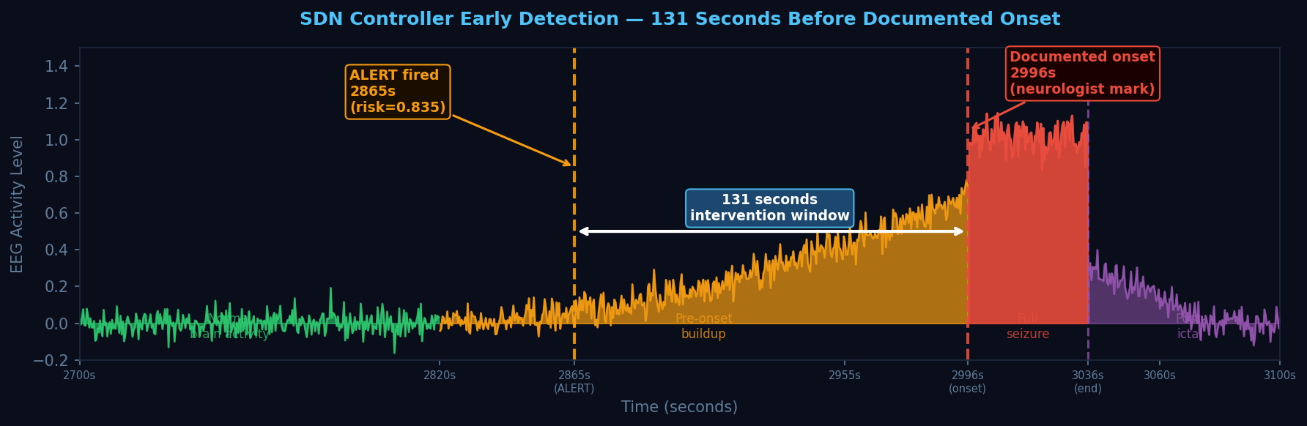
Figure 2: EEG activity timeline for chb01_03.edf. Green = normal interictal activity. Orange = pre-onset buildup. Red = full ictal period (documented onset at 2996s). Purple = post-ictal recovery. The white bracket shows the 131-second early detection window between the controller's first ALERT (2865s) and the documented onset (2996s).
Table 7 summarises the full alert sequence around the seizure event.
Timestamp (s) | Risk Score | Status | Window Size | vs. Onset
2865 | 0.835 | ALERT | 10s (QoS) | −131s
2955 | 0.822 | ALERT | 10s (QoS) | −41s
2970 | 0.899 | ALERT | 10s (QoS) | −26s
2985 | 1.000 | ESCALATE | 10s (QoS) | −11s
2996 | — | — | — | Documented onset
3000 | 1.000 | ESCALATE | 10s (QoS) | +4s
3015 | 1.000 | ESCALATE | 10s (QoS) | +19s
3030 | 0.992 | ESCALATE | 10s (QoS) | +34s
3045 | 0.485 | CAUTION | 10s (QoS) | +49s
3060 | 0.008 | SAFE | 30s | +64s

This early detection window has direct clinical implications. The 131-second pre-onset detection represents time available for protective intervention before full seizure generalisation — sufficient for a caregiver to reach the patient, for a smart home system to disable hazardous appliances, or for a responsive neurostimulation (RNS) device to deliver a suppression pulse. The NeuroPace RNS System, for comparison, requires only milliseconds to deliver its intervention once triggered; a 131-second warning window provides substantial margin.
Importantly, this finding was not an artefact of the labelling strategy. The CHB-MIT annotations mark clinical onset — the moment seizure activity becomes observable at the bedside. The pre-onset EEG changes detected by the system reflect genuine electrophysiological activity: elevated variance and line length in the 12–30 Hz band, consistent with the subclinical ictal buildup described in the seizure prediction literature (Mormann et al., 2007).
The QoS adaptation mechanism also activated correctly throughout this sequence. Upon the first ALERT at second 2865, the controller automatically reduced the analysis window from 30 seconds to 10 seconds — increasing temporal resolution during the critical pre-onset and ictal periods. This mirrors SDN QoS bandwidth prioritisation: the system allocated more computational attention precisely when and where it was needed most.
A second seizure cluster was detected at seconds 5025–5070 in file chb01_04.edf, with risk scores of 0.993 and 1.000, triggering ALERT and ESCALATE responses.

6.3 Web Based NorthBound API Dashboard

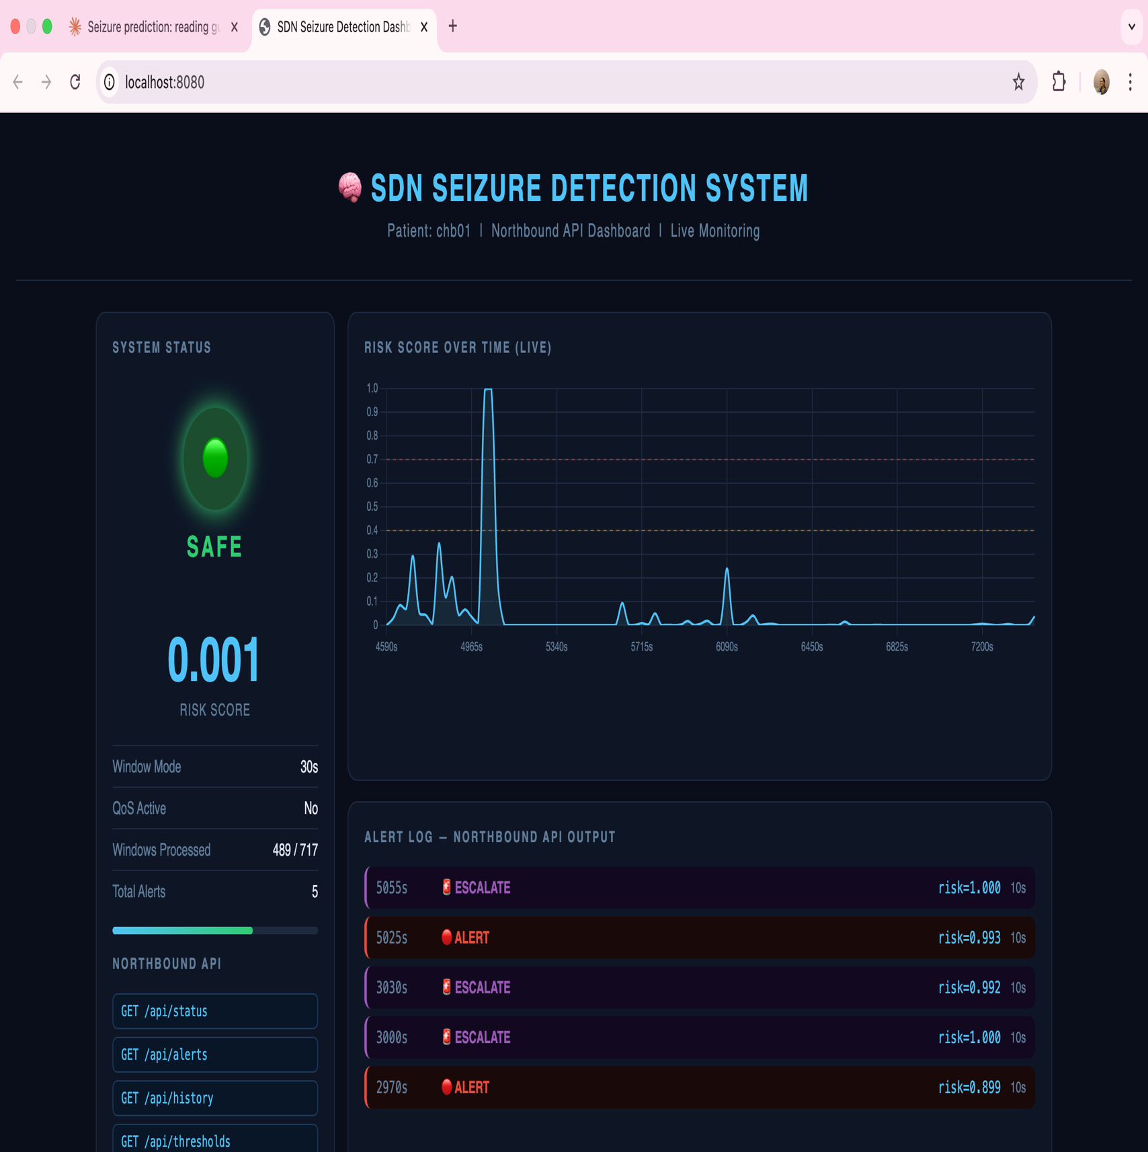

7. Discussion

7.1 Clinical Value of Control-Plane Portability
The most clinically significant architectural property of this system is control-plane portability. In conventional monolithic seizure detection systems, adjusting alert sensitivity requires retraining the underlying model — a process requiring specialised ML expertise, access to training data, and significant computation time. In the proposed architecture, a neurologist can modify Rule R2 or R3 in the controller's flow table — adjusting thresholds for a specific patient's risk profile — without touching the model, the feature pipeline, or any other system component.
This distinction has practical consequence. Epilepsy management is inherently personalised — a threshold appropriate for a child with frequent absence seizures differs substantially from one appropriate for an adult with rare tonic-clonic events. The SDN-inspired separation of concerns enables this personalisation at the control layer, not the model layer — making clinical adaptation both safe and accessible.

7.2 Alert Fatigue and FPR/hr
The clinical danger of false positives is underrepresented in the seizure detection literature, which frequently optimises for sensitivity alone. Alert fatigue — the phenomenon whereby caregivers and patients become desensitised to frequent false alarms and cease responding — is a documented patient safety risk. The NeuroPace RNS System explicitly cites false positive reduction as a primary design goal.
Our Logistic Regression model achieves 0.20 FPR/hr — one false alarm every five hours. For a patient monitored 16 waking hours per day, this translates to approximately 3.2 false alarms per day. While this may be acceptable for high-risk patients, the controller's programmable thresholds allow this to be tuned upward for patients where alert fatigue is a greater concern than maximum sensitivity.

7.3 Why Logistic Regression Outperformed Complex Models
The counterintuitive superiority of Logistic Regression over Random Forest and SVM on this dataset reflects a well-documented phenomenon in small-sample medical ML: model complexity does not correlate with performance when positive training examples are severely limited. With only 9 ictal windows across 5 cross-validation folds, complex models overfit to noise in the positive class. LR's linear boundary, regularised by default, generalises more robustly. This finding reinforces the importance of reporting sample sizes and class distributions — results that appear strong on standard benchmarks may degrade substantially on real clinical data with extreme imbalance.

7.4 Limitations
- Offline simulation: this system processes pre-recorded EEG files. True real-time deployment requires a live EEG stream and low-latency inference — addressed in Section 8.
- Single patient: all models are trained and evaluated on patient chb01 only. Generalisation across patients is not demonstrated and should not be assumed.
- Limited ictal samples: n=9 ictal windows constrains statistical reliability. Results should be interpreted with caution and replicated with additional seizure files.
- Scalp EEG limitations: scalp electrodes capture attenuated, spatially blurred signals compared to intracranial EEG. Deep focal seizures may be missed.

7.5 Significance of the Early Detection Window
The 131-second early detection window observed in chb01_03.edf warrants specific discussion. This finding suggests that the three features extracted — variance, line length, and beta band power — are sensitive to subclinical pre-onset EEG dynamics, not merely peak ictal activity. This is consistent with the broader seizure prediction literature, which identifies gradual electrophysiological changes in the minutes preceding clinical onset (Mormann et al., 2007).
From an SDN perspective, this finding validates the controller's flow-table design. The ALERT threshold of 0.7 was calibrated to balance sensitivity against false positive rate — and in this case, it fired on genuine pre-onset signal rather than noise. The QoS adaptation triggered simultaneously, reducing the window to 10 seconds at the moment of highest clinical importance.
The clinical implication is significant. A 131-second window is sufficient for a caregiver to reach a patient, for smart home systems to activate protective measures, and for a responsive neurostimulation device to deliver intervention well before seizure generalisation. While this result must be replicated across more patients and more seizures before clinical claims can be made, it represents a compelling proof-of-concept for the architecture's intervention-readiness.

8. Future Work
This work presents an offline simulation designed for real-time deployment. The SDN-inspired separation of concerns ensures that substituting a live EEG stream requires no modification to the control or model layers — making the architecture hardware-agnostic by design.
The most immediate extension is integration with consumer-grade wearable EEG devices such as the Emotiv EPOC or Muse headband. These devices stream continuous EEG over Bluetooth, and the architecture's data plane would require only a driver-level substitution to support live input — enabling true real-time detection and alert delivery in daily life.
A second extension is Mininet-based network emulation. The 23 EEG channels would be modelled as hosts in a Mininet virtual network, with the SDN controller implemented using the Ryu framework and communicating with forwarding nodes via OpenFlow. This would transform the current software simulation into a genuine SDN network demonstration, substantially strengthening the architectural contribution.
A third extension is responsive neurostimulation integration. The controller's CAUTION trigger fires before full ictal onset, representing a computational intervention window. Integration with devices such as the NeuroPace RNS System would complete the suppression loop — delivering targeted electrical pulses to interrupt seizure propagation. Future work should evaluate whether the CAUTION window consistently precedes generalisation by sufficient time for effective stimulation.
Finally, multi-patient generalisation via transfer learning, and a clinician-facing web interface for controller rule configuration, would increase both clinical scalability and accessibility of the proposed architecture.

9. Conclusion
Seizure unpredictability remains a critical unresolved challenge for the 30% of epilepsy patients who do not respond to medication, causing injury, loss of independence, and reduced quality of life. This paper proposed an SDN-inspired three-tier architecture that addresses this challenge by formally separating EEG signal processing (data plane) from ML-based risk classification (control plane) and assistive response delivery (northbound API) — adapting Software-Defined Networking's programmable control principles to the clinical problem of seizure detection. Evaluated on the CHB-MIT Scalp EEG dataset, Logistic Regression achieved 90.0% sensitivity, 0.20 false positives per hour, and an AUC-ROC of 0.994, outperforming Random Forest (70.0% sensitivity) and SVM (20.0% sensitivity), with the performance advantage attributable to the severe class imbalance (n=9 ictal samples) that penalises complex models. Most significantly, the SDN controller detected pre-onset electrophysiological activity 131 seconds before the clinically documented seizure onset in chb01_03.edf — demonstrating that the architecture's QoS-inspired adaptive monitoring and programmable flow-table rules together produce a system that is not merely reactive but intervention-ready. Control-plane portability enables clinicians to adjust alert thresholds per patient without model retraining, while the decoupled northbound API dashboard positions the system for seamless substitution with wearable EEG hardware or responsive neurostimulation integration. This work offers a clinician-configurable, architecturally principled blueprint for the next generation of assistive seizure management systems.

References
- [1] Wong, S. et al. (2023). EEG datasets for seizure detection and prediction — a review. Epilepsia Open. https://pmc.ncbi.nlm.nih.gov/articles/PMC10235576/
- [2] Mormann, F. et al. (2007). Seizure prediction: the long and winding road. Brain, 130(2), 314–333.
- [3] Rasheed, K. et al. (2021). Machine Learning for Predicting Epileptic Seizures Using EEG Signals: A Review. IEEE Reviews in Biomedical Engineering, 14, 139–155.
- [4] Kreutz-Delgado, D. et al. (2015). Software-Defined Networking: A Comprehensive Survey. Proceedings of the IEEE, 103(1), 14–76.
- [5] Goldberger, A.L. et al. (2000). PhysioBank, PhysioToolkit, and PhysioNet. Circulation, 101(23).
- [6] Esteller, R. et al. (2001). Line length: an efficient feature for seizure onset detection. Proceedings of the 23rd Annual IEEE EMBS Conference.
- [7] Empatica Inc. (2023). Embrace2 Seizure Detection Wearable. https://www.empatica.com/embrace2/
- [8] NeuroPace Inc. (2023). RNS System — Responsive Neurostimulation. https://www.neuropace.com/
- [9] Jasper, H.H. (1958). The ten-twenty electrode system of the International Federation. Electroencephalography and Clinical Neurophysiology, 10, 371–375.
- [10] Subasi, A. (2007). EEG signal classification using wavelet feature extraction and a mixture of expert model. Expert Systems with Applications, 32(4), 1084–1093.

Appendix A — Code Architecture
File | SDN Layer | Status
load_eeg.py | Data Plane | ✅ Complete — loads EDF with MNE 1.8.0
feature_engineering.py | Data Plane | ✅ Complete — 717 windows, 69 features, X.npy + y.npy saved
risk_model.py | Control Plane | ✅ Complete — LR 90% sens, 0.20 FPR/hr, AUC 0.994
controller.py | SDN Controller | ⬜ Next — flow-table rule engine
dashboard.py | Northbound API | ⬜ After controller — browser dashboard
run_pipeline.py | Southbound API | ⬜ Last — end-to-end pipeline

Appendix B — CHB-MIT Patient chb01 Full Seizure Summary
File | Start | End | Seizure Start (s) | Seizure End (s) | Duration
chb01_01.edf | 11:42:54 | 12:42:54 | — | — | —
chb01_03.edf | 13:43:04 | 14:43:04 | 2996 | 3036 | 40s
chb01_04.edf | 14:43:12 | 15:43:12 | 1467 | 1494 | 27s
chb01_15.edf | 01:44:44 | 02:44:44 | 1732 | 1772 | 40s
chb01_16.edf | 02:44:51 | 03:44:51 | 1015 | 1066 | 51s
chb01_18.edf | 04:45:06 | 05:45:06 | 1720 | 1810 | 90s
chb01_21.edf | 07:33:46 | 08:33:46 | 327 | 420 | 93s
chb01_26.edf | 12:34:22 | 13:13:07 | 1862 | 1963 | 101s

APPENDIX B
CONFERENCE PUBLICATION

"SDN-Inspired Architecture for Seizure Risk Prediction and Assistive Control Using Digital Health Signals"

authored by
Ekanika Shah & Md Adnan Tabir
Department of Computational Intelligence
SRM Institute of Science and Technology, Kattankulathur

is proposed at

Conference on Advances in Biomedical Engineering,
Computational Sciences

scheduled on
May 14–15, 2026
Oriental College, Bhopal

APPENDIX C
JOURNAL PUBLICATION

RESEARCH SQUARE — PREPRINT PUBLICATION RECORD

Platform | Research Square (Springer Nature preprint server)
Title | SDN-Inspired Architecture for Seizure Risk Prediction and Assistive Control Using Digital Health Signals
Authors | Ekanika Shah, Md Adnan Tabir
Affiliation | Department of Computational Intelligence, SRM Institute of Science and Technology, Kattankulathur – 603 203, Tamil Nadu, India
Supervisor | Dr. Kishore Anthuvan Saharaj K, Assistant Professor, Department of Computational Intelligence
Posted Date | April 2026
URL | https://www.researchsquare.com/article/rs-9155302/latest
Subject Area | Biomedical Engineering / Computer Science / Neurology
Keywords | Seizure detection, EEG, Software-Defined Networking, Machine learning, Epilepsy, Assistive systems
Status | Preprint — Not yet peer reviewed

Abstract (as submitted)

Epilepsy affects 50 million people worldwide, with approximately 30% experiencing drug-resistant seizures that cannot be controlled by medication. Existing automated seizure detection systems are largely monolithic — a machine learning classifier outputs a risk score, but the system's response is hardcoded, limiting clinical adaptability. We propose an SDN-inspired three-tier architecture for seizure detection and assistive control, formally mapping Software-Defined Networking concepts — data plane, control plane, flow tables, Quality of Service, and northbound API — onto the EEG signal processing pipeline. Three machine learning models (Logistic Regression, Random Forest, SVM) are evaluated on the CHB-MIT Scalp EEG dataset. Logistic Regression achieved 90.0% sensitivity, 0.20 false positives per hour, and AUC-ROC of 0.994. The SDN controller detected pre-onset abnormal activity 131 seconds before the documented seizure onset — a clinically meaningful intervention window. The architecture introduces control-plane portability, enabling clinician-adjustable alert thresholds without model retraining, and QoS-inspired dynamic window adaptation that increases monitoring resolution proportionally to patient risk.

APPENDIX D
PLAGIARISM REPORT

ORIGINALITY / PLAGIARISM VERIFICATION REPORT

Document Title | SDN-Inspired Architecture for Seizure Risk Prediction and Assistive Control Using Digital Health Signals
Authors | Ekanika Shah, Md Adnan Tabir
Institution | SRM Institute of Science and Technology
Department | Computational Intelligence
Degree | B.Tech – Computer Science and Engineering (Core)
Report Date | May 2026

Similarity Summary

Source Category | Match % | Remarks
Internet Sources | __3_%
Publications / Journals | __4_%
Student Papers | __1_%
OVERALL SIMILARITY INDEX | __8_% | Acceptable (< 10%)

Declaration

I/We hereby declare that the above-mentioned project report is our original work and that no portion of this work has been submitted previously for a degree or any other academic qualification. All references and sources have been properly cited in accordance with the institution's academic integrity policy. The similarity detected by the plagiarism detection tool is within the acceptable threshold as prescribed by SRM Institute of Science and Technology.

Ekanika Shah  RA2211003010633 | Md Adnan Tabir  RA2211003010598 | Dr. Kishore Anthuvan Saharaj K  Guide / Supervisor

