**UMDS**

**DONATINGMEDICINE : SAVING LIVES**

**Online Unused Medicine Donation System**

**TEAM:**

1. Ekansh Purwar (Team Lead)
2. Shobhit Shubham
3. Roshan Mishra
4. Neetu Saini
5. Payas Jaglan
6. **INTRODUCTION**

Covid times have been hard for the world, especially those who lost their dear ones to this pandemic. Doctors, Healthcare workers and personnel’s of many other essential services are fighting at the frontline to tackle this pandemic. Shortage of Medicine has been a big challenge during the battle due to which large number of people suffered.

To tackle and prevent situation of shortage of Medicine we introduce the Online Unused Medicine Donation System (UMDS), where you can donate the unused Medicine left with you. Your little step of kindness can help someone to battle against Covid-19. Let’s get together in this fight against Global Pandemic.

The UMDS aims to develop contents in the Donation module such as

1. Donor
2. NGO.
3. Admin.
4. Contact (Enquiry) and About

.

1. **Modules**
   1. **Donor**

**2.1.1 Donor Registration**

In this module we will allow the Donor to fill his necessary Details before he can proceed further. The details are stored in the Donor table of the database and they can be used if he/she wants to donate again, will get preference while receiving the medicines from the portal. The details can also be preserved in case any certificate to be issued to the donor for the donation.

The following are the parameters that display in this module.

* Donor Id
* Full Name
* Age
* Aadhar Number
* Mobile Number
* City
* State
* PIN
* Email
* Password

**2.1.2 Donor Login**

In this module the successfully registered Donor can login using their Login Id and password. After successful login the Donor will move to the Donor Dashboard.

The following parameter will appear on this webpage

* Email
* Password

**2.1.3 Donor Dashboard**

The Donor Dashboard is prime place for all the Donors where he can use the webiste in an efficient manner. The prime focus was to make the online system user friednly atleast for the Donor, so he can come and donate the medicines in a hassle free manner.

The Donor Dashboard will allow Donor to use following functionalities:

* Donate Medicine- Here the Donor can easily donate the medicine by giving simple details about the medicine such as Medicine Name, Expiry Date, Pharma Company Name and Quantity.
* View NGO’s- The Donor can here view the details of the NGO’s working for this good cause. This feature is added to bring transparency for the Donors.
* My Donations- The Donor can here view the donations made by him.
  1. **NGO**

**2.2.1 NGO Registration**

In this module we will allow the NGO to fill his necessary Details before he can proceed further. The details are stored in the NGO table of the database. The NGO’s will receive the medicines and distribute them further

The following are the parameters that display in this module.

* NGO Id
* Name
* Mobile
* City
* State
* PIN
* Email
* Password

**2.2.2 NGO Login**

In this module the successfully registered NGO can login using their Login Id and password. After successful login the NGO will move to the NGO Dashboard.

The following parameter will appear on this webpage

* Email
* Password

**2.2.3 NGO Dashboard**

The NGOs are main string between the Donors and the Patients. The NGOs after login can visit the NGO Dashboard and request for the Medicines.The medicine will appear from Stock of the Medicine.

The Donor Dashboard will allow Donor to use following functionalities:

* Request Medicine- Here the NGO will request for the medicines present in the stock. It will have details about Name, Expiry Date, Pharma Company, Quantity and Donor Id. The NGO can request for more medicine by the ADD button.

**Stock of Medicine**

Under this module the details about the medicine to be donated are displayed and stored. The Donor will give details about the medicine and describe the quantity to be donated.

It will display following details

* Medicine Id
* Medicine Name
* Donate Date
* Expiry Date
* Pharma Company Name
* Quantity
  1. **ADMIN**

**2.3.1 Admin Login**

In this module the admin will login and have the complete control over the system.

The following are the parameters that display in this module.

* Email
* Password

**2.3.2 Admin Dashboard**

The Admin Dashboard will have high number of features where he can see all the details about the Donors, NGOs, and Requests or about the Medicines. The Admin will need not to register, the Login Id password will be pre-assigned to him.

The Donor Dashboard will allow Donor to use following functionalities:

* Donor- Here the Admin can view and mange all the Donors. All details about the Donor will be visible to him here.
* NGOs- The Admin will keep track of all the NGOs from this tab. Manage Donor view will show all details about the NGOs.
* Requests- All incoming requests can be tracked from here. It will display Medicine Id, Medicine Name, Quantity and NGO Id.
* Medicine- The Medicines are managed in this view. It will pick all the details mentioned in stock of medicine. The Admin can view and update any details from here.
* Enquiry- All incoming enquiry can be tracked from here. It will display Name, Email Id, and the message of query.
  1. **CONTACT (Enquiry) and About**

This view will display the details about the UDMS and will share the contact details to make any query. The User can also write an Email using the Contact tab by just filling simple details and the message.

1. **DESIGN AND IMPLEMENTATION CONSTRAINTS**
   1. **Database**The system shall use the MS SQL Server, which is open source and free.
   2. **Operating System**

The Development environment shall be Windows 10.

* 1. **Web Based**

The system shall be a web based application in ASP.Net.

1. **TOOLS AND TECHNOLOGY**

* HTML
* CSS
* SQL
* ASP.NET MVC
* BOOTSTRAP

1. **DATA FLOW DIAGRAMS**

DONOR

SHOW MSG

REGISTER SUCCESSFULLY

DONATE

MEDICINE Form

REGISTRATION FORM

LOGIN

REGISTER

ALREADY REGISTERED

NO YES

Donation Id

Reciept(Address)

NO

YES

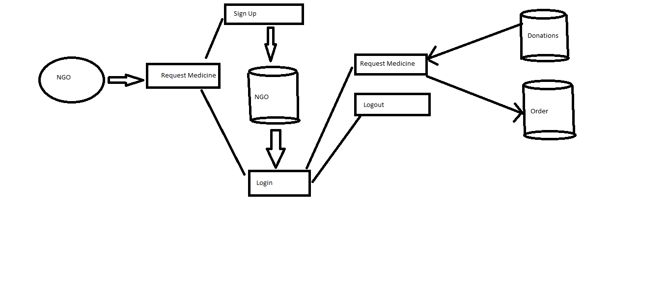

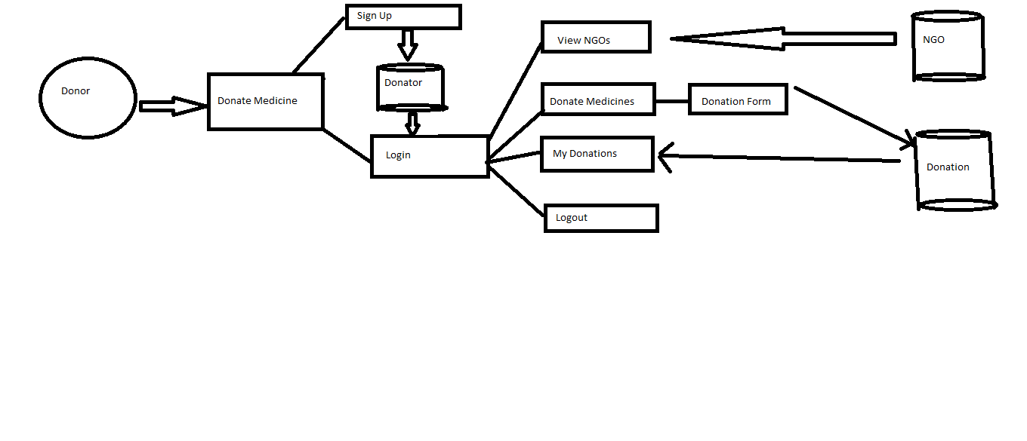

ENQUIRY

Medicine

Enquiry

Register

Submit Query

Q

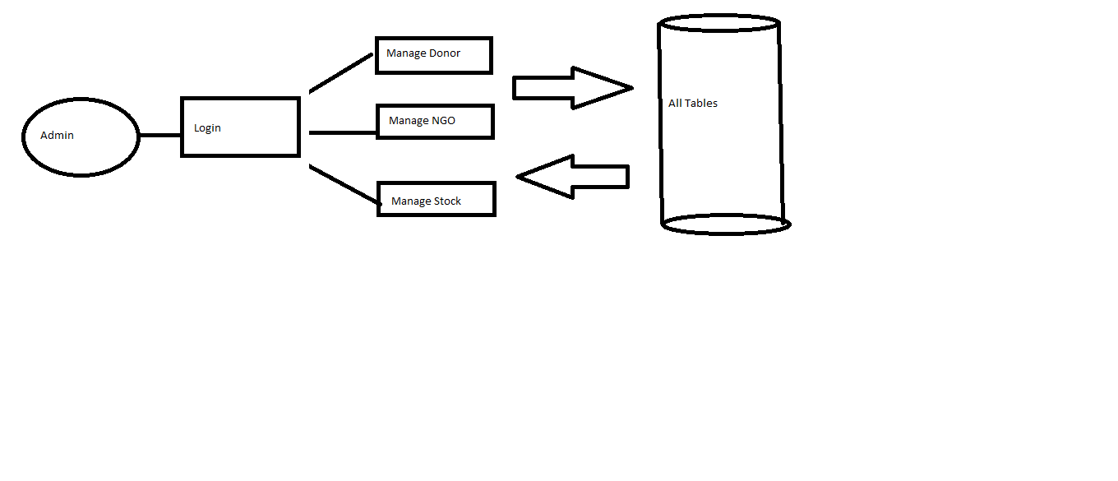

CONTACT (ENQUIRY)

REGISTER

NO YES

Enquiry Form Name , Email ID, Message

Sign Up

NGO

Submit

REGISTER SUCCESSFULLY

REQUEST

MEDICINE

REGISTRATION FORM

LOGIN

REGISTER

ALREADY REGISTERED

NO YES

Acknowledgement

NO

YES

SHOW MSG

**USER CASE DIAGRAM**

**DONOR**

**HOME**

**DONATE**

**NGO**

**NGO**

**ADMIN**

**CONTACT**

**ABOUT US**

**ADMIN**

**CLASS DIAGRAM**

Enquiry

* Id
* Name
* Email Id
* Message

NGO DETAILS

* NGO Id
* NGO Name
* Mobile Number
* City
* State
* Pin
* Email
* Password

Donation Details

* Medicine Id
* Medicine Name
* Expiry Date
* Pharma Company
* Quantity
* Donor Id

Final Request

* Order Id
* Medicine Id
* Medi Name
* Quantity
* NGO Id

Request Bag

* Order Id
* Medicine Id
* Medicine Name
* Quantity
* NGO Id

DONOR DETAILS

* Donor Id
* Donor Name
* Age
* Aadhar Number
* Mobile Number
* City
* State
* Pin
* Email
* Password

1. **FUTURE SCOPE**

This website is just for the purpose of Medicine Donation.

In future more features can be added such as

* Medical Equipment Donation.
* Blood Donation.
* Organ Donation.
* Other Donation too which can help Needy people.

1. **Conclusion**

Technology has taken over the world rapidly and the same technology can be used to save numerous lives. With the purpose of Donating Medicine: Saving Lives this website is designed to donate the needy people who suffer due to the shortage of the medicine. You can come forward with a helping hand for those needy people by donating the unused medicines.

This website will allow users to register for donation and receiving medicine and you can also search for the medicine of need from the search module.