* **DONOR Login and Registration**

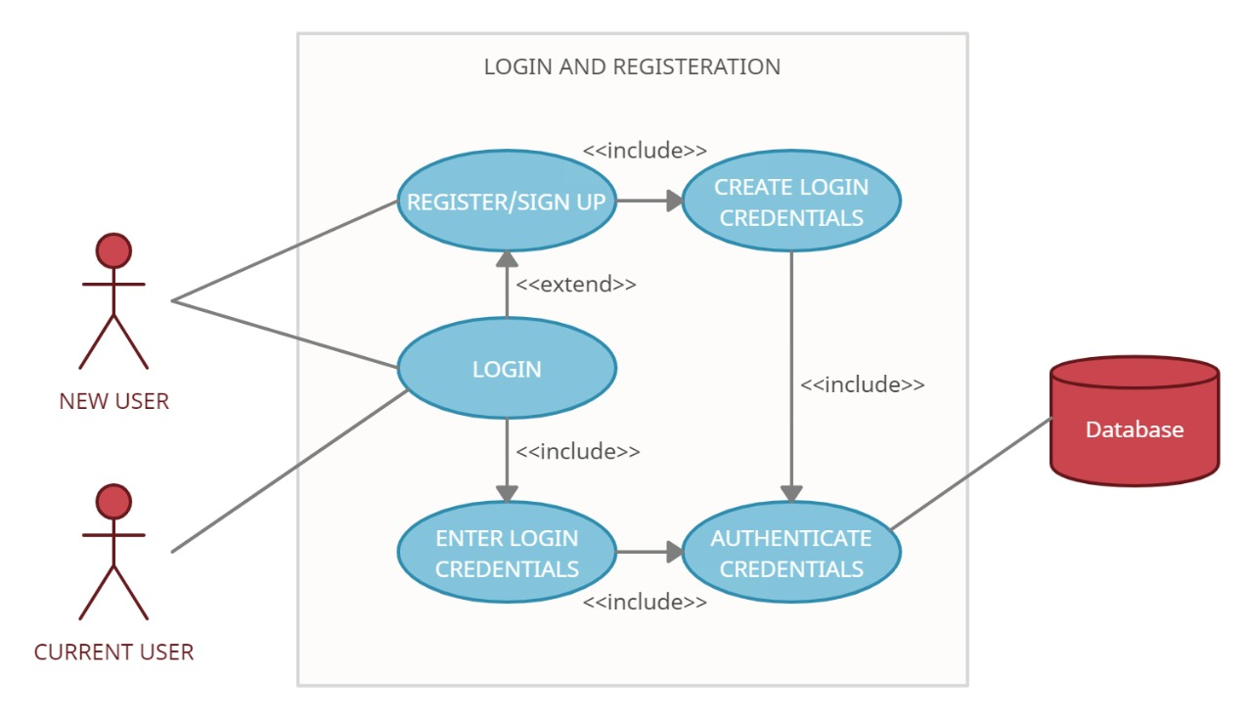

|  |  |
| --- | --- |
| Brief Description | Login and Registration |
| Basic Flow | This use case describes how a user logs in or register in to the system   1. The DONOR has to register himself into the system. 2. After the successful registration, donor requires his/her email and password on the login form. 3. The system validates the Donor’s password and logs him/her into the system. 4. The donor can now donate medicines as well as he/she can see his/her donation and about NGO’es also. 5. When donor press Logout Button the page will redirect to Login page.  * Name * Age * Aadhar Number * Mobile Number * City * State * Pin * Email * Password |
| Alternate Flow | 1. If the system cannot find the name or the password is invalid, an error message is displayed. 2. The donor can Sign Up again, at which point the use case ends |
| Validation | 1. Name should be in letters. 2. Age should be in numbers. 3. Aadhar number should be of 12 digit. 4. Mobile number should be of 10 digit. 5. The City field should be required 6. The State field should be required 7. The PIN should be of 6 digit 8. The Email should be letters with @. 9. The Password should be required. |
| Pre-Conditions | User should have network access and Browser with latest updates. |
| Post-Conditions | Donor Dashboard will be shown. |

**Wireframe for Login:**

**Log In Page**

|  |  |
| --- | --- |
| **Email Id** | textbox |
| **Password** | textbox |

Login

New Donor? Sign Up

**Registration Page**

|  |  |
| --- | --- |
| **Name** | textbox |
| **Age** | textbox |
| **Aadhar** | textbox |
| **Mobile** | textbox |
| **City** | textbox |
| **State** | textbox |
| **Pin** | textbox |
| **Email** | textbox |
| **Password** | textbox |



* **NGO Login and Registration**



|  |  |
| --- | --- |
| Brief Description | Login and Registration |
| Basic Flow | This use case describes how a NGO logs in or register in to the system   1. The NGO has to register himself into the system. 2. After the successful registration, NGO requires User name and password in the login form. 3. The system validates the NGO’s password and logs them into the system. 4. The NGO can now Request Medicine and can add Medicine which are available. 5. When NGO press Logout Button the page will redirect to Home page.   The following are the parameters that display in this module.   * Name * Mobile * City * State * PIN * Email * Password |
| Alternate Flow | 1. If the system cannot find the name or the password is invalid, an error message is displayed. 2. The NGO can Sign Up again, at which point the use case ends |
| Validation | 1. Name should be in letters. 2. Mobile number should be of 10 digit. 3. The City field should be required 4. The State field should be required 5. The PIN should be of 6 digit 6. The Email should be letters with @. 7. The Password should be required. |
| Pre-Conditions | User should have network access and Browser with latest updates. |
| Post-Conditions | NGO Dashboard will be shown. |

**Wireframe for Login:**

**Log In Page**

|  |  |
| --- | --- |
| **Email Id** | textbox |
| **Password** | textbox |

Login

New NGO? Sign Up

**Registration Page**

|  |  |
| --- | --- |
| **Name** | textbox |
| **Mobile** | textbox |
| **City** | textbox |
| **State** | textbox |
| **PIN** | textbox |
| **Email** | textbox |
| **Password** | textbox |

|  |
| --- |
| **Create** |

* **Admin Login**

**ADMIN**

Enter Login Credentials

**Login**

Authentication Credentials

|  |  |
| --- | --- |
| Brief Description | Login |
| Basic Flow | In this module the admin will login and have the complete control over the system.   1. Admin can manage Donors by editing or deleting the Donor’s details. 2. Admin can manage NGOes by editing or deleting the NGO details. 3. Admin can manage Request done by NGO by deleting the suspicious request. 4. Admin can manage Medicine by editing or deleting the medicine details. 5. Admin can manage Enquiry done by any customer by deleting it after solving the query. 6. When Admin press Logout Button, the page will redirect to Home page.   The following are the parameters that display in this module.   * Email * Password |
| Alternate Flow | If the system find the name or the password is invalid, an error message is displayed. |
| Validation | 1. The password should be required. 2. The Email should be letters with @. |
| Pre-Conditions | Admin should have default credentials to login.  Admin should have network access and browser with latest updates. |
| Post-Conditions | Admin Dashboard will be shown. |

**Wireframe for Login:**

**Log In Page**

|  |  |
| --- | --- |
| **Email Id** | textbox |
| **Password** | textbox |



* **Donor Dashboard**

Donation Form

------

---------

Donor

|  |  |
| --- | --- |
| Brief Description | Donor Dashboard |
| Basic Flow | This use case describes the donor dashboard after the login of Donor     1. After the successful login, Donor can see 3 details in front of him in which he can donate medicines, he can see my donations and he can view NGO’es. 2. Donor can donate medicines by filling the form. 3. Donor can see his/her donation which is donated 4. Donor can also see the NGO details. 5. When Donor press Logout Button, the page will redirect to Home page.   The following are the parameters that display in donate medicine module.   * Name * Expiry Date * Pharma Company * Quantity * Donor Id * Donation Date |
| Alternate Flow | If the system find the name or the quantity is invalid, an error message is displayed. |
| Validation | 1. Name should be in letters. 2. Expiry Date of medicine is required 3. Pharma Company name is required 4. The quantity of medicine should not be 0. |
| Pre-Conditions | 1. Donor Id and Donation date will be taken automatically 2. Donor should have valid email and password to login |
| Post-Conditions | Donor Dashboard will be shown. |

**Wireframe for Donate Medicines:**

**Donation Page**

|  |  |
| --- | --- |
| **Name** | textbox |
| **Expiry Date** | textbox |
| **Pharma Company** | textbox |
| **Quantity** | textbox |
| **Donor Id** | textbox |
| **Donation Date** | textbox |

|  |
| --- |
| **Create** |

Home

* **NGO Dashboard**

Medicine Inventory

------

---------

Your Medicine Bag

------

-----------

NGO

|  |  |
| --- | --- |
| Brief Description | NGO Dashboard |
| Basic Flow | This use case describes the NGO dashboard after the login of NGO     1. After the successful login, NGO can request medicines 2. NGO will redirect to the Medicine Inventory page in which they can add medicine that is available. 3. After adding medicines, they will redirect to Your Medicine Bag page in which they can see their requested medicine. 4. NGO can delete their request and finally they submit request. 5. When NGO press Logout Button, the page will redirect to Home page. |
| Alternate Flow | NA |
| Validation | NA |
| Pre-Conditions | NGO should have valid email and password to login |
| Post-Conditions | NGO Dashboard will be shown. |

**Wireframe for NGO:**

Medicine Inventory

Add

Add

Go to Bag

Your medicine Bag

Delete

Delete

Submit Request

* **Admin Dashboard**

Admin Dashboard

Donors

Medicines

NGOes

Requests

Enquiries

Logout

|  |  |
| --- | --- |
| Brief Description | Admin Dashboard |
| Basic Flow | This use case describes the Admin dashboard after the login of Admin   1. After the successful login, Admin can manage the following modules    * + Donors      + NGOes      + Requests      + Medicines      + Enquires 2. Admin get all records of .Donors, NGOes, Medicines modules and can modify records by Edit and delete. 3. Admin get all records of Enquiries and Requests and modify by delete. 4. When Admin press Logout Button, the page will redirect to Home page. |
| Alternate Flow | NA |
| Validation | NA |
| Pre-Conditions | Admin should have valid email and password to login |
| Post-Conditions | Admin Dashboard will be shown. |

**Wireframe for Admin:**

Edit

Manage Donors

Manage NGOes

Manage Medicines

Delete

Manage Requests

Manage Enquiries

Delete