**How many subnets and hosts per subnet can you get from the network 192.168.119.0/28?**

**Ans:**

Class C use default mask = 255.255.255.0

Given subnet mask = 255.255.255.240 = /28

= 255.255.255.11110000

Subnet bits = 2^4 = 16 subnets

Host bits = 2^4 - 2 = 14 hosts

**You need to subnet a network that has 5 subnets, each with at least 16 hosts. Which classful subnet mask would you use?**

1. **255.255.255.192**
2. **255.255.255.224** <----- CORRECT
3. **255.255.255.240**
4. **255.255.255.248**

**Ans:**

1. **255.255.255.192**  this ip has 2^2 = 4 subnets i.e. NOT CORRECT.
2. **255.255.255.224** this ip has 2^3 = 8 subnets and 2^5 -2 = 30 hosts. CORRECT.
3. **255.255.255.240** this ip has 2^4 = 16 subnets and 2^4 -2 = 14 hosts i.e. NOT CORRECT.
4. **255.255.255.248** this ip has 2^5 = 32 subnets but 2^3 -2 = 6 hosts i.e. NOT CORRECT.

**What is the broadcast address of the network 172.24.160.0 255.255.240.0?**

**Ans:**

172.24.160.0 /20

For 3rd octet: 2^4 = 16 subnets i.e. 0-15, 16-31,.....160-175.

And for fourth octet it is 255 for broadcast.

So the broadcast ip will be:

172.24.175.255

**Describe steps involved during communication between two network.**

**Ans:**

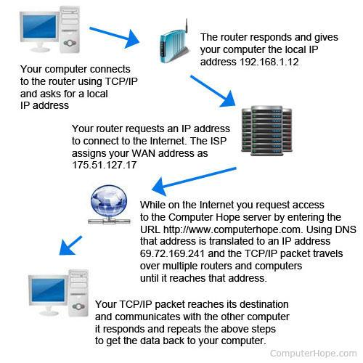

When requesting information from a web page, such as Computer Hope, you enter a URL that is easy to understand and remember. For your computer to access the computer containing the pages, that URL must be converted into an IP address, which is done with DNS. Once DNS has converted the URL into an IP address, the routers on the Internet will know how to route your TCP/IP packet.

When computers connect to each other on the same network, it is called a local area network, or LAN. When multiple networks are connected to each other, it is called a wide area network, or WAN. With this type of network, your home has a network router that connects to your ISP. The router is given the IP address for your connection to the Internet and then assigns local IP addresses to each device in your network. These local addresses are often 192.168.1.2-255. When accessing a local computer in your network, your router sends your TCP/IP packets between the local IP addresses. However, when you want to connect to the Internet, your router communicates to the Internet with the IP address assigned to it from the ISP. Your IP address is not a 192.168.x.x address because the ISP assigns that IP address and not your router.

**When to use Elastic IP over Public IP**

**Ans:**

An *Elastic IP address* is a static IPv4 address designed for dynamic cloud computing. An Elastic IP address is associated with your AWS account. With an Elastic IP address, you can mask the failure of an instance or software by rapidly remapping the address to another instance in your account.

An Elastic IP address is a public IPv4 address, which is reachable from the internet. If your instance does not have a public IPv4 address, you can associate an Elastic IP address with your instance to enable communication with the internet; for example, to connect to your instance from your local computer.

The public address that is automatically assigned to your instance is from a large pool that AWS has. If you stop & start your instance the IP address will change and the old address will go back into the pool for someone else to use. If this is the IP address that is published in DNS and your customers are trying to connect to they will not be able to connect and you will lose business.

There are two ways around this, an ELB and an Alias entry in DNS, or and Elastic IP address and an A or CNAME entry in DNS.

An Elastic IP address is a fixed address that is assigned to your account, and will never change as long is you follow the AWS rules. If you Stop & Start your server it will keep it's Elastic IP address. If you build a new server you can move your Elastic IP address to it (manually or by script). And yes you can use this to create fault tolerance.

**Valid IP Ranges for LAN, Implication of using Public IP ranges for Private Network.**

**Ans:**

10.0.0.0 – 10.255.255.255 (10/8 prefix)

172.16.0.0 – 172.31.255.255 (172.16 /12 prefix)

192.168.0.0 – 192.168.255.255 (192.168 /16 prefix)

**Draw AWS Network Arch Diagram based on following criteria :**

* **Tech Stack will have “Web, App, Cache, DB, Operation”.**
* **Web stack Required Public Interaction**
* **250 hosts, 10 nodes per stack**
* **Should be Redundant**
* **Enable Internet Access for Private Subnet**
* **Security Service at each Layer.**

