1. Calculate pricing for a client who wants migration there existing workload to AWS Mumbai Region, the existing setup includes:

Load Balancer

Web Server (Qty:4, CPU:2, RAM: 8GB, Storage: 20 GB )

App Server (Qty:4, CPU:2, RAM: 8GB, Storage: 20 GB)

Database Server (Qty: 1 Master and 1 Replica, CPU:2, RAM: 16GB. Storage: 50 GB)

Monthly Data Transfer Out: 100 GB

<https://calculator.s3.amazonaws.com/index.html#r=BOM&key=calc-921EB23B-3440-492F-AAE4-3BB7D1FE5D14>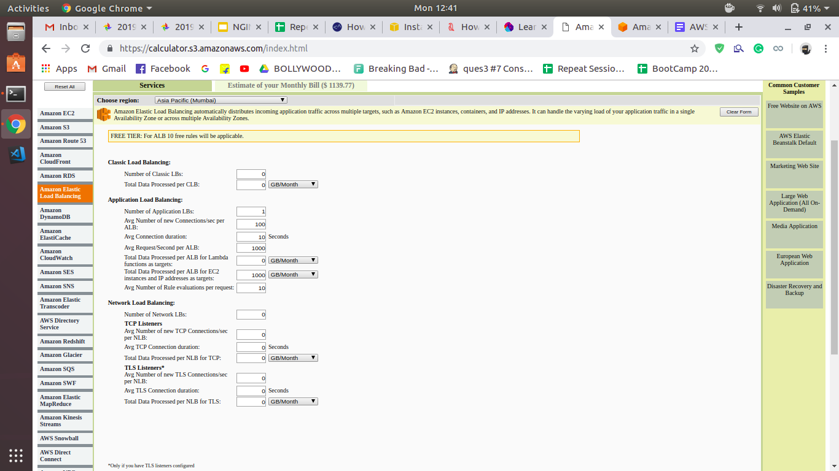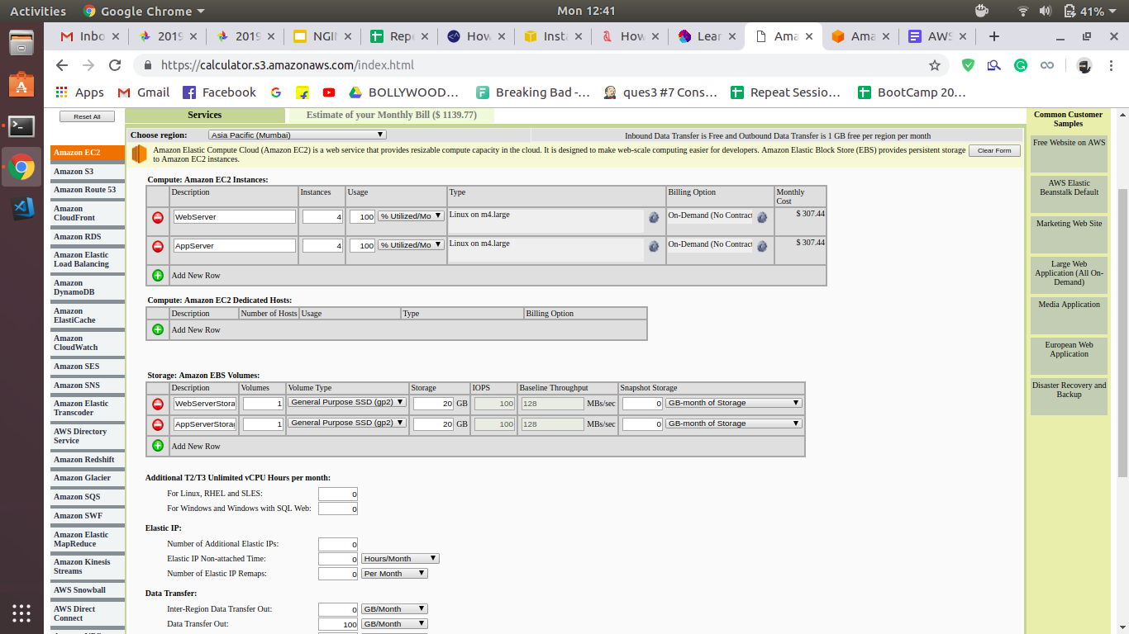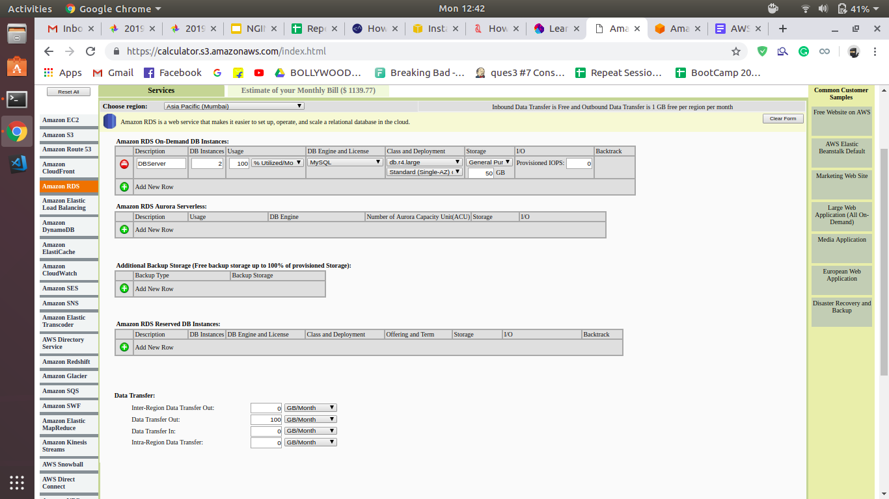

2. Calculate pricing for a client who wants migration the QA workload to AWS Mumbai Region, the existing setup includes:

Load Balancer

Web Server (Qty:10, CPU:2, RAM: 8GB, Storage: 20 GB )

Database Server (Qty: 10 Master, CPU:2, RAM: 16GB. Storage: 50 GB)

Monthly Data Transfer Out: 100 GB

The stack remains operational only for 8 hours per day

<https://calculator.s3.amazonaws.com/index.html#r=BOM&key=calc-67482FE8-402E-4EB3-A4B4-CC5CCCC60478>

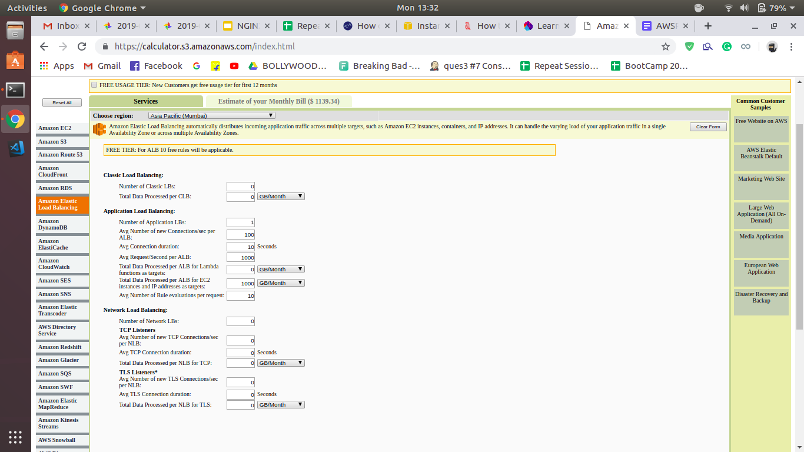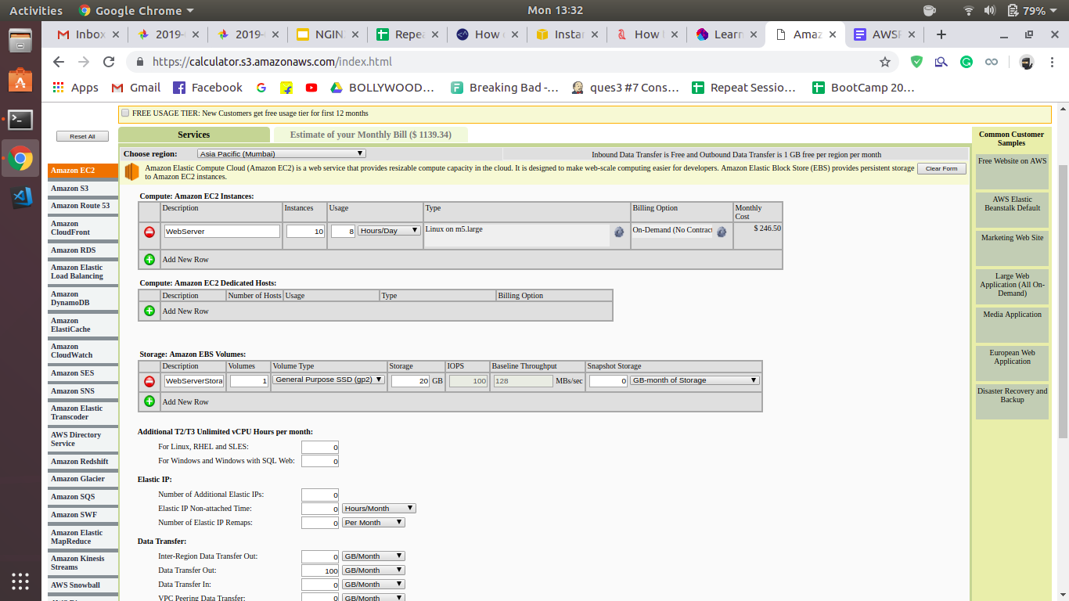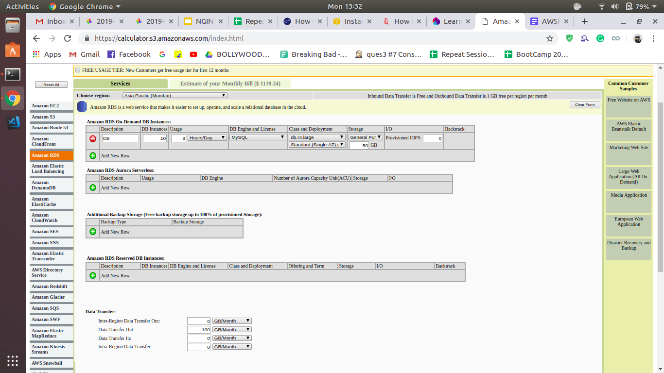

**3. Define the use cases where you will recommend using On demand, Reserve Instances (Standard & Convertiable) and Spot instances**

**Also calculate the 1 year no upfront pricing for the production environment (1 Question)**

**On demand:**

AWS On-Demand Instances (Amazon Web Services On-Demand Instances) are virtual servers that run in AWS Elastic Compute Cloud (EC2) or AWS Relational Database Service (RDS) and are purchased at a fixed rate per hour. AWS recommends using On-Demand Instances for applications with short-term, irregular workloads that cannot be interrupted. They are also suitable for use during testing and development of applications on EC2.

AWS EC2 instances are available in a variety of different levels of compute power and are designed for different tasks within the cloud. On-Demand Instances have no contract commitment and can be launched as needed -- except potentially during periods of very high compute demand in particular availability zones. This is generally the most expensive purchasing option for AWS instances, though exact hourly prices vary depending on the operating system and size of the instance. Each On-Demand Instance is billed per instance hour from time it is launched until it is terminated or stopped. Partial instance hours are rounded up to the full hour upon billing. A free tier of usage is also available.

AWS On-Demand Instances can be launched using the AWS Management Console or Amazon's RunInstances API. Users can launch up to 20 On-Demand Instances at one time; a request form is required for launching more than 20 instances. Some individual instance types are further limited in number or by availability zone.

**Reserve Instances:**

Reserved Instances provide you with a significant discount compared to On-Demand Instance pricing. Reserved Instances are not physical instances, but rather a billing discount applied to the use of On-Demand Instances in your account. These On-Demand Instances must match certain attributes in order to benefit from the billing discount.

When you purchase a Reserved Instance, choose a combination of the following that suits your needs:

Payment option: No Upfront, Partial Upfront, or All Upfront.

Term: One-year or three-year. A year is defined as 31536000 seconds (365 days). Three years is defined as 94608000 seconds (1095 days).

Offering class: Convertible or Standard.

In addition, a Reserved Instance has a number of attributes that determine how it is applied to a running instance in your account:

Instance type: For example, m4.large. This is composed of the instance family (m4) and the instance size (large).

Scope: Whether the Reserved Instance applies to a Region or specific Availability Zone.

Tenancy: Whether your instance runs on shared (default) or single-tenant (dedicated) hardware. For more information, see Dedicated Instances.

Platform: The operating system; for example, Windows or Linux/Unix. For more information, see Choosing a Platform.

Reserved Instances do not renew automatically; when they expire, you can continue using the EC2 instance without interruption, but you are charged On-Demand rates. In the above example, when the Reserved Instances that cover the T2 and C4 instances expire, you go back to paying the On-Demand rates until you terminate the instances or purchase new Reserved Instances that match the instance attributes.

Payment Options

The following payment options are available for Reserved Instances.

No Upfront – You are billed a discounted hourly rate for every hour within the term, regardless of whether the Reserved Instance is being used. No upfront payment is required.

Note

No Upfront Reserved Instances are based on a contractual obligation to pay monthly for the entire term of the reservation. For this reason, a successful billing history is required before you can purchase No Upfront Reserved Instances.

Partial Upfront – A portion of the cost must be paid upfront and the remaining hours in the term are billed at a discounted hourly rate, regardless of whether the Reserved Instance is being used.

All Upfront – Full payment is made at the start of the term, with no other costs or additional hourly charges incurred for the remainder of the term, regardless of hours used.

You can exchange one or more Convertible Reserved Instances for another Convertible Reserved Instance with a different configuration, including instance family, operating system, and tenancy. There are no limits to how many times you perform an exchange, as long as the target Convertible Reserved Instance is of an equal or higher value than the Convertible Reserved Instances that you are exchanging.

When you exchange your Convertible Reserved Instance, the number of instances for your current reservation is exchanged for a number of instances that cover the equal or higher value of the configuration of the target Convertible Reserved Instance. Amazon EC2 calculates the number of Reserved Instances that you can receive as a result of the exchange.

**Example: Convertible Reserved Instance with multiple instances**

In this example, you have a t2.micro Convertible Reserved Instance with four instances in the reservation. To exchange two t2.micro instances for an m4.xlarge instance:

1. Modify the t2.micro Convertible Reserved Instance by splitting it into two t2.micro Convertible Reserved Instances with two instances each.
2. Exchange one of the new t2.micro Convertible Reserved Instances for an m4.xlarge Convertible Reserved Instance.

**Example: Convertible Reserved Instance with a single instance**

In this example, you have a t2.large Convertible Reserved Instance. To change it to a smaller t2.mediuminstance and a m3.medium instance:

1. Modify the t2.large Convertible Reserved Instance by splitting it into two t2.medium Convertible Reserved Instances. A single t2.large instance has the same instance size footprint as two t2.mediuminstances. For more information, see [Modifying the Instance Size of Your Reservations](https://docs.aws.amazon.com/AWSEC2/latest/UserGuide/ri-modifying.html#ri-modification-instancemove).
2. Exchange one of the new t2.medium Convertible Reserved Instances for an m3.medium Convertible Reserved Instance.

