**EXERCISE - INTRODUCTION TO LINUX**

1.Create a directory "exercise" inside your home directory and create nested(dir1/dir2/dir3) directory structure inside "exercise" with single command.

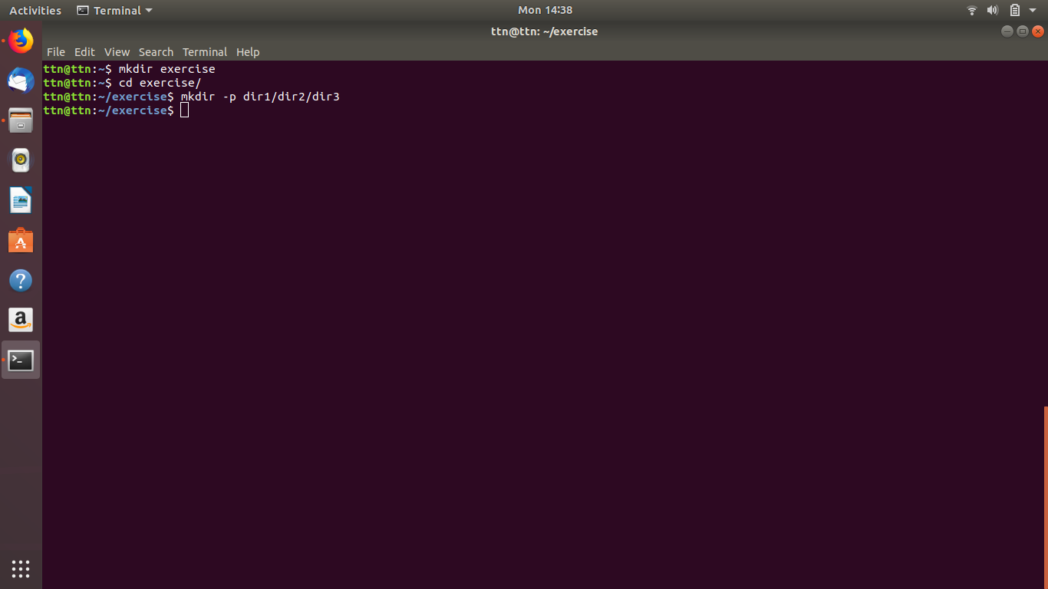

2. Create two empty files inside dir2 directory: emptyFile1,emptyFile2 in single command 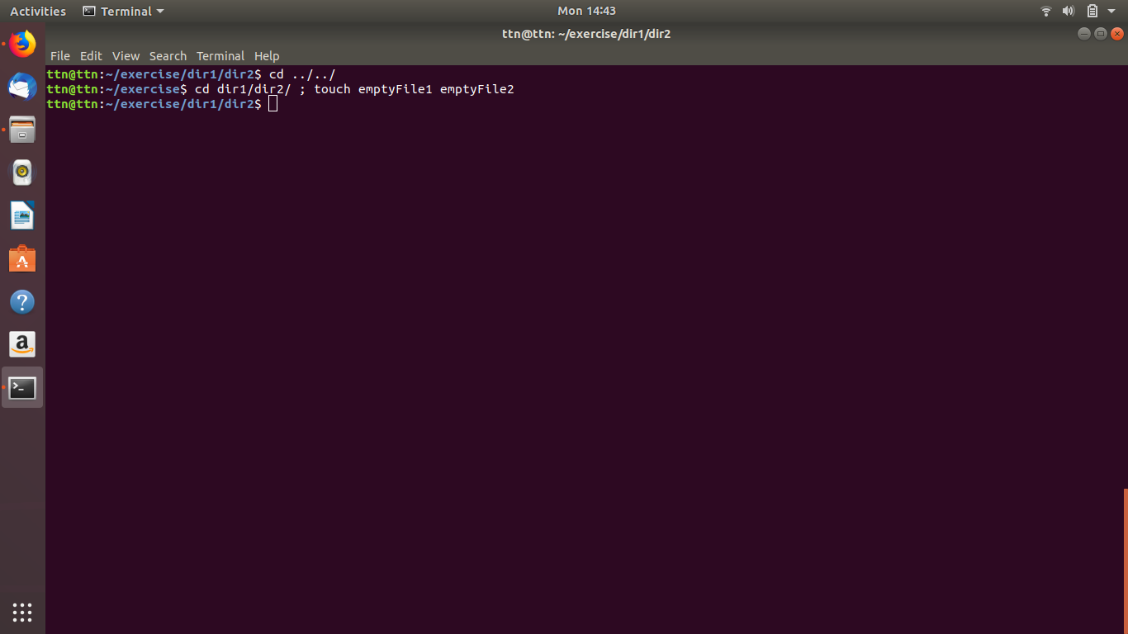

3. Create one file file1.txt containing text "hello world" and save it.

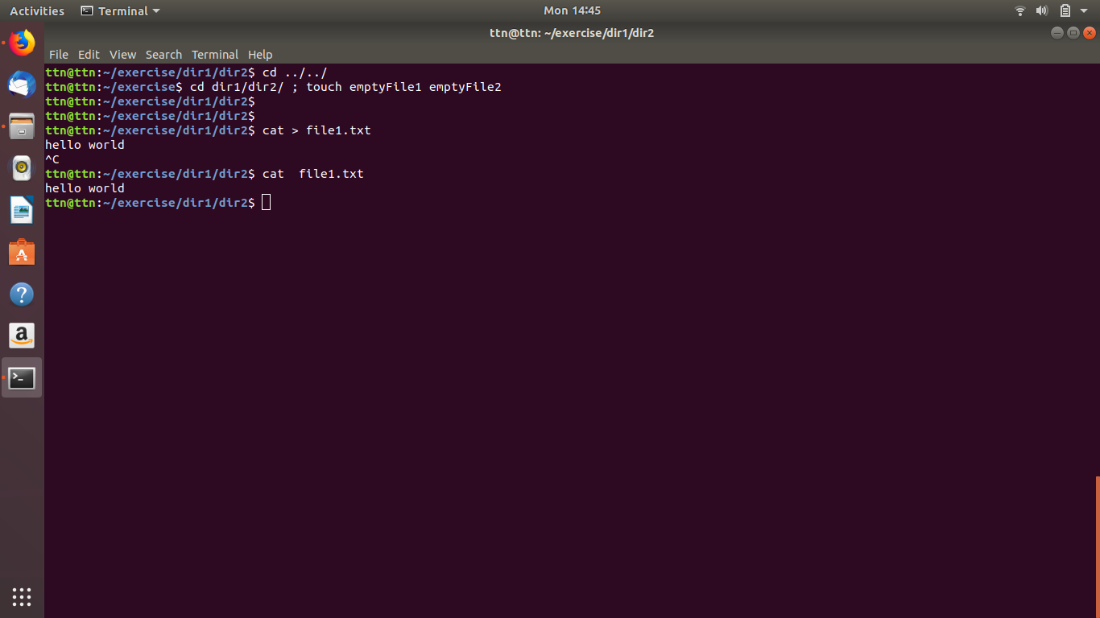

4. Find a "passwd" file using find command inside /etc. copy this files as passwd_copy and then rename this file as passwd_backup.

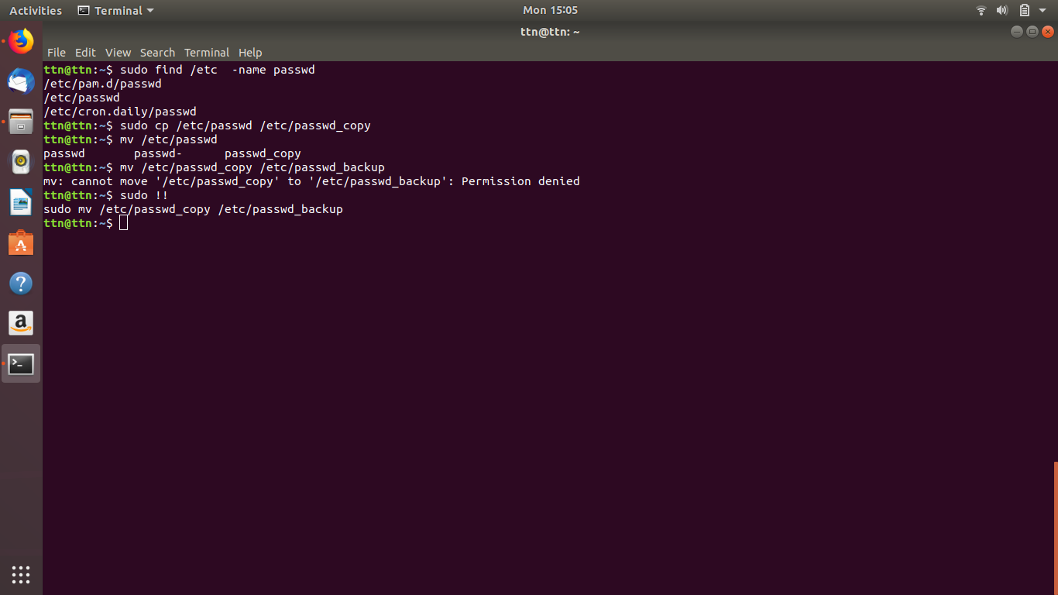

5. Try reading passwd_backup file in multiple tools: less,more,cat,strings etc and find the difference in their usage.

Command more

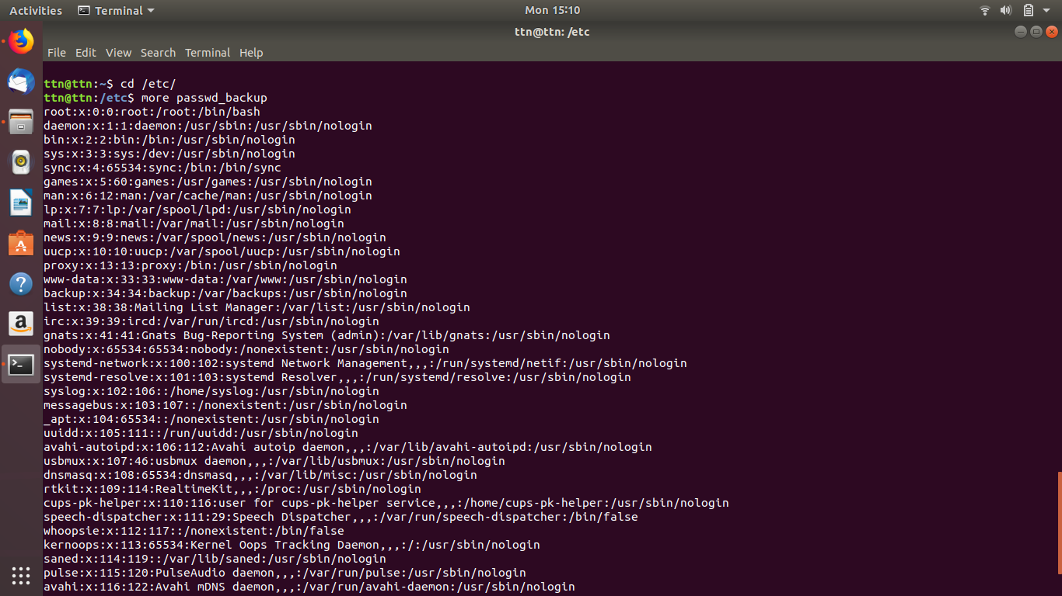

Command less

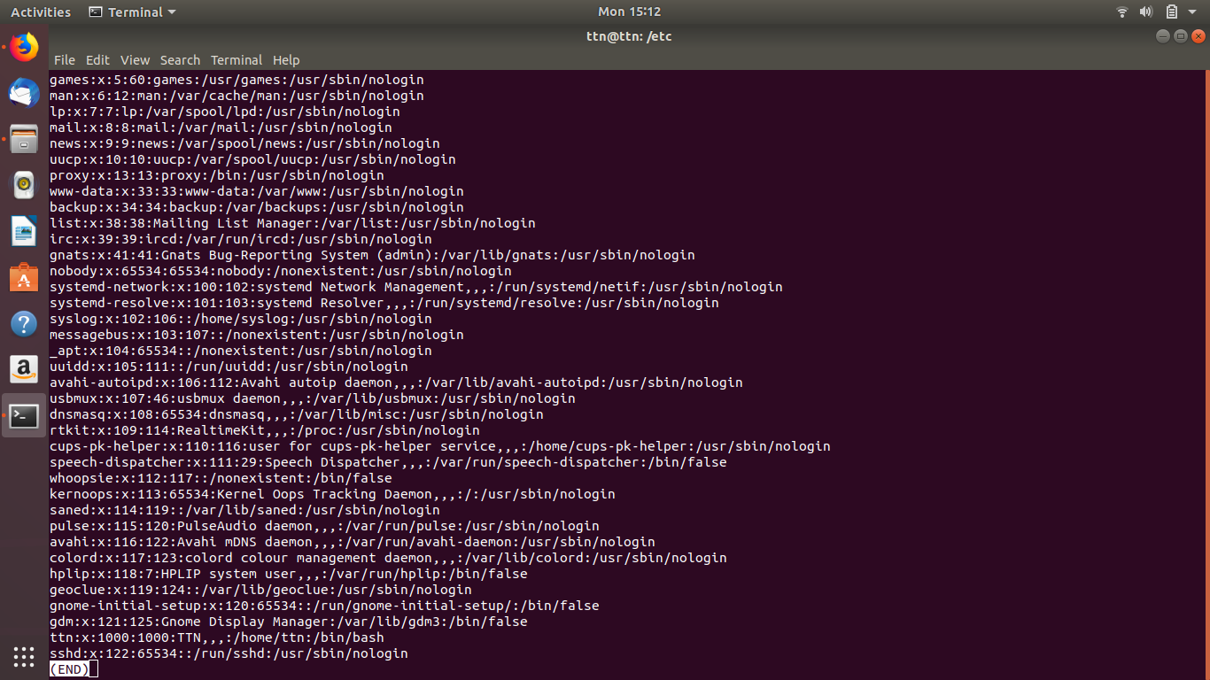

Command cat

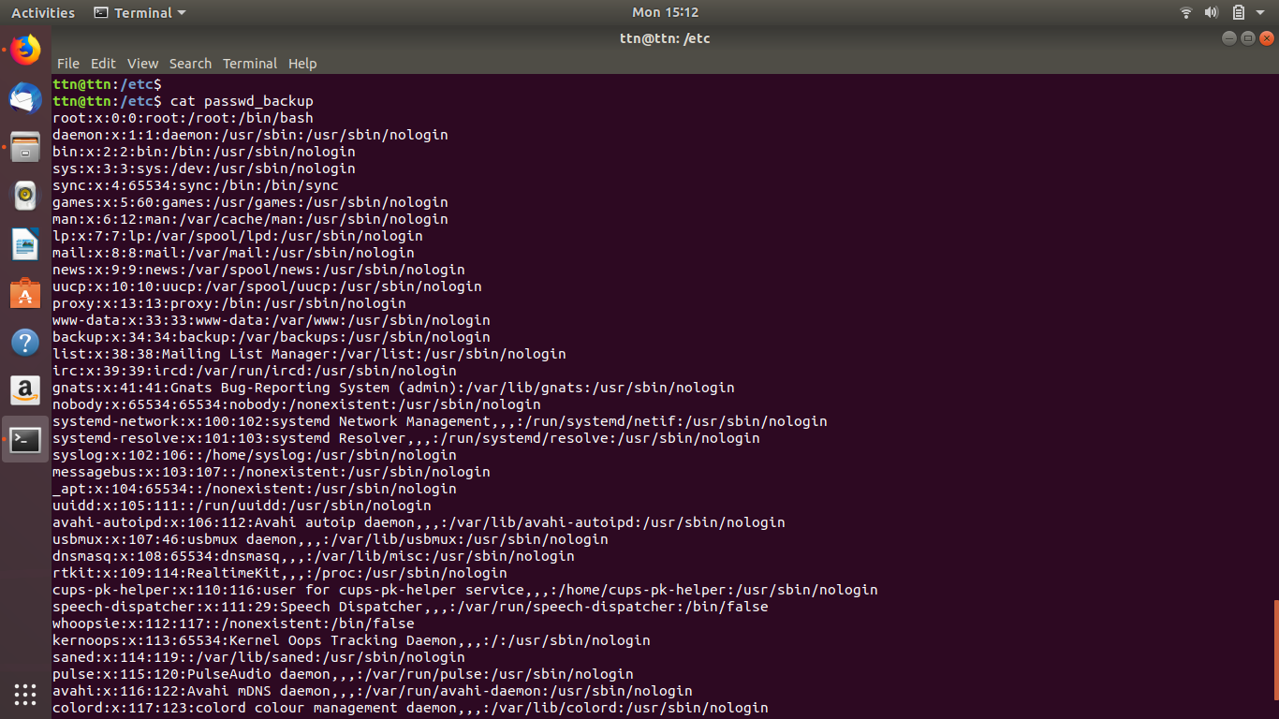

Command strings

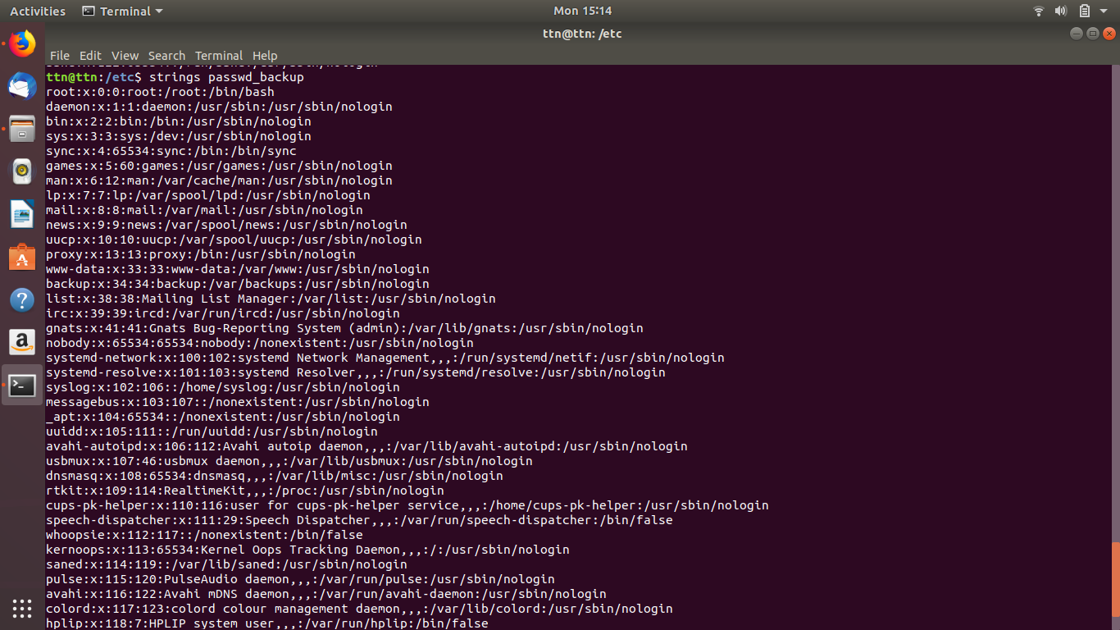

Command head

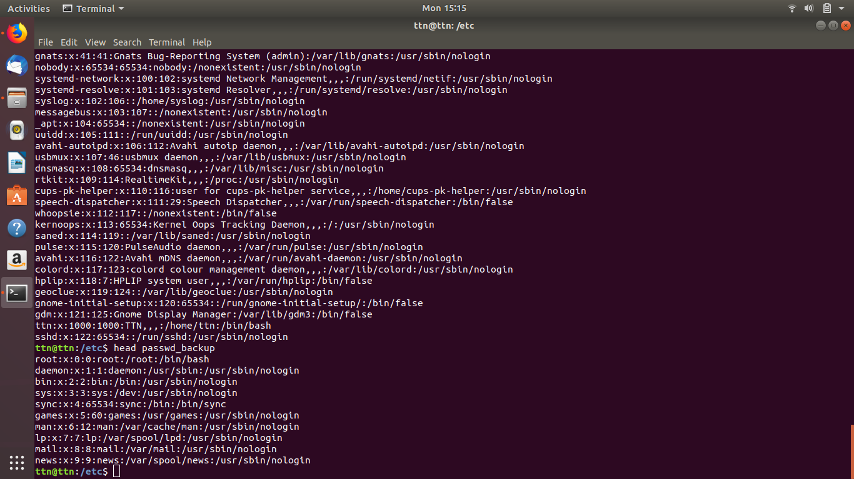

Command tail

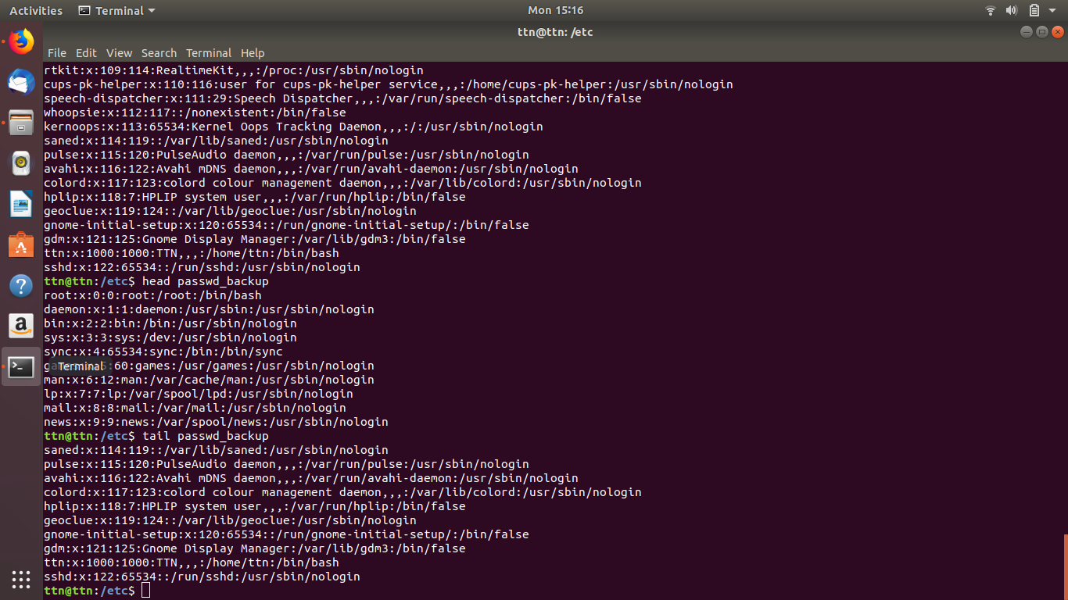

more - allows to view at a time in page and use spacebar to view next page

less - much same as more, allows to scroll up/down

cat - can be used as to join multiples and view their contents, using cat and redirection operator we can also overwrite the content and using “>>” to append.

strings - also used to view the strings of the files

head - default shows first 10 lines of the file

tail - default shows last 10 lines of the file

6. Find out the number of line in password_backup containing "/bin/false".

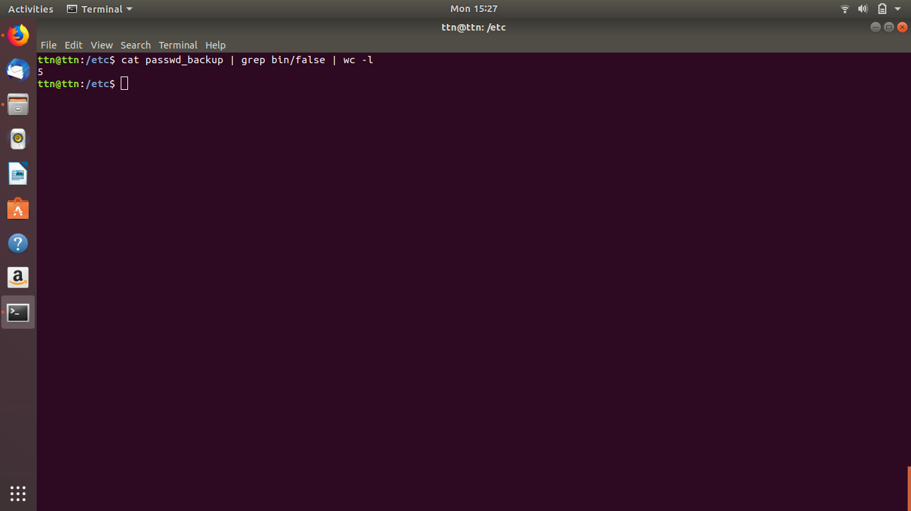

7. Get the first 5 lines of a file “password_backup” and Redirect the output of the above commands into file "output".

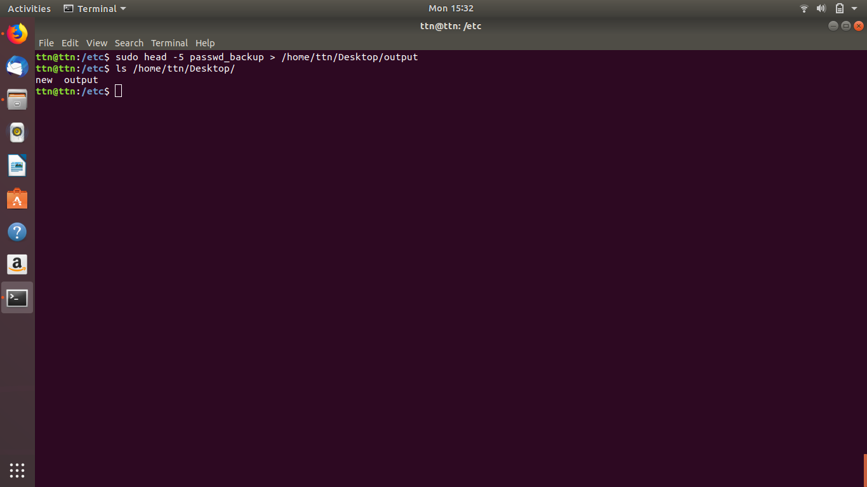

8. Create a "test" user,create its password and find out its uid and gid.

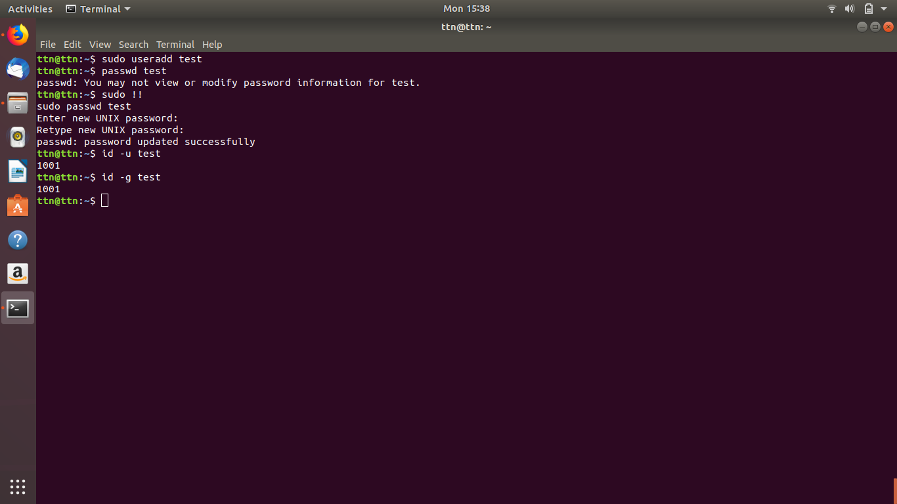

9. Change the timestamp of emptyFile1,emptyFile2 which are exist in dir2

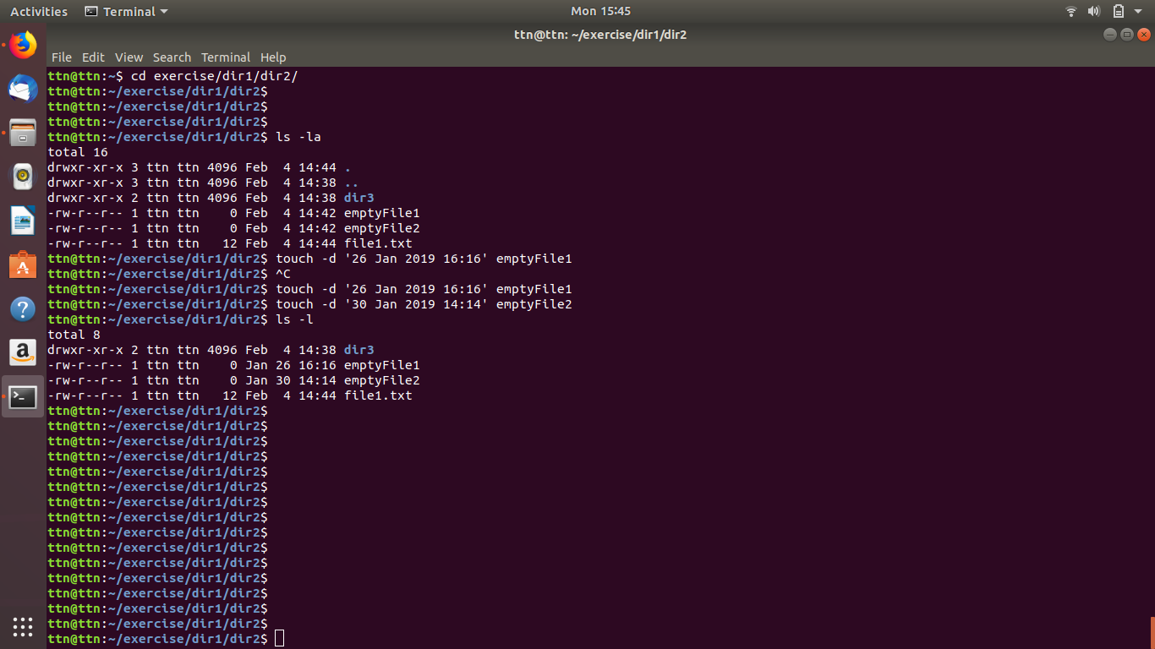

10. Login as test user and edit the "output" file created above. Since the permission wont allow you to save the changes. Configure such that test user can edit it.

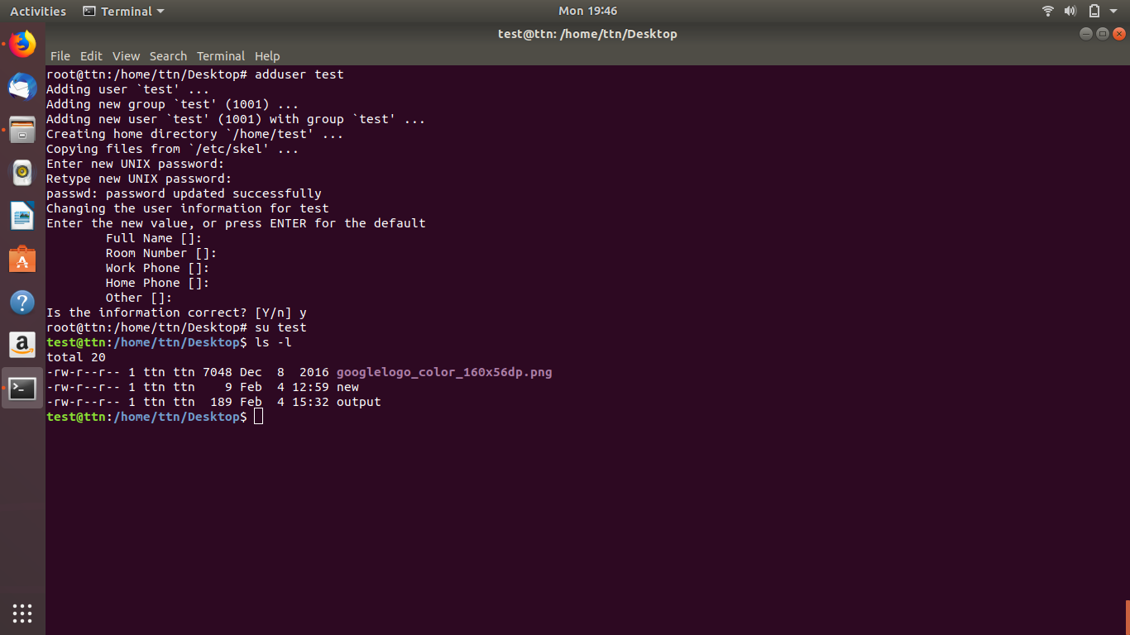

1. Add group owner of the "output" file as the secondary group of testuser and check/change the "output" file permission if it is editable by group. Once done revert the changes

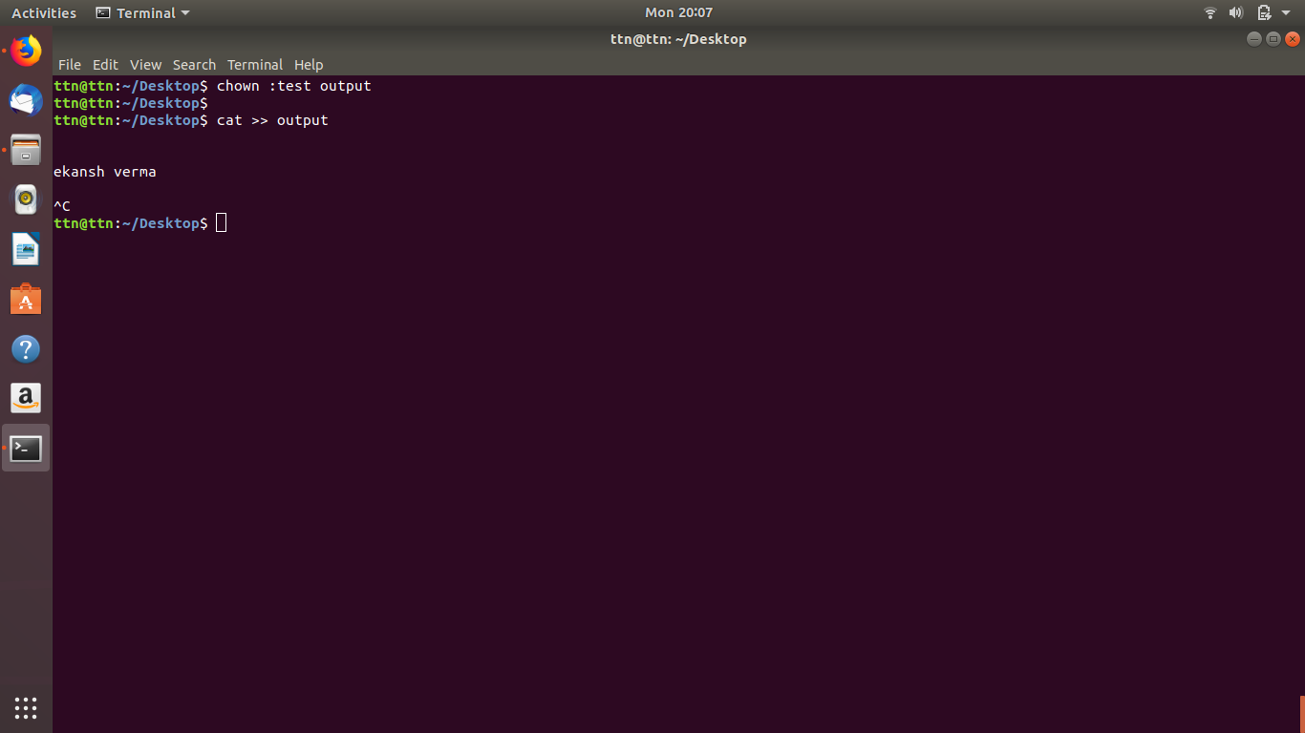

B. Make the file editable to the world so that test user can access it. Revert the changes after verification

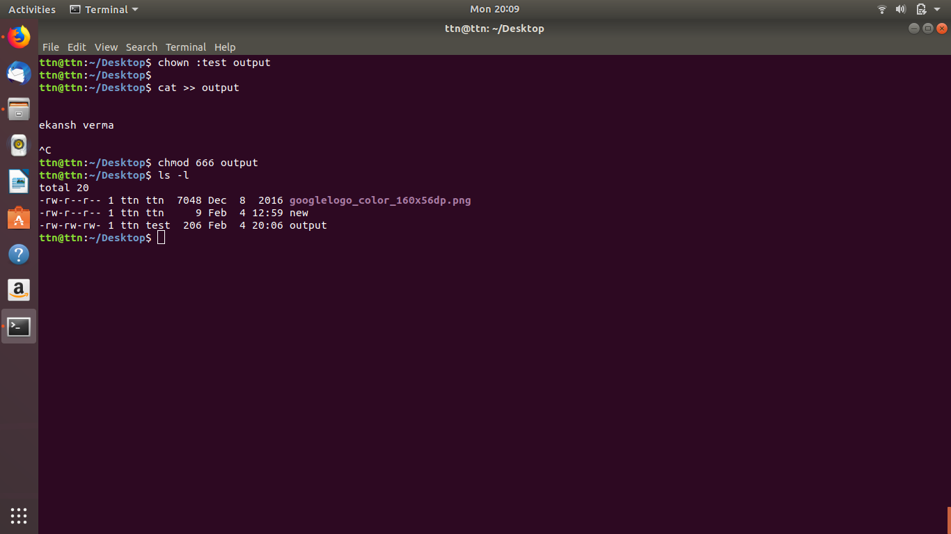

C. Change the ownership to edit the file.

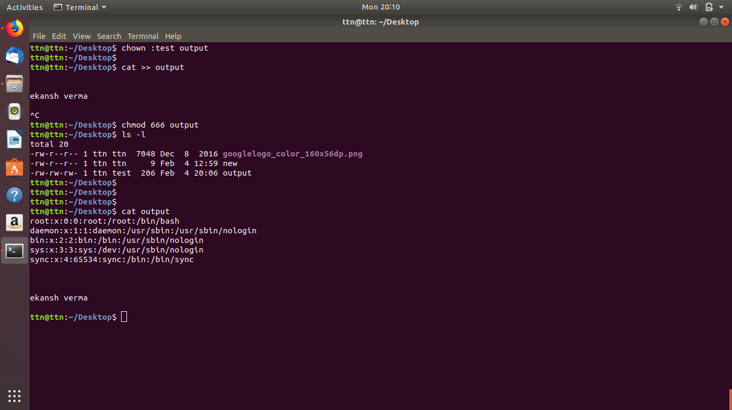

11. Create alias with your name so that it creates a file as "/tmp/aliastesting".

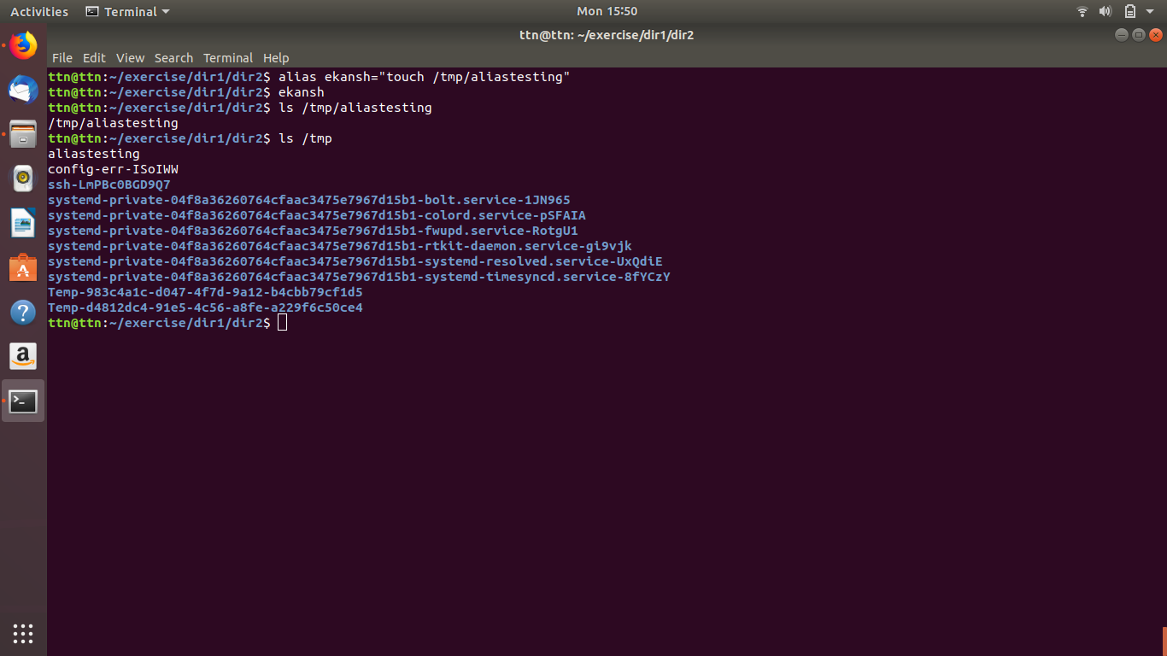

12. Edit ~/.bashrc file such that when you change to "test" user it should clear the screen and print "Welcome".

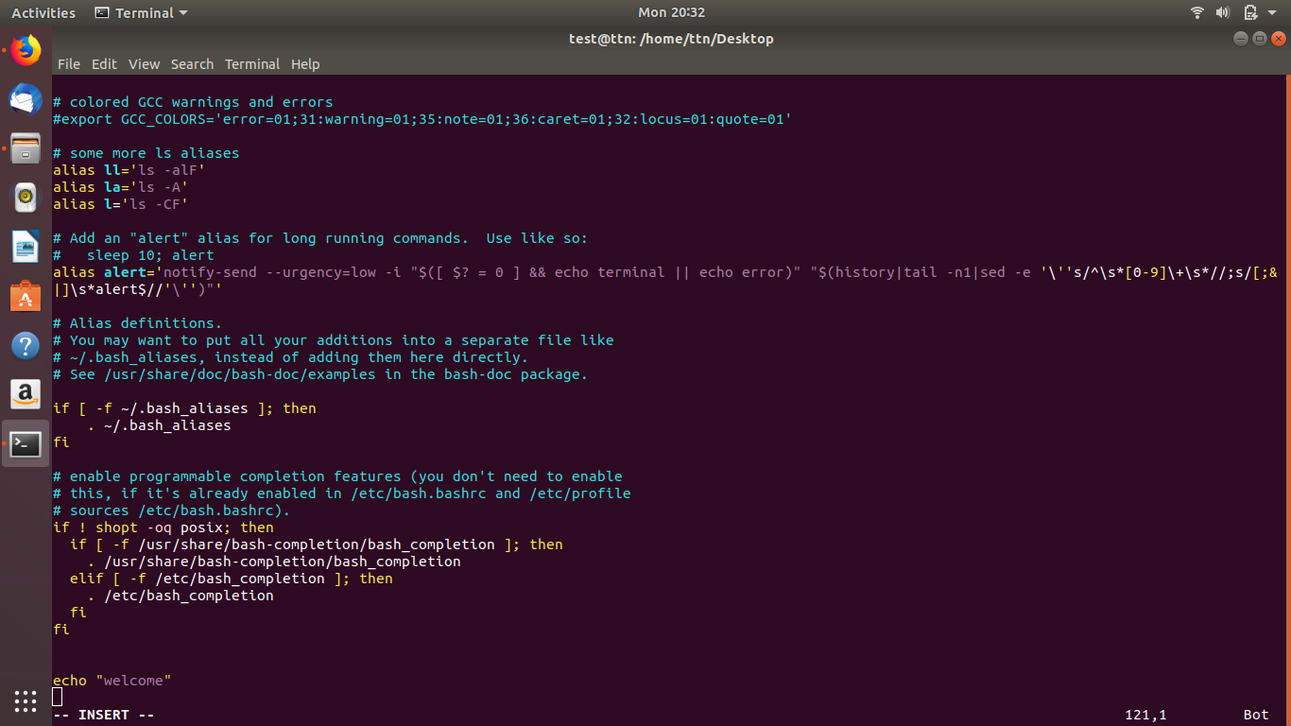

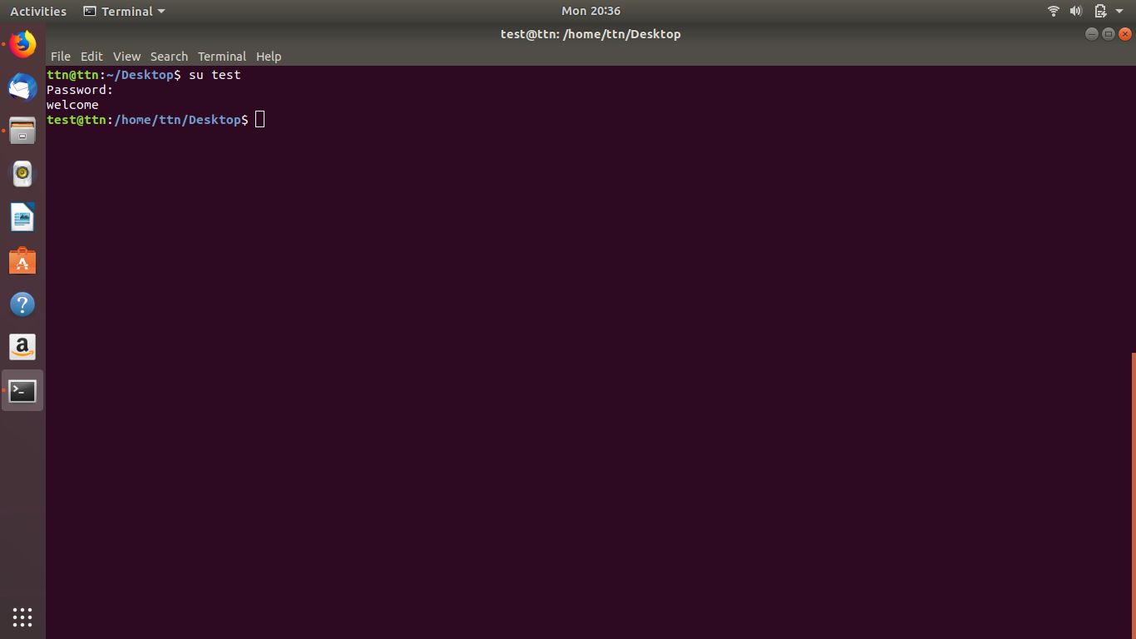

13. Install “zip” package.

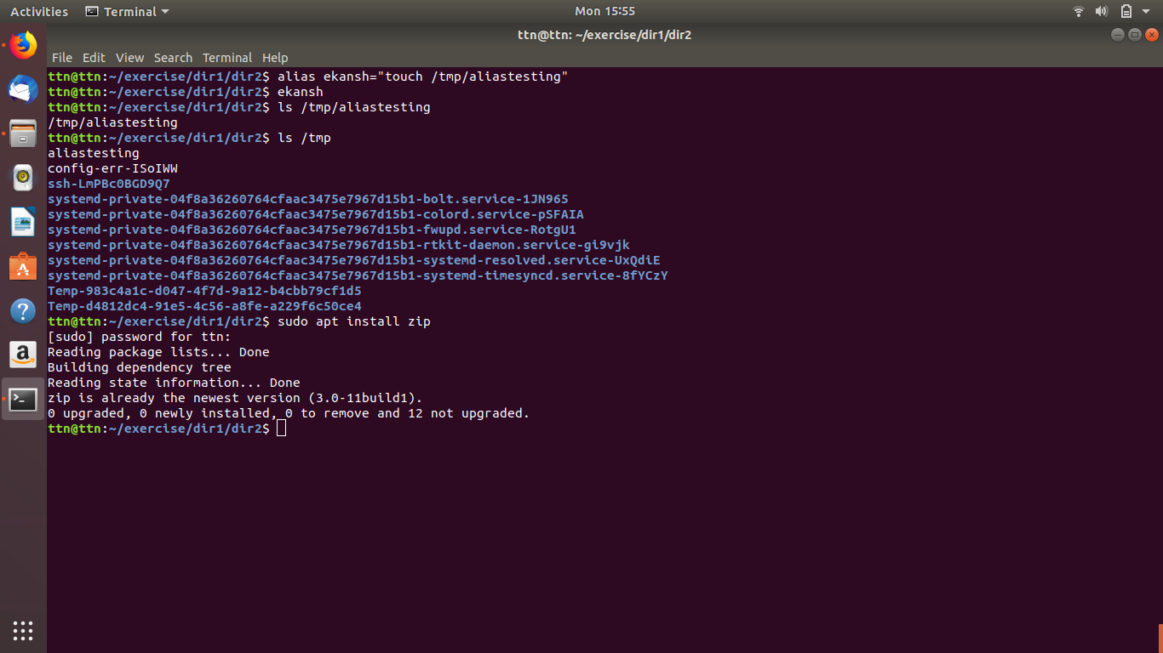

14. Compress "output" and "password_backup" files into a tar ball. List the files present inside the tar created.

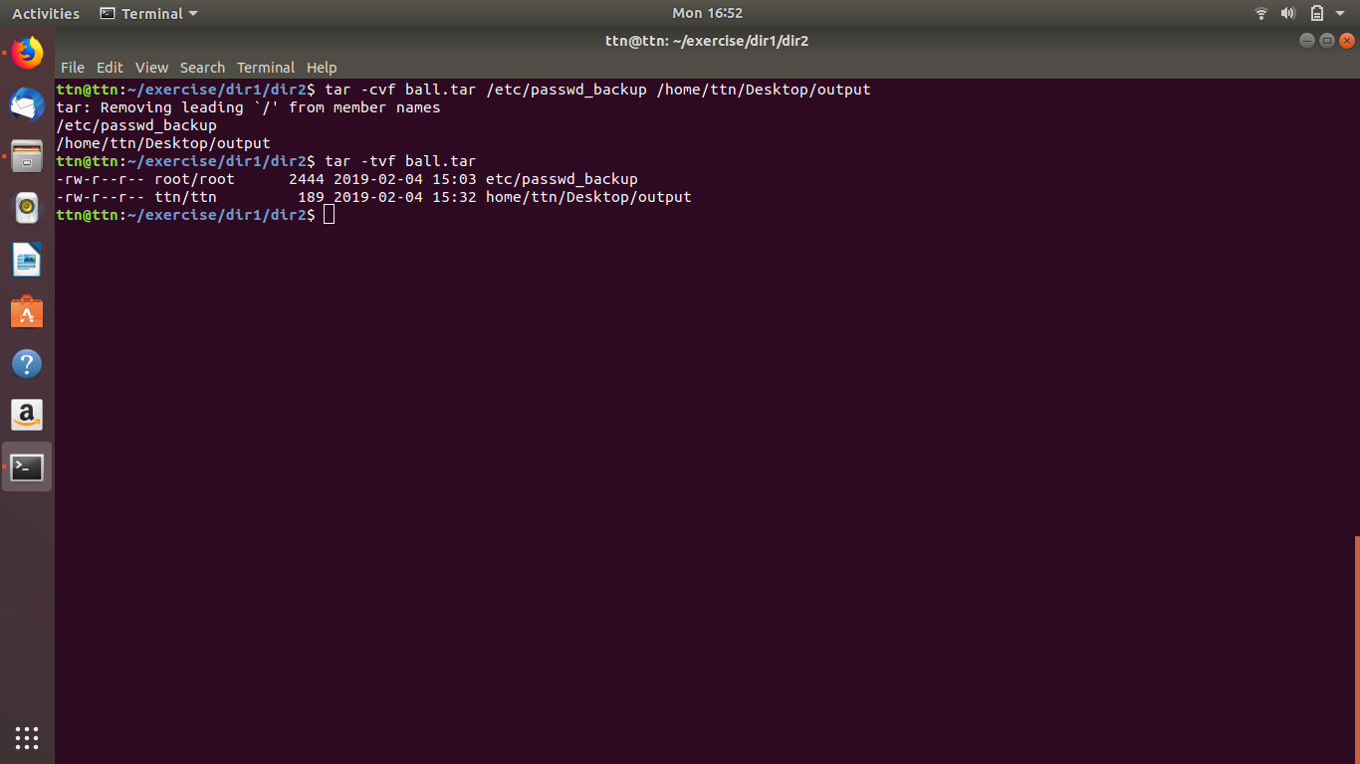

15. scp this file to test user

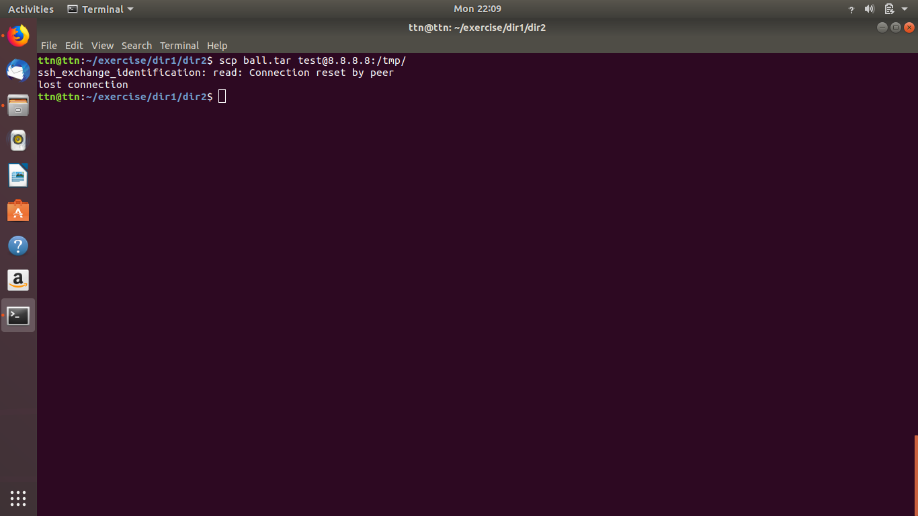

16. Unzip this tar bar by logging into the remote server

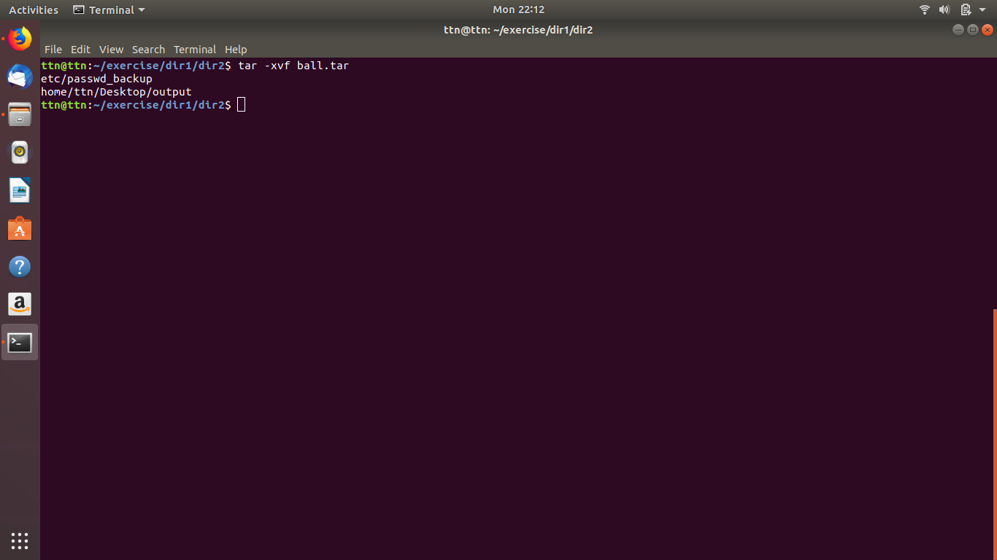

17. Download any image from web and move to desktop

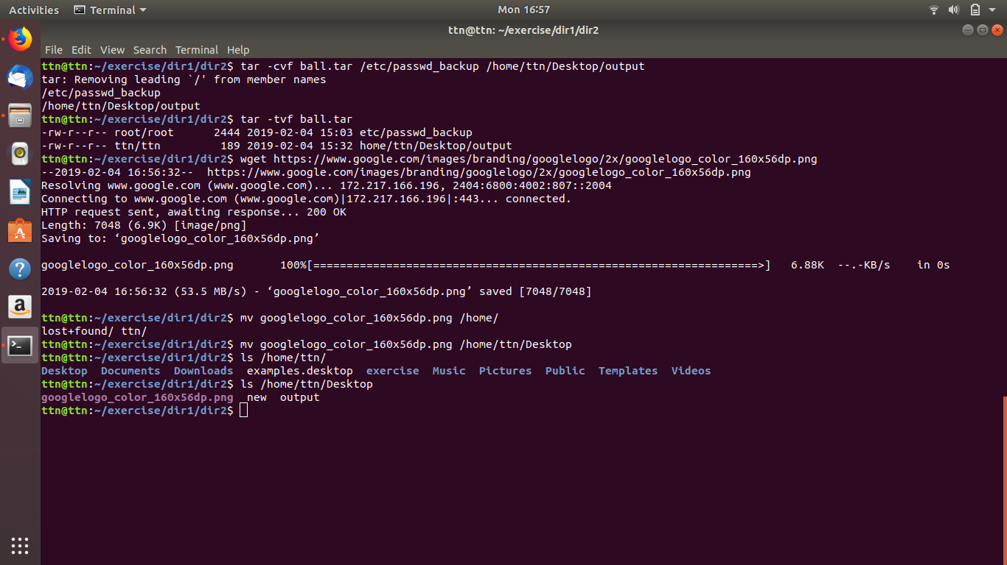

18. How to get help of commands usages.

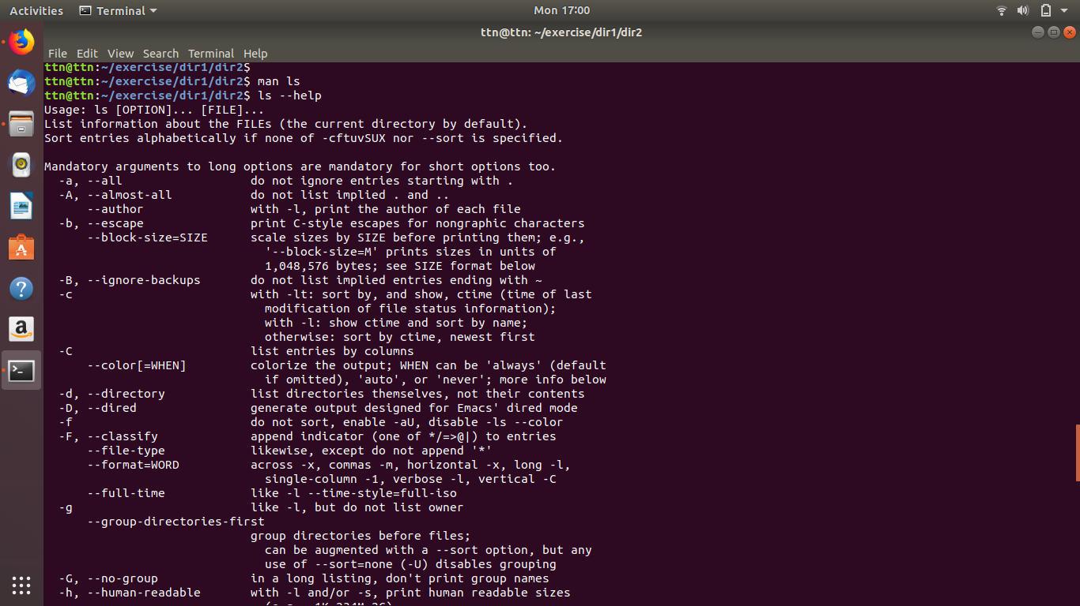

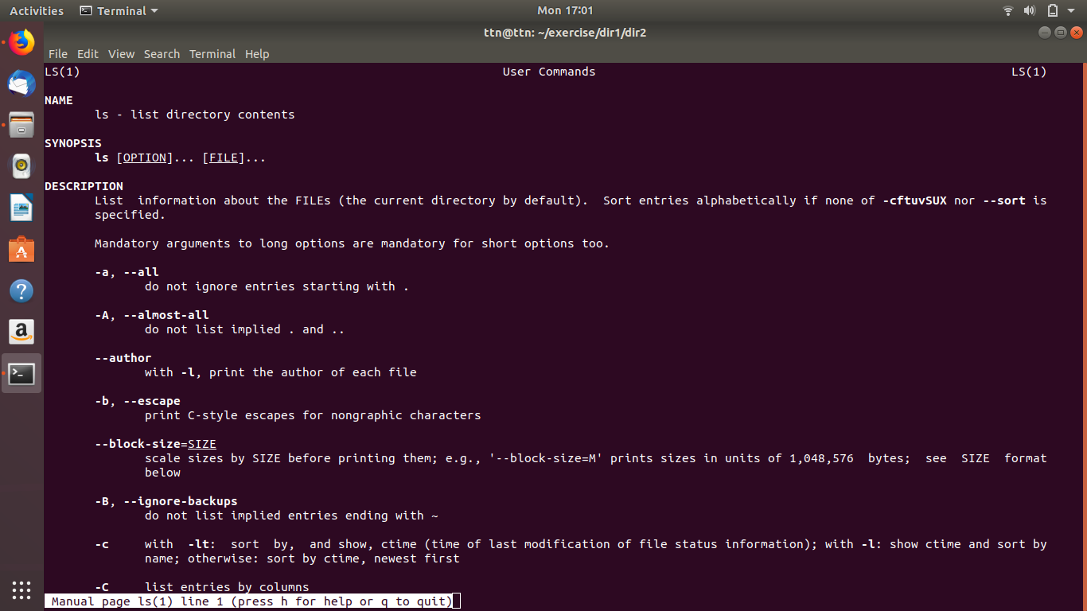

19. Create a symlink of /etc/services into /tmp/ports-info

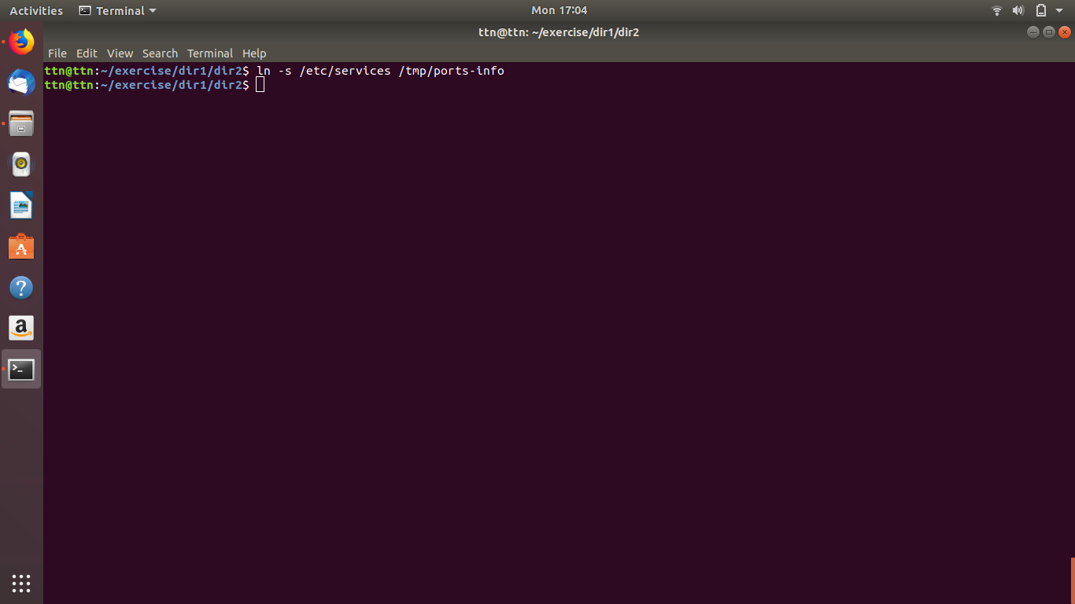

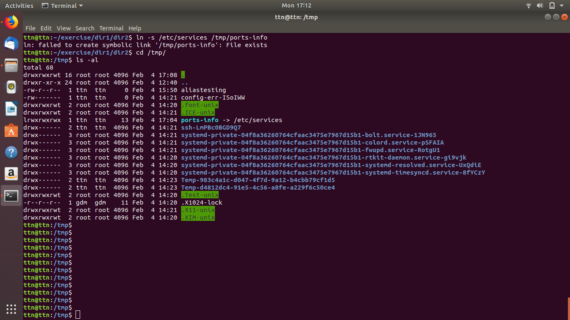

20. You are appointed as a Software/DevOps Engineer in ABC media services. On your first day you need to troubleshoot a problem. There is a command “xyz” somewhere installed in that linux system. But as a new joinee you do not have any idea about where is that Installed. How can you check that?

