1.Create Database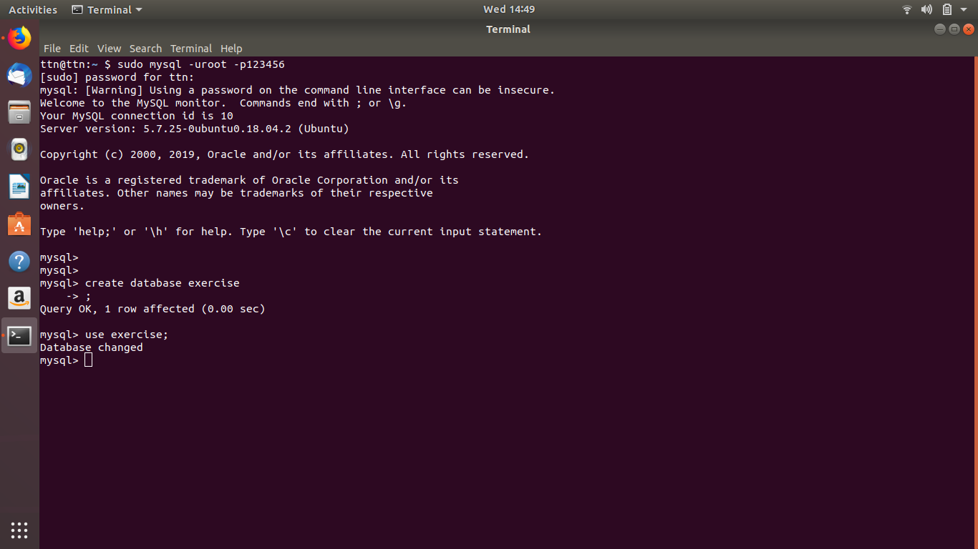

2. Design Schema

customer-table:

Cust_id cust_name cust_age cust_city ---------- -------------- ------------ -----------

salesperson-table:

S_id s_name s_age ----- ---------- -------

order-table:

Order_id order_date cust_id s_id

----------- -------------- --------- -------

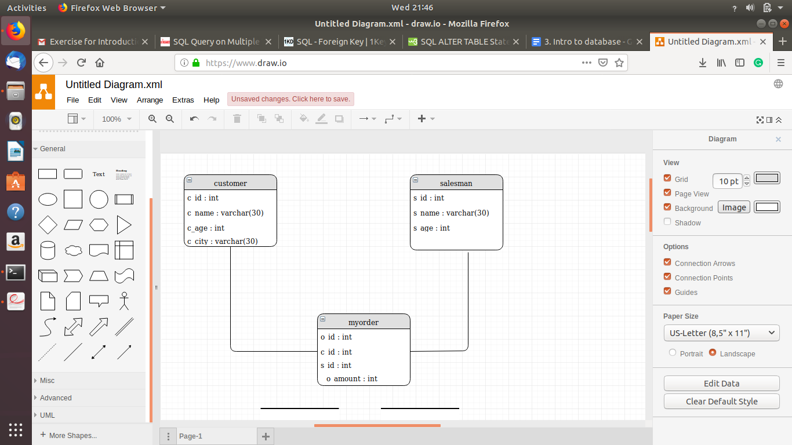

3. Create tables

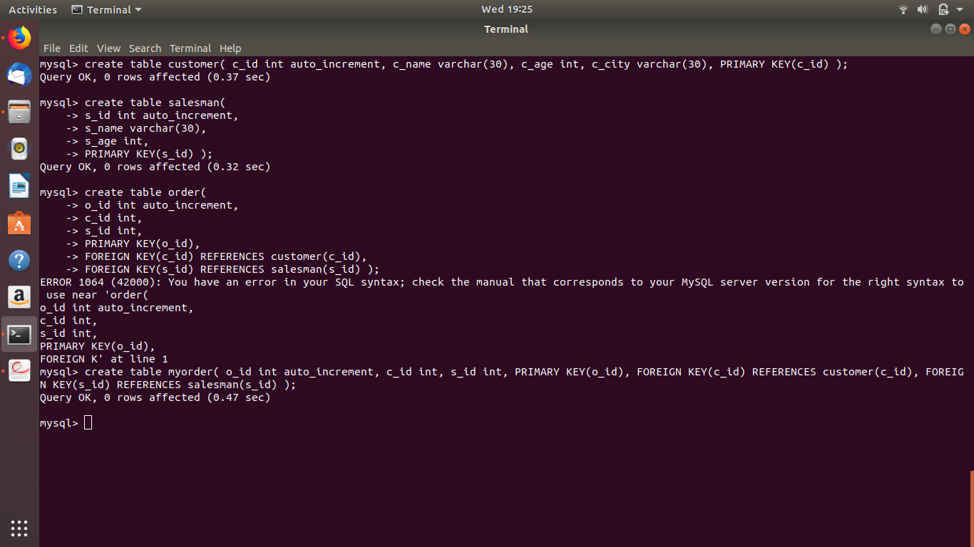

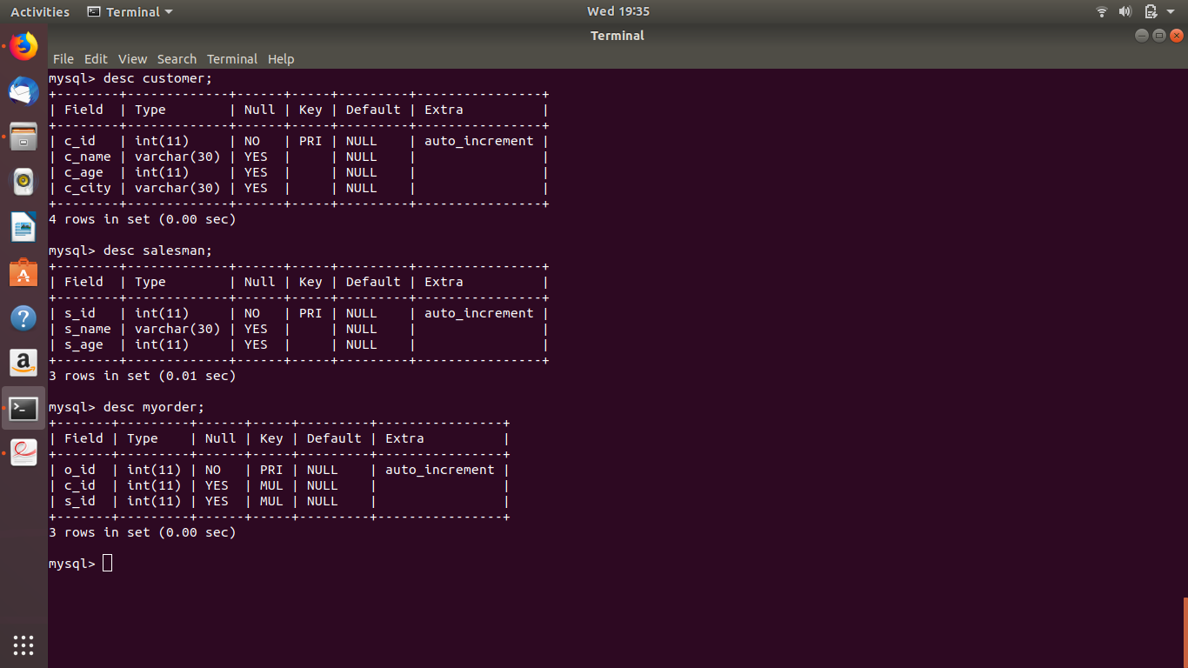

4.Insert sample data

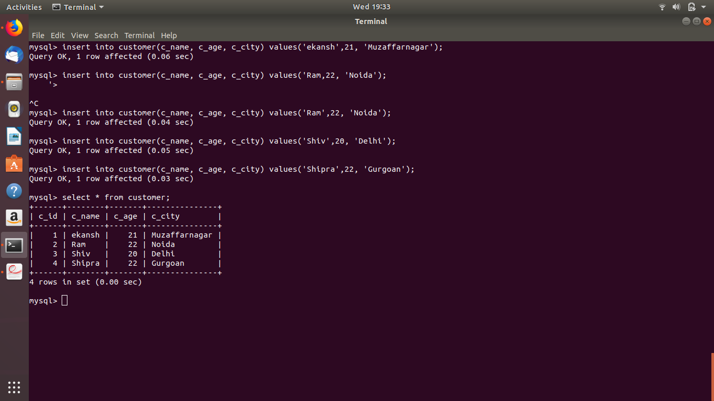

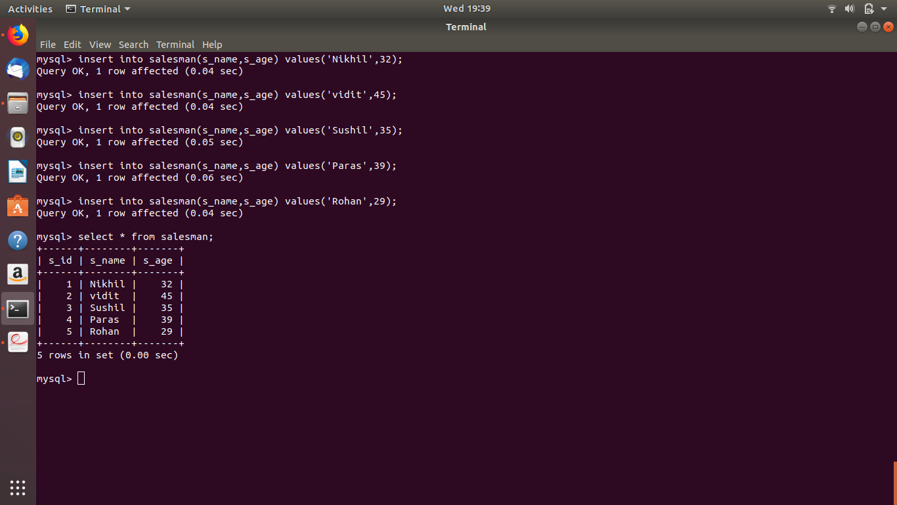

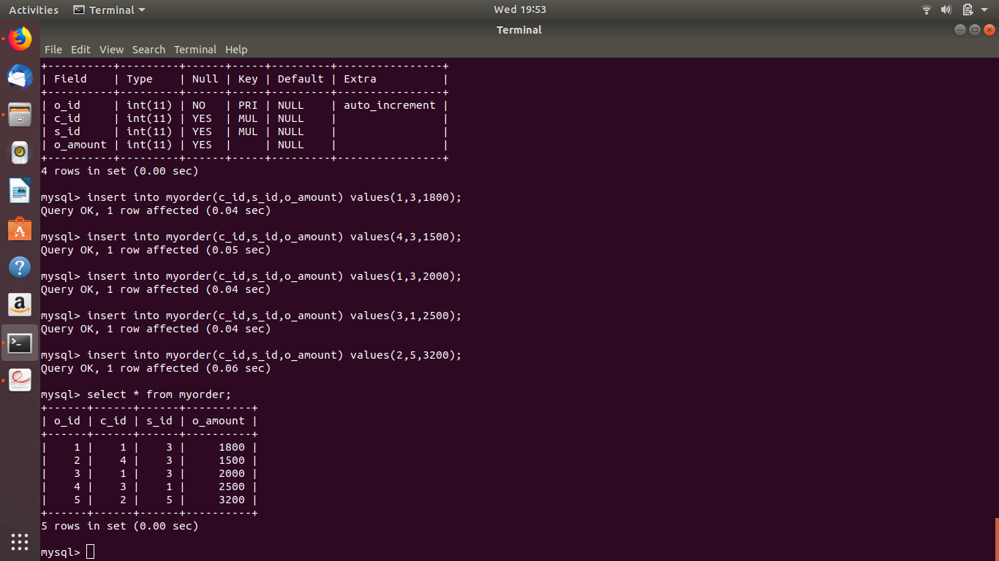

5. Find the sales person have multiple orders.

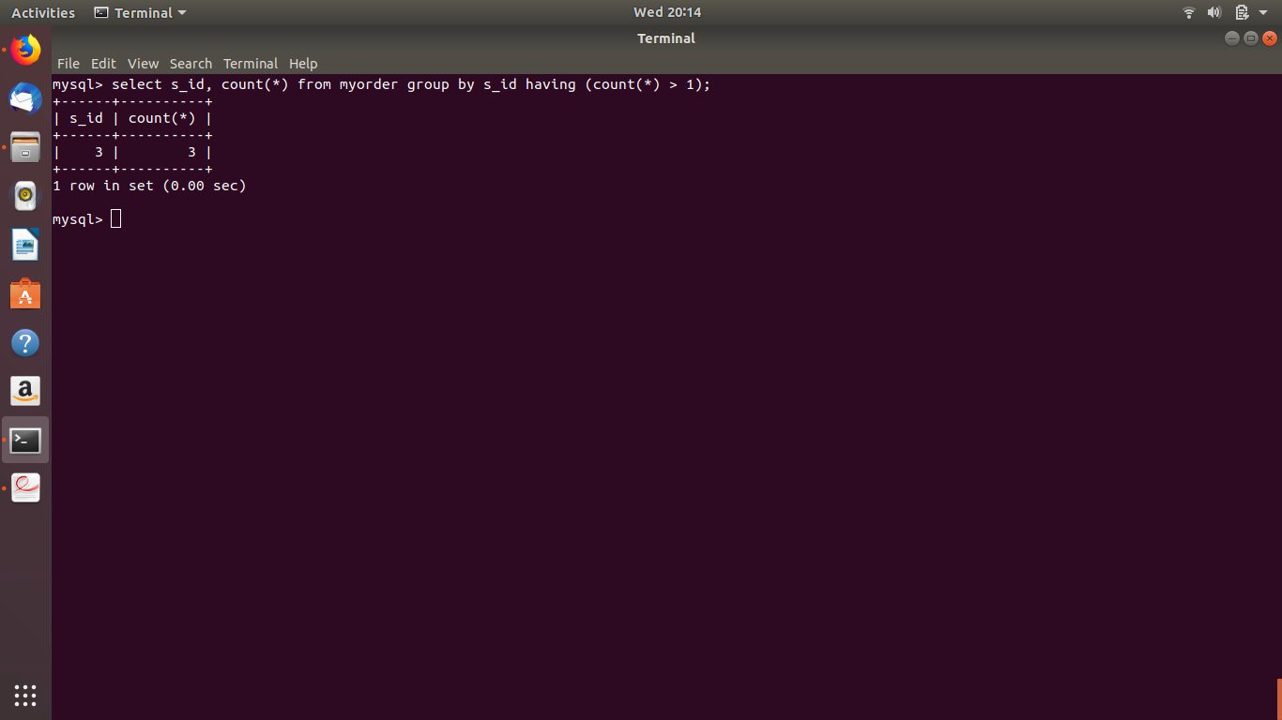

6. Find the all sales person details along with order details

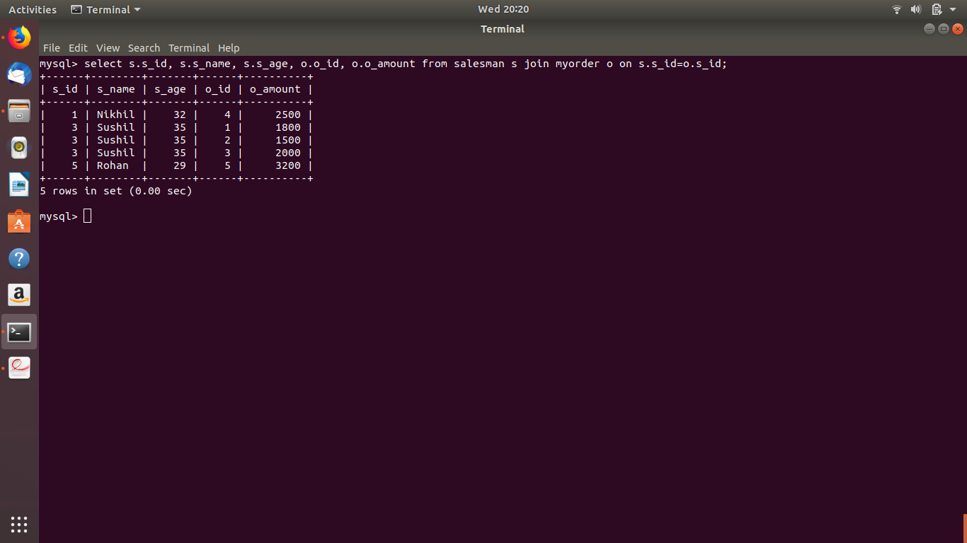

7. Create index

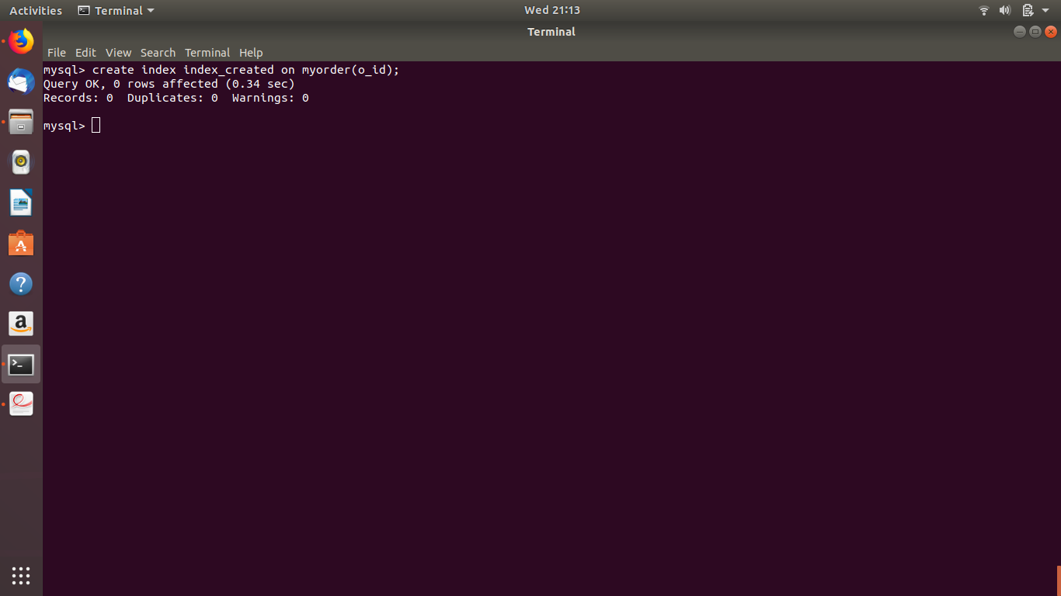

8. How to show index on a table

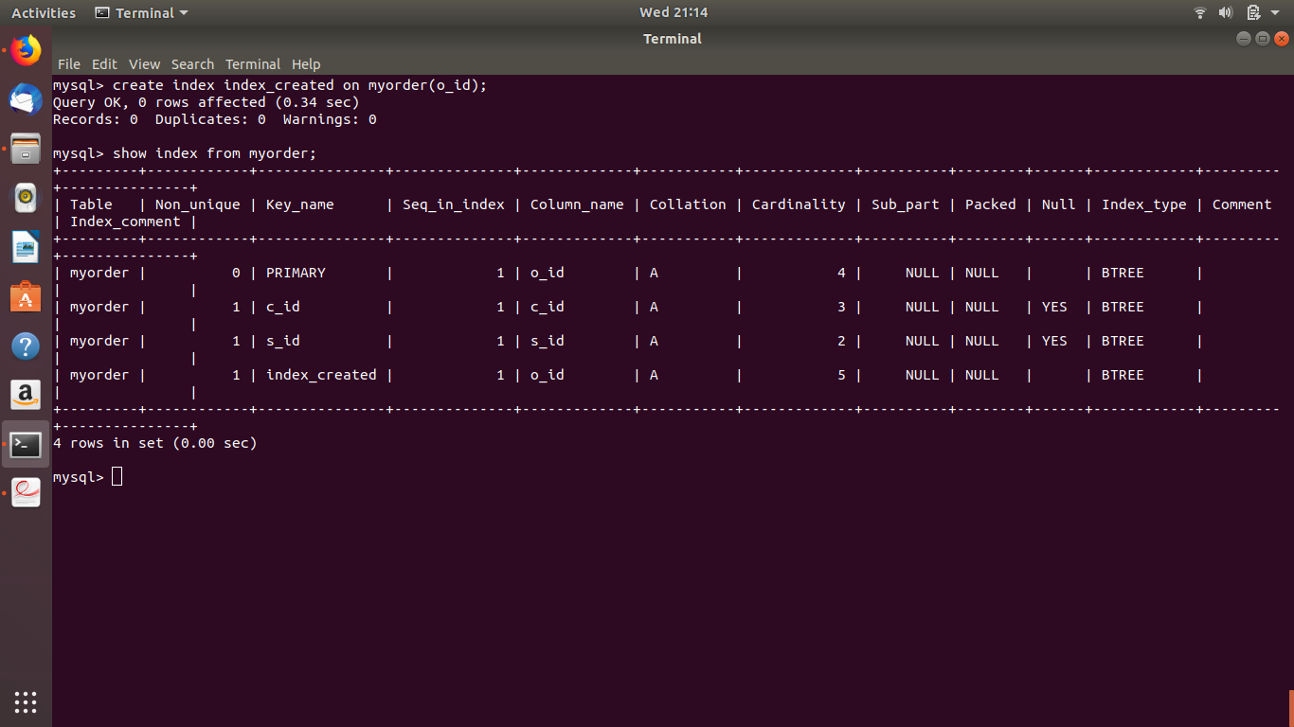

9. Find the order number, sale person name, along with the customer to whom that order belongs to

