# ridge regression

# manually tune alpha(s)

alpha_list =[0.0001,0.001,0.01,0.1,1,10,100]

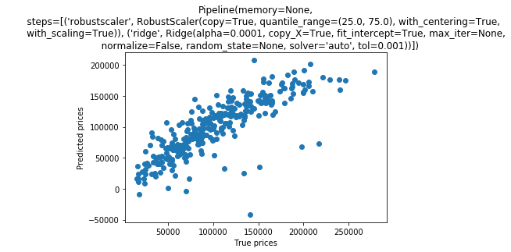

RMS: 61005.37 r2_score: 0.6694165072439878

param_grid = {

'bootstrap': [True],

'max_depth': [80, 90, 100, 110],

'max_features': [9, 40],

'min_samples_leaf': [3, 4, 5],

'min_samples_split': [8, 10, 12],

'n_estimators': [100, 200, 300, 1000]

}

# Create a based model

rf = RandomForestRegressor()

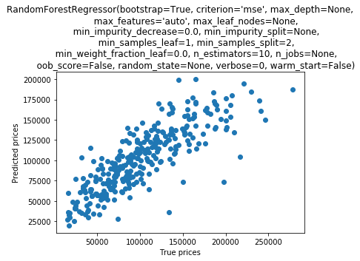

RMS: 32458.27 r2_score: 0.6860860976089398

# Create a based model

GBoost = GradientBoostingRegressor()

param_grid = {

'learning_rate': [0.05],

'max_depth': [10, 20, 50, 100],

'max_features': ['sqrt'],

'min_samples_leaf': [3, 5, 10],

'min_samples_split': [5, 10, 15],

'n_estimators': [100, 200, 300, 1000,3000],

'loss': ['huber'],

'random_state': [121]

}

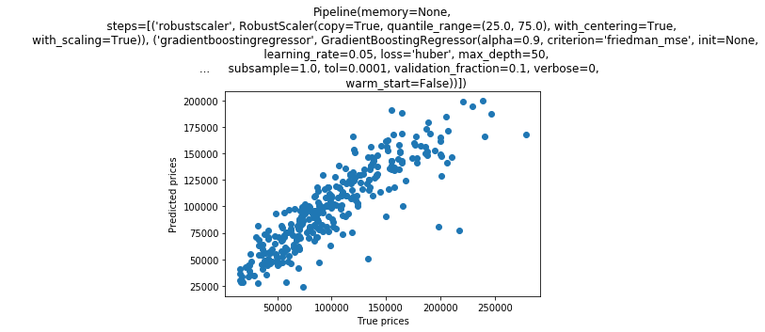

RMS: 29012.30 r2_score: 0.7558133923042479