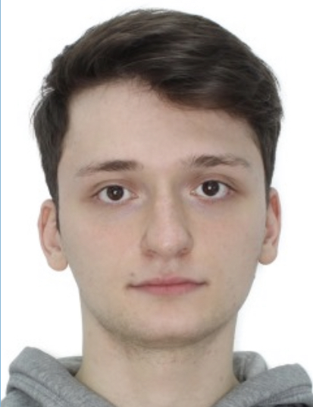 Karamian Eduard

**Frontend-developer**

City: Yerevan (Armenia).

Birth date: 15.03.2002

Permanent job.

**Citizenship:**

Ukraine.

**Employment:**

Internship, remote, permanent.

**Education:**

Bachelor: Donetsk National University;

Physics-Technics faculty: informatics and computer engineering.

**My Stack:**

HTML, CSS – advanced;

Sass (scss) – advanced;

Javascript(vanilla) – basics;

React.js – basics;

Vite.js - basics;

Wbpack – beginner;

C# (.net core, naudio, cscore) – basic;

SQL – basic.

**Publications:**

Term paper, topic: «Guitar sound app»:

<https://github.com/ekaramyan/GuitarStudio_Beta-1>

Term paper, topic: «Database for app working with sound»:

<https://github.com/ekaramyan/Guitar_Studio-beta2->

**Pet projects:**

<https://ekaramyan.github.io/Wanna_Latte-project1/>

<https://ekaramyan.github.io/Lampix/>

[https://github.com/ekaramyan/test-task/](https://github.com/ekaramyan/test-task/blob/master/src/scss/_second-page.scss)

<https://github.com/ekaramyan/Project-tofix>

**Languages:**

Russian (native);

English (intermediate);

Armenian (speaking);

Ukrainian (native).

**About me:**

I’m organized, have basic knowledge of front-end development. I have experience in writing console and window apps, as well as in CSS layout without preprocessors (SCSS, SASS) and with them. I am proactive and always ready to learn new things.

**Soft skills:**

- Purposeful;

- Communicative;

- Easily trained;

- Pedantic;

- Diligent.

**Contacts:**

Phone: +37498961620, +380502217366

Gmail: [ekaramyan@gmail.com](mailto:ekaramyan@gmail.com)

Github: github.com/ekaramyan

VK: vk.com/e.ddos

Instagram: @ed_karamian

Telegram: @e_ddos