Acoustic Phonetics

Vowels (ENG) | i | e | a | o | u
F1 | 591 Hz | 791 Hz | 1.012 Hz | 1.002 Hz | 455 Hz
F2 | 2.213 Hz | 2.044 Hz | 1.839 Hz | 1.511 Hz | 1.573 Hz

Vowels  (JP) | i | e | a | o | u
F1 | 342 Hz | 508 Hz | 717 Hz | 554 Hz | 317 Hz
F2 | 2.143 Hz | 1871 Hz | 1.234 Hz | 1.035 Hz | 902 Hz

Vowels  (FR) | i | e | a | o | u
F1 | 292 Hz | 356 | 749 Hz | 417 Hz | 325 Hz
F2 | 2.529 Hz | 2.428 | 1375 Hz | 949 Hz | 986 Hz

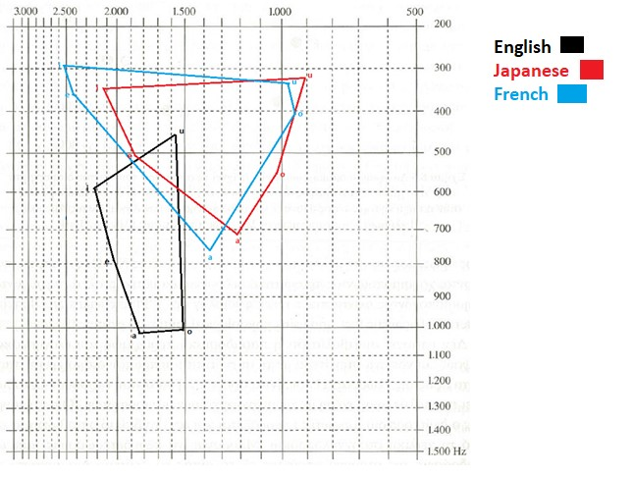

Comments:

A preliminary examination of the phonemic chart reveals that they are divided into two categories: the French and Japanese phonemic chart, and the English.
With regard to the English phonemic chart, it appears that the vowels are pronounced at a lower point in the vocal range than in the other two tables. Additionally, their pronunciation can be described as being shifted towards the front vowels of the other two tables. It is also noteworthy that there is minimal deviation in the second formant, F2, for both [o] and [u], in contrast to the greater divergence observed in the first formant, F1, for [a] and [o].
With regard to the second group, specifically Japanese, it is observed that the first formant exhibits minimal differentiation between the back [u] and [o] sounds, which are pronounced in close proximity to F1.
With regard to the French language, it has been established that the [i] and [e] phonemes exhibit minimal differentiation in terms of both shape and place of articulation, akin to the [u] and [o] phonemes. This indicates that some are articulated in a manner that is more front and high, while others are pronounced in a way that is more back and high.

