Assignment 3 - Week 4 – Rasa installation and intent classification
The objective of this task was to develop an intent classification model using Rasa. To accomplish this, I created a narrative about purchasing a sofa and experimented with various NLU intents and paraphrases before training and testing my model.

To enable clients to select a diverse range of sofas, I introduced six new intents: sofa_challenge, checking_type1, checking_type2, money, option, and don't_understand. These intents allowed users to choose a sofa, specify the desired number of seats (e.g., 2, 3), determine the price range, and identify a suitable sofa. Additionally, the bot could inform the client if only a sofa option was available, prompting them to provide more details.

The model demonstrated high accuracy in predicting the correct answers, as illustrated in the tables below. These tables present the results of an 80/20 split of my NLU training data and subsequent testing using "test data.yml."
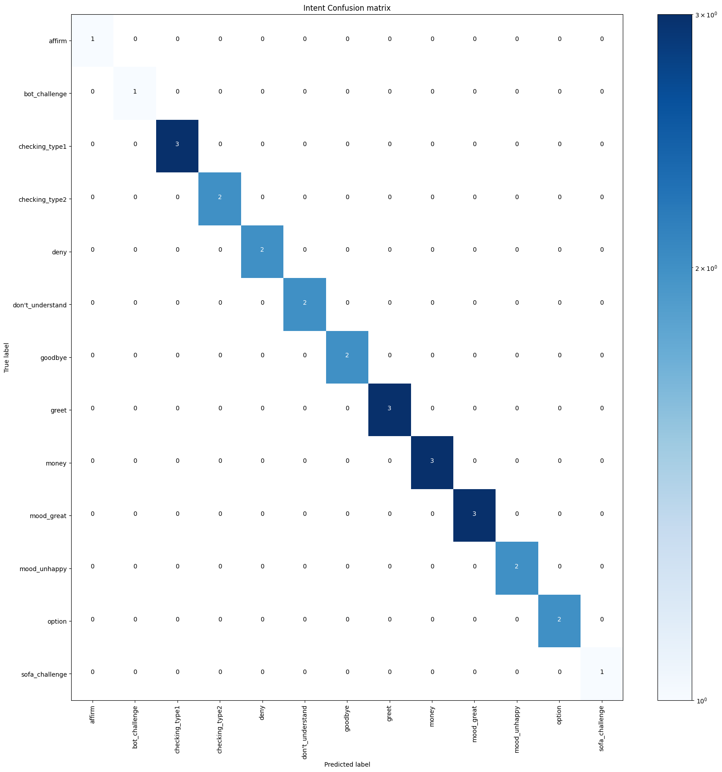

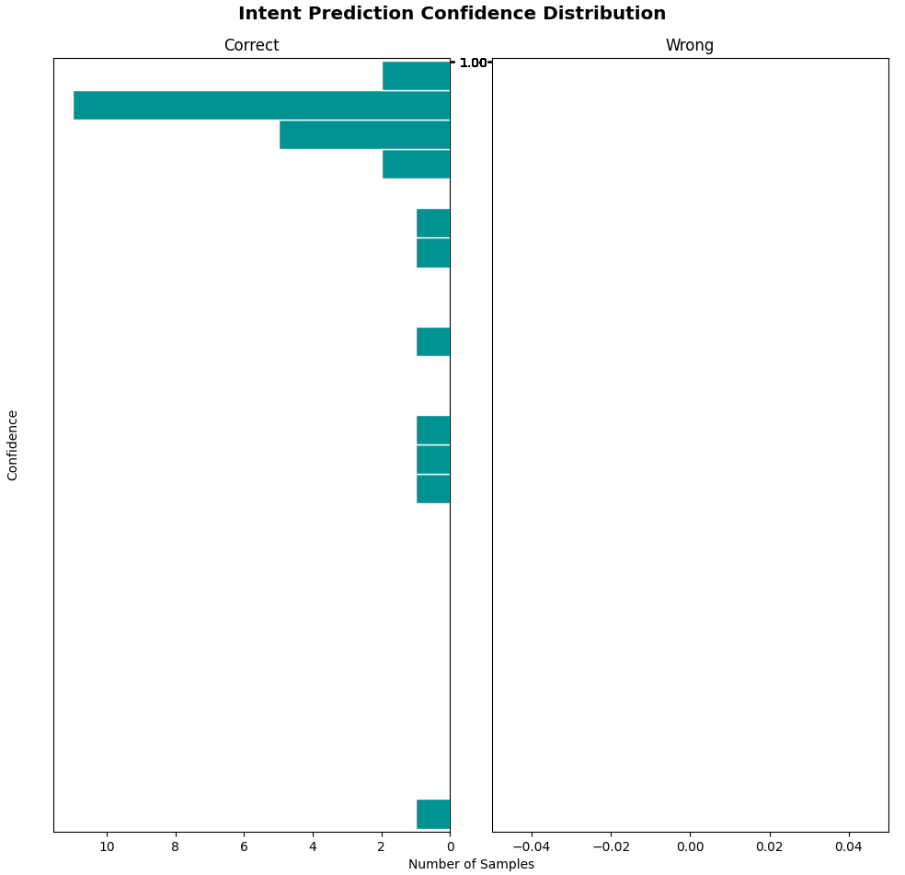

While the model exhibited excellent performance on the training data, it's important to note that this might be due to overfitting. This means the model might not generalize well to unseen data. To address this, I plan to increase the diversity of examples within my intents. Additionally, the similarity among the current intent examples could have contributed to overfitting. Therefore, introducing more varied and additional samples is crucial to enhance the bot's performance and ensure better generalization.

