Mummy’s Restaurant Online Order System

Follow the below instructions to complete this project successfully.

Participants as to develop 2 modules:
Online Restaurant System (Technologies to be used: Java, JDBC and Servlet & JSP. UI- HTML5, CSS3 and jQuery)
Online Payment System (Technologies to be used: Java, WS, and Spring DAO. UI- HTML5, CSS3, jQuery and Angular JS)
Use the below folder structure in the application development.
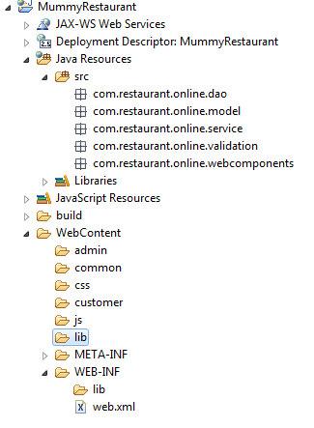

Day 1 & 2:
Complete Requirement gathering and analysis with necessary documentations (High level SRS with Use Case Diagram).
Day 3 & 4:
Complete Database designing and SQL statements will be used in JDBC (Creation of tables and Schema structures).
Day 5 to 12:
Develop all logical coding, Server side Validation Coding, POJO classes, and DAO classes. Do unit testing for these modules.
Day 13 to 15:
Develop web pages with and client validations using HTML5, CSS3, and JQuery.
Day 16 to 19:
Complete Core modules using Servlet and JSP concepts except Online Payment.
Day 20 to 21:
Develop online payment module screen using HTML5, CSS3, and Angular JS.
Day 22 to 24:
Develop business logical coding, Server side Validation Coding, POJO classes, and DAO classes using Spring.
Day 25 to 26:
Develop web services component for online payments and call them from client.
Day 27:
Complete your entire modules and integration and ready for evaluation.
Day 28 to 32:
Prepare test cases and do manual testing and automation testing.
Day 33:
Submit your project with complete testing coding.

