**Grant Writing Tool**

Prepared By: **Neel Kalyani**

Stream: **M.sc Data Science and Big Data Analytics**

PRN No: **1132231315**

**Mit World Peace University, Pune**

**Project Overview and Idea:**

Greetings everyone, my name is **Neel Kalyani** and currently pursuing **M.sc DSBDA** from **MIT WPU, pune.** Currently, I have prepared a model for basic grant writing which uses AI tools to generate grant report based on project ideas and goals mentioned by user. For, UI I have used python’s streamlit library and created a simple and interactive UI.

Currently, I have considered **OpenAI’s GPT-4** model, Huggingface’s **GPT-NEO-1.3B** model with 1.3 billion trained parameters, and **Mistral-7B-v0.1** model with 7 billion trained parameters to generate the grant report. All the mentioned model are good at generating the content based on prompt. Right now I have selected models which are supported in my machine for processing.

For GPT-neo and mistral, I have also added option of loading the model locally on system and then generating the grant.

For every model, I have also given option to access the model via API calls( serverless inference API calls). GPT-Neo and Mistral are accessed via huggingface’s API.

Due to large system requirements for model, larger parameter models were not supported by my system, but tried best to run this model.

Currently grants generated are not that accurate (sometimes creates random texts) but working on project will definitely improves the accuracy.

**Attaching below are project screenshot of output:**

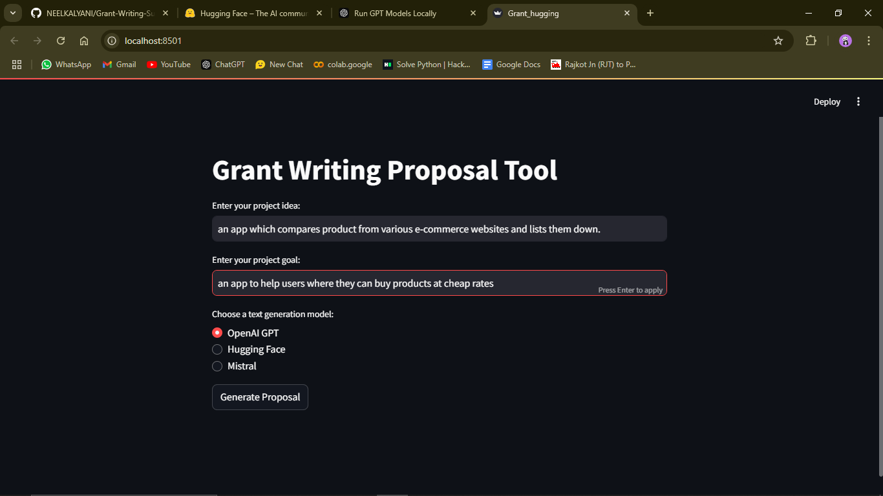

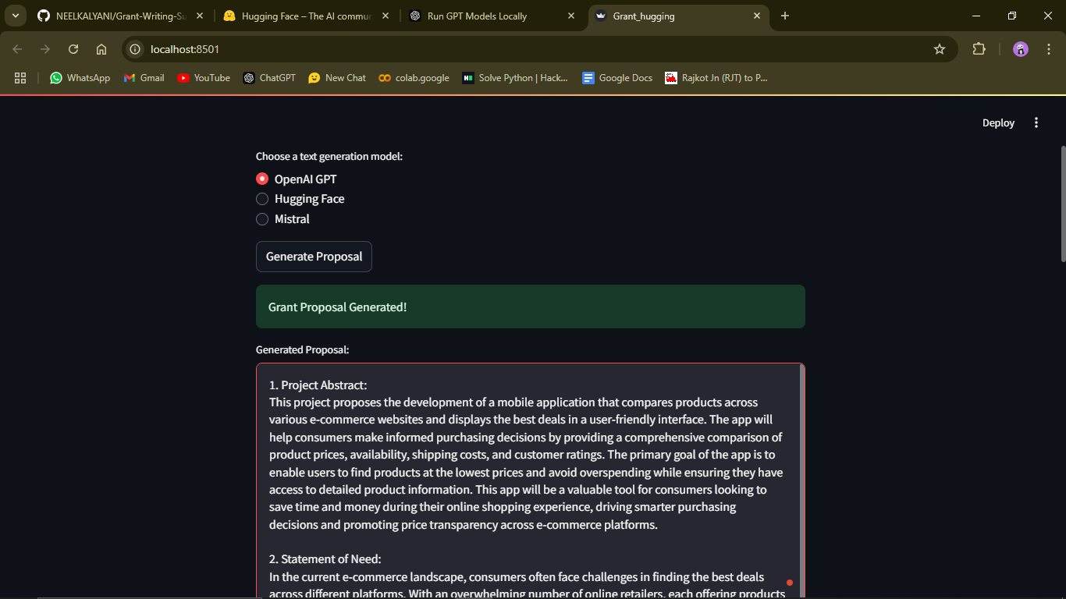

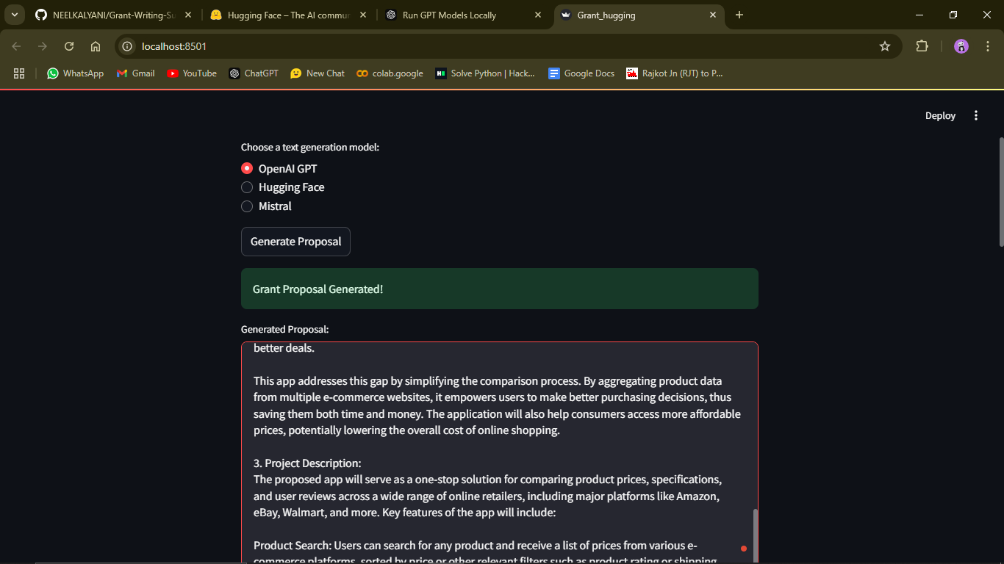

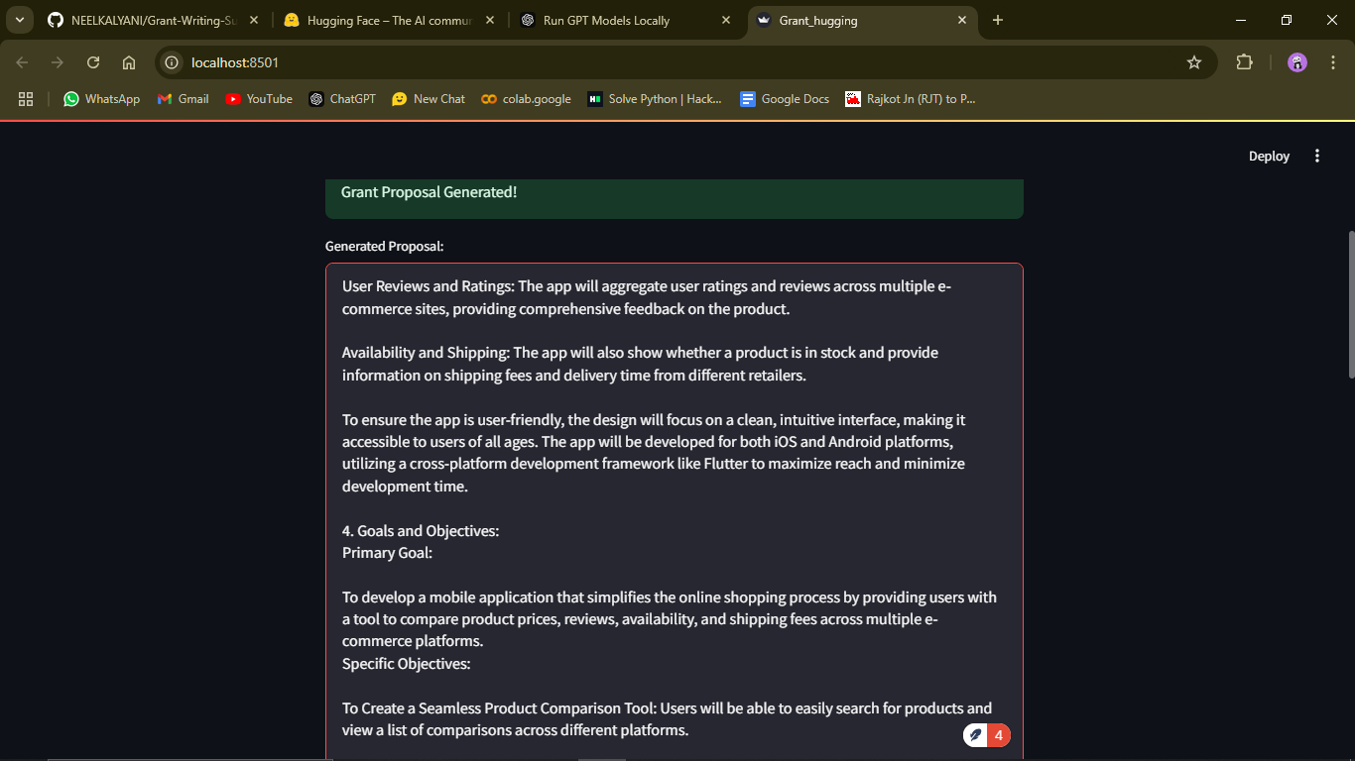

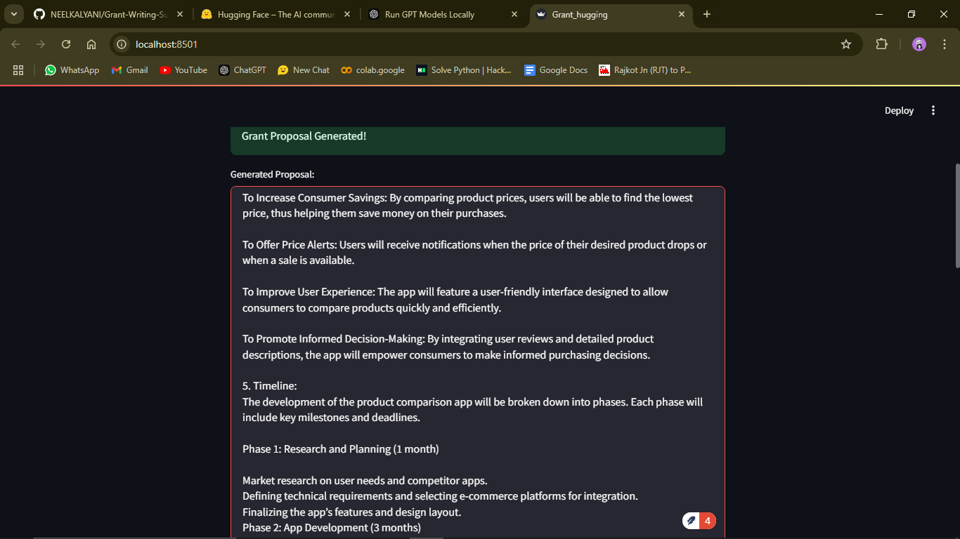

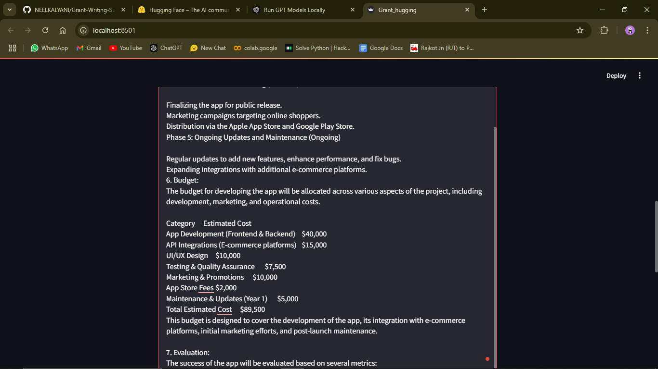

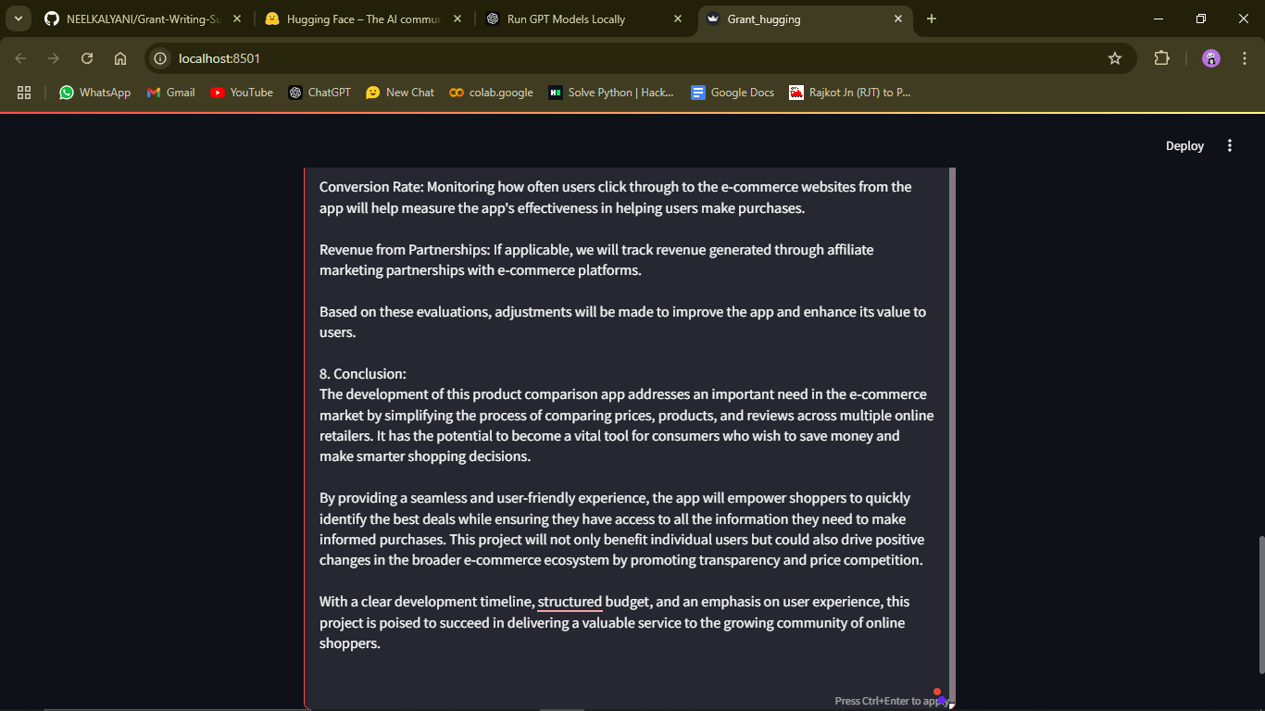

**Screenshot of API Keys:**

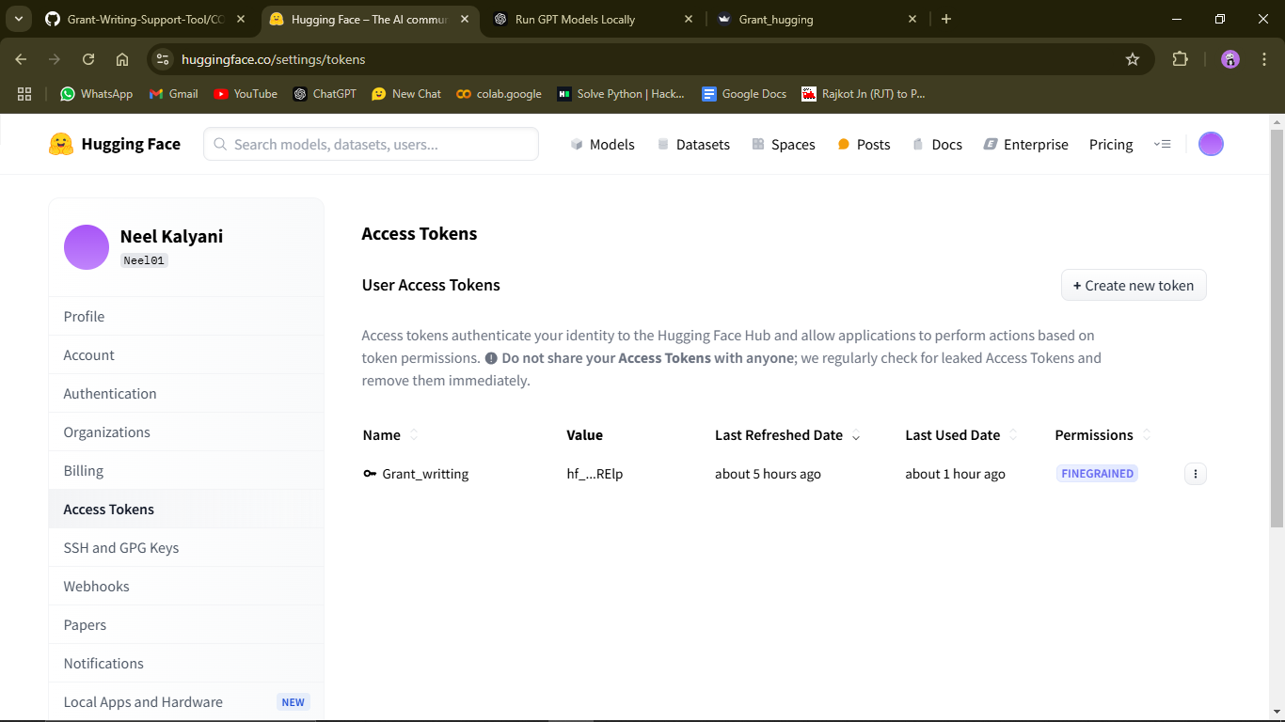

**GITHUB POJECT LINK:**

**https://github.com/NEELKALYANI/Grant-Writing-Support-Tool**