Synthetic data experiments

Data

Input: array of length 20, all zeros, except for two non-equal non-zero integers in the range (1,9). The non-zero entries have a least two zeros between them in the array.

Output: 0 if the second of the two non-zero entries is less than the first; 1 otherwise

Number of instances: 22032, evenly balanced between classes

Experiment 1:

Model: two fully-connected layers

Layer 1:
Input: 1 x 20 (1 example by 20 items in the sequence)
Output: 1 x 10
↓
Nonlinearity: ReLU
↓
Layer 2:
Input: 1 x 10
Output: 1 x 2 (1 example by 2 output classes)
↓
Nonlinearity: sigmoid
↓
Softmax

Hyperparameters:
Epochs = 1
Batch size = 1
Train/dev/test split: 60/20/20

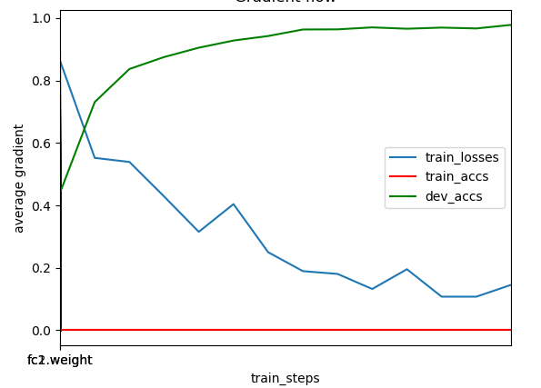
Results:

Dev accuracy: 97%
Time to converge: 900 examples

Experiment 2:

Model: single, unidirectional LSTM

LSTM:
Hidden size: 128
Input: 20 x 1 x 1 (20 items in the sequence by batch size of 1 by feature dim of 1)
Output: 20 x 1 x 128
↓
Take final timestep
↓
Fully connected layer:
Input: 1 x 10
Output: 1 x 2 (1 example by 2 output classes)
↓
Nonlinearity: sigmoid
↓
Softmax

Hyperparameters:
LSTM hidden size: 128
Epochs = 1
Batch size = 1
Train/dev/test split: 60/20/20

Results:
Dev accuracy: 100%
Time to converge: 11000 examples (only 5000 to get to 98%)

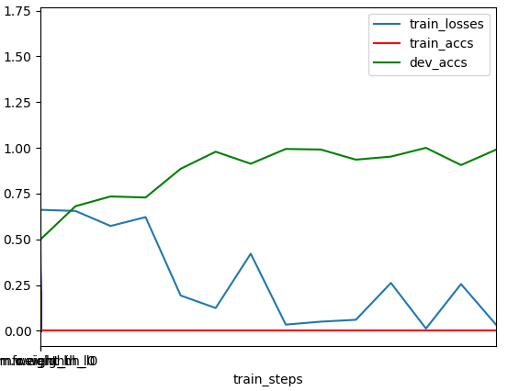

Experiment 3:

Model: CNN+MaxPool+Fully-connected

CNN:
Kernel = 5,1
Stride = 2,1
Padding = 2,0
↓
MaxPool:
Stride = 2
↓
Fully-connected 1:
Input: result of convolution compression on time dim
Output: 10
↓
Fully-connected 2:
Input: 10
Output: 1

Results:
Dev accuracy: 99%
Time to converge: 6000 examples

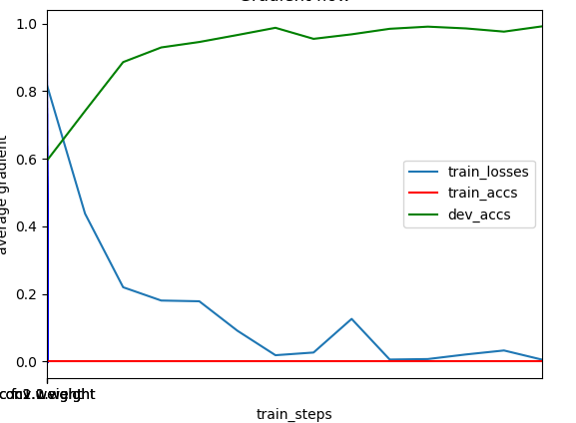

Experiment 4:

Model: CNN+LSTM+Fully-connected

CNN:
Kernel = 5,1
Stride = 2,1
Padding = 2,0
↓
LSTM:
Input: result of convolution compression on time dim
Output: 32
↓
Fully-connected:
Input: 32
Output: 1

Results:
Dev accuracy: 99%
Time to converge: 4000 examples

