**Lab Report**

Title: hello-world

Notice: Dr. Bryan Runck

Author: Emily K. Bender

Date: 9/10/24

**Project Repository:** <https://github.com/ekbender/GIS5571.git>

**Google Drive Link:** N/A

**Time Spent:** 20-25 hrs

**Abstract**

First objective was to get set up in Git and GitHub and become familiar with common calls. Second objective was to create buffers using the same dataset in three different environments: Arc Pro using out-of-the-box geoprocessing tools, ArcGIS Online in Jupyter Notebooks, and Arc Pro in Jupyter Notebooks.

**Problem Statement**

The Esri ecosystem has many different ways that you can access the same underlying functionality. The objective is to compare and contrast performing the same simple activity - buffer a network dataset - using three different tools: ArcPro, Jupyter Notebooks in ArcPro, Jupyter Notebooks in ArcOnline.

*Table 1. Project Requirements*

| **#** | **Requirement** | **Defined As** | **(Spatial) Data** | **Attribute Data** | **Dataset** | **Preparation** |
| --- | --- | --- | --- | --- | --- | --- |
| 1 | Road network system | Data set from MNDOT with all public and private road segments of Minnesota (*MnDOT Route Centerlines - Minnesota Geospatial Commons*, n.d.). | Road (line) geometry | N/A | <https://gisdata.mn.gov/dataset/trans-roads-centerlines> | No prep needed |

**Input Data**

The data I found was a simple Minnesota roads layer that is kept up by the Minnesota Department of Transportation.

*Table 2. Input Data*

| **#** | **Title** | **Purpose in Analysis** | **Link to Source** |
| --- | --- | --- | --- |
| 1 | MNDOT Route Centerlines (State Aid Routes) | Creating a buffer around all road segments of MN. | <https://gisdata.mn.gov/dataset/trans-roads-centerlines> |

**Methods**

*Figure 1. Data flow diagram.*

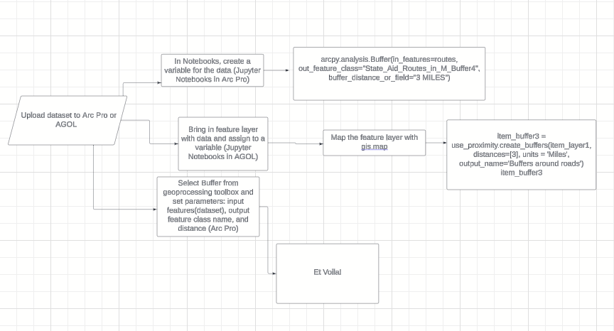

**Results**

As shown below, I was able to successfully buffer my road network dataset 3 different ways. ArcGIS Pro makes this process extremely easy to do with an analysis tool that requires no coding, you just need to be able to plug in your parameters to run the tool. To achieve the same goal in Arc Pro using Jupyter Notebooks, I imported the Arcpy library to call upon the buffer tool. This code was still very simple.

*Figure 2. Code used for Arc Pro Jupyter Notebook (can also be found in GitHub “Code” document)*

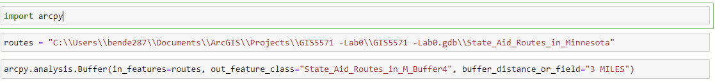

Finally, I created a buffer in ArcGIS Online using Jupyter Notebooks, which required the GIS and use_proximity libraries. However, performing the buffer this way was significantly more time consuming than the others because I performed this action on the entire state of Minnesota.

*Figure 3. Code used for ArcGIS Online Jupyter Notebook (can also be found in GitHub “Code” document)*

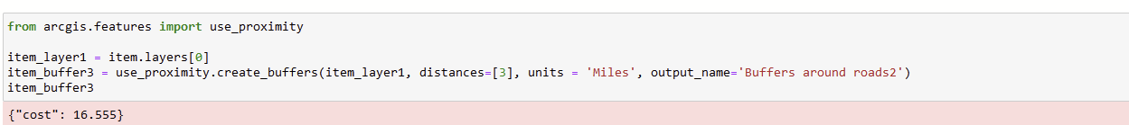

*Figure 4. End result in ArcGIS Pro using Buffer geoprocessing tool (5-mile buffer)*

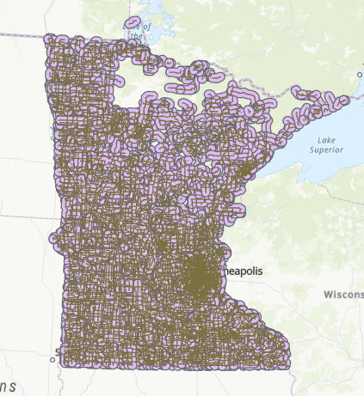

*Figure 5. End result in ArcGIS Pro using Jupyter Notebooks (3-mile buffer)*

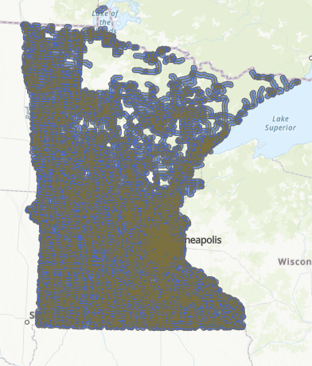

*Figure 6. End result in ArcGIS Online using Jupyter Notebooks (3-mile buffer)*

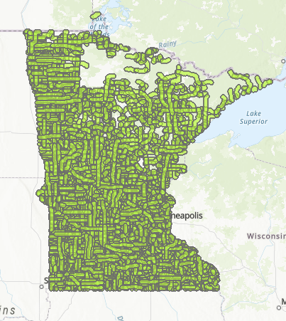

**Results Verification**

At the end of the day, all three methods produced identical results, which tells me that I was successful in completing this lab. I went from an out of the box tool in Arc Pro to writing code that would produce the same result in Jupyter Notebooks in two different Esri environments.

**Discussion and Conclusion**

GitHub:

It was pretty tricky getting everything set up correctly. I struggled a lot to work out how Git, GitHub and my text editor (Notepad) work together. I think that the amount of information in the form of tutorials got in my way a little bit because I was doing a lot of reading and not necessarily working on the actual objectives of the lab for the first few days of the assignment. I think it was just a case of information overload. There is also a learning curve at the beginning of this lab, using the GitHub platform, but I found it easier to find my own documentation and resources, when necessary.

ESRI Ecosystem:

I think that figuring out how to create the buffer in each of the different ecosystems was rather easy. I used the documentation and tutorials at my disposal and was able to produce identical results in all three cases. However, the other aspects that went with completing the lab were more challenging, like figuring out how to maneuver around Git Bash and GitHub to store my code, and learning how to fill out the first lab report with all the right components.

**References**

* *MnDOT Route Centerlines—Minnesota Geospatial Commons*. (n.d.). Retrieved September 9, 2024, from<https://gisdata.mn.gov/dataset/trans-roads-centerlines>
* *Notebooks in ArcGIS Pro—ArcGIS Pro | Documentation*. (n.d.). Retrieved September 9, 2024, from<https://pro.arcgis.com/en/pro-app/latest/arcpy/get-started/pro-notebooks.htm>
* *Proximity analysis*. (n.d.). ArcGIS API for Python. Retrieved September 9, 2024, from<https://developers.arcgis.com/python/guide/performing-proximity-analysis-on-feature-data/>

**Self-score**

*Fill out this rubric for yourself and include it in your lab report. The same rubric will be used to generate a grade in proportion to the points assigned in the syllabus to the assignment.*

| **Category** | **Description** | **Points Possible** | **Score** |
| --- | --- | --- | --- |
| **Structural Elements** | All elements of a lab report are included **(2 points each)**:  Title, Notice: Dr. Bryan Runck, Author, Project Repository, Date, Abstract, Problem Statement, Input Data w/ tables, Methods w/ Data, Flow Diagrams, Results, Results Verification, Discussion and Conclusion, References in common format, Self-score | 28 | 28 |
| **Clarity of Content** | Each element above is executed at a professional level so that someone can understand the goal, data, methods, results, and their validity and implications in a 5 minute reading at a cursory-level, and in a 30 minute meeting at a deep level **(12 points)**. There is a clear connection from data to results to discussion and conclusion **(12 points)**. | 24 | 24 |
| **Reproducibility** | Results are completely reproducible by someone with basic GIS training. There is no ambiguity in data flow or rationale for data operations. Every step is documented and justified. | 28 | 28 |
| **Verification** | Results are correct in that they have been verified in comparison to some standard. The standard is clearly stated **(10 points)**, the method of comparison is clearly stated **(5 points)**, and the result of verification is clearly stated **(5 points)**. | 20 | 20 |
|  |  | 100 | 100 |