PRODUCT INFORMATION · ëkcos
The plastic that returns to nature
Same product. Same performance. A fraction of the footprint.
Urinal screens cannot be recycled: through constant contact with urine they become biologically contaminated. Their only disposal routes are therefore incineration or landfill. In landfill, conventional plastic remains for centuries. Our products are manufactured with the Eco One additive, which allows the material to biodegrade.
Why ordinary plastic is a problem
Ordinary plastic products are engineered to last. Without a biodegradation additive, a plastic product sent to landfill can remain there for 300 to 1,000 years; foam “Crocs-style” clogs are a familiar example of plastic that is not biodegradable. Our products are made from the same kind of durable plastic (EVA) — but with one decisive difference: the Eco One additive.
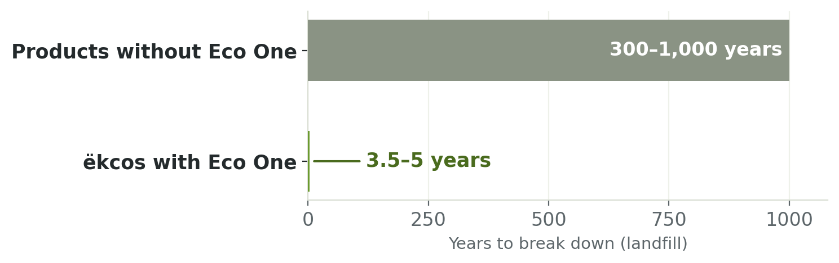

Products without Eco One compared with ëkcos products containing the additive.
Our solution: The Eco One additive
During manufacturing we incorporate approximately 1% of Eco One, an organic additive dosed in the same way as a colorant. It does not affect the product’s strength, appearance or performance.
In a biologically active landfill, naturally occurring microorganisms break down the treated plastic through enzymatic activity, converting it into biogas (methane, which modern landfill sites capture for energy recovery), carbon dioxide and humus.

Because the product ultimately breaks down into humus, it returns organic matter to the landfill and helps accelerate the biochemical processes already at work there. The product therefore contributes not only during its service life, but also after it.

Independent testing
The product was tested by an independent laboratory to the international standards ASTM D5511 and ISO 15985, comparing the same product with and without the Eco One additive. With Eco One, it reached 93.31% biodegradation within approximately 3.5 years, and up to 99% within five years; without Eco One, the product showed no measurable biodegradation.
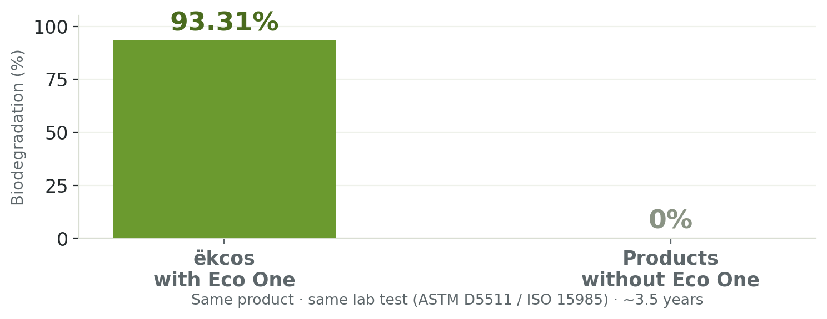
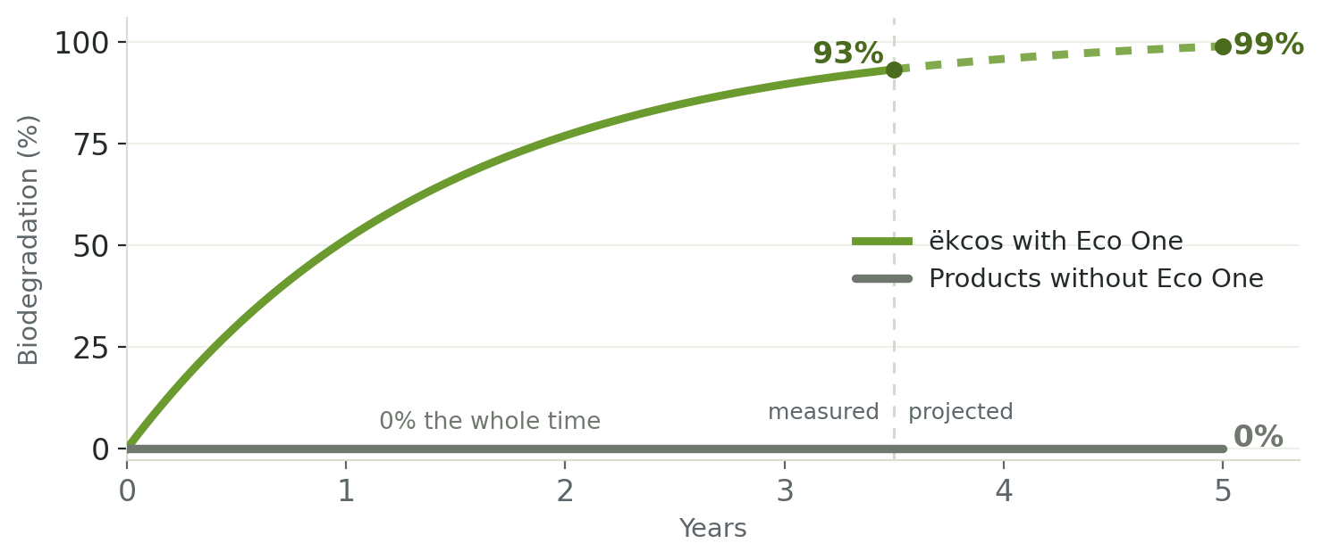
Biodegradation with and without the Eco One additive. Values beyond 3.5 years are projected from the measured trend.

~1%  additive content | ~3.5 yrs  to 93% biodegradation | up to 99%  within ~5 years

ëkcos biodegradable products
Our washroom products are manufactured with the Eco One additive and are up to 99% biodegradable, with performance identical to products without it and in many ways surpasses them. Full range: ekcos.eu
Data source: independent biodegradation test per ASTM D5511-02 and ISO 15985:2014 (Instituto Politécnico Nacional, Mexico City) — ëkcos product with 1% Eco One additive: 93.31% biodegradation over 1,288 days (≈3.5 years); the same product without the additive: 0%. Biodegradation beyond the test period (up to 99% within ~5 years) is projected from the measured trend. Persistence figures for conventional plastics (≈300–1,000 years) are widely cited industry estimates. The Eco One® additive is manufactured and certified by EcoLogic, LLC.

