Faya — onboarding and payments journey
Individuals and businesses, from first contact to the highest KYC/KYB tier: how onboarding works, how payments move, the external services involved, and the Trust Fabric and AML/CFT controls around it all. Every statement reflects the system as built; tiers that only repeat a lower tier with the same evidence are omitted.
1. The journey at a glance
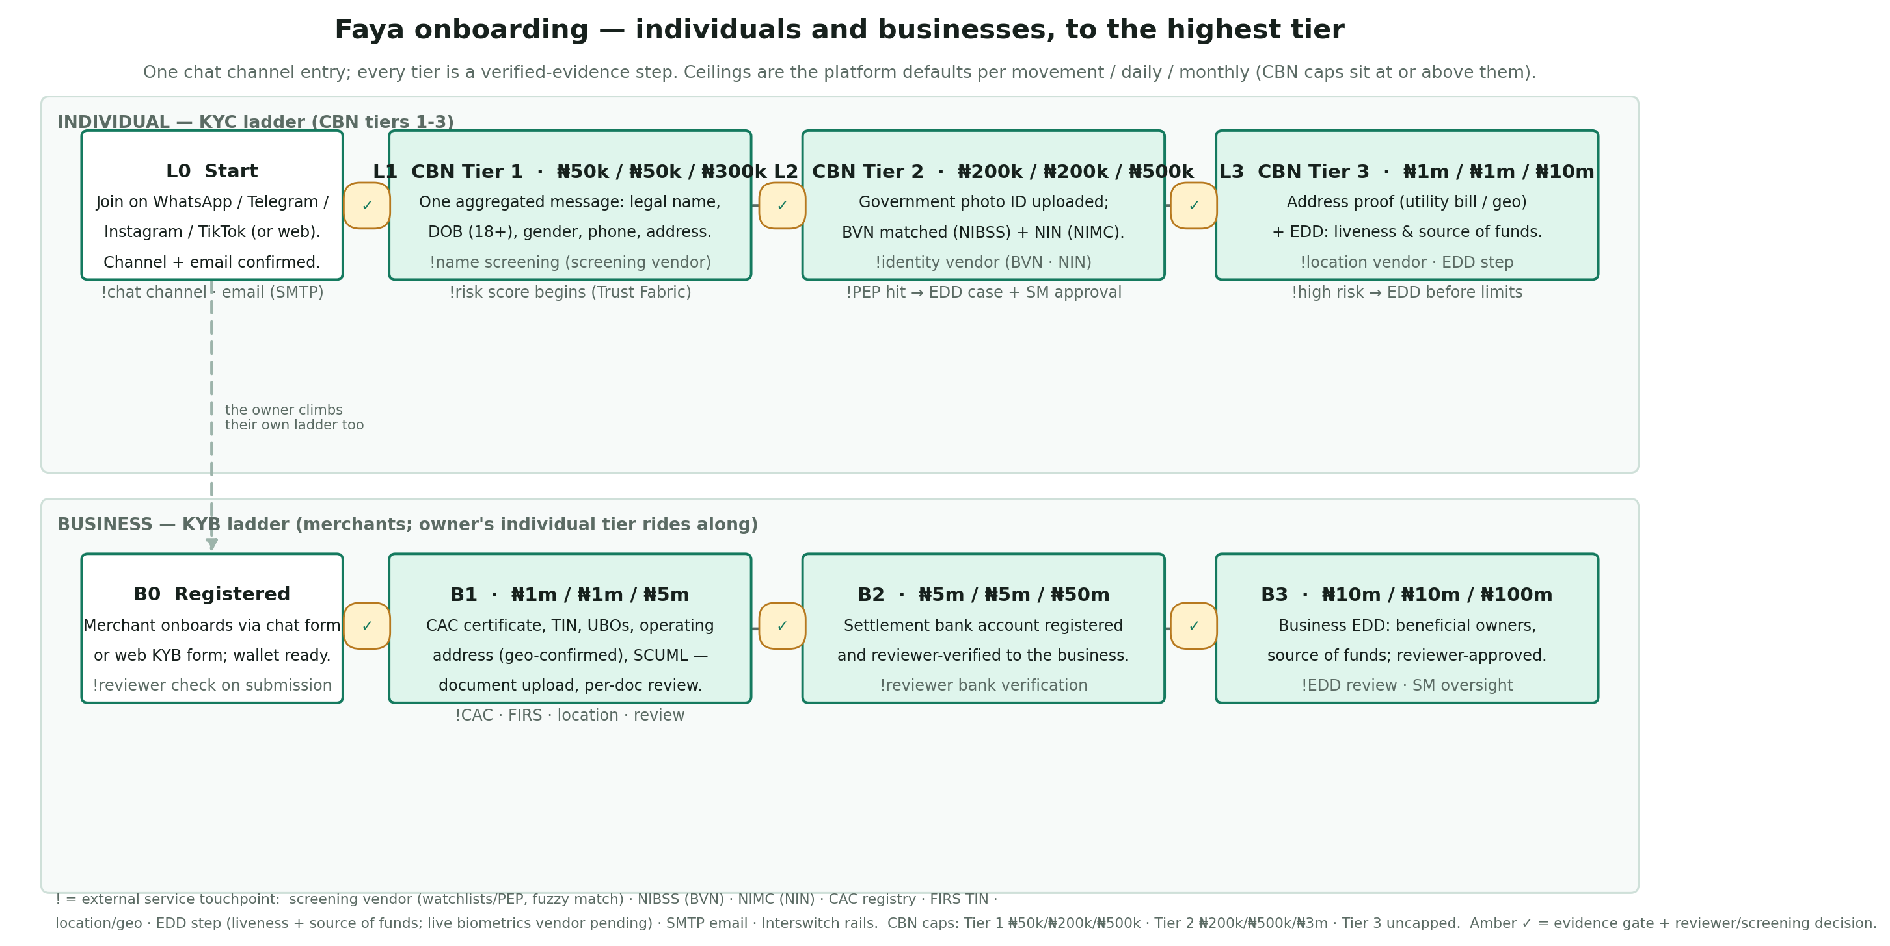
Onboarding is one ladder per account type, climbed by verified evidence — never by request alone. Amber gates are enforced in code: the required evidence keys must be present (and, for businesses, reviewer-verified against the submitted documents) before a tier advances. The ceilings shown are the platform's configured defaults (per movement / daily / monthly); the CBN correlation caps for individuals sit at or above them, and Tier 3 is uncapped by the CBN — the platform's own ceilings and absolute payment bounds still apply.
2. Onboarding, step by step
2.1 Entry
A customer joins on WhatsApp, Telegram, Instagram or TikTok, or opens a browser checkout link. The channel identity is confirmed and the email verified with a code (resend cooldown and lockout included). That alone establishes L0: a wallet-capable, low-ceiling account.
2.2 Individual ladder (L0 to L3)
L0 to L1 — CBN Tier 1. One aggregated message collects the Tier 1 data set: legal name, date of birth (18+), gender, phone and residential address. No more one-field-per-message chains. Platform ceilings: ₦50,000 / ₦50,000 / ₦300,000 — inside the CBN Tier 1 caps of ₦50,000 / ₦200,000 / ₦500,000.
L1 to L2 — CBN Tier 2. A government photo ID (passport, driver's licence, national ID or voter's card) plus electronic BVN matching against the NIBSS database and NIN matching against the NIMC database. Platform ceilings: ₦200,000 / ₦200,000 / ₦500,000 — inside the CBN Tier 2 caps of ₦200,000 / ₦500,000 / ₦3,000,000.
L2 to L3 — CBN Tier 3. Proof of residential address (a utility bill read structurally, or digital geolocation confirmation within the configured tolerance) and enhanced due diligence: a real-time liveness confirmation and a source-of-funds declaration, recorded through the EDD step (the live biometrics vendor is part of the identity purchase). Platform ceilings: ₦1,000,000 / ₦1,000,000 / ₦10,000,000; the CBN sets no Tier 3 cap, so only the platform's ceilings and absolute payment bounds apply.
2.3 Business ladder (B0 to B3)
B0 to B1. The corporate package, submitted as documents through the chat form or the browser KYB flow: CAC certificate, TIN certificate, beneficial-ownership declaration, operating address (with a browser-confirmed location step) and SCUML registration. Each document is reviewed individually; the tier advance requires all five evidence keys verified, so an upgrade request alone can never create a tier. This is the corporate hard gate. Ceilings: ₦1m / ₦1m / ₦5m.
B1 to B2. The settlement bank account is registered and reviewer-verified against the business identity before payouts can flow to it; the Interswitch account-name-enquiry adapter backs the live check. Ceilings: ₦5m / ₦5m / ₦50m.
B2 to B3. Business enhanced due diligence — beneficial owners and source of funds — approved by a reviewer. Ceilings: ₦10m / ₦10m / ₦100m.
A business owner also climbs the individual ladder: the payout risk step-up reads the owner's personal risk band, so the two ladders reinforce each other.
2.4 What can stop or pause a climb
Screening. Every profile is screened against watchlists with fuzzy matching; the decision vocabulary is clear / possible / strong / blocked. A blocking decision halts advancement and opens a review case. The platform's own internal watchlist outranks every vendor: a listed identity is never auto-cleared.
PEP hits. A politically-exposed-person determination opens one enhanced-due-diligence case that blocks every tier advancement until a senior manager approves or rejects it — an audited act in its own right, distinct from ordinary reviewer dispositions.
Risk band. A high ML/FT risk band caps the single-movement ceiling and requires EDD before higher-value activity. Old risk observations decay over time, and a false-positive alert writes a compensating event so the score does not ratchet.
Rescreening. Profiles are re-screened on a configured period, so a once-clear customer does not stay clear by default.
3. Payments
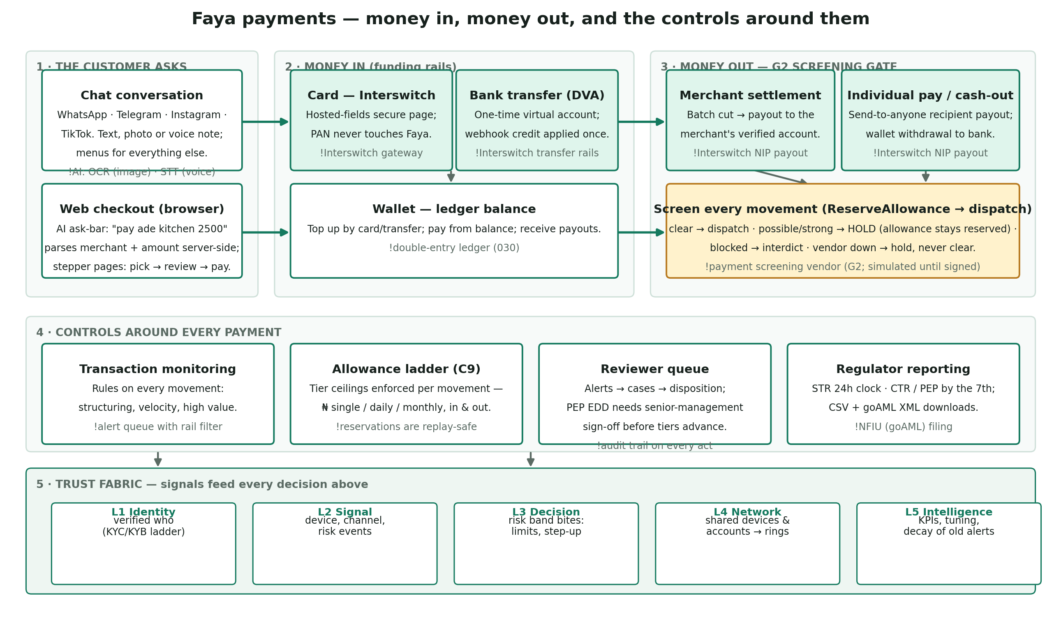
3.1 Money in
The customer asks in plain language — "pay ade kitchen 2,500" as text, a photo of a bill, or a voice note — in chat or in the web checkout's AI ask-bar. The AI provider turns images into text (OCR) and voice into text (STT); the parser extracts merchant, amount and intent server-side, then the stepper flow confirms: choose (or confirm the pre-selected) recipient, review, pay.
Card — Interswitch hosted fields: card data lives in the gateway's iframes and never touches Faya's servers.
Bank transfer — a one-time virtual account is issued; the webhook credit is applied to the wallet or payment exactly once, idempotently.
Wallet — a ledger-backed balance, topped up by card or transfer, spendable at any merchant or to anyone.
3.2 Money out — the screening gate
Settlement payouts to merchants, individual-pay recipient payouts and wallet withdrawals all pass the same pre-flight gate inside the window where the movement's allowance is already reserved:
clear — the movement dispatches to the Interswitch NIP rail;
possible / strong — the movement is held for review with the allowance still reserved: the money cannot be re-attempted past the screen, and the reviewer releases or rejects it from the queue (a release marks the screening manually cleared; a rejection reverses the payout and reopens the batch);
blocked — the movement is interdicted outright;
vendor unavailable — the movement holds rather than clears: an outage never becomes an approval.
Payout destinations are screened per destination account, so re-pointing a payout to a different bank account always re-screens the new counterparty.
3.3 One card payment, end to end
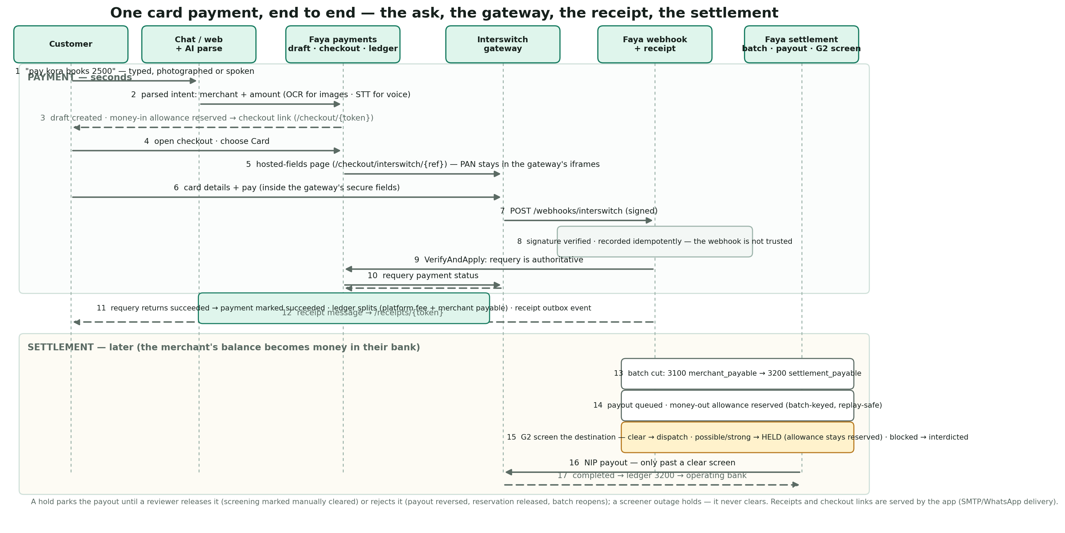
The figure traces one card payment from the first message to the money landing in the merchant's bank account. Three properties are load-bearing: the payment draft reserves the payer's money-in allowance before any gateway interaction, so the ceiling check cannot be raced; the card data never leaves Interswitch's hosted fields; and the webhook is treated as untrusted — it only triggers a requery, and the requery is what marks the payment succeeded, splits the ledger and emits the receipt. Settlement happens later: the batch cut freezes the merchant's balance, the payout reserves its money-out allowance, and the G2 gate screens the destination before any NIP dispatch. A hold parks the payout with the allowance still reserved until a reviewer releases or rejects it; a blocked counterparty is interdicted outright.
3.4 The controls around every payment
Allowance ladder. Every movement is validated against the subject's tier ceilings — single, daily, monthly, in and out — inside one atomic reservation; replays never double-count.
Transaction monitoring. Rules over every movement raise alerts (structuring around the reporting threshold, velocity, high value); the alert queue filters by rail and links to the exact payment, credit, refund or payout behind the alert.
Reviewer queue. Alerts become cases with dispositions; outcomes feed back as data — a false-positive cancels its risk contribution, a confirmed finding can freeze the whole network ring in one action.
Regulator reporting. STRs (24-hour clock from the determination of suspicion), CTRs and the PEP registry (by the 7th of the following month) are generated from audited data with filing clocks, overdue surfacing, and CSV plus goAML XML downloads. The audit log itself is hash-chained and re-verified on a schedule, with a reviewer disposition if the chain ever breaks.
4. External services
Service | Used for | Individual journey | Business journey | Payments
Chat channels (WhatsApp, Telegram, Instagram, TikTok) | Onboarding, commands, media collection | Onboarding, payments, statements | Onboarding, orders, settlement notices | Inbound instructions (text/image/voice)
AI provider (OpenAI-compatible) | OCR of images, STT of voice, chat parsing | Bill photos, voice notes | CAC/TIN/utility-bill document OCR | Ask-bar and conversational payment parsing
Identity vendor (NIN/BVN portal) | Electronic identity matching | BVN (NIBSS) and NIN (NIMC) at L2 | Owner identity where required | —
Screening vendor (watchlists / PEP) | Customer and payment screening, fuzzy matching | Onboarding screening, rescreening, PEP EDD input | Owner and UBO screening | G2 counterparty screening (simulated until signed)
CAC corporate registry | Company existence and status | — | B1 corporate hard gate | —
FIRS TIN service | Tax identification verification | — | B1 corporate hard gate | —
Interswitch account name enquiry | Bank account name resolution | — | B2 settlement verification (adapter ready; reviewer gate today) | Payout destination correctness
Location / geo service | Address confirmation | L2-L3 address proof | B1 operating address | —
Liveness / EDD step (simulated today) | EDD presence and source of funds | L3 EDD | B3 business EDD | —
Email (SMTP) | Verification codes, notifications | L0 email confirmation | Merchant admin accounts | Receipts and notifications
Interswitch | Card gateway, virtual accounts, NIP payouts/refunds | Funding and withdrawals | Collections and settlement payouts | All money movement
NFIU (goAML) | Regulatory filing destination | STR/CTR/PEP rows as applicable | As applicable | goAML XML filing
5. The Trust Fabric
The five layers turn isolated events into decisions; each layer is live in the platform today.
Layer | Question it answers | What exists today
1 · Identity | Who is this entity? | The KYC/KYB ladders above: evidence keys, verified documents, reviewer dispositions
2 · Signal | What is happening around it? | Trusted-device capture on sign-in and checkout, channel identity, risk events with time decay
3 · Decision | What should the platform do? | Risk bands that cap ceilings and force EDD, screening gates, allowance enforcement, G2 holds
4 · Network | How is it connected? | Entity-link analysis over shared devices, bank accounts and channel identities; ring detection with weighted, recency-scored edges; one-case-covers-the-ring reviewer tooling with allowance freezes
5 · Intelligence | Is the system working? | Trust KPIs on the admin dashboard (median alert resolution, false-positive rate), the rule-tuning queue, and annual independent-validation attestations
6. AML/CFT controls by journey stage
Stage | Control | Where it lives
Onboarding | Simplified DD (L1/B1) to enhanced DD (L3/B3) by tier | KYC/KYB ladders, evidence keys
Onboarding | Watchlist + PEP screening with fuzzy matching; internal watchlist precedence | Screening lane, record screening path
Onboarding | PEP EDD with senior-management approval; block while open | pep_edd case type, tier-advance gate
Transaction | Tier ceilings enforced atomically per movement | Allowance ladder (C9)
Transaction | Payment-time counterparty screening: block / hold / clear | G2 gate on payouts and withdrawals
Transaction | Monitoring rules and the alert-to-case pipeline | Transaction monitor, reviewer queue
Network | Ring detection across shared devices/accounts; one disposition covers the ring | Trust network view, network cases
Governance | Hash-chained audit log, scheduled chain verification, 5-year retention floor | Audit chain, retention policy
Governance | Annual independent-validation attestation | Compliance attestations page
Reporting | STR 24h / CTR monthly clocks, goAML XML | Filing clocks, goAML encoders
7. The highest tiers in one paragraph
An L3 individual or B3 business is the platform's fully-verified customer: government ID plus BVN and NIN (L2), then address proof and liveness-based EDD with source of funds (L3) — or the full corporate package, verified settlement account, and business EDD (B3). At the top tier the CBN sets no Tier 3 cap — the platform's default ceilings (₦1m / ₦1m / ₦10m) and the absolute payment bounds still apply, and B3 caps at ₦10m single / ₦100m monthly by platform policy — but everything they do still rides the same gates as everyone else: screening on themselves and on every counterparty they pay, monitoring on every movement, and the Trust Fabric scoring in the background. Reaching the top tier removes friction; it never removes oversight.

