

INTRODUCTION
Genesis Plus emulates the Sega’s Genesis/Mega Drive system. It was
originally created by Charles MacDonald and ported to the Nintendo GameCube by The “Genesis Plus” Team.
It is an open source emulator and a community project which aims to bring you blast processing into the past.Using this “emulator” you will be able to enjoy all of your classic 16bit games in all of their glory. GenesisPlus has been converted from a PC based platform to run on the GameCube’s proprietary PPC Gekko processor and features customized code to give you the best gaming experience possible.
This port is based on Genesis Plus 1.2 sourcecode but it’s also featuring a lot of modifications to improve games compatibility, emulation accuracy and adding various peripheral supports.
See below for specific user notes and history.txt for a full changelog.

FEATURES
- accurate & full speed Sega Genesis emulation
- Stereo Sound (@48 kHz)
- PAL Megadrive (50Hz) timings support
- 1~4 Players support
- 6-Buttons gamepad support
- Sega TeamPlayer & EA 4-Way Play support
- J-Cart support (autodetected)
- partial Sega Menacer support (autodetected for Menacer 6-in-1 game)
- Freeze State support
- SRAM support
- serial EEPROM support (used by a few games as backup RAM)
- ROM banking support (Super Street Fighter 2)
- External RAM banking support (Phantasy Star 4, Legend of Thor,…)
- Game Genie codes support
- ROM Information Screen
- Zipped roms support
- Interleaved roms support (.smd)
- Load roms from SDCARD or DVD (4.7GB DVD support for Wii users)
- Load/Save SRAM and FreezeState files (compressed) from/to Memory Card & SDCARD
- SRAM autoload
- SDLOAD or IPL reboot

CREDITS
- Charles Mc Donald for the original emulator
- The MAME team for several CPU emulation cores
- Stéphane Dallongeville for his GENS YM2612 core
- Maxim for his SN76489 core
- The “genesis plus team”: softdev, honkeykong & markcube for the original NGC port
- Brakken for the graphical interface and icon design
- EkeEke for new features implementation & emulation fixes
- Shagkur & Warmtoe for libogc
- Thanks to everyone at SMS Power and Spritesmind.net forums for providing technical informations about the Genesis and people from tehskeen.net forums for their feedback and support.

HOW TO COMPILE THE SOURCECODE ?

According to the GNU status of this project, the sourcecode MUST be included in any binary releases you made. To recompile the sourcecode, you will need to have installed:

DevkitPPC environment

libOGC last sources

You also need to replace the gu_psasm.S file which is located in the /LIBBOGC directory (from the root of libogc source directory) with the one included in this release and then recompile/reinstall libogc.

HOW TO INSTALL ?
The emulator is provided as a .dol which is a Gamecube Executable. You need to load and run the DOL on your GC or WII (Gamecube controller is needed) using various methods (Bootable DVD, SDLOAD,...). If you have no idea on how to load&run a DOL, please go here on follow the available guides: http://modyawii.tehskeen.com (Booting Homebrew Section)
SDCARD users should create a directory named "/genplus" at the root of the SDCARD. Inside this directory, you have to create a subdirectory named "/genplus/roms" to put all your roms. You should also create a subdirectory named "/genplus/saves" where SRAM and FreezeState files will be saved. For Wii users, please note that the SD slot can *NOT* be acceeded, you need to use a SD-Adapter in one of the MCARD Slot.
If you are using a DVD to load the roms, the format of the image you burned must be ISO9960 or you won't be able to read from it. The maximal readable size is 1.35GB for Gamecube users and 4.7GB for Wii users.
When putting roms either on DVD or SDCARD, it is recommended to use subdirectories as there is a limit of 1000 files per directory that could be read.

HOW TO USE ?
You'll start off with the main introduction screen and after pressing "A" you will be at the main menu. When you are navigating through the menus, the following keys on your Gamecube controller are used:
- "D-Pad" and Left Analog Stick let you move the select bar.
- "A Button" let you enter the selected submenu or performs the selected action
- "B Button" let you go back to the previous menu (it can also be used to go back to the game when you are at the main menu)
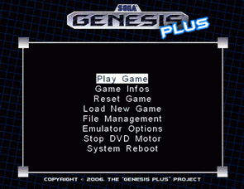

PLAY GAME
This will takes you into or back to the game. During gameplay, in addition of the usual controls, the following "special keys" on your Gamecube controller are used:
- pressing the "Z trigger" let you go back to the Main Menu
- pressing simultaneously "L + Z triggers" will execute a "Soft Reset" which should be like pressing the RESET button on a real Genesis. This is needed by some games to unlock special features or, for example, by the X-Men game to complete the "Mojo's Crunch" level.

GAME INFOS
This screen shows some basic informations for the loaded ROM.
You can use Up/Down buttons or Analog Stick to scrolldown the screen and display all informations. At the bottom of the list, you can see the peripherals that the game should be supporting: please note that if it supports 6-button gamepads, they are automatically selected for you. Otherwise, the standard 3-button pad is used (this can also be forced in Joypad Config menu).

RESET GAME
This should be like performing a "hard reset" on a real genesis. This will completely reinitialize the genesis virtual machine.

LOAD NEW GAME
Here you can choose to load a rom either from a SDCARD or a DVD and a file selection menu should appear.
In this new selection menu, the following controls can be used:
- A button : load the selected file
- B button : go up one directory
- Z button : quit the file selection menu
- L/R triggers : go down/up one full page
- Left/Right buttons or Analog stick : scroll the selected entry's filename when it can't be full displayed
- Up/Down buttons or Analog stick : select previous/next file
If you are using SDCARD, the program will look for a folder named "/genplus/roms".

EMULATOR OPTIONS

Misc. Options
X and Y Scale are to try to compensate for TVs with high overscan, or if you just want to play on a smaller area.
VDP Latency is used to be more accurate in term of VRAM write timing, it is required by some games (Chaos Engine...) to be displayed properly (OFF by default, automatically set when detecting specific game)
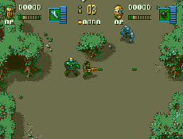
DMA Timing is used to be more accurate in term of VDP DMA timing, it is required by some games (Legend of Galahad...) to be displayed properly (ON by default)
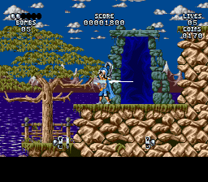
ALT. Timing let you use an alternate rendering timing. This is needed by some games (Lotus 2 RECS) to prevent display glitches (OFF by default, automatically set when detecting specific game)
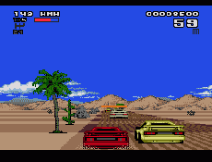
CPU Mode let you set overall timings for the Genesis system:
- AUTO: timings are automatically set according to the autodetected region (see below)
- NTSC: force 60hz Genesis timings
- PAL: force 50Hz Genesis timings
Some games won't work correctly or would display an error message if they are not designed to run at the selected timing.
Region let you force the region setting for the Genesis system:
- AUTO: original game region is automatically detected through rom header when loading the game
- EUR (europe PAL)
- USA (usa NTSC)
- JAPAN (japan NTSC)
- JAPAN_PAL (japan PAL)
Some games may display different things depending on the selected Region setting but also may not load if they have some internal region detection code.
Changing CPU mode or Region setting will reload the current game and reset the system.
SRAM Autoload let you enable/disable automatic SRAM loading when a new game has been loaded. The detection order is:
- MCARD (SLOTA)
- MCARD (SLOTB)
- SDCARD (SLOTA)
- SDCARD (SLOTB)

Sound Options
PSG Volume let you adjust the global volume level for the PSG output (0~200%)
FM Volume let you adjust the global volume level for the FM output (0~200%)
Boost Volume let you modify the overall sound level (0~4x). This could be useful when adjusting FM and PSG relative levels. Setting those values too high may produce some bad effects.
Default values depends on the current selected FM & PSG core and are automatically set when switching between cores (see below).
HQ YM2612 is only useful when selecting Gens FM core, in order to have the most accurate YM2612 emulation.
FM CORE let you choose which YM2612 emulation core to use, both have specific issues with some games:
- GENS is the core used in Gens, a famous Genesis emulator for PC platforms
- MAME is the one used in the M.A.M.E emulator (default)
PSG CORE let you choose which PSG emulation core to use:
- MAME is the one used in MAME
- SMSP is the SN76489 core developped by Maxim from smspower.org, which is also used in SMS Plus (default)

Joypads Configuration
Here you can remap all 6 buttons, and adjust the Analog stick sensitivity (a lower value being more sensitive). Note that the Analog Stick is also used when emulating the Sega Menacer lightgun, so you may want to reduce the sensibility when playing the Menacer 6-in-1 game.
TYPE let you choose the type of the emulated Genesis gamepads (3-Buttons or 6-Buttons) : Genesis Plus automatically detects and set this option if the current game supports 6-Buttons but you can also force 3-Buttons gamepads if you want:
- 3BUTTONS: use classic Genesis controllers
- 6BUTTONS: use 6-Buttons Genesis controllers
PORTA and PORTB let you choose which type of device to be plugged in each two Genesis input ports:
- GAMEPAD: single gamepad (3 or 6-buttons, see above)
- MULTITAP: multiplayer adapter (Sega Teamplayer or EA 4-Way Play)
- NONE: unplugged
Changing Controller Type or Port settings will reset the current game.

Some notes about Peripherals:
- MULTITAP is disabled by default. Only activate it with games supporting one of the following multiplayer adapters: actually, EA 4-Way Play and Sega TeamPlay adapters are fully supported.
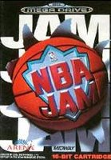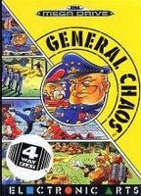
- Most multiplayer games will work with MULTITAP plugged in PORTA but some of them require a GAMEPAD to be plugged in PORTA and the MULTITAP to be plugged in PORTB. MULTITAP could be plugged in both ports but only games supporting more than 4 players can take advantage of this configuration. As we only have 4 controllers max. on the Gamecube, only the 4 first gamepads will effectively been seen as plugged.
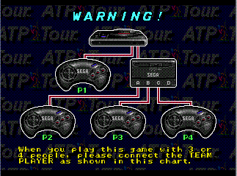
- J-CART games (Micromachines games, Pete Sampras games, Super Skidmarks) use a built-in adapter to enable 2 additional gamepads to be plugged and are not compatible with any of the above adapters. So, do not activate MULTITAP with those games, they are automatically detected by the system which configure itself to enable up to 4 players support.
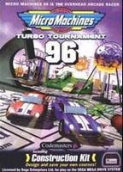

- When the 6-in-1 Menacer game is detected, PORTA is forced to NONE and PORTB forced to MENACER, you can not change those settings until another rom is loaded (previous settings will be restored). The only Genesis game that requires Sega Menacer lightgun support is the Menacer 6-in-1 game. Menacer input is automatically activated when you load this particular game: use the analog stick and be sure to activate the crosshair within game when it's possible.
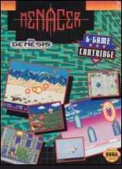
- Be sure that all controllers are correctly plugged when you switch on the console, otherwise, they won't be detected. Also don't unplug any controllers or you will need to reboot the system.

Game Genie Cheats
This screen lets you enter up to eight Game Genie codes. Use the A key to select/release an entry and the B key to exit.

MEMORY MANAGER

Let you managed SRAM and FreezeState files:
- SRAM Manager: Let you load/save SRAM data from/to the selected device
- STATE Manager: Let you load/save FreezeState data from/to the selected device
For each submenu, you can now choose the device type and location. Be sure to set this according to your system configuration before saving/loading files.
- DEVICE: Let you choose the device to use (SDCARD or MCARD).
- SLOT: Let you choose which MCARD slot to use for the device
when using NGC Memory Card in SLOTA, some mounting errors may occur. In this case, remove and insert the Memory Card again before trying to save/load anything. Be sure to have also enough space on the Card before trying to save something (Freeze State and SRAM files are usually compressed).
when using SDCARD, the directory /genplus/saves must exist. Wii users should also note that the SD slot can NOT be acceeded, you need to use a SD-Adapter into one of the Memory Card Slot.

STOP DVD MOTOR
Stop the DVD motor and the disc from spinning during playtime

SYSTEM REBOOT
For users of SDLoad or PSOLoad, you can call this to go back. Otherwise, this will reboot your console system.

