(Team Name)

(Project Title)

Software Design Document

Name (s):

Date: (mm/dd/yyyy)

TABLE OF CONTENTS

Contents

1. INTRODUCTION 3

1.1 Purpose 3

1.2 Scope 3

1.3 Overview 3

2. SYSTEM OVERVIEW 5

3. SYSTEM ARCHITECTURE 6

3.1 Architectural Design 6

3.2 Decomposition Description 8

4. DATA DESIGN 10

4.1 Data Description 10

4.2 Data Dictionary 10

5. COMPONENT DESIGN 11

6. HUMAN INTERFACE DESIGN 14

6.1 Overview of User Interface 14

6.2 Screen Images 14

6.3 Screen Objects and Actions 15

7. Requirements Matrix 16

# 1. INTRODUCTION

## 1.1 Purpose

This is a software Design Document that describes the architecture and system design of an ethanol detection software system in the human dermal skin layer using Non-Dispersive Infrared Spectroscopy (NDIR).

It is also intended to show how the system is structured to cater for the functional and non-functional requirements described in the SRS.

The major purpose of this document is to provide a description of the design of our system fully enough for system development to proceed with an understanding of what is to be built and how it’s expected to be built.

This document basically will provide information necessary to provide description of the details for the proposed system to be built.

## 1.2 Scope

This document is for the base level system which will work as a proof of concept for the use of building a system that provides a base level of functionality to show feasibility for large scale production use.

Our project is meant to benefit society by reducing on the number accidents that are as result of drunk driving. On the other hand, this project is meant to make the process of alcohol detection in drivers non inconveniencing, since as opposed to the old system, we shall not have to use invasive methods for example blowing into a machine, which not only is unhygienic but also requires one’s lung capacity to be fully sufficient in order to raise correct results.

Our project’s objectives include non-invasive detection alcohol using Near Infra-red radiation, elimination of the inconveniences and healthy issues that the old methods present, being able to disable car engine in case a device detects alarming ethanol results thus removing (corrupt) humans from the decision making process. Our system shall also be able to notify authorities who will keep track of those attempting to drunk drive.

## 1.3 Overview

This document is divided into 8 sections with various sub sections.

The sections in this Software Design document are;

1. Introduction

2. System Overview

3. System Architecture

4. Data Design

5. Component Design

6. Human Interface Design

7. Requirements Matrix

8. Appendices

# 2. SYSTEM OVERVIEW

For many decades now, the world has been relying on invasive techniques when checking trying to detect alcohol in the human blood system, these techniques require one’s body fluid such as blood, urine, sweat or breath for available devices to calculate the amount of ethanol (alcohol) in them and then deem it dangerous for conducting life risking activities like driving.

The problem with these techniques is, they are not only inconveniencing (in terms of producing body fluid or breath for analysis) but also are unhealthy, time consuming and the most common one (breathalyzer) requires one to have a sufficient lung capacity in order to yield correct results.

Our new system is meant to solve or improve on all these challenges that come with the old available techniques, the system shall also have a module connected to the car engine that will disable it in case the test is positive, this way we shall be removing the human from critical decision making since we know every human has a price.

The system is designed in order to be easily integrated in car systems and compatible with modern digital auto-mobiles.

One of the primary benefits of this system over the legacy techniques is its ability to detect alcohol in the human body without need for a body fluid, thus creating convenience and making it highly portable as well as yielding effective results in blink of an eye.

This new system is going to use Near Infrared Spectroscopy as the underlying technology

The new Alcohol(ethanol) detecting system will provide the following capabilities:

* Non-invasively detect ethanol in the human dermal layer of the skin.
* Display results detected to the operative of a given car
* Disables car engine if ethanol levels detected are higher than allowed.
* Notifies higher authorities by SMS

# 3. SYSTEM ARCHITECTURE

## 3.1 Architectural Design

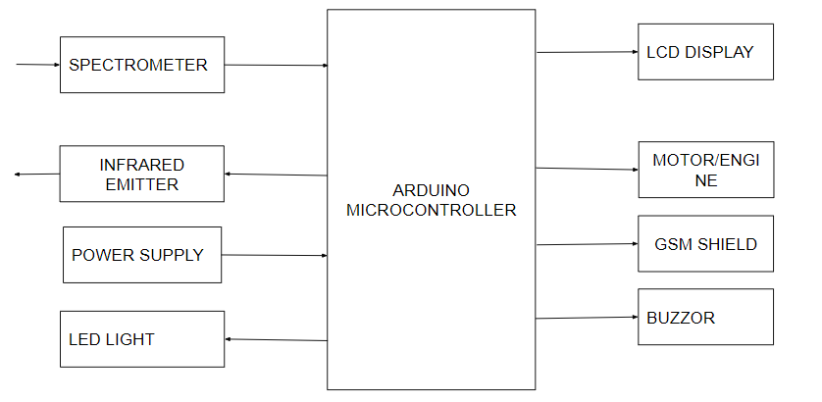

How the modules or components work?

At the center of the system we shall have an Arduino board that will interface various input and output components as well as central processing. Below are the components that will be attached to the Arduino board;

● Spark Fun Triad Spectroscopy Sensor - AS7265x (Qwiic)

● Infrared LED emitter to up to 1400nm

● GSM module

● LCD display

● Infrared Emitter

● Power Supply

● LED Conductor

● Buzzer

● Motor

With the required components attached to the Arduino board, the user shall power the system on. Then the infrared emitter shall emit an incident infra-red light of a known wave length to the human skin, (or alcohol solution of `a known percentage).

Using the chemistry (theoretic principles) involved as we shall clearly explain it at the end, some of the incident light is absorbed, and the rest is reflected back to our spectrometer (sensor) that will then measure it and triggers a corresponding voltage that will be picked out by the micro-controller for analysis.

The more concentrated the solution is with alcohol, the more it absorbs infrared and the less infrared reflected.

With this fact, the calibrated system shall be able to tell how much ethanol is contained in a solution or skin using the reflected intensity picked by the sensor.

Then if the amount is beyond the allowed amount, the Arduino code shall;

* disable the car engine system
* light the LED conductor with red
* make a buzzer beep for 1 minute
* and command the GSM module to forward an SMS to the phone number that is attached to the car’s owner.

The system shall assume the owner of the vehicle cannot drive it while drunk, so it will always notify them by SMS on how drunk their driver or themselves are or were by the time of measurement.

## 3.2 Decomposition Description

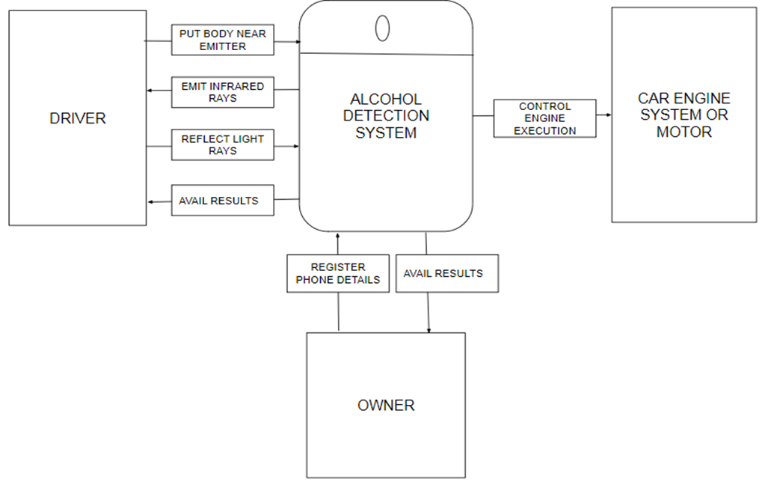

level 0 data flow diagram

From the above figure, the system emits infra-red rays to the body of the driver that is placed close to the emitter. Then the driver’s body with reflect light rays towards the system for further processing. The driver entity is also availed with the processed results from the system.

The system captures the car owner’s phone number which will be used to avail to him or her the results that are processed by the system. The system also controls the execution of the engine or the motor.

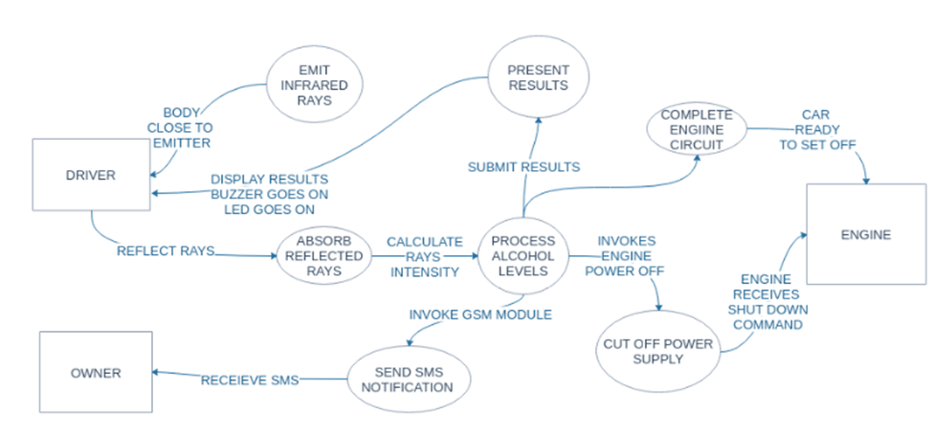

level 1 data flow diagram

The above figure shows a variety of processes that will be performed by the system which entail the presentation of results, emission of infra-red rays, absorption of reflected rays, SMS notification, and the processing of the alcohol levels.

The figure also shows the available entities that interact with the system which include the driver, owner, and the car engine system.

Also the reflected infrared rays play a major role in the system since they are used to determine the alcohol levels which determine further actions undertaken with regard to all the entities.

# 4. DATA DESIGN

## 4.1 Data Description

In this project, we shall mainly hold and receive data from the user while the system application is running. There will be no database for storing the data that is collected from the users of the system.

The data will be volatile implying that it will only be stored temporarily in memory only to be used to execute the specified functions.

The data will take different forms depending on different stages of processing within the system which include;

* From the driver to the spectrometer.
* From the spectrometer to the other system components.

## 4.2 Data Dictionary

* From the driver to the spectrometer.

Description

Rays from the emitter towards the human body are reflected back to the spectrometer which is responsible for calculating the intensity of the reflected light as to be converted into numerical values per given scale.

At this stage, the data is in form of light rays (infra-red) which are reflected by the human body. The reflected light rays depending on the alcohol content in the human body will produce different wave length, and henceforth the speed.

* From the spectrometer to the other entities.

At this stage, data is transformed into numerical values, which are used for further computations and hence different functions will be executed depending on the set conditions.

As for the GSM module, the phone number of the user/owner will be hard coded or stored by a variable in the software program.

# 5. COMPONENT DESIGN

The system consists of various processes that will be implemented and these will consist of the following;

**Infra-red Emission.**

* The System is triggered active as soon as power is supplied to the micro controller.
* The micro controller commands the emitter to emit an infra-red flash light towards the human skin or ethanol solution.
* The spectrometer senses and captures the partly reflect infra-red rays from the skin surface or ethanol solution surface then converts the analog signal to a digital signal voltage.
* The Spectrometer the forwards the converted digital voltage signal to the micro controller for analysis.

**Ethanol Measurement**

* The microcontroller stores the digital voltage signal for processing.
* The microcontroller then converts the digital voltage into a percentage on the scale of 0-940 nm.
* If the percentage is above 39%.
* Then a high alcohol content is detected in the human body
* Else a low alcohol content is detected in the human body.

**Communication process**

* If a high alcohol content is detected
  + Then the microcontroller sends the detected ethanol values to the LCD display a message on the screen.
  + Then the microcontroller directs the buzzer to beep for a period of 60 seconds
  + Then the microcontroller directs the led conductor to emit red light
* Else the microcontroller directs the buzzer to beep once.
  + Then the microcontroller directs the led conductor to emit green light.
  + Then the microcontroller invokes the GSM module.

The messaging process involves the following;

* Create a local variable to track the connection status. You'll use this to keep the sketch from starting until the SIM is connected to the network.
* Connect to the network by calling gsmAccess.begin(). It takes the SIM card's PIN as an argument. By placing this inside a while() loop, you can continually check the status of the connection. When the modem does connect, gsmAccess() will return GSM_READY. Use this as a flag to set the unconnected variable to true or false. Once connected, the remainder of setup will run.
* Finish setup with some information to the serial monitor.
* Create a function named readSerial of type int. You'll use this to iterate through input from the serial monitor, storing the number you wish to send an SMS to, and the message you'll be sending. It should accept a char array as an argument.
* Create a variable to count through the items in the serial buffer, and start a while loop that will continually execute.
* As long as there is serial information available, read the data into a variable named inChar.
* If the character being read is a newline, terminate the array, clear the serial buffer and exit the function.
* If the incoming character is an ASCII character other than a newline or carriage return, add it to the array and increment the index. Close up the while loops and the function.
* In loop, create a char array named remoteNumber to hold the number you wish to send an SMS to. Invoke the readSerial function you just created, and pass remoteNumber as the argument. When readSerial executes, it will populate remoteNumber with the number you wish to send the message to.
* Create a new char array named txtMsg. This will hold the content of your SMS. Pass txtMsg to readSerial to populate the array.
* Call sms.beginSMS() and pass it remoteNumber to start sending the message, sms.print() to send the message, and sms.endSMS() to complete the process. Print out some diagnostic information and close the loop

**Engine or motor control management**

* If a high alcohol content is detected by the system on the first try.
* Then the microcontroller commands the motor to shut down by stopping the supply of power to it.
* Else the microcontroller directs the motor or the car engine to run or continue execution.
* If the motor is already running and a high alcohol content is detected by the system
* Then power supply to the motor will be shut down.
* If the motor is already running and a low alcohol content is detected by the system
* Then the execution of the motor will be done.

# 6. HUMAN INTERFACE DESIGN

## 6.1 Overview of User Interface

The user will place their finger over the LED emitter.

Once the level of alcohol is detected, the user will view results on the LCD display.

If the user’s level of alcohol is acceptable, the LCD display shows you have passed the alcohol detection procedure. Have a safe journey then the motor will be started.

For users who have an unacceptable level of alcohol, the LCD display shows Sorry! You can’t drive in this state and then the buzzer will go off and an SMS which will be received on their phone.

## 6.2 Screen Images

**User Alcohol Level Acceptable**

On successful detection and acceptable level detected, the above message is displayed.

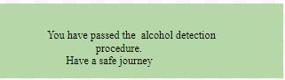

**User Alcohol Level Unacceptable**

When the alcohol level detected is beyond that accepted, the user will be view the message below.

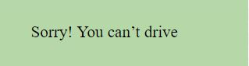

**SMS Notification**

The user will receive such an SMS regarding the test results.



## 6.3 Screen Objects and Actions

The You have passed the alcohol detection procedure message on the LCD will only display if level of alcohol detected is below the accepted limit. The user therefore has to place their finger close to the infrared emitter for the following message to be displayed.

The decline to drive screen will be displayed when the level detected on the user are unacceptable. The user will be shown a message prompting him or her to not bother attempting to drive.

# 7. Requirements Matrix

|  |  |  |
| --- | --- | --- |
| **FUNCTIONAL REQUIREMENTS** | **SYSTEM COMPONENT** | **SRS SECTION** |
| User Registration | GSM Shield | 4.1 |
| Infrared Emission | Infrared emitter | 4.2 |
| Alcohol Level Detection | Spectroscopy | 4.3 |
| Car Engine Management | Arduino board | 4.4 |
| User Notification | GSM Sheild | 4.5 |