**SOFTWARE DESIGN DOCUMENT**

**BSE 20-33**

**NON-DISPERSIVE INFRARED**

**ETHANOL DETECTOR SYSTEM**

**GROUP MEMBERS**

|  |  |  |  |
| --- | --- | --- | --- |
| **NAME** | **REG NO.** | **STUDENT NO.** | **SIGNATURE** |
| KEEYA EMMANUEL LUBOWA | 16/U/5843/EVE | 216006992 |  |
| GAVOOLA JUMA | 16/U/4817/EVE | 216012520 |  |
| YIGA MARK GABRIEL | 16/U/12433/EVE | 216006690 |  |
| CHRISTOPHER MWAKA NWANG | 16/U/20001/EVE | 216021559 |  |

Date: (02/11/2020)

Table of Contents

1. INTRODUCTION 3

1.1 Purpose 3

1.2 Scope 3

1.3 Overview 4

Reference material 5

Definitions and acronyms 5

2. SYSTEM OVERVIEW 6

3. SYSTEM ARCHITECTURE 7

3.1 Architectural Design 7

3.2 Decomposition Description 8

4. DATA DESIGN 9

4.1 Data Description 9

4.2 Data Dictionary 10

5. COMPONENT DESIGN 11

6. HUMAN INTERFACE DESIGN 12

6.1 Overview of User Interface 12

6.2 Screen Images 12

6.3 Screen Objects and Actions 13

7. Requirements Matrix 14

# 1. INTRODUCTION

## 1.1 Purpose

This design document describes the architecture and system design of the Non-Dispersive InfraRed Ethanol Detection (NDIRED) system. It is a living document that shall evolve throughout the architecting and design of the NDIRED.

The goal of this document is to cover the high-level system architecture and detailed design of the NDIRED. The document is divided into three major parts: system architecture, software design, and the external interfaces. The system architecture includes views from various perspectives, the software design details the main software and hardware components that constitute and support the system architecture, and the external interfaces show and describe how the user will interact with the system.

The design documentation will enable stakeholders to understand the system architecture and detailed design of NDIRED system. It will also be needed by the testing team to confirm whether the requirements specified are met in the architecture and design of the system. Below is a summary of the development team to whom the design document will be of use.

NDIRED Developers: To understand the architecture and flow of the design in order to build the system.

NDIRED Maintenance team: To understand the external and internal components and structure of the system in order to make changes to the system in accordance to the changing user demands and needs.

NDIRED Testing team: To enable them keep track of the requirements from specification to implementation of the system. This will be achieved by comparing the requirements specifications to the design specification and the design specification to the implementation.

NDIRED Users: To improve on their productivity while using the system on a daily basis

## 1.2 Scope

The scope of this project covers the architecting and design of all the components of the NDIRED system that will be used in detection of ethanol. The major components of the system include spectrometer sensor, Arduino output(display).

This document is for the base level system which will work as a proof of concept for the use of building a system that provides a base level of functionality to show feasibility for large scale production use.

Our project is meant to benefit society by reducing on the number accidents that are as result of drunk driving. On the other hand, this project is meant to make the process of alcohol detection in drivers non-inconveniencing, since as opposed to the old system, we shall not have to use invasive methods for example blowing into a machine, which not only is unhygienic but also requires one’s lung capacity to be fully sufficient in order to raise correct results.

Our project’s objectives include non-invasive alcohol detection using Near Infra-red radiation, elimination of the inconveniences and healthy issues that the old methods Our system shall also be able to notify authorities who will keep track of those attempting to drunk drive.

## 1.3 Overview

This software design document is divided into eight sections in order to provide a completely understable perception of the NDIRED system.

The first section of the document is concerned with the importance of this document while highlighting different stakeholders that will benefit from it.

In the second section, a system overview giving a general description of the NDIRED including the functionality and matters related to the overall system and design are provided. The intended goal, objectives and benefits of the project are also stated in this section

The third section is the most important section of this document which has the overall system architecture consisting of the following: Architectural design that provides a modular program structure and explains the relationships between the modules to achieve the complete functionality of the system, Decomposition description provides a decomposition of the subsystems in the architectural design including critical issues and trade/offs that were considered.

The fourth section is concerned with the data design that provides a data description explaining how the information domain of the NDIRED system will be transformed into the data structures. It also describes how the major data or system entities will be stored, processed and organized as well as listing the database and data storage items. This section also provides a data dictionary that alphabetically lists the system entities or major data along with their types and descriptions. It also lists all the functions function parameters, objects and its attributes, methods and method parameters.

The fifth section describes the component design of each component of the NDIRED system. It provides an explanation what each component does in a more systematic way by providing a summary of the algorithm for each function listed in description language (PDL) or pseudo-code.

The sixth section is concerned with the human interface design that include the following: Overview of User Interface that describes the functionality of the system from the user’s perspective as well as explaining how the user will be able to use the NDIRED system to complete all the expected features and the feedback information that will be displayed for the user, images that display interface of the user’s perspective, images of the system’s components.

The seventh section gives Requirement matrix provides a cross reference that traces components and data structures to the requirements SRS document. A tabular format is used to show which system components satisfy each of the functional requirements from the SRS.

## Reference material

[1].<https://learn.sparkfun.com/tutorials/spectral-triad-as7265x-hookup->guide?_ga=2.223929563.1189608745.1604910649-1219398962.1604910649

[2]. <https://cdn.sparkfun.com/assets/learn_tutorials/8/3/0/AS7265x_Datasheet.pdf>

[3]. <https://github.com/sparkfun/Qwiic_Spectral_Sensor_AS7265X>

[4]. <https://github.com/sparkfun/SparkFun_AS7265x_Arduino_Library>

## Definitions and acronyms

Upper case words refer to abbreviations. For more information on a topic, read the relevant section within the body of this document.

|  |  |
| --- | --- |
| **NDIRED** | Non-Dispersive InfraRed Ethanol Detector |
| **API** | Application Programming Interface |
| **OS** | Operating System |
| **LED** | Light Emitting Diode |
| **LCD** | Liquid Crystal Display |
| **DC** | Direct Current |
| **V** | Voltage |
| **IC** | Integrate Circuit |

# 2. SYSTEM OVERVIEW

For many decades now, the world has been relying on invasive techniques when checking or trying to detect alcohol in the human blood system, these techniques require one’s body fluid such as blood, urine, sweat or breath for available devices to calculate the amount of ethanol (alcohol) in them and then deem it dangerous for conducting life risking activities like driving.

The problem with these techniques is, they are not only inconveniencing (in terms of producing body fluid or breath for analysis) but also are unhealthy, time consuming and the most common one (breathalyzer) requires one to have a sufficient lung capacity in order to yield correct results.

Our new system is meant to solve or improve on all these challenges that come with the old available techniques.

One of the primary benefits of this system over the legacy techniques is its ability to detect alcohol in the human body without need for a body fluid, thus creating convenience and making it highly portable as well as yielding effective results in blink of an eye.

This new system is going to use Near Infrared Spectroscopy as the underlying technology

The new Alcohol(ethanol) detecting system will provide the following capabilities:

* Non-invasively detect ethanol in the human dermal layer of the skin.
* Display results detected to the user (target individual)
* Notifies higher authorities by SMS

# 3. SYSTEM ARCHITECTURE

## 3.1 Architectural Design

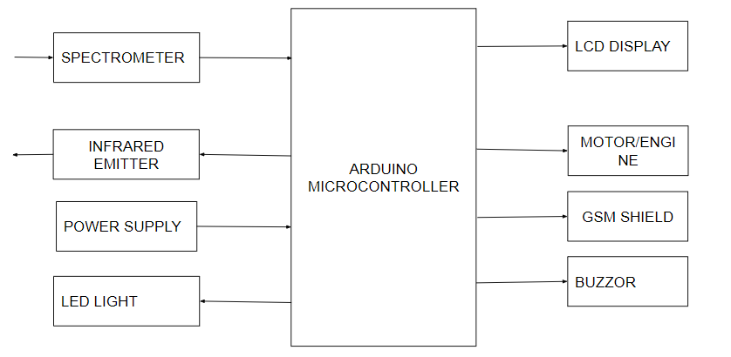

Figure 1 Architectural Diagram

How the modules or components work?

At the center of the system we shall have an Arduino board that will interface various input and output components as well as central processing. Below are the components that will be attached to the Arduino board;

● Spark Fun Triad Spectroscopy Sensor - AS7265x (Qwiic)

● GSM module

● LCD display

● Infrared Emitter

● Power Supply

● LED Conductor

● Buzzer

With the required components attached to the Arduino board, the user shall power the system on. Then the infrared emitter shall emit an incident infra-red light of a known wave length to the human skin, (or alcohol solution of `a known percentage).

Using the chemistry (theoretic principles) involved as we shall clearly explain it at the end, some of the incident light is absorbed, and the rest is reflected back to our spectrometer (sensor) that will then measure it and triggers a corresponding voltage that will be picked out by the micro-controller for analysis.

The more concentrated the solution is with alcohol, the more it absorbs infrared and the less infrared reflected.

With this fact, the calibrated system shall be able to tell how much ethanol is contained in a solution or skin using the reflected intensity picked by the sensor.

Then if the amount is beyond the allowed amount, the Arduino code shall;

* light the LED conductor with red
* make a buzzer beep continuously
* and command the GSM module to forward an SMS to the phone number that was hardcoded as the authority’s number.

The system shall assume the target individual is drunk, so it will always notify them by SMS on how drunk their they are or were by the time of measurement.

## 3.2 Decomposition Description

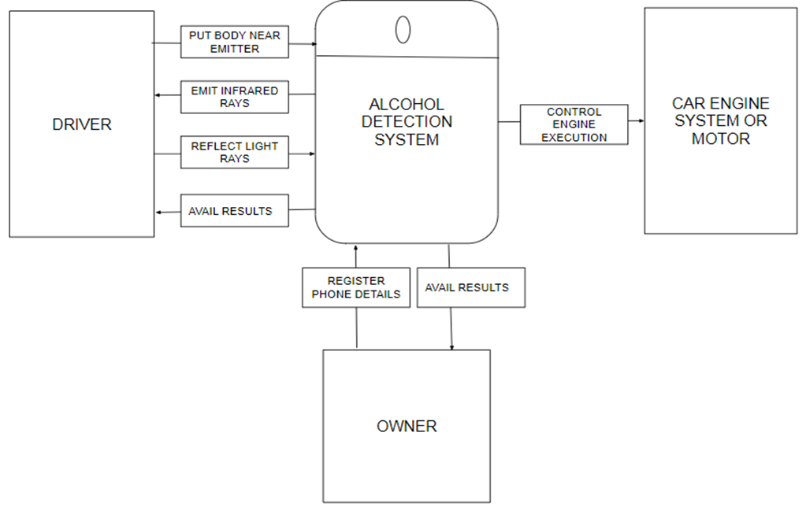

**Target subject**

Figure 2: Decomposition diagram

From the above figure, the system emits infra-red rays to the body of the driver that is placed close to the emitter. Then the driver’s body with reflect light rays towards the system for further processing. The driver entity is also availed with the processed results from the system.

The system captures the car owner’s phone number which will be used to avail to him or her the results that are processed by the system. The system also controls the execution of the engine or the motor.

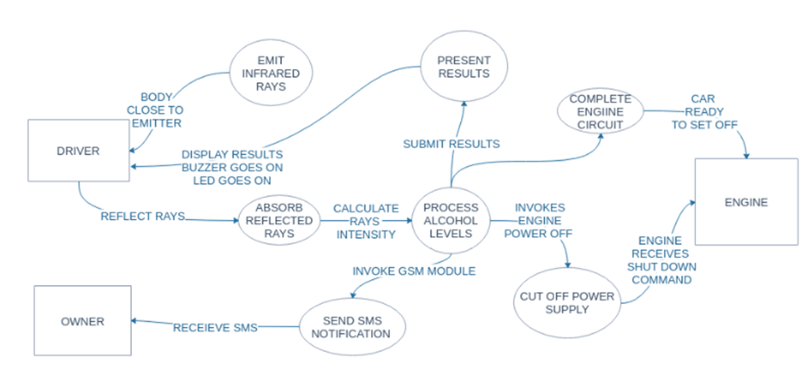

Figure 3: level 1 data flow diagram

The above figure shows a variety of processes that will be performed by the system which entail the presentation of results, emission of infra-red rays, absorption of reflected rays, SMS notification, and the processing of the alcohol levels.

The figure also shows the available entities that interact with the system which include the driver, owner, and the car engine system.

Also, the reflected infrared rays play a major role in the system since they are used to determine the alcohol levels which determine further actions undertaken with regard to all the entities.

# 4. DATA DESIGN

## 4.1 Data Description

In this project, we shall mainly hold and receive data from the user while the system application is running. There will be no database for storing the data that is collected from the users of the system.

The data will be volatile implying that it will only be stored temporarily in memory only to be used to execute the specified functions.

The data will take different forms depending on different stages of processing within the system which include;

* From the target individual to the spectrometer.
* From the spectrometer to the other system components.

## 4.2 Data Dictionary

**Description**

Rays from the emitter towards the human body are reflected back to the spectrometer which is responsible for calculating the intensity of the reflected light as to be converted into numerical values per given scale.

At this stage, the data is in form of light rays (infra-red) which are reflected by the human body. The reflected light rays depending on the alcohol content in the human body will produce different wave length, and henceforth the speed.

At this stage, data is transformed into numerical values, which are used for further computations and hence different functions will be executed depending on the set conditions.

As for the GSM module, the phone number of the user/owner will be hard coded or stored by a variable in the software program.

# 5. COMPONENT DESIGN

The system consists of various processes that will be implemented and these will consist of the following;

**Infra-red Emission.**

* The System is triggered active as soon as power is supplied to the micro controller.
* The micro controller commands the emitter to emit an infra-red flash light towards the human skin or ethanol solution.
* The spectrometer senses and captures the partly reflect infra-red rays from the skin surface or ethanol solution surface then converts the analog signal to a digital signal voltage.
* The Spectrometer the forwards the converted digital voltage signal to the micro controller for analysis.

**Ethanol Measurement**

* The microcontroller stores the digital voltage signal for processing.
* The microcontroller then converts the digital voltage into a percentage on the scale of 0-940 nm.
* If the percentage is above 39%.
* Then a high alcohol content is detected in the human body
* Else a low alcohol content is detected in the human body.

**Communication process**

* If a high alcohol content is detected
  + Then the microcontroller sends the detected ethanol values to the LCD display a message on the screen.
  + Then the microcontroller directs the buzzer to beep for a period of 60 seconds
  + Then the microcontroller directs the led conductor to emit red light
* Else the microcontroller directs the buzzer to beep once.
  + Then the microcontroller directs the led conductor to emit green light.
  + Then the microcontroller invokes the GSM module.

The messaging process involves the following;

* Create a local variable to track the connection status. You'll use this to keep the sketch from starting until the SIM is connected to the network.
* Connect to the network by calling ***gsmAccess.begin().*** It takes the SIM card's PIN as an argument. By placing this inside a ***while()*** loop, you can continually check the status of the connection. When the modem does connect, ***gsmAccess()***will return **GSM_READY**. Use this as a flag to set the unconnected variable to true or false. Once connected, the remainder of setup will run.
* Finish setup with some information to the serial monitor.
* Create a function named ***readSerial*** of type int. You'll use this to iterate through input from the serial monitor, storing the number you wish to send an SMS to, and the message you'll be sending. It should accept a char array as an argument.
* Create a variable to count through the items in the serial buffer, and start a while loop that will continually execute.
* As long as there is serial information available, read the data into a variable named ***inChar***.
* If the character being read is a newline, terminate the array, clear the serial buffer and exit the function.
* If the incoming character is an ASCII character other than a newline or carriage return, add it to the array and increment the index. Close up the while loops and the function.
* In loop, create a char array named ***remoteNumber*** to hold the number you wish to send an SMS to. Invoke the ***readSerial*** function you just created, and pass ***remoteNumber*** as the argument. When ***readSerial*** executes, it will populate ***remoteNumber*** with the number you wish to send the message to.
* Create a new char array named ***txtMsg***. This will hold the content of your SMS. Pass ***txtMsg*** to ***readSerial*** to populate the array.
* Call ***sms.beginSMS()*** and pass it ***remoteNumber*** to start sending the message, ***sms.print()*** to send the message, and ***sms.endSMS()*** to complete the process. Print out some diagnostic information and close the loop

# 6. HUMAN INTERFACE DESIGN

## 6.1 Overview of User Interface

The user will place their finger over the LED emitter.

Once the level of alcohol is detected, the user will view results on the LCD display.

If the user’s level of alcohol is acceptable, the LCD display shows you have passed the alcohol detection procedure. Have a safe journey then the motor will be started.

For users who have an unacceptable level of alcohol, the LCD display shows Sorry! You can’t drive in this state and then the buzzer will go off and an SMS which will be received on their phone.

## 6.2 Screen Images

**User Alcohol Level Acceptable**

On a negative measurement of ethanol, the LCD displays a message similar to the one in the image below



Figure 4:LCD display output for a negative test

**User Alcohol Level Unacceptable**

When the alcohol level detected is beyond that accepted, the user will be viewing the message below.



Figure 5:LCD display for viewing a positive test

**SMS Notification**

The user will receive such an SMS regarding the test results.

## 6.3 Screen Objects and Actions

The You have passed the alcohol detection procedure message on the LCD will only display if level of alcohol detected is below the accepted limit. The user therefore has to place their finger close to the infrared emitter for the following message to be displayed.

The decline to drive screen will be displayed when the level detected on the user are unacceptable. The user will be shown a message prompting him or her to not bother attempting to drive.

# 7. Requirements Matrix

|  |  |  |
| --- | --- | --- |
| **FUNCTIONAL REQUIREMENTS** | **SYSTEM COMPONENT** | **SRS SECTION** |
| User Registration | GSM Shield | 4.1 |
| Infrared Emission | Infrared emitter | 4.2 |
| Alcohol Level Detection | Spectroscopy | 4.3 |
| Car Engine Management | Arduino board | 4.4 |
| User Notification | GSM Sheild | 4.5 |