k_f = 1e5; d_f = 2e2;

k_i = 0 k_t = 1e3; d_t = 5e1;

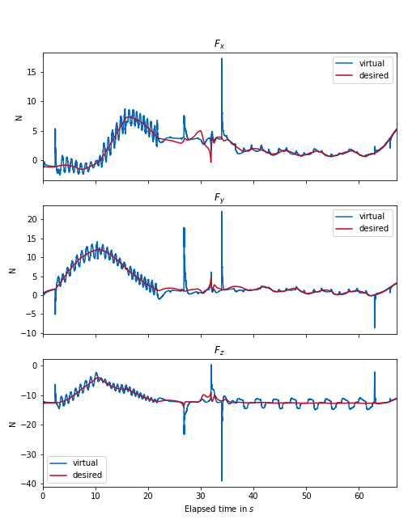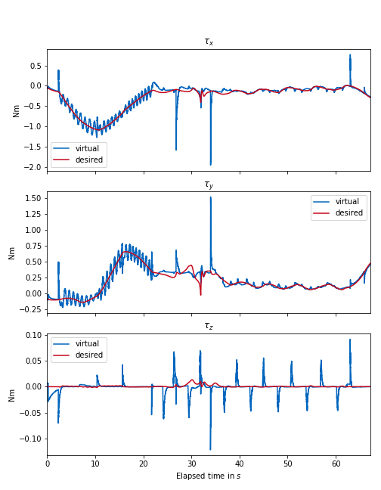

double k_t_z = 1e3;

double d_t_z = 5e1;

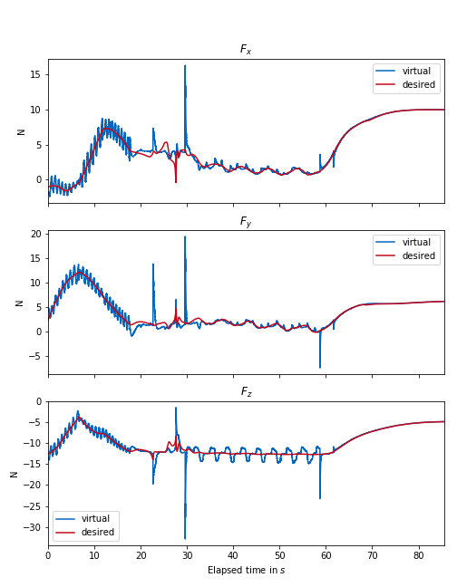k_f = 5e4; d_f = 3000; k_i = 0 k_t = 5e2; d_t = 50;

