1. Introduction
Introduction: póki co szkic. Może zawierać błędy z racji skrótów myślowych.
TBD poprawić w weekend

JTAG standards as part of market development
Before writing about the revolution of JTAG standards, it should be mentioned how the technology of testing has changed during two last decades. The most important factor that has influenced testing was miniaturization of integrated circuit. Most of the old methods either enabled exclusively optical inspection of the device under test or relied only on physical connection with tested I/O ports by probes. Obviously, their usability has sharply decreased when tested circuit dimensions have become so small that it was impossible to establish a physical connection between the circuit ports and the testing environment. Testing multi-layer boards seemed very cumbersome. Furthermore, this technological mismatch caused a risk that at some point minimization would be stopped because of no sufficient testing method. //referencje
To overcome abovementioned connectivity problems, JTAG group was formed. Its main goal was to create a standard of board level testing that would be versatile, independent from tested circuit specie and provide a way to test a circuit with a reduced-pin separate interface. First JTAG standard became popular due to its simplicity and scalability(???). According to IEEE standard of JTAG, it required XXX registers to maintain its full functionality.
JTAG interfaces are nowadays included in most of integrated circuits. They are used in everyday work to test interconnections between devices, debug embedded software applications, identify unknown circuits as well as program their non-volatile memories. Obviously, JTAG interfaces are constantly improved to satisfy the customers' needs. All currently available JTAG standards and their applications are shortly described in Table XX. It should be mentioned that all the standards are compatible with the basic 1149.1 standard.
Table XX. Brief description of JTAG standards.
Standard name | Year of introduction | Introduced functionalities
IEEE 1149.1 | 1990 | Device identification, boundary scan testing
IEEE 1149.4 | 2000 | Support for analog pins
IEEE 1149.6 | 2003 | Support for differential pin pairs
IEEE 1532 | 2012 | Support for System-on-Chip architecture
All the JTAG standards are constantly improved. The oldest 1149.1 standard was upgraded twice: in 2001 and 2013 [SOURCE].

Points of the thesis
There are two main points of this thesis. The first one concerns the theoretical research and the second one concerns software implementation.
- Theoretical research: prove that JTAG standards have been changing according to market needs and are that they are still improved;
- Software implementation: implement a functional JTAG interface, basing on information present in IEEE standards.

Result of the theoretical research is included in chapters 2 and 3 which describe evolvment of JTAG standards and their applications. Functionalities introduced in 1149.1 JTAG standard are described in chapter 4. Chapters 5 and 6 include details of JTAG interface implementation in chosen FPGA devices.

2. Design For Testability
This chapter presents general idea of so-called Design for Testability. IEEE standards regarding testing are also explained. Moreover, most common methods of PCB optical and functional testing paradigms are shortly described.

2.1 Testing in production engineering

In modern electronics, testing has become a crucial issue of every production line. Detecting potential faults during manufacturing may save a lot of effort and reduce overall production costs, according to the Pay more now and pay less later rule. Good test should give an unequivocal answer whether the design works properly and what kind of error (stuck at 1, stuck at 0, short or bridge [Wil]) was detected. Two main attributes of testing are: [DFT]

- Controlability – ability to control the tested unit in order to set the desired input sequence;
- Observability – ability to observe unit's output signals in order to gather the output data.

Many approaches to measuring controlability and observability of a given design are currently in use. The most popular one is the Sandia Controllability Observability Analysis Program method, also known as SCOAP. This method uses integers to describe difficulty of controlling and observing internal nodes of a system. The higher the number, the harder it is to observe the considered node. Moreover, good testing environment should be universal and fast enough to test many components at once. In an ideal situation all the nodes are controllable. In reality, there are various methods of testing, concerning both optical inspection of the devices under tests, functional testing of already manufactured boards as well as in-circuit testing. It should be emphasized that none of this methods is 100% self-sufficient – usually two of more testing methods are used in the manufacturing process.

PCB inspection is used for two general uses. Naturally, the most important one is capturing the manufacturing defects, so that they can be eliminated or corrected before next stage of a production process. The earlier defects are found, the smaller is later cost of fixing detects present in the design. The second use is to provide process feedback into the manufacturing process, so that faults of patterns or machines may be found. As a result, correction of related processes should be made to stop or reduce pattern faults. Typical PCB production process flow diagram with process feedback is shown on Fig.XX.

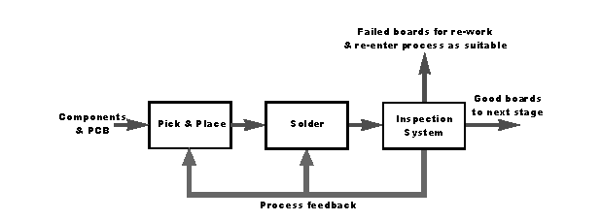
Fig.XX Manufactured PCB production process flow diagram. Process feedback is performed between each of the production stages. Source: [Ra2]

2.2 Optical methods of PCB testing

Many optical methods relying of taking snapshots of PCB components are used to test quality of manufacturing and assembling the boards, basing on optical inspection. Naturally, these methods range is very wide, ranging from a simple visual recognition to complex optical inspection conducted by machines. Three most popular optical inspection methods are AOI (Automated Optical Inspection), AVI (Automated Vision Inspection) and AXI (Automated X-ray Inspection). Comparison of capability of AXI and AOI defect detection possibilities is shown in Tab.XX. Capabilities of In-Circuit Testing, which is described in next chapters, is also presented as a reference.

Tab.XX Comparison of major defect detection capabilities of AXI, AOI and ICT. Source: [Rad]
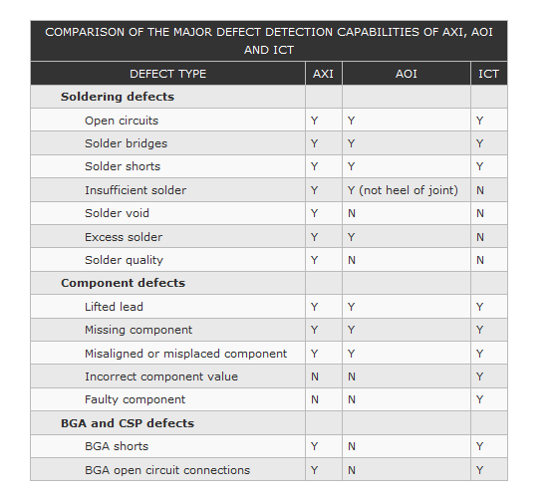

AOI testing functionalities

AOI systems were introduced to the industrial marked in mid 90's and they remain very popular, especially regarding SMT technology production lines. The main purpose of AOI optical inspection is a fully automated visual inspection of the board during manufacturing process. Obviously, each AOI system contains a camera with autonomous light system and a set of lens that scans the surface of the device under test. Obtained picture is then processed by using template matching or pattern matching techniques to detect its structural errors. Even though it is the general board structure that is put under inspection, there exist various AOI systems specialized in i.e.inspecting solder paste quality or only the placement of components. Inspection is performed in an early stage of manufacturing, therefore disfunctional elements are not passed to next production processes. After performing etching and stripping of the tested PCB board, visual scanning is made, eventual structural efects are detected. AOI machines are capable of finding and identifying all the defects. There is a possibility to perform oxide replacement or scrubbing after AOI inspection to correct detected defects. Modern AOI software enables on-the-fly inspection at a speed of 200 cm²/sec connected with high-speed image acquisition and additional statistical modeling algorithms [Cyb]. AOI software is capable of deciding whether the detected defect is critical or non-critical. Example of structural defects marked as critical and non-critical is shown on Fig.XX.
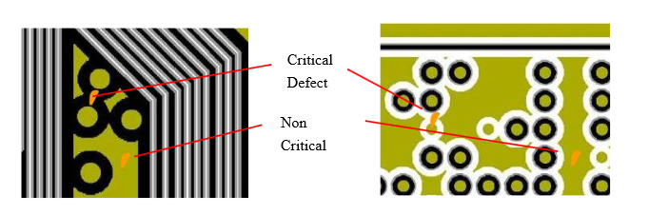
Fig.XX Critical and non-critical defects of a single PCB identified by AOI. Source: [IPC]

AVI testing functionalities

AVI stands for Automated Visual Inspection performed on a final PCB product. It is the last inspection process, hence it is also known as final vision inspection. AVI is used to obtain faster and more accurate result that simple optical inspection made with human eyes. The most required feature of the AVI machines is intelligent color analysis that can distinguish different layers of the final PCB. Example final board layers that need to be distinguished are presented on Fig.XX.
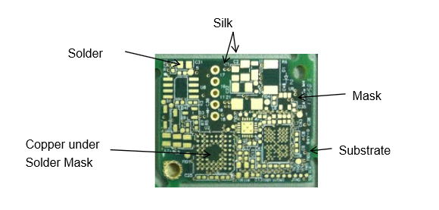

Fig.XX Different layers of final PCB that need to be distinguished by AVI. Source: [IPC]
AXI testing functionalities

Automated X-ray inspection is a technology similar to AOI. The main difference is the wavelength of light used as source – obviously, AXI uses X-rays instead of visible light. This allows to automatically inspect features that would be hidden from human eyes. AXI became popular in conjunction to Ball Grid Array, CSP or Flip Chip package chips whose pins are located right under the chip. Moreover, internal view of solder joints is also possible by using AXI – information about solder thickness, joint size or profile can be easily obtained.

2.3 In-circuit testing functionalities
The main purpose of in-circuit testing is to gain access to specified circuit nodes located on the board and then measure performance of some specified components, no matter which other components are connected to them. Test results were easy to interpret because response of each component was known. Before Boundary Scan Test was introduced, the most popular ICT testing method was based on a so-called „bed-of-nails” technique. It was mainly used to test for manufacturing defects, not to test the functionality of the tested device. Structure of a simplified bed-of-nails test is shown on Fig. XX.
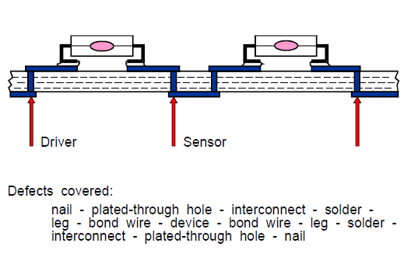
Fig. XX Structure of a „bed-of-nails” test and covered defects. Source: [AsT]

This method made use of a structure containing bed-of-nails that accessed chosen tested devices by a direct connection with the copper signal path or a contact point. Physical access to all of the tested devices was a must. Testing was then divided into two phases. These phases were called power-off and power-on tests:

- Power-off tests: tests that verified connection between nails and the access points of the board. If power-off tests were passed, power-on tests could be started.
- Power-on tests: tests that applied some known input data to individual device located on a board by the driver pin and then measured the response coming from the device under test by using the sensor pin. All the other devices connected to the tested device must have been driven into a safe state.

This technique became obsolete when dimensions of a single printed circuit board decreased to the point where it was impossible to gain physical access to a single component. Step by step, it was replaced by a boundary scan architecture that didn't require physical access to a tested device.

2.4 Functional testing
Functional testing is a general term that involves all the tests that examine the function of a circuit. There are various approaches to functional testing various types of circuits, tester category or their various functionalities. The most popular approach is Functional Automated Test Equipment that means large functional automatic test equipment in a specially designed console. Large digital boards are tested this way.
Special test programs need to be written or automatically generated. They need to contain test conditions and a control test sequence with strict timing restrictions.

2.5 Design for Testability
Design for Testability (DFT) is a method of circuit design that enhances the design with special testing functionalities and enables forming test scan chains out of units under test (UUTs). In every unit, an additional piece of hardware is required to perform nothing but tests.

Testing according to the DFT guidelines provides a response vector which is later being compared with a response vector coming from a properly functioning device. As a result, it is possible to both define and locate faults within the tested unit. Obviously, test vectors must be chosen carefully to provide a full diagnostic functionality. Apart from ad hoc testing by using test points within the design, two main methods are used: scan chains and built-in scan tests. It is possible to mix DFT-compliant functionalities together i.e. as presented in [Dat]. The most popular methods are described below.

2.6 Built-in Scan Test
It is possible to implement a simple and quick DFT-compliant internal test which is used by an unit to test itself. Such mechanism is called a Built-in Scan Test (BIST) and its functional diagram is shown on Fig. XX.
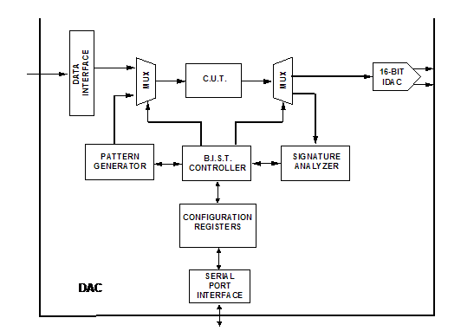

Fig. XX Example functional diagram of a built-in scan test. Source: [Ana]

Three main functional blocks may be distinguished as presented in [Cec]:

- Pattern generator that uses a stored or pseudo-random pattern;
- Signature analyzer that stores unit's response;
- BIST controller that activates the test and analyzes the response.

As a result, the unit itself may decide whether it works properly. Such test may be programmable, or involve testing memories used in the design [Ncu]. It may also run automatically when powering up the device as so-called Power On Self Test (POST).

2.7 Scan-chain Test
Scan-chain testing is a sequential DFT-compliant technique that allows to test many daisy-chained ICs simultaneously as presented on Fig. XX. It is widely used in testing electronic components. There are even approaches to tailor this technique to test 3D integrated circuits [Cse]. Naturally, more than one scan chain may be put under test at once.

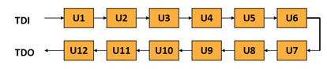
Fig. XX Scan-chained units under test. Source: [Cre]

In Scan-chain test, testing path leads through all the tested components. Automatic Test Pattern Generator (ATPG) is used to generate an input sequence which is being shifted in to a special test input of the first component. Output sequence is shifted out on a special test output of the last one. Special pin that triggers the test and clock signal are also required. Such transmission must be synchronous to gather a proper output vector.

The main application of a scan chain is a Boundary Scan Path present in IEEE 1149.1 standard described in chapter XXX.

2.8 DFx testing method
In a modern approach to testing, number of methods that can be used to debug or verify circuits is large. As a result, one must test all of the functionalities and production processes to ensure that system works properly. Innovative Design for Testability must take into account much more aspects of testing [TEF], including:

- Circuit debugging that supports internal access to logical registers and allows to trace their values, as well as detect badly processed data. This part is known as Design for Debugging (DFD);
- Circuit manufacturing that verifies whether board was correctly and thoroughly manufactured. This part is known as Design for Manufacturing (DFM). It is getting more and more important alongside the decreasing size and increasing complexity of modern printed circuit boards;
- Verification of circuits' reliability known as Design for Reliability (DFR).

A versatile, interdisciplinary approach that merges all of abovementioned aspects is known as DFx. The name suggests that x is a variable that can be replaced by the last letter standing for every single process that is put under test. Obviously, DFx is an ambiguous term that does not concern only circuit testing. It may even be interpreted as organization culture or a tool of continuous improvement [AMA]. Modern IEEE standards such as P1687 (also known as Instrument JTAG) make use of the DFx approach in their lifecycle. Different DFx steps that require usage of IJTAG are shown on Fig.XX. P1687 standard is separately described in chapter 3 of the thesis.
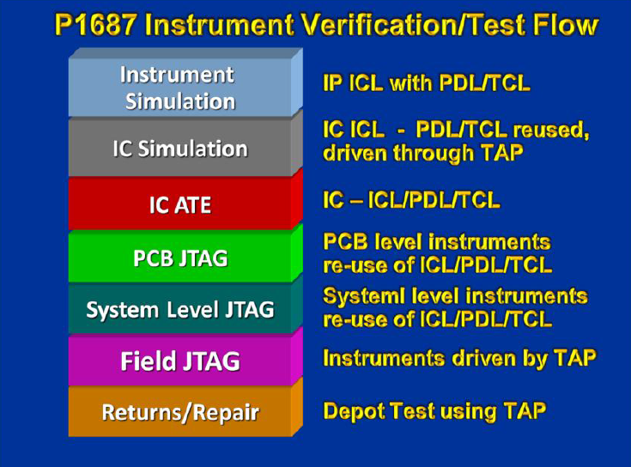
Fig.XX Test flow of P1687 JTAG standard showing different steps of testing. Source: [IJT]

3. IEEE standards regarding scan test

To meet the market requirements, IEEE standards regarding testing are still developed. In this chapter, IEEE standards regarding boundary scan tests will be presented and described in brief. The main standard will be further explained in next chapter

3.1 Role of the JTAG group
JTAG is an abbreviation of a Joint Test Action Group (previously the Joint European Test Action Group). It was formed in middle 80s by a group of engineers from various companies that decided to form an universal standard regarding debugging and testing electrical components. The first result was the IEEE 1149.1 standard commonly known as JTAG introduced in 1990.
JTAG is a special serial interface added to a chip that consists of four or five pins. In order to test many electrical component, they require to be daisy-chained, unless several scan chains are used. The main point of the JTAG norm was board-level testing of both components and their interconnection. This is done by using a 5-pin or 4-pin interface connected to the Test Access Port that controls the data flow. Standard JTAG architecture is shown in Fig. XX.

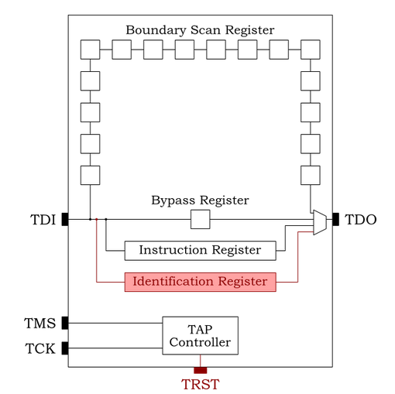
Fig. XX Standard JTAG architecture introduced in IEEE 1149.1. Source: [Embe]

Nowadays, its application range includes debugging embedded systems that uses JTAG as a communication interface. There is also a possibility to use JTAG to write software and data into NOR and NAND Flash memory.

3.2 JTAG-related IEEE standards
The main JTAG standard has been extended into various related standards regarding tests of some specific components. The main standards derived from IEEE 1149.1 are: IEEE 1149.4, IEEE 1149.6, IEEE 1149.7 and IEEE 1150. Each of these standards doesn't replace JTAG, but supplies it with some specific functionality, depending of what kind of integrated circuits is to be tested.
Notwithstanding the main standards, IEEE groups are currently working on new ones such as IEEE P1687 or SJTAG that present an utterly different approach to boundary scan testing. These standards are strongly bound to the DFx paradigm of testing described in chapter 2.

IEEE 1149.4 standard
The 1149.4 standard was introduced in order to enable measuring analog components placed on printed circuit boards. General block diagram of the 1149.4 standard is shown in Fig. XX.

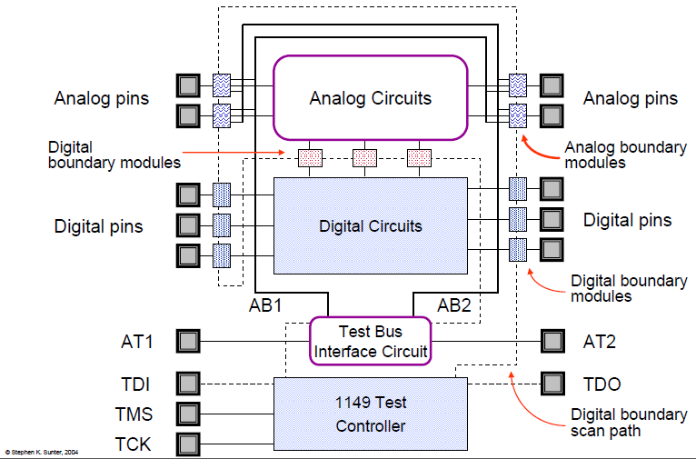
Fig. XX Block diagram of a mixed-signal IEEE 1149.4 structure. Source: [Sun]

In this standard, additional analog pins are handled: two extra pins, AT1 and AT2, are added to the interface. Generally, AT1 pin is stated to be used as a stimulus, whereas AT2 pin is used to capture response of a circuit. These pins act independently from other four/five TAP pins. They may be connected to parallel low-frequency analog test buses as well as to the analog pins of the tested integrated circuits. One design may contain various analog test buses for different frequency ranges or accepted voltage levels.

IEEE 1149.6 standard
IEEE 1149.6 standard is a boundary scan standard prepared for advanced digital networks and devices making use of low-voltage differential signaling (LVDS). The general functionality enhancement is shown in Fig.XX.
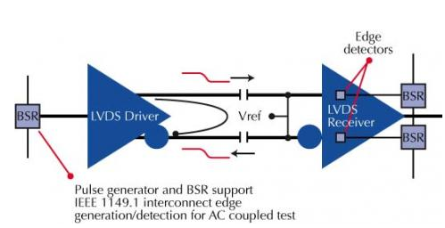

Fig.XX LVDS support introduced in IEEE 1149.6. Source: [Jta]

It was developed to test AC-coupled signals which are denoted by placing a coupling capacitor between driver and receiver as shown on Fig. XX. In such circuit, signal passing through the capacitor decays over time. This extension wasn't considered in the basic IEEE 1149.1 functionality. A new instruction called AC-EXTEST is added to the instruction register to send and save data pulses. Any fault may be identified by analysing the pulse response of the tested device.
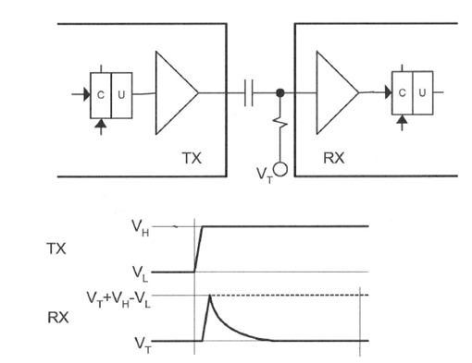

Fig.XX Coupling capacitor placed between driver and receiver. Source: [Agi]

This standard is also enriched with possibility of using AC test pattern generator.

IEEE 1149.7 standard
IEEE 1149.7 (aka Compact JTAG or cJTAG) is a a complementary enhancement of the 1149.1 standard. It is known as standard for reduced pin and enhanced functionality TAP and overall boundary scan architecture. This standard was ratified by IEEE in December 2009. Main differences between IEEE 1149.1 and 1149.7 are shown in Tab. XX.

Tab.XX Main differences between JTAG and cJTAG standards.

Property | IEEE 1149.1 - JTAG | IEEE 1149.7 - cJTAG
Power consumption | Only one ON state. | Four selectable power modes used to reduce power consumption and enable low-power devices
Accessing a specific device | Available only by setting other devices into BYPASS state | Individual device addressing and system-level bypass that shorten the length of a scan chain
Topology | Standard (serial) | Star topology with simplified physical connection of the devices
Number of pins | Four or five: TDI, TDO, TMS, TCK and TRST (optional) | Reduced to two: TMS and TCK

Idea of a chip-level bypass introduced in IEEE 1149.7 is shown in Fig. XX.

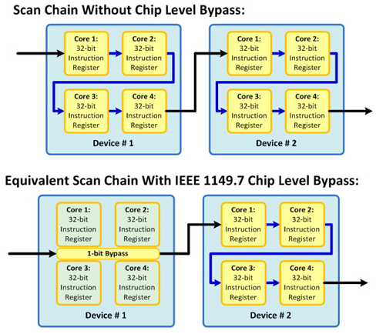

Fig. XX Concept of a scan-level chain with and without bypass. Source: [Cor]

IEEE 1150 standard
IEEE 1150 is a separate JTAG standard derived from IEEE 1149.x standards family. Its application is a bit different- it concerns testing embedded cores with System on Chip (SoC) functionality and their associated circuitry. This standard enriches IEEE 1149.1 with many new, FPGA-specific features. Parallel test access mechanisms (TAM) are introduced. New way of describing units under test is also developed: Boundary Scan Description Language is being replaced by a Core Test Language (CTL) whose main purpose is to faciliate interoperability and cooperation between various entities. General description of the Core Test Language functionality is shown in Fig. XX.

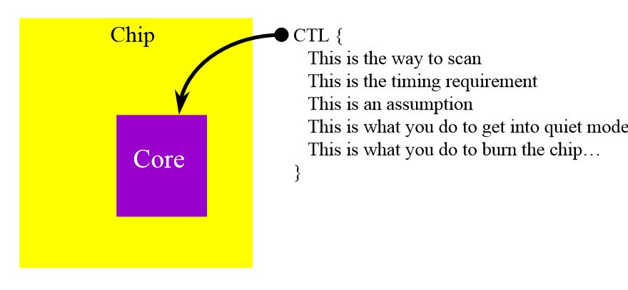
Fig. XX Schematic idea of Core Test Language applications. Source: [Ctl]

This standard is still under development by 1450.6.2 IEEE group.

IEEE 1532 standard
IEEE 1532 standard stands for Boundary-Scan-based In System Configuration (ISC) of Programmable Devices (PLD). The In System Configuration term means that there exists a possibility of programming the specified devices after they have been located on the board. It is already used in some chips by Altera from the MAX family [EET]. This standard introduces a new feature called an „in-system configuration”. This feature enables simultaneous programming of standard-compliant devices mounted on a PCB what would reduce overall programming time. Every such component would be possible to reconfigure, verify or erase its content, despite its vendor and despite its vintage [Spr]. The main purpose of so-called concurrent programming would be to significantly improve programming time efficiency: there would be no need to use special procedures just to reprogram the device. Therefore, IEEE 1532-compliant BSDL files are enhanced with algorithmic information used for automatic configuration of tested devices [Ste]. System state machine has become equipped in 4 new modes, apart from 2 states available in IEEE 1149.1 (System and Test) : Unprogrammed, ISC Accessed, ISC Complete and Operational. 1532 standard system state machine is shown on Fig. XX.

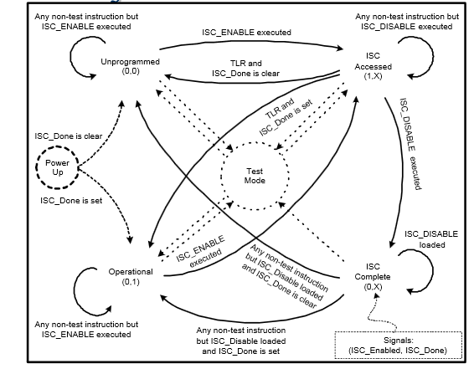
Fig. XX System state machine of the IEEE P1532 standard. Source: [IEP]

Instruction set has been improved with new functionalities. Instead of instructions known from IEEE 1149.1, there are four new ISC_xxx mandatory instructions in Test Access Port (ISC_ENABLE, ISC_PROGRAM, ISC_DISABLE and ISC_NOOP) and many optional ones that support additional access procedures (i.e. ISC_DISCHARGE, ISC_PROGRAM_DONE, ISC_ERASE_DONE, ISC_DATA_SHIFT, ISC_ADDRESS_SHITF etc.). As a result, device behaviour is well-defined before, during and after programming and it is theoretically impossible to induce any unexpected behavior that could damage other mounted components. Security mechanisms are also introduced by a special ISC_PROGRAM_SECURITY mode.

1532 standard introduces various formats and languages may be used to program PLD devices [Isy]:
- Serial Vector Format files acting as an assembly code of a boundary scan and most basic programming file format that is supported by most vendors. It doesn't allow control flow – the only possibility is the straight-line execution of given commands;
- STAPL JEDEC Standard Test & Programming Language based on JAM made by Altera that includes programming data and basic programming algorithm. Used by embedded system programmers;
- 1532 ISC (In System Configuration) data file defined in 1532 standard that includes program data to be matched with BSDL flows. Requires separate data and algorithm using extension to 1149.1 BSDL files and new ISC data format. Control flow is limited.

IEEE P1687 standard
IEEE P1687 standard is also known as Internal JTAG. Its main goal is to replace basic 1149.1 standard by improving its functionality. Migration to P1687 on device that already uses 1149.1 or even 1500 standard is meant to be easy and don't require changes in circuit hardware [TUJ]. Table XX presents comparison of P1687 versus the basic JTAG standard.

Table XX. Key differences between 1149.1 JTAG and IJTAG standards. Source: [IJE]
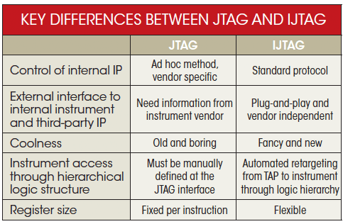
P1687 JTAG uses standard Test Access Port,but a 1500 standard-compliant Wrapper TAP may be also used. This standard introduces a variety of new functionalities, including:
- Testing, access and control of embedded IP cores;
- Possibility of describing connections and interactions between system components by using the Instrument Connectivity Language (ICL). Part of ICL may be an extension of BSDL language;
- Possibility of complex description of I/O ports by using the Procedural Description Language (PDL).

3.3 Vendor-specific programming interfaces
Requirement of 4, 5 or 6 pins was a main bottleneck of the 1149.1 standard, especially for low pin count circuits. If JTAG functionality was limited to a simple Flash programmer interface for a low-cost devices family, implementation of a whole Test Access Port interface was not feasible due to its complexity.

There were two main approaches to overcome this problem:

- Enforcing a new official JTAG expansion for a reduced pin count - companies such as Texas Instruments overcame this problem by introducing a reduced pin count JTAG standard known as IEEE 1149.7 [Chi]. Nowadays, Texas Instruments' cJTAG IP core whose name is an abbreviation of “Compact JTAG” is claimed to be the very first semiconductor solution having the standard fully implemented. Finally, 1149.7's ratification process began in late 2009 and was announced in February 2010. cJTAG was described as “a flexible, dynamic solution for designers and engineers contending with shifting design paradigms without eroding the firm foundation established by earlier standards, such as IEEE 1149.1“ [SIe]. Naturally, 1149.7 standard did not replace 1149.1 in full. Potential risks of such replacement are well described in [IPE].

- Implementing a custom, reduced pin count interface designed from scratch - unlike Texas Instruments, various vendors such as ARM or ST Microelectronics introduced their own JTAG-like protocols with reduced pin count. ARM introduced SWD, whereas Atmel introduced PDI and DebugWIRE for 8-bit processors with limited resources [Mik]. As a result, even Texas Instruments developed its own Spy-Bi-Wire protocol used to program MSP430 devices [MSP]. In most cases, such devices provides support of both 1149.1 JTAG and vendor-specific interfaces with a well-defined procedure of switching between the interfaces.

General structure of a reduced pin count interface

Typically, vendor-specific protocol is a two-wire protocol. The first pin is used as a clock signal and the second pin is a bi-directional data bus with the following generic configuration:

- Pin acts as a transmitter when data are sent to the processor;
- Pin acts as a receiver when acknowledge signals, ID codes or read memory values are sent by the processor.

Example of an interface of Atmel XMEGA AVR devices family that makes use both of a default JTAG and a two-wire vendor-specific interface is shown on Fig.XX.

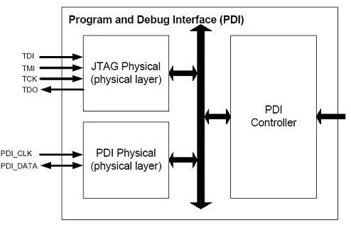

Fig. XX Example interface supporting both JTAG and vendor-specific interface (PDI). Source: [Equ]

Two common vendor-specific interfaces, SWD and PDI, are described below. Description of the SWD interface is based on its implementation in STM32F4 devices family [STM], whereas description of the PDI interface is based on its implementation in AVR1612 [APD].

Description of a SWD programming interface

The name SWD is an abbreviation of “Serial Wire Debug”. This serial interface provides an alternative to a typical 1149.1 JTAG interface in ARM processors family. It was introduced with the Cortex-M family [Cor] and finally specified in [AD5]. Some Cortex-M based MCUs support only SWD interface. Nowadays, cores of ARM processors integrate both Serial Wire and JTAG debug ports. Both interfaces make use of the same I/O pins.

SWD makes use of only two pins used in the JTAG interface: TMS becomes its Serial Wire Data IO (SWDIO) pin and TCK becomes its serial wire clock (SWCK) pin. However, sometimes an additional trace output TRACESWO pin is used to access the Serial Wire Viewer that can be accessed only by SWD. By default, JTAG port is active. To switch from JTAG to SW-DP, a special sequence of bits described in [STM] must be sent on the TMS pin while TCK pin is set active.

SWD interface allows read and write operations on both DPACC and APACC banks of registers. All bits are transmitted LSB-first. Each transaction consists of three phases:

- An 8-bit long packet request is transmitted by the host via SWDIO pin. Packet requests defines operation type (read/write) and registers that are accessed (DPACC or APACC). It also includes an address field of the register and a parity bit.
- Target replies the host with an acknowledge response. SWD uses the same acknowledge values as JTAG-DP (OK and WAIT), but it also introduces a new FAULT acknowledge.
- Target or host transmits 32 bits of write/read data, expanded with an additional single parity bit.

Cortex-M3 family expanded the interface with an auxiliary CoreSight debugger block. This block enables variety of debugging possibilities, such as a Serial Wire Viewer macrocell enabling a real-time data tracing by SWD pins. As a result, the following data become traceable [Epr]:

- Program counter;
- Read/write data cycles;
- I/O port states;
- Variable values;
- Input and output ports of interrupt handling routines;
- Event counters;
- Data about single instruction execution time.

All of the data above may be visualized in Keil Microvision Logic Analyzer[SWV].

Description of a PDI programming interface

The name PDI is an abbreviation of “Program and Debug Interface”. It supports high-speed programming of all species of non-volatile memory and on-chip debugging. As SWD interface, it makes use of two pins. However, an additional VCC/GND connection between the programmer and the device is also required. Mandatory data pins are:

- PDI_CLK: clock input acting as a reset pin;
- PDI_DATA: data input and output pin acting as a test pin.

PDI physical interface is serial and it uses a standard UART frame format as shown on Fig.XX.

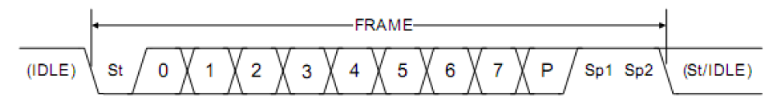

Fig.XX UART frame format used in PDI interface. Source: [APD]

PDI may be either in transmit or receive mode. By default, it is in receive mode in order to wait for a start bit. As in a standard 1149.1 JTAG interface, input data are sampled on a rising edge of PDI_CLK.

PDI must be enabled before it is used. As in SWD interface, a special sequence must be sent on PDI_DATA and PDI_CLK pins. In the case of PDI, switching procedure is much simpler. It consists of setting PDI_DATA high for a period longer than the equivalent external reset minimum pulse width. An additional process is required to get access to non-volatile memories and their controller for programming. User must send a correct 64-bit wide NVM key in the PDI while choosing the KEY instruction. PDI interface is automatically disabled if there is no activity on the PDI_CLK line for approximately 100 μs.

Control of PDI is made by a small set of its own 8-bit long commands. Most of these commands define an operation (load or store data) and applied mode of addressing (indirect or direct). Additional information about address size or pointer access are required when respectively direct or indirect addressing is used. Programming instructions enable a wide range of operations such as chip erase, reading the non-volatile memory, loading/erasing page buffer or loading/erasing application section. CRC value of Flash memory and application section are accessible too. Moreover, even boot loader and calibration sections may be accessed.

Different non-JTAG interfaces

Different vendor-specific programming interfaces are briefly described in Tab.XX.

Tab.XX Different non-JTAG interfaces

Standard name | Pinout | Company | Main features | Applications
DebugWIRE [Deb] | 1 wire with open drain, adjustable baud rate defined as a fraction of a main clock | Atmel | - Serial protocol communication, projected for resources-limited 8-bit microprocessors;  - Commands given in hex. | Debugging, setting breakpoints, reading/writing SRAM, Flash and EEPROM memories
Spy-Bi-Wire  [SBW] | 2 wires: bi-directional data bus and clock signal | Texas Instruments | - Time division multiplexing on a bi-directional data bus;  - Clock signal is divided into groups of three pulses;  - Clock pulses acting as time slots passing current value of TDI, TDO or TMS. | Controlling CPU registers, memory address bus and memory data bus, memory programming and verification.
Background Debug Controller [BDC] | 1 wire used to send commands to the target MCU | Freescale Semiconductors | - Separate command used to select baud rate;  - Two types of breakpoints: tag breakpoints for instruction opcodes and force breakpoints for any address access;  - Nine trigger modes;  - Two subsets of commands: active background commands used when user program is not running and non-intrusive commands executed at any time. | In-circuit programming on-chip non-volatile memories, providing a debug interface and a non-intrusive access to memory
Nexus 5001 [NeS] | Clock signal and two-wire bus, half- or full-duplex communication | Various companies (open industry) | - Wide range of applications depending on compliance class of the device;  - Compliance ranging from 1 (run-time control only) to 4 (advanced features, such as memory substitution)  - Possibility of data tracing; | Real-time debugging, multi-core debugging, SoC debugging

4. IEEE JTAG standard

This chapter describes detailed functionality of the IEEE 1149.1 JTAG standard and its auxiliary mechanisms, such as Instruction/Data registers and Test Access Port. It is fully based on the IEEE 1149.1-2001 standard. Example test patterns and example implementation in STM32F4 Discovery evaluation board are presented, too.

4.1 JTAG test circuitry
In IEEE 1149.1, a special model of test logic was defined. Such model should make use of 4 or 5 I/O signals: input data TDI, output data TDO, clock TCK, test mode select TMS and optional reset TRST. IEEE-compliant model included three crucial components:

- Test Access Port – a logic block allowing to control instruction and data registers by a finite state machine set by the TMS input pin;
- Instruction Register – latched shift register that can be serially loaded with the instruction selecting the performed test;
- Data Register – set of various shift-register based circuits. One of these registers (or even its part) is selected to be linked between TDI and TDO pins, basing on current instruction latched onto the instruction register. Example of a generic data register is shown in Fig. XX.

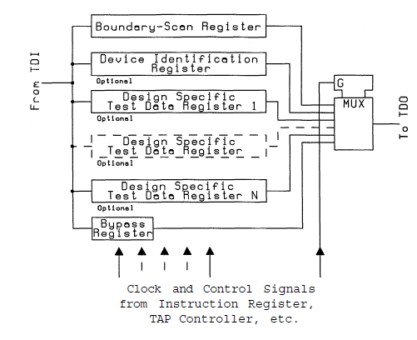
Fig. XX IEEE-compliant test data register. Source: [MAU]

What is important, some TAP actions take place on rising edge of TCK, whereas other actions are performed on its falling edge.

4.2 Boundary Scan Cell
Boundary Scan Cell is a basic memory component of every primary input and output signal. It is used to test the presence, orientation and bonding of devices. Many types of BSCs are supported by the IEEE 1149.1 standard [Goe] :
- Universal cell containing two multiplexers and master/shadow latch that enables input data captures and output data update operations;
- Capture-only cell with one multiplexer and master latch;
- Update-only cell with one multiplexer, master latch and shadow latch that supports only stimulation;
- Cell with output track sampling;
- Tri-state ousput cell;
- Bi-directional cells with direction control and additional possibility to control either input or output data;
- Internal cell without its physical pin used for internal measurements or simulations.
The most popular architecture of a Boundary Scan Cell is presented on Fig. XX.

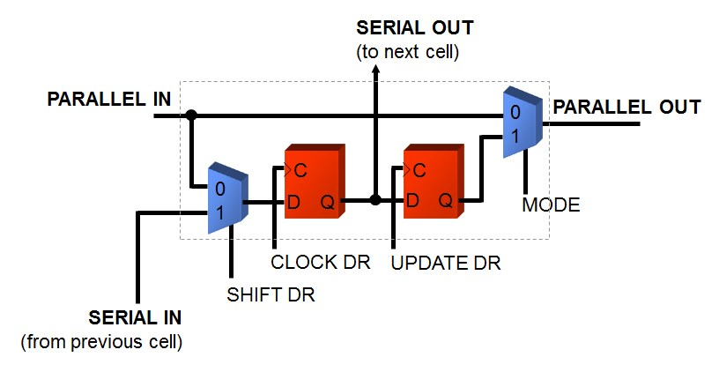
Fig. XX Basic structure of a Boundary Scan Cell. Source: [Goe]

Each Boundary Scan Cell must meet the following requirements:
- Capture data on its parallel input;
- Update data onto its parallel output;
- Shift serially data from its serial output to a neighbor's input;
- Behave transparently if MODE value is set to 0. That means that parallel input passes all the data to the parallel output;
- Do not intercept normal passing of application data from parallel input to parallel output during testing.

During the normal mode of work, parallel input acts as a data input and it passes all the data to the parallel output (which is a normal data output). During the so-called update mode, value from the CLOCKDR register is shifted out to the parallel output. During the capture mode of work, input data signal is redirected to the sift register and then captured by the CLOCKDR register. During shift mode, output value of the CLOCKDR register is passed as an input value to the adjacent connected Boundary Scan Cell.

4.3 Test Access Port
The main task of the Test Access Port is to define which operation is actually performed. It includes a TMS pin-driven finite state machine which allows to control both instruction and data registers. All possible states and transitions between them are presented in Fig.XX.

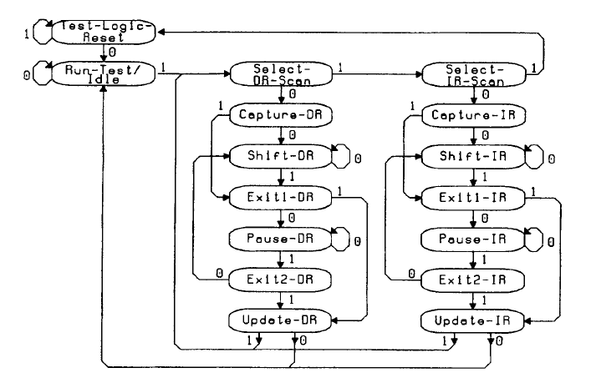

Fig. XX Test Access Port controller state diagram. Transitions between adjacent states depend on the value of the TMS signal. Source: [IEE].

Remarkably, all the IR-marked states concern instruction register operations, while all DR-marked states concern data register operations. Due to control faciliating, both registers-related state transitions are symmetric. All the transitions should take place on a rising edge of TCK, whereas test logic actions may occur either on rising or falling edge of TCK.

The most important states are Reset, Shift and Update states – other states may be considered temporary, i.e.the Pause state is used only to halt temporarily the shifting process. Exact role of each TAP state is described in Tab. XX.

Tab.XX Description of Test Access Port states.

State | Role | Remarks
Test-Logic Reset | Test Access Port reset state | Achievable by setting the TRST pin or within 5 clock cycles by passing from any other state when TRST is not used.
Run-Test/Idle | Test Access Port Idle state
Select-XX-Scan | Selects whether next state will regard Instruction or Data Registers
Capture | Test data bits are loaded parallelly
Shift | Shifts bits serially from TDI to TDO
Exit1 | Exit from Capture or Shift state | Lasts for 1 clock cycle
Pause | Halts current operation
Exit2 | Exit from Pause state | Lasts for 1 clock cycle
Update | Updates shadow registers with values from either data or instruction register

4.4 Example JTAG in STM32F4 Discovery evaluation board
In STM32F4 Discovery evaluation board, implemented 1149.1 JTAG model is identical with general model used in Cortex-M4 family of processors. Its complex debug extension allows to examine both the state of the core and external system state, provided that the core is stopped. This architecture supports two different modes of debugging: serial wire debugging and JTAG debug port [MAN]. By default, JTAG debug port is the active mode – switching to serial wire debugging requires sending a special bit sequence on the TMS pin.

When JTAG debug port is chosen as active mode, two separate Test Access Ports can be distinguished: Boundary Scan TAP and Cortex-M4 TAP. Connection between both ports is shown in Fig. XX.

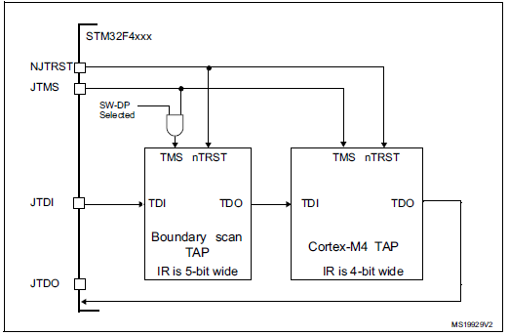
Fig. XX JTAG TAP connection in STM32. Source: [MAN]

Boundary scan TAP and Cortex-M4 TAP are daisy-chained, so that output of boundary scan TAP becomes input of Cortex-M4 TAP. Their instruction registers vary in length, what allows to bypass them separately. The connection between test access ports must be taken into account during testing: if one of the test access ports is set as bypass, it adds one extra bit to the output data. Reset (NJRST) and test mode select (JTMS pin) are common for both test access ports.

Cortex-M4 JTAG debug port instructions

Cortex-M4 JTAG debug port enables two aforementioned basic instructions: BYPASS and IDCODE, as well as instructions concerning boundary scan tesing. However, JTAG in Cortex-M4 is also enhanced with the following custom instructions:

- DPACC instruction – instruction initiating a debug port and allowing access to a debug port register. Bidirectional data transfer is possible – data can be written or read.
- APACC instruction – instruction initializing access port and allowing access to an access port register. Again, bidirectional data transfer is possible. Moreover, several additional operations may be requested, i.e. System or debug power-up or reading status flags.
- ABORT – instruction generating an abort when its least significant bit is set (all other bits of this instruction are reserved).

4.5 Boundary Scan Description Language
Boundary Scan Description Language (BSDL) is a standard and universal modeling language designed for boundary-scan devices that describes all the boundary scan features of a device under test. It also defines the data flow characteristics of the device, including register lengths and instruction codes. Syntax of BSDL is based on a subset of VHDL, even though BSDL itself is not used for hardware description. It has been developed since the first JTAG 1149.1 standard was introduced. Full definition of BSDL is included in IEEE 1149.1-2001 JTAG standard. Each BSDL file consists of the following modules:

- Entity declaration identifying the name of the device (represented as a single string);
- Generic parameter specifying which package is currently described;
- Port description of device's pinout. All the pins are divided into generic power pins, ground pins, I/O pins marked as inout bits, JTAG ports where TCK, TMS, TDI and TRST are marked as input bits, whereas TDO is marked as an output bit. Power and ground pins are marked as linkage what makes them unavailable for boundary scan operations;
- "Use" statement declaring which of the JTAG standard packages is currently used. If required, there is a possibility to define cells different than standard cell type package and create custom package files [XJT];
- Netlist with pin mapping that must reveal how the device pads are connected with external pins;
- TAP ports description providing additional information about JTAG pins, such as clock frequency of TCK;
- Instructions and register access description providing information about length of instruction register and opcodes of all the supported instructions. Sometimes various instructions are not publicly defined and therefore marked as INSTRUCTION_PRIVATE or RESERVED. Values of USERCODE and IDCODE registers are also provided in this section. Programmable bits are marked as X;
- Boundary scan cell information providing data about length of boundary scan chain and all the boundary scan cells included;
- Additional design warnings and revision history.

Next releases of BSDL were introduced with each revision of standards 1149.4, 1149.6 and 1532. Each time BSDL was expanded with functionalities related to the appropriate standard. Nowadays, BSDL files may be used even in particular software JTAG emulators[SDI].

5. Implementation of JTAG interface

This chapter includes description of implementation tasks performed for the thesis. The following JTAG and SWD interfaces were implemented:
- 1149.1 JTAG Test Access Port;
- Communication via 1149.1 interface with selected microprocessors and FPGA devices;
- Communication via SWD protocol with STM32F4 Discovery and reverse engineering of SWD packets.
Whole VHDL implementation of each interface is shown in Appendix.

5.1 Design assumptions
The main purposes of implementation tasks was to make use of a knowledge about JTAG standards. Furthermore, they were implemented to proof that JTAG communication is simple in handling and that standards are independent from applied hardware. Therefore, project was paralelly developped and launched on various devices (STM32, Spartan 3E Evaluation Board, DE2-115 Evaluation Board and DE0-Nano Evaluation Board) and various IDEs (Xilinx ISE and Quartus 13.1).
1149.1 JTAG Test Access Port was implemented particularly to be used in future testbenches. It gave precised information about device's current TAP state. As a result, verification of TAP sequences was simplified and didn't require tracking of the whole TMS sequence.
Communication via JTAG and SWD interfaces allowed to verify theoretical information included in chapters XXX and YYY. Moreover, it enabled comparison of timing and complexity of both protocols.

5.2 Implementation of 1149.1-compliant Test Access Port
In the first step, Test Access Port emulator was implemented, basing on [Iee]. The main purpose of creating the VHDL version of emulator was to obtain a self-standing and transparent TAP device that could be connected to the project and act as a real TAP controller. As a result, identifying all the errors and latches present in the actual project would be simplified and some kind of a functional testing could be applied.
The implemented solution consists of two main functional blocks placed in separate entities:

* TAP - the Test Access Port entity that includes TAP-specific signals used to drive the Instruction/Data register entity. It also includes the IEEE 1149.1-based TAP state machine;
* JTAGIDRegister – the Instruction and Data register entity that includes aforementioned registers and a rudimentary mechanisms used to recognize shifted instruction and update it as well as choose the appropriate data register located between TDI and TDO.

TAP and JTAGIDRegister entities are shown on snippet 1.1:

entity TAP is
port(
TMS: in std_logic; --mode select: sampled at rising edge of TCK to determine the next state
TCK: in std_logic; --synchronizes intenal state machine operators
TRST: in std_logic;
--output signals
CLOCKIR: out std_logic;
UPDATEIR: out std_logic;
SHIFTIR: out std_logic;
TRESET: out std_logic;
TSELECT: out std_logic; --TSELECT: SELECT is a reserved name!
ENABLE: out std_logic;
SHIFTDR: out std_logic;
UPDATEDR: out std_logic;
CLOCKDR: out std_logic;
--optional signals used to set some values
CAPTUREDR: out std_logic;
CAPTUREIR: out std_logic
);
end TAP;

entity JTAGIDRegister is
port(
--serial input/output
TDI : in std_logic;
TDO : out std_logic;
TCK : in std_logic; --required for events occuring @ falling edge of TCK. Me thinks.
TRST : in std_logic; --asynchronous reset
-- instruction register:
SHIFTIR : in std_logic;
CLOCKIR : in std_logic;
UPDATEIR : in std_logic;
TRESET : in std_logic; --reset from TAP (@ falling edge of TCK in Reset state)
--data register:
SHIFTDR : in std_logic;
CLOCKDR : in std_logic;
UPDATEDR : in std_logic;
--optional signals used to set some values
CAPTUREDR : in std_logic;
CAPTUREIR : in std_logic
);
end JTAGIDRegister;

Snippet 1.1 TAP and JTAGIDRegister entities

For educational purposes, version with boundary scan cells was implemented as well, even though it wasn't used in further applications. Boundary scan cells were created as self-standingVDL entities.

A special testbench was implemented in ISim in order to test the functionality of the emulator. The main purpose of this testbench was to reproduce TAP's waveforms present in [Iee, p. XXXX], further considered as a reference pictures. Emulator was considered passed if the same given input sequence of the JTAG pins gave the same output signals sequence and the same states transition as in the reference pictures. Comparison of final results versus the reference is shown on Fig. XX.
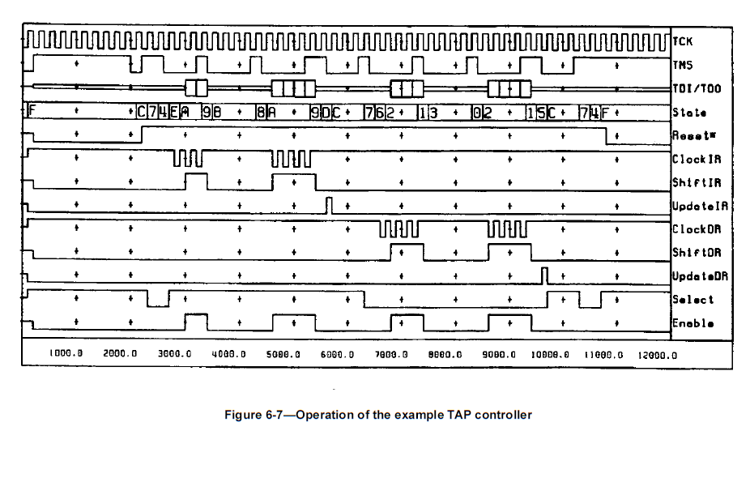

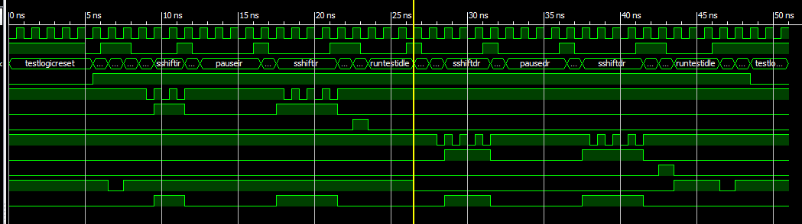
Fig.XX Reference picture from [IEE] vs. Waveform obtained in Isim

Basing on the testbench results, it was stated that TAP controller emulator enables the same set of functionalities as the original TAP controller.

5.3 Implementation of communication via JTAG interface
A separate project was created in order to implement a simple communication with STM32F4 Discovery evaluation board via JTAG interface. The main part of the project was a state machine consisting of 3 states with the following transitions as shown on Fig. XX:

RESET
RUN
DATAREG

Trigger
ON

Last bit shifted
(TMS)
Max prescaler
value

Fig. XX JTAG communication state machine

- Reset – default idle state entered after asynchronous reset. After the trigger sequence, system goes into Run mode;
- Run – mode in which TMS and TDI values are changed in order to reach the SHIFTIR state, load the proper instruction and then proceed to the SHIFTDR state. Once shifting the last bit into TMS and reaching the maximum value of a clock prescaler, system goes into DataReg mode and TMS value is changed to 0;
- DataReg – mode in which a specified data register is placed between TDI and TDO ports. User can send a custom sequence of TDI values by using a separate knob or button placed on the evaluation board and observe the behavior of the TDO port value on a LED or by using SignalTap.

In the first test, BYPASS instruction was shifted into instruction register of both Cortex-M4 and STM32F4's boundary scan register. In that case, TDO value was just a TDI value delayed by 1 clock cycle. As a result, user could control TDI value by a knob and watch TDO value on a chosen LED diode.

In the second test, IDCODE instructions of Cortex-M4 processor and STM32F4 Discovery's debug port were shifted out. Both instructions were shifted separately – if one component's instruction was read, the second component remained successfully in BYPASS mode. TDO value was supervised in Quartus 13.0's SignalTap. Exact waveforms are shown on Fig. XX and Fig. XX.

(SKOPIUJ Z MAILA)

Fig.XX IDCODE value of STM32F4's debug port shifted out on TDO

Fig.XX IDCODE value of Cortex-M4 shifted out on TDO

Both obtained id values were identical with IDCODE values for these components, according to [Stm, p.1670 -Cortex M4 and 1667 – JTAG debug port]. Therefore, communication with STM32F4 Discovery board was considered successful.

The same project was used to communicate with Digilent's Spartan-3E board. Board's scan chain is presented on Fig.XX. JTAG parameters of each component of the scan chain are presented in Table XX.

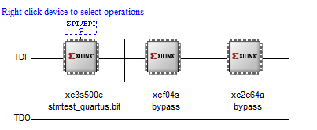
Fig. XX Scan chain of Digilent's SPARTAN 3E board as shown in iMPACT programmer

Table XX. JTAG parameters of Digilent's Spartan-3E evaluation board scan chain components.
WYPEŁNIJ
Component name | Instruction register length [bits] | IDCODE operation code | IDCODE value
XC3S500E
XCF04S
XC2C64A

IDCODE value of each component of the scan chain was shifted out and then compared from the values taken from appropriate BSDL files. Parameters summary is presented in Tab.XX. When shifting out IDCODE value of one of the components, all other components were put into BYPASS state, so that only one IDCODE was shifted at time. Naturally, BYPASS instruction code was all-ones and it depended on instruction register size of a particular circuit.

Final conclusions

REFERENCES
[Wil] http://www.wiley.com/legacy/wileychi/mblin/supp/student/LN16DesignforTestability.pdf
[DFT] http://www.asic.co.in/ppt/DFTnew.pdf
[Ra2] http://www.radio-electronics.com/info/t_and_m/ate/electronics-pcb-inspection.php
[Rad] http://www.radio-electronics.com/info/t_and_m/ate/automated-x-ray-inspection-pcb-bga.php
[Cyb] http://www.cyberoptics.com/automated-optical-inspection-index.php
[IPC] http://www.ipcoutlook.org/pdf/analysis_aoi_avi_ipc.pdf
[AsT] Asset Co., Boundary Scan Tutorial.
[Dat]http://www.dateconference.com/proceedings/PAPERS/1998/DATE98/PDFFILES/03D_3.PDF
[Ana] http://www.analog.com/library/analogDialogue/archives/42-02/bist.html
[Cec] http://web.cecs.pdx.edu/~ecex75/pdf/BIST_Tut1.pdf
[Cse]http://www.cse.psu.edu/~yuanxie/Papers/ICCD2007-3D.pdf
[TEF] Al Crouch, The Evolution and Future of DFx in Modern ICS, Future FAV International, Design Implementation & Process Integration, Issue 24;
[AMA] Martin Tarr, The DfX Concept, materials for a course „Design Issues in Electronics”, University of Bolton;
[Cre] http://www.corelis.com/education/Tips_DFT_Considerations_Boundary_Scan_Chain.htm
[Ncu] http://www.ee.ncu.edu.tw/~jfli/memtest/lecture/ch04.pdf
[Cor] http://www.corelis.com/whitepapers/Major-Benefits-of-IEEE-1149.7.pdf
[Sun] http://grouper.ieee.org/groups/1149/4/Sunter_1149.4_Tutorial.pdf
[Agi] http://www.home.agilent.com/en/pd-1730771-pn-E1196A/ieee-11496-boundary-scan?&cc=PL&lc=eng
[Jta] http://www.jtag.com/en/content/ieee-11496
[IJT] CJ Clark, Bill Tuthill, Introduction to IEEE P1687/IJTAG, IJTAG/P1687 Tutorial NATW 2010, Intellitech Corp;
[Embe] http://www.embecosm.com/appnotes/ean5/html/ch02s01s02.html
[Ctl] http://grouper.ieee.org/groups/1500/itc00/ctl.pdf
[Goe] http://www.goepel.com/en/jtag-boundary-scan/ieee-11491-tutorial/part-3.html
[EET] http://www.eetimes.com/document.asp?doc_id=1128318
[Spr] http://link.springer.com/chapter/10.1007%2F978-1-4615-0367-5_9#page-2
[TUJ] Martin Keim, Welcome to IJTAG: a no-risk path to IEEE P1687, Mentor Graphics, July 11, 2012;
[IJE] Martin Keim, What’s The Difference Between JTAG (IEEE 1149.1) And IJTAG (IEEE P1687)?, Electronic Design, May 16, 2012;
[Chi] http://chipdesignmag.com/display.php?articleId=2668
[SIe] https://standards.ieee.org/news/2010/1149.7.html
[IPE]http://blogs.ip-extreme.com/2010/03/myth-busted-ieee-11497-does-not-replace-ieee-11491.html
[MIK] http://www.mikrocontroller.net/articles/DebugWIRE
[MSP] Texas Instruments, MSP430™ Programming Via the JTAG Interface:User's Guide, SLAU320M
[Equ] http://www.equinox-tech.com/products/details.asp?ID=1429
[Cor] http://www.support.code-red-tech.com/CodeRedWiki/HardwareDebugConnections
[AD5] ARM Debug Interface v5
[STM] STM32xx manual
[Epr] Paweł Adamczyk, Serial Wire Viewer:„Śledzenie” ARM-ów w realu, Elektronika Praktyczna 2/2009, s.124-127.
[SWV] Robert Boys, Serial Wire Viewer (SWV) for ARM Cortex-M3 Processors ARM Real-Time Trace aids debugging, Version 2.1, ARM, Ltd.
[APD] AVR1612: PDI programming driver
[Deb] http://www.ruemohr.org/docs/debugwire.html
[SBW] SLAU320M, MSP430™ Programming Via the JTAG Interface, Texas Instruments, July 2010- revised February 2014.
[BDC] HCS08RMv1/D, HCS08 Family Reference Manual, Freescale Semiconductors, May 2007,Rev. 2.
[NeS] Hugh O'Keeffe, IEEE-ISTO 5001™-1999, The Nexus 5001 Forum™ Standard providing the Gateway to the Embedded Systems of the Future, Version 1.1, Ashling Microsystems Ltd.
[Ste] http://www.dateconference.com/proceedings/PAPERS/2004/DATE04/PDFFILES/09C.PDF
[Isy] Neil G. Jacobson, The In-system configuration handbook:A designer's guide to ISC, 2004, Springer;
[IEP] http://grouper.ieee.org/groups/1532/p1532.PDF
[MAU] (co to było :P)
[IEE] (norma IEEE 1149.1)
[XJT] http://www.xjtag.com/app-note-3.php
[SDI] http://www.spectrumdigital.com/product_info.php?cPath=22&products_id=207

