INSTITUTIONAL TRADING ACADEMY
English Foundation Handbook
Missions 01-20 | Build v0.3

Education only. Trading and leveraged products involve substantial risk. No lesson, example, exercise, or AI interaction is a promise of profit or personalized financial advice.

How to Use This Handbook
- Read the objective before the lesson.
- Describe observations before interpretations.
- Complete the practice exercise before reading answers.
- Record uncertainty and missing information.
- Do not advance to strategy until you can verify the instrument, data, session, and risk conditions.

Mission Map
- L00-M01 - Why Markets Exist
- L00-M02 - Investing, Trading, Speculation, and Gambling
- L00-M03 - Who Participates in Markets?
- L00-M04 - Exchanges, Brokers, Clearing, and Settlement
- L00-M05 - Bid, Ask, and the Last Traded Price
- L00-M06 - The Bid-Ask Spread and Liquidity
- L00-M07 - Market Orders: Execution First
- L00-M08 - Limit Orders: Price First
- L00-M09 - Stop and Stop-Limit Orders
- L00-M10 - Risk, Leverage, and Survival
- L01-M01 - Candlesticks and OHLC: What One Bar Actually Says
- L01-M02 - Timeframes and Multi-Timeframe Context
- L01-M03 - Trading Sessions, Opens, and Market Overlap
- L01-M04 - Volatility and ATR: Measuring Movement, Not Direction
- L01-M05 - Gaps, Repricing, and the Market Open
- L01-M06 - Stocks, ETFs, Futures, Forex, and CFDs
- L01-M07 - Chart Platforms, Brokers, and Data Feeds
- L01-M08 - Real-Time, Delayed, and Historical Data
- L01-M09 - Economic Calendars, Scheduled Risk, and News
- L01-M10 - Foundation Assessment: Read the Market Screen

L00-M01 - Why Markets Exist
Estimated time: 15 minutes
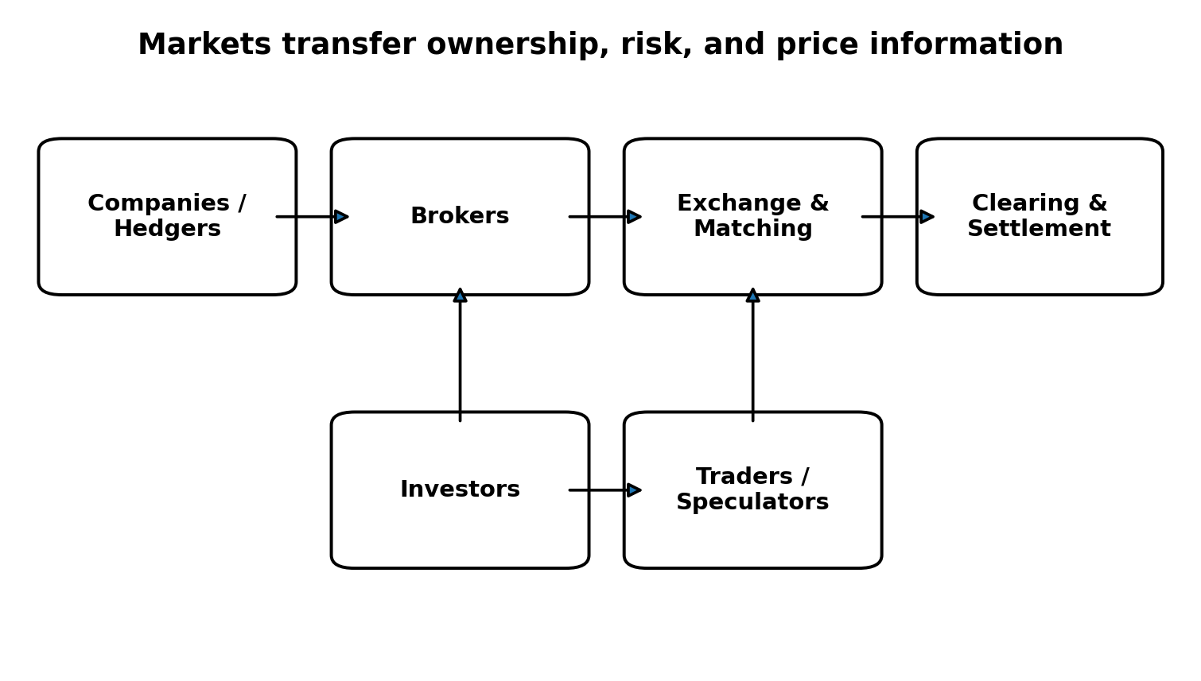
Figure: Why Markets Exist

Objective
Explain the economic purpose of financial markets before learning how to trade them.

Why it matters
A learner who sees a market only as a place to win money will misunderstand nearly every later concept. Markets help transfer ownership, allocate capital, manage risk, and discover prices.

Core ideas
- Primary markets connect issuers with capital; secondary markets let existing claims change hands.
- Futures and derivatives can transfer price risk between participants with different needs.
- The displayed price is the latest result of interacting orders, not a promise about the future.

Scenario
A European manufacturer expects a US-dollar payment in three months and wants less currency uncertainty. Another participant is willing to accept that exposure because of a different forecast or business need. The same market serves both.

Practice
Write one sentence explaining how an airline, a pension fund, and a short-term trader might each use a financial market.

Knowledge check
Which is a core market function? Transferring ownership, capital, and risk.
Do all participants seek the same outcome? No.
Does an indicator create price? No.

Common mistake
Treating the market as a machine designed to pay traders.

Evidence classification
Market fact

Sources
- Understanding the Role of Hedgers - CME Group - https://www.cmegroup.com/education/courses/introduction-to-futures/understanding-the-role-of-hedgers
- Understanding the Role of Speculators - CME Group - https://www.cmegroup.com/education/courses/introduction-to-futures/understanding-the-role-of-speculators
- Introduction to Futures - CME Group YouTube playlist - https://www.youtube.com/playlist?list=PLkJQh4MWlJksEOMuHaYxkK0-yHsrhS8kW

L00-M02 - Investing, Trading, Speculation, and Gambling
Estimated time: 18 minutes
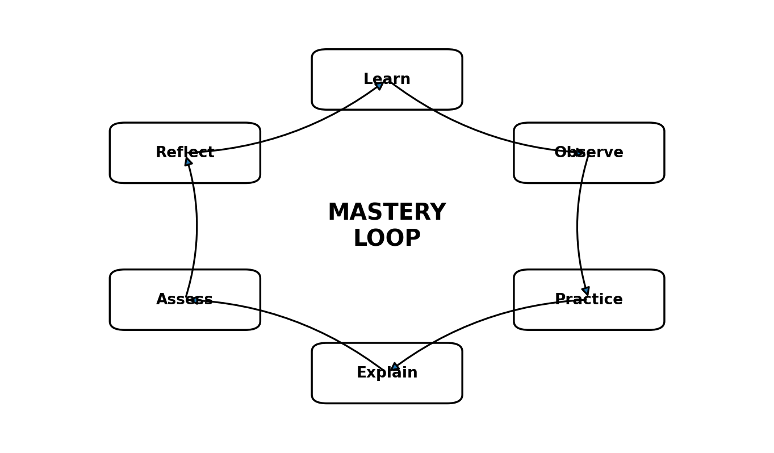
Figure: Investing, Trading, Speculation, and Gambling

Objective
Distinguish activities by decision process rather than by holding period or outcome.

Why it matters
A short holding period does not automatically make an activity gambling. The important differences are evidence, risk limits, repeatability, and whether the decision has a rational basis.

Core ideas
- Investing usually seeks participation in longer-term economic value or cash flows.
- Trading seeks to manage a shorter-term opportunity with a defined thesis, invalidation, and risk.
- Speculation accepts uncertainty in pursuit of gain and can be disciplined or reckless.
- Gambling behavior appears when hope, excitement, or uncontrolled size replaces a tested process.

Scenario
Two people buy the same index. One follows a diversified ten-year plan. The other uses extreme leverage after reading a social-media prediction. The instrument is identical; the process is not.

Practice
Classify three past market decisions as investment, disciplined trade, or gambling behavior. Explain each classification without referring to whether it made money.

Knowledge check
Can a profitable trade be a poor decision? Yes.
Is holding time the only distinction? No.
What matters most? Process, evidence, and risk.

Common mistake
Judging decision quality only by the profit or loss.

Evidence classification
Widely accepted professional practice

Sources
- Position and Risk Management - CME Group - https://www.cmegroup.com/education/courses/things-to-know-before-trading-cme-futures/position-and-risk-management

L00-M03 - Who Participates in Markets?
Estimated time: 18 minutes

Figure: Who Participates in Markets?

Objective
Identify major participant groups and understand why their motives differ.

Why it matters
A hedge, an investment, a market-making action, and a speculative trade can produce similar transactions for very different reasons.

Core ideas
- Hedgers seek to reduce an existing commercial or portfolio risk.
- Speculators intentionally accept price risk in pursuit of profit.
- Investors allocate capital according to longer-term objectives.
- Market makers quote prices and manage inventory risk.
- Brokers provide customer access and route or execute orders.
- Exchanges and clearing systems establish rules, matching, and post-trade obligations.

Scenario
A gold producer sells futures to stabilize revenue while a macro fund buys because it expects lower real yields. The matched transaction does not reveal each participant's complete motive.

Practice
Create a two-column table: participant and likely objective. Include a bank, pension fund, airline, market maker, day trader, and central bank.

Knowledge check
Who commonly reduces commercial price risk? A hedger.
Who provides market access to customers? A broker.
Does a trade print reveal motive with certainty? No.

Common mistake
Assuming every large transaction is directional speculation.

Evidence classification
Market fact

Sources
- Understanding the Role of Hedgers - CME Group - https://www.cmegroup.com/education/courses/introduction-to-futures/understanding-the-role-of-hedgers
- Understanding the Role of Speculators - CME Group - https://www.cmegroup.com/education/courses/introduction-to-futures/understanding-the-role-of-speculators

L00-M04 - Exchanges, Brokers, Clearing, and Settlement
Estimated time: 20 minutes

Figure: Exchanges, Brokers, Clearing, and Settlement

Objective
Trace a transaction from the learner's instruction through execution and settlement.

Why it matters
A platform makes execution look instant, but legal relationships, routing, matching or dealer execution, clearing, and settlement sit behind a click.

Core ideas
- A broker receives the client instruction and provides market access.
- An exchange or trading venue applies its rules and matches compatible orders.
- Clearing manages obligations and counterparty risk according to the market structure.
- Settlement completes the transfer of cash and the financial instrument.
- CFDs, exchange-traded futures, and shares can have materially different execution and legal structures.

Scenario
A learner presses Buy and sees a confirmation. Behind that message may be routing, execution at a venue or dealer, trade confirmation, clearing, and settlement.

Practice
Draw the transaction path for one exchange-traded share order and one OTC CFD order. Highlight where their structures differ.

Knowledge check
Who usually provides the learner's access? The broker.
Where are compatible exchange orders matched? At a trading venue or exchange.
Is every product centrally cleared? No.

Common mistake
Assuming all instruments and brokers use the same execution model.

Evidence classification
Market fact

Sources
- Executing an Order - Investor.gov - https://www.investor.gov/introduction-investing/investing-basics/how-stock-markets-work/executing-order
- How Online Stock Trading Works - FINRA - https://www.finra.org/investors/insights/online-trade-lifecycle

L00-M05 - Bid, Ask, and the Last Traded Price
Estimated time: 18 minutes
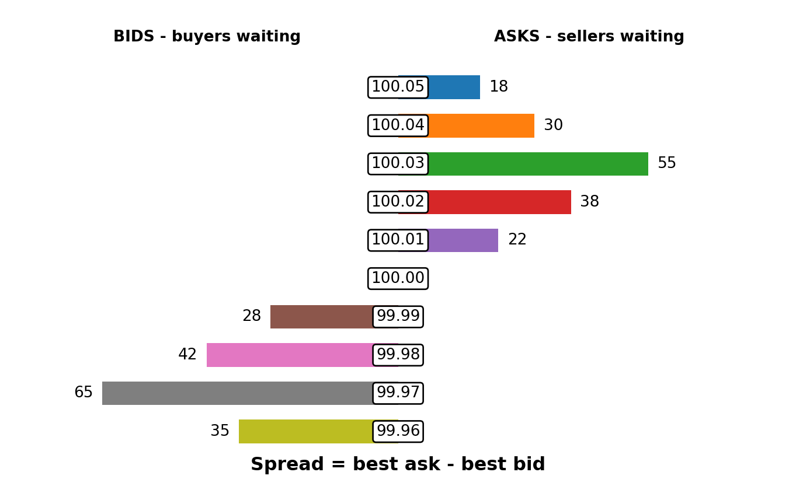
Figure: Bid, Ask, and the Last Traded Price

Objective
Differentiate the last traded price from current executable quotations.

Why it matters
The last price shown on a chart is not automatically available for a new order.

Core ideas
- The bid is the highest displayed price a buyer is currently willing to pay.
- The ask is the lowest displayed price a seller is currently willing to accept.
- The last price records a completed transaction and may no longer be available.
- Quotes can change before an order reaches the market.
- Different venues, data feeds, instruments, and brokers can display slightly different prices.

Scenario
The chart shows 100.00, while the best ask is 100.03. An immediate market buy is likely to execute at the ask or worse, not automatically at 100.00.

Practice
On a demo platform, record bid, ask, spread, and last price five times during an active session.

Knowledge check
Which quotation is relevant to an immediate buy? The ask.
Is the last price guaranteed for a new order? No.
What does the last price represent? A completed transaction.

Common mistake
Using the last candle close as a guaranteed execution price.

Evidence classification
Market fact

Sources
- Types of Orders - Investor.gov - https://www.investor.gov/introduction-investing/investing-basics/how-stock-markets-work/types-orders
- Order Types - FINRA - https://www.finra.org/investors/investing/investment-products/stocks/order-types
- Placing Orders on Charts - TradingView video - https://www.youtube.com/watch?v=DuhcjrwSRDQ

L00-M06 - The Bid-Ask Spread and Liquidity
Estimated time: 20 minutes

Figure: The Bid-Ask Spread and Liquidity

Objective
Explain the spread as an immediate cost and a partial clue about liquidity.

Why it matters
An aggressive buyer crosses to the ask and an aggressive seller crosses to the bid. This matters especially in frequent trading and thin markets.

Core ideas
- Spread equals best ask minus best bid.
- Tighter spreads often accompany liquid conditions, but top-of-book size alone does not fully describe liquidity.
- Spreads can widen around news, session changes, quiet hours, or stress.
- Total transaction cost may include spread, commission, fees, financing, and slippage.

Scenario
Gold has a normal spread before a major release. Seconds before the announcement, quotations widen and available depth changes, increasing execution uncertainty.

Practice
Compare the spread of the same instrument during its primary session and during a quiet period. Record the difference and possible reason.

Knowledge check
How is spread calculated? Best ask minus best bid.
Can the spread change quickly? Yes.
Is spread the only cost? No.

Common mistake
Backtesting without realistic spread and transaction-cost assumptions.

Evidence classification
Market fact

Sources
- Order Types - FINRA - https://www.finra.org/investors/investing/investment-products/stocks/order-types
- How Online Stock Trading Works - FINRA - https://www.finra.org/investors/insights/online-trade-lifecycle
- Futures Order Types - CME Group - https://www.cmegroup.com/education/courses/things-to-know-before-trading-cme-futures/futures-order-types

L00-M07 - Market Orders: Execution First
Estimated time: 20 minutes
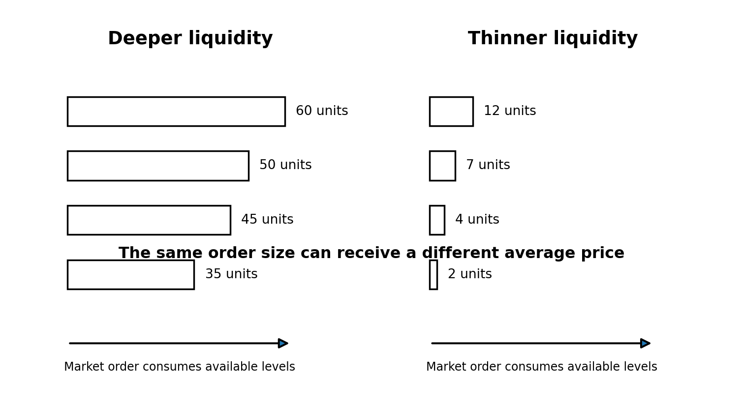
Figure: Market Orders: Execution First

Objective
Understand what a market order prioritizes and what it cannot guarantee.

Why it matters
Market orders seek execution against available liquidity. In fast or thin conditions, the actual average price can differ significantly from the expected price.

Core ideas
- A market order seeks immediate execution against available opposite-side liquidity.
- It offers high execution certainty in normal conditions but no exact price guarantee.
- A large order can fill at several price levels.
- Slippage is the difference between a referenced or expected price and actual execution.

Scenario
A large buy order enters a thin ask book. The first units fill near the best ask; the remainder consumes higher offers, producing a worse average price.

Practice
Use the order-book illustration to estimate how a small and a large market order could receive different average fills.

Knowledge check
What does a market order prioritize? Execution.
Does it guarantee an exact price? No.
Can one order fill at multiple prices? Yes.

Common mistake
Using market orders around high-impact news without considering liquidity and slippage.

Evidence classification
Market fact

Sources
- Types of Orders - Investor.gov - https://www.investor.gov/introduction-investing/investing-basics/how-stock-markets-work/types-orders
- Order Types - FINRA - https://www.finra.org/investors/investing/investment-products/stocks/order-types
- Futures Order Types - CME Group - https://www.cmegroup.com/education/courses/things-to-know-before-trading-cme-futures/futures-order-types

L00-M08 - Limit Orders: Price First
Estimated time: 20 minutes
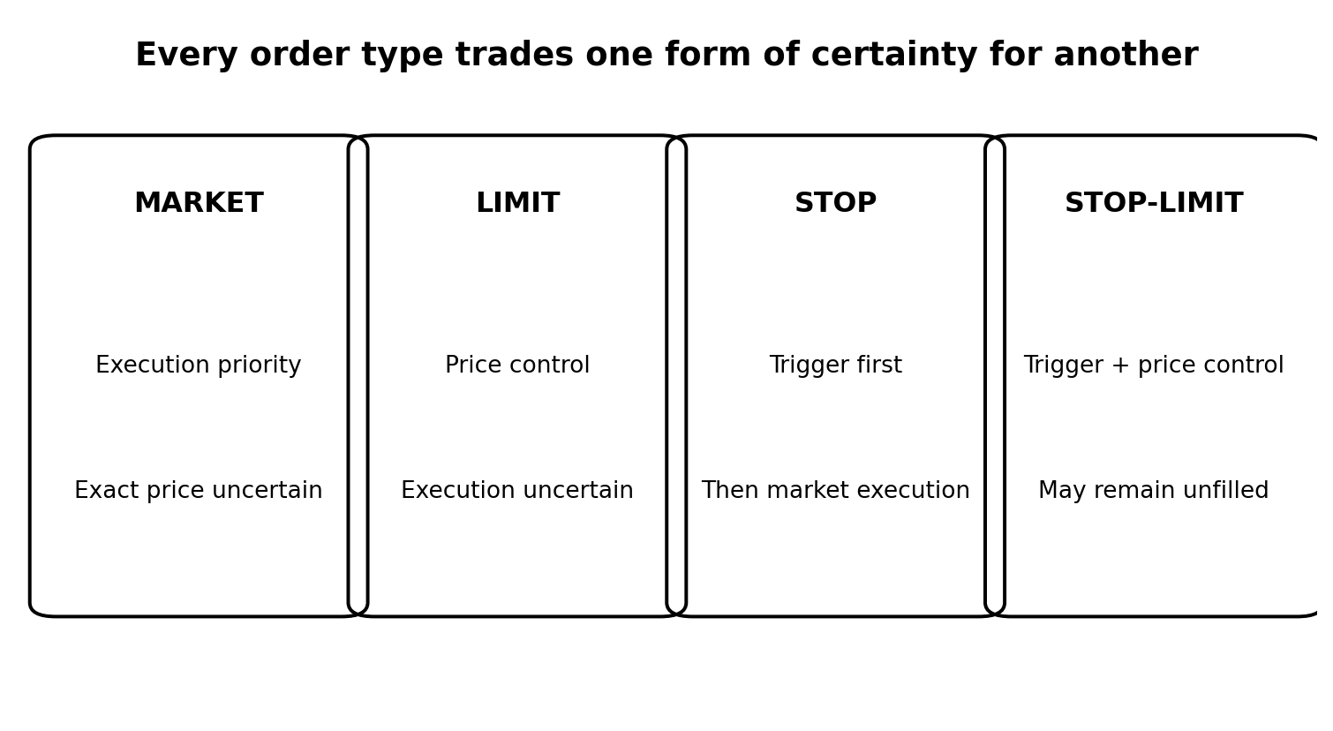
Figure: Limit Orders: Price First

Objective
Understand the trade-off between price control and execution uncertainty.

Why it matters
A limit order protects the permitted price but cannot force another participant to trade with you.

Core ideas
- A buy limit can execute at the limit price or lower.
- A sell limit can execute at the limit price or higher.
- A limit order can partially fill, remain unfilled, or lose queue priority after modification.
- A historical price touch does not prove that every waiting order filled.

Scenario
Price touches a learner's buy limit and rises immediately. The learner assumes a fill, but insufficient sell volume reached the order after earlier orders in the queue.

Practice
Define the execution condition for a buy limit at 99.50 and a sell limit at 101.20. Give one reason each might remain unfilled.

Knowledge check
What does a limit order control? The permitted execution price.
Is execution guaranteed? No.
Can a limit order partially fill? Yes.

Common mistake
Treating every historical touch as a filled limit order in a backtest.

Evidence classification
Market fact

Sources
- Types of Orders - Investor.gov - https://www.investor.gov/introduction-investing/investing-basics/how-stock-markets-work/types-orders
- Order Types - FINRA - https://www.finra.org/investors/investing/investment-products/stocks/order-types
- Futures Order Types - CME Group - https://www.cmegroup.com/education/courses/things-to-know-before-trading-cme-futures/futures-order-types

L00-M09 - Stop and Stop-Limit Orders
Estimated time: 22 minutes

Figure: Stop and Stop-Limit Orders

Objective
Distinguish a stop trigger from a guaranteed exit price.

Why it matters
A stop defines when another order activates. It does not guarantee the exact execution price during a gap or rapid move.

Core ideas
- A stop order generally becomes a market order after the trigger condition is met.
- A stop-limit becomes a limit order after activation.
- A stop may slip but prioritizes execution.
- A stop-limit controls price but can remain unfilled, leaving exposure open.
- Broker and venue rules must be checked because implementation details can differ.

Scenario
A long position gaps below its stop. The stop activates and sells into the next available bids. A stop-limit might not execute if the market is already below its limit.

Practice
For a long position, explain the difference between a stop at 98 and a stop-limit with trigger 98 and limit 97.80.

Knowledge check
What does a stop order become after activation? A market order.
What does a stop-limit become? A limit order.
Which can remain unfilled after activation? A stop-limit.

Common mistake
Calling the stop trigger a guaranteed exit price.

Evidence classification
Market fact

Sources
- Stop, Stop-Limit, and Trailing Stop Orders - Investor.gov - https://www.investor.gov/introduction-investing/general-resources/news-alerts/alerts-bulletins/investor-bulletins-15
- Stop Orders During Volatile Markets - FINRA - https://www.finra.org/investors/insights/stop-orders-factors-consider-during-volatile-markets
- Futures Order Types - CME Group - https://www.cmegroup.com/education/courses/things-to-know-before-trading-cme-futures/futures-order-types

L00-M10 - Risk, Leverage, and Survival
Estimated time: 25 minutes
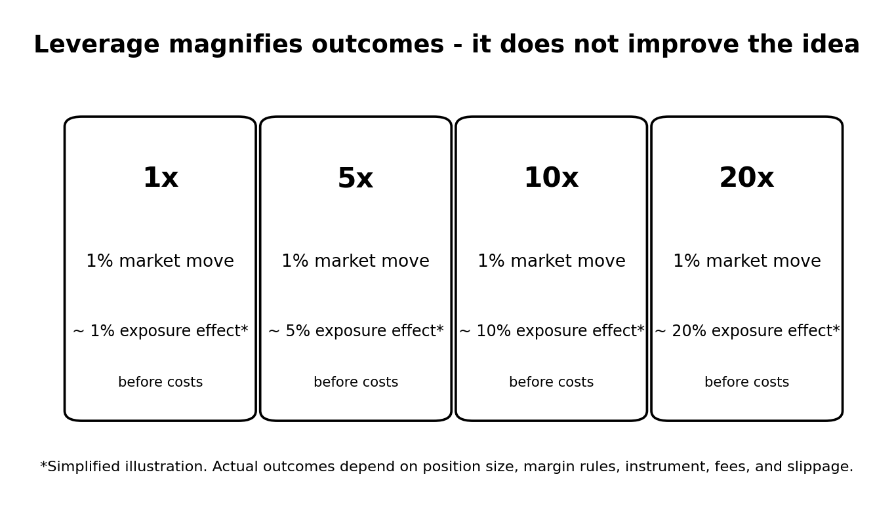
Figure: Risk, Leverage, and Survival

Objective
Explain why controlled exposure and survival come before strategy optimization.

Why it matters
A valid analysis can still produce a loss. Excessive size converts ordinary uncertainty into account-threatening damage.

Core ideas
- Risk is uncertainty that can negatively affect capital or financial welfare.
- Leverage creates exposure larger than the cash committed.
- Margin is collateral, not the maximum possible loss.
- Position size should come from acceptable account risk and the distance to invalidation, not the maximum leverage offered.
- A professional plan sets per-trade and daily loss limits before considering targets.

Scenario
Two learners use the same setup and stop distance. One risks 0.5% of capital; the other risks 20%. The market outcome is the same, but the consequences for survival are radically different.

Practice
For a EUR 10,000 account, calculate the cash amount represented by 0.25%, 0.5%, 1%, and 2%. Explain which is more appropriate for a novice simulation plan and why.

Knowledge check
Is margin the maximum possible loss? No.
What should determine position size? Accepted account risk and invalidation distance.
Does leverage improve a trading edge? No.

Common mistake
Choosing the position size first and forcing the stop to fit afterward.

Evidence classification
Market fact plus risk-management practice

Sources
- Position and Risk Management - CME Group - https://www.cmegroup.com/education/courses/things-to-know-before-trading-cme-futures/position-and-risk-management

L01-M01 - Candlesticks and OHLC: What One Bar Actually Says
Estimated time: 22 minutes
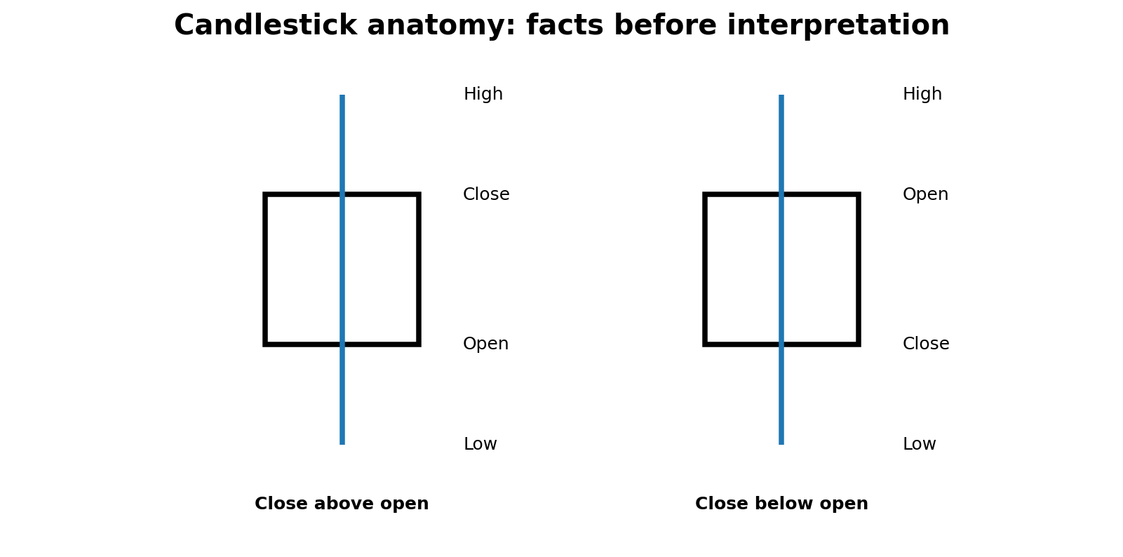
Figure: Candlesticks and OHLC: What One Bar Actually Says

Objective
Read open, high, low, and close values without attaching unsupported stories to a candle shape.

Why it matters
Candles compress a period of trading into four prices. They are useful summaries, but a candle does not reveal every order, participant, or reason behind the move.

Core ideas
- The open is the first recorded price for the selected interval; the close is the last recorded price for that interval.
- The high and low mark the interval extremes.
- A candle body shows the distance between open and close; wicks show prices traded beyond the body.
- The same market move appears differently when the timeframe changes.
- A single candle is evidence of price movement, not a complete trading signal.

Scenario
A five-minute candle opens at 100, trades to 103, falls to 99, and closes at 102. A learner calls it bullish. A professional description first records the OHLC facts, then asks where it formed and what preceded it.

Practice
Draw a candle for O=50, H=55, L=48, C=53. Then redraw the same values when C=49. Label every component.

Knowledge check
What four prices define an OHLC bar? Open, high, low, and close.
Does a long wick prove manipulation? No.
Can the same data look different on another timeframe? Yes.

Common mistake
Memorizing candle names while ignoring location, timeframe, and context.

Evidence classification
Market fact plus analytical practice

Sources
- TradingView Help Center - https://www.tradingview.com/support/

L01-M02 - Timeframes and Multi-Timeframe Context
Estimated time: 24 minutes
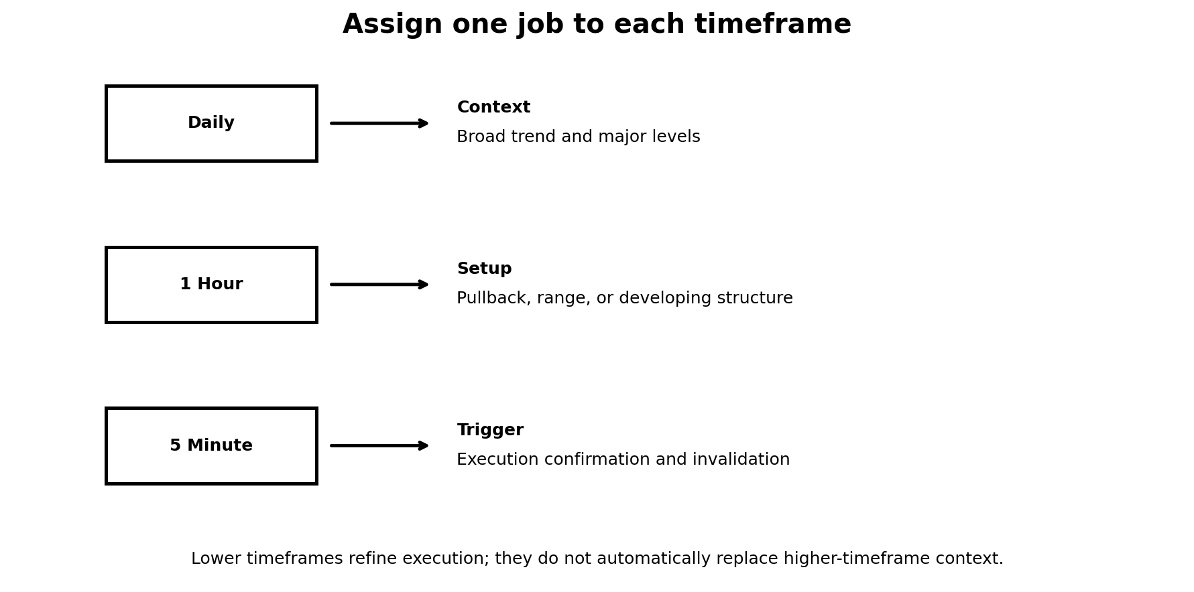
Figure: Timeframes and Multi-Timeframe Context

Objective
Explain how higher and lower timeframes answer different questions without letting a small chart override broader context.

Why it matters
A market can be rising on the daily chart, correcting on the hourly chart, and rallying on the five-minute chart at the same time. These statements can all be true.

Core ideas
- Higher timeframes compress more trading and usually define broader structure.
- Lower timeframes reveal execution detail but contain more noise.
- Analysis should assign a purpose to each timeframe: context, setup, or trigger.
- A lower-timeframe reversal may be only a pullback inside a higher-timeframe trend.
- Timeframe selection should match the expected holding period and risk plan.

Scenario
The daily chart is in an uptrend. The hourly chart is pulling back. The five-minute chart breaks upward. The correct interpretation depends on whether the five-minute move confirms the end of the hourly pullback or is only temporary noise.

Practice
Create a three-row plan using Daily for context, 1H for setup, and 5m for execution. Write one question each timeframe must answer.

Knowledge check
Can different timeframes show different trends? Yes.
Which timeframe should define strategic bias? The designated higher context timeframe.
Should a two-minute signal automatically reverse a daily bias? No.

Common mistake
Changing timeframe until a preferred trade appears.

Evidence classification
Analytical practice

Sources
- TradingView Help Center - https://www.tradingview.com/support/

L01-M03 - Trading Sessions, Opens, and Market Overlap
Estimated time: 25 minutes
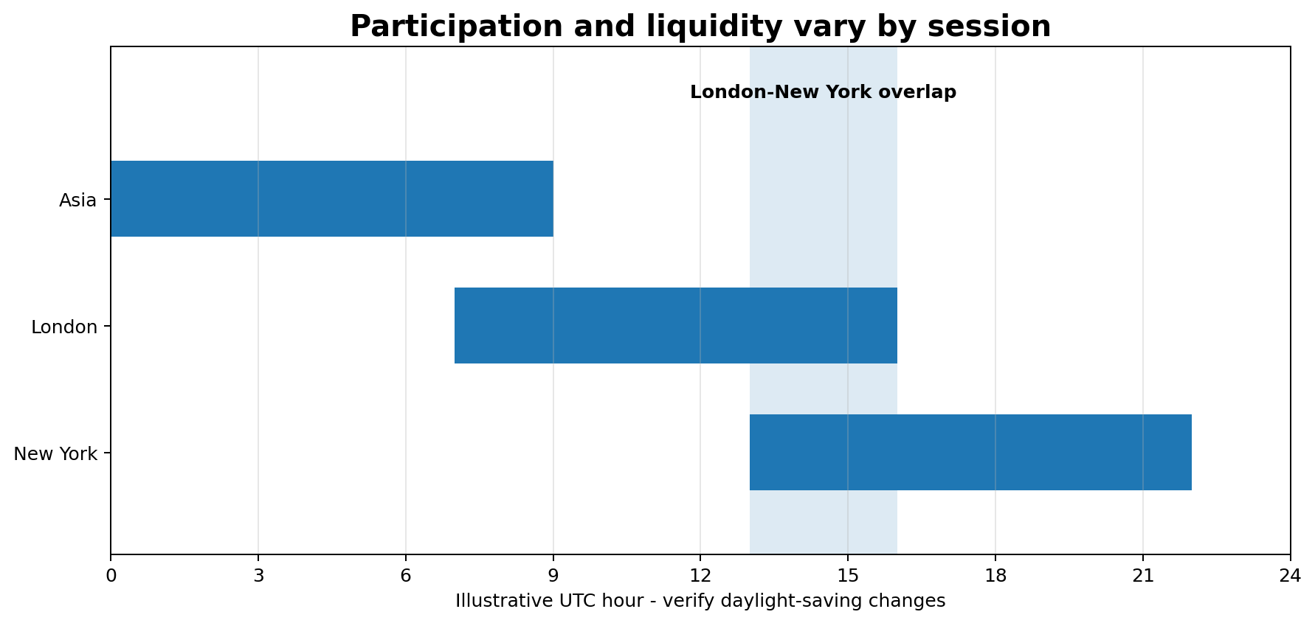
Figure: Trading Sessions, Opens, and Market Overlap

Objective
Recognize how exchange hours, regional sessions, and overlaps influence liquidity and volatility.

Why it matters
Participation is not evenly distributed across the day. A strategy tested during a liquid open may behave very differently during a quiet period or extended hours.

Core ideas
- Cash equities trade around an exchange-defined regular session, with separate pre-market and after-hours conditions where available.
- Futures and foreign exchange may trade for longer hours, but liquidity still changes by time of day.
- Session opens can reprice markets as new participants and information arrive.
- Overlaps may increase activity, while off-hours can bring wider spreads and thinner depth.
- Daylight-saving changes can shift local clock times relative to another region.

Scenario
A stock has a narrow spread during the main US session but a much wider spread after hours. The chart still prints prices, yet execution quality and available liquidity are different.

Practice
Build a session table for your local timezone with London open, New York cash open, and the London-New York overlap. Add a daylight-saving reminder.

Knowledge check
Is liquidity constant throughout the day? No.
Why can extended hours be riskier? Lower liquidity, wider spreads, and higher volatility can occur.
Do long trading hours guarantee deep liquidity at every moment? No.

Common mistake
Backtesting at one session and trading the same rules at every hour.

Evidence classification
Market fact plus risk-management practice

Sources
- Extended-Hours Trading: Know the Risks - FINRA - https://www.finra.org/investors/insights/extended-hours-trading
- Trading Terms: Time Parameters and Qualifiers - FINRA - https://www.finra.org/investors/insights/time-parameters-qualifiers-stock-orders

L01-M04 - Volatility and ATR: Measuring Movement, Not Direction
Estimated time: 26 minutes
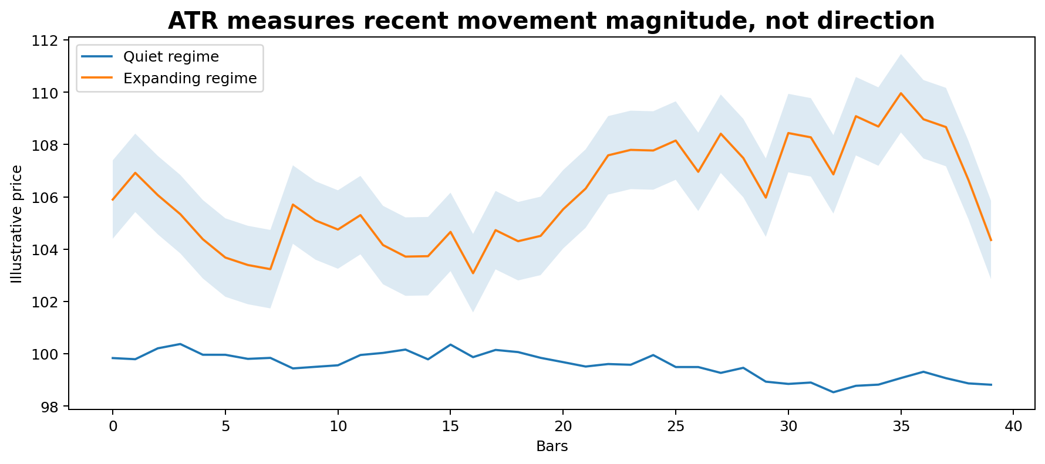
Figure: Volatility and ATR: Measuring Movement, Not Direction

Objective
Use range and Average True Range as context for movement and risk without treating volatility as a directional forecast.

Why it matters
Stops, targets, and expectations should account for how much an instrument normally moves. A fixed ten-point stop can be huge in one regime and insignificant in another.

Core ideas
- Volatility describes the magnitude and variability of price movement.
- True range accounts for the current high-low range and gaps from the previous close.
- ATR averages true range over a selected lookback.
- ATR rises after larger ranges and falls after quieter ranges; it does not predict direction.
- ATR settings depend on timeframe, instrument, and purpose.

Scenario
Two instruments both trade at 100. One has a daily ATR of 1; the other has a daily ATR of 8. The same two-point stop represents very different market breathing room.

Practice
Record the current 14-period ATR for one instrument on Daily, 1H, and 5m. Compare your proposed stop distance to each ATR and explain the relevant comparison.

Knowledge check
Does ATR indicate bullish or bearish direction? No.
What does rising ATR suggest? Recent ranges are expanding.
Should ATR be identical across timeframes? No.

Common mistake
Buying because ATR rises or using ATR without a structural invalidation level.

Evidence classification
Indicator definition plus risk-management practice

Sources
- TradingView Help Center - https://www.tradingview.com/support/

L01-M05 - Gaps, Repricing, and the Market Open
Estimated time: 23 minutes
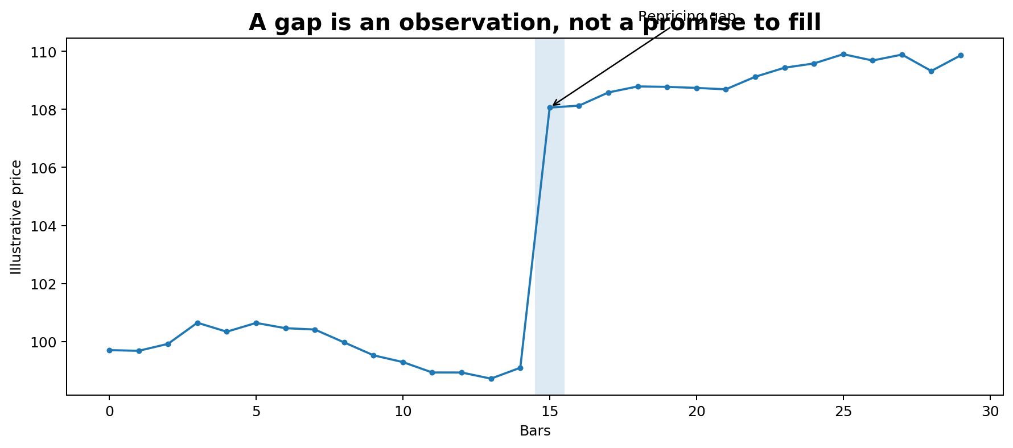
Figure: Gaps, Repricing, and the Market Open

Objective
Identify a gap and distinguish the observation from assumptions about whether it must fill.

Why it matters
A gap can reflect new information or a discontinuity between sessions. Traders often turn the visible space into a rule that price must return, but no such guarantee exists.

Core ideas
- A gap appears when the next traded range does not overlap a prior reference range.
- Stocks commonly gap after earnings or news outside the regular session.
- Futures can show weekend or session gaps depending on chart settings and trading hours.
- A gap may fill, partially fill, or remain open.
- The opening auction and early liquidity can produce rapid repricing and slippage.

Scenario
A company reports earnings after the close and opens 8% higher the next day. The gap is evidence that market participants accepted materially different prices; it is not automatically a short signal.

Practice
Find three historical gaps. Label the catalyst if known, initial direction, maximum extension, whether the gap filled, and how long that took.

Knowledge check
Must every gap fill? No.
Can news outside regular hours contribute to a gap? Yes.
Is an unfilled gap alone a complete setup? No.

Common mistake
Trading against every gap because “all gaps fill.”

Evidence classification
Market observation plus analytical practice

Sources
- Extended-Hours Trading: Know the Risks - FINRA - https://www.finra.org/investors/insights/extended-hours-trading

L01-M06 - Stocks, ETFs, Futures, Forex, and CFDs
Estimated time: 30 minutes
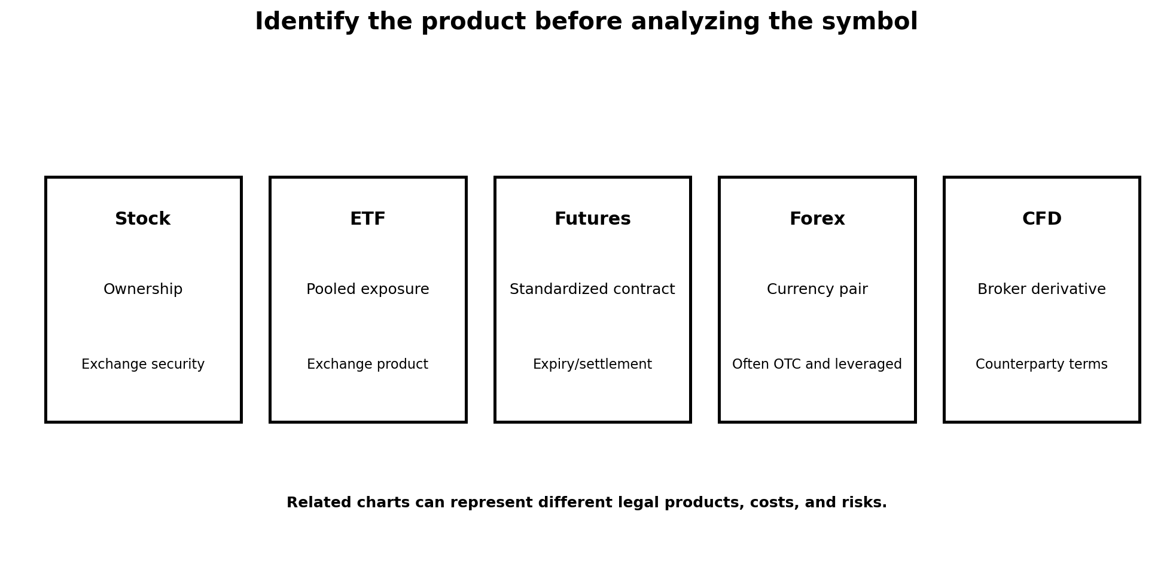
Figure: Stocks, ETFs, Futures, Forex, and CFDs

Objective
Compare major instrument types by ownership, contract structure, trading venue, leverage, expiry, and counterparty risk.

Why it matters
A symbol that tracks the S&P 500 may represent an ETF share, a futures contract, a CFD, or another derivative. Similar-looking charts do not mean identical rights, costs, or risks.

Core ideas
- A stock represents an ownership interest in a company.
- An ETF is a pooled product whose shares trade on an exchange and may track a basket or strategy.
- A futures contract is a standardized agreement with defined terms and an expiry or settlement process.
- Retail forex commonly involves leveraged over-the-counter trading through a dealer or broker.
- A CFD is a broker-provided derivative in permitted jurisdictions; the learner must understand local regulation and counterparty terms.

Scenario
SPY, an S&P 500 futures contract, and an S&P 500 CFD all respond to related market forces, yet they differ in contract size, trading hours, fees, tax treatment, regulation, and counterparty exposure.

Practice
Create a comparison matrix for SPY, ES futures, and one broker’s index CFD. Include ownership, expiry, minimum size, spread/commission, financing, market hours, and regulator.

Knowledge check
Does buying a CFD make you a shareholder? No.
Does a futures contract have standardized terms? Yes.
Can related instruments have different costs and risks? Yes.

Common mistake
Choosing an instrument only because its chart looks familiar.

Evidence classification
Market fact and product-risk practice

Sources
- Stocks - Investor.gov - https://www.investor.gov/introduction-investing/investing-basics/investment-products/stocks
- Exchange-Traded Funds (ETFs) - Investor.gov - https://www.investor.gov/introduction-investing/investing-basics/investment-products/mutual-funds-and-exchange-traded-2
- Basics of Futures Trading - CFTC - https://www.cftc.gov/LearnAndProtect/AdvisoriesAndArticles/FuturesMarketBasics/index.htm
- Eight Things You Should Know Before Trading Forex - CFTC - https://www.cftc.gov/LearnAndProtect/AdvisoriesAndArticles/CustomerAdvisory_MustKnowForex.html

L01-M07 - Chart Platforms, Brokers, and Data Feeds
Estimated time: 25 minutes
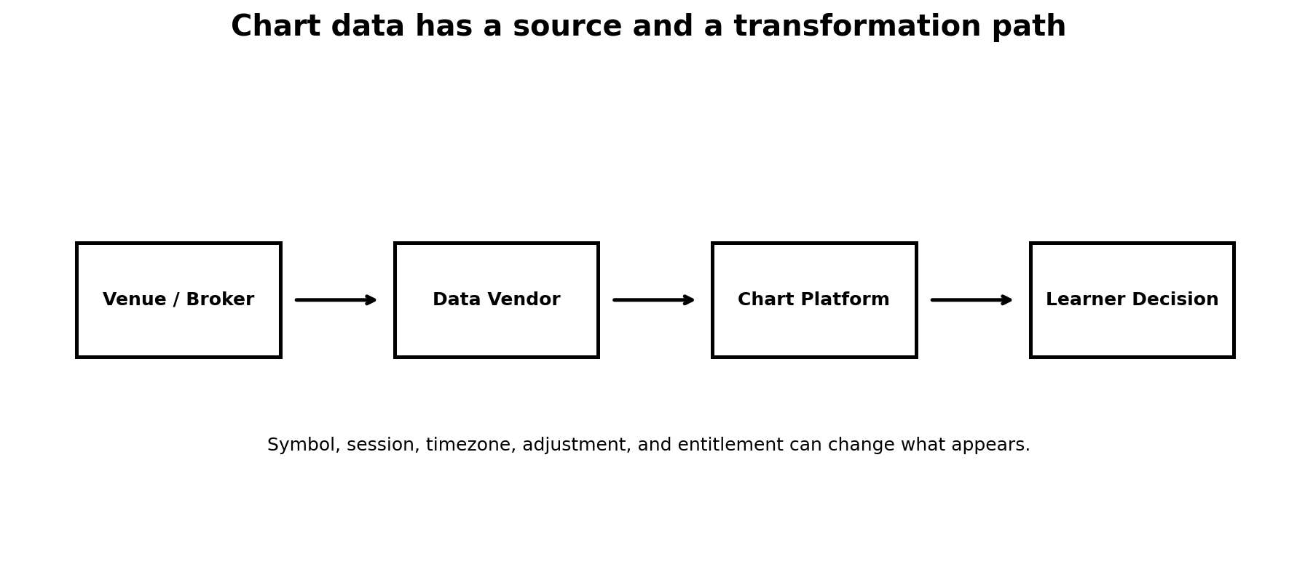
Figure: Chart Platforms, Brokers, and Data Feeds

Objective
Describe the path from venue and data vendor to chart platform and broker execution.

Why it matters
The chart, broker, and underlying exchange can be separate systems. Small differences in symbols, feeds, sessions, and aggregation can produce different candles and indicator values.

Core ideas
- A charting platform displays data obtained from one or more providers.
- A broker routes or internalizes orders according to its execution model and product.
- The same market can have multiple symbols, contract months, composite feeds, or broker-specific prices.
- Session settings and adjusted data can change historical candles.
- Platform tools should support analysis; they do not guarantee execution quality.

Scenario
Two learners compare a gold CFD chart with COMEX gold futures. The broad direction is similar, but exact highs, lows, spreads, and session behavior differ because the instruments and feeds are not identical.

Practice
For one instrument, record platform, symbol, exchange or broker, data status, timezone, session setting, and whether the series is adjusted or continuous.

Knowledge check
Can two legitimate feeds print slightly different candles? Yes.
Is a chart platform always the executing broker? No.
Why document the exact symbol? To make analysis and review reproducible.

Common mistake
Assuming every symbol with the same nickname is the same product.

Evidence classification
Platform and market-data practice

Sources
- TradingView Help Center - https://www.tradingview.com/support/

L01-M08 - Real-Time, Delayed, and Historical Data
Estimated time: 22 minutes
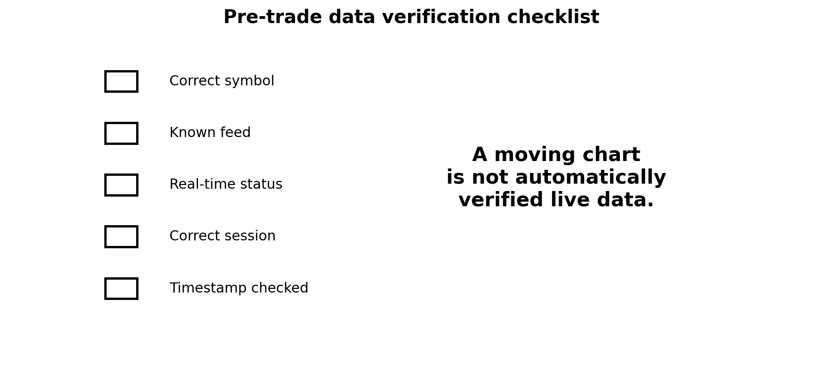
Figure: Real-Time, Delayed, and Historical Data

Objective
Verify whether a chart is real-time, delayed, replayed, or historical before making a time-sensitive decision.

Why it matters
A clean chart is not necessarily current. Exchanges may require separate market-data permissions, and platforms can display delayed or vendor-dependent information.

Core ideas
- Real-time data is delivered with minimal distribution delay under the relevant entitlement.
- Delayed data can be suitable for education but unsuitable for live execution decisions.
- Historical and replay modes deliberately show past data.
- Bid/ask data, last-trade data, and indicative prices are different information types.
- Data quality checks belong in every trading checklist.

Scenario
A learner sees a breakout on a delayed index feed and enters through a separate broker whose live price has already moved far beyond the planned level.

Practice
Audit five symbols on your platform. Record feed source, delay indicator, exchange entitlement, last-trade time, and comparison with your execution venue.

Knowledge check
Can delayed data look visually normal? Yes.
Should a live order be based on an unverified delayed feed? No.
Are bid/ask and last price identical concepts? No.

Common mistake
Assuming a moving screen equals exchange-grade real-time data.

Evidence classification
Data-quality practice

Sources
- TradingView Help Center - https://www.tradingview.com/support/

L01-M09 - Economic Calendars, Scheduled Risk, and News
Estimated time: 28 minutes
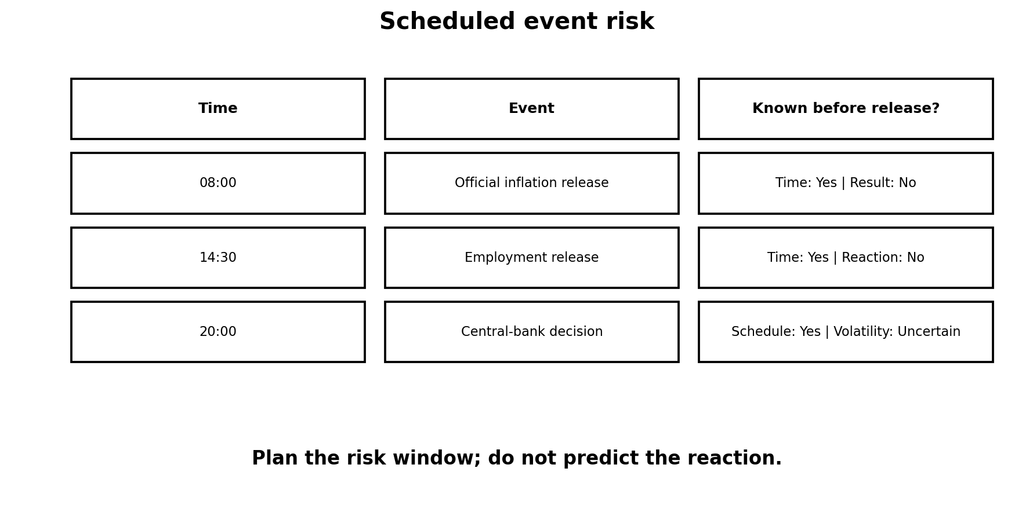
Figure: Economic Calendars, Scheduled Risk, and News

Objective
Use official release schedules to identify event risk without pretending to know the market reaction in advance.

Why it matters
Employment, inflation, growth, and central-bank decisions can sharply change volatility, spreads, and liquidity. The release time is knowable; the size and direction of the reaction are not.

Core ideas
- An economic calendar lists scheduled releases and events.
- Official statistical agencies and central banks are primary sources for timing and published data.
- Consensus forecasts are estimates, not facts.
- A release can cause slippage, spread expansion, and rapid two-way movement.
- The correct response may be reduced size, wider planned risk, waiting, or no trade.

Scenario
Inflation data is released at 14:30 local platform time. Price first spikes upward, then reverses sharply. A directional guess was fragile; an event-risk plan was controllable.

Practice
Build tomorrow’s event-risk sheet using official sources. Include release time, affected markets, expected volatility window, and your rule for trading or standing aside.

Knowledge check
Is the release time usually more knowable than the market reaction? Yes.
Is a consensus forecast guaranteed? No.
Can spreads and slippage increase around news? Yes.

Common mistake
Treating the “high impact” label as a guaranteed direction.

Evidence classification
Market fact plus risk-management practice

Sources
- BLS Release Calendar - https://www.bls.gov/schedule/
- Federal Reserve FOMC Calendars and Information - https://www.federalreserve.gov/monetarypolicy/fomccalendars.htm
- BEA News Release Schedule - https://www.bea.gov/news/schedule

L01-M10 - Foundation Assessment: Read the Market Screen
Estimated time: 40 minutes
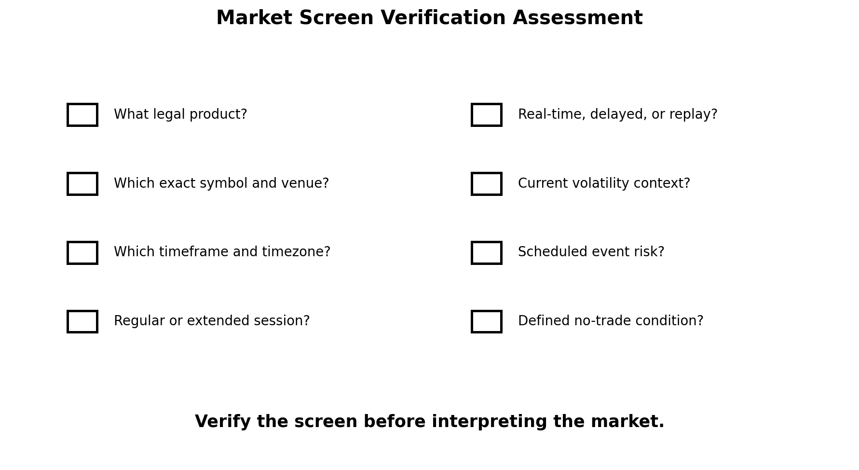
Figure: Foundation Assessment: Read the Market Screen

Objective
Demonstrate that you can identify what is on a trading screen before analyzing direction or placing a trade.

Why it matters
Most avoidable beginner errors occur before strategy: wrong symbol, wrong session, wrong timeframe, delayed data, misunderstood product, or unrecognized event risk.

Core ideas
- Identify the instrument and legal product.
- Confirm venue or broker, contract month if relevant, and price currency.
- Confirm timeframe, timezone, session, and data status.
- Read OHLC and current volatility context.
- Check scheduled event risk and define a no-trade condition.

Scenario
You receive a screenshot labeled “NAS100.” It has no visible broker, exchange, data status, timezone, or contract specification. The professional answer is not immediately bullish or bearish; it is a list of missing facts.

Practice
Complete the Market Screen Verification Checklist for three instruments: SPY, a DAX futures contract, and a gold CFD. Then explain which comparisons are valid and which are not.

Knowledge check
What comes before directional analysis? Instrument and data verification.
Can a nickname uniquely identify a legal product? Not always.
What is a valid outcome when key information is missing? No decision until verified.

Common mistake
Starting with pattern recognition before confirming the screen itself.

Evidence classification
Competency assessment

Sources
- Stocks - Investor.gov - https://www.investor.gov/introduction-investing/investing-basics/investment-products/stocks
- Exchange-Traded Funds (ETFs) - Investor.gov - https://www.investor.gov/introduction-investing/investing-basics/investment-products/mutual-funds-and-exchange-traded-2
- Basics of Futures Trading - CFTC - https://www.cftc.gov/LearnAndProtect/AdvisoriesAndArticles/FuturesMarketBasics/index.htm
- TradingView Help Center - https://www.tradingview.com/support/

