To run the application, run the Sudoku.class
The game (screenshot 1) has the following menus:
- Game
New: Create a blank new game
Solution: Show the solution of the current game
Level – V.Easy: Set the game level to very easy
Level - Easy: Set the game level to easy
Level - Medium: Set the game level to medium
Level - Hard: Set the game level to hard
Level - V.Hard: Set the game level to very hard
Level - Expert: Set the game level to expert
Save: Save the current game
Exit: Exit the current game
- Action
Check: Display some invalid moves
Undo: Undo the current move (i.e. restore the previous state)
- Help
About: Show the version of the software

In each game, we can show use the solution finder (i.e. go to Game -> Solution) to find all possible solutions (screenshot2 and screenshot3).

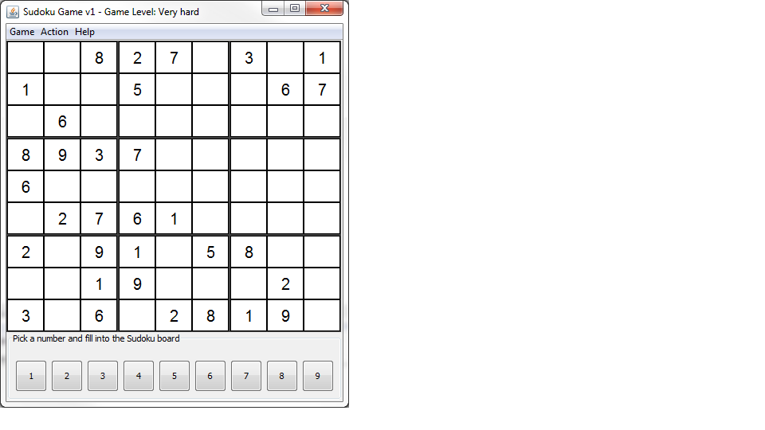
Screenshot 1: When the game is loaded

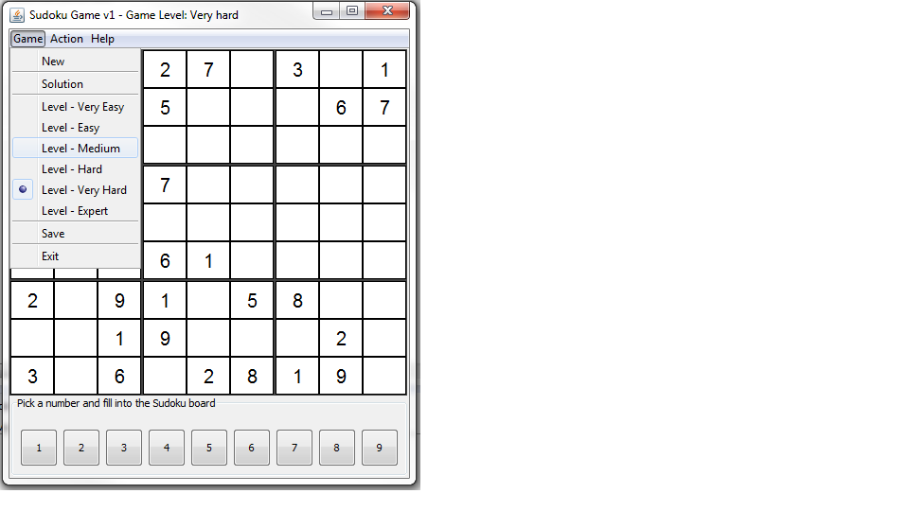
Screenshot 2: when the solution button is clicked

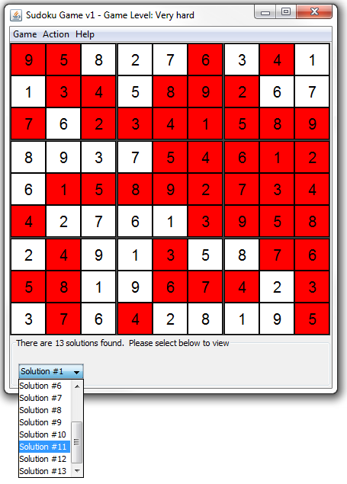
Screenshot 3: When we click the solution finder to find all solutions. In this example, 13 solutions are found in the given Sudoku game

