df.drop_duplicates()

df.drop(columns = "Not_Useful_Column")

df["Last_Name"] = df["Last_Name"].str.lstrip("/")
df["Last_Name"] = df["Last_Name"].str.rstrip("_")
df["Last_Name"] = df["Last_Name"].str.lstrip("...")
df["Last_Name"] = df["Last_Name"].str.strip("123._/") # All of above in one string

# Replcae every character except in braket with blank
df["Phone_Number"] = df["Phone_Number"].str.replace('[^a-zA-Z0-9]','')

# convert 1235455421 to 123-545-5421
df["Phone_Number"].apply(lambda x: x[0:3] + '-' + x[3:6] + '-' + x[6:10])

# Convert all values to str in this column
df["Phone_Number"] = df["Phone_Number"].apply(lambda x: str(x))

# split data in this column to seprate values in different columns(when you write expand=true)
df["Address"].str.split(',',2, expand=True)

# Create 3 new column and values them with this command
df[["Street_Address", "State", "Zip_Code"]] = df["Address"].str.split(',',2, expand=True)

df=df.fillna('') # replace null values with blanks

for x in df.index:
if df.loc[x, "Do_Not_Contact"] == 'Y':
df.drop(x, inplace=True)

df = df.dropna(subset="Phone_Number", inplace=True) #Another way to drop null values

df = df.reset_index(drop=True)
\
pd.set_option('display.float_format', lambda x: '%.2f' % x) # show for example 11572.0 to 11572.00

df.info()
df.describe()

df.isnull().sum() # show isnull count for each column
df.nunique() # shows count of unique values in every column

df.sort_values(by="World Population Percentage", ascending=False).head(10) # shows very top values

df[df['Continent'].str.contains('Oceania')] # we can filter output of dataframe by this command

df.corr() # show correlation for number values

sns.heatmap(df.corr(), annot = True)  plt.rcParams['figure.figsize'] = (20,7)  plt.show()  # no correlation is black | 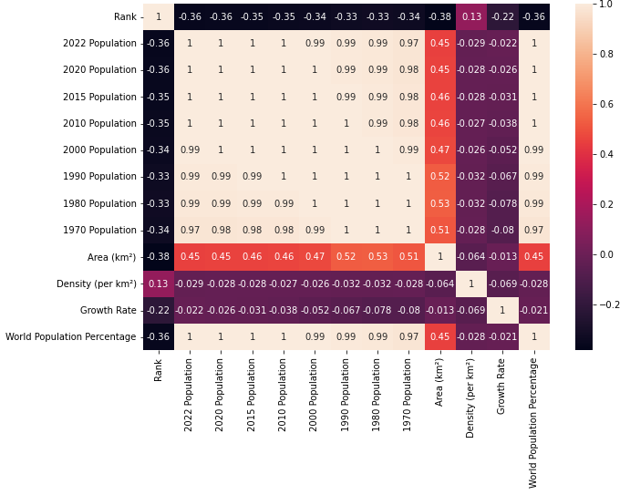

df.groupby('Continent').mean()
df.groupby('Continent').mean().sort_values(by="2022 Population", ascending=False)

df.columns # shows the list of all columns of dataframe

# only some coulmns considered in calculation of output , index for columns list start from zaro
df.groupby('Continent')[df.columns[5:13]].mean().sort_values(by="2022 Population",ascending=False)
OR
df.groupby('Continent')[['1970 Population',
'1980 Population', '1990 Population', '2000 Population',
'2010 Population', '2015 Population', '2020 Population',
'2022 Population']].mean().sort_values(by="2022 Population",ascending=False)

df2.transpose() # switch column and rows. it means shows df2 rows as columns

df2.plot() # plot the existing columns
df2.boxplot(figsize=(20,10))

df.dtypes # show types of our dataframe
df.select_dtypes(include='float') # show columns datafram with considered type in include parameter

