Document identifier: **Decipher-T4.3-Annotation editor Theme Documentation-v1**

Project title: **Digital Environment for Cultural Interfaces; Promoting Heritage, Education and Research**

Project acronym: **DECIPHER**

Project identifier: **FP7-270001-DECIPHER**

Partners: **Dublin Institute of Technology  
 National Gallery of Ireland  
 Irish Museum of Modern Art  
 Open University  
 System Simulation Limited  
  Brno University of Technology  
 Alinari 24 ORE SpA**

Author(s): **Marie Kratochvílová**

**Brno University of Technology**

Version: **Draft 1.0**

Type: **Documentation**

Date: **July 2012**

Content

Dialog 5

Buttons 6

Iframe dialog 9

Icons 10

Person 12

Message 13

Group 15

Corners 16

Draggable 16

Resizable 16

Clickable 17

DLG statusBar 17

Tree 18

Suggestion bar 19

Eric Mayer’s Reset CSS styles 20

Body 20

The .aed-form class 21

Fieldset 22

The .aed-form table 23

The table’s columns 23

The table cells 24

Input and select 24

The textarea 25

Span 25

DLG Annotate 25

DLG Suggest annotations 29

DLG Settings 30

DLG Subscriptions 32

DLG Persons and Groups 33

DLG Typecolors 35

DLG annotate, types, DLG attrtypes 35

Annotation text highlight 36

Suggestion text 36

Introduction

This documentation tries to describe a behavior CSS styles of Annotation editor in StorySpace. You should have elementary knowledge of CSS styles.

Theme.css

## **Dialog**

Dialog is a general class for windows. Subclasses begin with **.aed-ui-dlg-…**

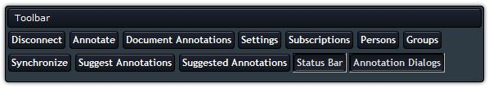

Figure : Screenshot of dialog window:

The dialog has these classes:

**.aed-ui-dlg** - Sets up padding, font size and type and overflow on hidden. Hidden means, that there will be no scroll bar on the right side of the dialog window.

**.aed-ui-dlg-header** - Sets up relative position, which means the element is positioned relative to its normal position, so "left:20" adds 20 pixels to the element's LEFT position, next it is display, padding, where a top and a bottom have a length 0.1em and a right and a left side have the length same as the top and the bottom. This header has sets up background, border and color for font.

There is the class **.aed-ui-dlg-header** in figure 2.header.jpg

Figure : The .aed-ui-dlg-header class of dialog window

There were used to classes **.aed-ui-dlg-titlebar** and **.aed-ui-dlg-title** in the figure 2. The class **.aed-ui-dlg-titlebar** takes care of display and of position. The class **.aed-ui-dlg-title** takes care of color and of size for font and sets up padding for the left side on length 0.4em.

The classes **.aed-ui-draggable** and **.aed-ui-dlg-titlebar** change cursor to drag icon.

## Buttons

bottoms.jpg

Figure : The buttons of dialog window

Here you can see a buttons in the figure 3. They have these classes:

* **.aed-ui-dlg-buttons**
* **.aed-ui-dlg-header-buttons**
* **.aed-ui-btn**
* **.aed-ui-btn-selected**
* **.aed-ui-btn-hover**
* **.aed-ui-btn-text**
* **.aed-ui-btn-disabled**
* **.aed-ui-dlg-header-buttons**
* **.aed-ui-btn**
* **.aed-ui-msg-buttons**
* **.aed-ui-btn**
* **.aed-ui-toolbar**
* **.aed-ui-dlg-buttons**
* **.aed-ui-btn,**
* **.aed-ui-btn-text**
* **.aed-ui-btn-noicon**
* **.aed-ui-btn-text.**

Main class is an **.aed-ui-btn** class. The class takes care of button. Buttons you can see in bottom.jpgfigure 3. The **aed-ui-btn** class sets up font type, font size, text align, font weight, background and background position. Main class **aed-ui-btn** sets up the element, which is placed as an inline element (on the same line as adjacent content), but it behaves as a block element. Next it is right margin, overflow, padding, position and the others. There is the cursor render as a pointer.

Figure : Hover button of dialog window

btnselected.jpgThere are classes, which take care of styles, which begin after selected and hovered on button. It means what will be font color or background in button. This makes **.aed-ui-btn-selected** class and **.aed-ui-btn-hover** class. The **.aed-ui-btn-selected** class selects (figure 5) a button and the **.aed-ui-btn-hover** makes hover via button (figure4).

Figure : Selected buttons of dialog window

There is class **.aed-ui-btn-disabled**, which sets up the default cursor, font color and background color and background image. The class disables cursor.

Classes **.aed-ui-dlg-header-buttons** and **.aed-ui-btn** together set up height, margin, padding for top, bottom, right and left side and border as solid. There is class **.aed-ui-msg-buttons** together **.aed-ui-btn**.These classes set up same styles as preview classes. These used classes you can see in figure 6.

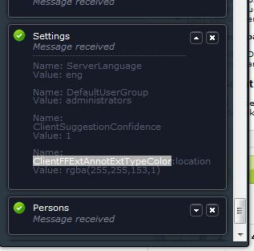

Figure : Used to .aed-ui-msg-buttons and .aed-ui-btn classes of dialog window

msg bottoms.jpg In figure 6 you can find these classes:

Figure : The .aed-ui-msg-buttons class of dialog window

* **.aed-ui-toolbar, .aed-ui-dlg-buttons, .aed-ui-btn** (these classes set up margin and left float)
* **.aed-ui-btn-text** (the class sets up padding for left side)
* **.aed-ui-btn-noicon, .aed-ui-btn-text** (these classes set up padding for left side)

The dialog subsumes next classes:

* **.aed-ui-overlay**
* **.aed-ui-dlg-content**

The **.aed-ui-overlay** classsets up width, height and background. This class makes overlay. The **.aed-ui-dlg-content** class (in figure 8) sets up width, height and overflow-y as auto. It’ll be should cause a scrolling mechanism to be provided for overflowing boxes.

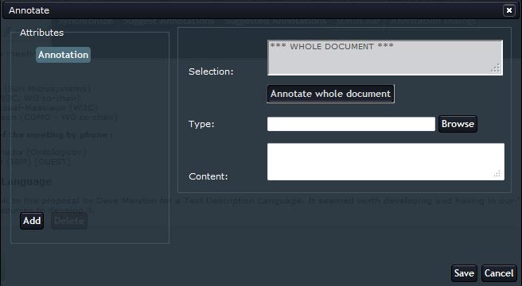

Figure : Used to .aed-ui-dlg-content class of dialog window

## Iframe dialog

This general class you find in figure 9. The dialog is an iframe.

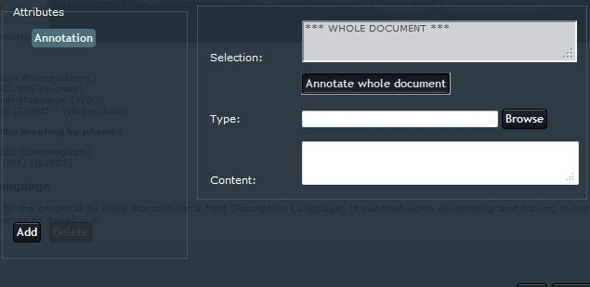

Figure : The iframe of dialog window

In figure 9 there is the iframe. The iframe includes these classes:

* **.aed-ui-iframe-wrapper**
* **.aed-ui-iframe-wrapper iframe**

Both classes set up width and height for iframe.

## Icons

This general class you can find for example in figure 10.

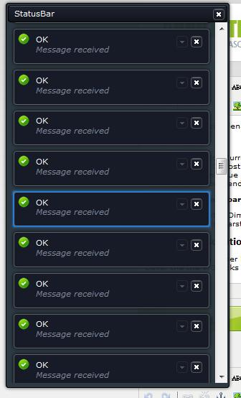

Figure : The statusBar with icons of dialog window

iconOK.jpgIcons are small pictures in **.jpg, .gif** or **.png** format. There is an icon in figure 11 and in the figure 10 you can see used to scrolling mechanism as I mentioned before.

Figure : Used icon from statusBar of dialog window

This general class includes classes, which have set sup background image or position. All icons have set up padding and minimal weight and height. Minimal weight and height has sets ups **.aed-ui-icon** class.

There are including classes:

* **.aed-ui-icon-error**
* **.aed-ui-icon-warning**
* **.aed-ui-icon-info**
* **.aed-ui-icon-ok**
* **.aed-ui-icon-anno**
* **.aed-ui-icon-loading**
* **.aed-ui-icon-close**
* **.aed-ui-icon-showdetails**
* **.aed-ui-icon-hidedetails**
* **.aed-ui-icon-join**
* **.aed-ui-icon-leave**
* **.aed-ui-icon-expandtree**
* **.aed-ui-icon-collapsetree**
* **.aed-ui-icon-edit**
* **.aed-ui-icon-delete**
* **.aed-ui-icon-accep**
* **.aed-ui-icon-explore**

General class includes **.aed-ui-dlg-header-buttons, .aed-ui-icon, .aed-ui-msg-buttons .aed-ui-icon, .aed-ui-toolbar .aed-ui-dlg-buttons .aed-ui-btn** and **.aed-ui-icon-close**. These classes have been describing before.

## Person

There is a general class in the figure 12.

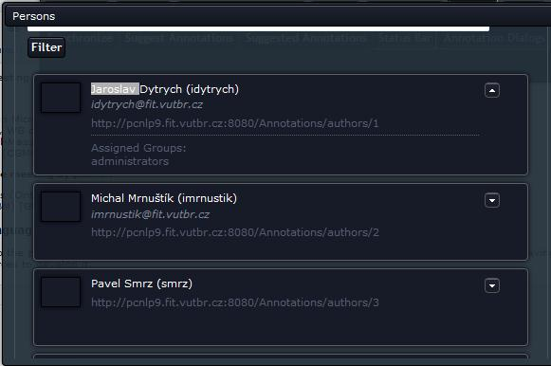

Figure : General class Person of dialog window

This class includes these classes:

* **photo.jpg .aed-ui-msg-person**

Figure : The .aed-ui-msg-photo class of dialog window

* **.aed-ui-msg-photo**
* **.aed-ui-dlg-person**
* **.aed-ui-msg-buttons**
* **.aed-ui-btn**
* **.aed-ui-msg-person**
* **.aed-ui-msg-main**

These classes set up padding, minimal height and right float. But class **.aed-ui-msg-photo** makes position, top size, left size, width size. The class sets up minimal height and max height border. This class sets up box shadow for Mozilla Firefox and filter for Internet Explorer for version 5.5-7 and 8. The **.aed-ui-msg-photo** class you can see in figure 13.

## Message

There is a general class Message in figure 14. Here you can see dialog, which name is **statusBar.**

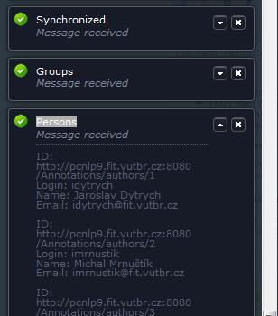

Figure : The general class Message in the statusBar of dialog window

The general class has these classes:

* mssf.jpg **.aed-ui-msg**

Figure : The .aed-ui-msg and .aed-ui-msg-main classes of dialog window

* **.aed-ui-msg-main**
* **.aed-ui-msg-main-header**
* **.aed-ui-msg-main-content**
* **.aed-ui-msg-buttons**
* **.aed-ui-msg**
* **.aed-ui-icon**
* **.aed-ui-msg**
* **.aed-ui-msg-buttons**
* **.aed-ui-btn**
* **.aed-ui-msg**
* **.aed-ui-msg-buttons**
* **.aed-ui-btn**
* **.aed-ui-icon**
* **.aed-ui-msg-title**
* **.aed-ui-msg-subtitle**
* **.aed-ui-msg-header-content**
* **.aed-ui-msg-main-content**

There is used to an **.aed-ui-msg** class in figure 15. The class sets up relative position, background color, border, minimal height, margin for all sides (top, right, bottom and left). The class sets up box shadow for Mozilla Firefox, filters for Internet Explorer for versions 5.5-7 and 8. For Internet explorer for versions 5.5-7 sets up border radius.

There is an **.aed-ui-msg-main** class in the figure 15. This class sets up only padding for right, bottom and left side.

There are you can find another used to classes in the figure14. These classes have same repeating style.

## Group

This general class includes these classes:

* **.aed-ui-msg-group** (the class sets up minimal height)
* **.aed-ui-msg-group-joined** (the class sets up border his size, color and type)

Here is a general class Group in the figure 16.

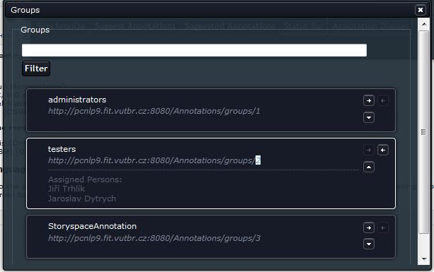

Figure : The general class Group of dialog window

## Corners

This general class has classes, which make rounded corners of the windows. These classes are:

* **.aed-ui-corner-all, .aed-ui-corner-bottom, .aed-ui-corner-right, .aed-ui-corner-br**
* **.aed-ui-corner-all, .aed-ui-corner-bottom, .aed-ui-corner-left, .aed-ui-corner-bl**
* **.aed-ui-corner-all, .aed-ui-corner-top, .aed-ui-corner-right, .aed-ui-corner-tr**
* **.aed-ui-corner-all, .aed-ui-corner-top, .aed-ui-corner-left, .aed-ui-corner-tl**

## Draggable

This general class has classes, which make windows draggable. These classes are:

* **.aed-ui-draggable**
* **.aed-ui-draggable-handle**

## Resizable

This general class has classes, which make windows resizable. These classes are:

* **.aed-ui-resizable**
* **.aed-ui-resizable-handle**
* **.aed-ui-resizable-handle-n**
* **.aed-ui-resizable-handle-s**
* **.aed-ui-resizable-handle-e**
* **.aed-ui-resizable-handle-w**
* **.aed-ui-resizable-handle-se**
* **.aed-ui-resizable-handle-sw**
* **.aed-ui-resizable-handle-nw**
* **.aed-ui-resizable-handle-ne**

## Clickable

Change cursor to hand. This general class includes class:

* **.aed-ui-clickable**, which makes clickable the windows

## DLG statusBar

This general class includes these classes:

* **.aed-ui-dlg-statusbar, .aed-ui-dlg-content**
* **.aed-ui-dlg-statusbar , .aed-ui-dlg-buttons**

These classes you can find in dialog, which name is “**statusBar**”.

## Tree

This general class styles expandable trees. There is tree in figure 17.

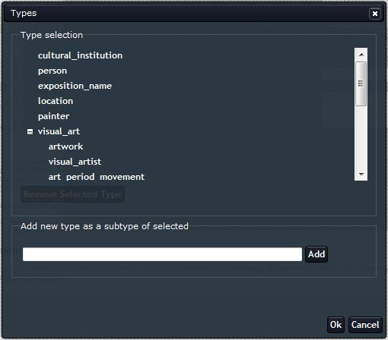

Figure : The tree of dialog window

This class includes these classes, which take care of tree:

* **.aed-ui-tree**
* **.aed-ui-tree-node**
* **.aed-ui-tree-node, .aed-ui-btn**
* **.aed-ui-tree-node, .aed-ui-btn-hover**
* **.aed-ui-tree-node, .aed-ui-icon-expandtree, .aed-ui-tree-node , .aed-ui-icon-collapsetree**
* **.aed-ui-tree-node-selected > .aed-ui-tree-node-btn-text**
* **.aed-ui-tree ul**
* **.aed-ui-tree-node-btn-expand**
* **.aed-ui-tree-node-btn-text**
* **span.annoed-ui-tree-btn**
* **a.annoed-ui-tree-btnplus**
* **a.annoed-ui-tree-btnminus**
* **ul.annoed-ui-tree-ul**
* **ul.annoed-ui-tree-root**
* **li.annoed-ui-tree-li**
* **a.annoed-ui-tree-btnnode**

## Suggestion bar

This general class makes suggestion bar. You can find it in the figure 18.

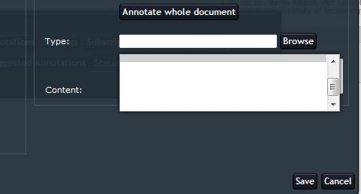

Figure : The suggestion bar of dialog window

This class includes these classes:

* **.aed-ui-suggestions_bar**
* **.aed-ui-suggestions_bar_item**
* **.aed-ui-suggestions_bar_item_selected**

iframe.css

## Eric Mayer’s Reset CSS styles

Eric Mayer – he pioneered the technique of CSS Reset.

The reset styles given here are intentionally very generic. There isn't any default color or background set for the body element, for example. It should be edited, extended, tweaked and otherwise tuned to match your specific reset baseline.

The goal of a reset stylesheet is to reduce browser inconsistencies in things like default line heights, margins and font sizes of headings, and so on.

## Body

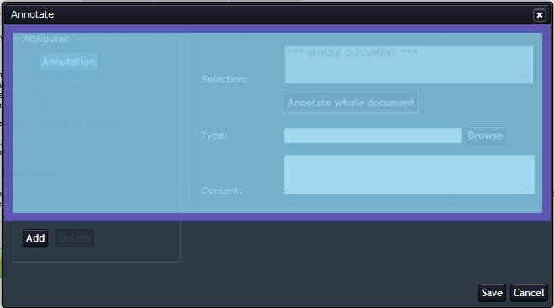

Figure : The body of dialog window

There is a body of dialog window in the figure 19. The body has sets up font type, color and size and padding.

## The .aed-form class

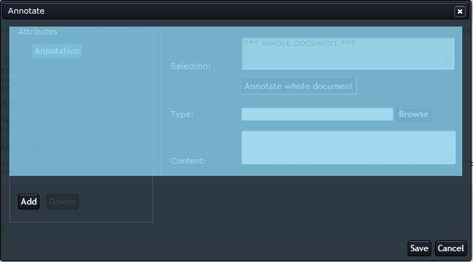

Figure : The form of dialog window

Here you can see the **.aed-form** class in figure 20. This class sets up width and height for form of dialog window. The form, you can imagine like a container, for example. This container has some items, for example it will be fieldset, table and so on. And all these container’s items have own styles. There are items on next pages.

## Fieldset

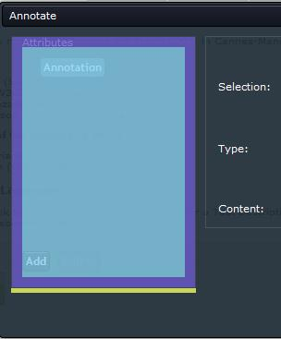

Figure : The fieldset of dialog window

There is an **.aed-form fieldset** class in the figure 21. This class sets up margin for bottom, padding and border for fieldset.

## The .aed-form table

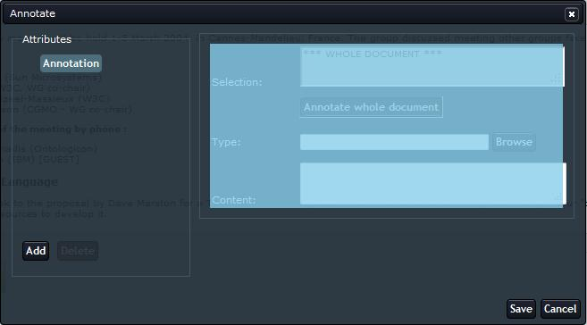

Figure : The table of dialog window

Here you can see **.aed-form table** class, which sets up width table in figure 21.

## The table’s columns

The table has some columns. The table’s columns you can see in figure 22.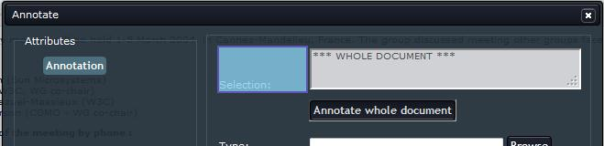

Figure : The table's column of dialog window

There are **.aed-form table** and **.aed-ui-table-column1** in the figure 23. These classes set up width column.

## The table cells

Here you can see table cell in the figure 24. There is **.aed-form table td** class, which sets up padding for table cells in the figure 24.

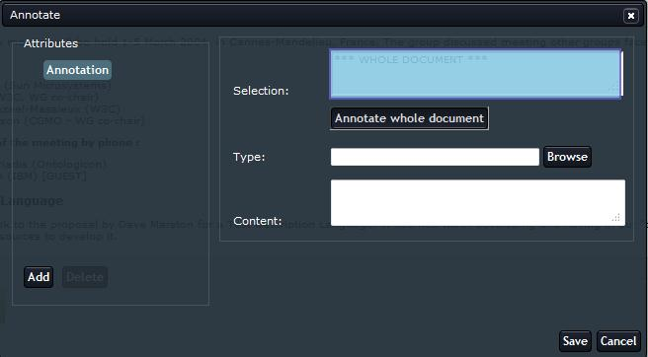

Figure : The table cell of dialog window

## Input and select

There are you can see **.aed-form input** class and **.aed-form select** class in the figure 25. The **.aed-form select** class sets up width, font type and size after select button. The **.aes-form input** class sets up width, font type and size input button.

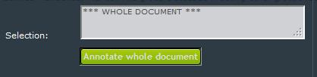

Figure : Input and select of dialog window

## The textarea

There is the textarea in the figure 26. There was used to **.aed-form textarea** class, which sets up width, font size and type in the figure 26.

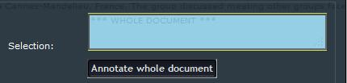

Figure : The textarea of dialog window

There were used to **.aed-form textarea, .aed-disabled** class, which set up font color and background color and an **.aed-form input, .aed-disabled**, which set up background color and font color in the figure 26.

## Span

The **#aedEmptyDiv** class sets up height for empty div.

## DLG Annotate

This general class has these classes and ids:

* **#aedFormAnnotate** – id sets up relative position (the class you can see in the figure 20)
* **#aedAnnotateLeft**  – id sets up absolute position, size for top and left and width
* **#aedAnnotateRight**  – id sets up margin for left side
* **#aedType** – id sets up width
* **#aedSimpleType, #aedGeoPointType, #aedNestedAnnotationType**  – ids set up width
* **#aedAnnotationLinkValue**  – id sets up width
* **#aedSuggestions, #aedSimpleSuggestions, #aedGeoPointSuggestions, #aedNestedAnnotationSuggestions**  – ids set up relative position and height
* **#aedSuggestions, .aed-ui-suggestions_bar, #aedSimpleSuggestions, .aed-ui-suggestions_bar, #aedGeoPointSuggestions, .aed-ui-suggestions_bar, #aedNestedAnnotationSuggestions, .aed-ui-suggestions_bar** – ids set up absolute position, width and size for top and left
* **.aed-ui-suggestions_bar_item**  – id sets up font color
* **#aedAnnotateTreeWrapper** – id sets up height and overflow as auto

These classes and ids you can find in annotate of dialog window.

The **#aedAnnotateLeft** id you can see in the figure 27.

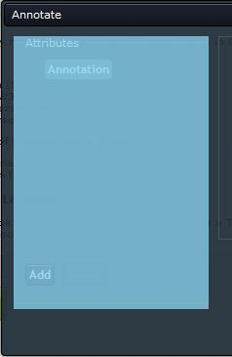

Figure : The left annotate of dialog window

The **#aedAnnotateRight** id you can see in the figure 28.

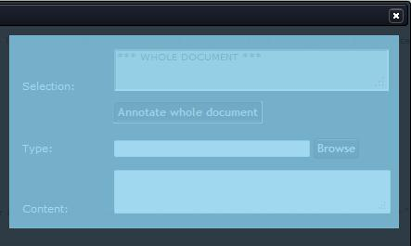

Figure : The right annotate of dialog window

There is a **#aedType** id in figure 29.

aedType.jpg

Figure : The annotate type of dialog window

There is a **#aedAnnotateTreeWrapper** id in the figure 30.

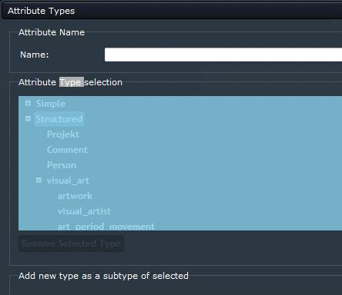

Figure : The tree wrapper of dialog window

## DLG Suggest annotations

A general class DLG Suggest annotations you can find in the **suggest annotations** of dialog window. The suggest annotation of dialog window you can see in the figure 31.

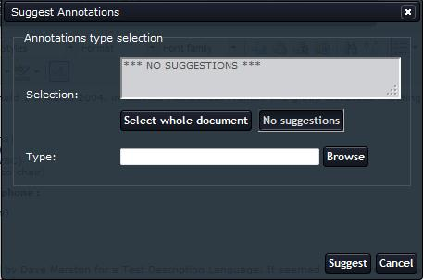

Figure : The suggest annotation of dialog window

This general class includes these ids and class:

* **#aedFormSuggestAnnotations** – id sets up relative position
* **#aedSuggestType** – id sets up width
* **#aedSuggestSuggestions** – id sets up relative position and height
* #**aedSuggestSuggestions, .aed-ui-suggestions_bar** – id and class set up absolute position, width, size for top and left

## DLG Settings

The general class DLG Settings you can find in Setting of dialog window. There is a dialog Settings in figure 32.

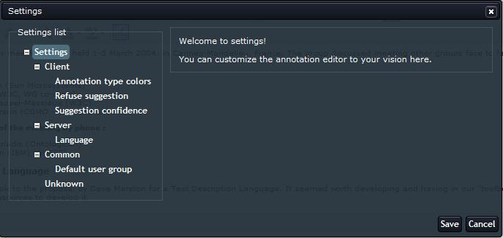

Figure : The dialog Settings of dialog window

The general class has these ids and classes:

* **#aedFormSettings** – id sets up relative position
* **#aedSettingsLeft**  – id sets up absolute position, width and size for top and left
* **#aedSettingsRight**  – id sets up margin for left side
* **#aedSettingsTreeWrapper**  – id sets up height and overflow as auto
* **#aedSettingsClientAnnotationTypeColorTable td** - id for item td sets up padding
* **#aedSettingsClientAnnotationTypeColorTableHeader, .aed-ui-table-column1** – set up width
* **#aedSettingsClientAnnotationTypeColorTableHeader, .aed-ui-table-column2** – set up width
* **#aedSettingsClientAnnotationTypeColorTableHeader, .aed-ui-table-column3** - set up width and minimal width
* **#aedSettingsClientAnnotationTypeColorTableHeader, .aed-ui-table-column4** – set up width and minimal width
* **#aedSettingsClientAnnotationTypeColorTable, .aed-ui-table-column1** – set up width
* **#aedSettingsClientAnnotationTypeColorTable, .aed-ui-table-column2** – set up width
* #**aedSettingsClientAnnotationTypeColorTable, .aed-ui-table-column3** – set up width
* **#aedSettingsClientAnnotationTypeColorTable, .aed-ui-table-column4** – set up width
* **#aedSettingsClientAnnotationTypeColorTable, .aed-ui-btn** – set up margin for top, right, bottom and left sides.
* **#aedSettingsClientAnnotationTypeColorTable input** – id for item input sets up background color, border, border radius, padding and font color
* **#aedSettingsClientRefuseSuggestionValue** – sets up inline block display, float left and width
* **#aedSettingsClientRefuseSuggestionWrapper** – sets up display block and margin for top
* **#aedSettingsUnknownTable td** - id sets up padding for item td
* **#aedSettingsUnknownTableHeader, .aed-ui-table-column1** – set up width
* **#aedSettingsUnknownTableHeader, .aed-ui-table-column2** – set up width
* **#aedSettingsUnknownTableHeader, .aed-ui-table-column3** – set up width and minimal width
* **#aedSettingsUnknownTable, .aed-ui-table-column1** – set up width
* **#aedSettingsUnknownTable, .aed-ui-table-column2** – set up width
* **#aedSettingsUnknownTable, .aed-ui-table-column3** – set up width
* **#aedSettingsUnknownTable, .aed-ui-btn** – set up margin
* **#aedSettingsUnknownTable input** – id sets up background color, border, border radius, padding and font color for item input

## DLG Subscriptions

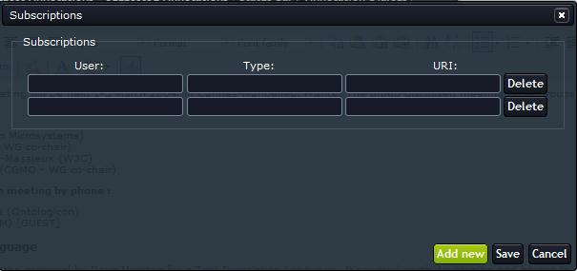

Figure : The dialog Subscriptions of dialog window

There is a dialog Subscriptions in the figure 33. Here you can find these classes and ids:

* **#aedTableSubscriptions td** - id sets up padding for item td
* **#aedTableSubscriptions, .aed-ui-table-column1** – set up width
* **#aedTableSubscriptions, .aed-ui-table-column2** – set up width
* **#aedTableSubscriptions, .aed-ui-table-column3** – set up width
* **#aedTableSubscriptions, .aed-ui-btn** – set up margin for top and bottom
* **#aedTableSubscriptions input** – id sets up background color, border, border radius, padding and font color for item input

## DLG Persons and Groups

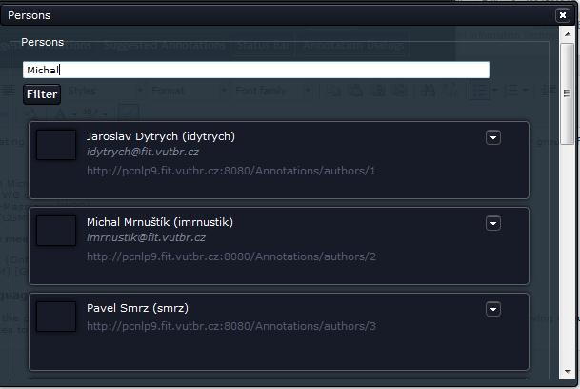

Figure : The dialog Persons of dialog window

Here is a dialog Persons in the figure 34. You can find these classes and ids there:

* **.aed-form #aedPersonsSearch** – class sets up width for item, which have id **#aedPersonsSearch**

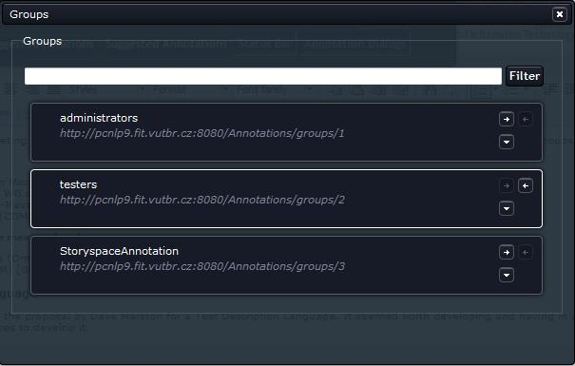

Figure : The dialog Groups of dialog window

Here is a dialog Groups in the figure 35. You can find these classes and ids there:

* **.aed-form #aedGroupsSearch** – class sets up width for item, which have id **#aedGroupsSearch**

## DLG Typecolors

This general class includes these ids:

* **#aedFormTypeColors** – id sets up relative position
* **#aedTypeColorsType** – id sets up width
* **#aedTypeColorsSuggestions** – is sets up relative position and height
* **#aedTypeColorsSuggestions, .aed-ui-suggestions_bar** – set up absolute position , width, size for top and left sides.
* **#aedTypeColorsAlpha** – id sets up width

## DLG annotate, types, DLG attrtypes

The general class includes these ids:

* **#aedTypesTreeWrapper** – id sets up height and overflow as auto
* **#aedAttrTypesTreeWrapper** – id sets up maximal height and overflow as auto
* **.aed-form #aedAddType** – class sets up width, which have id **#aedAddType**
* **#aedAddToTypeAttributes, #aedAddToTypeAttributesSimple, #aedAddToTypeAttributesGeoPoint, #aedAddToTypeAttributesNested** – ids set up inline block display, float left and width
* **#aedRequired, #aedRequiredSimple, #aedRequiredGeoPoint, #aedRequiredNested** – ids set up inline block display, float left and width
* **#aedAddToTypeAttributesWrapper** – id sets up display as block
* **#aedAddToTypeAttributesWrapperSimple, #aedAddToTypeAttributesWrapperGeoPoint, #aedAddToTypeAttributesWrapperNested** – ids set up display as block and margin for top side
* **#aedRequiredWrapper, #aedRequiredWrapperSimple, #aedRequiredWrapperGeoPoint, #aedRequiredWrapperNested** – ids set up display ad block and margin for top and left sides
* **#aedRequiredWrapper, #aedRequiredWrapperSimple, #aedRequiredWrapperGeoPoint, #aedRequiredWrapperNested span** – ids set up padding and display as block for item **span**

wysiwyg.css

## Annotation text highlight

This general class includes these classes:

* **.aed-anno**
* **.aed-anno-multi**
* **.aed-anno-hightlight** – class sets up border, cursor, box shadow for Mozilla Firefox, filters for Internet Explorer for version 5.5-7 and 8
* **.aed-anno-annolink** – sets up cursor as hand and pointer
* **.aed-anno-annolink-hover** – sets up border
* **.aed-anno-hover**

## Suggestion text

This general class includes this **.aed-anno-suggestion** class. The class sets up border, box shadow for Mozilla Firefox and filter for Internet Explorer for version 5.5-7 and 8.