Part 1: Understanding the Problem

Team UI French Fry

Emma Hanson, Erin Kim, Hye Lim Kim, Philena Yang, Zehao Tan

| Table of Contents  Problem Space  Overview  Methodology  User Characteristics  Task Analysis  Usage Scenarios  Current UI Critique  Usability Goals  Requirements and Constraints  Implications  Limitations  Reflection  Sustainability Goals  Citations | Page 2  Page 2  Page 2  Page 5  Page 8  Page 10  Page 12  Page 16  Page 17  Page 18  Page 18  Page 19  Page 19  Page 21 |
| --- | --- |

## Problem Space

Food insecure people often do not have the means of transportation to access food and resources provided by the Atlanta Community Food Bank.

# Overview

The Atlanta Community Food Bank (ACFB) is a network program of Feeding America, a non-profit organization consisting of a nationwide network of over 200 food banks. ACFB works to end hunger by collecting and distributing donated food and goods across Metro Atlanta and North Georgia. ACFB has multiple food distribution routes, including food pantries and community kitchens where they partner with other organizations. The focus of this project will be on distribution routes in which ACFB connects directly to those in need, which currently includes mobile markets and community food centers.

Data shows that food insecurity is growing the fastest in the suburbs of Atlanta, where there are few, if any, bus and MARTA lines. This, as well as the general lack of access to transportation in metro Atlanta highlights the need for the distribution of food and resources to food insecure people with issues of mobility, especially the elderly, children, or those with disabilities. The existing system includes ACFB partnering with other agencies and operating mobile “pop-up” pantries each month in areas with inadequate infrastructure or public transportation. It also includes people finding their own forms of transportation, from walking to public transportation.

This system is needed because people in need of food have to access the food and goods provided by the ACFB. The user group of our system will be those in need. To access the resources, they need to have the means of communication with ACFB to receive information and a means of physically receiving the supplies.

# Methodology

*In our analysis of the problem space with regards to ACFB, we considered data from various sources, including data from ACFB’s website(*[*https://www.acfb.org/*](https://www.acfb.org/)*) with their work, interviews with an ACFB representative and a MealsOnWheels volunteer, and statistics gathered through surveys of proxy users(*[*https://tinyurl.com/ACFBSurveyResults*](https://tinyurl.com/ACFBSurveyResults) *) in the community. We also looked at studies regarding transportation and food insecurity in the Atlanta area. We also collected data through questionnaire surveys from people that do not have transportation access on campus and utilized them as proxy users.*

Current ACFB Programs

Before examining services outside of ACFB, we researched the services that ACFB provides to the Atlanta community to understand the resources that users typically use in order to obtain food from this food bank.

ACFB currently supports those who are food insecure by providing food drives, pantries, kitchens, shelters, and collaboration with partners to make food accessible in other locations such as “childcare centers, healthcare facilities, shelters, and senior centers across Atlanta and north Georgia” (“Stories of Hunger”). ACFB has also created a mobile pantry program where a “pop-up” pantry is operated in communities where public transportation is an issue in getting to a food bank. The information collected from ACFB allowed us to understand the level of accessibility in and around Atlanta and that many food insecure people were able to access food through these food banks, community kitchens, and other locations. However, the services that ACFB currently provides does not thoroughly help those with little to no mobility. In order to find data and other information to better understand accessibility to those with little to no mobility, we conducted qualitative research techniques through interviews and quantitative research techniques through a survey to answer the problem space.

Surveys

Another method in which we gathered data was through a questionnaire in which we were able to receive 35 responses. We first developed the survey questions individually during an in class participation activity, and then came together as a group during a studio activity and chose questions that allowed us to assess the current problem space best. From here, we were able to receive feedback from our TA, and upon discussion, we realized that we would need to adjust our questions in order to best address the proxy users. Initially, we developed the survey to be filled out by users of the ACFB, but this was not possible, so we changed questions such as “How far is the nearest ACFB location to you?” to “How far is the nearest grocery store to you?” because the proxy user’s source of food would be grocery stores and not ACFB. All responses from our questionnaire were completed by proxy users. These proxy users are all Georgia Tech students who do not have access to a car on campus. Due to the nature of the pandemic, ethical concerns, and the inability to easily survey those affected by food insecurity, we had to pivot our target group for the questionnaire. The nature of our problem space lies in helping those who are both affected by food insecurity and lack access to transportation. Because we couldn’t survey those affected by food insecurity, we targeted those around us who don’t have access to transportation while being on campus because they would be able to represent those who need access to food but lack access to transportation.

Our survey consisted of 15 questions and we were able to ask questions about the user’s demographics, preferences regarding delivery and food pick up, ease of transportation, and general questions to gain insight on the problem space. We asked a mix of open, closed, semantic scale questions in the questionnaire. In order to encourage a good response, we made our survey fully anonymous, avoided asking leading questions, and intentionally ordered the questions so the longer questions were at the end and wouldn’t discourage the respondent from filling out the survey .

The survey informed us that 80% of respondents would prefer food delivery as their choice of accessing food and that 50% of respondents walk to get food from their nearest food access point(in this case, grocery stores or restaurants). A larger sample size with more accurate users could have yielded more accurate results for our problem space. Raw survey data can be found [here](https://drive.google.com/file/d/1YgzjNFkI0Roi-jQKDPkMm1vDvI4W_RZN/view?usp=sharing).

Interviews

*Class Interview with ACFB Representative*

The first interview was conducted by Dr. Rosa Arriaga with ACFB representative Luisa Fortin. Fortin is an education and outreach specialist for ACFB. A semi-structured interview format was conducted where a formalized list of questions were asked, but additional follow-up questions to elaborate more on a certain topic were also given to create a fluid discussion. All questions asked were open ended questions that do not have a predetermined answer format. There was a clear introduction/warm-up where Fortin introduced herself, her position in ACFB, and how she came about working for ACFB. It was a good beginning for the interview to get to know who the interviewee is as a person and how her perspective is valuable for the research we are conducting. After the introduction, Dr. Arriaga began to ask Fortin the list of questions in order and deviated from the order towards the beginning for students to ask their group’s questions directly to Fortin. Lastly, there was a clear closure where the Dr.Arriaga and the students participating thanked Fortin for her time. Although a lot of questions were effective, some questions had the pitfalls of being too long and would have been more effective given as separate questions for Fortin to discuss in better detail rather than all at once. For future interviews, I believe having a list of questions organized by topic would facilitate better, more detailed answers rather than having to go back and forth with different topics.

In regards to the information collected during the interview, Fortin provided many insights on the goals of ACFB, volunteers, and the populations seeking help from the ACFB. One main takeaway from this interview is the largest demographic facing food insecurity is children. After children, the 2nd largest demographic is working families, and the 3rd largest demographic is the elderly. This takeaway gave us insight into why a large population of ACFB users could potentially have trouble getting access to food. Fortin listed barriers that children, the largest demographic group facing food insecurity, are facing when trying to get access to food, including transportation and resources. Another takeaway from this interview is that there are many barriers of obtaining food for rural communities. Fortin mentions that a major barrier is transportation and internet for the rural communities. According to Fortin, rural areas do not have equal access to the internet, making it a barrier to access information and services. Due to the lack of transportation in rural areas compared to urban areas, a lack of transportation is a major barrier for ACFB users living in rural areas. Overall, Fortin provided us with a lot of information that was very useful to connect with our problem space.

*Interview with Meals On Wheels Volunteer*

The second interview was conducted by Emma with a volunteer for Meals On Wheels Atlanta, which is an organization that addresses both food insecurity and transportation issues for seniors in the Metro Atlanta area. We used a structured interview format with open ended questions in order to collect the data we needed but allow the interviewee to elaborate on her answers. The interviewee had volunteered for Meals On Wheels Atlanta multiple times, as both on-site packaging food and as a food delivery driver. As an on-site food packaging volunteer, she packaged meals and assisted in an assembly line process to fill each driver’s car with the correct number of meals. As a delivery driver, she was given a route, a list of seniors who had previously signed up to receive services from Meals On Wheels, and a set number of meals to deliver to the locations given to her. She emphasized that both volunteer positions are well organized and allow for a smooth volunteer experience. This system is very strong for addressing the food insecurity and transportation needs of seniors in the Metro Atlanta area, but does not address the food insecurity and transportation needs of younger members of the community. The interview went very well and included a warm up as well as a debrief for the interviewee, so she was able to understand why she was asked to answer our questions. In the future, interviewing more volunteers with experience at both ACFB and Meals on Wheels could be beneficial.

# User Characteristics

Primary Stakeholders

Primary users interact directly with the system. Food insecure people with transportation/mobility issues are one of our primary users because they are in need of food and cannot access it through their own means. They could be elderly, children, disabled or have medical conditions. They interact with the system to communicate and receive food from ACFB.

Secondary Stakeholders

Secondary users do not interact directly with the system but they are affected by it and interact with the system through primary users. These users would be ACFB volunteers and workers as they help the system function. We determined that these users affect the system as they are the ones supporting it. Many of these volunteers donate their time to do good in the community. They are secondary users because while the focus of the system is on food insecure people with limited means of mobility, ACFB workers play an integral role in making sure the food and resources end in the hands of the primary users.

Tertiary Stakeholders

Tertiary users do not interact with the system but affect it and can be affected by it. People that donate money to ACFB are one of our tertiary users because they provide support for ACFB and the system to operate while never directly interacting with the system. Feeding America, the parent organization of ACFB, is also a tertiary user. Since they encompass a network of over 200 food banks, they have an interest in ACFB and their other networks succeeding. Public transportation workers and rideshare drivers are also tertiary users because they provide a means of transportation for many food insecure people. Since the system targets transportation needs, these workers would be affected.

Personas

|  | Food insecure person with accessibility issues (elderly/disabled) | ACFB volunteer | ACFB donor | Transportation worker |
| --- | --- | --- | --- | --- |
| Age | ~30+ | ~18+ | ~18+ | ~18+ |
| Sex | Both | Both | Both | Both |
| Educational Background | May have minimal qualification | May be in school / have minimal qualifications / educated | Educated | May have minimal qualification / educated |
| Family Status | May be a single parent / no family | May be single / married / have children | May be single / married / have children | May be a single parent / diverse family status |
| Physical Limitations | May be disabled / have medical issues | Able-bodied | Likely to be in decent health | Likely to be in decent health |
| Transportation Access | May have access to transportation but only some of the time / no access | May have access to transportation / have a car | Likely to have a car | Have a car / use public transportation |
| Technology Access | May have phone access | May have smartphone access | Smartphone access | Smartphone access |
| Attitude | May be food insecure due to lack of transportation | Want to give back to community / help people around them | Want to give back to community but may not / do not have the time | Hoping to make money through working for public transit / rideshare |

We first developed these user personas individually, thinking about our target users and attributes that would represent them well. From there, we worked in studio to refine these personas as well as using evidence found in our surveys and on the ACFB website and studies of food insecurity and transportation in Atlanta. Using these resources, iteratively developed our user personas by finding evidence of the issues they face and attributes they possess.

*Primary User Persona*

Janet, 46, is a single parent who has a 13 year old child, Jackson. She is currently out of work as the local pizza shop that she worked at shut down due to COVID. She is having trouble finding a job due to the pandemic, and she has a high school education. She has been facing some health complications and all of her savings has been used on medical bills and supporting Jackson. Because she lives far from the city where there are more food banks and resources, each trip is a big undertaking and takes a lot of her time. She owns a smartphone but doesn’t have the means to Uber and will have to rely on a neighbor to take her to the nearest MARTA station or will have to walk there. After riding the MARTA, she will have to walk some more to the nearest food bank and bring the food back with her, going through the MARTA and then walking home. Janet will also walk to the ACFB mobile food pantry when they pop up a couple times a month. Even though there are some sources of free food, none of them are consistent and convenient for her during these struggling times, and on many nights she and Jackson will not have enough food to eat. She feels like a bad mother to Jackson and is in need of help.

*Secondary User Persona*

Becky, 23, recently graduated college and is working a full time job at a small consulting firm. She is unmarried with no kids so she has a lot of free time to do what she wants. She keeps herself physically active by going to the gym and has a smartphone to communicate with her friends and family on social media. Since she has graduated, she’s thought a lot about what she wants to do in life and realized that she wants to give back to the community she’s been a part of since college. Over the past couple of months, she has been volunteering for ACFB and has helped set up mobile pantries in the suburbs of Atlanta a couple times per month. She is fortunate that she has a car and uses it to volunteer when she drives the food from ACFB storage to the pop up pantry for the week. She is grateful that she can help others and finds the work fulfilling.

*Tertiary User Persona*

John, 30, is a rideshare driver and works primarily in Atlanta suburbs. He graduated from Georgia State University but was laid off recently due to the pandemic. He’s been driving Uber and Lyft with his old Honda Civic for a couple months now and drives most of his customers from their homes to the nearest MARTA station. He transitions between the Uber and Lyft apps on his smartphone when he is working and the apps notify him when there is a customer and handles the routing and transaction. He’s glad that there are customers even in the suburbs and is glad that he can drive to sustain himself during this time of hardship.

# Task Analysis

The major tasks can be broken down as follows: picking up food from ACFB locations, receiving food from the mobile pantries, and receiving food via delivery from HandsOn Atlanta, a partner of ACFB. The current system uses multiple means of transportation and communication.

The task environment is currently characterized by a majority of food distribution occurring through food pickup. There are 700 locations across 29 counties in Georgia that are partnered with ACFB to help distribute food. These locations primarily operate via food pickup from users. Users must contact their nearest ACFB location and visit the location in person to receive the food. The mode of transportation to arrive at these locations is dependent on the users.

There are also mobile markets which serve as pop up food pantries across ACFB’s service area. There are only a dozen or so of these a month, so access to these mobile markets are very limited. These mobile markets are located in areas where there is typically a lack of public transportation.

Finally, users can receive food via delivery. ACFB partners with organizations like HandsOn Atlanta to deliver food to users. Users apply for a delivery, then schedule, then have the meal delivered to their location of choice.

A detailed task analysis for this system can be seen on the page below. To develop this task analysis, each of our team members initially created a list of tasks during a series of class activities and homework assignments. From here, we each created an HTA diagram for a task pertaining to our P0 during an in class assignment. We then reviewed each of our HTA diagrams as a group in the studio and ranked them in importance from 1 to 5 as there are 5 of us in the group. The top three tasks are shown in the detailed task analysis. To verify that we didn’t miss any steps, our team interacted with the website to find the steps that a user would take to complete these tasks.

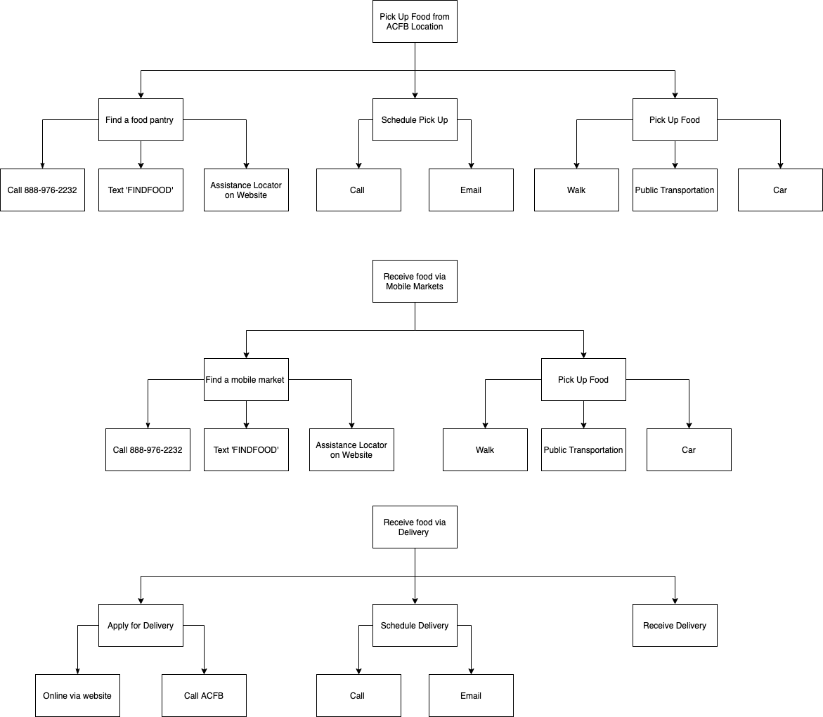

# Usage Scenarios

Our usage scenarios are based on common tasks completed by users facing food insecurity to obtain food and users volunteering to deliver food. We first individually developed scenarios and then developed the following scenarios from those.

**Usage Scenario #1**: Users picking up food from ACFB via walking

One common scenario for current ACFB users is picking up food through means of walking to the nearest food pantry. Compared to the metro Atlanta area, a larger proportion of users in the suburbs do not have “reliable vehicles,” and there are notably fewer operating food pantries (Shannon). Therefore, many ACFB users living in the suburbs are faced with the situation of walking when there is no reliable transportation to get them directly to their destination.

*Cindy is 32, a single mother with twin children in elementary school. She currently works as a waitress in a restaurant that is a 15 minute walk from her house in the suburbs. She does not own a car, and prefers to walk to work. This is because the bus is the only form of transportation near her, but it takes her 10 minutes just to walk there. With the income she earns, she has enough to pay off loans and rent every month. However, she does not have enough money to pay for groceries for the rest of this month and needs to go to a food pantry to pick up food for her family. The closest food pantry is a 30 minute walk from her house, and the bus that is closest to her home does not go in the direction of the food pantry. So, she decides to walk there. It is a very sunny day, so she starts to sweat and feels dehydrated while walking. Once she arrives at the food pantry, she waits in line to pick up her allotted food. After obtaining her food, she walks back home to cook for her children*.

**Usage Scenario #2**: Users picking up food from ACFB via transportation(car, MARTA)

Another common scenario for current ACFB users is picking up food from a food bank through means of transportation such as a car, bus, or the MARTA. A large proportion of users in metro Atlanta travel to the nearest food pantry by means of public transportation such as the bus system and the MARTA.

*Martin is 35, the head of a family consisting of his wife and his two middle school children. He is currently looking for a job after being fired from his office job 4 months ago, and his wife works at a clothing store as a cashier. He sold his car recently in order to pay incoming loan payments that his wife’s income could not cover. Although he was able to fulfill their loan payments for the month, he does not have enough money to pay for groceries for the rest of this month and needs to go to a food pantry to pick up food for his family. The closest food pantry is a 45 minute walk or a 15 minute drive from his house. Since he had sold his car and the food pantry is located too far to walk, he decides to take the bus to travel there. After walking 5 minutes to the closest bus stop, he rides the bus for 17 minutes. It is a very sunny day, and the bus is packed with people. So, he begins to sweat and feel uncomfortable. After arriving at the closest bus stop to the food pantry, he walks 3 minutes and arrives at the food pantry. He waits in line to pick up his allotted food. After obtaining his food, he walks back to the bus stop to take the bus home, carrying his food in bags.*

**Usage Scenario #3**: Delivery via HandsOn Atlanta

Another scenario only available for disabled users is getting food delivered directly to their homes through volunteer delivery drivers. From the interview of the ACFB representative, Fortin discusses how the 3rd largest demographic facing food insecurity is the eldery/disabled. Because of their age/disability, many organizations such as HandsOn Atlanta and Meals on Wheels have been developed to help provide food for this demographic and help them obtain food without having to directly pick it up themselves.

*Jina is 40 and is paralyzed from the waist down. She currently lives by herself in an apartment and her family lives 1 hour away from her. She has friends and neighbors who check in on her occasionally. She works as a freelance writer and does not have a steady income. She has not been getting income for the past 3 months and needs to go to a food pantry to pick up food for herself. She could ask her neighbors or friends to help her, but she feels uncomfortable asking for their help all the time. Because she is disabled, it is hard for her to get around places, so she decides to contact HandsOn Atlanta regarding their delivery service to the disabled facing food insecurity. She sets up a time and date for delivery and gives them her address to deliver the food. On the day of the delivery, she gets a call from the delivery volunteer. He confirms her address and tells her that he will arrive shortly. The doorbell of her apartment rings, and she opens the door to receive her requested food. She thanks the delivery volunteer and closes the door.*

**Usage Scenario #4**: Volunteers register via website

A common task for users who help deliver the food is registering to volunteer via website. For a system to provide food to the food insecure, there needs to be volunteers to help facilitate this distribution of food. From the interview of the ACFB representative, Fortin discusses the importance of volunteers and the methods of registering on their website and through a volunteering app.

*Mia is 21 and a college student. She enjoys volunteering her time to help others in need and is a member of a volunteer organization at her college. As a member, she participates in different volunteer events and comes across a volunteering event for HandOn Atlanta that needs volunteers who drive to deliver to the disabled who are facing food insecurity. Since she can drive and owns a car, she decides to register for volunteering on the HandsOn Atlanta website. She creates an account and inputs her contact and driver license information. After confirming her information is correct, she signs up for a volunteering date and time for delivering food to the disabled. She finalizes her registration and prepares for the volunteering day by checking her car’s engine, fuel, oil, and tires.*

# Current UI Critique

*Meals on Wheels*

Strengths

Meals on Wheels provides a service where the organization delivers food for food insecure elders 60 and over who have mobility issues. This service allows seniors who do not have access to transportation or have disabilities affecting their mobility to still be able to have food on their plate. With the current COVID-19 pandemic, the delivery service of Meals on Wheels also provides safety towards these elders because they are at higher risks for COVID-19. Staying at home and having food delivered allows these elders to stay safe and healthy quarantined. Meals on Wheels helps seniors nationwide, and addressing senior hunger is major because before the pandemic, nearly 9.7 million seniors were food insecure, but now, that number has increased to a greater number, and this service is helping those who are in need of food services (“The Issue: Meals on Wheels America”). The Meals on Wheels website (<https://www.mealsonwheelsamerica.org/>) interface utilizes good design techniques such as its visibility and affordance. The website’s home page displays the main options of donating, volunteering, and where to find meals, in large sized, bolded fonts and buttons allowing users to instantly access the information and pages they need. The website’s home page also displays high affordance because the key words such as “donate” is visibly in a button, allowing users to understand that in order to donate, the button needs to be clicked. Other key words such as “volunteer” is able to found when users hover over “take action” on the tab bar at the top of the home page and because the options of “take action”, which includes the volunteer button, changes colors to highlight that the user is under the specific option, users can easily understand to click on volunteer to access the next steps and pages. Unlike “take action” where many options are displayed when hovered over, “find meals” does not have options shown but also changes colors to indicate that the button is ready to be clicked, which allows users to understand that a simple click will lead them on to a different page with further information. The website also displays consistency because the colors of the page are consistent from text to buttons to tab bars with their logo colors, navy, turquoise, and light green, allowing users to easily access the website.

Weaknesses

One major weakness of Meals on Wheels’s delivery program is that the service only provides to seniors. There are many families who are single parents, adults with disabilities, adults with no access to transportation who are also food insecure that have no methods of providing food for their families or themselves due to mobility issues. Transportation is limited, especially if individuals do not own a car, because nationwide transportation such as subways or bus systems are limited to major cities or states such as New York or California. States who do have a subway or bus system of some sort are very limited in range as it mainly resides near the major cities such as the MARTA system in Georgia. MARTA only offers its subway system in the city of Atlanta, and although their bus system has a wider range on where it can go, having to rely on a small ranged transportation service only causes more problems such as time because going to the closest grocery store or even a food bank can take hours. It is important to take into consideration of those who are food insecure and aren’t over 60 because although there are more than 9.7 million seniors who are food insecure, there are over 116 million U.S. households in total that are food insecure and need the help of services such as Meals on Wheels’s delivery program (“Key Statistics & Graphics”). Some weaknesses of the Meals on Wheels website (<https://www.mealsonwheelsamerica.org/>) interface includes the consistency across different Meals on Wheels websites and pages. When a user clicks on the volunteer button, it leads them to a separate page where they can easily type in their information to sign up. However, the website diverts from the use of their brand colors, navy, turquoise, and light blue, to a bright magenta color at the top of the page which includes the button to sign up. For great user experience, users must be met with consistent colors, texts, fonts, logos, and more, but the drastic changes in colors does not fit as a good design. Other inconsistent techniques used include the Meals on Wheels pages across different cities. When a user types their zip code to find meals near them, a list of locations that direct them to its respective websites are shown, and once they click on the Meals on Wheels page for their city, they are directed to a different page.. However, websites are drastically different. For instance, the Meals on Wheels Atlanta website (<https://mowatl.org/>) not only has different fonts and colors with navy, white, and gold, but the logo is also different from the main Meals on Wheels page, which may cause confusion for users who may believe the website is not associated with Meals on Wheels America.

*ACFB Mobile Pantries*

Strengths

The Atlanta Community Food Bank has expanded their accessibility by creating mobile, or “pop-up” pantries. ACFB operates these pop-up pantries specifically in places where public transportation is an issue with users getting access to ACFB’s pantries, kitchens, shelters, and its partners. These pop-up pantries have allowed those who are food insecure with limited to no mobility to get access to nutritious food without worrying about transportation. This expansion of accessibility has increased food security around Georgia. ACFB’s Stories of Hunger (<https://www.acfb.org/stories-of-hunger/>) website interface shows its strengths through high affordance. The page includes a static tab bar at the top where users can instantly access information they would like to see such as “Food Insecurity”, “Food Bank Response”, and more. When the cursor is hovered over each section in the tab bar, a blue line is displayed under the words in order to show the users that it is able to be clicked in order to move on to its segment of the page. The consistency of the tab bar being static and always displayed at the top allows users to easily access other sections of the page with a simple click instead of having to scroll through to find what they need. When users are at the Mobile Pantries section, they are easily able to understand where the mobile pantries are located with the map displayed in the background with pantry locations highlighted in neon green circles.

Weaknesses

Some weaknesses from ACFB’s pop-up pantries is that it is limited not only in location, but also the number of occurrences. The pop-up pantries are located mainly in the city and only 1 to 2 in further counties (shown in Fig 1). Although ACFB has expanded their accessibility from outside their main headquarters in Atlanta, the location of the pop-up pantries are gathered along one area in certain counties but not farther out to the rest of the county. The pop-up pantries also only occur a couple of times each month in different locations, so users cannot rely on the pop-up pantries in obtaining their food and have to find another method in bringing food to their homes. Weaknesses of ACFB’s Stories of Hunger (<https://www.acfb.org/stories-of-hunger/>) website interface includes poor mapping. When a user scrolls through the page, the website automatically zooms in and out to the Atlanta location because the information provided on the screen is associated with Atlanta communities. However, if a user would like to look into other areas of the country, the user must drag across the map and use the “+” and “-” signifiers in order to go to a different location, but when the user starts scrolling again, the new location that they are at remains despite the information associated with Atlanta communities provided on the page is changing. In order to return to the Atlanta map, users have to manually drag the map back, or refresh the entire page. The control of moving the map and its effect of not returning back to its original state showcases bad mapping design principles in this website. Another weakness is that there is no actual page for the mobile pantries, making it difficult for users to find where the locations of the mobile pantries are or learn more information about it despite it being a big factor in expanding ACFB accessibility for users.

*Fig. 1* (“Stories of Hunger”)

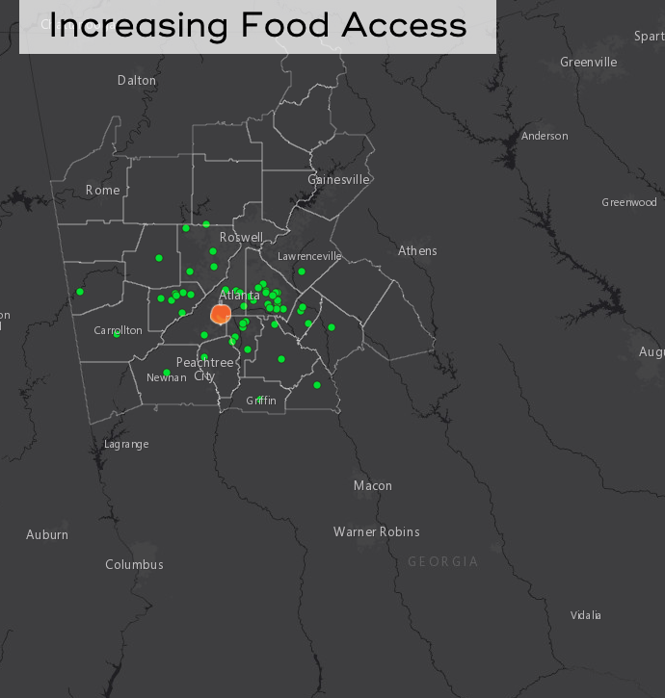

# 

# Usability Goals

| Goal | Details | How It Will Be Measured | The Design of Everyday Things Connections |
| --- | --- | --- | --- |
| Convenience | Conveniently be  able to either receive food delivery or access food pickup locations through an interface that most food secure people are able to access | The distance between how much people have to travel to receive food and their home location | Physical constraint - Limitations with the size of mobile pantries because they are transported/set up by car affects the amount of food available at that location |
| Inclusiveness | The interface must be able to effectively provide information about food for all those who need it, not just some. The interface must also be usable by all those who have access to it. | Estimated percent of ACFB users who have reliable access to ACFB’s interfaces, ease of use of interfaces to access ACFB programs | The system should make use of signifiers in order to clearly communicate appropriate behavior so that all users (even those with little technological background or disabilities) can use the system |
| Communication | Be able to communicate with ACFB on pickup or mobile pantry locations/times through an interface with clear and concise information and details | Affordances to  communicate are  available / number of ways that users  can communicate with ACFB | System should utilize feedback to communicate the status of mobile pantries or pickup times to users |
| Utility | Provide food insecurity services to stakeholders.  The current interface has a “Get Help” page that details the ways that users can get food | Number of  ways that users  can receive food from ACFB | Affordances - providing food by mobile pantries, providing food by pick up location |

# Requirements and Constraints

Functional Requirements

Atlanta Community Foodbank’s existing interface on both social media and on their website is designed to support its mission of alleviating food insecurity for individuals and families within the community. It does this through providing information relating to donation and volunteer opportunities, as well as information about food pickup and other available services, such as childcare, at its many locations across the Metro Atlanta area. The website also provides information about food insecurity in the Metro Atlanta area, as well as information about ACFB’s current programs and anecdotes from those who have been assisted by ACFB.

Non-Functional Requirements

The existing user interface has a variety of non-functional requirements and constraints. It must be updated regularly with new volunteer opportunities and ways to receive food, especially with the changing situation of the COVID-19 pandemic. It must also be secure, especially for the portions of the website relating to monetary donations.

Constraints

Constraints in ACFB’s website and Instagram page include the fact that internet connection is required in order to access them, despite the fact that not all those who utilize ACFB’s services will necessarily have access to internet connection.

Our group is experiencing a variety of constraints for this project, including the fact that we only have a semester to complete it. We are also all taking classes other than CS 3873 and are involved in other organizations on campus, and therefore can only spend a limited amount of time on this project every week, and can only meet once a week outside of time due to scheduling conflicts. We are also facing the constraint of the COVID-19 pandemic, and are only able to meet and work on this project virtually. We are also unable to contact system users directly, and therefore we must rely on archival data from their website and interviews of non-users exclusively.

# Implications

The survey sent out to proxy users shows that most users without cars walk to get food, and would prefer food delivery over food pickup if it was made available to them. This implies that our focus should be on a food delivery service rather than a more convenient food pickup service, as that would be prefered by users, and the data collected from the interview with the Meals On Wheels Atlanta volunteer shows that such a system is feasible and is already currently in place for a select demographic. The proxy users preferred text message communication over calling, emailing, or utilizing flyers for communication, which implies that our solution should utilize text messaging as a primary means of communication between the system and users.

The Atlanta food insecurity study referenced earlier shows that while food insecurity is the highest in Metro Atlanta, it is growing the fastest in the suburbs of Atlanta. In the study, the map of the current MARTA routes show the lack of range of public transportation and therefore people living in Atlanta suburbs have more difficulty utilizing these services. This, coupled with the fact that Atlanta is ranked among the worst cities to commute by public transit, highlights the growing need for food and resources in those areas in addition to just Metro Atlanta. While ACFB has been seeking to mitigate food insecurity in these areas through partnering with other local organizations and running mobile “pop-up” food pantries, food insecure people who do not have the means of transportation or mobility are still struggling to find consistent sources of food. This implication gives credence to our problem space and shows that it is in need of solutions.

# Limitations

A limitation that we had was the lack of detailed information and data from ACFB programs on the ACFB website. While looking for information on the existing system for the problem space, we found general descriptions of programs implemented including food pantries, community kitchens, mobile markets, etc. However, because we wanted to analyze whether these services and programs were meeting the needs of our primary users (food insecure people with mobility issues), it was hard to determine the range and scope of these programs as well as the extent of their usefulness for our primary users.

Another limitation is the limited access to actual users (lecture). We were able to access our target users through Dr. Arriaga’s interview and through our survey with proxy users. These proxy users are Georgia Tech students who are not food insecure and do not utilize ACFB’s services, but do not own their own car and therefore have to rely on other means of transportation to obtain food. These proxy users enabled us to study the characteristics of our target users, including a need for food and a lack of access to convenient transportation. However, these proxy users are not completely representative of our actual users because they are not food insecure and are students.

# Reflections

As we reflect on Part 1, these were some of our key takeaways. To accurately tackle Part 1, you must first shift your mindset away from all of the solutions that you want to bring, and instead focus on the current system as it is. Part 1 lays the foundation for future development, and it is essential to evaluate the current system robustly to move forward with the project. Another area that we found difficult to approach was finding information and data on users of the current system. This information is not available to the public, and if we wanted to go in and conduct an observational study to derive some of this information, there are some ethical concerns facing that, so this would not be possible. Because we are unable to interact with and gather data from users, we were also only able to use proxy users which doesn’t accurately portray our problem space, but this works in the context of this class. Our team found it easy to find archival data about the current system in place including how it works and what those processes look like because of the plethora of available information online. ACFB’s website is a great start, and you can even search further into the internet to find more information on food insecurity and the problem space. If we had more time, we would send out more surveys to a larger demographic and do more research on the specifics of what the specific tasks look like from start to finish. This includes food pick up and/or delivery.

# Sustainability Goal

The United Nations have aligned 17 sustainability goals to showcase sustainability internationally and what nations should also strive for. Three goals of sustainability are met in our project listed below. We looked into which goals should be specifically addressed first in class and then as a part of Part 0, and re-evaluated these goals while developing Part 1.

The first goal our project meets is zero hunger. By collaborating with ACFB, we are providing ways to provide food to those who are food insecure in Atlanta in order to reach food security and help them always have access to food and not have their life threatened by hunger.

Another goal our project meets is good health and well being. Through food banks and collaboration with other food resource services, we are able to provide healthy and nutritious food to users, and by doing that, we are promoting well-being and good health to our users.

The last goal our project meets is reduced inequality. Users who do not have transportation access or are disabled struggle with obtaining food because they are not able to personally go to food banks or nearby grocery stores, in which is a major barrier for them, but by setting up delivery services or pick up locations at common locations such as schools or churches near locations where food insecurity is common allows these users to be able to get food like others who have access to mobility. Through our goals of providing easier access to food to those who have problems with mobility, we are reducing the inequality of who can access the food from food banks.

# Citations

Keenan, S. “Atlanta ranked among worst U.S. cities to commute by public transit, car.” 2019, May 03, <https://atlanta.curbed.com/2019/5/3/18528037/atlanta-worst-cities-commute-public-transit-car>

“Key Statistics & Graphics.” *USDA ERS - Key Statistics & Graphics*, 9 Sept. 2020, [www.ers.usda.gov/topics/food-nutrition-assistance/food-security-in-the-us/key-statistics-graphics.aspx/](http://www.ers.usda.gov/topics/food-nutrition-assistance/food-security-in-the-us/key-statistics-graphics.aspx/).

“Stories of Hunger.” *Atlanta Community Food Bank*, 22 Sept. 2020, [www.acfb.org/stories-of-hunger/](http://www.acfb.org/stories-of-hunger/).

Shannon, Jerry. “Mapping Food Insecurity in Metro Atlanta.” Atlanta Studies. June 20, 2017, <https://doi.org/10.18737/atls20170620>

“The Issue: Meals on Wheels America.” *The Issue | Meals on Wheels America*, [www.mealsonwheelsamerica.org/learn-more/the-issue?gclid=Cj0KCQiAhP2BBhDdARIsAJEzXlGRZiTdmdhhjZpALytIJxAhK00Um_7HFH8r8J3a7F5Tf3mbUedMKIgaAvDTEALw_wcB](http://www.mealsonwheelsamerica.org/learn-more/the-issue?gclid=Cj0KCQiAhP2BBhDdARIsAJEzXlGRZiTdmdhhjZpALytIJxAhK00Um_7HFH8r8J3a7F5Tf3mbUedMKIgaAvDTEALw_wcB).