**Homework 4**

Team UI French Fry

**Introduction**

The problem space we are trying to address is that food insecure people often do not have the means of transportation to access food and resources provided by the Atlanta Community Food Bank. In response to this problem space, the solution space we are focusing on is delivering food to these users. After discussing various potential solution spaces, we decided to focus on delivery. By having a delivery system, users who do not have a means of transportation will be able to obtain food without having to worry about how to travel to the nearest food pantry. Likewise, the Atlanta Community Food Bank will be able to reach out to and help alleviate hunger for more people in the community. To address this solution space, the prototype we are focusing on is a website. This website will help facilitate a delivery system for ACFB users, and users will be able to sign up for and schedule food delivery to their homes.

**Stakeholders**

* Primary: ACFB Users(Food Insecure), Organizers behind the delivery system, ACFB
* Secondary: ACFB Volunteers, Children in food insecure families, rideshare drivers
* Tertiary: People who donate to ACFB

**Prototype Overview**

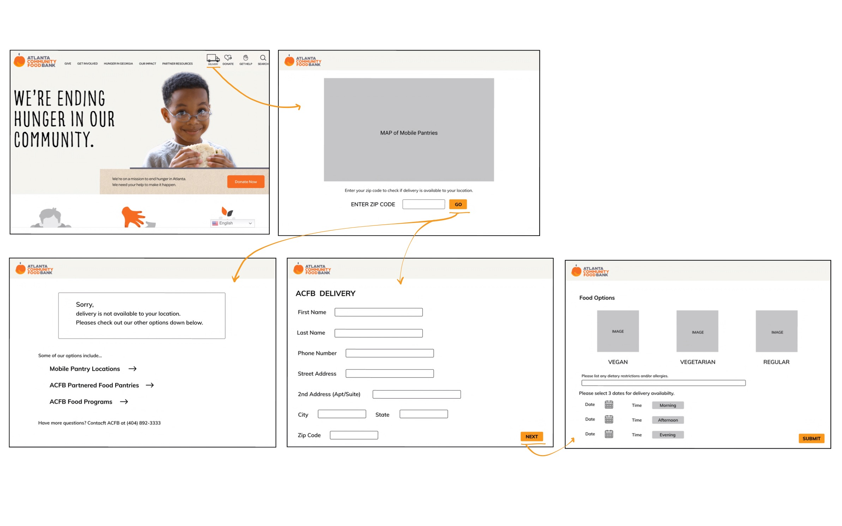

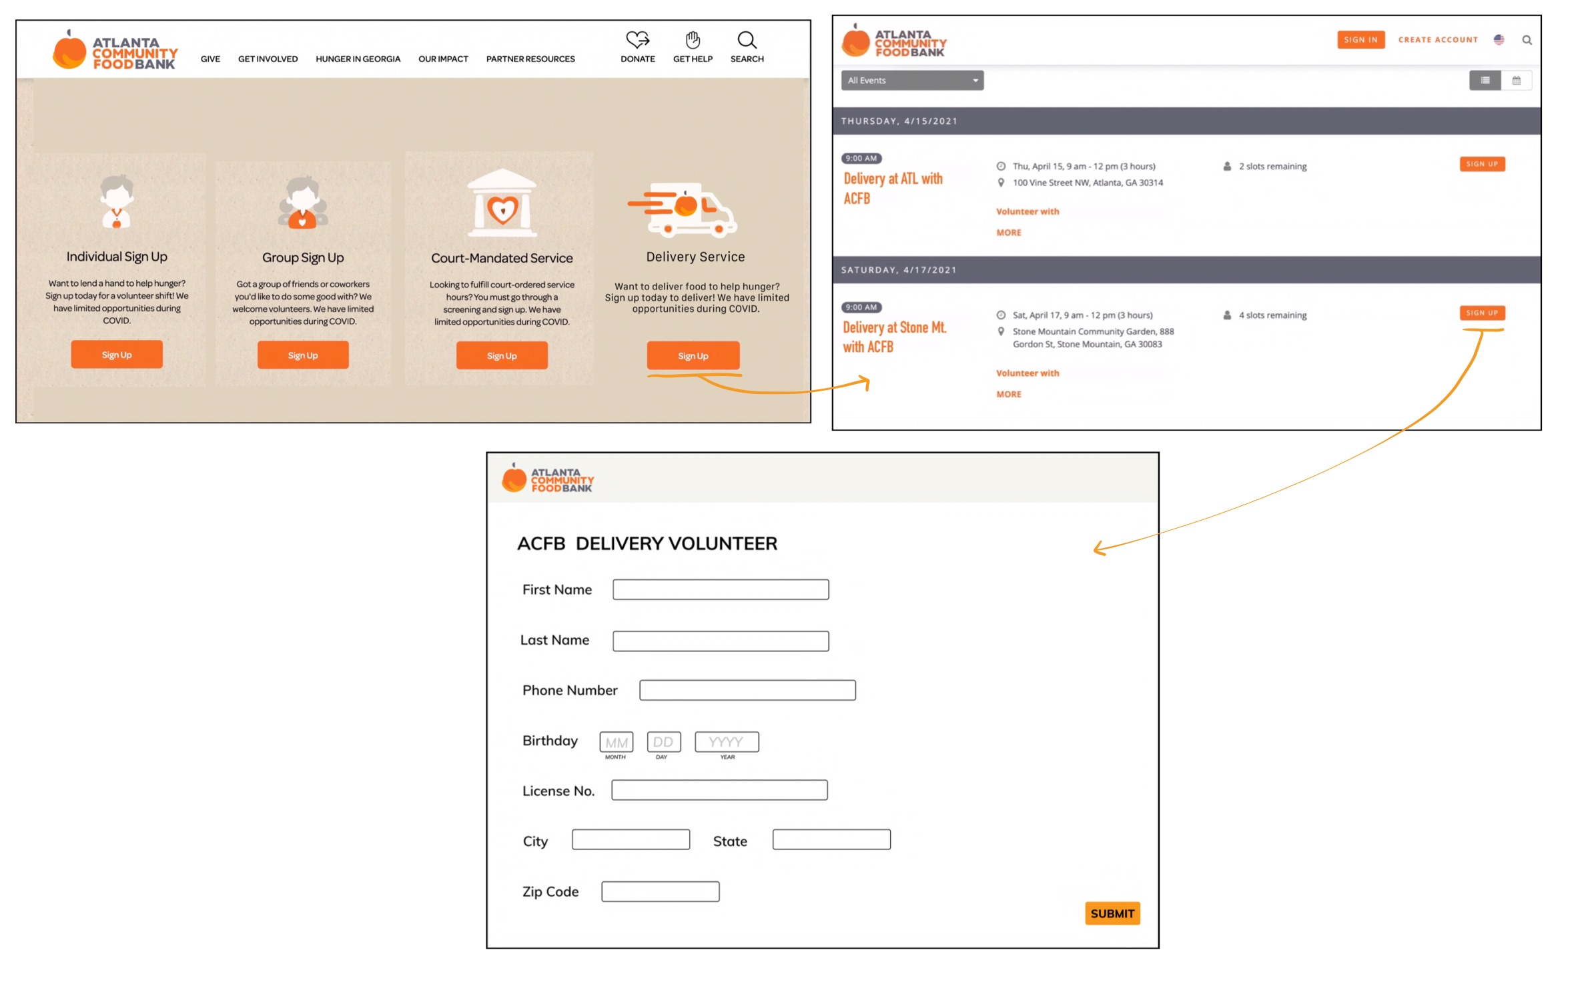

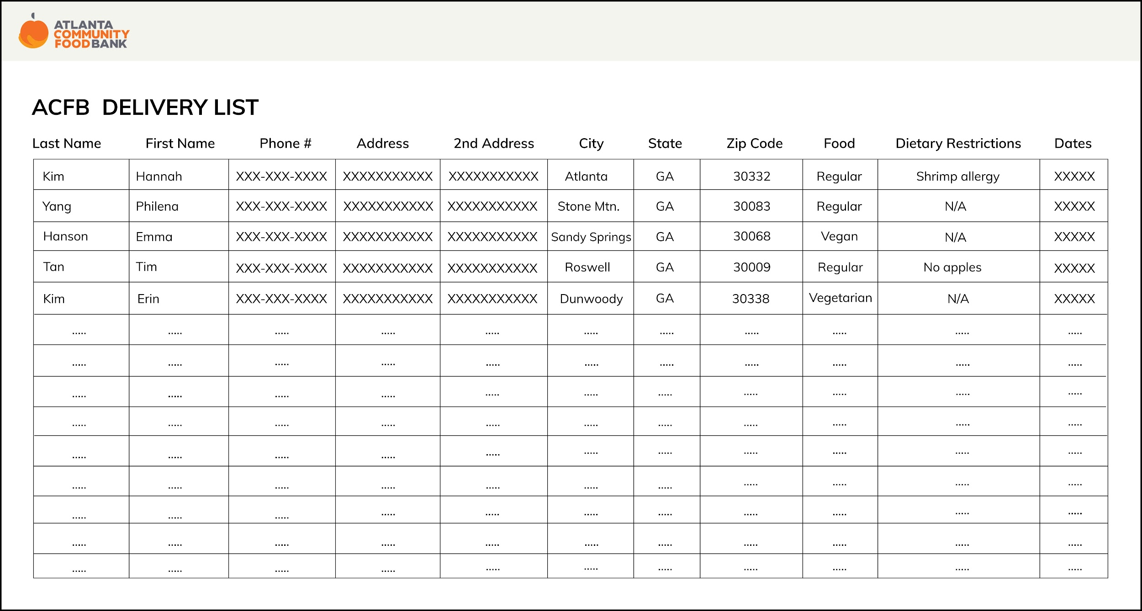

**Description of Prototype**

This prototype is an extension of the Atlanta Community Food Bank website that would allow users to sign up for one-time or recurring food delivery services. Three main tasks that the prototype supports are: the food insecure scheduling food delivery, volunteers signing up to deliver food, and ACFB viewing delivery requests in order to view each delivery request.

With our primary stakeholders including those who are food insecure and lack access to transportation, our users need to have a means of scheduling food deliveries within our system. This is the focus of our first task. In our prototype, we accomplished this by adding a “Delivery” button on the landing page of the ACFB website as seen on the ACFB Home Page w/ Delivery Button (see Figure 1.1). This button is the leftmost option on the top menu bar indicated by the truck option labeled as “DELIVERY”.

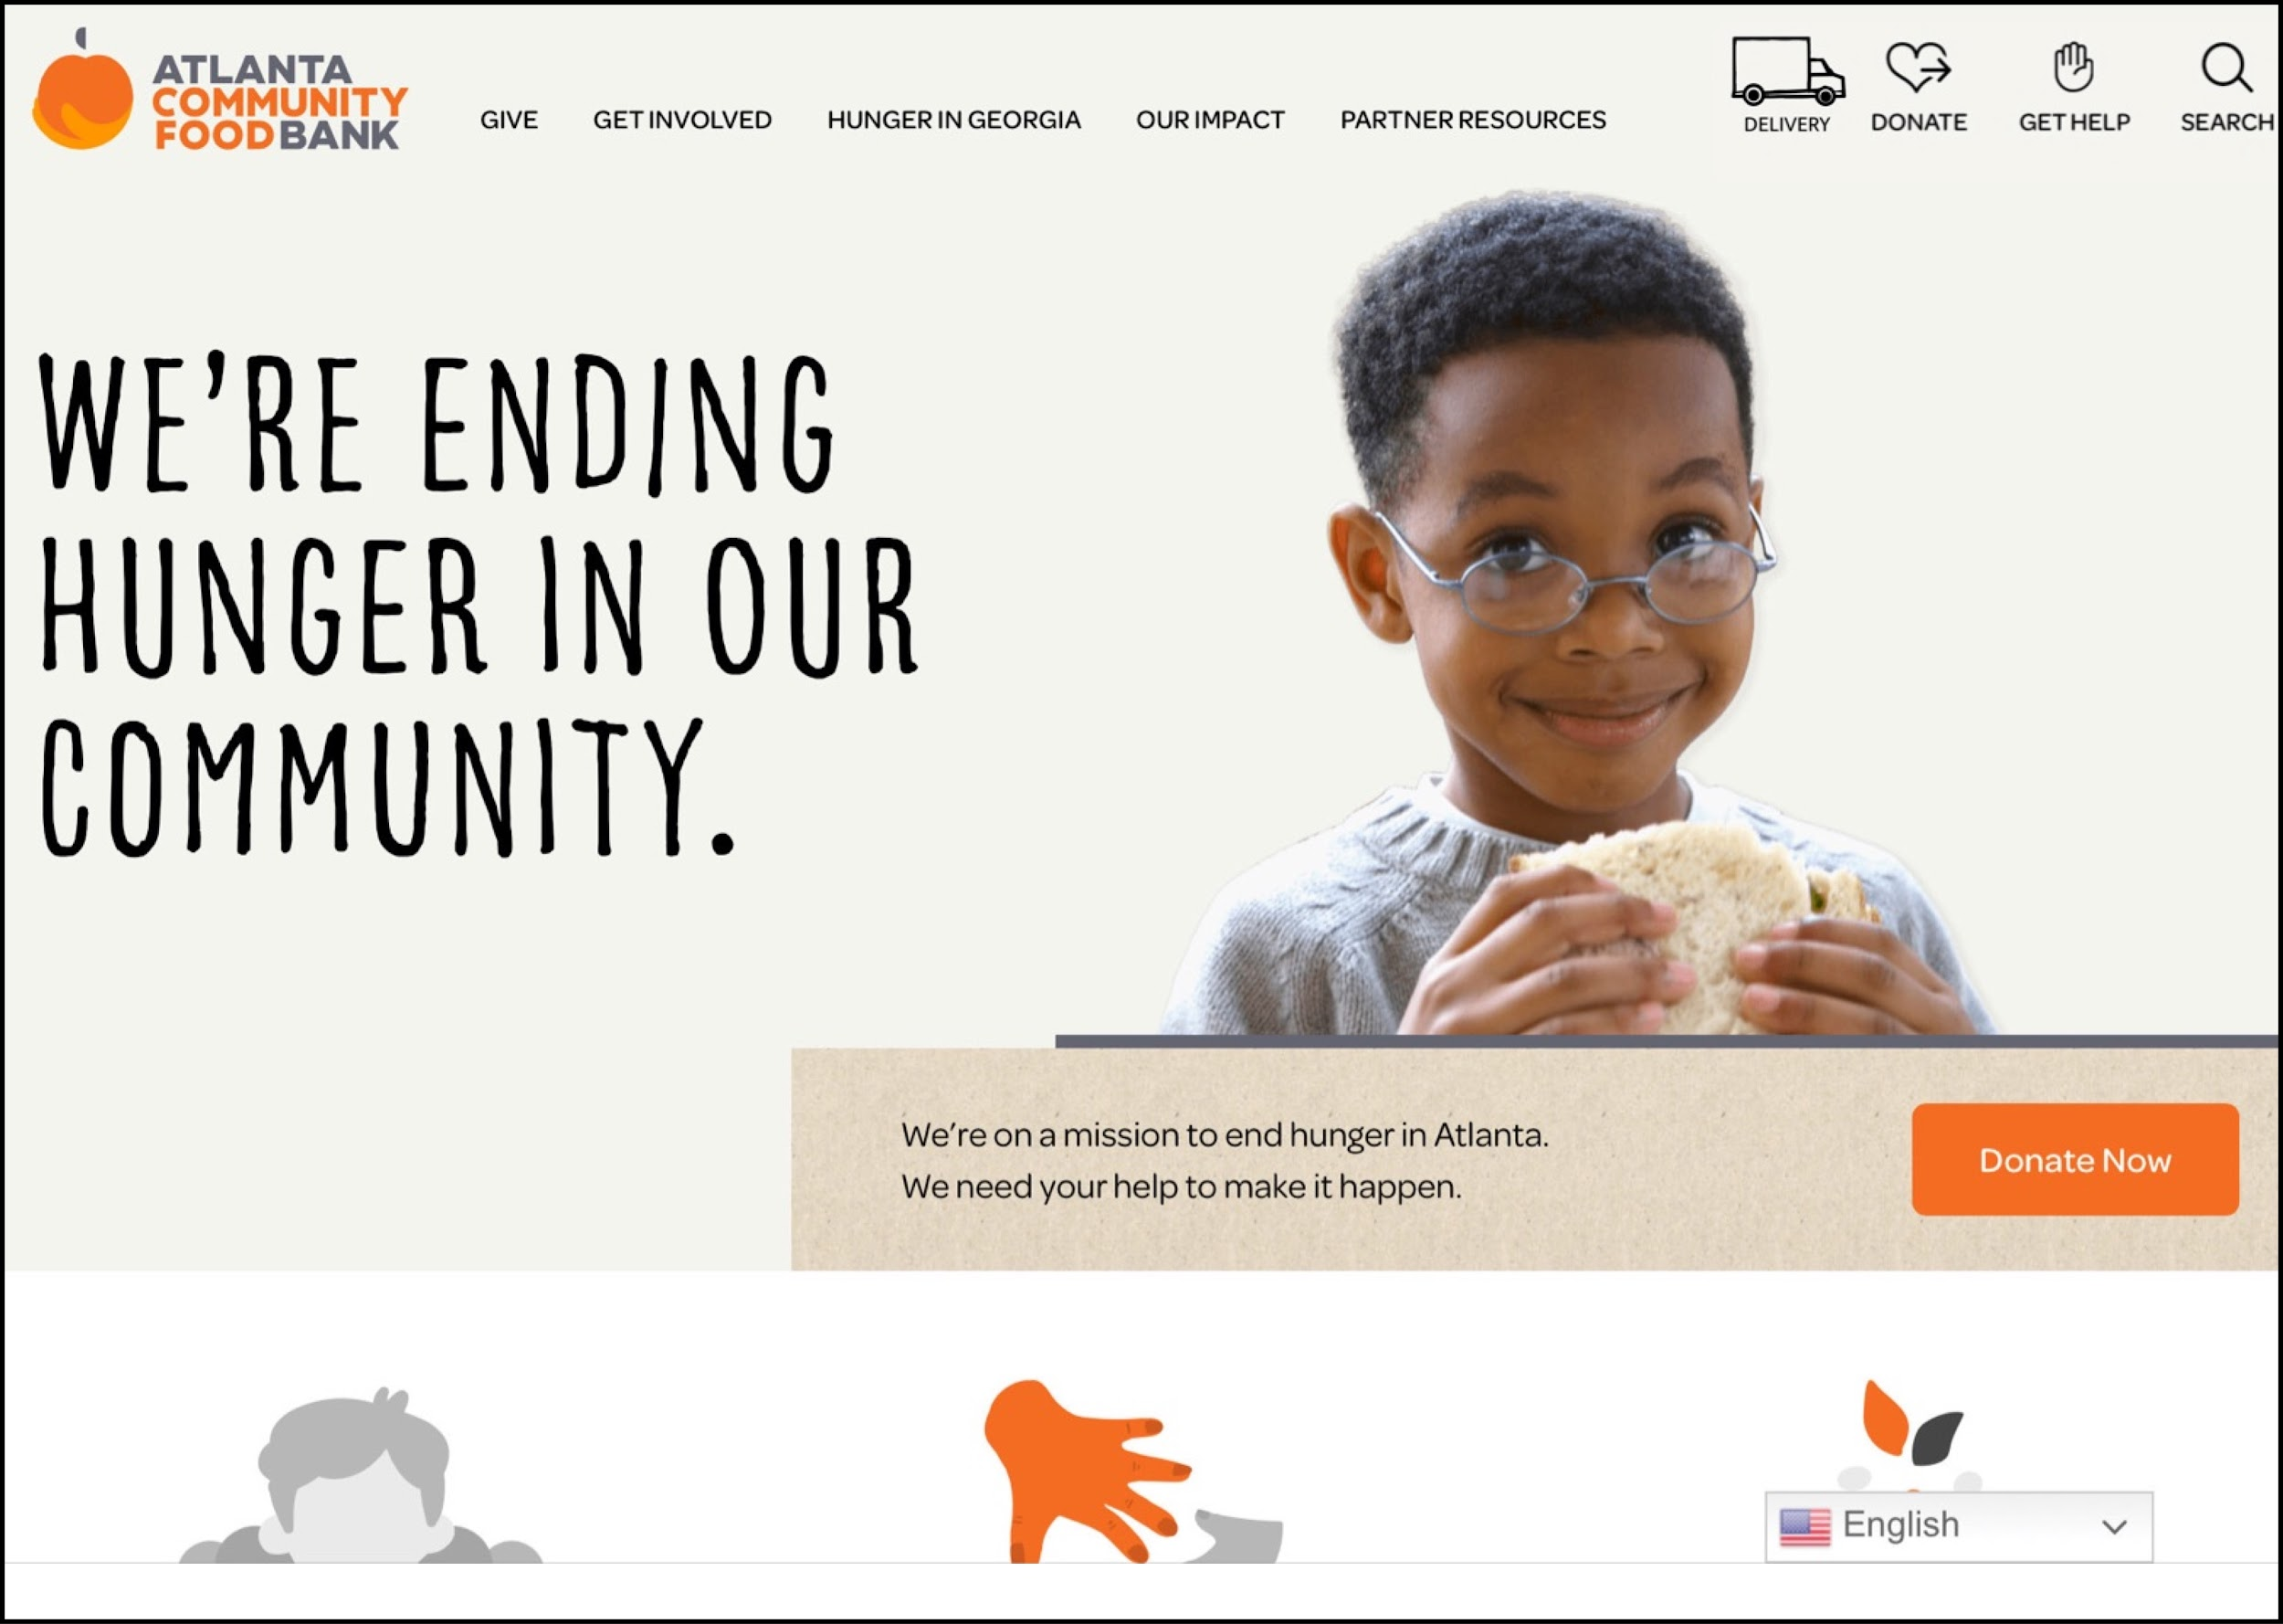

Figure 1.1 ACFB Home Page w/ Delivery Button

When the “DELIVERY” button is pressed, the user is then prompted to enter a zip code on the Check Delivery Availability Page (see Figure 1.2), and our system checks if the user's location is in the area of delivery. From here, the user is taken to one of two different pages based on delivery availability. If the user's location is not in the deliverable range, our prototype displays other ACFB resources and its partner's services like mobile pantries (see Figure 1.3), so that the user can still find other resources to get food even if they are not in the range of delivery. If the user’s location is valid, the next page is a screen in which users are prompted to fill out their personal information. This includes full name, phone number, street address, city, state, and zip code (see Figure 1.4). Users will then be able to select food options/preferences, and select a time(s) to have their food delivered able. Food preferences include vegan, vegetarian, gluten-free, and regular food options, and the users can also list out any other dietary restrictions or allergies in order to meet the user's needs.

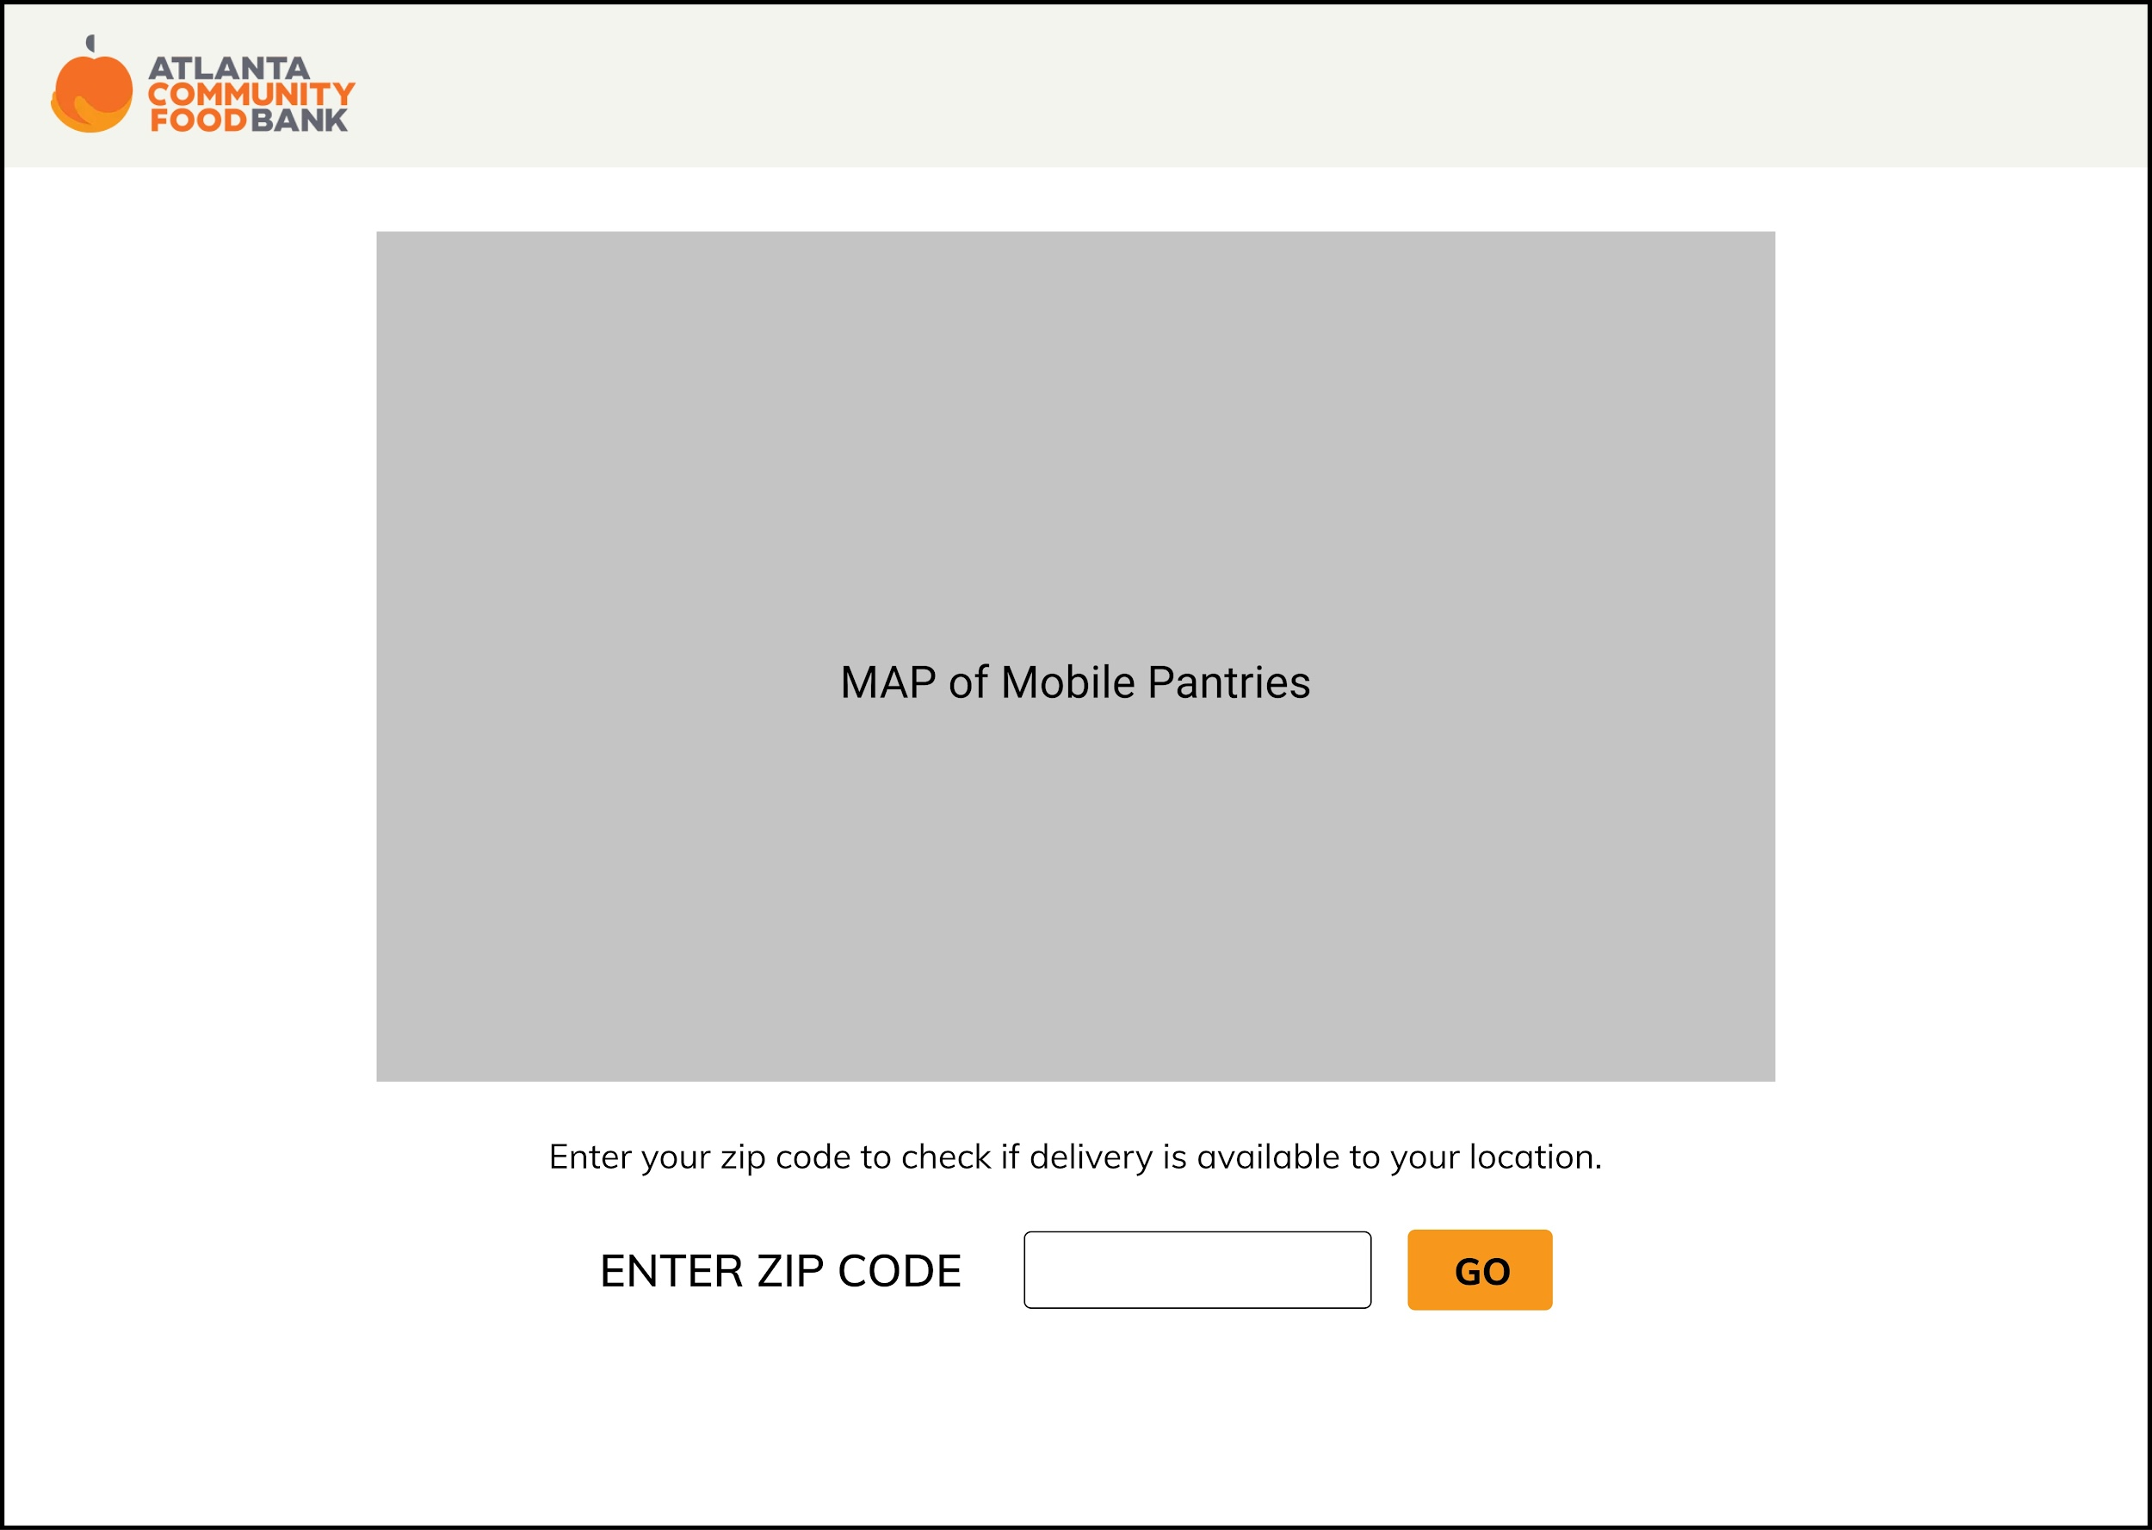

Figure 1.2 Check Delivery Availability Page

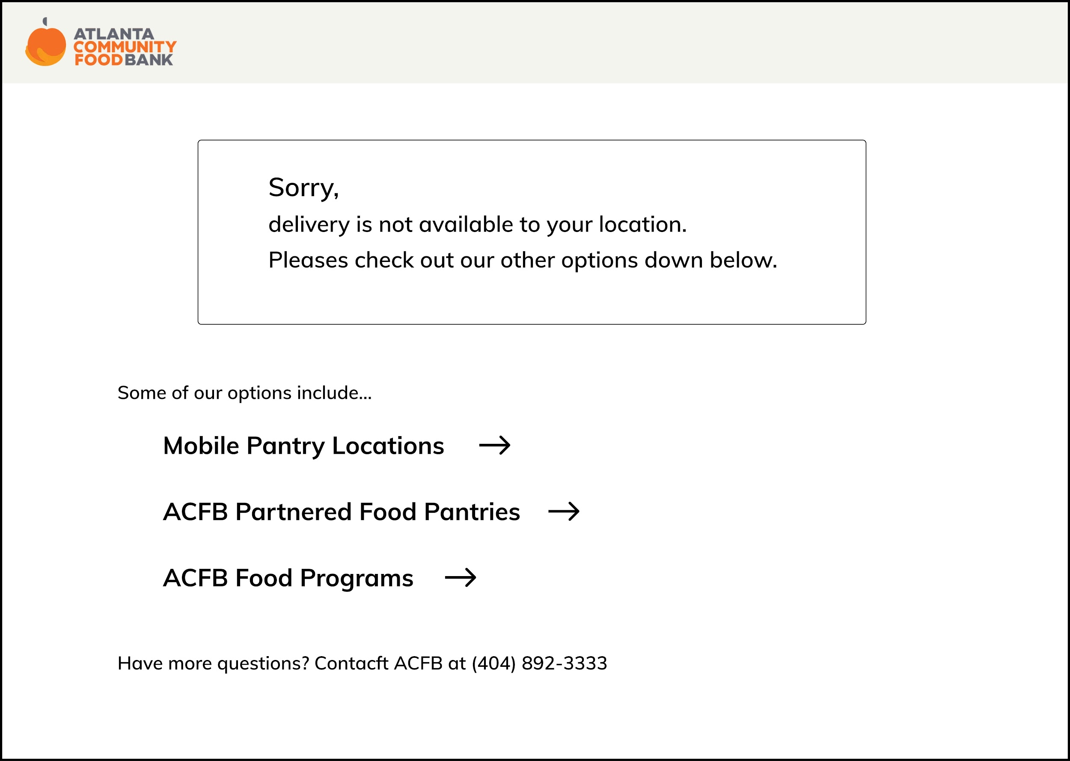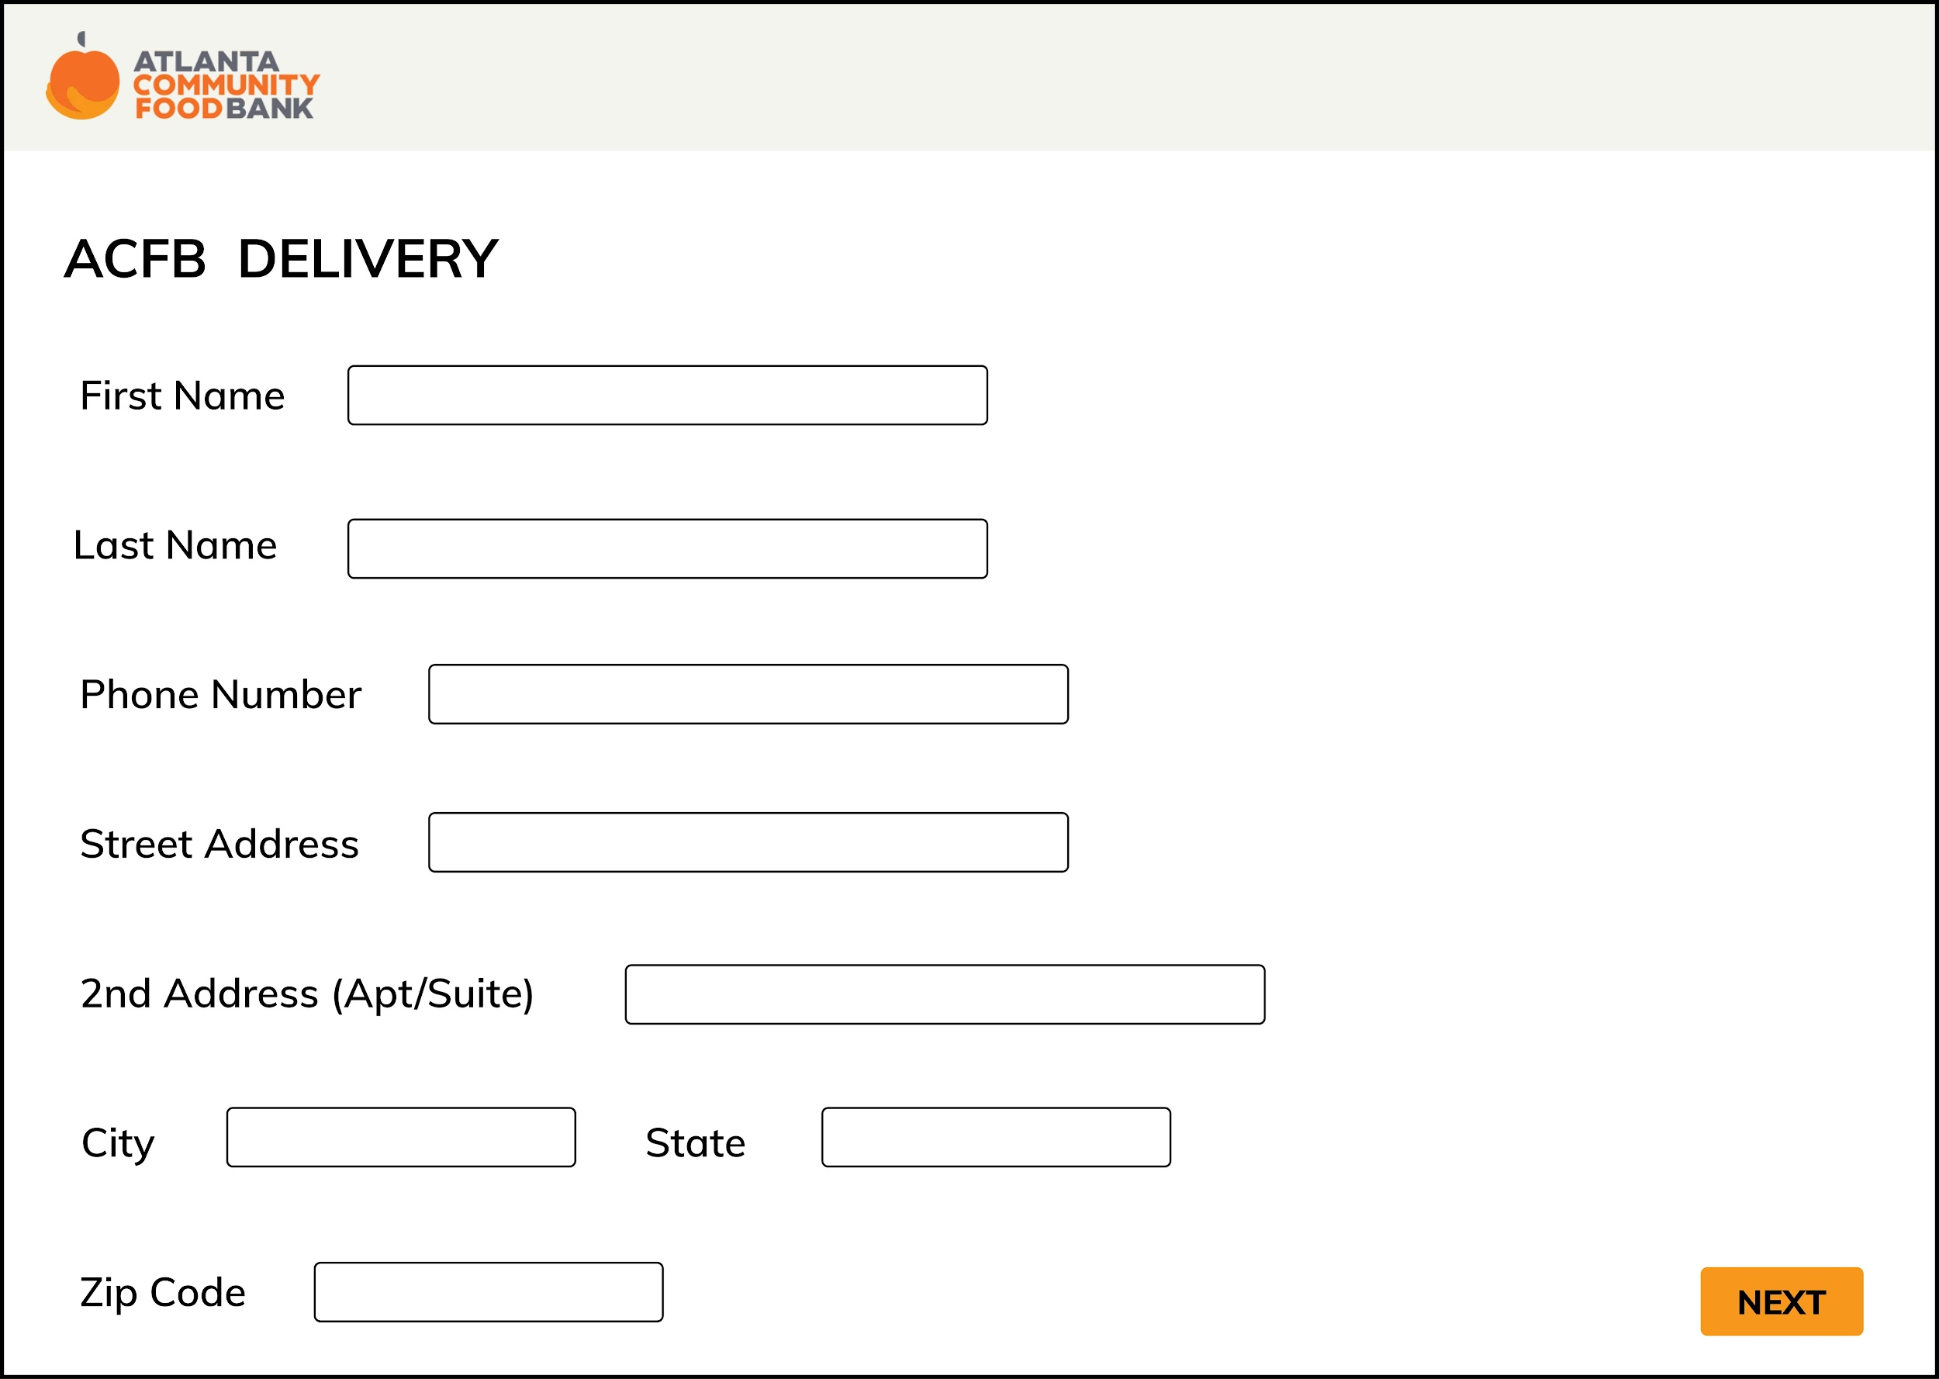

Figure 1.3 Other Resources Page Figure 1.4 Food Delivery Information Page

Users are also able to schedule up to 3 dates for food delivery at once (see Figure 1.5) for added convenience. If they click on the calendar icon, they will be able to go through the months of the current year and by clicking on the day, the website will automatically get the information into its database. ACFB will not be able to delivery to all users’ at their preferred specific time as in a specific hour and/or minute, so instead we have created three options of morning, afternoon, and evening which will be shown as a dropdown once the user clicks on it, in order for ACFB to also be able to organize the deliveries that need to be made and create a delivery route that efficiently accounts for time and mileage.

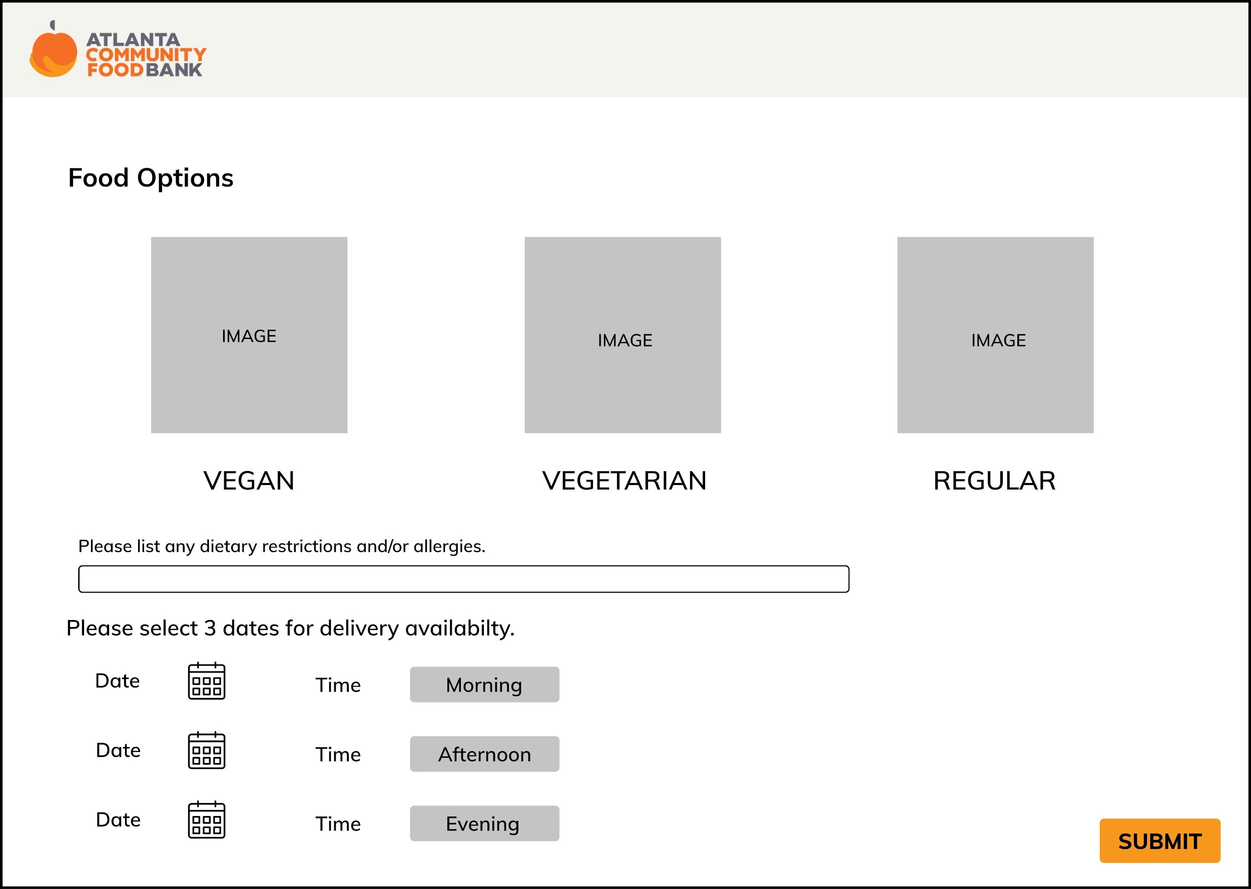

Figure 1.5 Food Options & Schedule Page

Our primary stakeholders also include ACFB organizers that interact directly with the system. They need to be able to view the information inputted by ACFB users who are requesting food delivery services in order to manage and view active delivery requests. To facilitate this, we designed a page that would display active food delivery requests from users in the form of a table that displays information such as name, address, dietary restrictions, and the date/time that the delivery is requested (See Figure 1.6). From here, ACFB workers have access to all of the information regarding delivery requests in order to make sure that food packages are being prepared on time for the deliveries.



Figure 1.6 Food Delivery Information Table Page

As a secondary stakeholder, we also had to consider ACFB volunteers in creating our prototype. Our delivery system requires sufficient drivers, so we designed our prototype to include the task of allowing volunteers to sign up as a delivery service driver. This can be seen in Figure 1.7 on the right side indicated by the Sign-Up button under Delivery Service button. Previously, there were only three options on the Volunteer: Get Involved page, but we added a fourth option for volunteers to volunteer to deliver food.

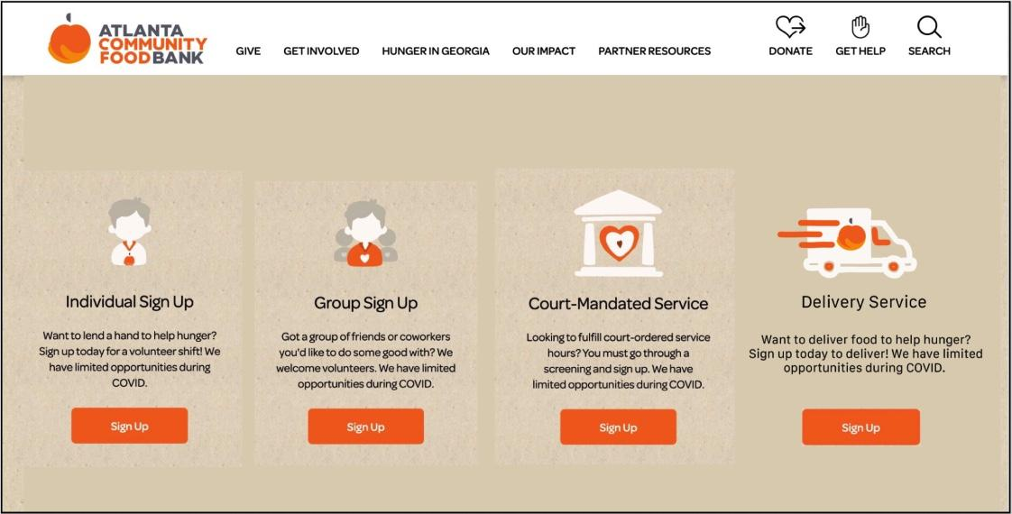

Figure 1.7 Volunteer: Get Involved Page

After a volunteer clicks the “Sign-Up” button under delivery service, the user is then prompted to the Volunteer Delivery Sign-Up Page (see Figure 1.8) in which they are able to sign up for various delivery requests. After clicking sign-up for one of the available deliveries, they are then navigated to a Volunteer Information Page (see Figure 1.9) in which they must fill out information pertaining to them to be registered as a delivery service volunteer. These fields include name, phone number, birthday, license plate number, and address. After filling this information out and clicking submit, they are then registered as a delivery service volunteer, and ACFB will be in contact with them with further information.

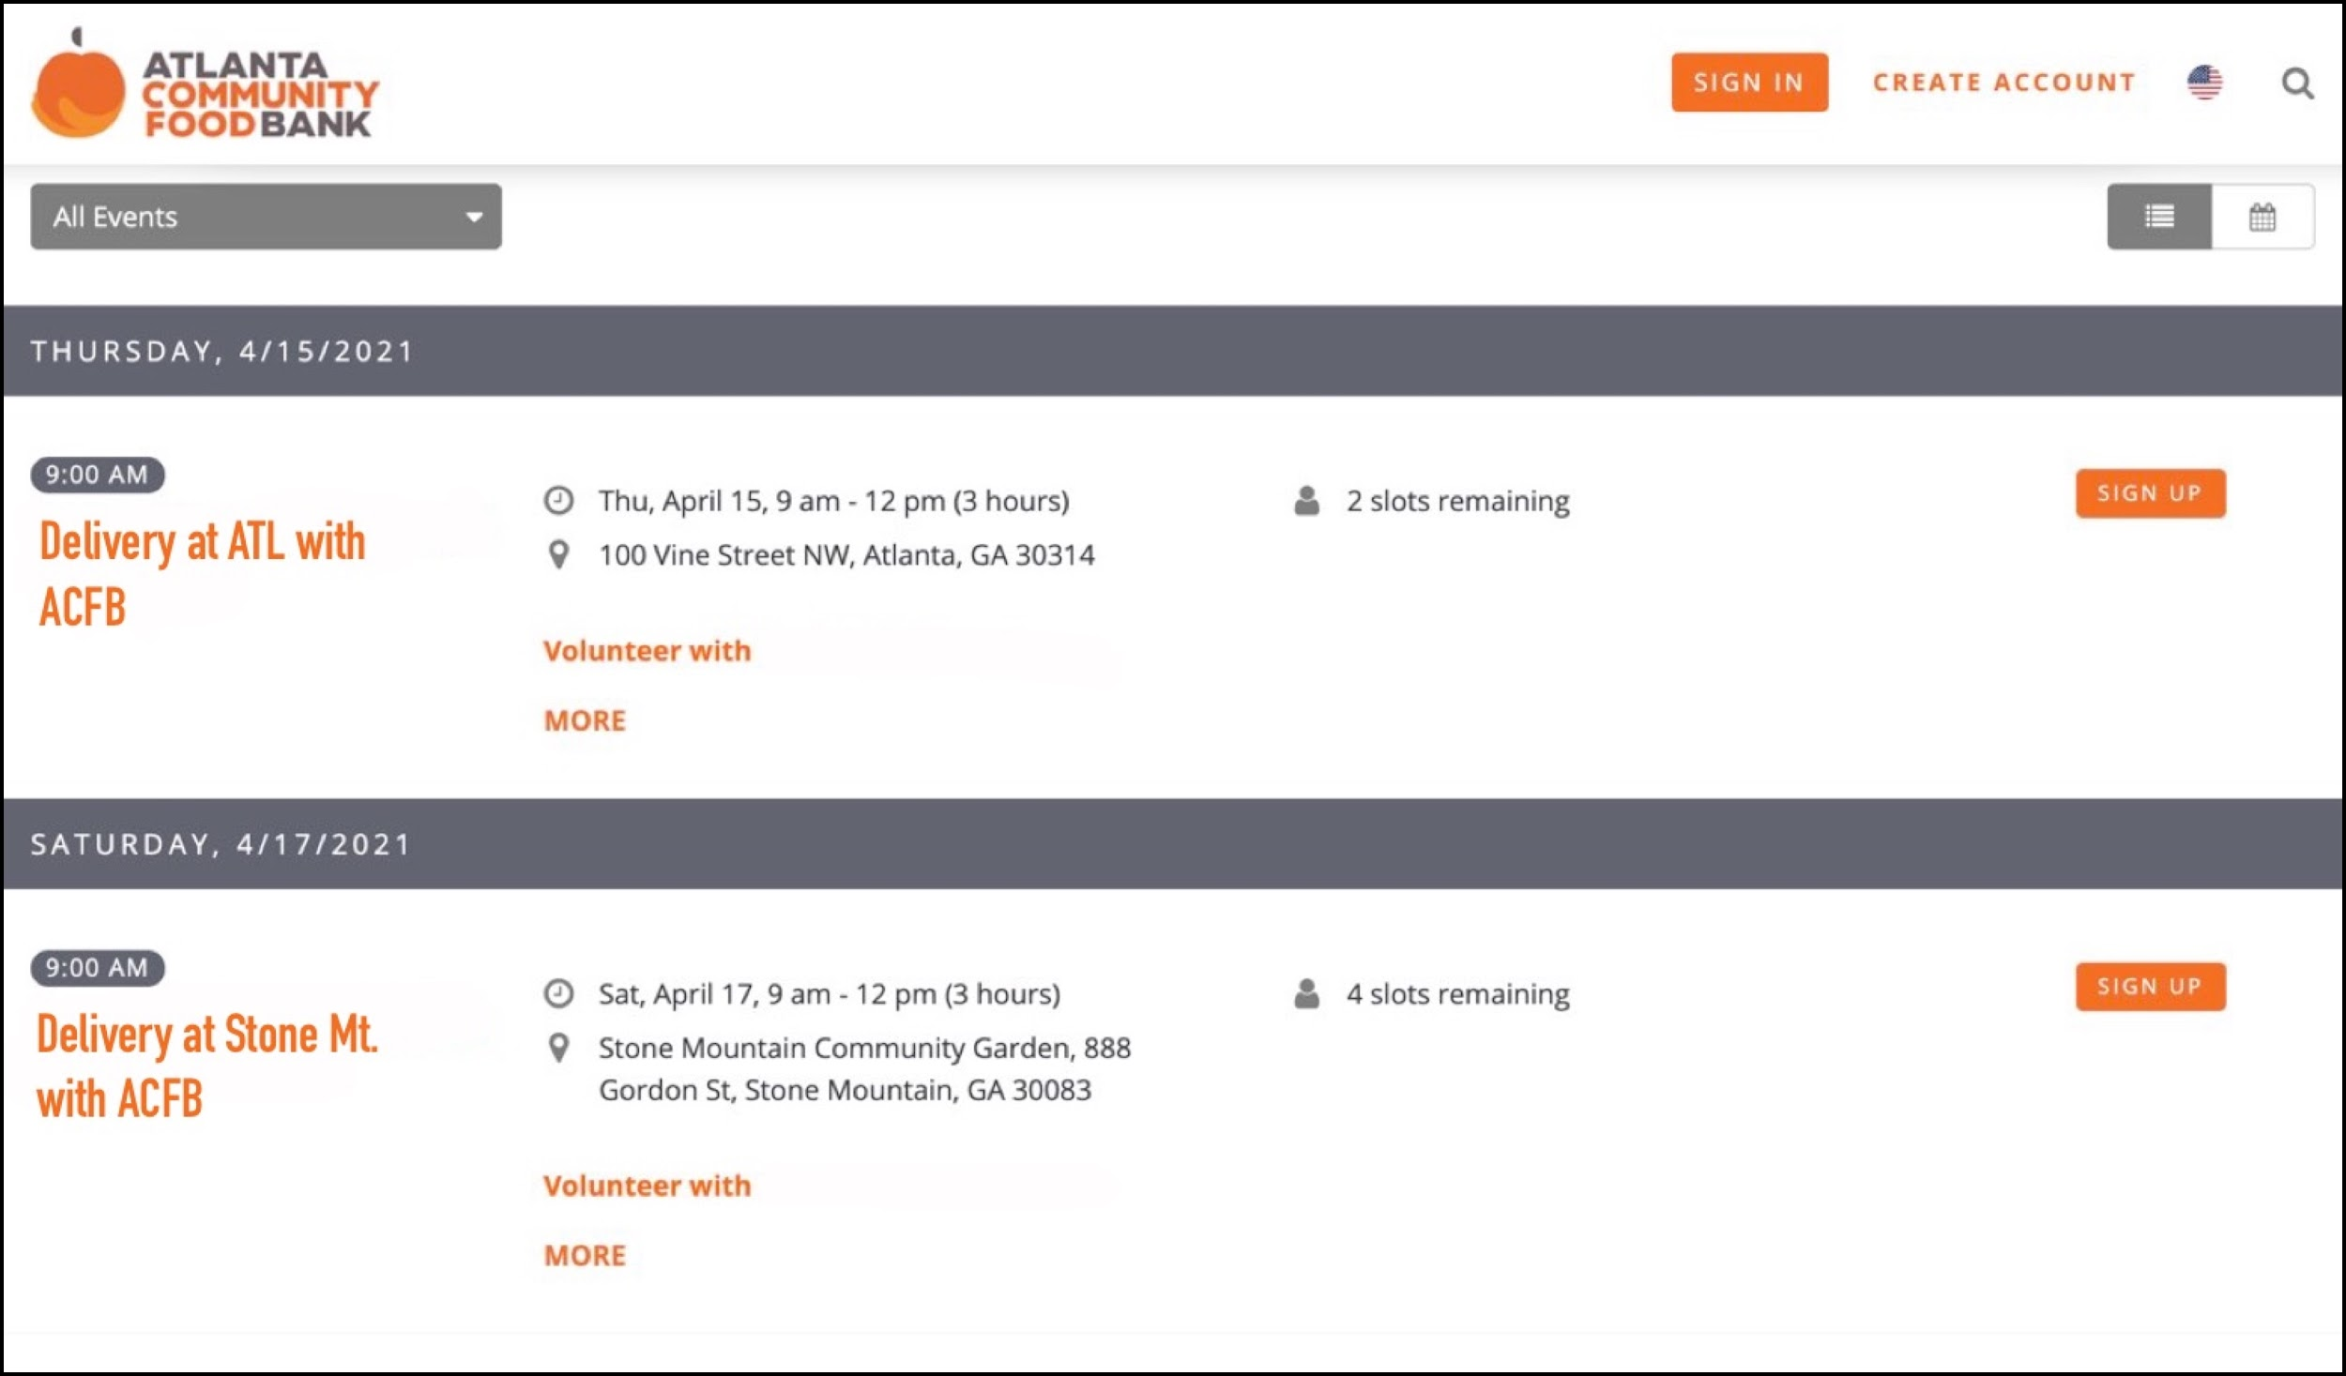

Figure 1.8 Volunteer Delivery Sign-Up

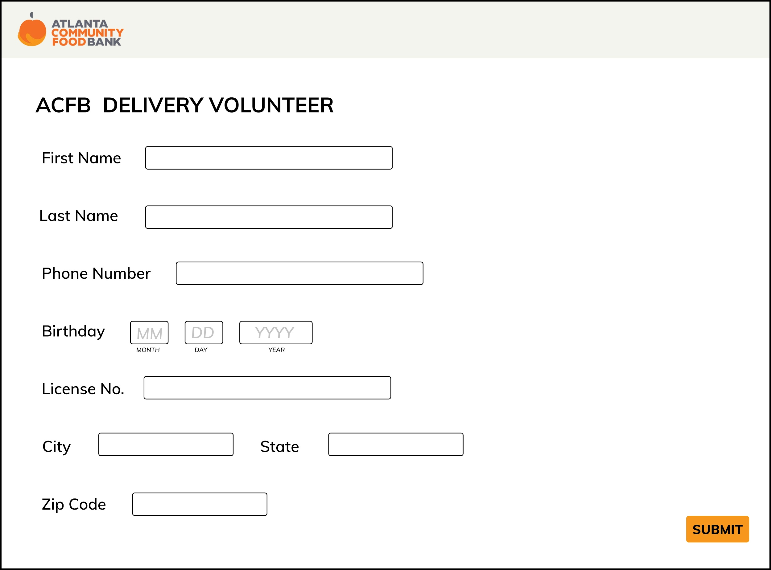

Figure 1.9 Volunteer Information Page

**Rationale for Prototype**

We chose this prototype because it would alleviate transportation issues faced by users through circumventing the need for them to find their own transportation. This prototype would be helpful based on evidence from P1 which includes data from the survey sent out to proxy users that showed that most proxy users without cars preferred to have food delivered to them as an alternative to walking or taking public transportation. This prototype would be especially useful in more suburban and rural areas, where forms of transportation such as walking and public transportation are less useful. We found during our research for P1 that food insecurity is growing the most in these areas of Atlanta. The interview with the Atlanta Community Foodbank also showed that a large majority of users are children and those with disabilities, both of whom lack access to transportation. A delivery system interface that is included onto the existing ACFB website would be helpful in that users already know how to access and navigate the website, and adding a new button for delivery next to the donations button would allow users to easily access the delivery tab. This design alternative helps ACFB in reaching their goal of eliminating hunger in Atlanta and throughout Georgia by bringing in more primary stakeholders, those who are food insecure, through the expanded accessibility by providing a delivery service.

From our P2 report, we were able to find that our website rated the highest amongst our evaluation criteria. In addition, amongst the feedback received from the poster session, we also received feedback that the website was the optimal design alternative. We also wanted to make sure that the interface that we chose would be an interface that users would have access to. From our survey in P1, we found that most users had access to a laptop device and the internet. In the case that the users don’t, there is also the opportunity for users to go to public spaces like libraries to use laptops and access our web application. With all these considerations in mind, we decided that a website is best fit for the task of scheduling food delivery.

A website provides a richer interface for more information to be presented and more feedback to be given. It can have multiple pages to include all of the functionality that we aim to create for our users. Stakeholders’ tasks are able to be fulfilled through the prototype as food insecure people can schedule food delivery, ACFB organizers can coordinate delivery schedules, and volunteers can sign up for delivering food. Compared to other interfaces such as a mobile app or text service, a website allows for more flexibility in structure and organization of information and data for all stakeholders.

**User Scenario**

Janet is a single mother with two children living in suburbia Atlanta. She works at a local coffee shop very close to her apartment, but her hours were cut due to a lack of business at the beginning of the pandemic. After her savings started to dwindle, she sold her car in order to continue paying for rent, utilities, and food for her children, but the money she made from that sale soon started to deplete as well. She became concerned about not being able to feed herself and her children, and began looking for food assistance somewhere close to her house, since she relied on walking and public transportation after selling her car. She came across ACFB through searching online for assistance, but unfortunately there were no ACFB locations or mobile pantries within walking distance of her apartment. There was, however, a food delivery service offered in her area. She signed up for a food delivery to her apartment the following evening, after the coffee shop closed, and was also able to input her daughter’s tree nut allergy so they would not receive any food that she could not eat. That following evening, the driver arrived at her apartment with enough food for at least 2 or 3 meals, and food that all members of her household could eat. Because of this service, Janet was able to feed her family nutritious and filling meals and pay for her rent and utilities on time.