P3: Prototype and Evaluation Plan

H06

Team UI French Fry

Emma Hanson, Erin Kim, Hye Lim(Hannah) Kim, Philena Yang, Zehao(Tim) Tan

# Table of Contents

| Project Description | 3 |
| --- | --- |
| Requirements Summary | 4 |
| Design Summary | 5 |
| Prototype: ACFB Website  Description  User Scenario  Rationale | 6 |
| Evaluation Plan | 23 |
| Summary and Reflections | 27 |
| Appendix  Appendix I. Script  Appendix II. Consent Form  Appendix III. Note-Taking Template  Appendix IV. Table Usability Criteria for 3 Prototypes | 29 |

# Project Description

From the various sources that we considered in P1, we found that accessing food and resources provided by ACFB is a big issue for food insecure people in metro Atlanta and areas outside of Atlanta, especially for the elderly, children, or those with disabilities. While the current systems of public transportation, limited delivery services, and popup food pantries attempt to provide food, insecure people access to resources, they fail to meet their needs as data shows that food insecurity is fastest growing in rural areas of Atlanta, where there is little public transportation and issues of internet access. From surveys with proxy users, we also found that 30% of respondents don't have reliable transportation and 50% walk to their nearest grocery stores. As the need for distribution of food and resources to food insecure people with issues of mobility rises, the goal of our system is to support accessibility needs by establishing an Atlanta Community Food Bank delivery service in and outside of metro Atlanta, bridging the gap between food insecure people and the food that ACFB provides.

Our intended user groups consist of four main categories of users. The primary user groups include food insecure people and ACFB organizers. The food insecure users are in need of food and are unable to access ADFB resources due to issues with mobility and transportation. ACFB organizers coordinate volunteers in their many responsibilities, including food distribution. The secondary user group is ACFB donors. These volunteers perform tasks given by organizers for ACFB. The tertiary user group is ACFB donors; they provide the means and funds for ACFB to operate. As the interface of our system is to facilitate the delivery of food to food insecure people, we developed our tasks to reflect the needs of our users when interacting with the system. Three tasks that our system supports include:

* Schedule a food delivery via the ACFB website (food insecure people)
* Sign up to volunteer to delivery food via the ACFB website (ACFB volunteers)
* View delivery requests to coordinate volunteers via the organizer portal (ACFB organizers)

# Requirements Summary

Functional Requirements

**Information collection**: The system’s main functional component will be to set up a method for food insecure people to receive ACFB’s food services. Requirements include gathering user information, including name, location, contact, food preferences, and availability for food insecure users as well as delivery volunteers. Food insecure users will request ACFB’s delivery services, and their information will be stored somewhere such as a database, with users being able to update their information as it changes.

**Availability feedback**: The system must also be able to inform users whether delivery is available to them based on their location. It should also account for the availability of volunteers/drivers and supply of food. This information should be queried from another database to determine whether the delivery is available.

**View delivery requests’ details**: When delivery requests come in, the system should update the organizer page with new requests. These requests can be accessed through the organizer portal after they sign in. This will enable organizers to effectively coordinate and set up deliveries to food insecure users with delivery volunteers. It will also allow them to organize the requested food to be delivered.

Non-Functional

**Usability**: The system interface must facilitate the process of requesting food delivery for food insecure people. The interface must be understandable to all users and the information and actions should be presented clearly.

**Utility**: The system must be useful for food insecure people. Food delivery should improve access to ACFB’s food services for many in the community. The interface should allow users to receive useful information and feedback from the information they input.

**Accessibility**: The system interface must be accessible to as many food insecure people as possible. Technological constraints involving those that don’t have access to the Internet or a smartphone or computer need to be considered in designing the prototype.

**Reliability**: The system must be reliable for its users. Because it is a food delivery system, an error can result in food insecure people not receiving food and not being able to eat.

# Design Summary

To facilitate accessibility for food insecure people through an ACFB delivery system, our team decided to build a prototype that is able to support the needs of our multiple user groups. This is due to the multifaceted nature of a delivery system, where multiple components have to be in place for the system to operate. For the scope of our prototype, we’ve identified three user groups that will interact with the system, each using different parts of the prototype to perform separate tasks. Food insecure users will schedule a delivery; ACFB organizers will view delivery requests; volunteers will sign up for shifts. We decided that these tasks should be accomplished through an extension of the ACFB website, an interface that many food insecure people and ACFB volunteers are already familiar with.

Our prototype is high-fidelity as it resembles an actual implementation of an ACFB delivery system built into the ACFB website with simple features. The design is simplistic and resembles theme of the current ACFB website, with the same colors, fonts, and layouts. Our design is simplistic in that it incorporates all the functions and details necessary without being overbearing. This is to account for users that aren’t too familiar with technology and navigating web pages. We were also mindful of how much effort is needed for users to fill out the different forms. If the forms were too long or complex, users and volunteers could be deterred from completing it, resulting in insufficient users or volunteers.

We chose a website as our interface because it rated the highest amongst our evaluation criteria in P2 as well as in the feedback from the poster session. A website will be able to support all the functionality needed for users to accomplish their tasks by providing a richer interface for more information and feedback. This enables the system to meet the requirements, including collecting information from users, providing feedback, and showing delivery request details. The web interface would be easier to navigate when providing information, as well as when looking at data. In addition, from our survey in P1, we found that most users had access to a laptop device and the Internet. The system is also accessible in the case that the users don’t have access by providing the opportunity for users to go to public spaces like libraries to use laptops to access the website.

# Prototype - Website

**Introduction**:

The problem space we are trying to address is that food insecure people often do not have the means of transportation to access food and resources provided by the Atlanta Community Food Bank. In response to this problem space, the solution space we are focusing on is delivering food to these users. After discussing various potential solution spaces, we decided to focus on delivery. By having a delivery system, users who do not have a means of transportation will be able to obtain food without having to worry about how to travel to the nearest food pantry. Likewise, the Atlanta Community Food Bank will be able to reach out to and help alleviate hunger for more people in the community. To address this solution space, the prototype we are focusing on is a website. This website will help facilitate a delivery system for ACFB users, and users will be able to sign up for and schedule food delivery to their homes.

### Description:

This prototype is an extension of the Atlanta Community Food Bank website that would allow users to access food delivery services. Three main tasks that the prototype supports are: the food insecure scheduling food delivery, volunteers signing up to deliver food, and ACFB viewing delivery requests in order to view each delivery request.

**Task 1: Use ACFB website to schedule a food delivery.**

*1a.* *From the home page, users can click on the delivery button to begin a delivery process.*

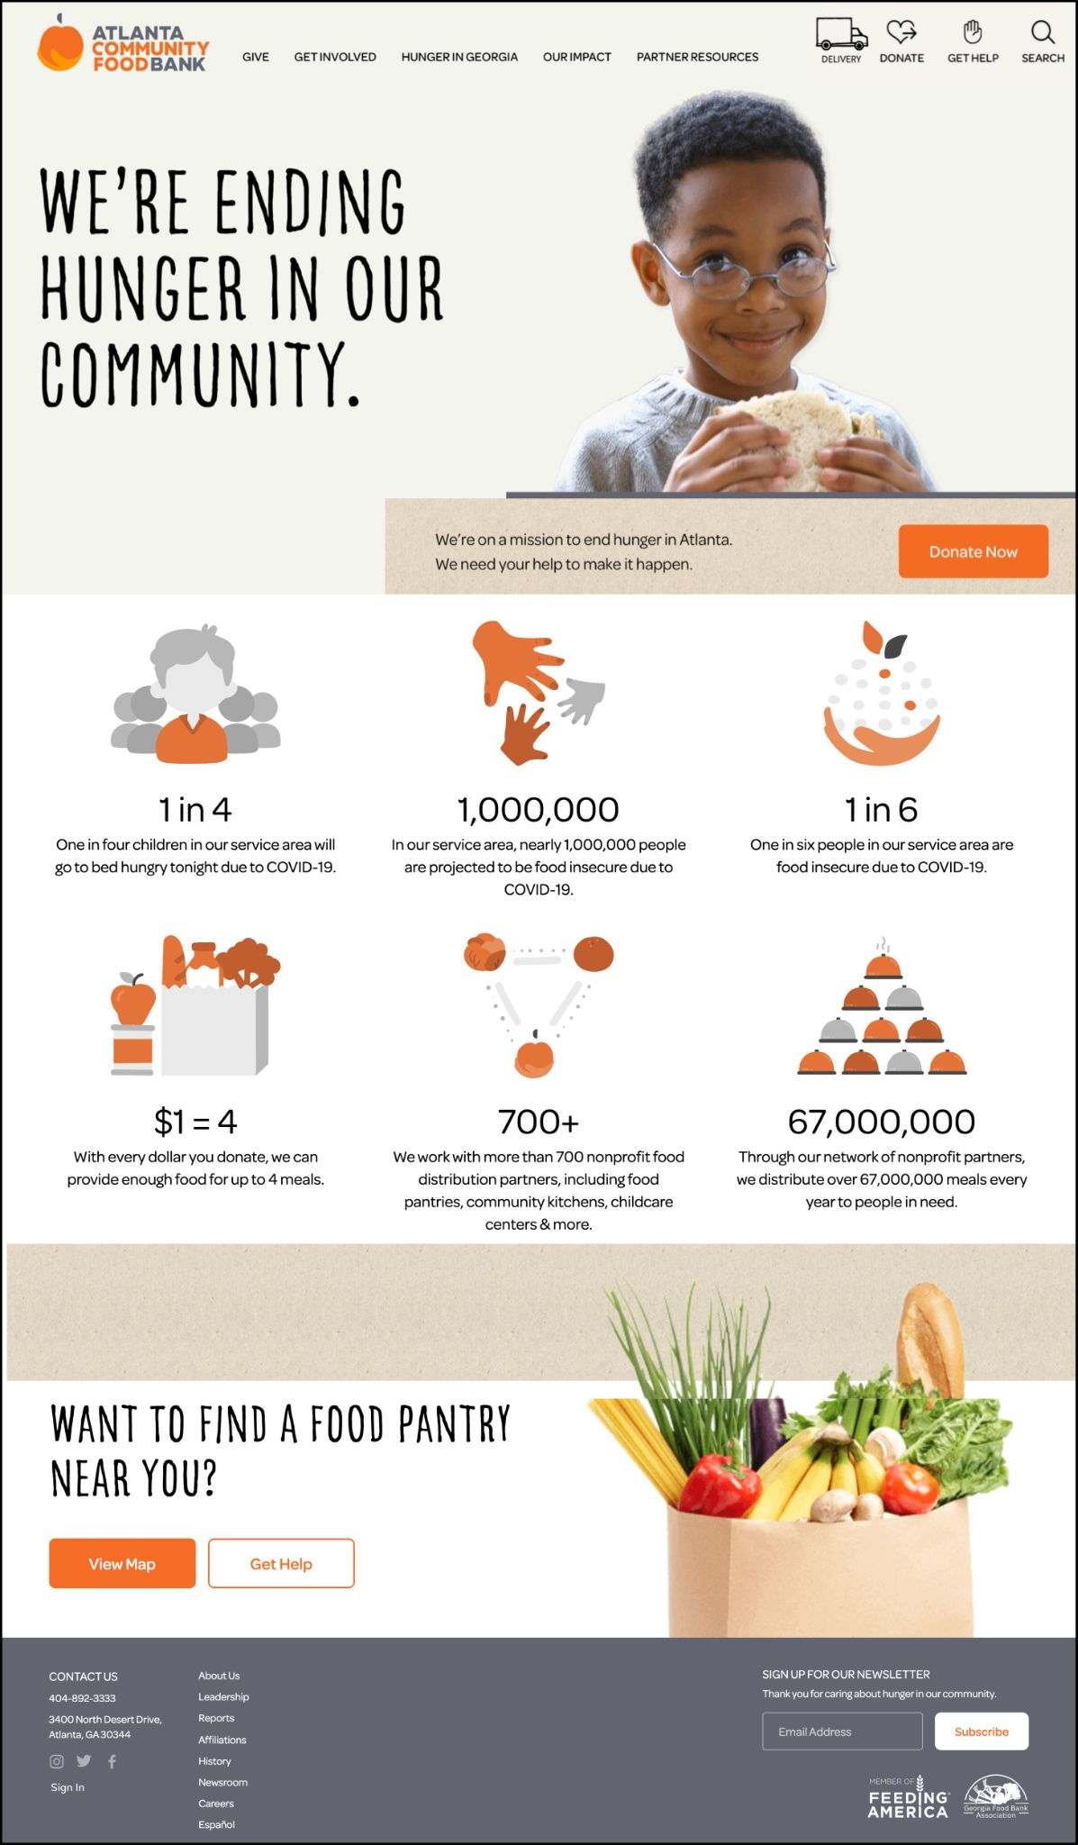

With our primary stakeholders including those who are food insecure and lack access to transportation, our users need to have a means of scheduling food deliveries within our system. This is the focus of our first task. In our prototype, we accomplished this by adding a “Delivery” button on the landing page of the ACFB website as seen on the ACFB Home Page w/ Delivery Button. This button is the leftmost option on the top menu bar indicated by the truck option labeled as “DELIVERY”.

*1b. Users can type in their zip code, and press go to see if their location is deliverable.*

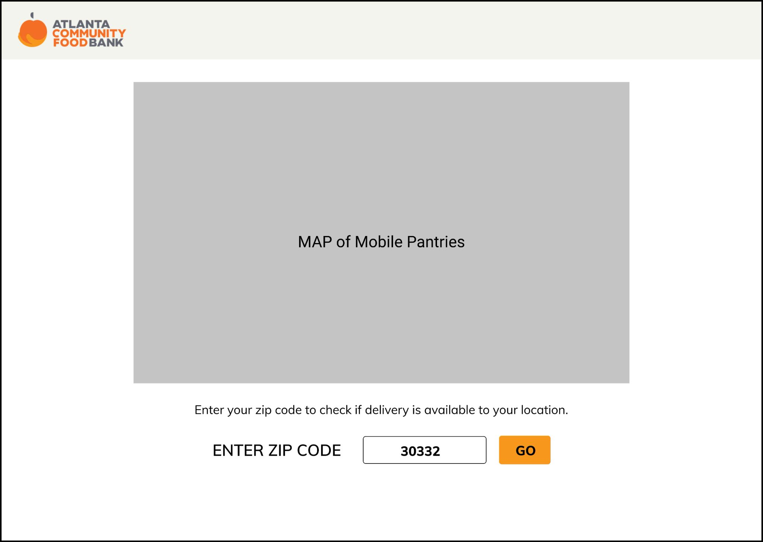

When the “DELIVERY” button is pressed, the user is then prompted to enter a zip code on the Check Delivery Availability Page, and our system checks if the user's location is in the area of delivery. From here, the user is taken to one of two different pages based on delivery availability.

*1c. Users can access more resources by clicking on “Find Assistance Near You” or contact ACFB with their customer service number.*

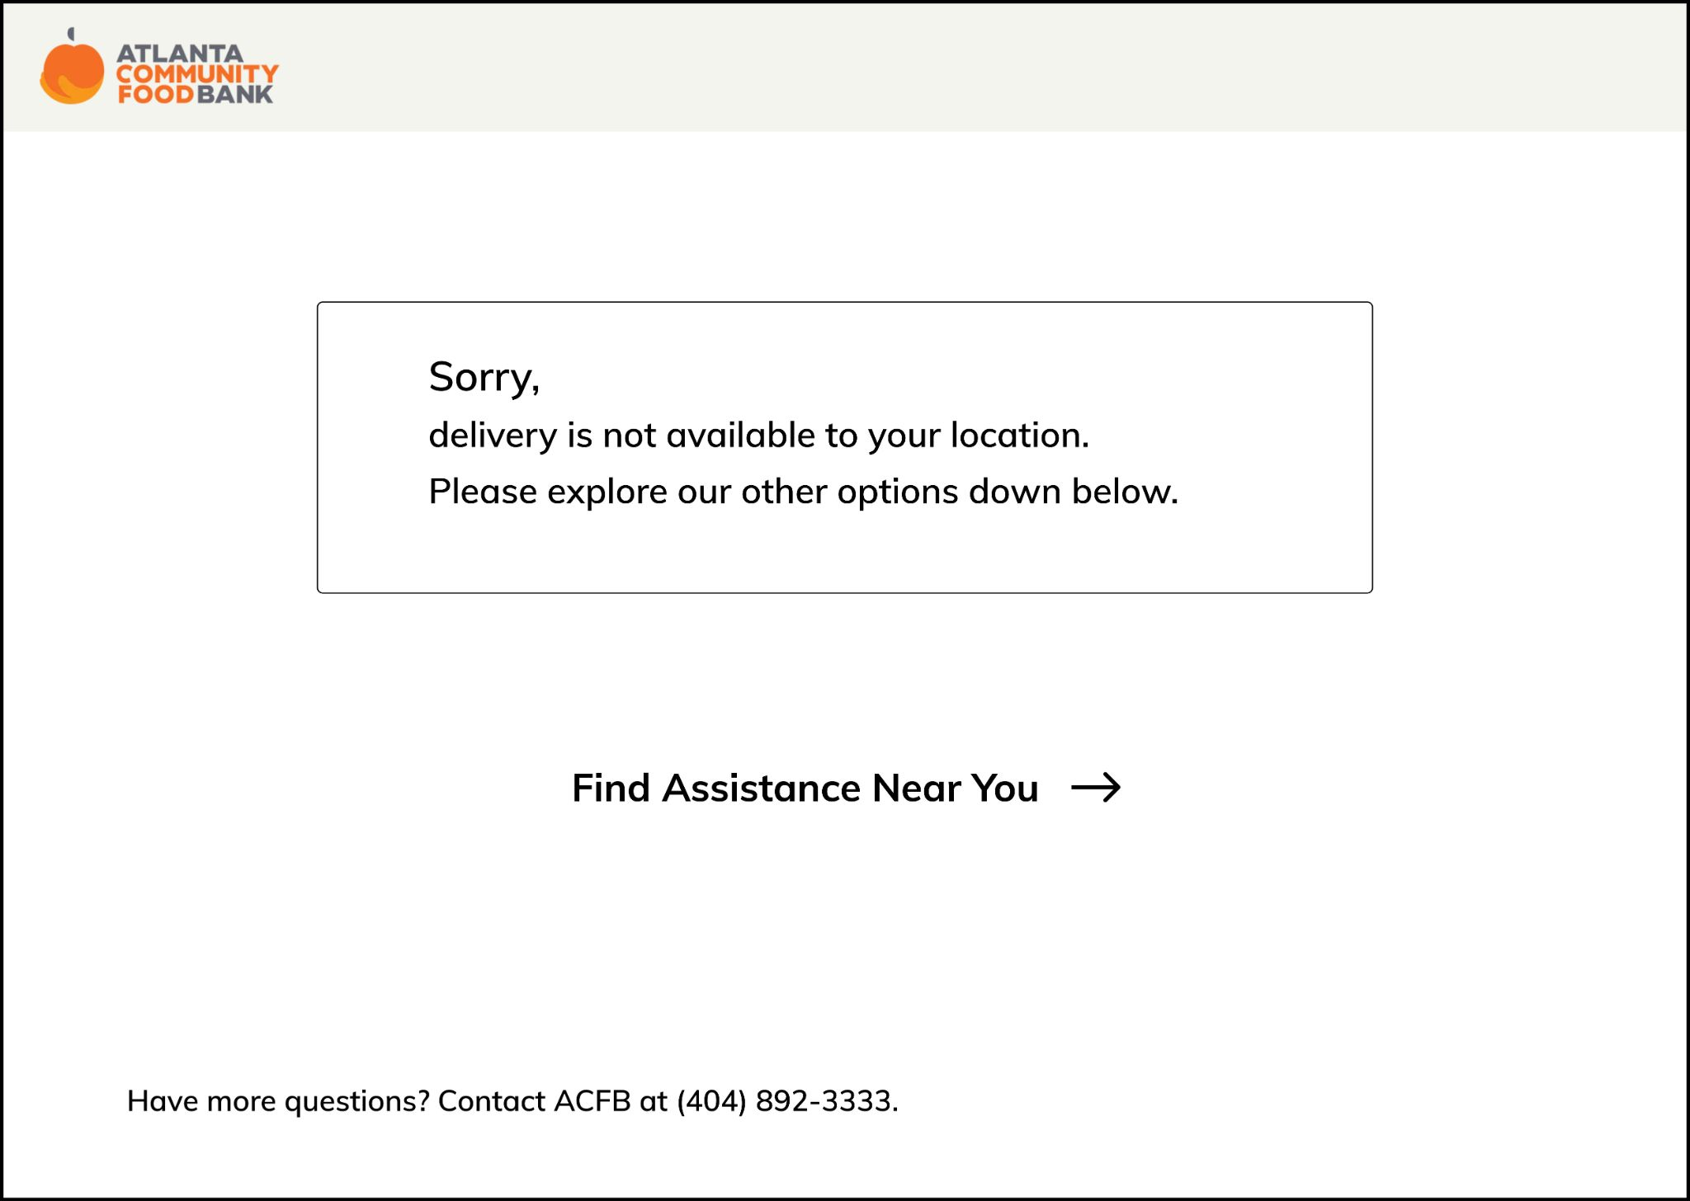

If the user's location is not in the deliverable range, our prototype displays an alert on the pae indicating that there is no delivery service available around the user’s area. We have included ACFB’s customer service phone number and added a clickable text, “Find Assistance Near You” that leads users to a separate page with other ACFB resources so that the user can still find other resources to get food even if they are not in the range of delivery. In our previous prototype in homework 4, we have included several clickable texts with 3 different other ACFB services that users could reach to, but we have decided that leading users to an entire page dedicated for ACFB food pantries, ACFB partner pantries, and other sources would allow users to access the multiple services at once.

*1d. Users can access other resources other than food delivery if their location is not deliverable.*

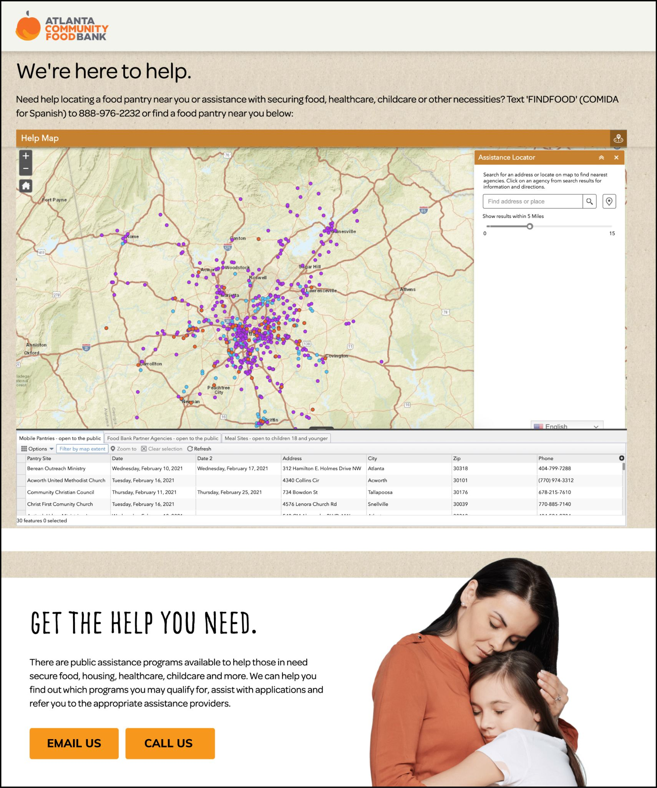

Users can find food pantries near their location by typing their address or choosing a location on the map. They can look on the list of mobile pantries, ACFB partner pantries, and other services ACFB offers on the scrollable spreadsheet under the map to look for specific details such as name of pantry or organization, availability date, address, and phone number of ACFB services. If users are not satisfied with finding a nearby service, they are also able to contact ACFB by emailing or calling through the “EMAIL US” and “CALL US” buttons on the bottom of the page that will show users the email address or phone number that should be used. It is important to address more information to users whose locations are not deliverable because in order to be sustainable, it is important to not discriminate and be inclusive against those that do not have the same resources, so creating a separate page with other resources these users can access allows them to be able to interact with ACFB and obtain food in other ways.

*1e. Users will fill out their information on a delivery request form to get food delivery service.*

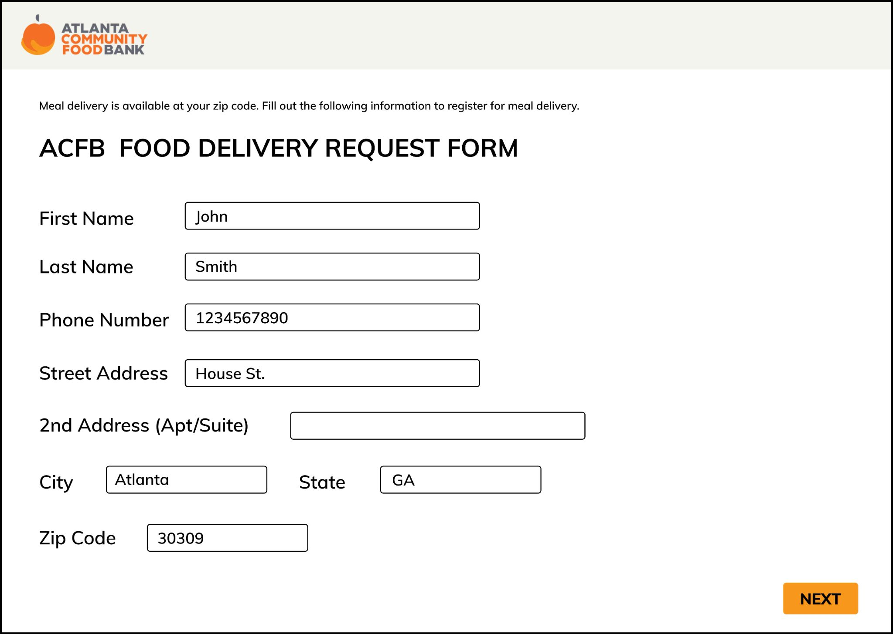

If the user’s location is valid, users are prompted to fill out their personal information. This includes full name, phone number, street address, city, state, and zip code.

*1f. Users will select a food option and type any dietary restrictions.*

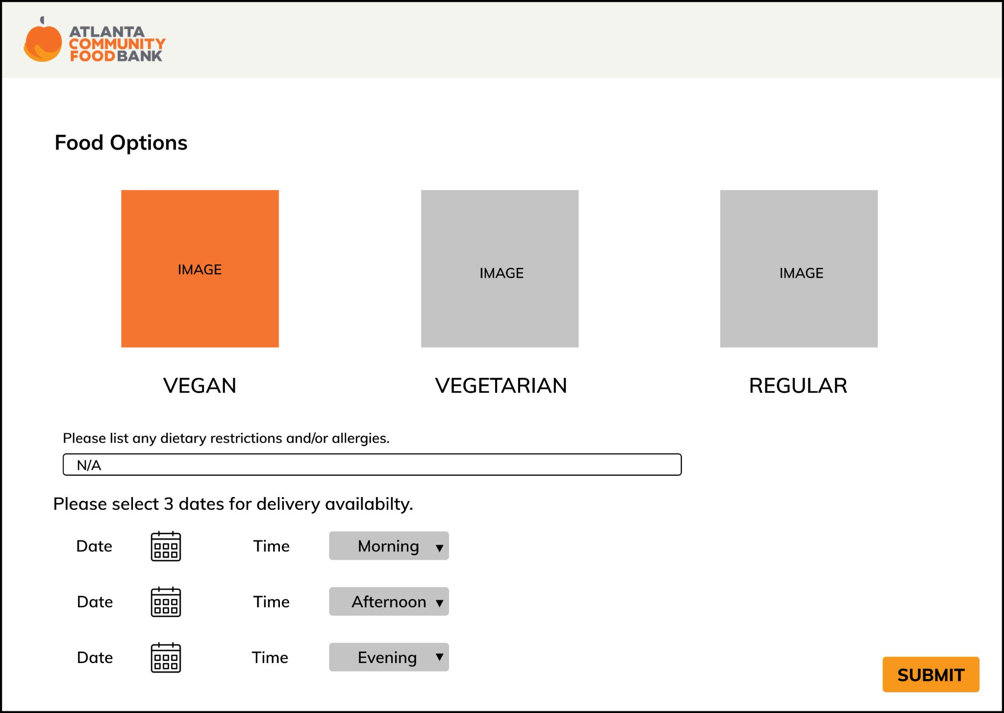

Users will then be able to select food options/preferences. Food preferences include vegan, vegetarian, and regular food options, and the users can also list out any other dietary restrictions or allergies in order to meet the user's needs. In our prototype in homework 4, we did not have any indication of whether a certain option was selected, and based on Norman’s design principles, feedback is an essential feature to implement in order for users to know that the system has detected their selection, specifically the food option for our prototype.

*1g. Users will select 3 different dates for delivery availability.*

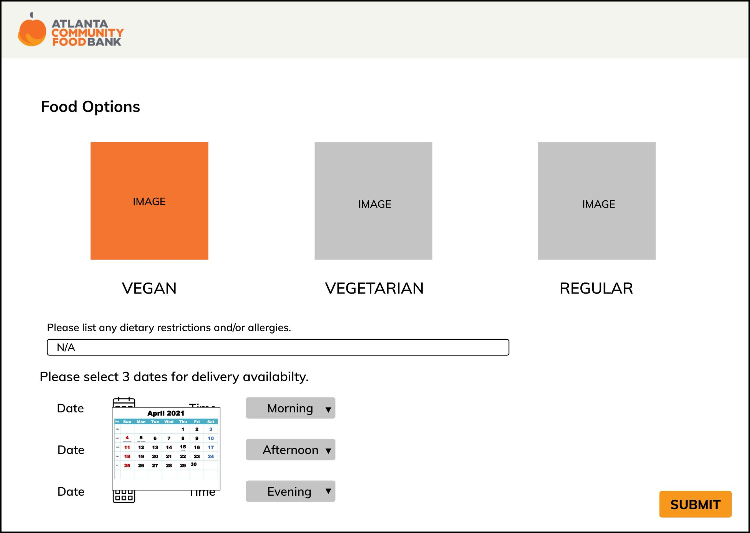

Users are also able to schedule up to 3 dates for food delivery at once for added convenience and availability of both users and ACFB volunteer drivers. If they click on the calendar icon, they will be able to go through the months of the current year and by clicking on the day, the website will automatically get the information into its database. ACFB will not be able to delivery to all users’ at their preferred specific time as in a specific hour and/or minute, so instead we have created three options of morning, afternoon, and evening which will be shown as a dropdown once the user clicks on it, in order for ACFB to also be able to organize the deliveries that need to be made and create a delivery route that efficiently accounts for time and mileage.

*1h. Users will receive an error alert if any of the fields for the delivery request form is not filled out.*

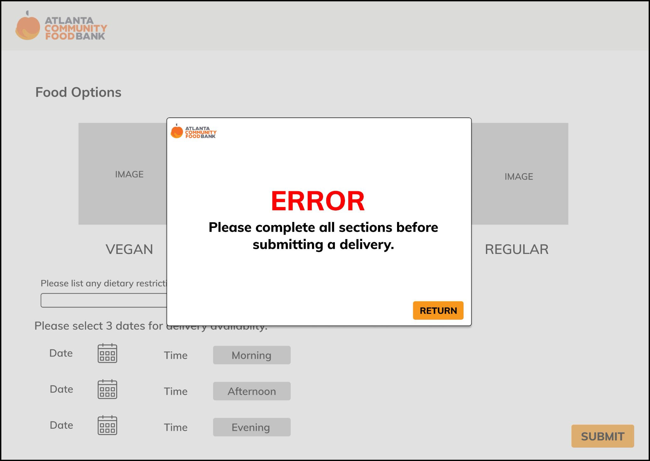

All fields of the delivery request form are required in order for ACFB admins to obtain necessary information from users to efficiently deliver food to users while meeting user’s needs. If any of the fields are not filled out, users will receive an alert that says all fields must be completed to submit a delivery. Once users press return, they will be led back to the original page that they were on.

*1i. Users submit a delivery request form.*

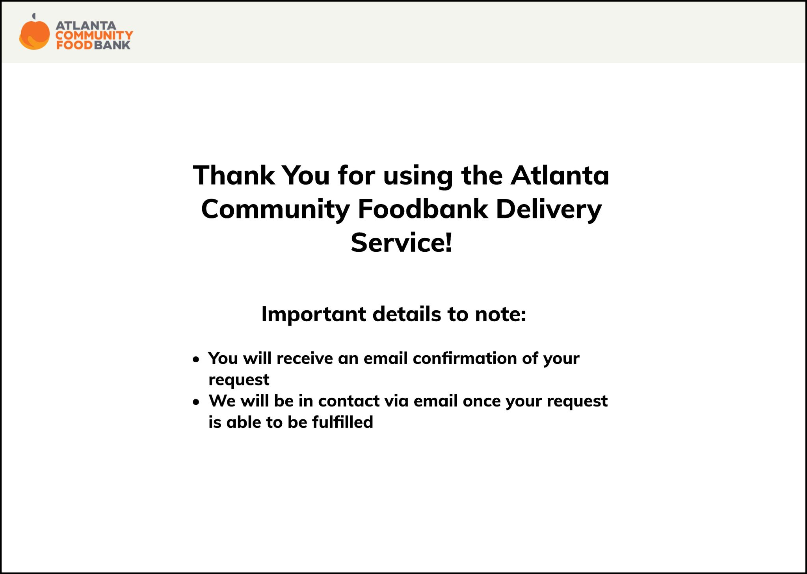

Once a user completes a delivery request form, they will be notified with a “Thank You” page to indicate that their information has been submitted and what the next steps are. In our prototype for homework 4, we had our prototype lead users back to the home page once users submitted their delivery request form, but we realized that it was not a good design as users were not shown whether their form was successfully submitted. It is important to notify the users with feedback like this page because it gives them confirmation that their request has been sent to the ACFB database. With the two notices, an email confirmation is sent out and that they will be contacted once their request is fulfilled, also displayed on the page allows users to know what they must check or stay alerted for any incoming email notifications.

**Task 2: Use the website to sign up to volunteer to deliver food.**

*2A. From the homepage, users can click on “GET INVOLVED” to access the ACFB volunteer page.*



*2B. From the volunteer page, users can click on the “Sign Up” button under Delivery Service to sign up for delivering food.*

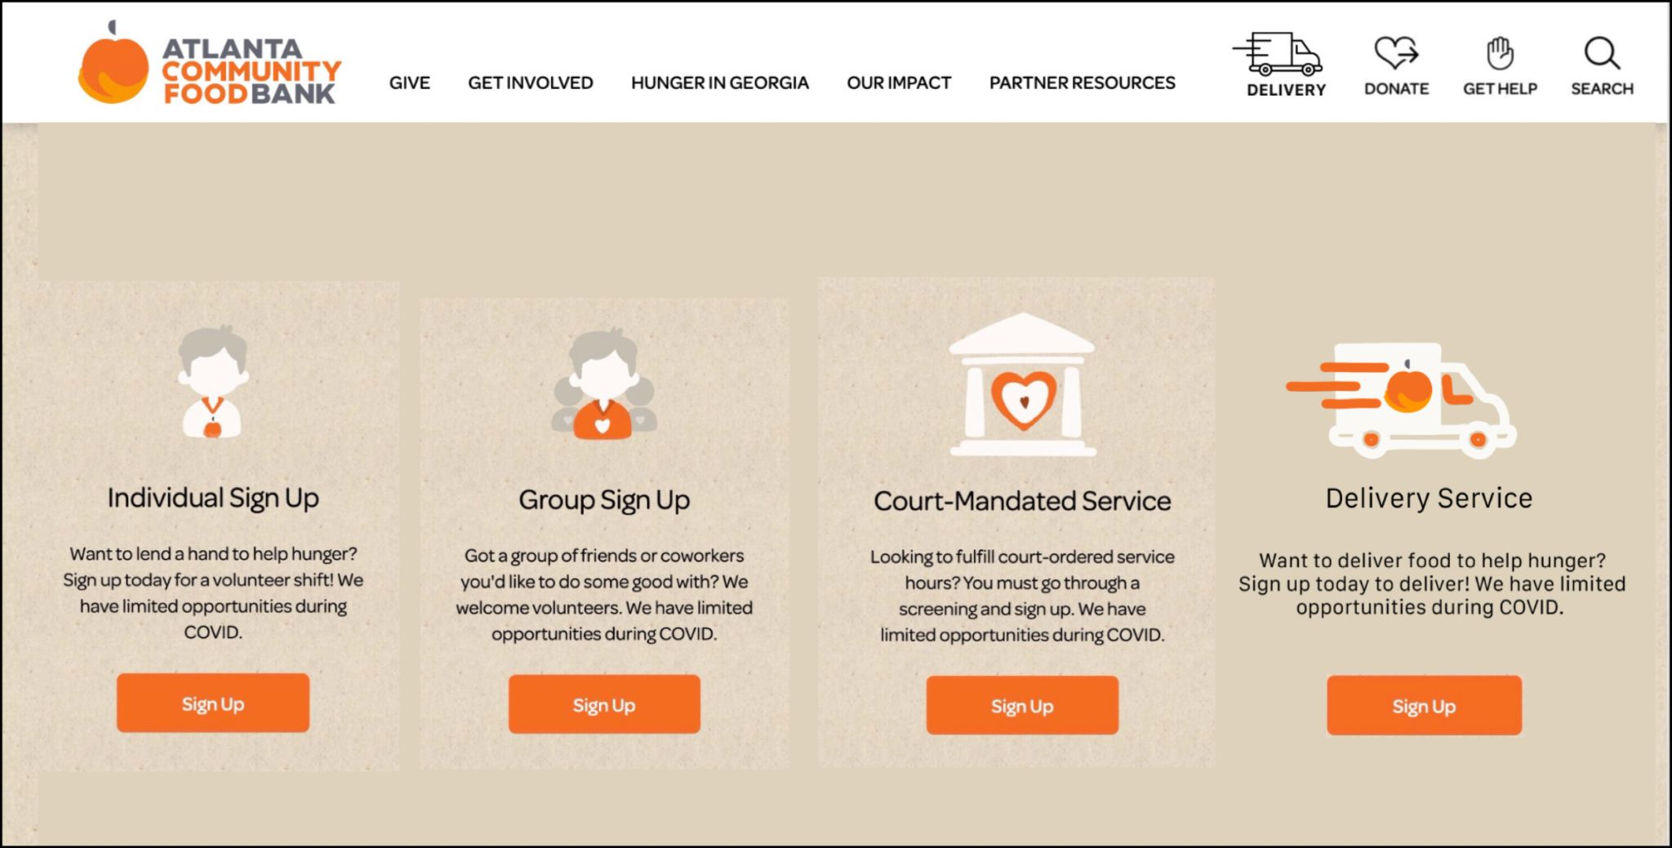

As a secondary stakeholder, we also had to consider ACFB volunteers in creating our prototype. Our delivery system requires sufficient drivers, so we designed our prototype to include the task of allowing volunteers to sign up as a delivery service driver. Previously, there were only three options on the Volunteer: Get Involved page, but we added a fourth option for volunteers to volunteer to deliver food. After a volunteer clicks the “Sign Up” button under delivery service, the user is then prompted to the Volunteer Delivery Sign-Up Page in which they are able to sign up for various delivery requests.

*2C. Users can view all delivery volunteer opportunities and click on the “SIGN UP” button for the volunteer event they wish to participate in.*

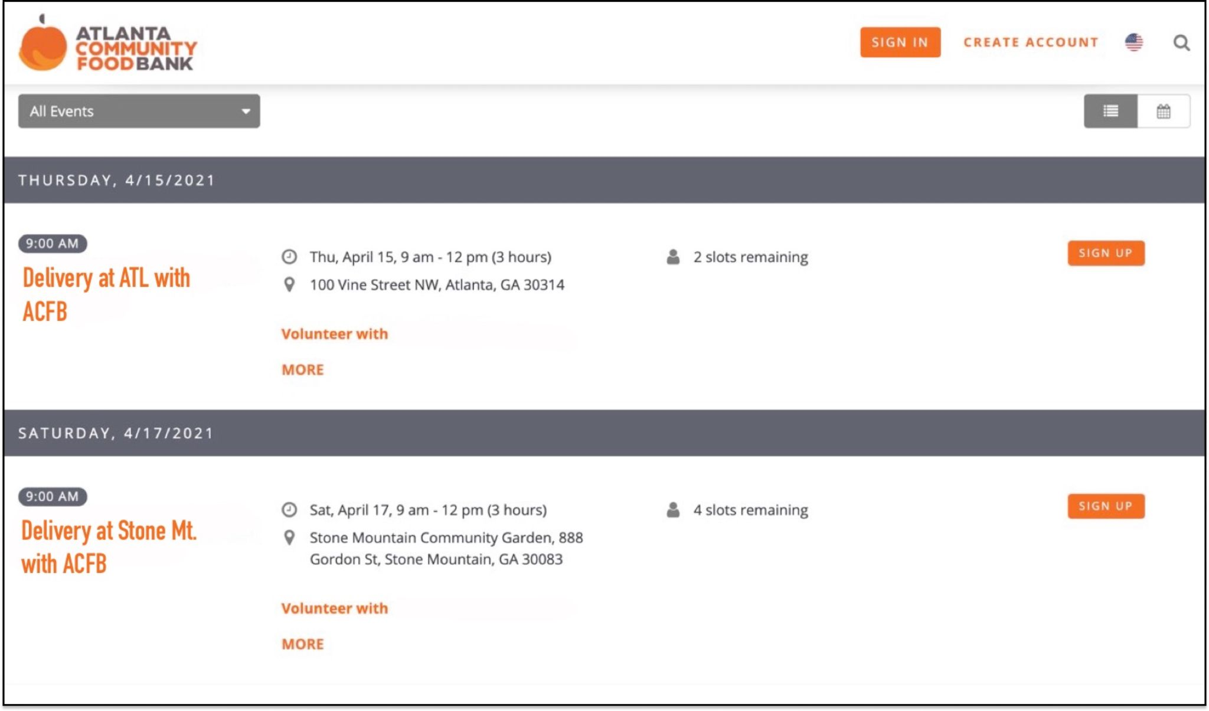

The Volunteer Deliver Sign-Up page lists out different volunteer opportunities for delivering food to food insecure people. Originally, we thought of having a calendar where users can click on certain days and the volunteer opportunities for that day would be displayed on the page. However, after looking at ACFB’s current volunteer sign-up page, we decided to use the same format so that all volunteer opportunities have the same design and process for registering. By having a common format, past ACFB volunteers who are interested in volunteering to deliver food would be able to register easily from their past knowledge of volunteering for other events. After clicking “SIGN UP” for one of the available deliveries, they are then navigated to a Volunteer Information Page.

*2D. Users can fill out the ACFB Delivery Volunteer registration information page.*

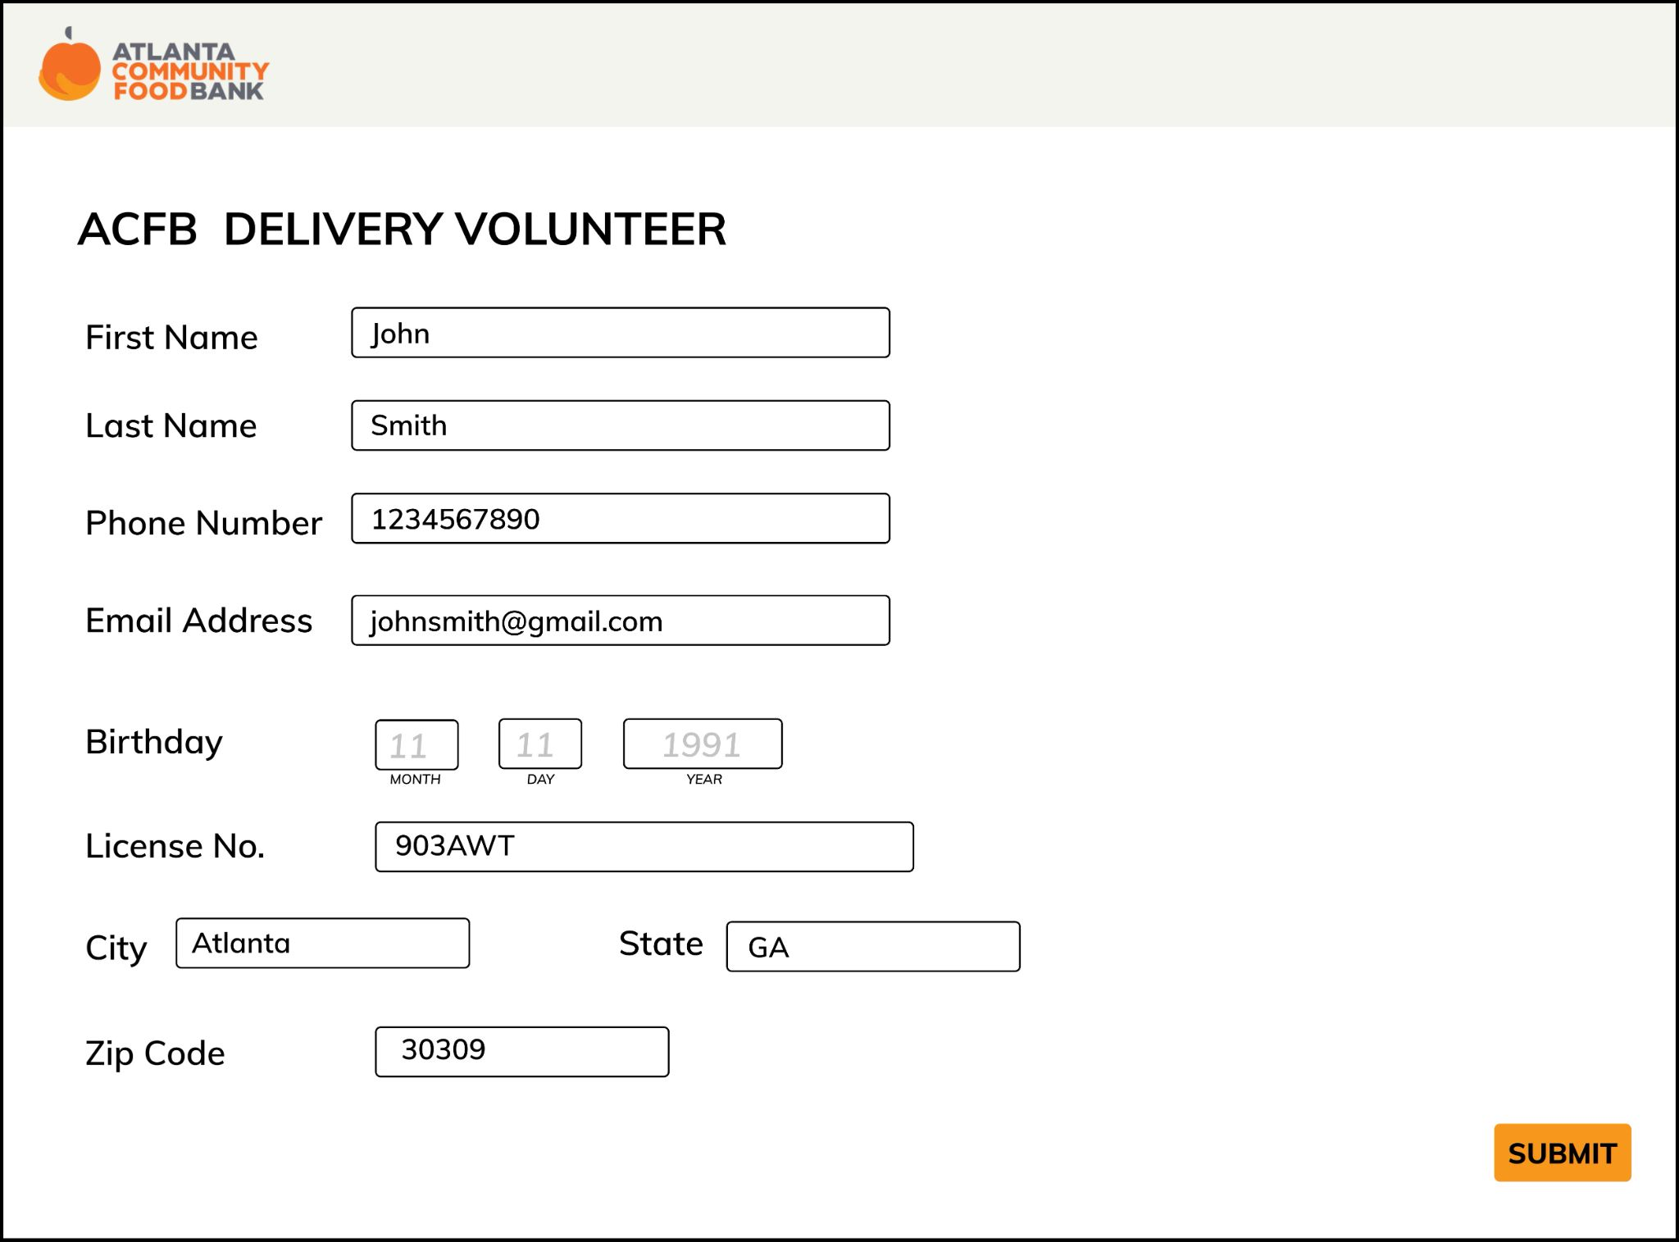

On this page, the user must fill out information pertaining to them to be registered as a delivery service volunteer. These fields include name, phone number, birthday, license plate number, and address. After filling this information out and clicking submit, they are then registered as a delivery service volunteer, and ACFB will be in contact with them with further information. After clicking “SUBMIT”, the user is taken to a confirmation page.

*2E. After Users submit information, a confirmation page will appear with further instructions.*

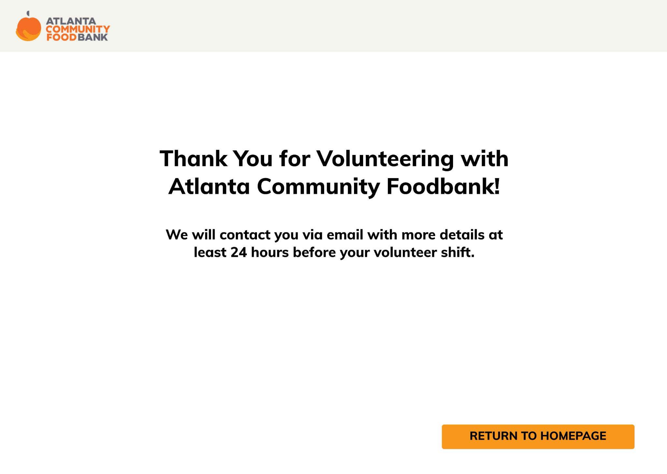

Once the information has been submitted, a confirmation page will appear, thanking the user for registering to volunteer and telling the user that there will be an email sent with more details on the shift. When first creating the prototype in homework 4, we did not have a confirmation page. However, we realized that there needed to be a page to travel to once the user submits their volunteer information. We decided to make this page a confirmation page rather than making it travel back to the homepage with no notification of if the registration was successful. From here, the user can press on the “RETURN TO HOMEPAGE” button or the ACFB icon at the top left of the page to return back to the homepage.

**Task 3: As an ACFB admin, use the website to view delivery requests.**

*3A. From the homepage, users can scroll down to the bottom of the page and click on “Sign In” to access the ACFB admin domain.*



Our primary stakeholders also include ACFB organizers that interact directly with the system. They need to be able to view the information inputted by ACFB users who are requesting food delivery services in order to manage and view active delivery requests. At first, we only created an ACFB Delivery list to view all delivery requests for our homework 4 prototype. However, we realized that there needed to be somewhere in the website to access this list. Therefore, to facilitate this, we created a “Sign In” button for ACFB organizers to sign in to the system and have access to the delivery request page. We placed the “Sign In” button at the bottom of the website in a small font because the only users accessing this section of the website will be the ACFB organizers/administrators. We decided to make the font small and at the bottom of the page in order for it to not be noticeable, only letting the users who know about the purpose of the sign in to click on it. When the “Sign In” button is clicked, a sign in screen appears over the homepage.

*3B. Users can sign in with their email address and password to access the delivery request list.*

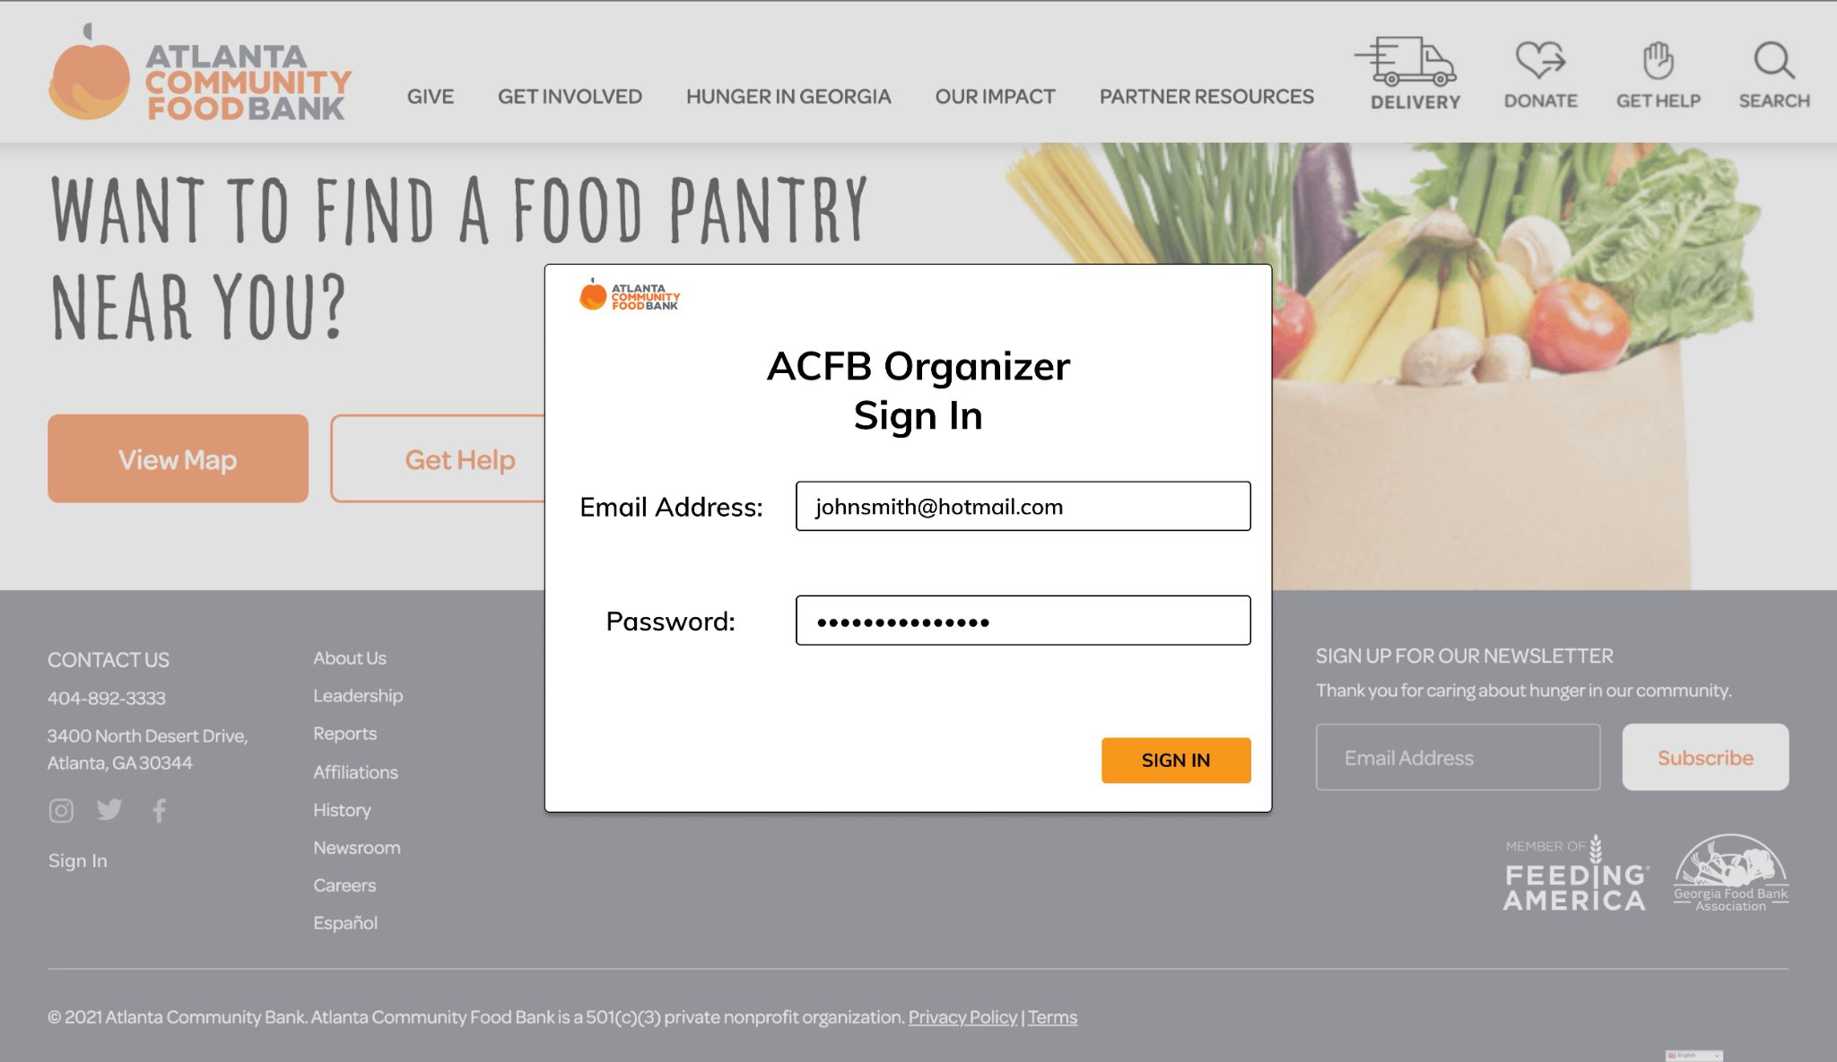

On this page, the user or ACFB organizer can sign in using their email address and password credentials in order to access the delivery request list. Only ACFB organizers and administrators in the user pool system can access the delivery request list after signing in. After the user clicks on the “SIGN IN” button, the user is taken to the ACFB Delivery List page.

*3C. Users can view the delivery requests made by ACFB food insecure users.*

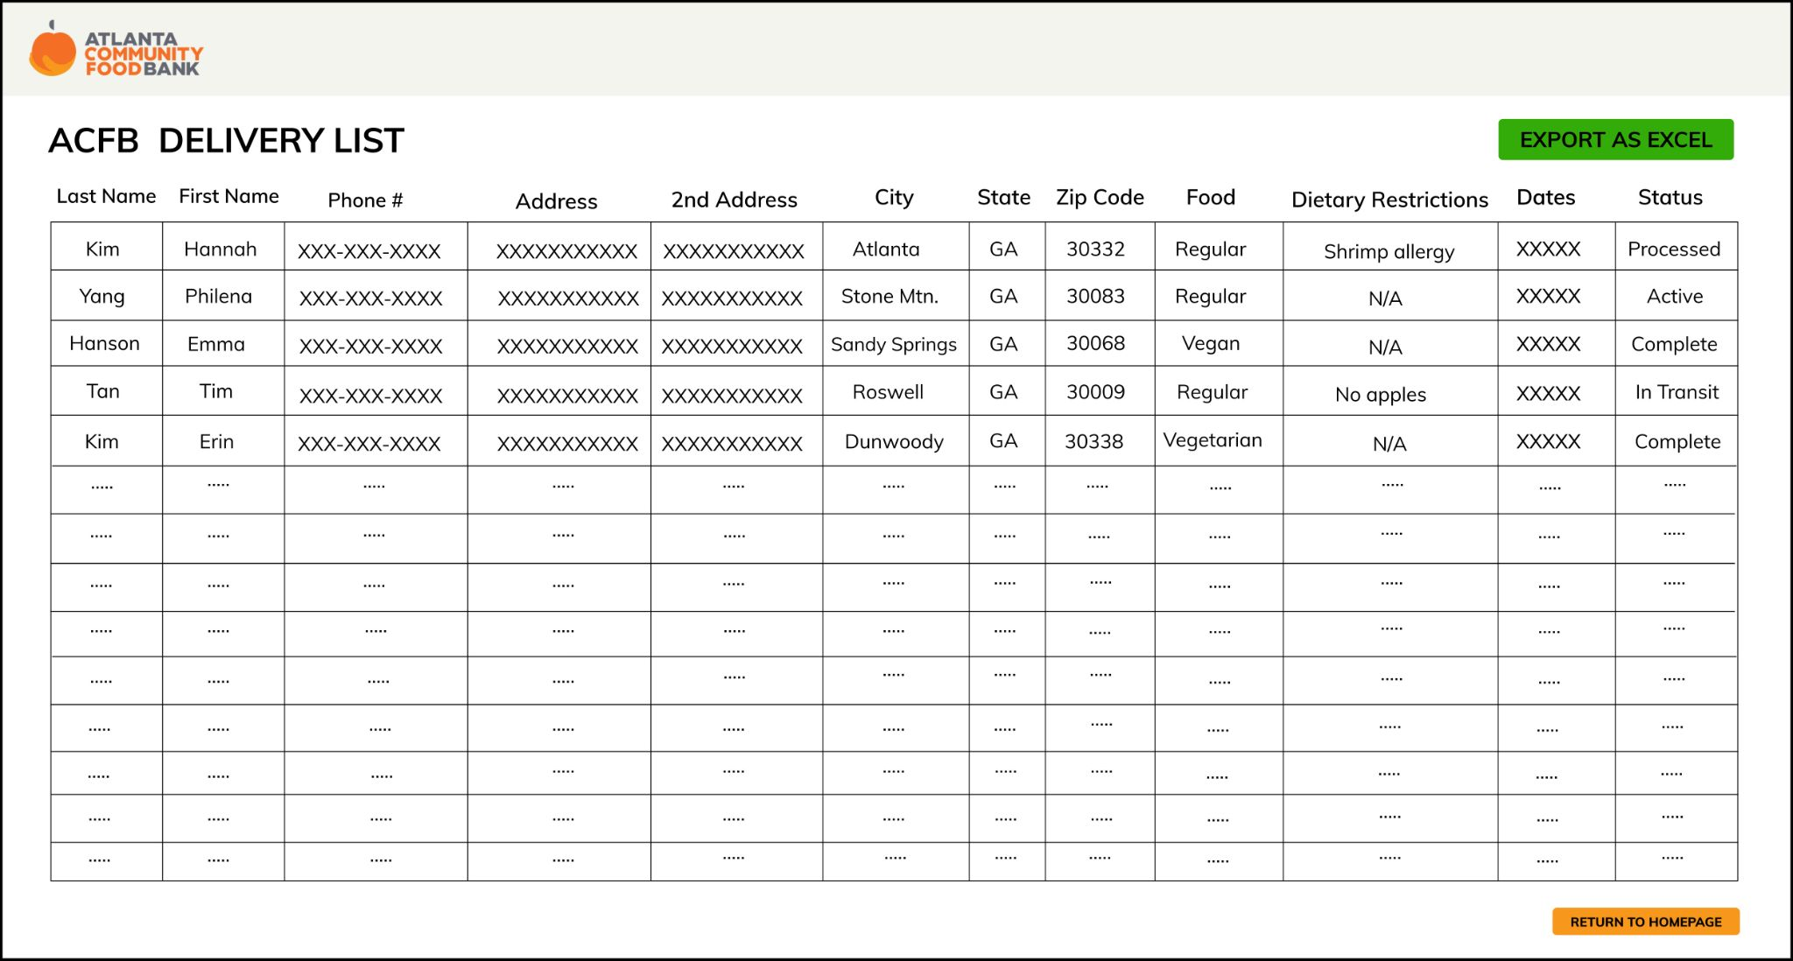

We designed a page that would display active food delivery requests from users in the form of a table that displays information such as name, address, dietary restrictions, and the date/time that the delivery is requested. From here, ACFB workers have access to all of the information regarding delivery requests in order to make sure that food packages are being prepared on time for the deliveries.

### Rationale:

We chose this prototype because it would alleviate transportation issues faced by users through circumventing the need for them to find their own transportation. This prototype would be helpful based on evidence from P1 which includes data from the survey sent out to proxy users that showed that most proxy users without cars preferred to have food delivered to them as an alternative to walking or taking public transportation. This prototype would be especially useful in more suburban and rural areas, where forms of transportation such as walking and public transportation are less useful. We found during our research for P1 that food insecurity is growing the most in these areas of Atlanta. The interview with the Atlanta Community Foodbank also showed that a large majority of users are children and those with disabilities, both of whom lack access to transportation. A delivery system interface that is included onto the existing ACFB website would be helpful in that users already know how to access and navigate the website, and adding a new button for delivery next to the donations button would allow users to easily access the delivery tab. This design alternative helps ACFB in reaching their goal of eliminating hunger in Atlanta and throughout Georgia by bringing in more primary stakeholders, those who are food insecure, through the expanded accessibility by providing a delivery service.

From our P2 report, we were able to find that our website rated the highest amongst our evaluation criteria. In addition, amongst the feedback received from the poster session, we also received feedback that the website was the optimal design alternative. We also wanted to make sure that the interface that we chose would be an interface that users would have access to. From our survey in P1, we found that most users had access to a laptop device and the internet. In the case that the users don’t, there is also the opportunity for users to go to public spaces like libraries to use laptops and access our web application. With all these considerations in mind, we decided that a website is best fit for the task of scheduling food delivery.

A website provides a richer interface for more information to be presented and more feedback to be given. It can have multiple pages to include all of the functionality that we aim to create for our users. Stakeholders’ tasks are able to be fulfilled through the prototype as food insecure people can schedule food delivery, ACFB organizers can coordinate delivery schedules, and volunteers can sign up for delivering food. Compared to other interfaces such as a mobile app or text service, a website allows for more flexibility in structure and organization of information and data for all stakeholders.

### User Scenario

User Scenario 1:

Janet is a single mother with two children living in suburbia Atlanta. She works at a local coffee shop very close to her apartment, but her hours were cut due to a lack of business at the beginning of the pandemic. After her savings started to dwindle, she sold her car in order to continue paying for rent, utilities, and food for her children, but the money she made from that sale soon started to deplete as well. She became concerned about not being able to feed herself and her children, and began looking for food assistance somewhere close to her house, since she relied on walking and public transportation after selling her car. She came across ACFB through searching online for assistance, but unfortunately there were no ACFB locations or mobile pantries within walking distance of her apartment. There was, however, a food delivery service offered in her area. She signed up for a food delivery to her apartment the following evening, after the coffee shop closed, and was also able to input her daughter’s tree nut allergy so they would not receive any food that she could not eat. That following evening, the driver arrived at her apartment with enough food for at least 2 or 3 meals, and food that all members of her household could eat. Because of this service, Janet was able to feed her family nutritious and filling meals and pay for her rent and utilities on time. The next week, Janet ordered another delivery service for her family, but she had to refill all her personal information again. She felt that it was unnecessary to have to fill in her information every time since she was a frequent user of ACFB services. Nevertheless, she was able to order another delivery service, allowing her family to have meals for another week.

User Scenario 2:

Nick, a frequent ACFB volunteer, goes to the ACFB website to check if there are any new volunteer events. He notices that there is a food delivery volunteer event available near his home at Stone Mountain. He signs up for the event and receives an email later in the evening with confirmation of the event he has chosen and his next steps. On the day of April 17th, he goes out to an ACFB food pantry located in the city of Stone Mountain and meets with an ACFB admin who gives him a list of the people and their information he must deliver food to. He places the food items into his car and begins to deliver. Nick was able to successfully fulfill his volunteer duties using ACFB’s volunteer sign up page.

# 

# Evaluation Plan

Using our prototype, the user will complete three tasks. These three tasks are:

* Scheduling food delivery
* Signing up as a delivery service volunteer
* Viewing delivery requests

We will be evaluating these tasks using:

* Demographic questions
* Number of clicks required to complete task
* Time required to complete task
* Number of clarifying questions needed to complete task
* Questions regarding ease of use
* Follow up interview questions regarding open ended feedback

In order to evaluate the usability of our prototype, we individually brainstormed seven tasks each relevant to the prototype and from that group of 35 tasks, we chose three that would be best to evaluate. The final tasks are: scheduling a food delivery, viewing delivery requests, and signing up as a delivery service volunteer.

For our first task, we chose scheduling delivery as a primary task because this task directly pertains to the needs of a group of primary users, the food insecure users of ACFB. The main focus of our system is to provide a food delivery system for the food insecure, so evaluating this task will provide us feedback on this functionality.

For our second task, we chose to evaluate the task of viewing scheduled food deliveries because this feature is important for ACFB organizers who are a part of our primary stakeholder group. They need to be able to view food deliveries in order to track the status of delivery requests to manage the system.

For our third task, we chose signing up to deliver food because volunteers are essential for this delivery system to operate, and volunteers are a third set of stakeholders, our secondary stakeholders. Volunteers need a means of registering to deliver food, so we designed an interface for them to do so.

We will evaluate these tasks through usability testing in which proxy user volunteers will be asked to complete each task while using our prototype. For evaluation, our users will be interacting with a high fidelity prototype that is fully implemented and functional for users to scroll, click, and interact with. We chose to use a high fidelity prototype because we wanted users to be able to accurately interact with a prototype that was as close to a final product as possible in order to best display the functionality, affordances, and design of our project.

While proxy users are completing each task, our team members will observe users and record data such as number of clicks required to complete each task, time required to complete each task, the number of clarifying questions needed to complete each task, and ease of use ratings. These data points will be used to evaluate our prototype according to our requirements and usability criteria. We will also ask follow-up questions in an interview format regarding user satisfaction, in order to gain all of the feedback users may have for us outside of the questions posed directly. Our team members will also be taking field observations of any general observations they make during the completion of the tasks. To create a controlled environment with consistent procedure, we developed a script for our team members to follow during the evaluation. This can be seen in Appendix I. This script involves an introduction, receiving consent via a Qualtrics form (Appendix II), task completion, and a conclusion. We also formulated a note taking template to standardize the result gathering (Appendix III).

Regarding data, we will be collecting objective data including number of clicks required to complete a task, time required to complete a task, number of clarifying questions needed to complete a task, and the number of incorrect clicks. We will also be collecting subjective data including asking open ended questions regarding ease of use, aesthetic, and satisfaction.

Our usability criteria includes sustainability, convenience, inclusiveness, utility, efficiency, and learnability. The data on how the website performed according to these usability criteria can be found in the table below. This table was taken from P2, but these scores were generated as an average out of 5 based on ratings from five team members while interacting with the website prototype.

| **Criteria** | Website |
| --- | --- |
| Sustainability: | 3.4 |
| Convenience: | 3.6 |
| Inclusiveness: | 3.6 |
| Utility: | 4.8 |
| Efficiency: | 4.2 |
| Learnability: | 3.8 |
| **Total**: | **3.925** |

Learnability will be measured through a combination of the ease of use rating, number of clarifying questions asked, and the time required to complete a task versus the baseline time required to complete a task. The baseline time was recorded as an average of five team members who completed the same task. The ease of use rating, number of questions asked, and time comparison should be strong indicators of how big or little the learning curve of the website design is. We aim for the website to be simple and not be difficult to learn to use with minimal clarifying questions needed, high ease of use rating, and a similar completion time to the baseline time.

To measure efficiency, we will use the number of clicks required to complete a task. This objective data provides us with a number to compare to the expected and minimum number of clicks required to complete a task as determined by the designers of the prototype(our team). With this number, we can also compare the data to extrapolate which parts of the task gave the user the most trouble by paying attention to when a spike in the number of clicks occurred.

Utility will be measured by whether the individual is able to successfully complete the task. If the user completes the task, this gives us feedback that the functionality of the prototype works thus supporting the utility of the prototype.

With the demographic questions of asking whether the user has daily access to the internet and what devices they have access to, we will be able to determine convenience and inclusiveness. The prototype will be measured as convenient and inclusive if the majority of users have access to the internet and devices to access the prototype.

Regarding sustainability, through research and previous work done(P1 & P2), we discovered that a web application would be the most sustainable for ACFB and convenient and inclusive for ACFB and food insecure users alike, so this web application was chosen as the best prototype to move forward with. Specific comparisons to the other prototypes via usability criteria can be seen in Appendix IV.

Through evaluating the tasks based off of our usability criteria and gathering data from user testing(see Appendix III. Note Taking Sheet), our prototype also addresses our functional and nonfunctional requirements. The three tasks that we are evaluating cover the functional requirements of setting up a method for the food insecure to receive ACFB’s food services, inform users whether delivery is available to them, and update the organizer page with new delivery requests. Each evaluated task corresponds directly to one of these requirements respectively. Usability corresponds to learnability and other measures such as open ended questions that ask users to describe their experience. Utility is described in a paragraph above. Reliability is measured in completion of tasks especially task 3 in which users view food delivery requests, and accessibility will be measured via the demographic questions to gauge users’ access to internet and devices.

# 

# Summary and Reflections

Through the process of deciding on a final interface and the tasks that the system will support, we have updated our requirements specification. In Homework 4, we brainstormed and decided on tasks that our system will support for our stakeholders. Our final prototype supports tasks for our primary users of food insecure people and ACFB organizers as well as our secondary users of ACFB volunteers. The requirements specification was updated to reflect these tasks, with changes pertaining to the users of ACFB organizers and volunteers. The functional requirements were updated to include information collection from ACFB volunteers and delivery requests’ details for ACFB organizers. The system needs volunteers to help delivery food requests, and organizers need to be able to coordinate volunteers and requests using the system. Because we decided on a website for the prototype, we are able to support all tasks through the website interface as an extension of the ACFB website. Our non-functional requirements did not change, as our system should still facilitate the process of food delivery and be useful, accessible, and reliable for our users. Our usability criteria also did not change, and the data to be collected in the evaluation of tasks as well as follow up questions measure these criteria for the prototype. For our design process, we first generated ideas individually and then shared and grouped our design alternatives by similar interfaces. We then picked three design alternatives: a mobile app, website delivery service implementation, and a texting service. We then evaluate each design by rating each design using the evaluation criteria that we developed on a scale from 1-5, with 5 being the best for that criteria, and averaged and summed the ratings for each design and criteria. As the website scored the highest, we felt that it would best meet the requirements and evaluation criteria of our prototype. For the design and implementation of our prototypes, we adapted and built on our design for the website interface from Part 2. We continued designing screens and features for our tasks, expanding on the interface for food insecure people and ACFB organizers and volunteers. We focused on a simple design that encapsulates all features necessary for the completion of tasks. Since we developed the prototype in Figma, our team was able to collaborate and make changes to the prototype as needed.

To create a coherent set of prototypes, each member of our group individually designed individual prototypes, then we came together and iterated to combine the best features of each, and collaborated for the design of the final prototype. We took into consideration factors such as functionality, usability criteria, requirements, and overall aesthetic. This process was pretty smooth as our group practiced effective communication methods via our Groupme and consistent group meetings outside of studio and class to maintain steady progress and facilitate a collaborative environment. In order to develop our evaluation plan, we utilized the DECIDE framework. The DECIDE framework provides a framework for evaluation and includes determining the goals, exploring the questions, choosing the evaluation approach and methods, identifying the practical issues, deciding how to deal with ethical issues, and evaluating, analyzing, interpreting, and presenting the data. This framework allowed us to plan our evaluation in a systematic and structured way, and ultimately allowed us to successfully evaluate our prototype.

# Appendix

## Appendix I. Script

<https://docs.google.com/document/d/14E2FApPMqJ70-HtCr3Xa_r0_6hxf0E86IQIluxA6hDA/edit?usp=sharing>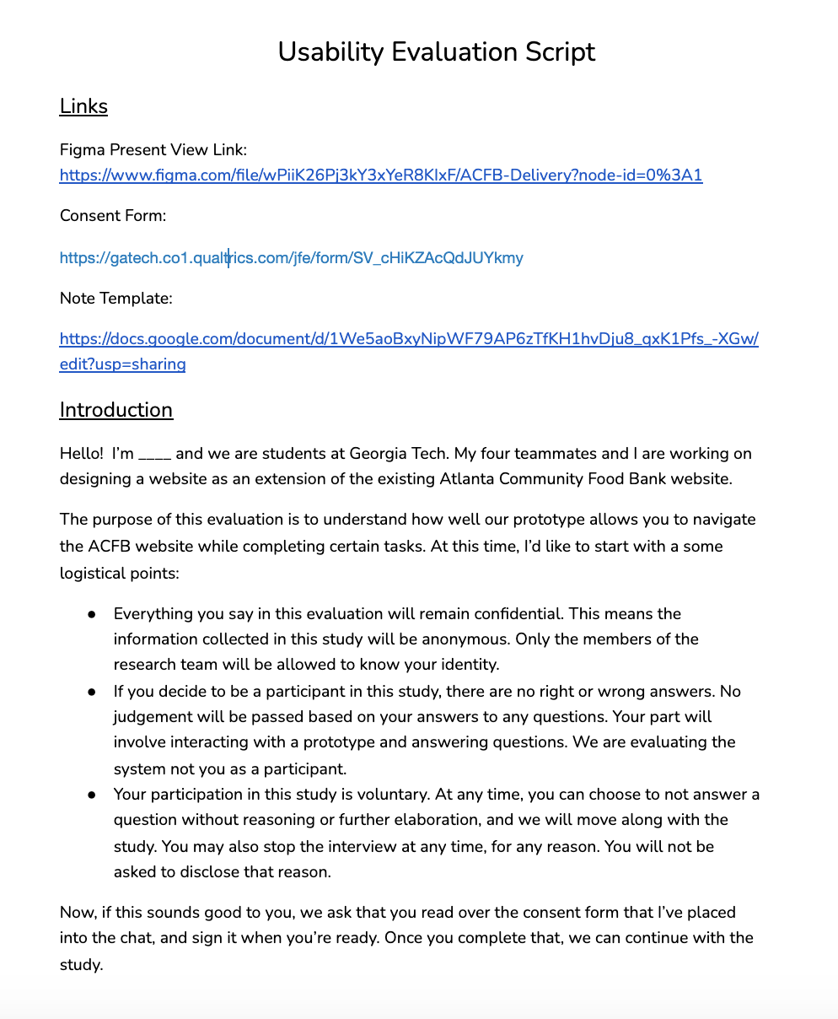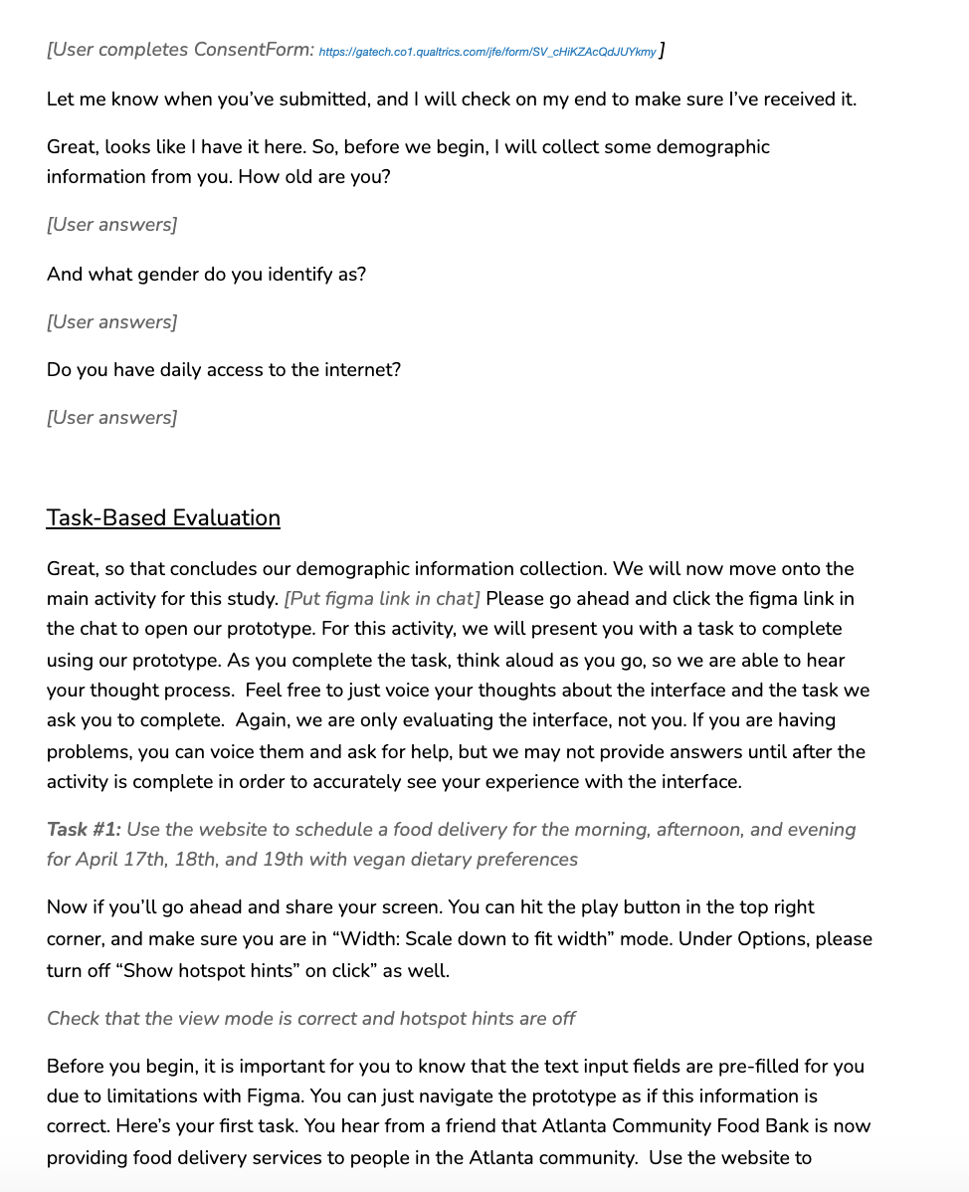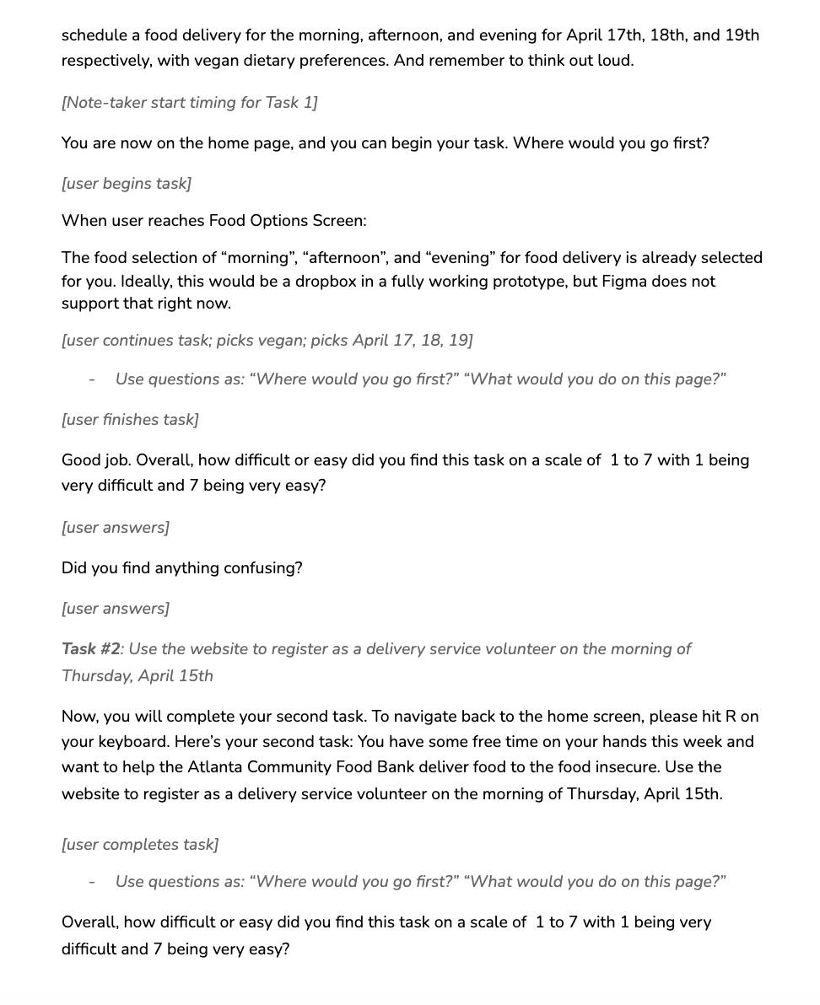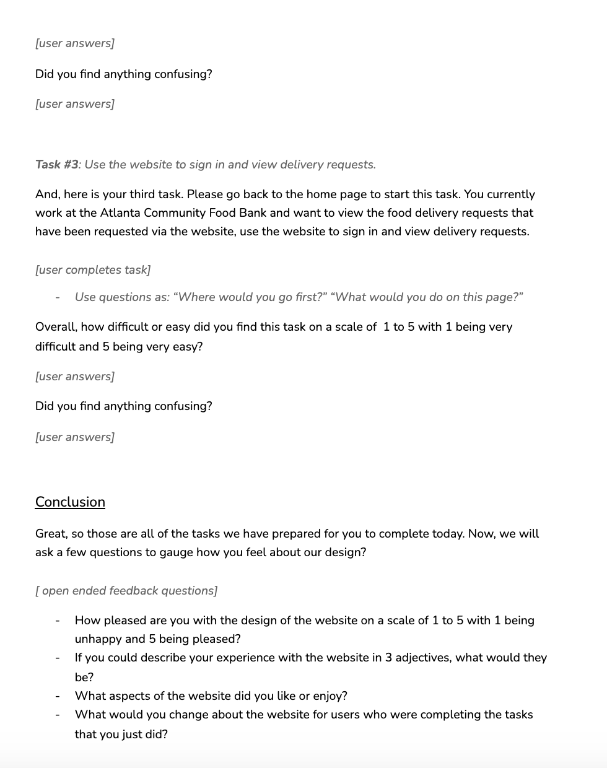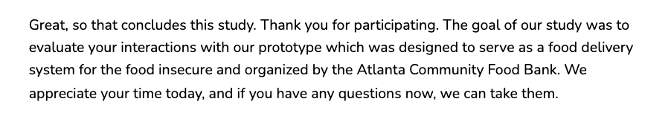

## Appendix II. Consent Form

<https://gatech.co1.qualtrics.com/jfe/form/SV_cHiKZAcQdJUYkmy> 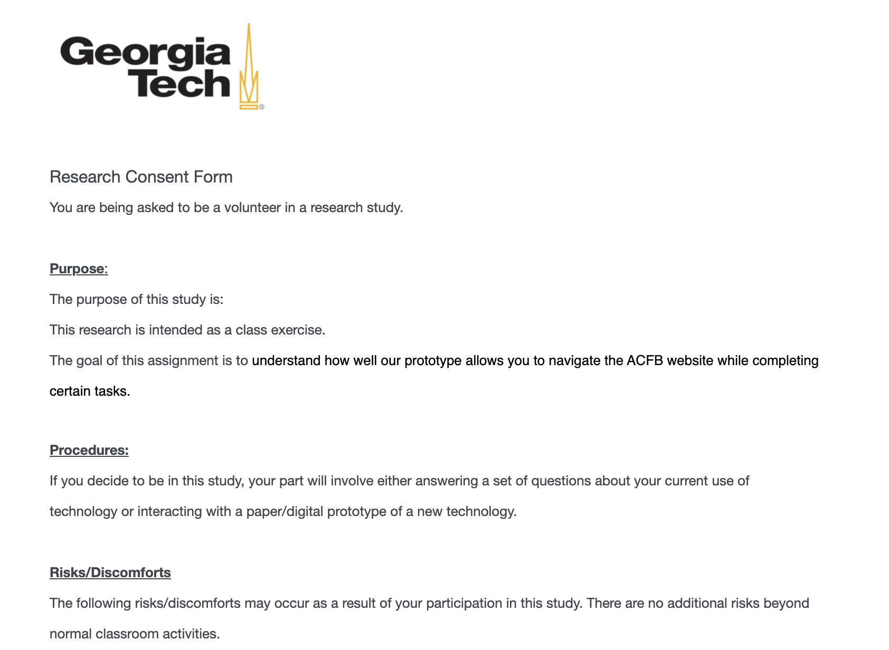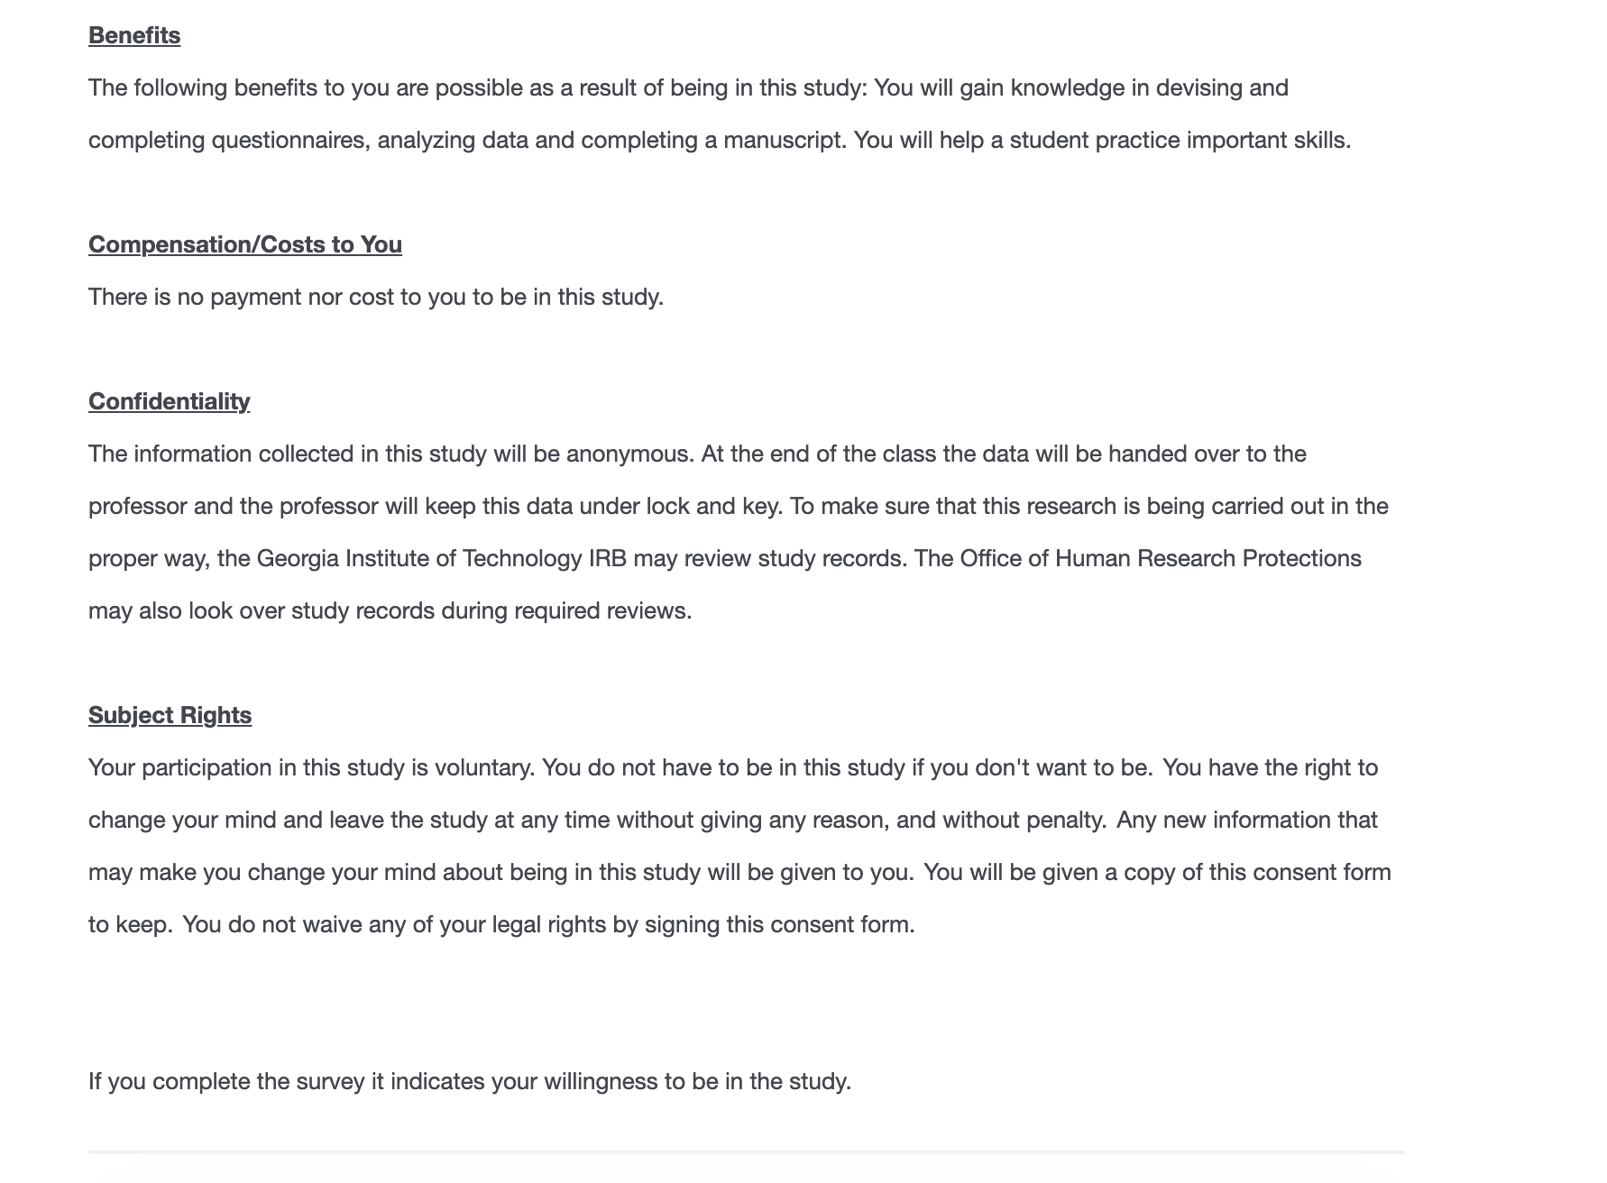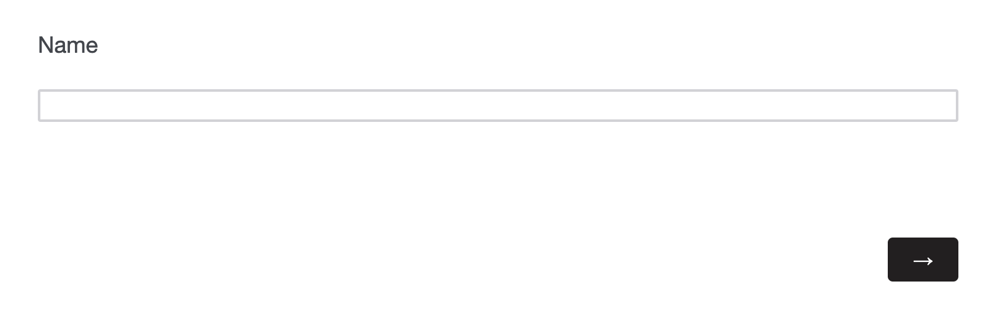

## Appendix III. Note-Taking Template

<https://docs.google.com/document/d/1TvmQTrTFH5g7FH2HZM6iCa2vy_gx84Xk7QYGs6zF7UY/edit?usp=sharing>

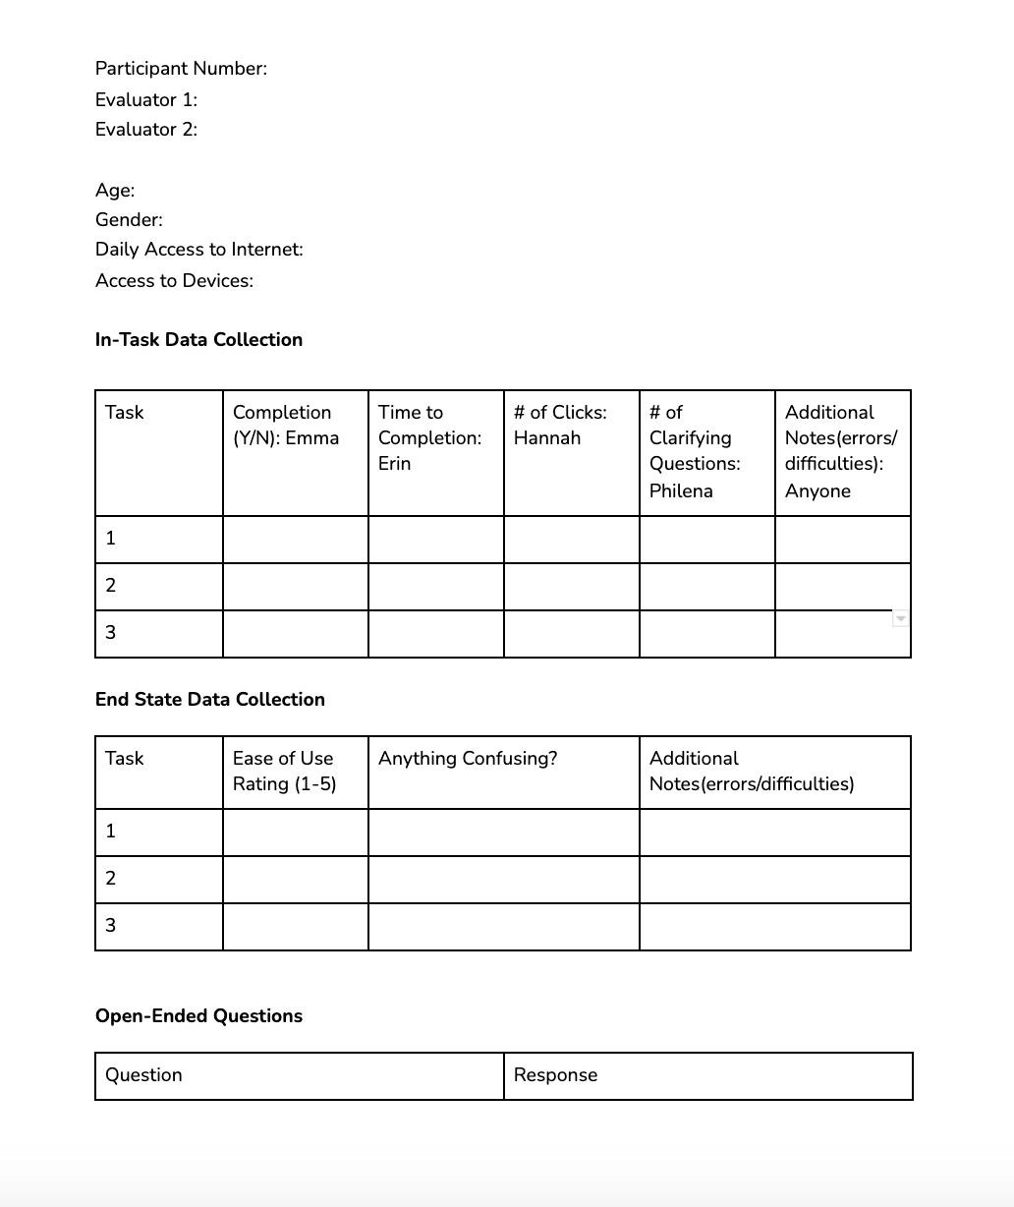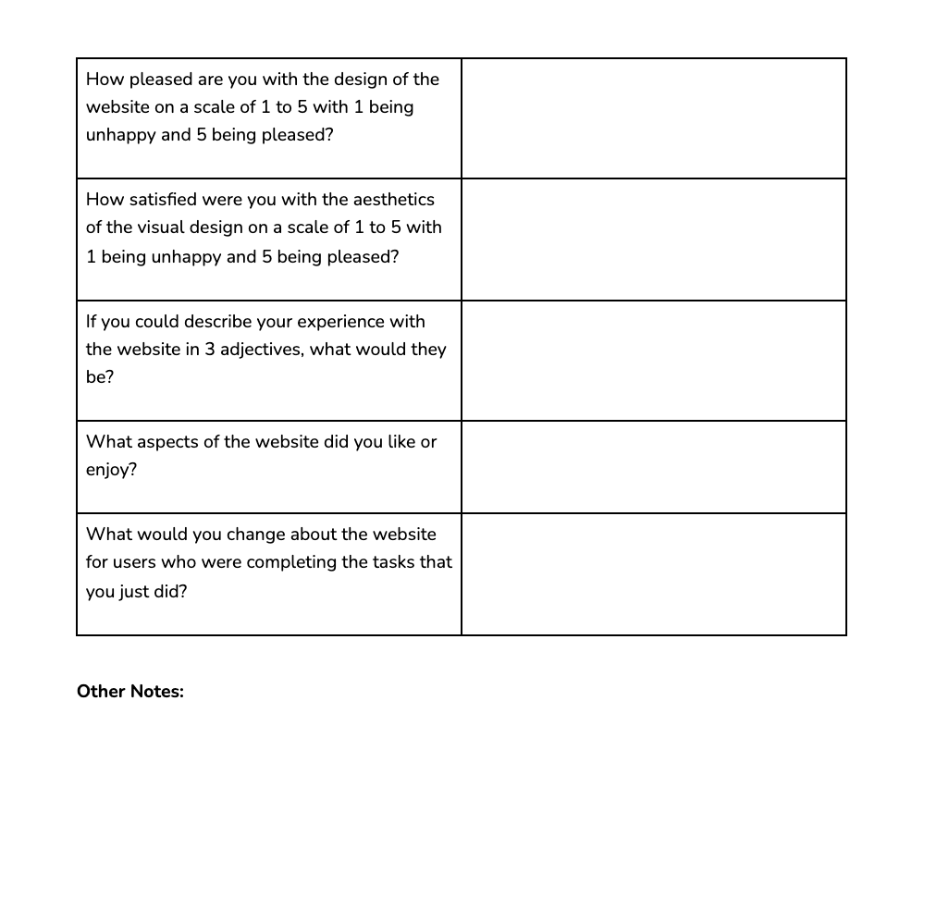

## Appendix IV. Table Usability Criteria for 3 Prototypes

| **Criteria** | Website | Mobile App | Text Service |
| --- | --- | --- | --- |
| Sustainability: | 3.4 | 2.8 | 3.8 |
| Convenience: | 3.6 | 4 | 4.4 |
| Inclusiveness: | 3.6 | 2.8 | 4 |
| Communication: | 4.6 | 3.6 | 3.6 |
| Utility: | 4.8 | 4 | 2.6 |
| Cost: | 3.4 | 2 | 4.6 |
| Efficiency: | 4.2 | 4 | 3.2 |
| Learnability: | 3.8 | 3.2 | 3.6 |
| **Total**: | **3.925** | **3.3** | **3.725** |