P4: Evaluation Report

H06

Team UI French Fry

Emma Hanson, Erin Kim, Hye Lim(Hannah) Kim, Philena Yang, Zehao(Tim) Tan

# Table of Contents

| Introduction | 3 |
| --- | --- |
| Evaluation Overview | 3 |
| Rationale for Evaluation Tasks/Materials | 6 |
| Evaluation Results | 8 |
| Evaluation Results Analysis | 16 |
| Updated Design | 18 |
| Implications | 23 |
| Conclusion | 25 |
| Appendix  Appendix I. Consent Form  Appendix II. Note-Taking Template  Appendix III. Script  Appendix IV. Data and Data Reduction | 28 |

# Introduction

The problem space we are trying to address is that food insecure people often do not have the means of transportation to access food and resources provided by the Atlanta Community Food Bank. In response to this problem space, the solution space we are focusing on is delivering food to these users. After discussing various potential solution spaces, we decided to focus on delivery. By having a delivery system, users who do not have a means of transportation will be able to obtain food without having to worry about how to travel to the nearest food pantry. Likewise, the Atlanta Community Food Bank will be able to reach out to and help alleviate hunger for more people in the community. To address this solution space, the prototype we are focusing on is a website. This website will help facilitate a delivery system for ACFB users, and users will be able to sign up for and schedule food delivery to their homes.

# 

# Evaluation Overview

Our prototype is an extension of the Atlanta Community Food Bank website that will allow users to access food delivery services. Three main tasks that the prototype supports are: the food insecure scheduling food delivery, volunteers signing up to deliver food, and ACFB viewing delivery requests in order to view each delivery request. We evaluated these tasks through usability testing of 10 participants who served as proxy users to our application. The average age of participants within our study is 20.6 with 50% of participants being male and the other 50% being female. It is important to note that these participants are not reflective of the population of ACFB users and stakeholders of our project. All study participants served as proxy users. These proxy users are all Georgia Tech students. Due to the nature of the pandemic, ethical concerns, timing of the project, and the inability to easily survey those affected by food insecurity, we had to pivot our target group for the evaluation.

## Stakeholders:

* Primary: ACFB Users(Food Insecure), Organizers behind the delivery system, ACFB
* Secondary: ACFB Volunteers, Children in food insecure families, rideshare drivers
* Tertiary: People who donate to ACFB

## 

## Tasks Descriptions

Using our prototype, three tasks will be evaluated. They are:

1. Scheduling food delivery
2. Signing up as a delivery service volunteer
3. Viewing delivery requests

## Task 1: Scheduling Food Delivery

Description: Use the website to schedule a food delivery for the morning, afternoon, and evening for April 17th, 18th, and 19th with vegan dietary preferences.

Evaluation:

* Number of clicks required to complete task
* Time required to complete task
* Number of clarifying questions needed to complete task
* Questions regarding ease of use
* Follow up interview questions regarding open ended feedback

**Task 2: Signing up as a Delivery Service Volunteer**

Description: Use the website to register as a delivery service volunteer on the morning of Thursday, April 15th.

Evaluation:

* Number of clicks required to complete task
* Time required to complete task
* Number of clarifying questions needed to complete task
* Questions regarding ease of use
* Follow up interview questions regarding open ended feedback

**Task 3: Viewing Delivery Requests**

Description: Use the website to sign in and view delivery requests.

Evaluation:

* Number of clicks required to complete task
* Time required to complete task
* Number of clarifying questions needed to complete task
* Questions regarding ease of use
* Follow up interview questions regarding open ended feedback

**Evaluation Techniques**

Usability testing was the primary evaluation technique for our evaluation. During the beginning of the evaluation, the participant was first asked to complete a Consent Form (see Appendix I). After this, we began the evaluation with some demographic questions about age, sex, and daily access to internet/devices. This information helps frame our user group and gives us insight into whether our users are able to access the internet and/or devices which are both necessary for our access to our prototype. The users then proceed with the prototype evaluation in which they were asked to complete each of our three tasks while using our prototype. They were asked to speak aloud and complete the task while a note taker from our team recorded various measurements such as:

* Number of clicks required to complete task
* Time required to complete task
* Number of clarifying questions needed to complete task
* Questions regarding ease of use

These were all recorded on a note-taking template (See Appendix II). At the end of the three tasks, the user was asked 4 open ended questions in regards to the overall user experience, aesthetics, usability, and satisfaction of the prototype. Our team members also took field observations of any general observations they made during the completion of the tasks.

To create a controlled environment with consistent procedure, we utilized a script during the usability testing for our team members to follow during the evaluation. This can be seen in Appendix III. This script involves an introduction, receiving consent via a Qualtrics form, task completion, and a conclusion.

# Rationale for Evaluation Tasks/Materials

## Task Rationale

## Task 1: Scheduling Food Delivery

Rationale: For our first task, we chose scheduling food delivery because this task directly pertains to the needs of a group of primary users, the food insecure users of ACFB. The main focus of our system is to provide a food delivery system for the food insecure, so evaluating this task will provide us feedback on this functionality in determining whether the interface is usable. In addition, we added the vegan dietary preferences to the task because we wanted to make sure that our interface is accessible to those with special dietary needs.

Task 2: Signing up as a Delivery Service Volunteer

Rationale: For our second task, we chose to evaluate the task of viewing scheduled food deliveries because this feature is important for ACFB organizers who are a part of our primary stakeholder group. They need to be able to view food deliveries in order to track the status of delivery requests to manage the system.

Task 3: Viewing Delivery Requests

Rationale: For our third task, we chose signing up to deliver food because volunteers are essential for this delivery system to operate, and volunteers are a third set of stakeholders, our secondary stakeholders. Volunteers need a means of registering to deliver food, so we designed an interface for them to do so.

## 

## Evaluation Rationale

We chose a website as our interface because it rated the highest amongst our evaluation criteria in P2 as well as in the feedback from the poster session. A website will be able to support all the functionality needed for users to accomplish their tasks by providing a richer interface for more information and feedback. This enables the system to meet the requirements, including collecting information from users, providing feedback, and showing delivery request details. The web interface would be easier to navigate when providing information, as well as when looking at data. In addition, from our survey in P1, we found that most users had access to a laptop device and the Internet. The system is also accessible in the case that the users don’t have access by providing the opportunity for users to go to public spaces like libraries to use laptops to access the website.

Our prototype is high-fidelity as it resembles an actual implementation of an ACFB delivery system built into the ACFB website with simple features. The design is simplistic and resembles the theme of the current ACFB website, with the same colors, fonts, and layouts. Our design is simplistic in that it incorporates all the functions and details necessary without being overbearing. This is to account for users that aren’t too familiar with technology and navigating web pages. We were also mindful of how much effort is needed for users to fill out the different forms. If the forms were too long or complex, users and volunteers could be deterred from completing it, resulting in insufficient users or volunteers. We chose to use a high fidelity prototype because we wanted users to be able to accurately interact with a prototype that was as close to a final product as possible in order to best display the functionality, affordances, and design of our project.

We chose to use usability testing for our evaluation because it provides solid feedback and insight on the user experience and satisfaction with limited bias and under similar conditions. The quantitative and qualitative results can be used and extrapolated to improve our product in future iterations. Usability testing allows us to identify problems and confusing aspects of our product that we may have missed previously. Through the user satisfaction questions and ratings, we were able to gain data about users’ opinions, and the data collected will allow us to calculate performance times to find errors in our product.

# Evaluation Results

Before starting the tasks, we collected demographic information such as age, gender, and highest level of education from 10 participants. We also asked if they had daily access to the internet and daily access to devices.

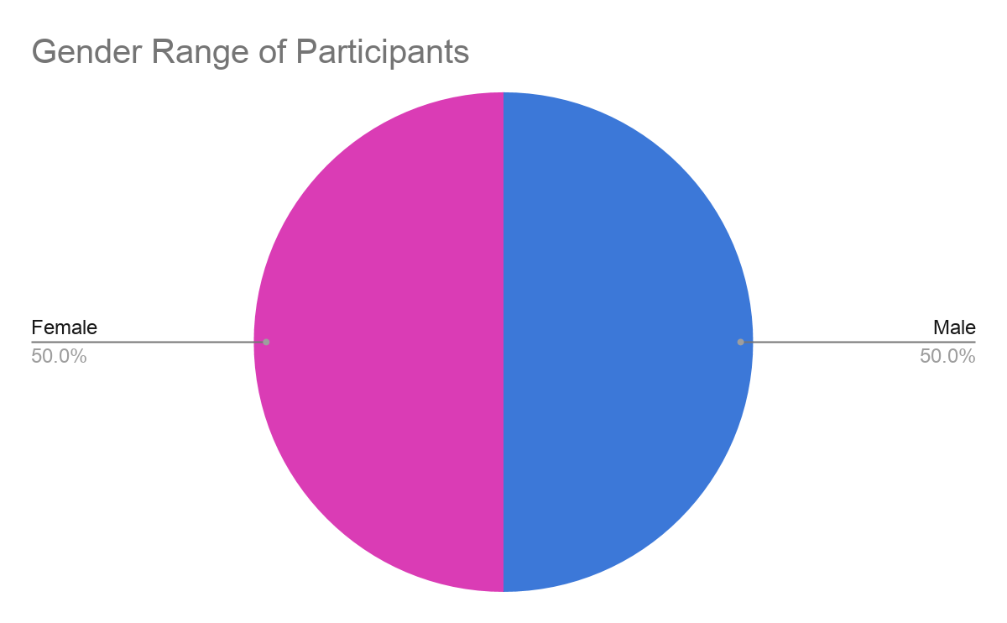

Figure 1. Pie chart of participants’ gender

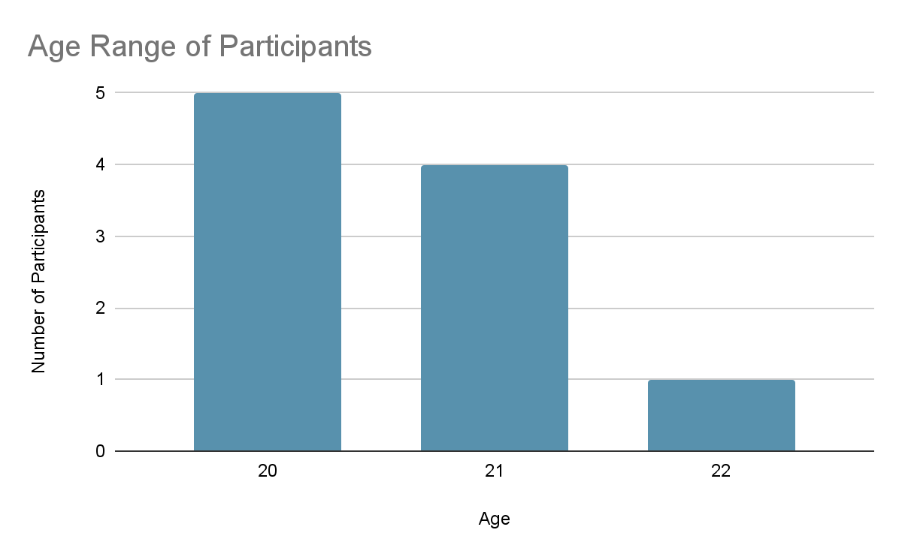

Figure 2. Bar graph of participants’ age

We found that the gender of participants was an equal ratio of 5:5 as shown in Figure 1. Also, the age of participants ranged from 20 to 22, having an average age of 20.6.

| **Participant #** | **Highest Level of Education** | **Daily Access to the Internet?** | **Access to Devices?** |
| --- | --- | --- | --- |
| **1** | Some College | Yes | Yes |
| **2** | Some College | Yes | Yes |
| **3** | Some College | Yes | Yes |
| **4** | Some College | Yes | Yes |
| **5** | Some College | Yes | Yes |
| **6** | Some College | Yes | Yes |
| **7** | Some College | Yes | Yes |
| **8** | Some College | Yes | Yes |
| **9** | Some College | Yes | Yes |
| **10** | Some College | Yes | Yes |

Figure 3. Table listing other information regarding education, Internet, and devices

Regarding the remaining demographic information collected, we found that the highest level of education for all participants was “Some College” and all participants had daily access to the internet and access to devices.

Because our prototype is a website, we thought that it was important to obtain demographic information like age and education to assess how the results are different between age groups and different levels of education. The rest of the information collected is useful for understanding if the participant has internet and devices where they can view a website on a daily basis. This can assess if the participant has prior experience accessing websites and using technology, allowing us to compare results later on based on prior or little experience using technology.

After collecting demographic information, we collected various data as participants were undergoing 3 tasks. For each task, we measured the amount of time, the number of clicks, and the number of clarifying questions it took to complete the task. After completing each task, we asked the participants various questions regarding their experience using the prototype to complete the task. To measure their experience, we asked them to rate the ease of use of the prototype for the specific task on a scale from 1 to 5 with 1 being very difficult and 5 being very easy and asked if there was anything confusing when completing the task.

***Task 1: Scheduling Food Delivery***

*In-Task Data Collection for Scheduling a Food Delivery*

| **Participant #** | **Completion** | **Time to Completion (seconds)** | **# of Clicks** | **# of Unnecessary Clicks** | **# of Clarifying Questions** |
| --- | --- | --- | --- | --- | --- |
| **1** | Yes | 90 | 12 | 0 | 0 |
| **2** | Yes | 111 | 12 | 0 | 1 |
| **3** | Yes | 105 | 17 | 5 | 2 |
| **4** | Yes | 127 | 14 | 2 | 2 |
| **5** | Yes | 88 | 14 | 2 | 3 |
| **6** | Yes | 119 | 22 | 10 | 5 |
| **7** | Yes | 95 | 11 | -1 | 2 |
| **8** | Yes | 84 | 15 | 3 | 2 |
| **9** | Yes | 75 | 13 | 1 | 2 |
| **10** | Yes | 105 | 16 | 4 | 1 |
| **Average** | **Yes** | **99.9** | **14.6** | **2.6** | **2** |

Figure 4. Table for in-task data collection for Task 1

We calculated the number of unnecessary clicks by counting the minimum number of necessary clicks it takes to complete the task. For Task 1, scheduling food delivery, it took 12 clicks to complete the task. Therefore, the number of unnecessary clicks is equal to the number of clicks minus 12.

*End State Data Collection for Scheduling a Food Delivery*

| **Participant #** | **Ease of Use Rating (1-5)** | **Anything Confusing?** | **Additional Notes** |
| --- | --- | --- | --- |
| **1** | 5 | Words like “map is here” | Thought it was easy |
| **2** | 4 | no | Had trouble just at the beginning with the zip code (text fields already filled out) |
| **3** | 4.5 | Didn’t understand that the text fields were already filled out | N/A |
| **4** | 5 | no | N/A |
| **5** | 5 | no | N/A |
| **6** | 5 | no | N/A |
| **7** | 4 | Confused at first after first 2 pages | Didn’t like to type information first; usually last since participant didn’t know what he was getting into |
| **8** | 3 | no | straightforward |
| **9** | 5 | no | N/A |
| **10** | 4 | no | Confusion with pre filled blanks |
| **Average** | **4.45** | - | - |

Figure 5. Table for end state data collection for Task 1

***Task 2: Signing up as a Delivery Service Volunteer***

*In-Task Data Collection for Signing Up as a Delivery Service Volunteer*

| **Participant #** | **Completion** | **Time to Completion (seconds)** | **# of Clicks** | **# of Unnecessary Clicks** | **# of Clarifying Questions** |
| --- | --- | --- | --- | --- | --- |
| **1** | Yes | 130 | 7 | 3 | 1 |
| **2** | Yes | 113 | 6 | 2 | 2 |
| **3** | Yes | 17 | 4 | 0 | 2 |
| **4** | Yes | 45 | 8 | 4 | 1 |
| **5** | Yes | 20 | 4 | 0 | 1 |
| **6** | Yes | 53 | 5 | 1 | 1 |
| **7** | Yes | 29 | 4 | 0 | 0 |
| **8** | Yes | 47 | 5 | 1 | 0 |
| **9** | Yes | 35 | 5 | 1 | 1 |
| **10** | Yes | 82 | 5 | 1 | 2 |
| **Average** | **Yes** | **57.1** | **5.3** | **1.3** | **1.1** |

Figure 6. Table for in-task data collection for Task 2

For Task 2, signing up as a delivery service volunteer, it took 4 clicks to complete the task. Therefore, the number of unnecessary clicks is equal to the number of clicks minus 4.

*End State Data Collection for Signing Up as a Delivery Service Volunteer*

| **Participant #** | **Ease of Use Rating (1-5)** | **Anything Confusing?** | **Additional Notes** |
| --- | --- | --- | --- |
| **1** | 3.5 | Delivery sign up button vs. get help button; words not clear | N/A |
| **2** | 5 | no | N/A |
| **3** | 4.5 | Zoomed in too far | N/A |
| **4** | 5 | no | N/A |
| **5** | 5 | no | N/A |
| **6** | 5 | no | N/A |
| **7** | 5 | Had to click delivery even though he is an individual | N/A |
| **8** | 4 | Going through get involved not donate, thinking of donating first not volunteering | N/A |
| **9** | 5 | no | N/A |
| **10** | 5 | no | N/A |
| **Average** | **4.7** | - | - |

Figure 7. Table for end state data collection for Task 2

***Task 3: Viewing Delivery Requests***

*In-Task Data Collection for Viewing Delivery Requests*

| **Participant #** | **Completion** | **Time to Completion (seconds)** | **# of Clicks** | **# of Unnecessary Clicks** | **# of Clarifying Questions** |
| --- | --- | --- | --- | --- | --- |
| **1** | Yes | 110 | 7 | 4 | 1 |
| **2** | Yes | 57 | 4 | 1 | 0 |
| **3** | Yes | 29 | 3 | 0 | 0 |
| **4** | Yes | 46 | 3 | 0 | 1 |
| **5** | Yes | 110 | 9 | 6 | 3 |
| **6** | Yes | 15 | 3 | 0 | 0 |
| **7** | Yes | 118 | 7 | 4 | 2 |
| **8** | Yes | 25 | 4 | 1 | 1 |
| **9** | Yes | 20 | 3 | 0 | 1 |
| **10** | Yes | 138 | 14 | 11 | 2 |
| **Average** | **Yes** | **66.8** | **5.7** | **2.7** | **1.1** |

Figure 8. Table for in-task data collection for Task 3

For Task 3, viewing delivery requests, it took 3 clicks to complete the task. Therefore, the number of unnecessary clicks is equal to the number of clicks minus 3.

*End State Data Collection for Viewing Delivery Requests*

| **Participant #** | **Ease of Use Rating (1-5)** | **Anything Confusing?** | **Additional Notes** |
| --- | --- | --- | --- |
| **1** | 3 | Couldn’t locate sign in button | Thought that people that actually work there would know where the button is |
| **2** | 4 | Sign in button was small | N/A |
| **3** | 3 | Sign in button was small, not used to them being at the bottom | Sign in button really small |
| **4** | 4 | Location of sign in button | Did not like the location of sign in button |
| **5** | 3 | Did not know where the sign in button was | N/A |
| **6** | 5 | no | N/A |
| **7** | 1 | Couldn’t find sign in - worker with no prior knowledge - impossible to find button | N/A |
| **8** | 5 | no | N/A |
| **9** | 4 | Couldn’t find sign in small - bottom of page | Sign in button at top |
| **10** | 3 | Sign in button is hard to find | N/A |
| **Average** | **3.5** | - | - |

Figure 9. Table for end state data collection for Task 3

| **Task #** | **Average Completion Time (seconds)** | **Standard Deviation for Completion Time** | **Average # of Clicks** | **Average # of Unnecessary Clicks** | **Average # of Clarifying Questions** | **Average Ease of Use Rating** |
| --- | --- | --- | --- | --- | --- | --- |
| **1** | 99.9 | 16.4 | 14.6 | 2.6 | 2 | 4.45 |
| **2** | 57.1 | 38.6 | 5.3 | 1.3 | 1.1 | 4.7 |
| **3** | 66.8 | 47.1 | 5.7 | 2.7 | 1.1 | 3.5 |

Figure 10. Table for average measurements per task

We found the standard deviation of completion time and the averages of the completion time, the number of clicks, the number of unnecessary clicks, the number of clarifying questions, and the ease of use rating as shown in Figure 10.

After collecting data for each task, we collected quantitative and qualitative data regarding the overall website prototype design, aesthetics, and usage for the completion of the tasks.

| **Participant #** | **Design Rating (1-5)** | **Aesthetics Rating (1-5)** | **3 Adjectives to Describe Website** | | |
| --- | --- | --- | --- | --- | --- |
| **1** | 5 | 5 | effective | **simple** | enjoyable |
| **2** | 5 | 5 | educational | **easy** | **smooth** |
| **3** | 5 | 5 | colorful | fine | **easy** |
| **4** | 4 | 4 | standard | intuitive | dull |
| **5** | 5 | 4.5 | **easy** | common | clean |
| **6** | 5 | 4 | **easy** | navigable | bright |
| **7** | 4.5 | 4.5 | **smooth** | **pleasing** | nice |
| **8** | 5 | 5 | ease-of-use | **pleasing** | **straightforward** |
| **9** | 4.5 | 4 | efficient | **easy to use** | **simple** |
| **10** | 5 | 4 | quick | **easy** | **straightforward** |
| **Average** | **4.8** | **4.5** | **Common adjectives: easy, simple, smooth, pleasing, straightforward** | | |

Figure 11. Table for data regarding overall website design/visuals

To measure the overall design and aesthetics, we asked the participants to rate the website based on how pleased they were with its design and aesthetics on a scale from 1 to 5 with 1 being unhappy and 5 being pleased. The average of the design rating was 4.8, while the average of the aesthetics rating was 4.5. Overall, the rating for both was quite high for all participants. To understand how the participants felt about their experience with the website, we asked for 3 adjectives to describe their experience. For the most part, many of the adjectives were similar and the most common adjectives were easy, simple, smooth, pleasing, and straightforward. These adjectives indicated that the participants had little difficulty using the website to complete the tasks given to them.

| **Participant #** | **What aspects of the website did you like or enjoy?** | **What would you change about the website for users who were completing the tasks that you just did?** |
| --- | --- | --- |
| **1** | aesthetics (pleasing to look at), simple and not too complicated | volunteer opportunities - doesn't know the difference between volunteering and delivery volunteering, make a distinction |
| **2** | the design of the website, the images | increase the size of the sign in button and make it more visible |
| **3** | enjoyed the color scheme and facts on the website | larger sign in button for task 3 |
| **4** | like the logos for some of the tabs | change the sign in location |
| **5** | easy to navigate, organized, not really different from any other website | place boxed around "Give", "Get Involved", "Hunger in Georgia", etc. |
| **6** | not many clicks, efficient, tasks don't take a lot of time to complete | easy for this person b/c this person has a lot of experience using technology, but not sure if others with little experience would feel the same |
| **7** | pleasing to the eye, icons are homey and friendly, font is nice - not in your face, landing page is very professional - helps user trust | Used to giving info at the end, before browsing for items  Log in at the bottom was hard to find if no prior knowledge beforehand |
| **8** | the colors | volunteering as an option for donating |
| **9** | Pictures, looks nice, pleasing to look at, not confusing, color scheme - ties in with everything  Delivery font smaller than the rest, images kind of cut off | Sign in at bottom hard to find - maybe change color to orange or box around it |
| **10** | colors, design, how fast the actions are | 3rd task was confusing, figure out way to make that easier |

Figure 12. Table for data regarding overall opinion on website and efficiency of website

# Evaluation Results Analysis

All of the users who evaluated our design were able to successfully complete each of the three tasks. There were, however, some trends in the difficulties the users experienced while attempting to complete the tasks. Users had some difficulties with task 1, which was the longest and most involved task, but these difficulties were primarily due to figma and not the design of the prototype itself. It took users an average of 99.9 seconds to complete the first task, with a standard deviation of 16.4 seconds, using an average of 2.6 unnecessary clicks to complete the task with a standard deviation of 3.6. This shows that users were consistently able to complete the task in a timely manner. Users rated the ease-of-use of this aspect of the system to be 4.45/5, also showing that users found this task to be somewhat easy.

Users had the least difficulties with the second task, and completed the task in an average of 57.1 seconds with only an average of 1.3 unnecessary clicks. The standard deviation for the time, however, was 38.9 seconds, as some users struggled to identify which of the tabs at the top of the page pertained to food delivery volunteering, and one struggled to differentiate between the ‘Get Involved’ tab and the ‘Donate’ tab, as both pertain to giving to ACFB. On average, however, users rated the ease-of-use of this aspect of the system to be 4.7/5, showing that the task overall was not too difficult.

Users had the most difficulties with the third and shortest task, and on average completed this task in 66.8 seconds with a standard deviation of 47.1 seconds, using an average of 2.7 extra clicks with a standard deviation of 3.7 clicks, which is quite a lot for a task involving only 3 necessary clicks. Users on average rated the ease-of-use of this aspect of the system to be 3.5/5. Users primarily struggled to find the ‘Sign In’ button, which was located in small print at the bottom of the page, due to both its size, location, and discreteness. It was suggested by one user to add color to the button in order to help users locate this button.

One key takeaway from our evaluation was that users struggled to understand that the ‘Get Involved’ portion of the website included volunteering, and more specifically volunteering to deliver meals. This could be fixed through making an independent button on the home page for volunteering, which could provide direct access to volunteering. A link to the volunteering page could also be included on the ‘Get Involved’ page and on the ‘Donate’ page. Another key takeaway was that users had a lot of difficulties locating the button to sign in to see delivery sign ups, and one user even stated that he would not be able to find the sign in button individually without help. This confusion could be fixed through changing the colors of the sign in button, as suggested by one user who was struggling with this task, which would visually aid users in locating it in order to view the delivery sign ups.

Lastly, our evaluation criteria includes convenience, inclusiveness, utility, efficiency, and learnability. Learnability is measured through a combination of the ease of use rating, number of clarifying questions asked, and the time required to complete a task versus the baseline time required to complete a task. Efficiency is measured using the number of clicks required to complete a task. This objective data provided us with a number to compare to the minimum number of clicks required to complete a task which was determined to be 12 clicks for task 1, 4 clicks for task 2, and 3 clicks for task 3. Utility is measured by whether the individual is able to successfully complete the task. As all participants were able to complete the tasks, this gives us feedback that the functionality of the prototype works thus supporting the utility of the prototype. Convenience and inclusiveness is determined by the demographic questions of asking whether the user has daily access to the internet and what devices they have access to. As indicated in Figure 3, all participants had access to the internet and devices to access the prototype, measuring this prototype as convenient and inclusive.

# Updated Design

*Change design and text of “Sign In” Button*

Before

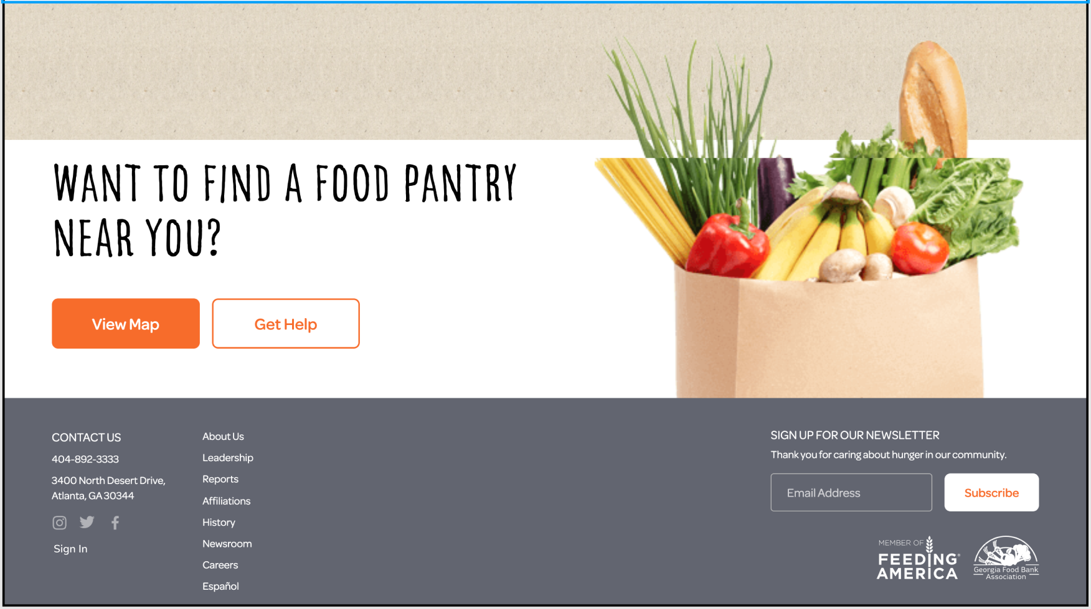

*Figure 13..0*

After

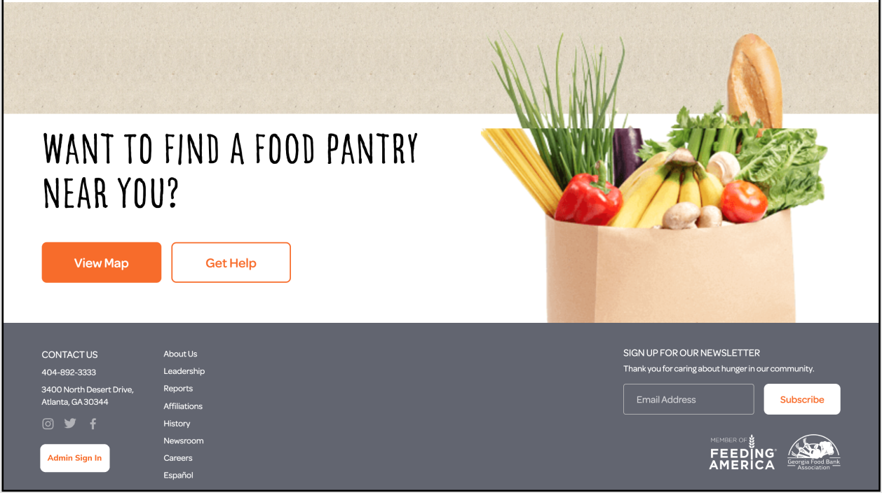

*Figure 13.1*

Throughout our participation demos, many participants commented that the “sign in” button was difficult to find. On average, it took our participants 1 minute and 6 seconds to complete this task when we predicted it to take less than 30 seconds and most of the time was spent trying to find where the sign in button was. As mentioned in P3, we made the font small and placed the button at the bottom of the page so that ACFB’s main users, the food insecure and volunteers/donors, would not mistake the sign in button as a task they must perform as it is only for ACFB administrators, shown in Figure 13.0. An alteration to the design we currently have is to first change the text to “Admin Sign In”. By changing the text to include “Admin” will allow non-administrative users to understand that the sign in is specifically for ACFB admins. Another change we thought of was making the button have a rounded, white, rectangular background with an orange colored text, similar to the “Subscribe” button, shown in Figure 13.1. We made the new design of the button similar to the “Subscribe” button so that we can follow Norman’s design principles for consistency with the button design and colors. The participant users’ comments has allowed us to make meaningful changes to our UI so that it is clear to the admins to know where the button is and not let them have an experience like we had with our participants.

*Add “E-mail” Text Input in Delivery Request Form*

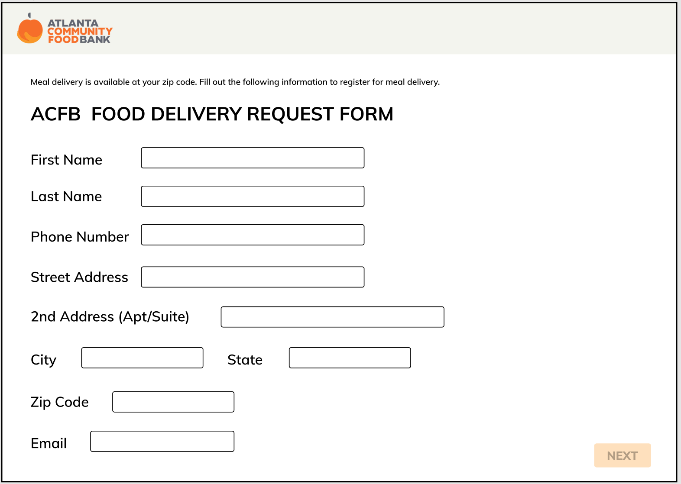

*Figure 14.0*

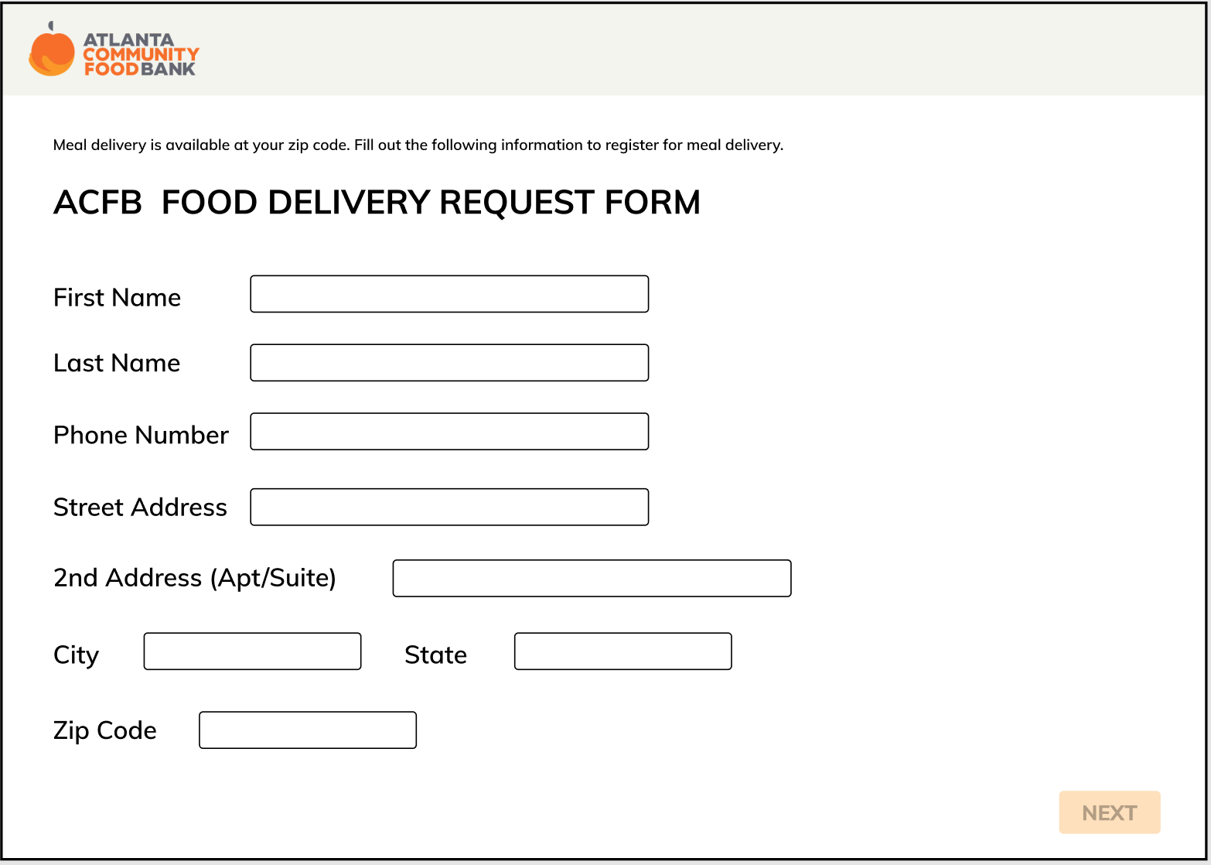

*Figure 14.1*

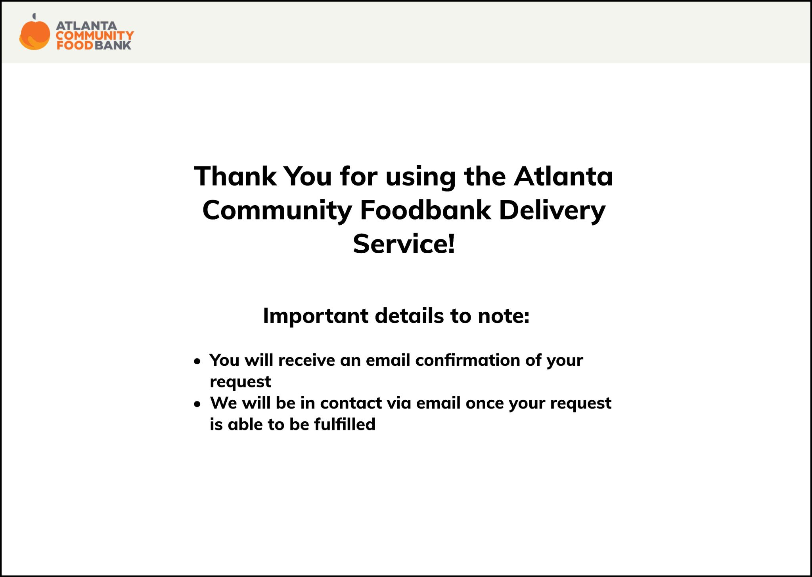

*Figure 14.2*

In P3, we mentioned that users will get an email confirmation once they have submitted the delivery request form, but one participant during our demo commented, “Did I type in an email earlier?” when they reached the page where we thank our users for submitting a delivery request and will send an email confirmation, shown in Figure 14.2. We realized that we have forgotten to include an email text field, which is crucial for our users to receive information about their submitted request and updates on their order and delivery. As shown in Figure 14.0, users submit their personal information, but we had the email text input missing, which we would alter, as shown in Figure 14.1

*Make “Volunteer” an Independent Button*

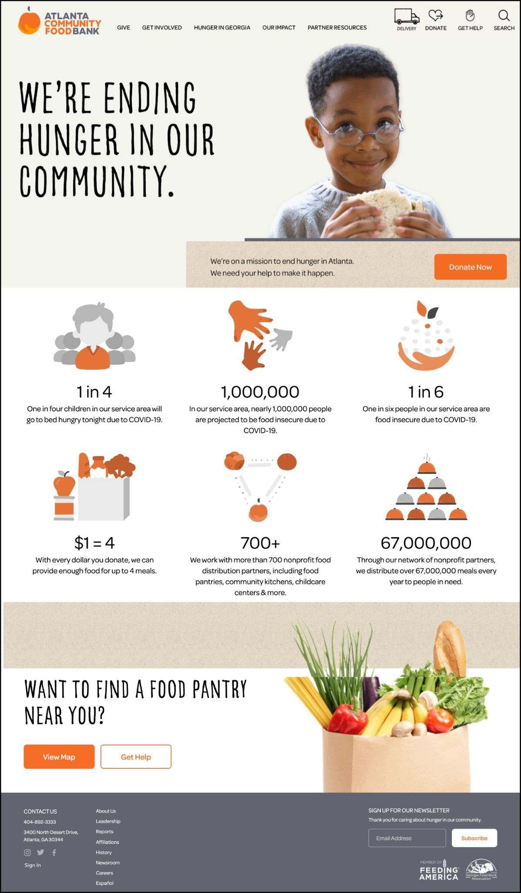

*Figure 15.0*

Some of our participants struggled finding the volunteer page for our second task: “Use the website to register as a delivery service volunteer on the morning of Thursday, April 15th.” Our participants expected a volunteer button, similar to the “Donate”, “Delivery”, “Get Help”, and “Search” buttons, shown in Figure 15.0, because volunteers are also our primary stakeholders and having an independent button is important for them to easily access the volunteer page. However, we did not make changes to this in our initial prototype from P3 or create an altered prototype to fit this expectation because of limitations. In the original ACFB website, users can see the pages they can access by hovering over the tab bar such as “Get Involved”, where they would have seen the volunteer button. However, due to limitations with Figma, we were unable to enable the hovering functions in our prototype, which may have been the reason why our participants made comments about this task. Another limitation includes that our role was to add more features to the ACFB website in order to create a better prototype to the original page, but the volunteer button was under the “Get Involved” tab, which was part of the original design of ACFB’s website, in which we could not alter. If we were able to make changes to the original website, we would take into consideration the results of our user tests by including an independent “Volunteer” button.

*Alterations based on Lectures*

If we had used the heuristic evaluation predictive evaluation method, we would have our “usability experts” evaluate our prototype against heuristics in order to find problems and use the data to organize and structure the problems by categories using an affinity diagram to document the qualitative data we would have collected. We would then rate the problems based on severity to identify what needs to be potentially changed. This would benefit ACFB as it would be a cheaper alternative, as they are a non-profit organization and be able to quickly identify problems and change their system accordingly.

If we had used this method for Task 2, “Use the website to register as a delivery service volunteer on the morning of Thursday, April 15th.”, we could have identified a limitation with achieving the task. The first step of our task would be to hover over the “Get Involved” button, shown in Figure 15.0. If this task were done on the actual ACFB website, then a drop down would appear with a list of various buttons, including “Volunteer”. However, this was not implemented in our prototype due to limitations with Figma as features like hovering are not offered in this software. Since the task tells users to “volunteer”, it is difficult for users to identify that the “Get Involved” tab is what they need to click on in order to access the volunteer page.

# Discussion

## Implications

From the results of our evaluations, users were able to successfully complete the three tasks, but not without some difficulties. Because our design is built off of the current user interface of the ACFB website, navigating our prototype should be intuitive to returning ACFB users and volunteers. However, since our design added features and components, users may not be able to locate certain buttons or views. As reflected in the results section, this occurred with the “Sign In” button for ACFB organizers to view delivery requests in task 3. Our solution to this was to change the design of the button to be more differentiable from the other buttons around it. Changes to smaller details like these can have a substantial impact on the user as it creates less confusion and frustration.

Most users found our prototype straightforward and easy to use. Even though there was some confusion of the difference between the ‘Get Involved’ tab and ‘Donate’ tab in task 2, because the ease-of-use rating of this task was fairly high (4.7/5), this means that there is a considerable difference in the meanings of these two buttons and the perception of where they navigate to for the user. Users were all able to accomplish their tasks with relative ease, showing that the prototype is useful and usable.

Ultimately, our design is built off of the requirements gathering from part 1 as well as the problem and solution space in part 2. In part 1, our team researched and studied multiple sources including ACFB’s website, surveys with proxy users in the community, interviews with an ACFB representative and a MealsOnWheels volunteers, and studies regarding transportation and food insecurity in the Atlanta area. From these sources, we found that accessibility was a big issue for food insecure people in metro Atlanta and areas outside of Atlanta. We also researched the current system, which includes public transportation, limited delivery services, and popup food pantries. However, food insecure users are in need of food and are unable to access ACFB resources due to issues with mobility and transportation. Unlike the current system, our prototype ensures that food insecure users are able to access and receive their food directly through delivery from ACFB, bridging the gap between food insecure people and ACFB food and resources.

Since the current system relating to ACFB utilizes a website as their user interface, we took that into consideration in part 2 and decided our prototype be an extension of the current ACFB website. In part 2, our team had functional requirements of information collection and availability feedback. The system’s main functional component is to set up a method for food insecure people to receive ACFB’s food service. It will need to gather user information as well as provide feedback to the user of whether delivery is available. Our web prototype was able to achieve both, as it provides a form to the user to fill out and provides feedback on the delivery availability. However, it does not instantaneously provide feedback as we anticipate ACFB organizers will have to coordinate deliveries based on the availability of drivers and food supplies. Because of this, in our prototype, we inform the user that they will receive an email on the status of their delivery request. Our non-functional requirements in part 2 include usability, utility, accessibility, and reliability. Our prototype is able to achieve all four as it allows users to request food delivery, is useful for food insecure people based on our research, is accessible due to the web interface, and is reliable.

Our design meets the sustainability goals from part 1. First, our system increases accessibility to food resources provided by ACFB; this meets the sustainability goal of zero hunger as we are provided more food to people in need. Next, we promote good health and well being. Through the delivery service, we are able to provide healthy and nutritious food to users with issues of mobility. Lastly, our design meets the goal of reduced inequality. Food insecure people who do not have transportation or have issues of mobility now don’t have to struggle with obtaining food as they don’t have to physically go to food banks or grocery stores. Through our goals of facilitating accessibility to food, we reduce the inequality of who can receive food resources from ACFB

# Conclusion

## Critique of Evaluation Plan

We initially attempted to standardized our evaluation plan using a script. This script followed the steps needed to conduct the evaluation word for word in order to create similar testing conditions and minimize skew of results. However, in this script, we failed to include transitions or guiding questions for our team members to say during the evaluation. This led to impromptu guidance that may have impacted the participants’ response. In the future, we should account for this by scripting out possible scenarios and leads to use to create a cohesive testing environment between all of the participants. In addition, all of our participants were similarly aged and were not actual intended users of ACFB or our project. This was due to the nature of the pandemic, ethical concerns, timing of the project, and the inability to easily survey those affected by food insecurity. Using proxy users as participants creates limitations because the participants are not reflective of actual stakeholders, so the responses and data collected will not be completely accurate.

## Class Reflection

As we reflect on our semester, our team noted some takeaways that stood out to us. In regards to the class, we found that one of the most valuable takeaways were the fundamental UI Design Principles. The repetitive nature of repeating, recalling, and incorporating these principles over the past semester has given us a foundation for UI Design moving forward into the rest of our courses and work experience in the future. In terms of project teamwork, we learned to set clear expectations of responsibilities, division of work, and deadlines with one another. With a fast paced class like this one, it was imperative that we were consistently communicating with one another, and this proved to be a strength for us as we were able to easily contact one another for deliverables. We also learned the value of teamwork. As a team of 5 members, we learned just how fast and how much more effective it is for us to complete all of our tasks and assignments as a team with all 5 of us contributing equally. This collaborative environment gave way to productive discussions and working meetings.

Reading Norman this past semester gave us incredible insight into the world of UI Design. We especially enjoyed the various real world examples that helped us visualize the concepts described in the book. With a lot of the concepts (ex: affordance) that can be hard to understand, we found Norman’s examples and elaboration to be incredibly useful. If we could redo the semester, one of the most valuable lessons that we wish we would’ve embraced from the beginning of the semester is to trust the process. Previous to this class, most of us immediately thought of the design aspect when we thought of UI Design, so when we were identifying the problem space and conducting user research, there were times when we felt lost and/or without purpose. This class taught us that there is so much more to UI Design outside of the designing aspect. From user research to prototyping to user testing, being able to follow the process from start to finish opened our eyes, and we are incredibly grateful for the experience. We also learned the value of the iterative process of design. At every report and assignment that we’ve completed, we’ve had to approach it iteratively. Whether it was in class through participation activities, in studio, in our homeworks, or for a specific report, we were consistently iterating on ideas, solutions, prototypes, and so much more. This helped us keep an open mind and really come to a solution that was evidence based and not just out of our own intuition.

Sustainability was a class theme that was carried out through the past semester. Many classes we’ve taken have been very niche without much application to the real world, so it was refreshing to take a class that was connected to a real client, but also pushed us to make meaningful contributions to the world and build sustainable communities. Food insecurity is a growing problem in and around Atlanta, and we were able to learn a lot about the issue through the beginning stages of the class. It was an eye opening experience to learn about issues that face so many people in a city and world that we live in. We hope to continue learning about important issues such as this and work to make a difference with our skills in the future.

# Appendix

## Appendix I. Consent Form

<https://gatech.co1.qualtrics.com/jfe/form/SV_cHiKZAcQdJUYkmy> 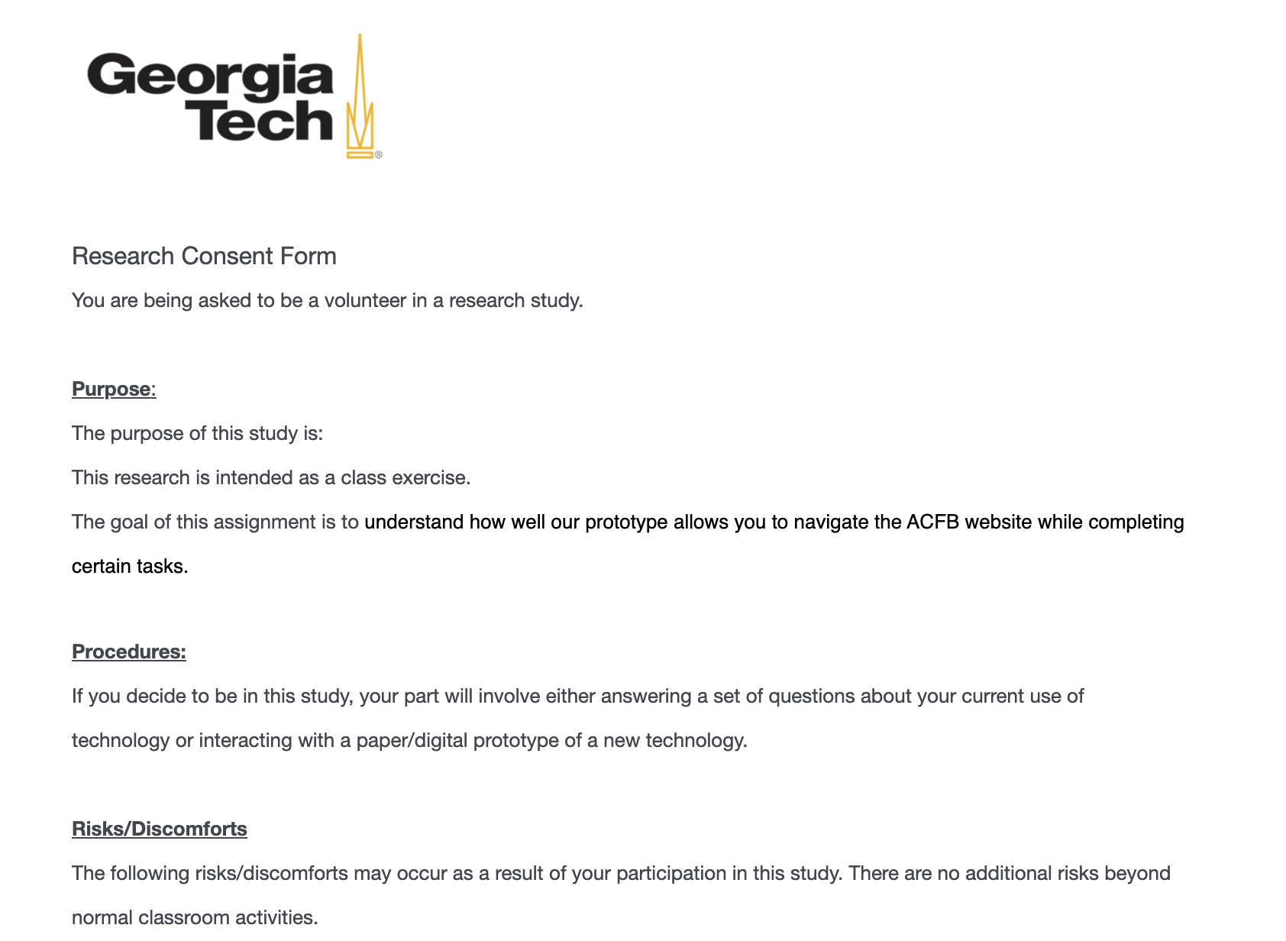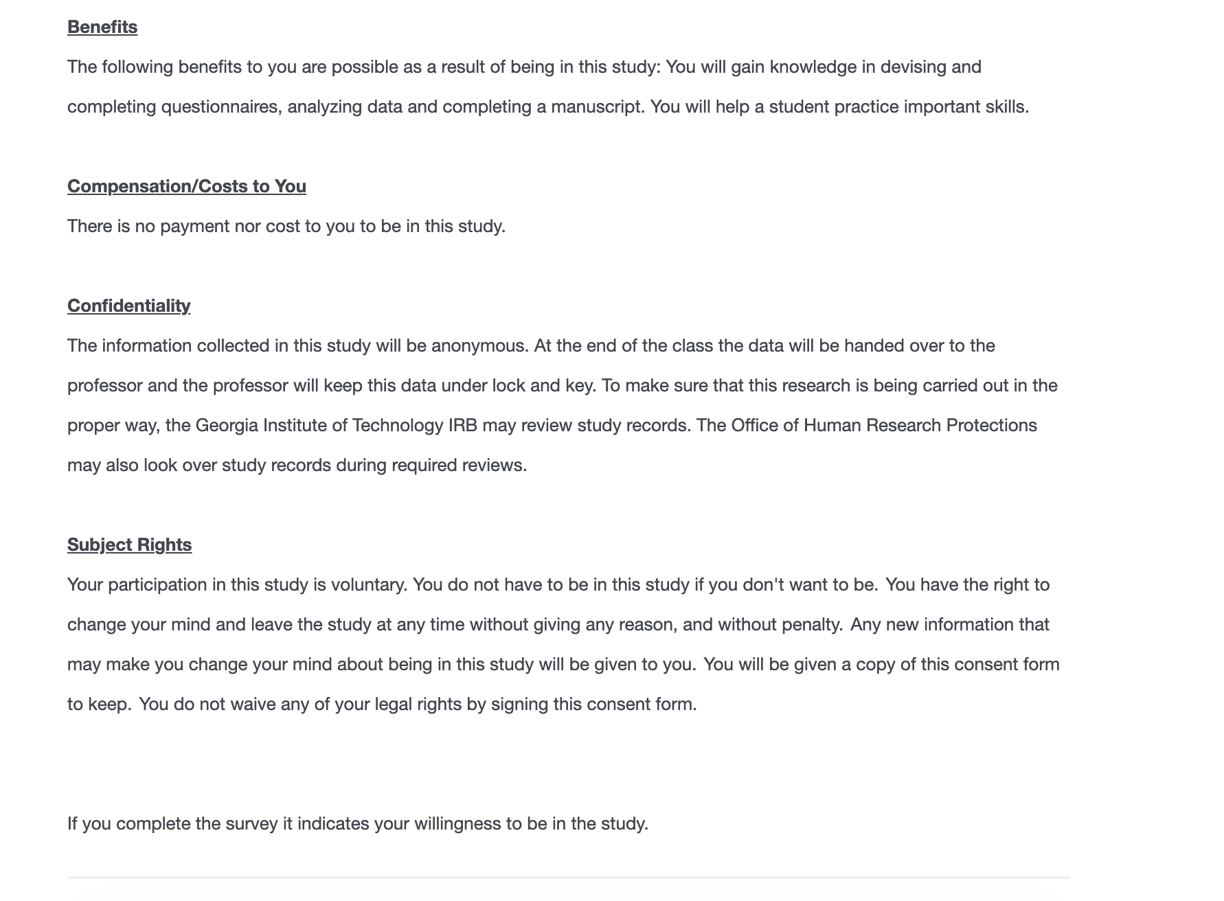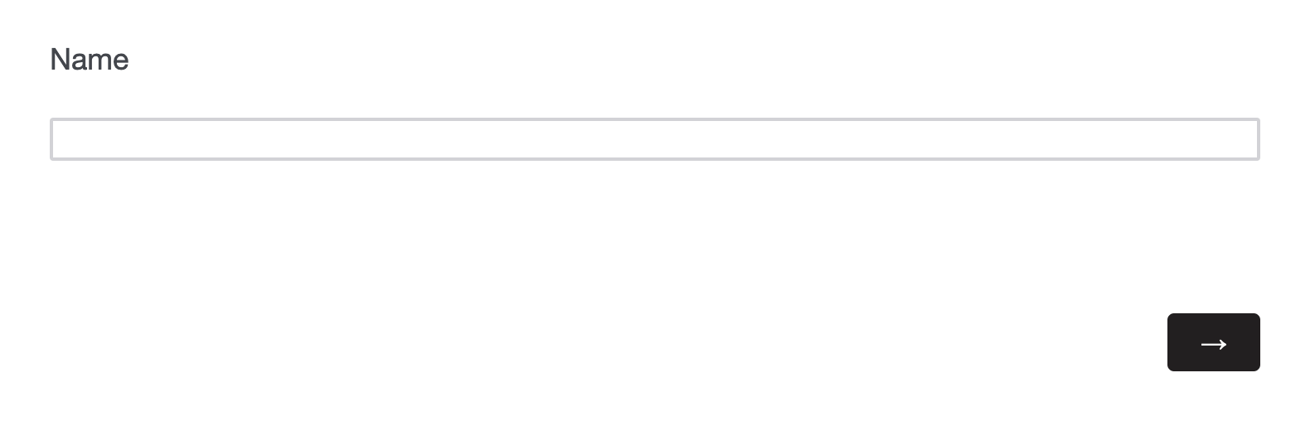

## 

## Appendix II. Note-Taking Template

<https://docs.google.com/document/d/1TvmQTrTFH5g7FH2HZM6iCa2vy_gx84Xk7QYGs6zF7UY/edit?usp=sharing>

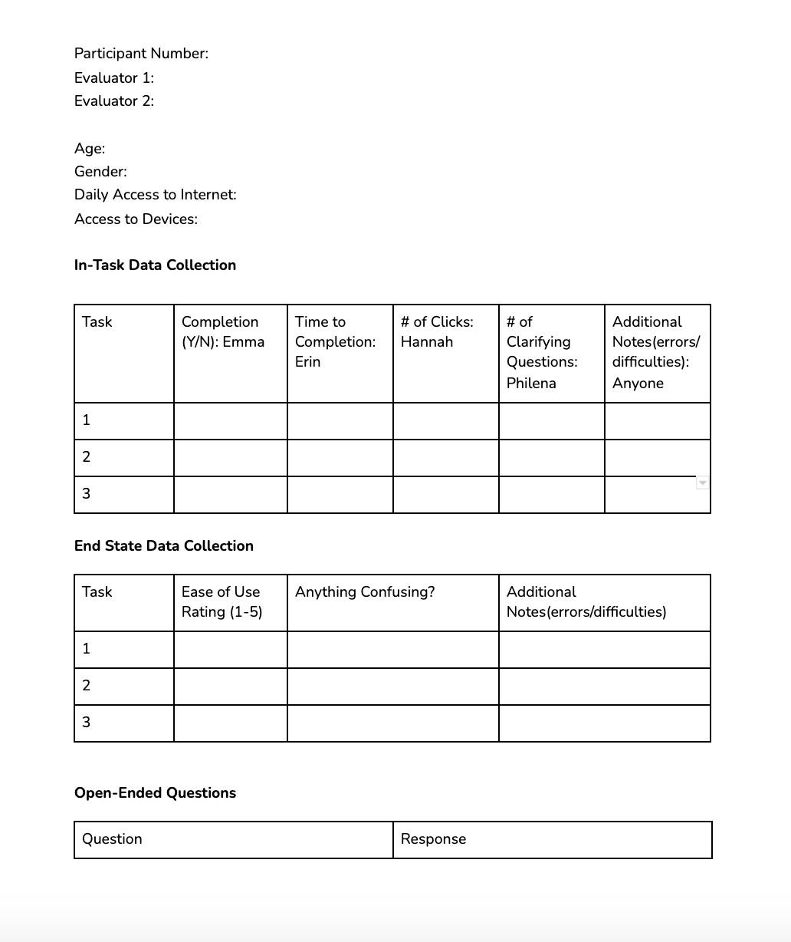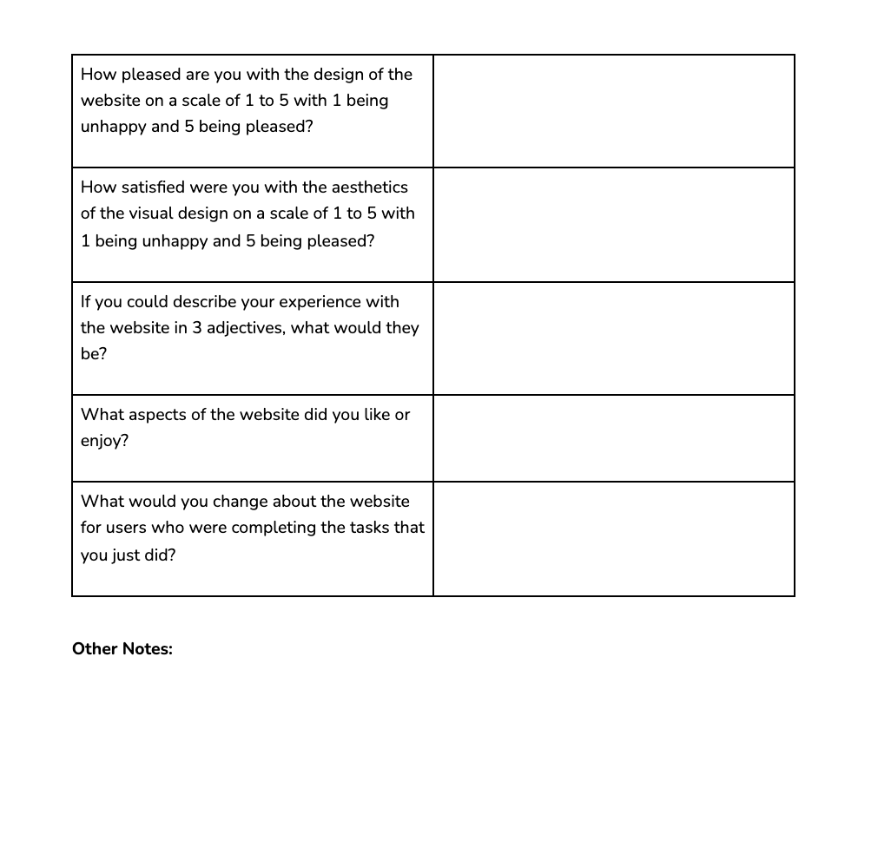

## Appendix III. Script

<https://docs.google.com/document/d/14E2FApPMqJ70-HtCr3Xa_r0_6hxf0E86IQIluxA6hDA/edit?usp=sharing>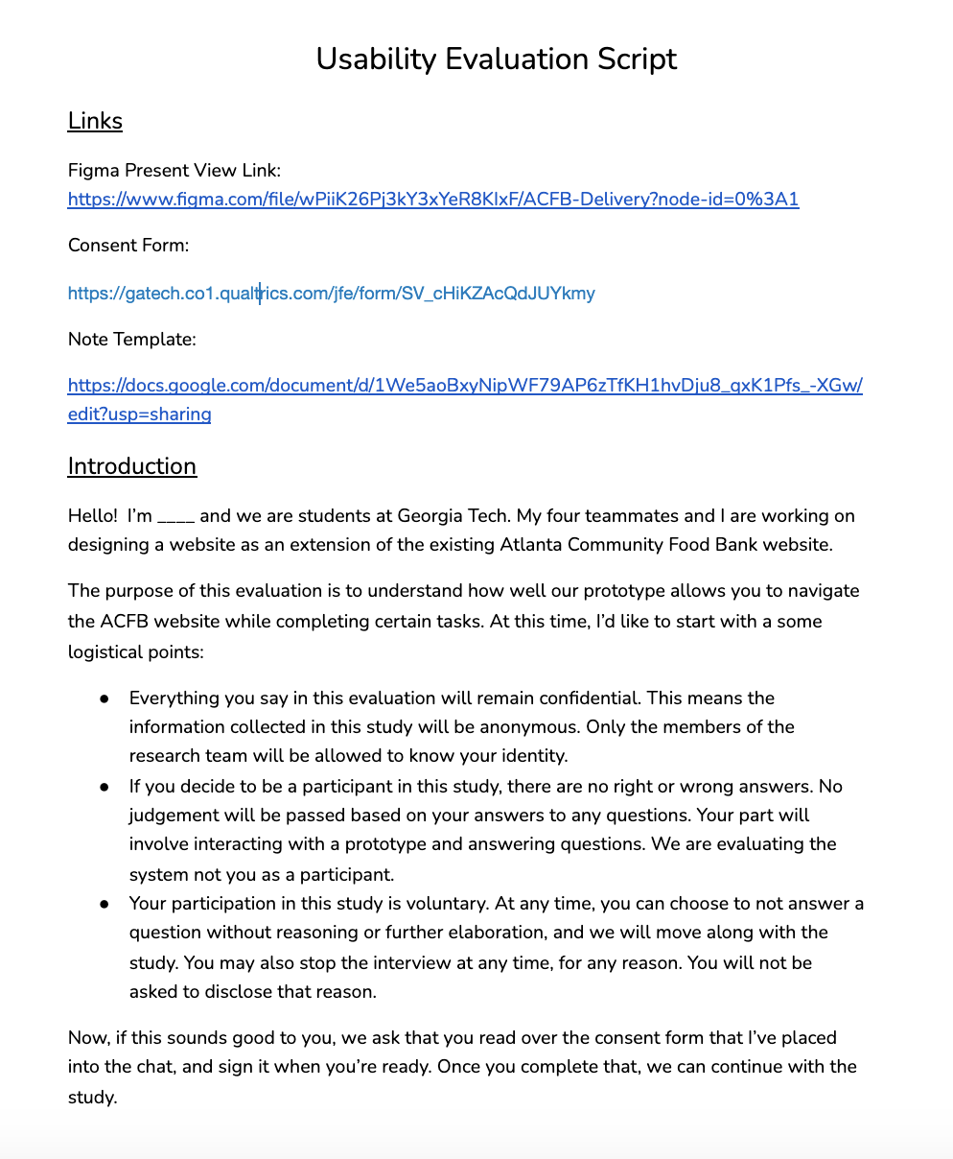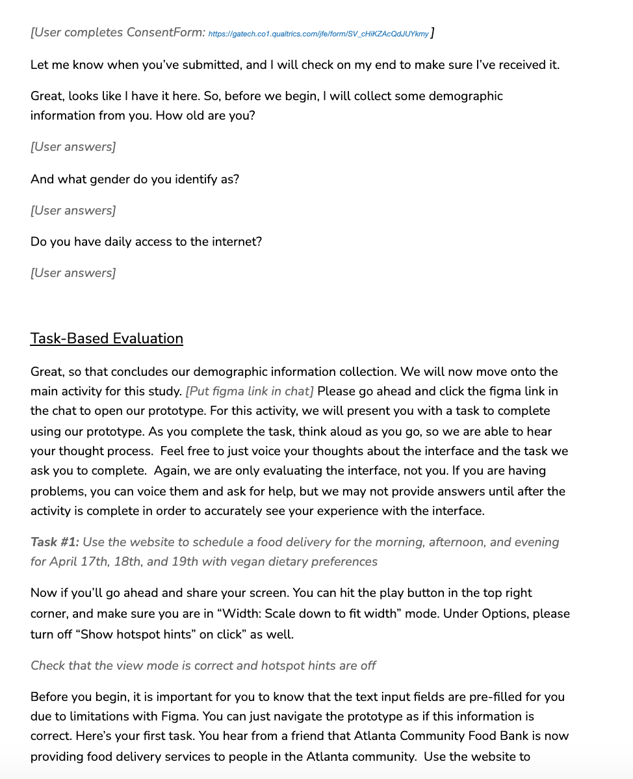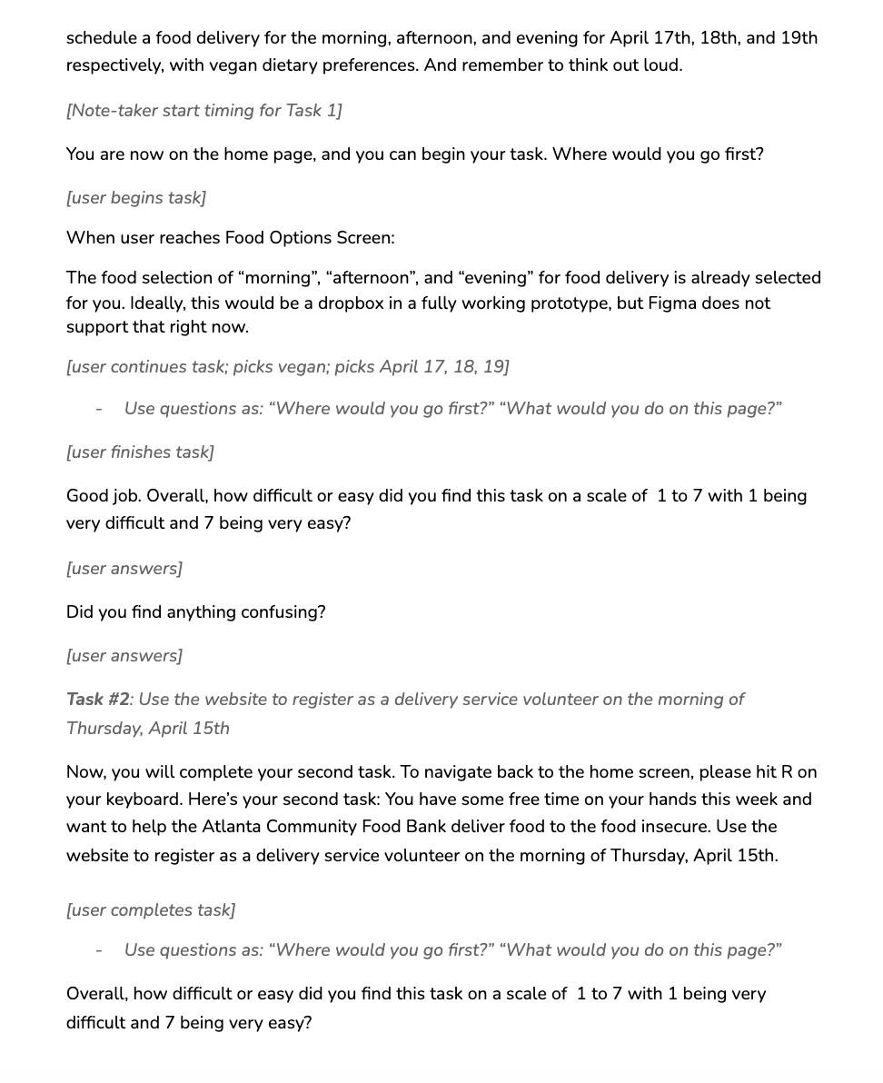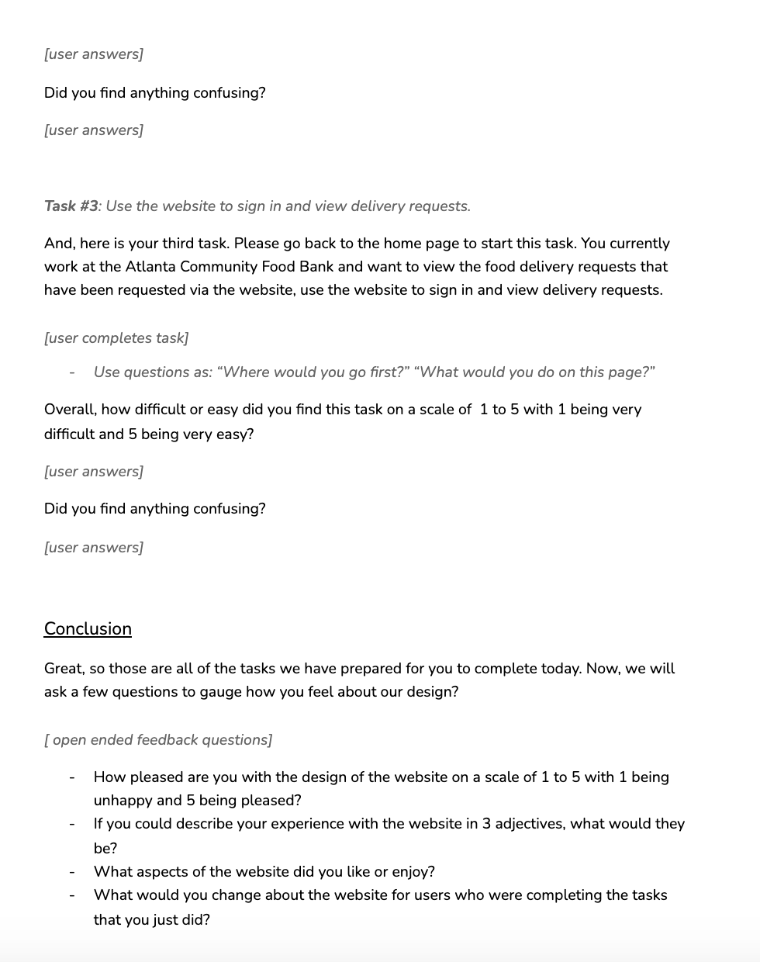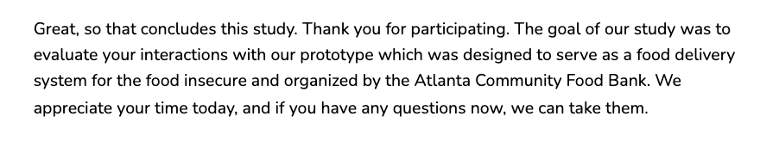

## Appendix IV. Data and Data Reduction

|  | **Task 1** |  |  |  |  |  |
| --- | --- | --- | --- | --- | --- | --- |
| Participant | Completion | Time(s) | Clicks | unnecessary clicks | Questions/Confusion? | Ease of use |
| 1 | yes | 90 | 12 | 0 | n/a | 5 |
| 2 | yes | 111 | 12 | 0 | n/a | 4 |
| 3 | yes | 105 | 17 | 5 | got a bit lost in website at first | 4.5 |
| 4 | yes | 127 | 14 | 2 | figma problems | 5 |
| 5 | yes | 88 | 14 | 2 | figma problem | 5 |
| 6 | yes | 119 | 22 | 10 | struggled w inputing dietary preferences | 5 |
| 7 | yes | 95 | 11 | -1 | Task clarification | 4 |
| 8 | yes | 84 | 15 | 3 | 2 | 3 |
| 9 | yes | 75 | 13 | 1 | forgot times and dates | 5 |
| 10 | yes | 105 | 16 | 4 | Figma problem | 4 |
| Averages |  | 99.9 | 14.6 | 2.6 |  | 4.45 |
| Stand. dev |  | 16.367 | 3.205 | 3.20416396 |  | 0.68516016 |
| Per necessary click |  | 8.325 |  | 0.21666667 |  |  |

|  | **Task 2** |  |  |  |  |  |
| --- | --- | --- | --- | --- | --- | --- |
| Participant | Completion | Time(s) | Clicks | unnecessary clicks | Questions/Confusion? | Ease of use |
| 1 | yes | 130 | 7 | 3 | clarified task, confused about delivery sign up vs get help | 3.5 |
| 2 | yes | 113 | 6 | 2 | 2 | 5 |
| 3 | yes | 17 | 4 | 0 | 2 | 4.5 |
| 4 | yes | 45 | 8 | 4 | n/a | 5 |
| 5 | yes | 20 | 4 | 0 | 1 | 5 |
| 6 | yes | 53 | 5 | 1 | clarified task | 5 |
| 7 | yes | 29 | 4 | 0 | clicked delivery service even though individual | 5 |
| 8 | yes | 47 | 5 | 1 | thought going thru get involved instead of donate was confusing, thinking of donating time kind of | 4 |
| 9 | yes | 35 | 5 | 1 | n/a | 5 |
| 10 | yes | 82 | 5 | 1 | n/a | 5 |
| Averages |  | 57.1 | 5.3 | 1.3 |  | 4.7 |
| Stand. dev |  | 38.854 | 1.3375 | 1.33749351 |  | 0.53748385 |
| Per necessary click |  | 14.275 |  | 0.325 |  |  |

|  | **Task 3** |  |  |  |  |  |
| --- | --- | --- | --- | --- | --- | --- |
| Participant | Completion | Time (s) | Clicks | unnecessary clicks | Questions/Confusion? | Ease of use |
| 1 | yes | 110 | 7 | 4 | couldn’t find sign in button at first | 3 |
| 2 | yes | 57 | 4 | 1 | sign in button was small | 4 |
| 3 | yes | 29 | 3 | 0 | not used to sign in button being on the bottom | 3 |
| 4 | yes | 46 | 3 | 0 | struggled to find sign in button, did not like sign in button location | 4 |
| 5 | yes | 110 | 9 | 6 | difficulty finding sign in button | 3 |
| 6 | yes | 15 | 3 | 0 | n/a | 5 |
| 7 | yes | 118 | 7 | 4 | evaluator had to tell user to scroll to bottom, confusions with task, would struggle to find sign in button individually without help | 1 |
| 8 | yes | 25 | 4 | 1 | n/a | 5 |
| 9 | yes | 20 | 3 | 0 | sign in clarification, couldn’t find button | 4 |
| 10 | yes | 138 | 14 | 11 | struggled to find sign in link | 3 |
| Averages |  | 66.8 | 5.7 | 2.7 |  | 3.5 |
| Stand. dev |  | 47.142 | 3.6225 | 3.62246080 |  | 1.17851130 |
| Per necessary click |  | 22.267 |  | 0.9 |  |  |

|  | **Overall ratings** |  |  |  |  |  |  |
| --- | --- | --- | --- | --- | --- | --- | --- |
| Participant | Design | aesthetics | adjective 1 | adjective 2 | adjective 3 | Fav aspect of website | changes to website? |
| 1 | 5 | 5 | effective | simple | enjoyable | aesthetics, simplicity | distinction between volunteering and volunteer delivery was not clear |
| 2 | 5 | 5 | easy to use | educational | smooth | design of website, images | increase size of sign in button maybe |
| 3 | 5 | 5 | colors were good | fine | easy | color scheme, facts on website | Larger sign in button |
| 4 | 4 | 4 | standard | intuitive | dull | logos for tabs | sign in button location |
| 5 | 5 | 4.5 | easy | common | clean | easy to navigate, organized, similar to other websites | boxes around tabs |
| 6 | 5 | 4 | easy | navigable | bright | not many clicks, efficient, tasks don’t take long to complete | person in question has a lot of experience with technology, thought everything was very easy |
| 7 | 4.5 | 4.5 | smooth | pleasing | nice | pleasing to eye, icons are nice, font is nice | used to giving info after browsing for items, log in button was hard to find |
| 8 | 5 | 5 | easy to use | pleasing | straightforward | color scheme | Volunteering as an option under donating |
| 9 | 4.5 | 4 | efficient | easy to use | simple | Pictures, looks nice, pleasing to look at, not confusing, color scheme - ties in with everything | sign in button hard to find, maybe highlight with a color |
| 10 | 5 | 4 | quick | easy | straightforward | colors, design how fast the actions were | was confused about 3rd task |
| Averages | 4.8 | 4.5 |  |  |  |  |  |
| Stand. dev | 0.349603 | 0.4714045 |  |  |  |  |  |