

MIDDLE EAST TECHNICAL UNIVERSITY

Electrical & Electronics Engineering

Project

EE 462 – Utilization of Electric Energy

Instructor:

Dr. Emine BOSTANCI

Students:

Ali Aydın - 2093326



**PART A: PRE-DESIGN STAGE**

1-) We know a relation between torque and power. By using that equation, we can find the rated speed.

wmech = 266.67 rad/sec

Trated=300 N.m

The rated torque is given the specification.

2-) Maximum speed is given the specification. By using that, we can find maximum applied frequency.

fmaximum is 467 Hz. For switching frequency, we should take it at least 21 times of fmaximum. We can choose the switching frequency as 10 kHz.

3-) The ripple value of input voltage is not specified but we want almost DC voltage and we can choose the ripple value as %2. We can use below equation

Where I=250A (maximum motor current), f=300 Hz (since three phase rectifier output)

When we calculate by using that equation, we find DC link capacitor value as 83 mF.

**PART B: SINUSOIDAL PWM**

1-)

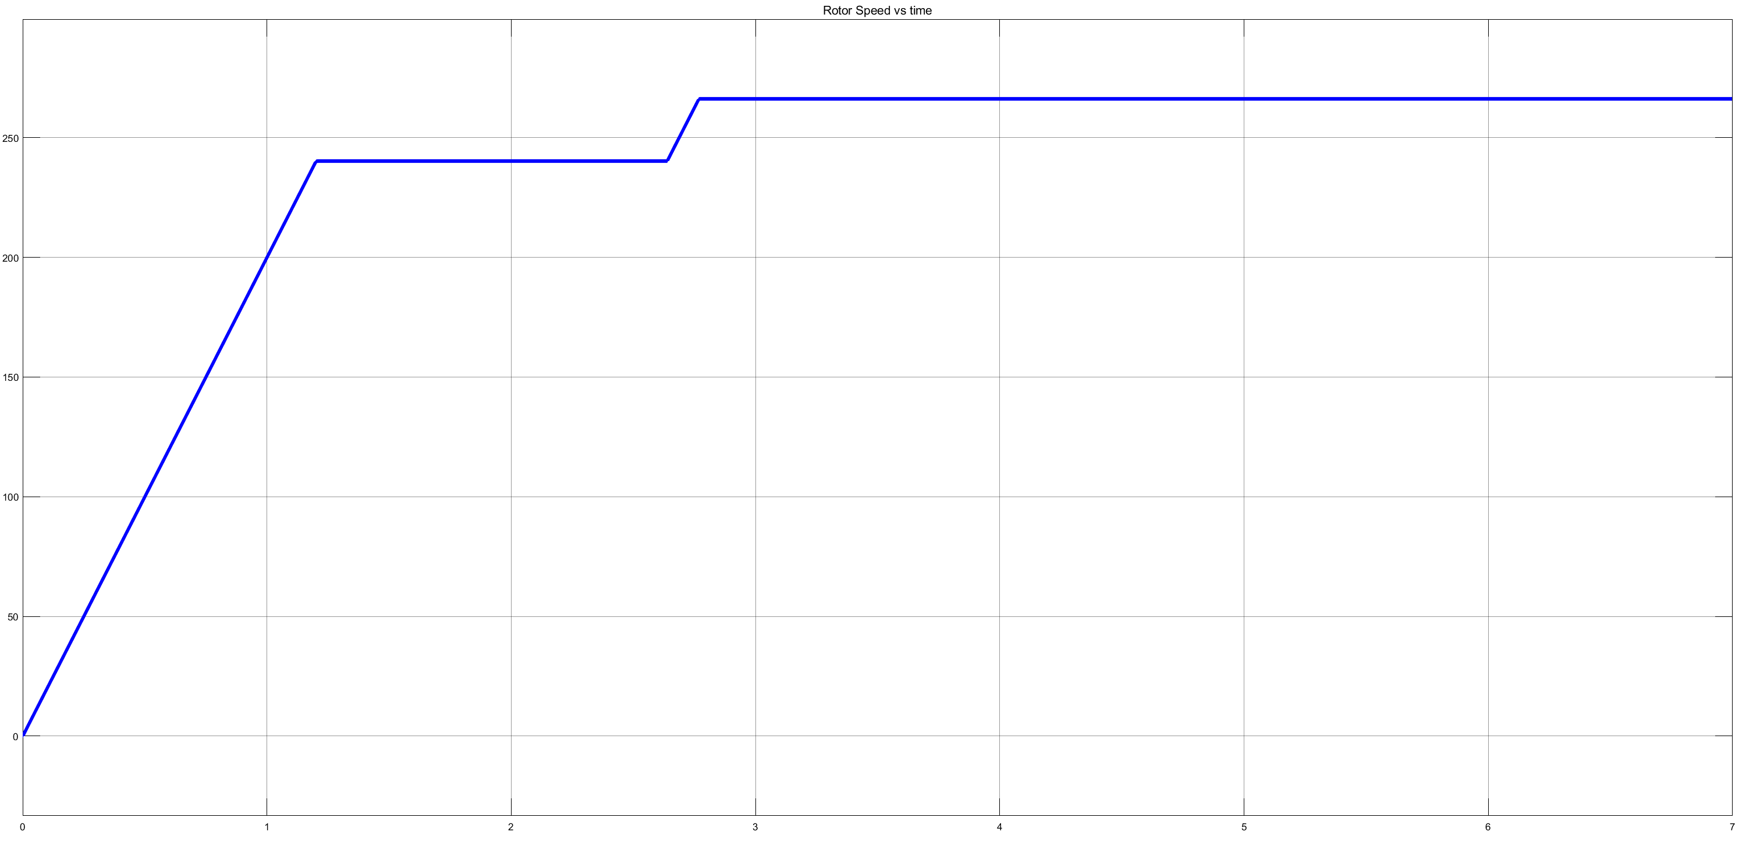

Figure : Rotor Speed(rad/sec) vs time(sec) characteristic

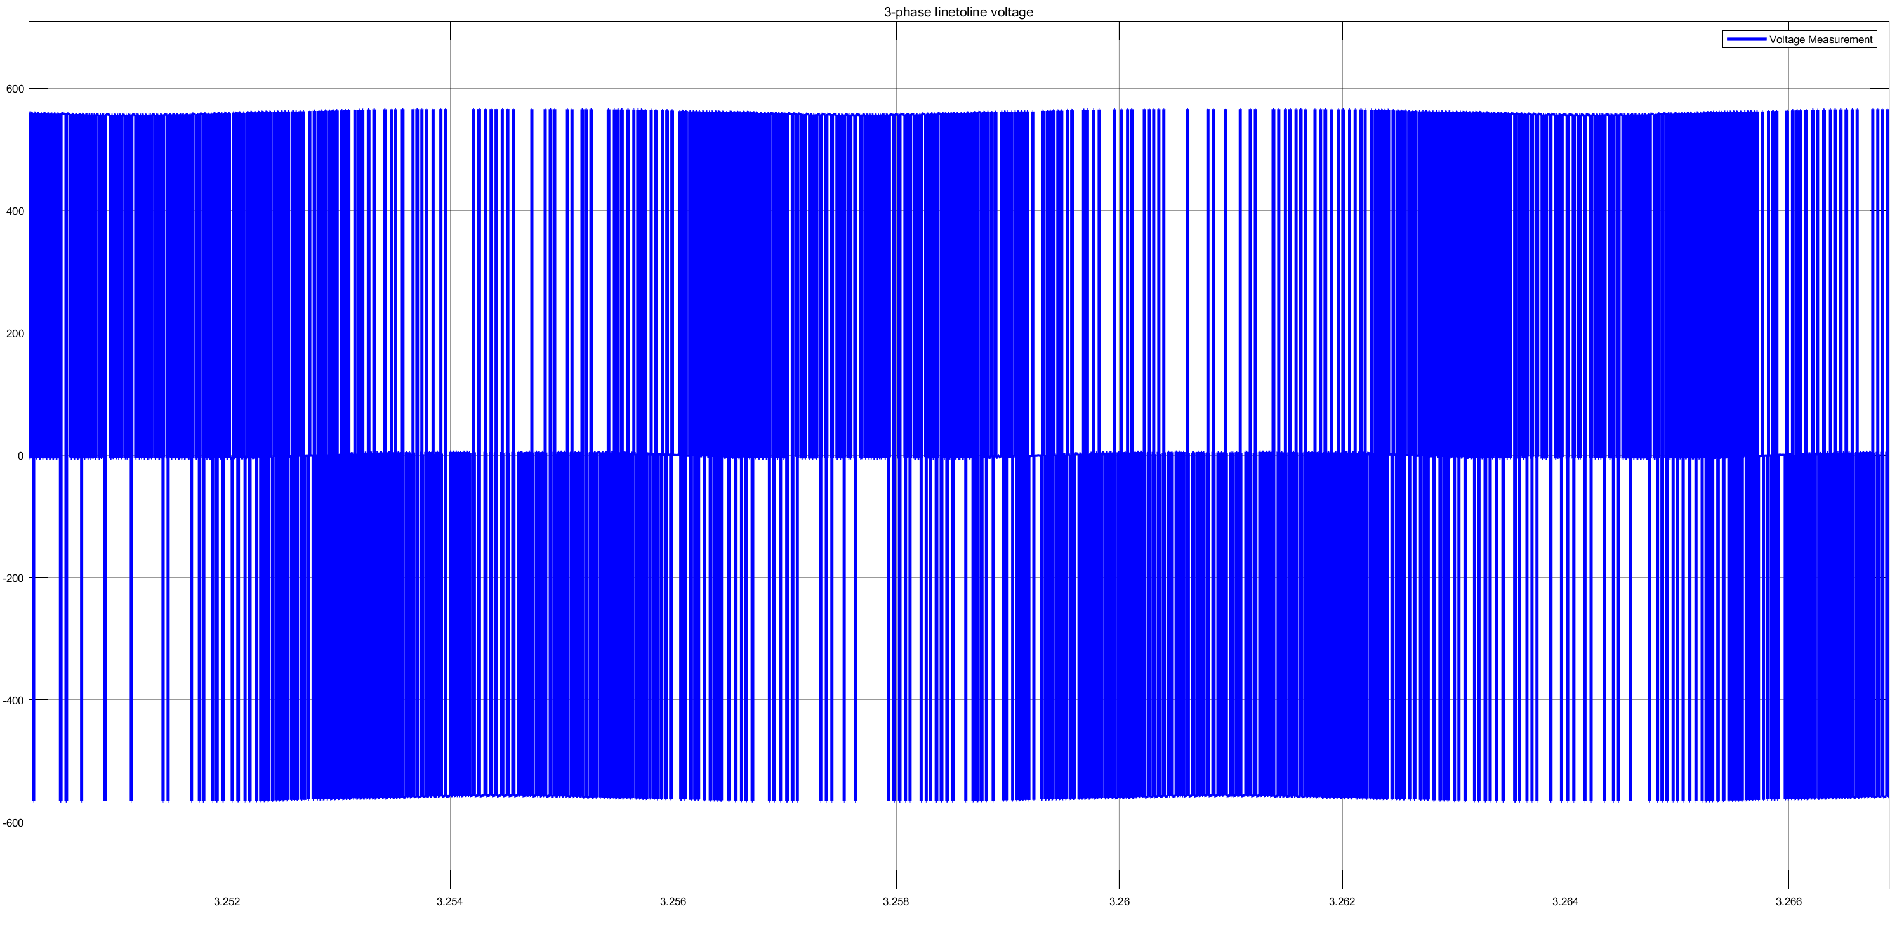

Figure : VAB linetoline voltage from a distance

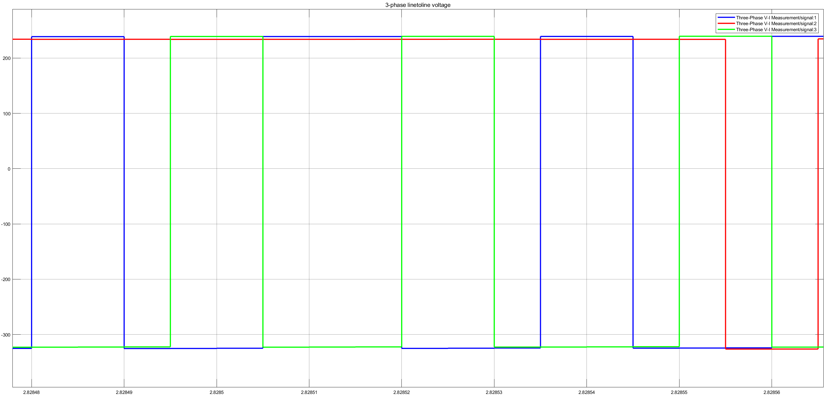

Figure : Three phase line voltages upon close look

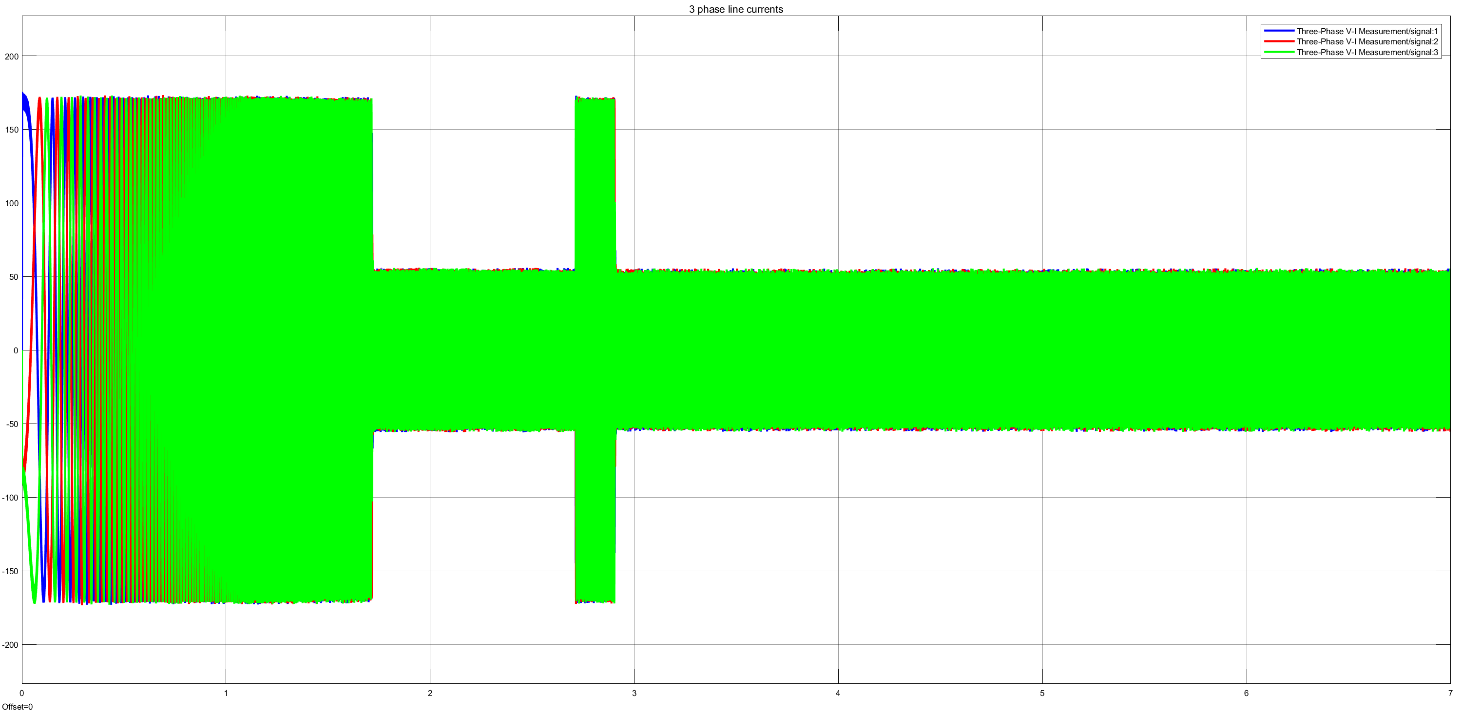

Figure : VAB linetoline currents from a distance

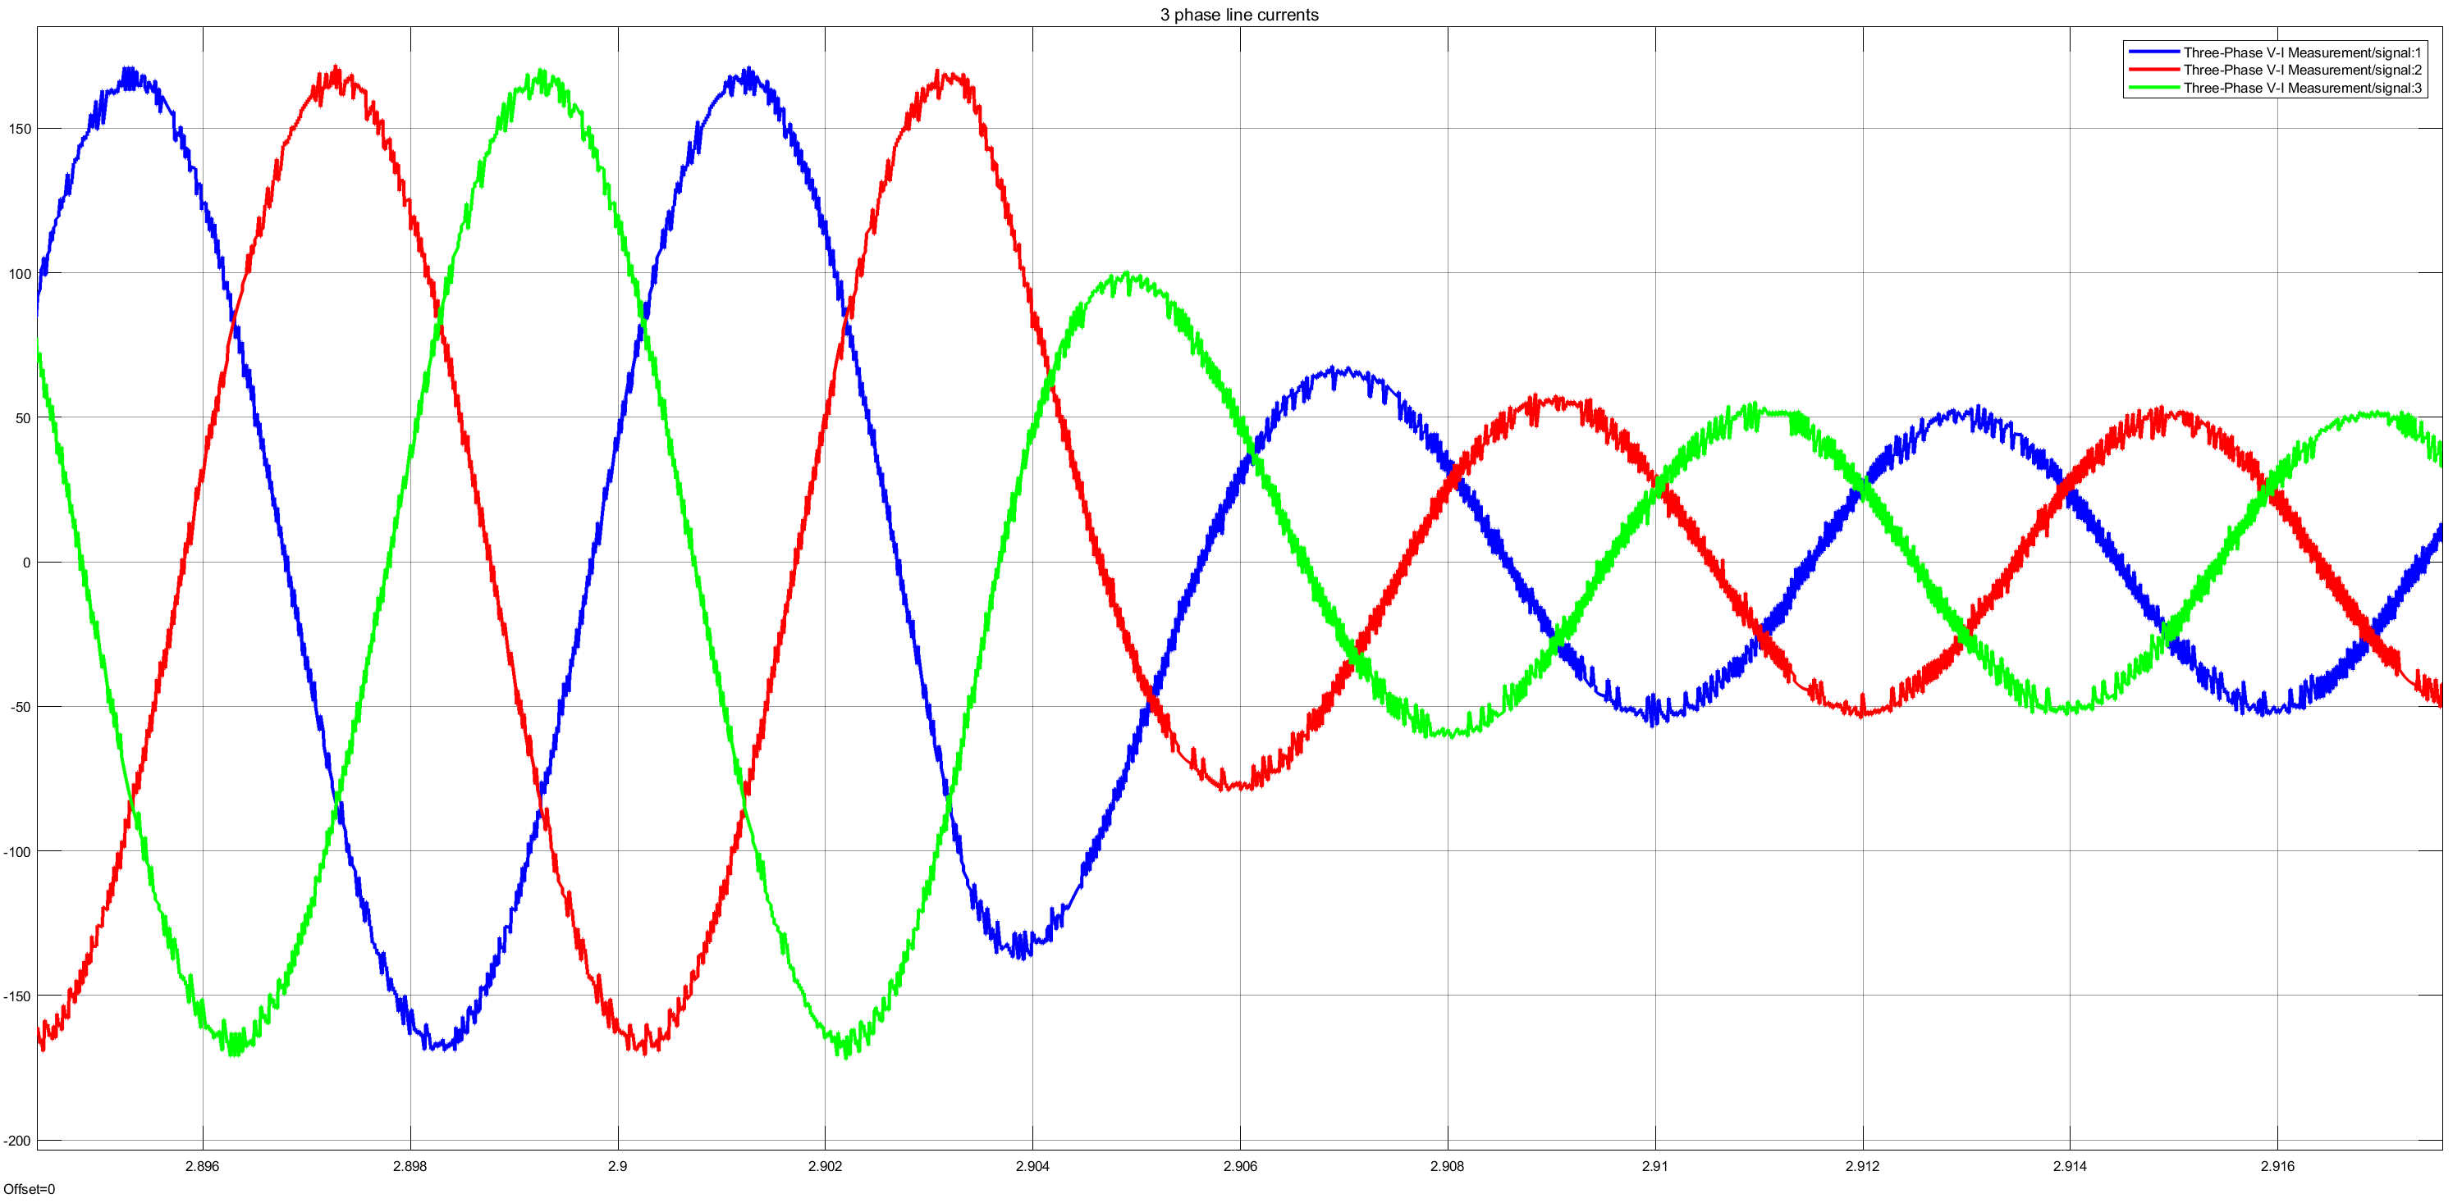

Figure : Three phase line currents upon close look

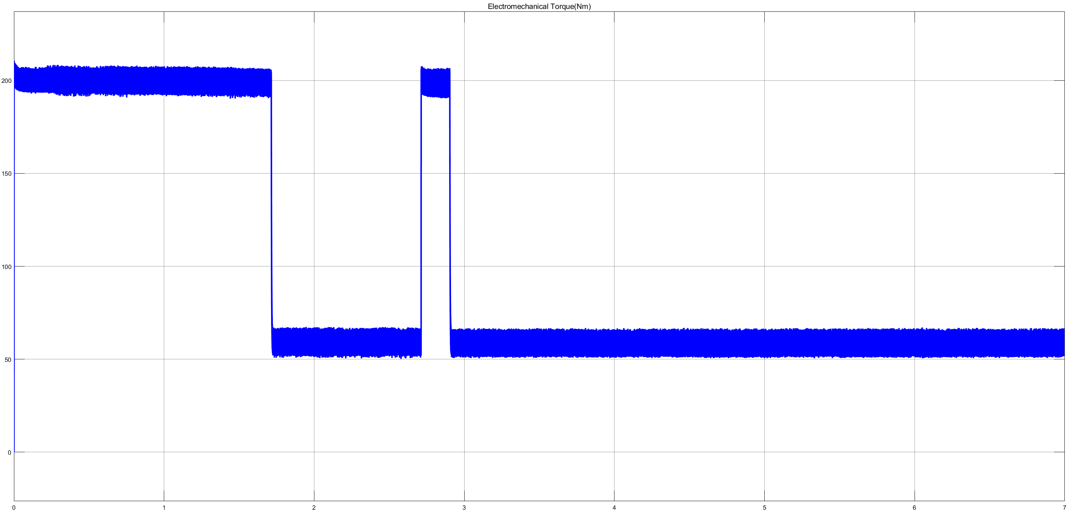

Figure : Electromechanical Torque (Nm) vs time characteristic

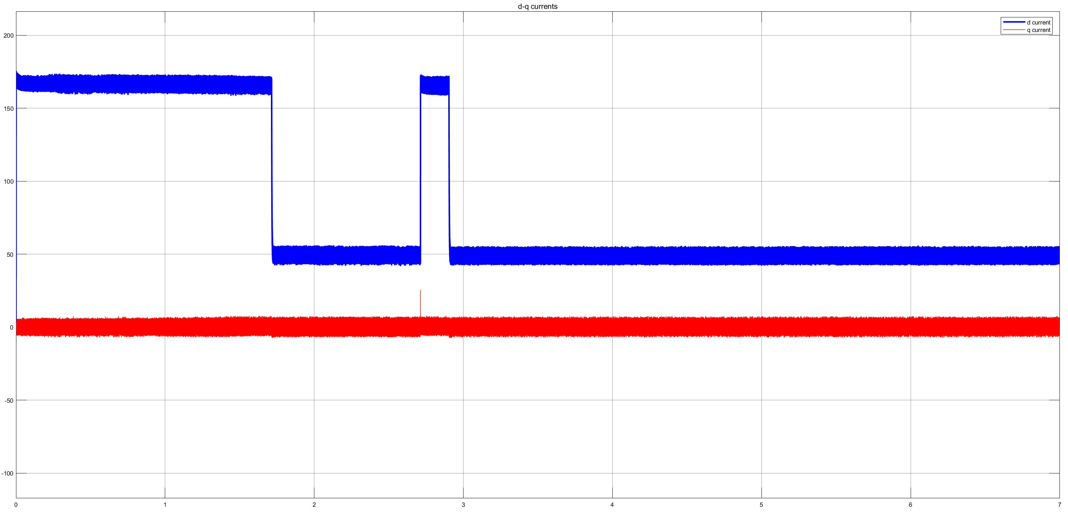

Figure : d (blue) and q(red) currents vs time characteristics

2-)

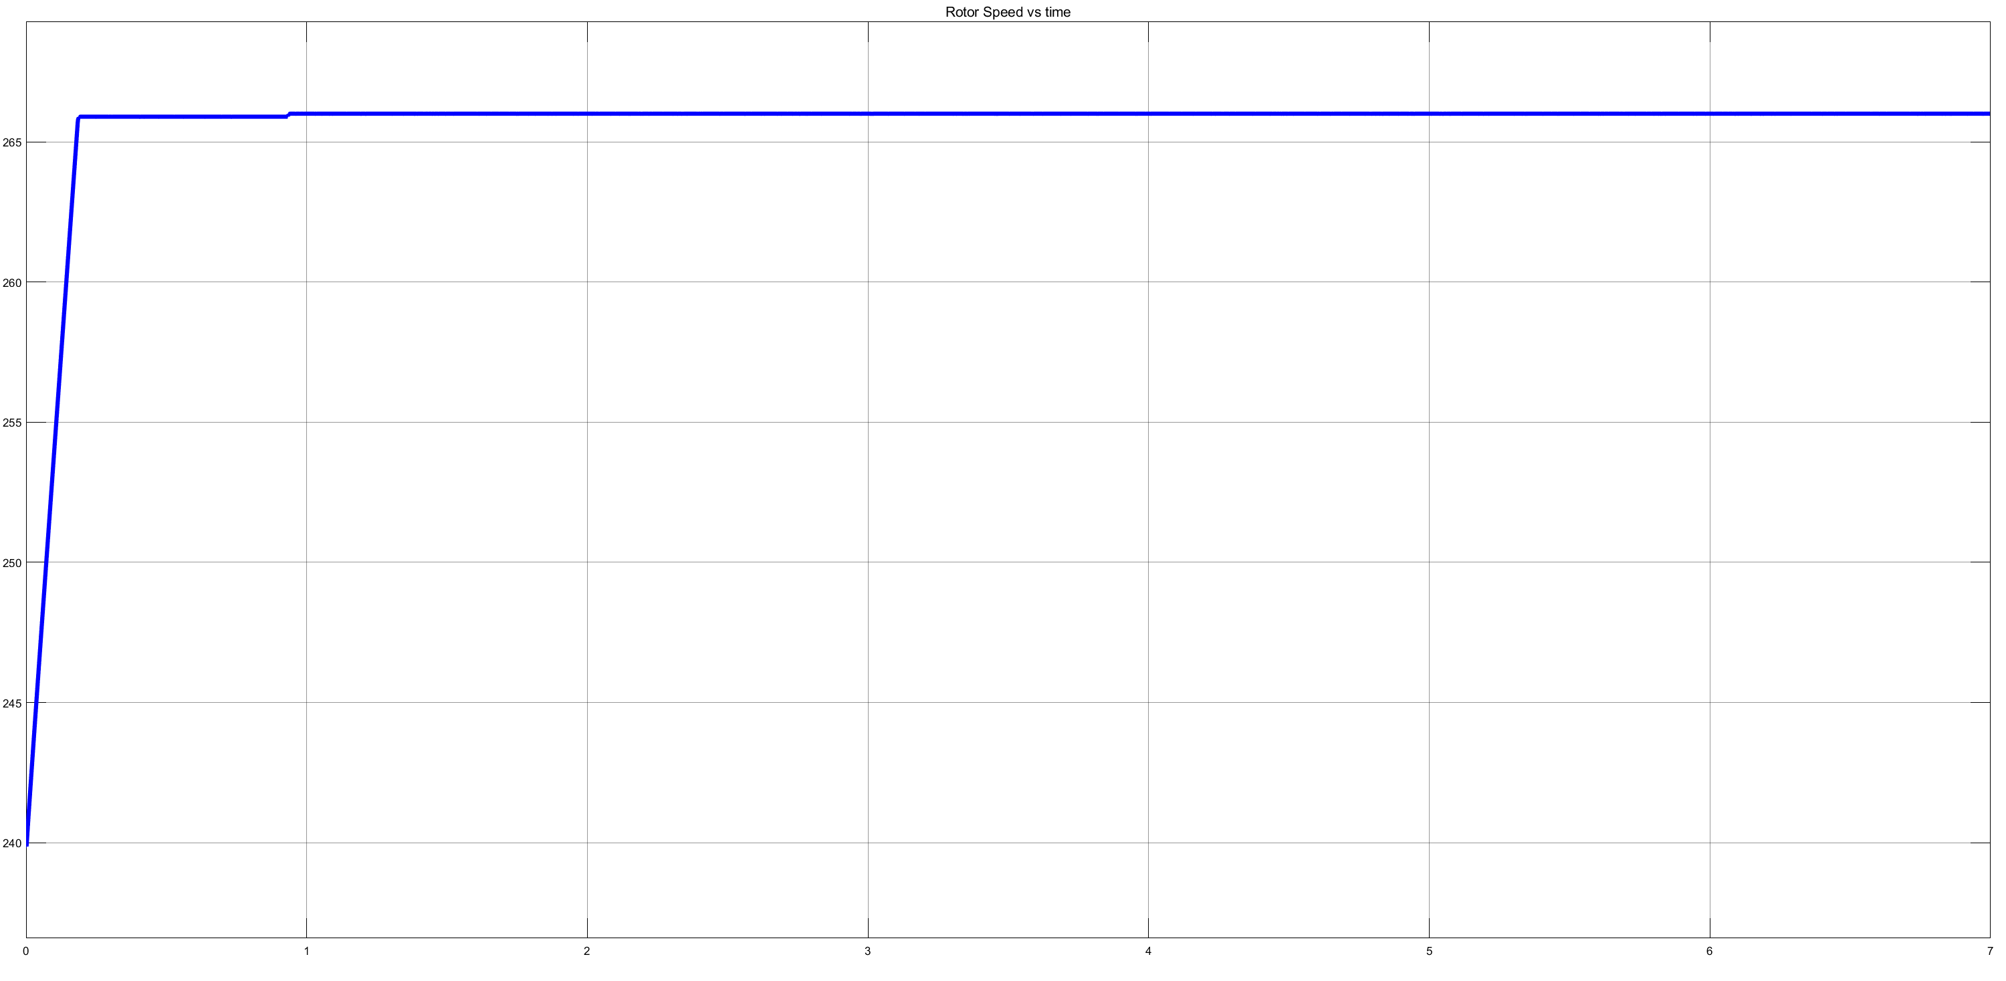

Figure : Rotor Speed(rad/sec) vs time(sec) characteristic

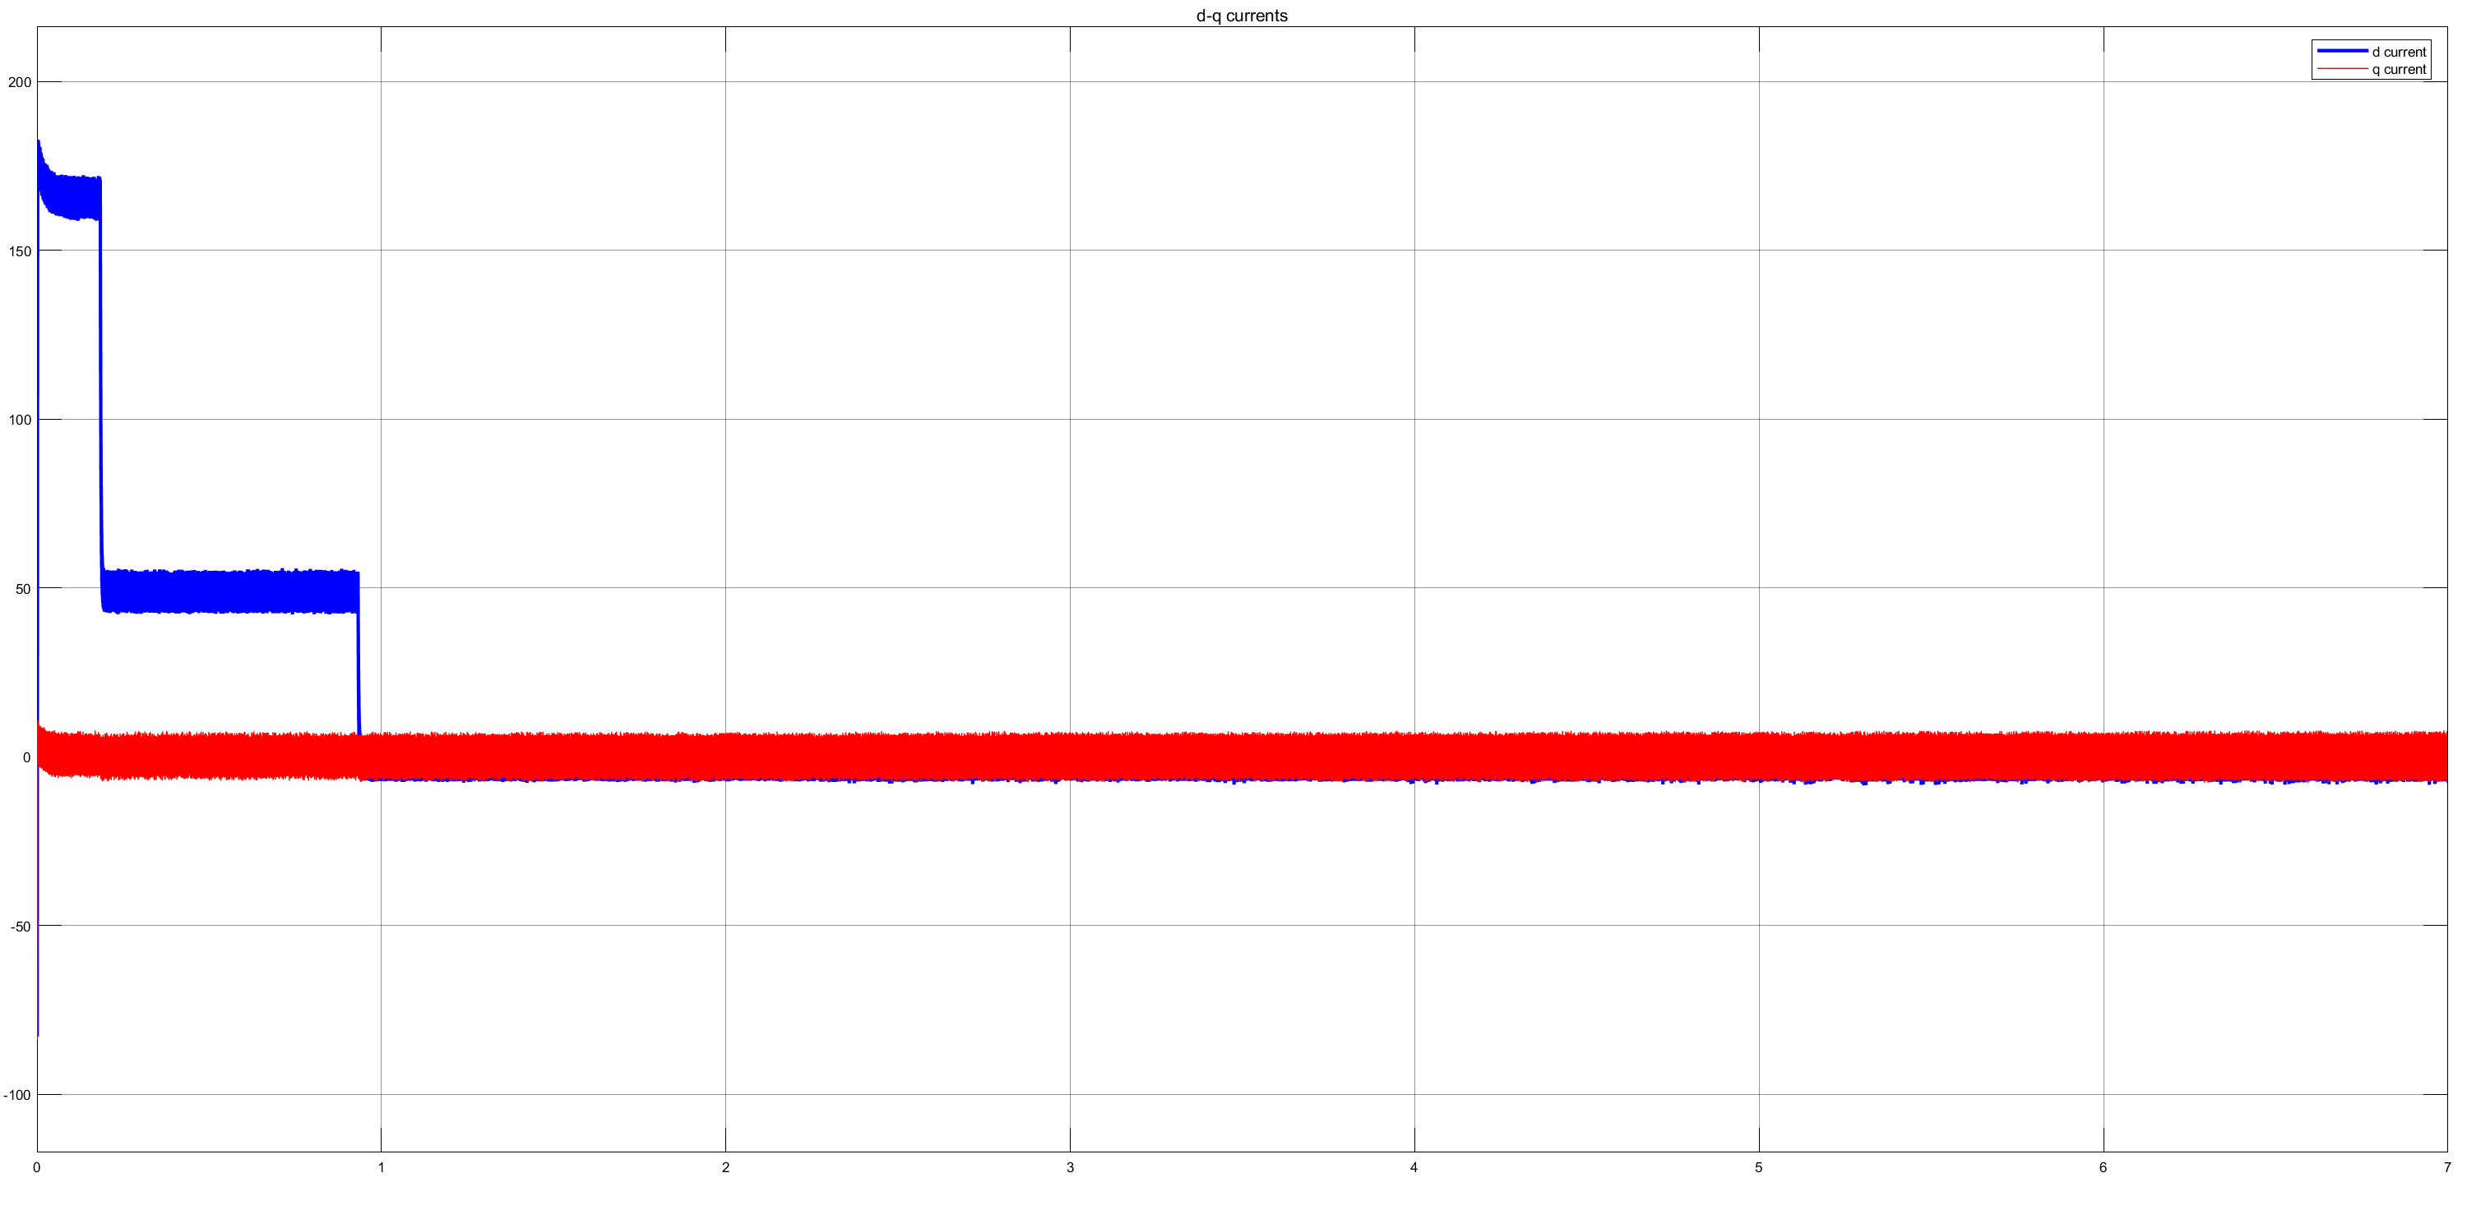

Figure : d (blue) and q(red) currents vs time characteristics

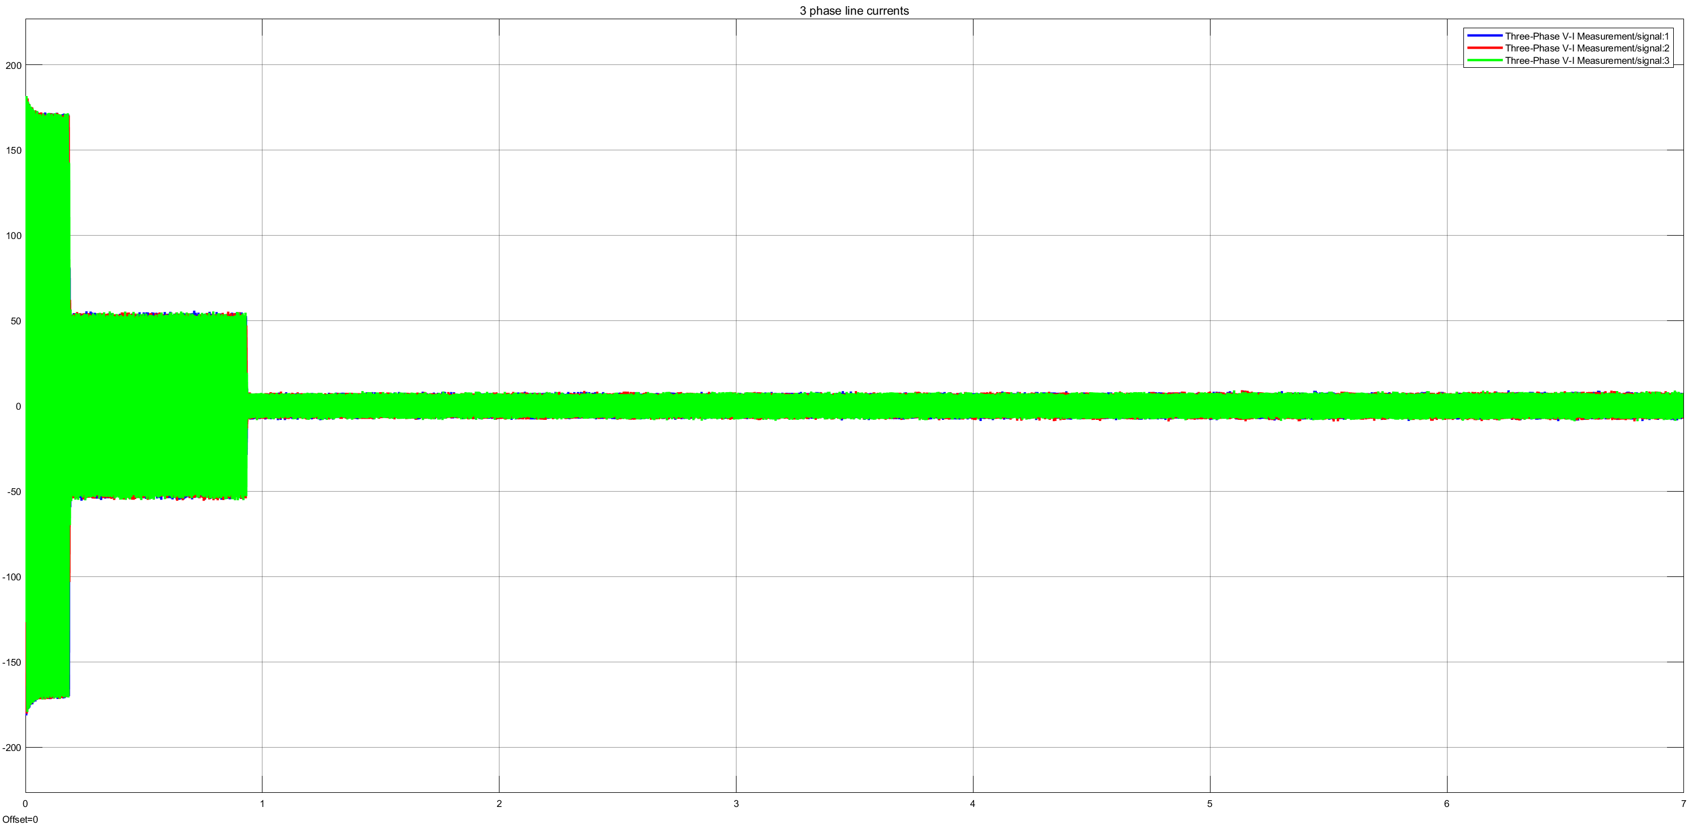

Figure : VAB linetoline currents from a distance

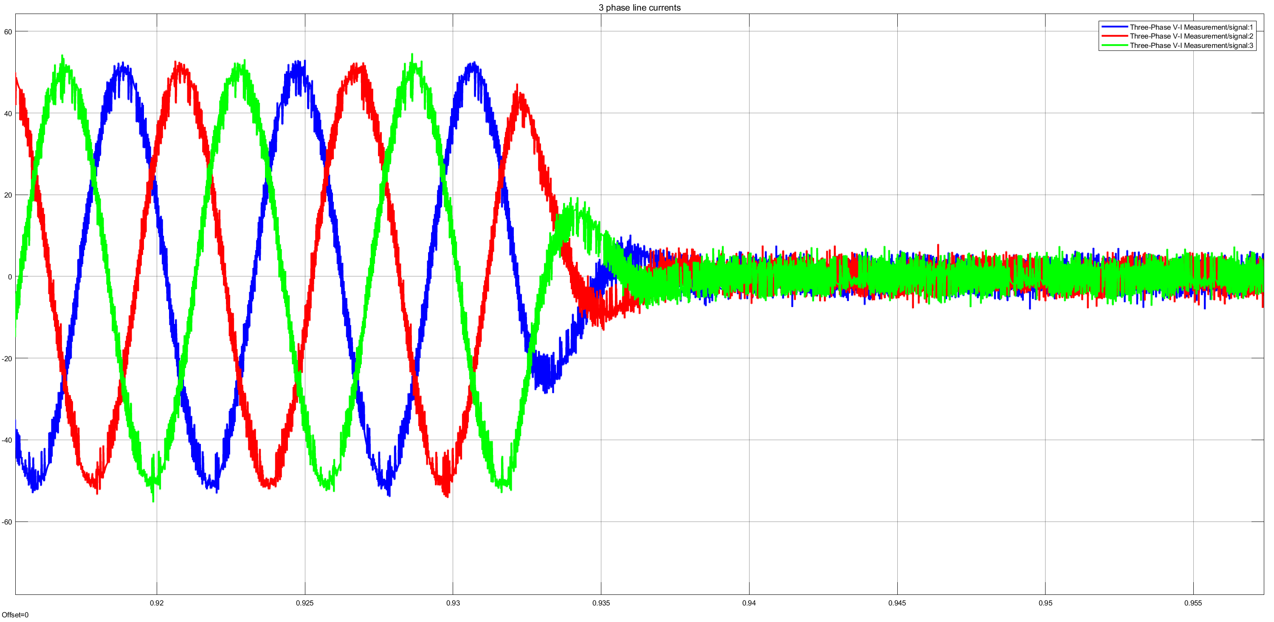

Figure : Three phase line currents upon close look