3)

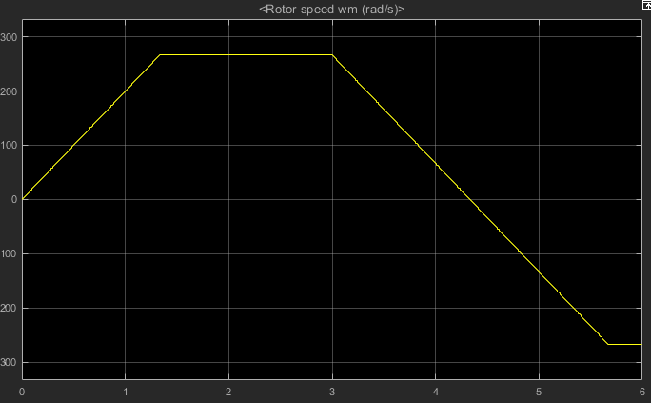

Figure: Rotor speed vs time graph

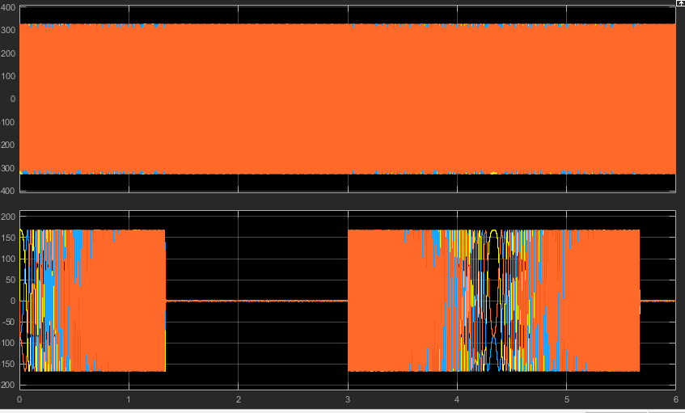

Figure: inverter current and voltage output for the 6 second simulation time

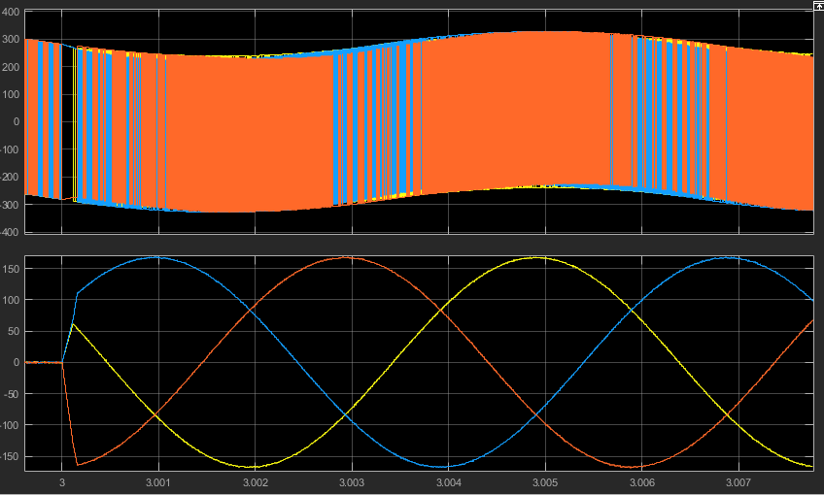

Figure: phase currents at the speed reference change

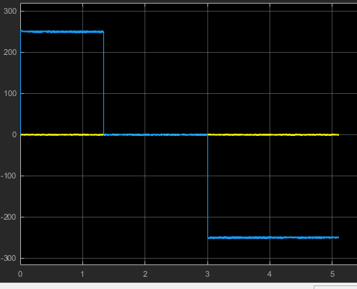

Figure: id and iq currents vs time

When the speed reference changes, the motor turns into a generator. Therefore, it starts pumping energy back into the inverter, and through the inverter, to the DC link. Since the diode bridge does not let the excess energy to go back into the grid, the created energy will be stored in the capacitor. However, as the capacitor collects energy, the dc link voltage levels will rise and it could damage the switches, capacitor or the diodes. In order to prevent this, we can add a resistance to dissipate the excess energy. The simulations above are done with the resistance. On figure below, we can see the voltage increase when there is no resistor.

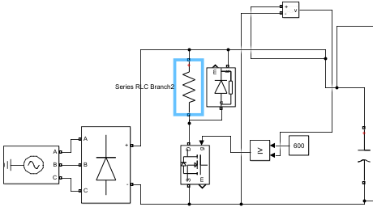

Figure: The breaking resistor circuit.

Also, notice that we have lowered the inertia value to 1 in order to have a shorter simulation time.

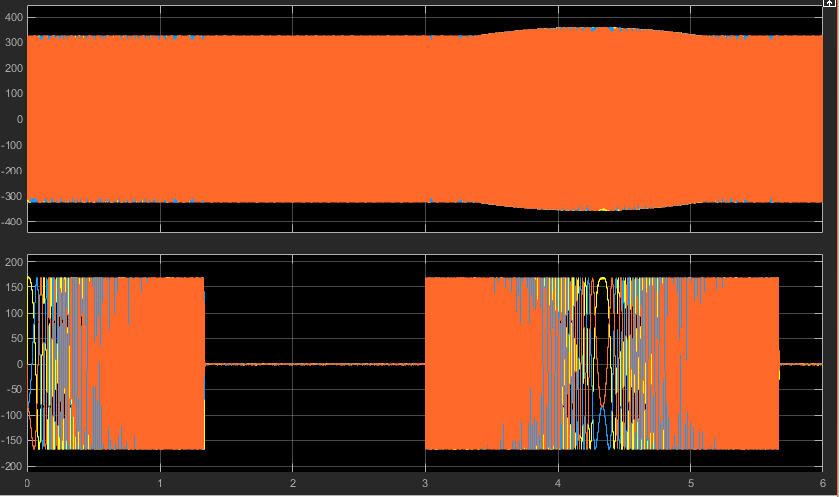

Figure: the waveforms when there is no breaking resistor. Notice the CD ling going fat

4)

We can go into field weakening region to increase the speed.

Firstly, we need to figure out the iq value to provide half the rated torque.



* Iq = 125 A

We can use the following formula to figure out the id value.



* Id = -45.45 A

In order to achieve this, we simply set the reference value of the id current o -45.45 A. After running the simulation, the speed characteristics are as follows.

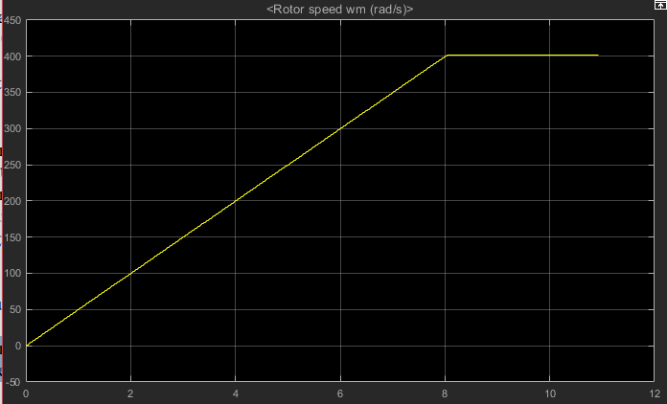

Figure: speed vs time graph of the rotor

Part D:

For the bridge rectifier:

Since our DC link is maximum at 600 V, and we know the power of the motor(80 kW). Therefore , the dc link current should be around 130 A. so we need diodes that can conduct 130 A and can withstand at least 600 V.

Therefore, we can use this full bridge rectifier:

<http://www.vishay.com/docs/94354/vs-130mt80k.pdf>

Von is 1.5 V, and there will be two diodes conducting at a time. Therefore,

Ploss = 1.5 *2 *130 = 390 W

For the inverter transistors:

Irms= 175/sqrt(2) = 124 A

When we look at the IGBT’s that can handle 200 A and 650 V, we find this bad boy:

With the datasheet: <https://www.littelfuse.com/~/media/electronics/datasheets/discrete_mosfets/littelfuse_discrete_mosfets_n-channel_ultra_junction_ixfn170n65x2_datasheet.pdf.pdf>

Let’s find the conduction losses:

Rds = 13 mohm => Irms^2 *Rds = 200 W per MOSFET.

Since we have 6 of them: 1200 W for MOSFET conduction losses

From the application note <http://www.ti.com/lit/an/slyt664/slyt664.pdf>:

Switching loss is:



Vin = 600 V

Iout= 124 A

Fsv = 10 kHz

Qgs2 = 166 nC

Qgd = 137 nC

Ig = 1 A

* Psw = 112.5 W

For 6 switches:

Psw = 6* 112.5 = 1300 W

As the current passes from the motor, Rs will also dissipate energy.

Depending on torque this loss will change. At max torque, iq will be 250 and therefore:

Pmotor = 250^2 * 0.05 = 3125 W

**Total loss:**

Pmosfet = 1300 + 1200 = 2500 W

Pdiode = 390 W

Psemiconductor = 2890 W

Pmotor = 3125 W

Ptotal = 6 kW

* Eff = 80000/86000 = %93