# Client Architecture

Below image displays the dependencies of both web and wpf clients. Both clients have separate Bussiness layers which provide related components.

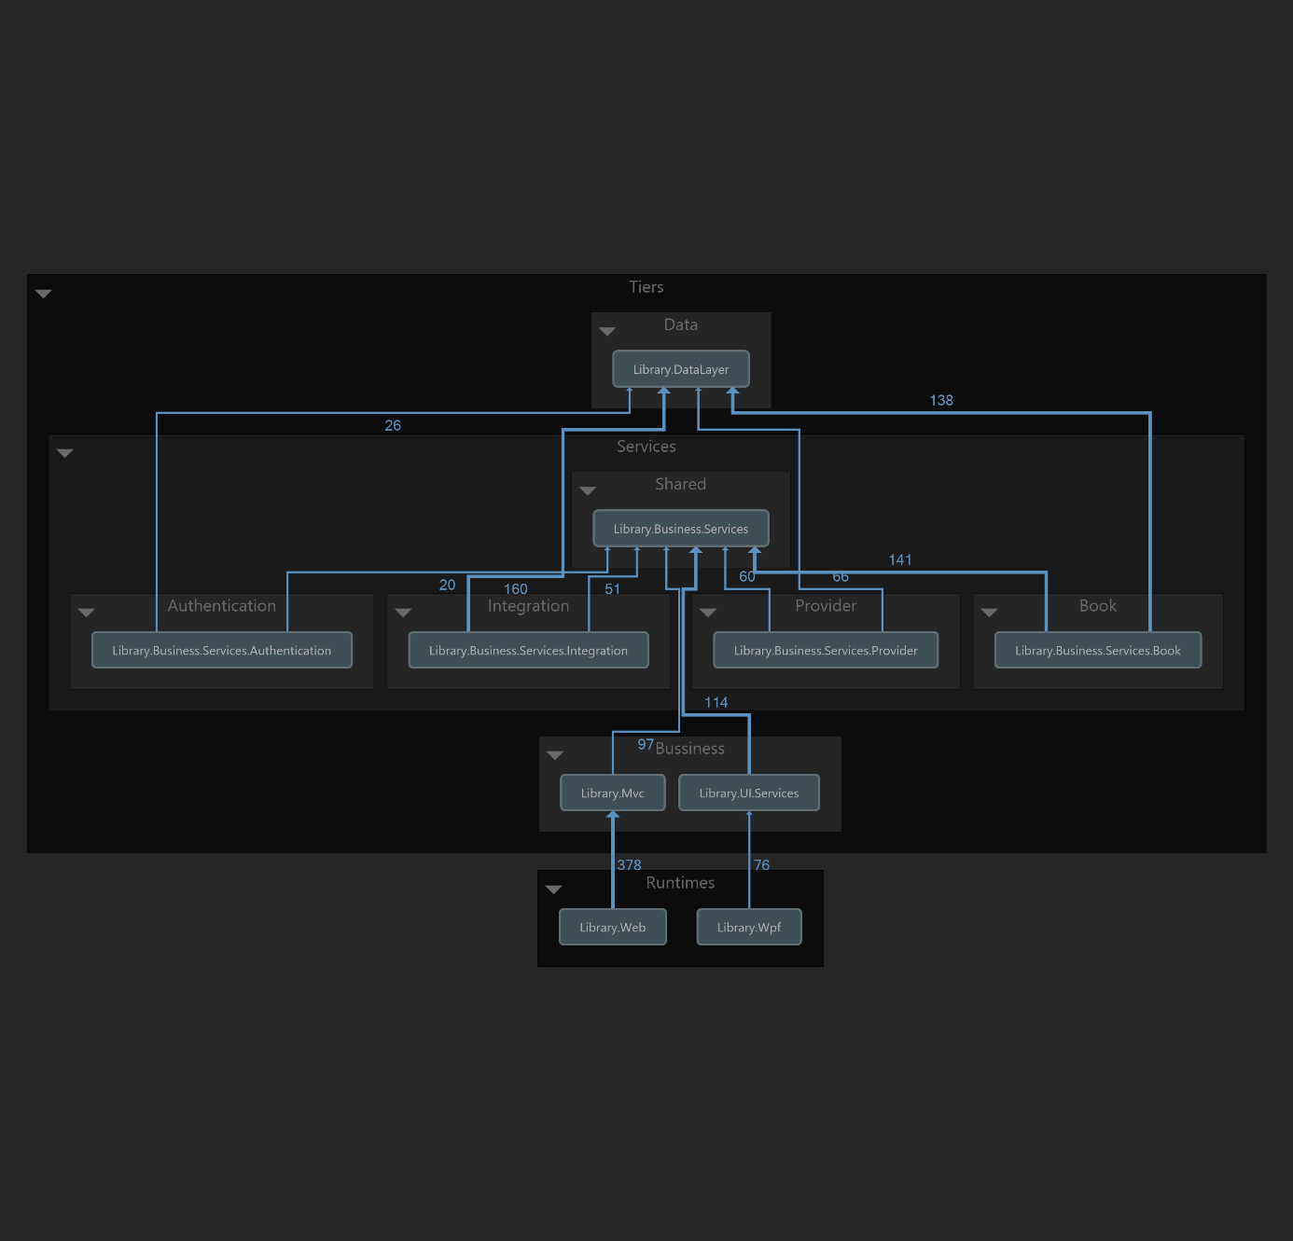

ımage – 1

If we try to look into how services consumption goes there is direct dependency between client and data layers.

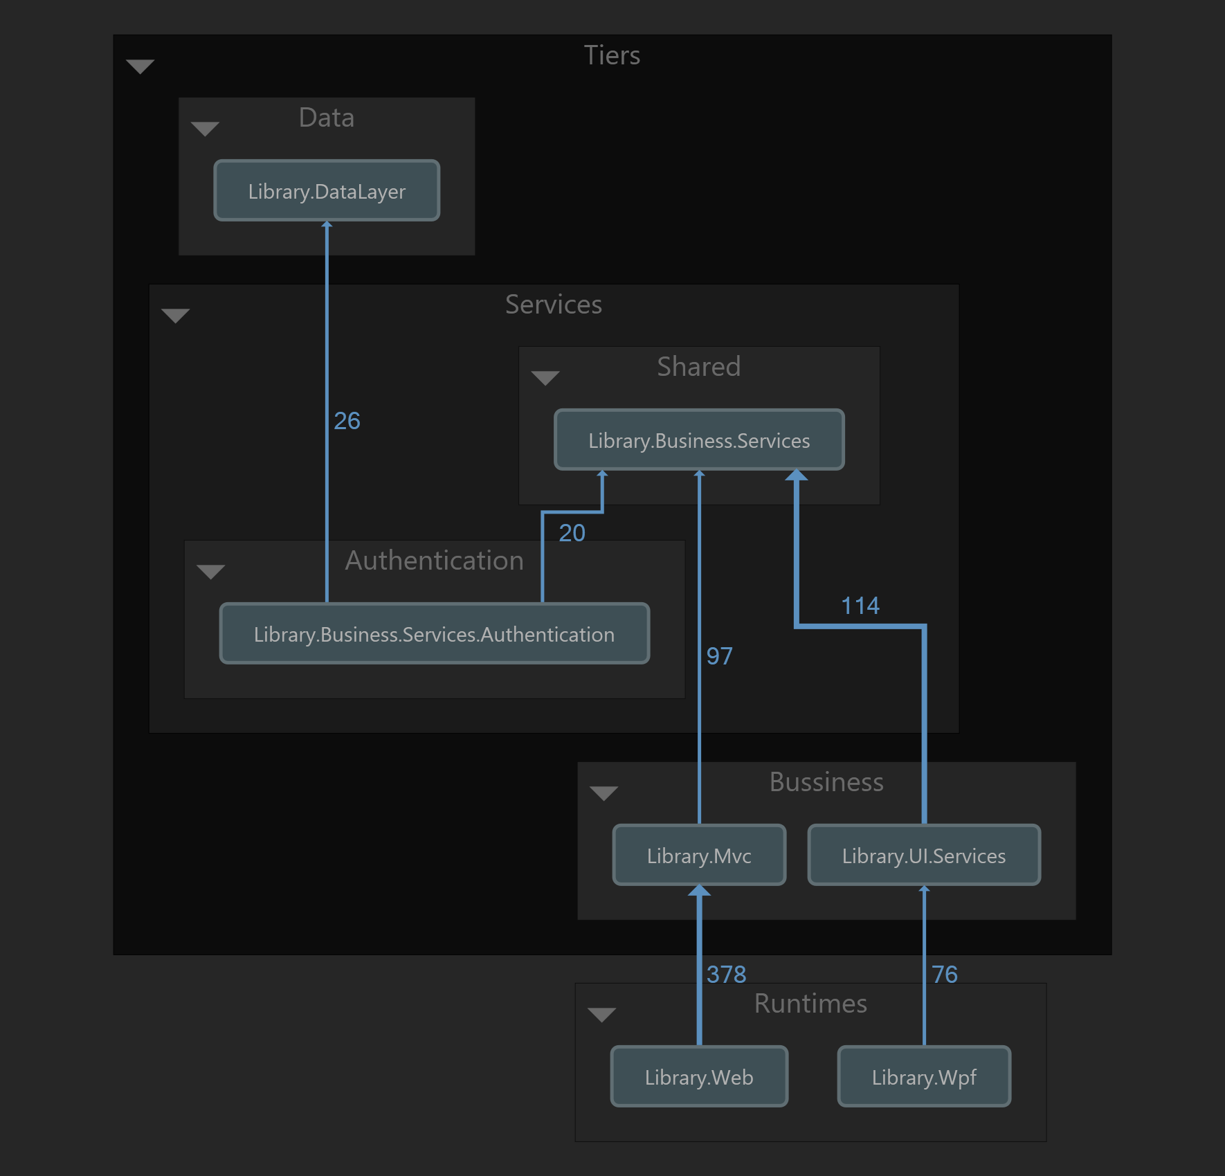

ımage – 2

# Host Service Architecture

Below image displays the dependicies of host applications.

