Day 1
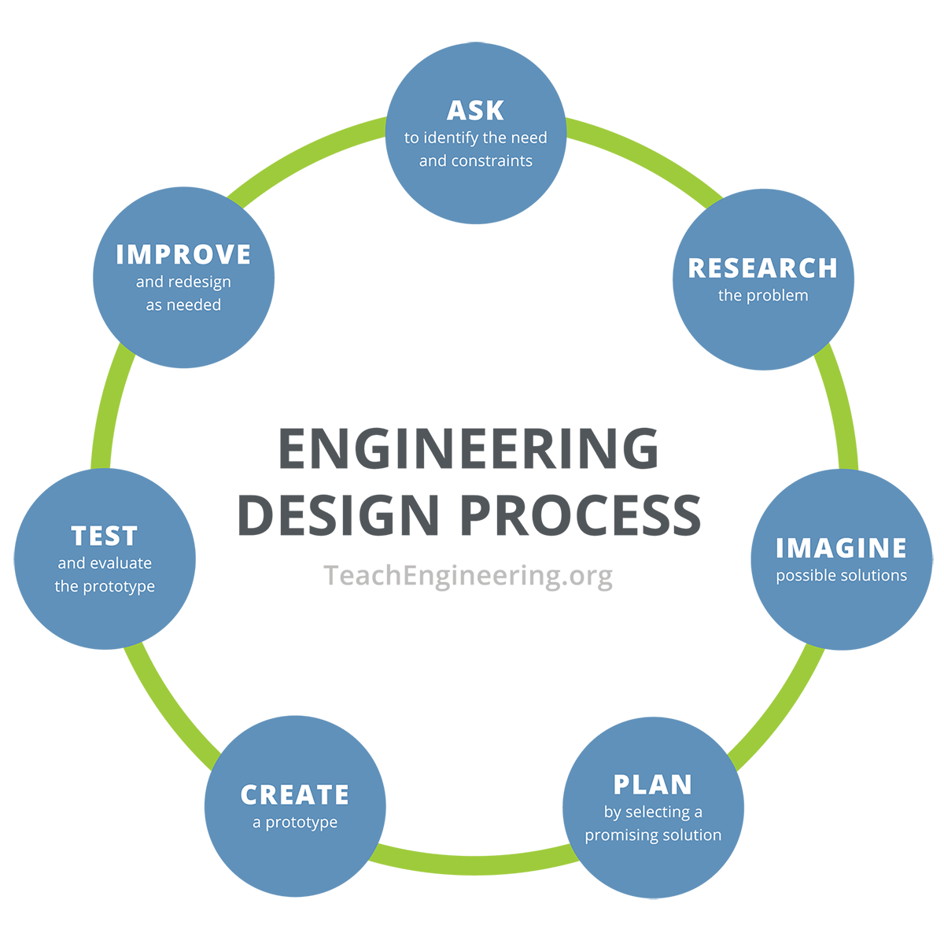
Engineering cycle
- Paper airplane lab?
- Syllabus etc
- Repeat kids?
- Introduce engineering cycle in an authentic way
- What do you do if something doesn’t work?
- Solution for notebooks? Consequences for not turning in

Notes on voltage
- Voltage is current times resistance
Month | Savings
January | $250
February | $80
March | $420

Link to Classroom?
assignment

