Energy
Energy can only change form, not be created or destroyed.
The two kinds of energy we will talk about are kinetic and potential.

Kinetic Energy
Energy in movement
$E_{k}=\frac{1}{2}mv^{2}$
m = mass (kg)
v = velocity (m/s)

Potential Energy
The kind of potential energy we care about for this project is elastic potential energy. This is what builds up when you pull back on a spoon or rubber band.
$E_{p}=mgh$
m = mass (kilograms)
h = height (meters)
g = gravitational constant ($9.81\frac{m}{s^{2}}$)

Shape
Objects launched through a gravitational field form the shape of a parabola
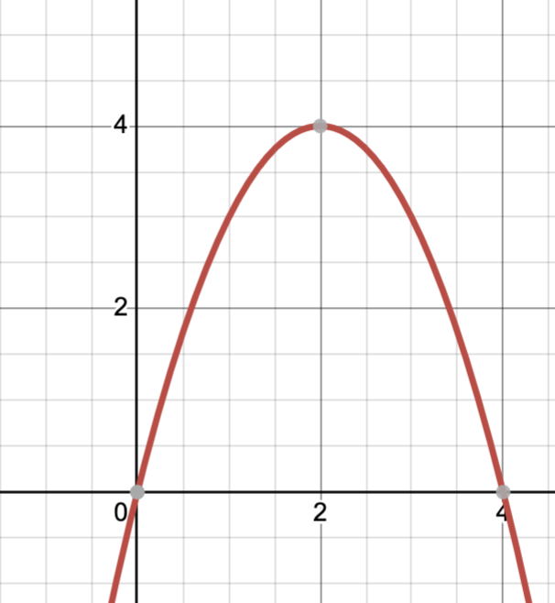
Parabola
What angle do you think would be best for launching the bean bag?

Elastic energy
E_ = k x^2

