Ski week!!
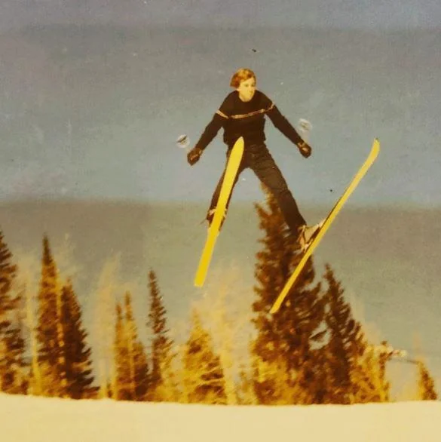
ski

Guides
- Ed
- Geoff
- Nick ?
- Danny ?

Todo
- Find out if Nick/Danny are joining
- Make form for ski/snowboard, rental/bring, basin/valley
- Come up with price point
  - After we have form filled out

