Through the simulations it is decided that the required capacitance value is greater than 0.4 mF. At 0.4 mF the ripple with respect to the average of the output turns out to be as 19.7%. As the capacitance value is increased the percentage ripple will decrease. We picked the rated voltage as 385 V. The choice fort he value of the capacitance is 470 µF which is a common value in this interval. The cheapest one with these requirements on DigiKey is [SLPX471M385E9P3-ND](https://www.digikey.com/product-detail/en/cornell-dubilier-electronics-cde/SLPX471M385E9P3/SLPX471M385E9P3-ND/4470596) .

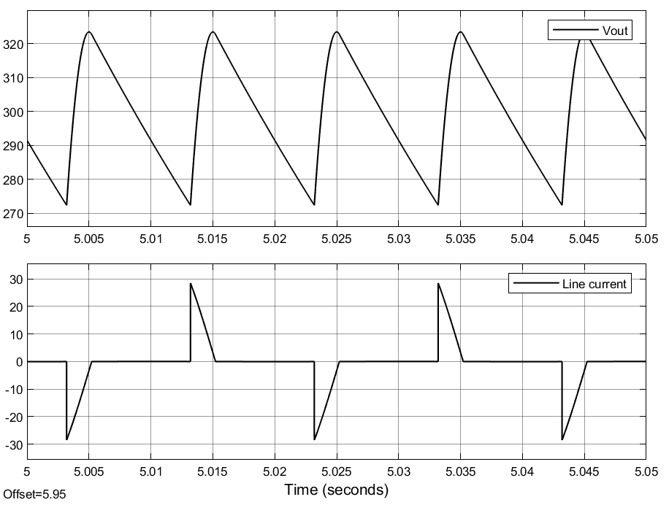

Figure: 17% ripple with respect to average value of output voltage