Astro
Tutorial (draft)
Table of Contents
Astronomy and computations 2
General 2
Configuration 2
Body position computation 3
Working with GUI interface 5

Astronomy and computations

General
Program implements some basic astronomical computations. Given a date and location on the Earth’s surface, it can compute the positions of the fixed body (star). In additions to fixed body position calculations, it computes Julian date, local sidereal time. Also represents raising and setting times, exposition time and coordinates in horizontal system (altitude and azimuth) for selected fixed body object. For all astronomy camputations PyEphem library is used. The numerical routines that lie behind PyEphem are those from the wonderful XEphem astronomy application, whose author, Elwood Downey, generously gave permission for us to use them as the basis for PyEphem.

Configuration
The accurate location of observatory is needed for computation right Apparent Topocentric Position of the fixed body. It can be done through common configuration file “default.conf”, which can be found in programs main folder. Observer configuration located under [observer] section. Latitude and longitude should be presented as float numbers, elevation in meters.

Default values are:
[observer]
latitude = 58.26574191042049
elevation = 65.42
temperature = 24.0
longitude = 26.4600670337677

Body position computation
Fixed body position computation take many steps inside PyEphem library, it takes in account observer position. Common calculation flow is follow:

- Having “star-atas position” of the body PyEphem calculates for choosen epoch Atrometric Geocentic Position
- Next, PyEphem adjusts the body’s position for relativistic deflection, which is the slight nudge that gravity gives to light that passes very close to the Sun. This only affects objects within about 10° of the Sun and which lie on the far side of it from the Earth.
- Next, PyEphem adjusts the body’s position for nutation, which is really not an adjustment to the body’s apparent location at all, but a correction for the fact that the platform from which we observe — the Earth — wobbles over the span of months and years. If you want to point a very accurate telescope at an object, then you have to account for this wobble in the Earth’s pole. (Star atlas coordinates always ignore this, and pretend that the Earth’s pole doesn’t have this slight wobble, which is why the “Astrometric” coordinates above don’t have to include this correction.)
- Next, PyEphem adjusts the body’s position for the aberration of light, the fact that the motion of the Earth through space causes a slight slant to the light reaching us from other objects, in the same way that driving through rain or snow will make the precipitation look like it is coming down diagonally, from in front of you, instead of looking like it is coming straight down from overhead. (PyEphem skips this step for the Moon, since the Moon travels with the Earth through space.)
- Having made all of these adjustments, PyEphem is now confident that it knows the direction in which the object appears to lie from the Earth, so it stores the computed Apparent Geocentric Position.
- The first adjustment that PyEphem makes based on the location of the Observer is to correct for parallax. This is needed because all of the previous steps computed where the body lies when viewed from the location of the Earth itself in its orbit — that is, from the Earth’s exact center, which is why the previous coordinate sets were all named “Geocentric” (the Greek prefix geo- means Earth). But someone on the Earth’s surface is more than 6,300 kilometers away from the Earth’s center, which will shift, very slightly, the position of Solar System bodies against the background of stars (and will move nearby bodies like the Moon, or an artificial Earth satellite, even more). The parallax correction adjusts for this.
- Finally, the very atmosphere through which we view the sky acts as a lens that displaces the positions of bodies when they get close to the horizon. PyEphem has to correct for this refraction both in order to give you a more accurate idea of where to point your telescope, and to be able to make correct predictions of rising and setting times.
- Based on this all calculations PyEphem computes Apparent Topocentric Position.

Working with GUI interface

- Start program
After successful program start on display appears main window (fig. 1). The main view consists of selected object data and current object position, Time and Date for observer, telescope position, manual control panel and telescope panel with additional information.

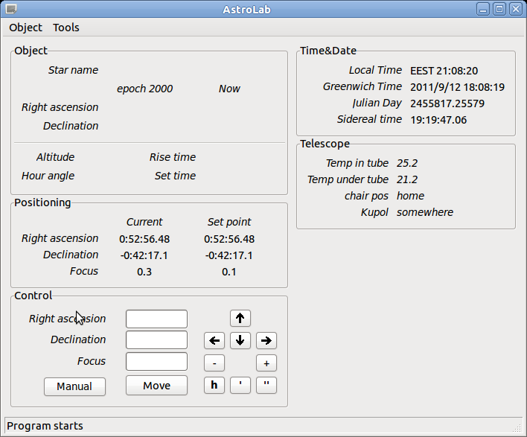Fig 1: Main view

- Object (star) adding, editing

You can add new object to database through menu Object/Edit Objects or by using shortcut ctrl+e. Dialog window should appear on the main view (fig. 2)

Find field filters search result set by input.
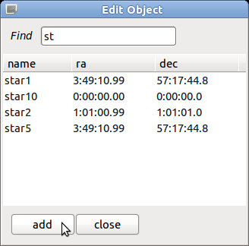Fig 2: Edit dialog
You can add new object by pressing Add button or edit selected object by double click on star name (fig. 3). For coordinate input formating colon separation is used. For example degrees coordinate 10:10:10 means 10 deg 10 min 10 sec.

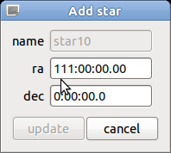Fig 3: Object update

If coordinate input is wrong Update button become inactive. After pressing update changes will be written into database immediately.
Also you can delete object by selecting object and pressing del button on the keyboard.

- Object (star) selection

You can select observation object through menu Object/Select Object or by using shortcut ctrl+o. Dialog window should appear on the main view (fig. 4). The result list is filtering dynamically by inputted name.

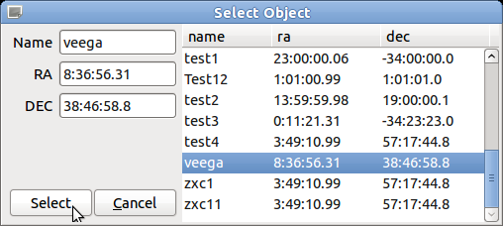Fig 4: Object selection

Selection can be done by pressing Select button or by double click on star name. You also can add new object if you will put unique star name and correct coordinates into fields.

- Selected object information

After object selection main view will apply selected object coordinates and show detail information about its current position (fig. 5).
The coordinates (ra, dec) for epoch2000 and current epoch will be displayed in Object panel.
Also telescope altitude and hour angle will be shown.
For every object program tries to calculate Rise and Set times, if it not possible the always or never state will be shown (star is always visible or never sets).

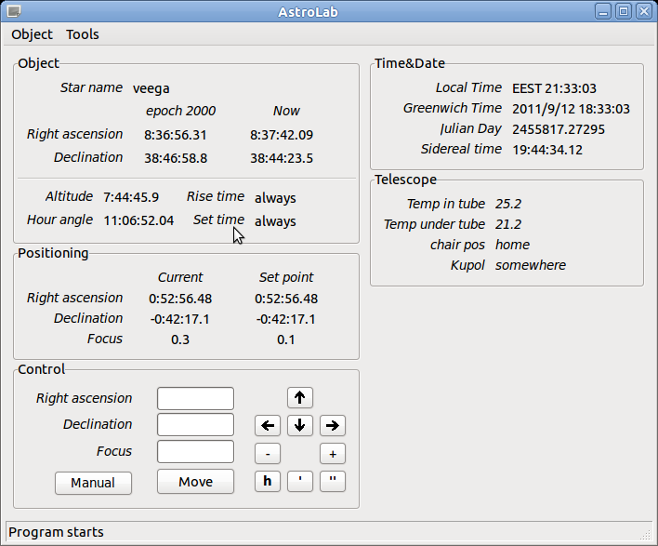Fig 5: Selected object info

- Automate telescope moving

After object selected and if object is “visible” for telescope in PC mode you can start to automate moving by pressing Move button. The aim position will be shown in Positioning panel, you can also track telescope current position by using this panel.

- Manual mode

Astro program supports two main modes: auto and manual.
If manual control is needed, you can catch control by selection Manual mode (Auto/Manual button).
In control panel you can manually move telescope by using keyboard arrows or corresponding buttons.

- Time & Date panel

Time and Date panel shows local time, Greenwich time, Julian date and Sidereal time (GST not LST)

Interface is totally translatable in can be translated into any language.

