Astro
Tutorial (draft)
Table of Contents
Astronomy and computations 2
General 2
Body position computation 2
Configuration 4
General 4
Observer 4
Database 5
PLC configuration 5
Working with GUI interface 6
General 6
Date and angle representation 6
Overview 6
Object panel 8
Positioning panel 8
Control panel 8
Setpoint panel 9
Time&Date panel 9
Telescope panel 9
Status panel 9

Astronomy and computations

General
Program implements some basic astronomical computations. Given a date and location on the Earth’s surface, it can compute the positions of the fixed body (star). In additions to fixed body position calculations, it computes Julian date, local sidereal time. Also represents raising and setting times, exposition time with horizon offset and coordinates in horizontal system (altitude and azimuth) for selected fixed body object. For all astronomy computations PyEphem library is used. The numerical routines that lie behind PyEphem are those from the wonderful XEphem astronomy application, whose author, Elwood Downey, generously gave permission to use them as the basis for PyEphem.

Body position computation
Fixed body position computation take many steps inside PyEphem library, it takes in account observer position. Common calculation flow is follow:
- Having “star-atas position” of the body PyEphem calculates for choosen epoch Atrometric Geocentic Position
- Next, PyEphem adjusts the body’s position for relativistic deflection, which is the slight nudge that gravity gives to light that passes very close to the Sun. This only affects objects within about 10° of the Sun and which lie on the far side of it from the Earth.
- Next, PyEphem adjusts the body’s position for nutation, which is really not an adjustment to the body’s apparent location at all, but a correction for the fact that the platform from which we observe — the Earth — wobbles over the span of months and years. If you want to point a very accurate telescope at an object, then you have to account for this wobble in the Earth’s pole. (Star atlas coordinates always ignore this, and pretend that the Earth’s pole doesn’t have this slight wobble, which is why the “Astrometric” coordinates above don’t have to include this correction.)
- Next, PyEphem adjusts the body’s position for the aberration of light, the fact that the motion of the Earth through space causes a slight slant to the light reaching us from other objects, in the same way that driving through rain or snow will make the precipitation look like it is coming down diagonally, from in front of you, instead of looking like it is coming straight down from overhead. (PyEphem skips this step for the Moon, since the Moon travels with the Earth through space.)
- Having made all of these adjustments, PyEphem is now confident that it knows the direction in which the object appears to lie from the Earth, so it stores the computed Apparent Geocentric Position.
- The first adjustment that PyEphem makes based on the location of the Observer is to correct for parallax. This is needed because all of the previous steps computed where the body lies when viewed from the location of the Earth itself in its orbit — that is, from the Earth’s exact center, which is why the previous coordinate sets were all named “Geocentric” (the Greek prefix geo- means Earth). But someone on the Earth’s surface is more than 6,300 kilometers away from the Earth’s center, which will shift, very slightly, the position of Solar System bodies against the background of stars (and will move nearby bodies like the Moon, or an artificial Earth satellite, even more). The parallax correction adjusts for this.
- Finally, the very atmosphere through which we view the sky acts as a lens that displaces the positions of bodies when they get close to the horizon. PyEphem has to correct for this refraction both in order to give you a more accurate idea of where to point your telescope, and to be able to make correct predictions of rising and setting times.
- Based on this all calculations PyEphem computes Apparent Topocentric Position.

Configuration

General
AstroLab allows to change and adjust some parameters of work through configuration files and configuration menu. There are two configuration files in root folder: default.conf and plc.conf. By changing default.conf you can adjust database connection parameters, observer position and common program parameters, like selected language and logging time. The common parameters can also be changes through configuration menu.

Observer
The accurate location of observatory is needed for computation right Apparent Topocentric Position of the fixed body. It can be done through common configuration file “default.conf”, which can be found in programs main folder. Observer configuration located under [observer] section. Latitude and longitude should be presented as float numbers, elevation in meters.
Default values are:
[observer]
latitude = 58.26574191042049
longitude = 26.4600670337677
elevation = 65.42
horizon = 00:04:00
Latitude and longitude position should be presented as float numbed.
Elevation in meters above sea level and horizon can be any degree in follow format DEG:MIN:SEC

Database
AstroLab uses MySQL database, which is based on the same host, as program. This can be easily changed by reconfiguration of database connection. It can be done through common configuration file “default.conf”, which can be found in programs main folder.
Default values are:
[db configuration]
database = astro
host = localhost
user = astro
password = 5gh6w35
port = 3306

PS! In spite of any SQL database support and opportunities for changing connection parameters, correct work of program not assured.

PLC configuration
AstroLab holds continuous connection with main PLC block. The connection parameters can be changed in “plc.conf” file.
Default values for plc connection are:
[connection]
#tqravere
host = 193.40.1.221
slave id = 1
port = 502

PS! Do not change any values, if you do not know, what you do.

Working with GUI interface

General
AstroLab program was created to implement automatic position control and monitor telescope status. It allows to store atlas star position coordinates (epoch J2000) in database and use their coordinates to navigate telescope. AstroLab keeps continuous connection with PLC controller and database. This allows to monitor telescope state in real time (the maximum delay less than 0.5 sec) . AstroLab monitors connection statuses, alarms, different service parameters and states.

Date and angle representation
All calculations with angle are perform in radians. For increasing human readability in configuration files and graphic user interface of program follow format is using:
HH:MIN:SEC represents hour angles, for example right ascension.
DEG:MIN:SEC represents degree angle, for example declination or altitude.

Overview
At very first start main window looks like Fig. 1. Telescope and Status panels fields will be empty, if connection is not established yet. Setpoint panel can be missed, if remote or object control is taken. The main window is separated logically into independent blocks – panels: Object panel, Positioning, Control panel, Setpoint panel, Time&Date panel, Telescope panel, State panel. Depend on control mode manual positioning panel (Setpoint panel) can be hidden.

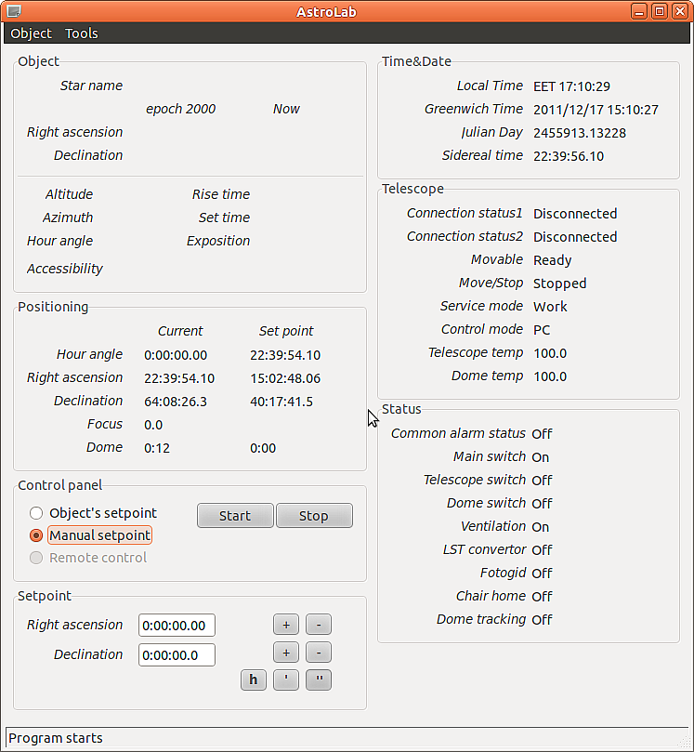Fig 1: Main window

Object panel
Object panel is most important panel in program. It holds all common information about observation object. Original and current position in equatorial and horizontal coordinate systems (topocentric positioning is used). Program automatically calculates current object position in sky, make all correction and put this new position value into Setpoint. By clicking start button in Control panel user sends this Setpoint value to PLC and telescope starts moving.
Raising and setting times are presented, if their calculation is possible from observation point. In other case “N/A” message will be displayed. This can occur in two cases, if star is never setting or raising. Exposition time calculated as difference between setting and current time. “N/A” will be displayed, if setting time is missed. This time values are corrected on horizon level, which can be set up in configuration file.
Hour angle (HA) calculates as difference between local sidereal time (LST) and local right ascension (RA). To determine objects visibility, program compares current object altitude value and horizon level.

Positioning panel
Positioning panel is used to represent current telescope axes positions in equatorial system. In addition to right ascension and declination, in positioning panel is shown also hour angle value and dome position. For representing angles, default format is used: HH:MIN:SEC and DEG:MIN:SEC.
Focus present only for current position, because of focus control is done through remote control. Focus value is presented in millimeters.

Control panel
Control panel gives base controls of telescope. It is possible to take control by choosing Object's or Manual setpoints. After that “Control mode” value in Telescope panel should change to “PC”. In some special cases “PC control” is not allowed, in that case “Remote control” will be taken back.
By clicking Start and Stop buttons start or stop command will be send to PLC controller. If telescope is not movable (see Telescope panel, Movable status) Start button will be not active. If telescope is moving, the start button also not active.

Setpoint panel
Setpoint panel adds opportunity to set Setpoint for telescope manually. Usually by choosing object through database, program automatically calculates current object position in sky, make all correction and put this new position value into Setpoint. By clicking start button in Control panel user sends this Setpoint value to PLC and telescope starts moving.
If Manual Setpoint selected, program will take the inputted values and sends them directly to PLC without any corrections and compensations.

Time&Date panel
Time&Date panel represents local and Greenwich times, Julian date and Sidereal time for observation position. System calculates Local Sidereal time (LST) and Julian date (JD) based on observer configuration.

Telescope panel
Telescope panel shows current telescope status. Two connection statuses check every 2 sec connection with main PLC block and secondary PLC block. The movable status informs about general telescope ready state. All consistency checks are implemented by first PLC block and moving will be blocked until all requirement will be met. Move/Stop status just represent current telescope moving status.
There are two main modes for telescope: work and service. Working with telescope through PC program allowed only in work mode.
The control of telescope can be done in different places, such as: PC room, Observation room, Telescope room and remove control. The current selected control mode is presented in telescope panel too.

Status panel
Status panel represents common system states, such as switchers and trailers, subsystem states. Monitoring of this states, can help to find most common failures and reasons, why they occurs.

Working with objects
AstroLab operates only with equatorial coordinates of stars in epoch J2000 format. Most operation with stars are perform in Edit Object dialog, which can be open through menu Object/Edit Object or by pressing short cut Ctrl+E (fig. 1). Search result is limited by 1000 objects. You can dynamically filter search result by typing star name in Find field. It will help more easier find needed object.
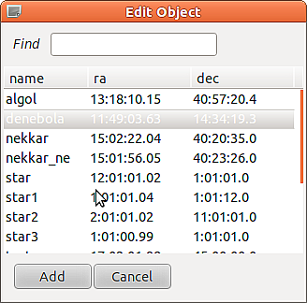Fig 1: Edit object dialog
Coordinates are represented in default standard:
HH:MIN:SEC for right ascension.
DEG:MIN:SEC for declination.
For example degrees coordinate 10:10:10 means 10 deg 10 min 10 sec.

Adding new object
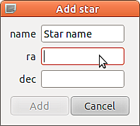Fig 2: Add star
New object can be easily added through editing object dialog by clicking Add button. Add star dialog should appear with 3 input fields: star name, star ra and dec position in J2000 format. The Add button will be disabled until you enter correct RA and DEC values, object name also should be unique.

Changing object
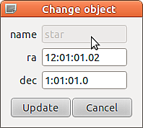Fig 3: Change object
Objects coordinates can be changed by double click on object in Edit Object dialog. (fig. 1). In dialog only coordinates can changed. The Update button will be disabled until you enter correct RA and DEC values. After pressing update changes will be written into database immediately.

Object selection

- Object (star) selection

You can select observation object through menu Object/Select Object or by using shortcut ctrl+o. Dialog window should appear on the main view (fig. 4). The result list is filtering dynamically by inputted name.

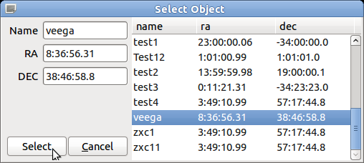Fig 4: Object selection

Selection can be done by pressing Select button or by double click on star name. You also can add new object if you will put unique star name and correct coordinates into fields.

- Selected object information

After object selection main view will apply selected object coordinates and show detail information about its current position (fig. 5).
The coordinates (ra, dec) for epoch2000 and current epoch will be displayed in Object panel.
Also telescope altitude and hour angle will be shown.
For every object program tries to calculate Rise and Set times, if it not possible the always or never state will be shown (star is always visible or never sets).

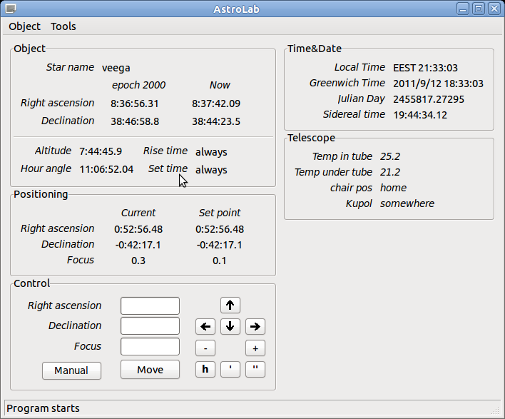Fig 5: Selected object info

- Automate telescope moving

After object selected and if object is “visible” for telescope in PC mode you can start to automate moving by pressing Move button. The aim position will be shown in Positioning panel, you can also track telescope current position by using this panel.

- Manual mode

Astro program supports two main modes: auto and manual.
If manual control is needed, you can catch control by selection Manual mode (Auto/Manual button).
In control panel you can manually move telescope by using keyboard arrows or corresponding buttons.

- Time & Date panel

Time and Date panel shows local time, Greenwich time, Julian date and Sidereal time (GST not LST)

Interface is totally translatable in can be translated into any language.

