Astro
Tutorial (draft)

The aim of this tutorial to introduce Astro program functionality and show how to operate with it.
It will be done by describing work flow with this program.

- Start program
After successful program start on display appears main window (fig. 1). The main view consists of selected object data and current object position, Time and Date for observer, telescope position, manual control panel and telescope panel with additional information.

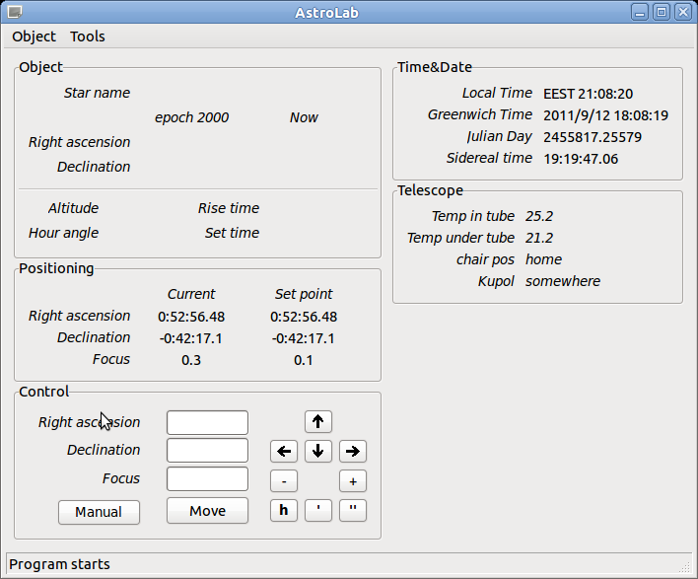Fig 1: Main view

- Object (star) adding, editing

You can add new object to database through menu Object/Edit Objects or by using shortcut ctrl+e. Dialog window should appear on the main view (fig. 2)

Find field filters search result set by input.
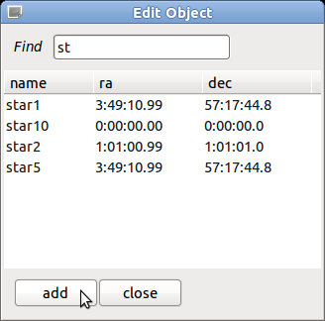Fig 2: Edit dialog
You can add new object by pressing Add button or edit selected object by double click on star name (fig. 3). For coordinate input formating colon separation is used. For example degrees coordinate 10:10:10 means 10 deg 10 min 10 sec.

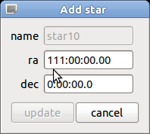Fig 3: Object update

If coordinate input is wrong Update button become inactive. After pressing update changes will be written into database immediately.
Also you can delete object by selecting object and pressing del button on the keyboard.

- Object (star) selection

You can select observation object through menu Object/Select Object or by using shortcut ctrl+o. Dialog window should appear on the main view (fig. 4). The result list is filtering dynamically by inputted name.

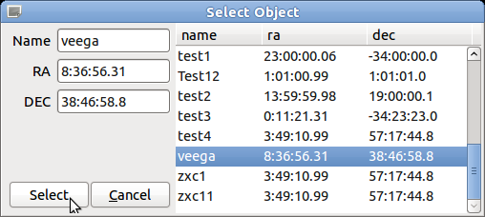Fig 4: Object selection

Selection can be done by pressing Select button or by double click on star name. You also can add new object if you will put unique star name and correct coordinates into fields.

- Selected object information

After object selection main view will apply selected object coordinates and show detail information about its current position (fig. 5).
The coordinates (ra, dec) for epoch2000 and current epoch will be displayed in Object panel.
Also telescope altitude and hour angle will be shown.
For every object program tries to calculate Rise and Set times, if it not possible the always or never state will be shown (star is always visible or never sets).

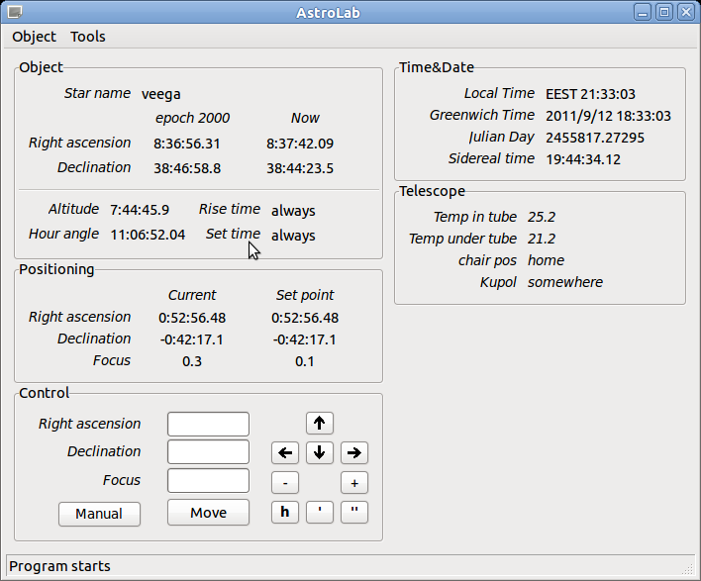Fig 5: Selected object info

- Automate telescope moving

After object selected and if object is “visible” for telescope in PC mode you can start to automate moving by pressing Move button. The aim position will be shown in Positioning panel, you can also track telescope current position by using this panel.

- Manual mode

Astro program supports two main modes: auto and manual.
If manual control is needed, you can catch control by selection Manual mode (Auto/Manual button).
In control panel you can manually move telescope by using keyboard arrows or corresponding buttons.

- Time & Date panel

Time and Date panel shows local time, Greenwich time, Julian date and Sidereal time (GST not LST)

Interface is totally translatable in can be translated into any language.

