

**Jewel catalogue**

Jewel catalogue is designed to use for marketing personnel to showcase the various jewels available with the vendor to customers. The application supports bulk Jewel tag printing, jewel lookups, advance search option in order to hassle less search all category of jewel.

The application has also has an option to create jewel stock manually, all tag, barcode, jewel image are available in this package. Application provides APIs to export data easily to any other system.

User can create catalog and export it to various formats viz. doc, pdf, excel and many others.

Order form has a emailing feature to send booking order directly to jewel vendors.

**Manage Transactions:**

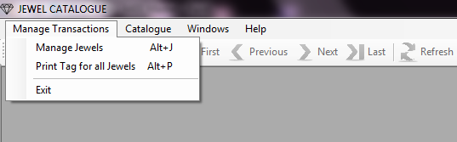

**Manage Jewels:**

This form allows saving alloy jewels information.

* Jewel no is auto generated from database.
* Give appropriate style no, for example for Necklaces use NK01.
* Click upload button to select image for the jewel.
* Enter all the inputs and click on save button.

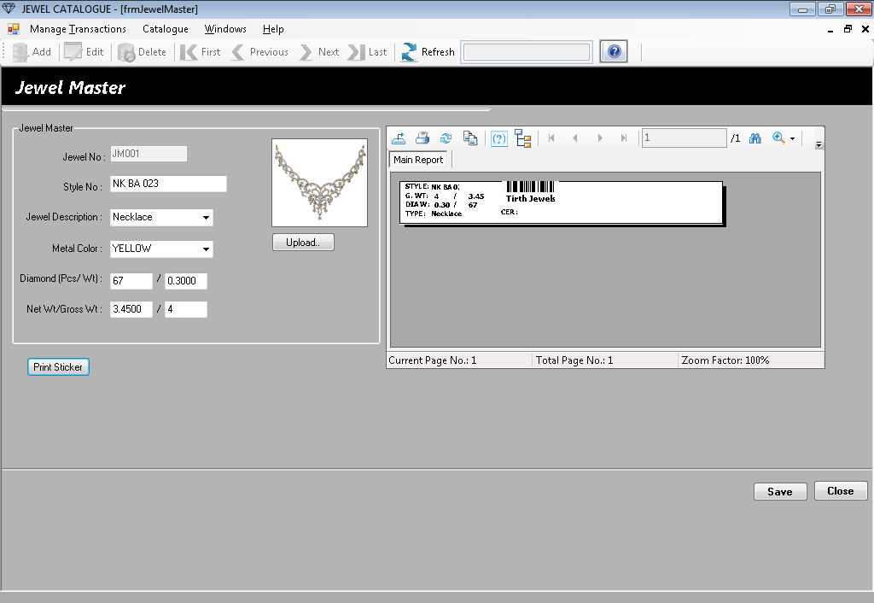

* Click on “Print Sticker” button to print the jewel sticker as shown below.

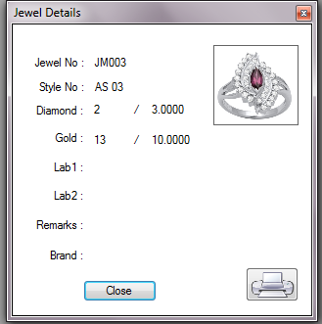

* Use right hand side report, to print the jewel barcode tag,

**Print Tag for All Jewels:**

**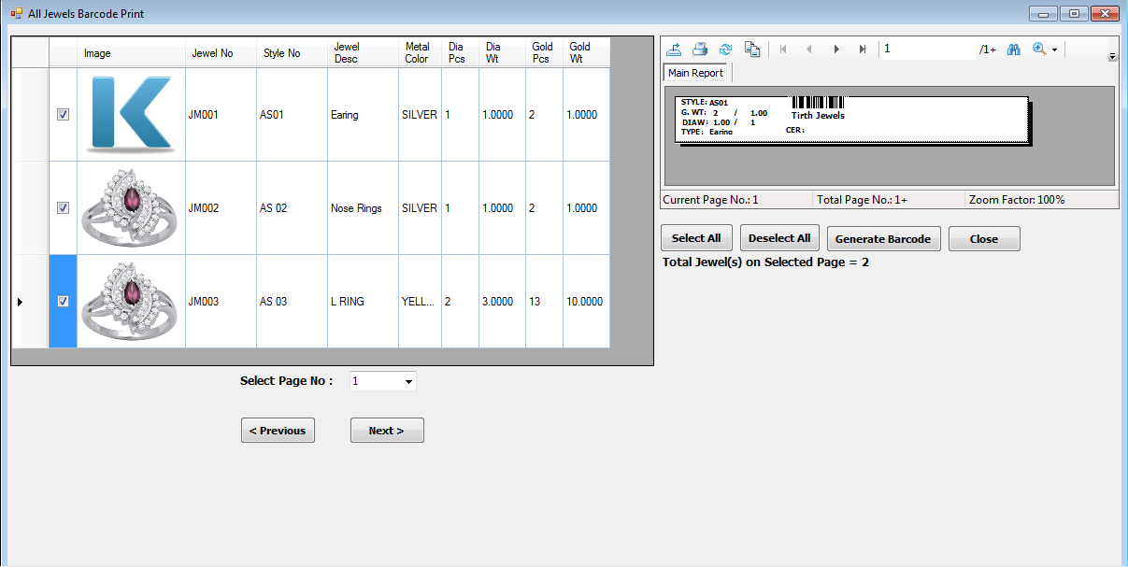**

This form allows us to generate & print barcode for selected jewels.

* Select jewels from the grid using checkboxes, maximum 10 jewels can be selected.
  + Click “Generate Barcode” button to generate barcode for selected jewels.
  + Click print to print the barcode tags.
* If there are more than 10 records that will go to next page, you can use “Select Page No:” to access more records.
* Click “Select All” button to select all the jewels (max. 10) on selected page.
  + Click “Generate Barcode” button to generate barcode.
  + Click on print to print the barcode tags.

**Catalogue:**

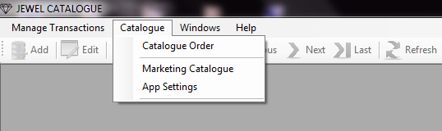

**Catalogue Order:**

This form allows us to generate “Marketing Order” or “Customer Order” or “Catalogue Order” form, all are for the same.

* Enter appropriate **Quotation No** and **Customer Name.**
* If we know the **Jewel No**, we can directly enter and then press **Enter** key. **OR**

Put your cursor on **Jewel No** textbox and scan barcode tag with barcode machine. It will read the barcode having Jewel No and if data is available it will display all the jewel information on the grid.

* Even we can use **Design Code or Style No** to search jewels.
* Once we are done with the search part, we can **Select** and **Unselect** jewels in the grid as per our choice.
* Click on “**Process**” button to generate the order form.

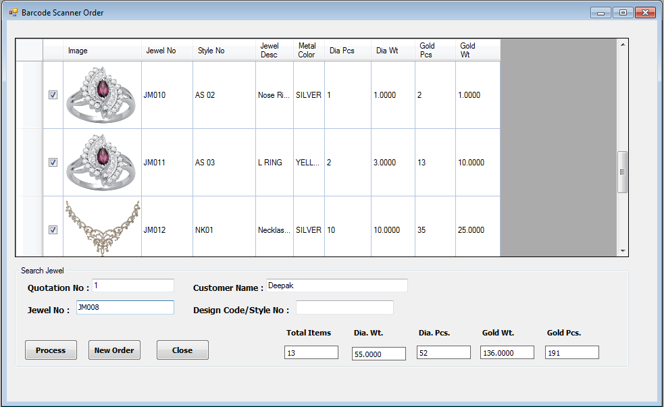

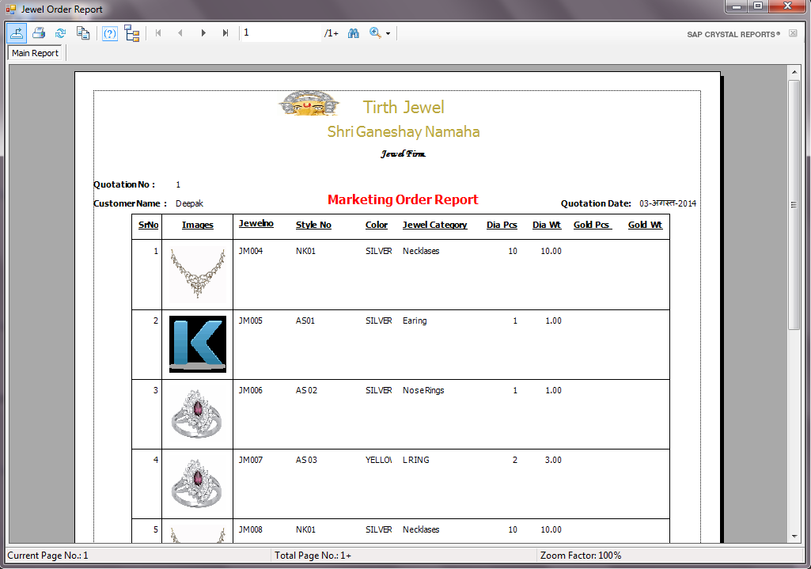

* Below is the order form it generates.

**Marketing Catalogue:**

This form generates the same order form as it generates in the **“Catalogue Order”** menu. But this form has more search criteria with the various options.

* Enter **Quotation No** and **Customer Name**, select **Jewel Description**, and enter **From and To** weight.
* There are various options available for **Diamond Wt** as shown below.

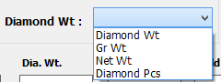

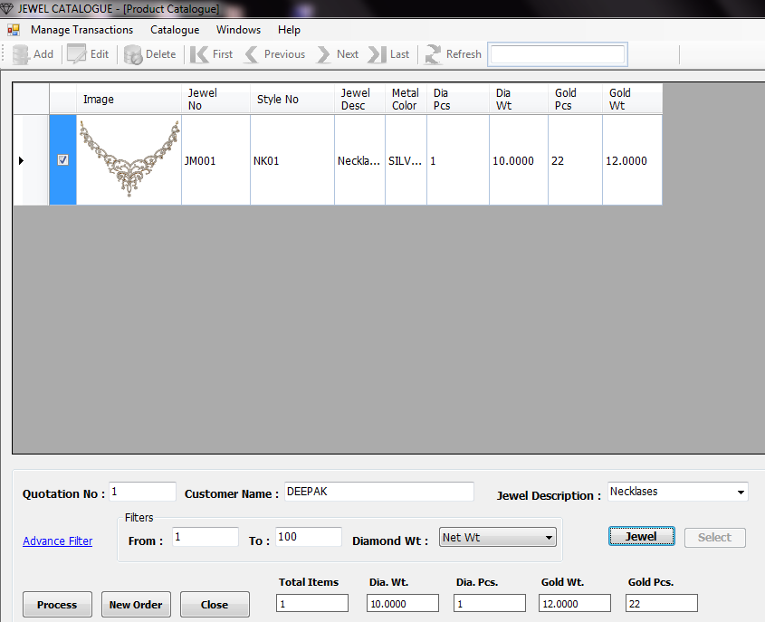

* Click on **“Jewel”** button, it will show below form, with all the **“Necklases”** of **Net Wt** between **1** and **100**.
* Select the jewels on left hand side checkbox. If there are more than **10** records, it will be available in subsequent pages.
* 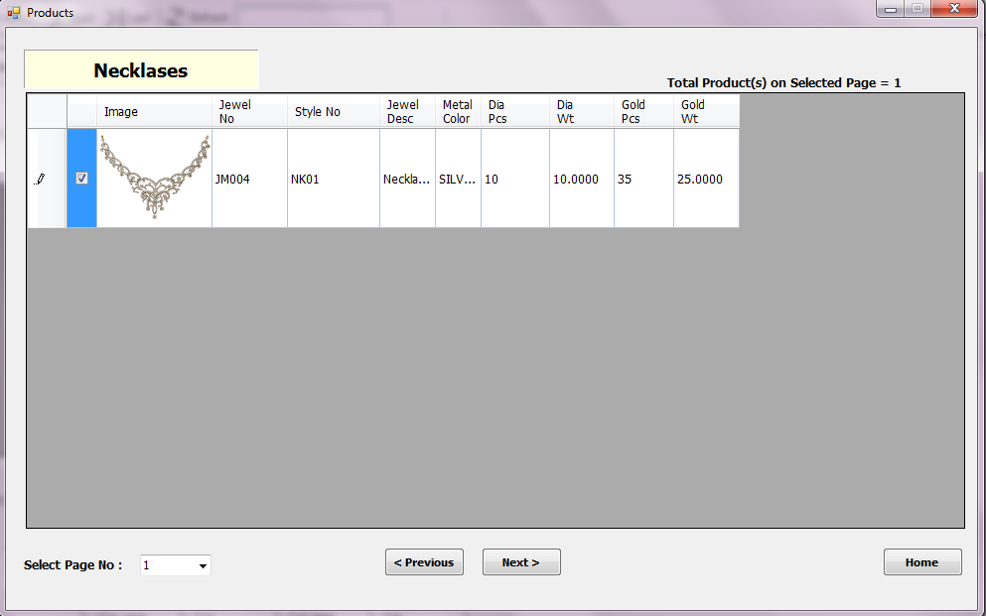After selecting jewels, click on **“Home”** button, it will redirect to main form with selected records.
* Click on **“Process”** button, to generate the order.
* There are **Advanced Filter** options available, for more refined search with various weight combinations.
* Click on “**Ok”** button, then **“Jewel”** button and follow subsequent steps to generate marketing order.

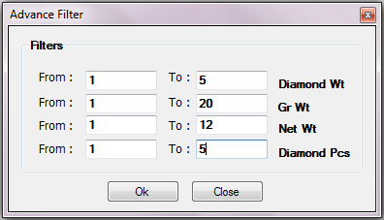

**App Settings:**

* Set **“Image Directory Path”** with the browse  button and click on **“Save”** button.
* Add your all jewel images into this folder.
* Application will retrieve images from this folder.

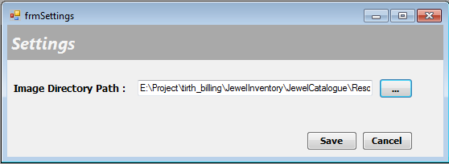

**Windows:**

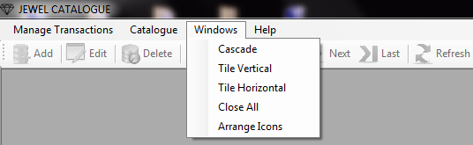

1. Go to Windows C:\ASP_Practice\ASP\ASP\session9\DataAccessI\images\Next.bmp Cascade/Tile Vertical/Tile Horizontal/Close All/Arrange Icons.
2. To arrange the various windows within the application.

**Help:**

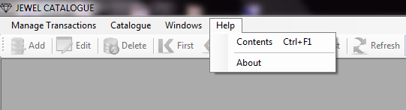

**Content:**

* Go to Help C:\ASP_Practice\ASP\ASP\session9\DataAccessI\images\Next.bmp Contents.
* For detailed help documentation of the application.

**About:**

* Go to Help C:\ASP_Practice\ASP\ASP\session9\DataAccessI\images\Next.bmp About.
* Displays application’s License number.

