

**Jewel Inventory**

Provide solution for Diamond & Jewelry Wholesalers, Retailers and Manufacturers.

It efficiently manages the major area of Jewelry business like Inventory, billing, consignments, marketing and approval transaction, Sales, jewel costing and pricing, loose diamond selling, marketing and accounts.

Although it is specifically designed to manage the standard aspects of any Jewelry & Diamond wholesaler and retailer, it can be customized to the individual demands of your business.

Jewel Inventory is designed to simulate the whole workflow of your business to simplify and streamline everyday tasks so that you get organized and run your business more efficiently.

A simple user friendly interface, BI (Business Intelligence) Reports and MIS statistics makes this tool the most reliable virtual manager of your business.

**Login Form:**

Inventory system has two user roles; Super user is a predefined user and super user will have all the rights to the system. All other user will be considered as non admin users.

This system has privilege to create any number of non super users only.

Non super user is restricted to following access:

* Managing financial year
* Managing configuration
* Master Maintenance
* Firm information settings
* DB backup utility
* User Management settings (Creating and Editing users)

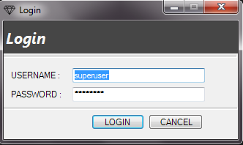

**Main Form:**

This is the master form for whole application. It has certain menus such as Master, Stock Inward, Manage Transaction, Sales, Tools, Reports, Windows, and Help. The all steps to use those menus are as follows:

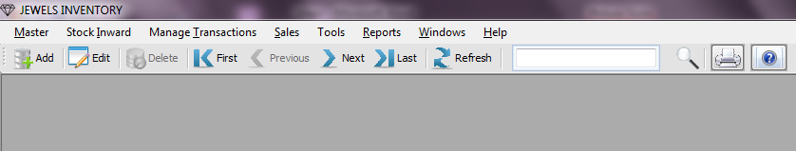

**Master Menu:**

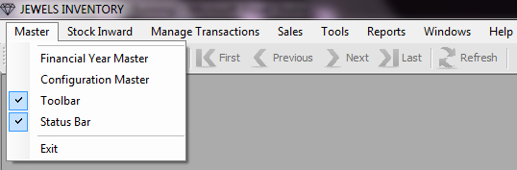

Help configuring financial and configurations masters.

**Financial Year Master:**

* Go to Master Menu C:\ASP_Practice\ASP\ASP\session9\DataAccessI\images\Next.bmp Financial Year Master

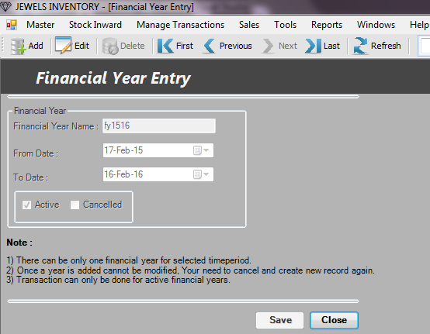

* Enter meaningful name for **Financial Year** name box. E.g. FY1415, FY1516.
* Select **from date and to date** for the financial year. Make sure your financial year is not conflicting with any other financial year.
* There should be only one active financial year at a moment. At yearend activity, current year financial year is supposed to be deactivated and new financial year should be created.

(Use active checkbox on the screen for activation and deactivation)

* Financial year cancellation option is provided to enable correction. Consider you created a financial year by selecting invalid date or name, so now if you wish to make correction, you should cancel the invalid financial year and create new financial year.
* Once a financial year is created, it will not show in system.

(Note, any transaction which is done for any cancelled financial year will not be shown in report, also it will not be searchable in system.)

**Configuration Master:**

* Go to Master Menu C:\ASP_Practice\ASP\ASP\session9\DataAccessI\images\Next.bmpConfiguration Master.

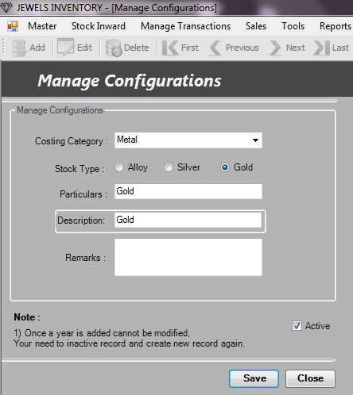

* All category for gold, diamond, silver and alloy can be viewed in this screen
* This configuration will be configured by vendor and starting setup and then it can be used at the time of transaction.
* A new category can be added in this screen, existing category can only be deactivated, please use Active checkbox for activation and deactivation.

**Stock Inward Menu:**

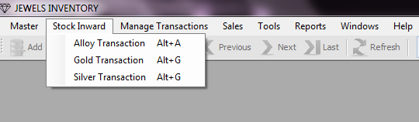

Stock inward is use to make purchase transactions. There are three categories for making purchases. Viz. Alloy, Gold and Silver.

**Purchase Transaction:**

* Go to Stock Inward C:\ASP_Practice\ASP\ASP\session9\DataAccessI\images\Next.bmp Alloy/ Gold/ Silver Transaction

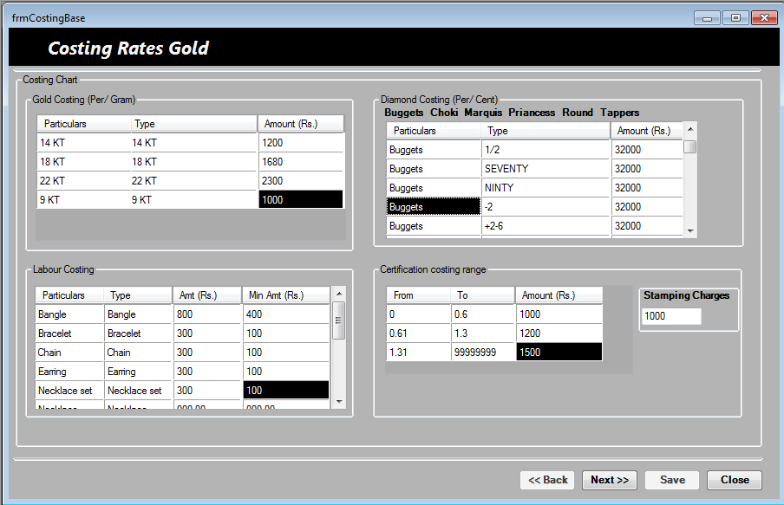

In any purchase transaction it is require provide costing details first, costing detail capture purchase amount for individual category of item. There are 5 purchase categories are defined in system

* **Metal Items:** All gold/ silver and alloy items, amount needs to be entered for per gram.
* **Stone Items:** All diamond/ color stone and cubic zircon items to be entered for per cent.
* **Labor charges:** labor amounts are captured for different jewel products, the charges is based on the gross weight of the jewels. User can also define minimum charges for individual jewel category
* **Certification charges:** Certification charges are applicable on stone products, similar to labor charges certification charges are define based on stone weight,

Here charges are applied for different range of weight, system has option to input user define ranges up to three different weight ranges.

* **Stamping charges:** stampingcharges are applied on stone products.

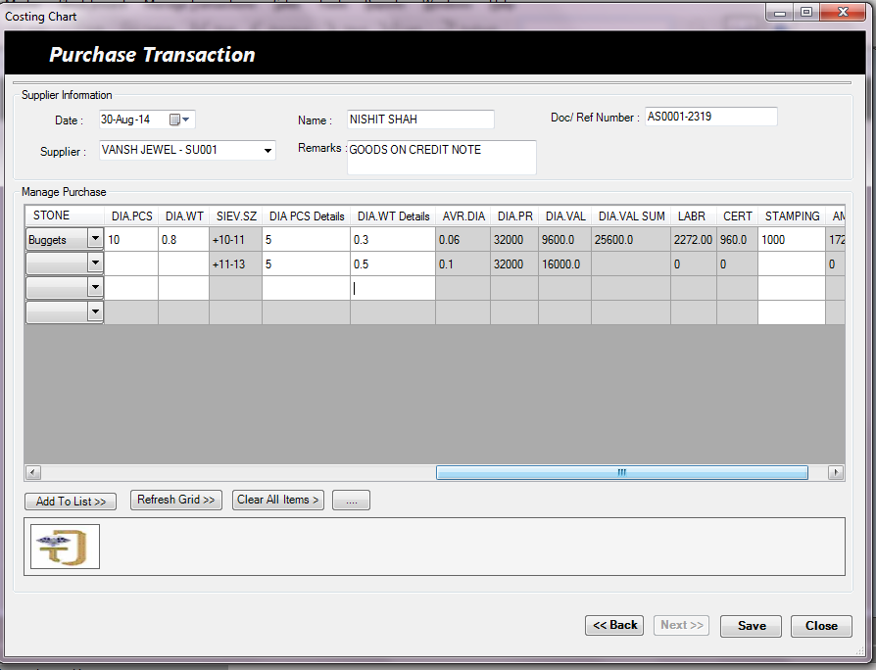

After setting the costing details we can make purchase entry for all jewel items, enter supplier information on top section, i.e. select supplier, contact name, remarks etc.

Please ensure you have all necessary jewel information with you while making purchase entry following information.

**Certificate Number (CERT):** Enter certificate Number

**Production Name (PRODUCT NAME):** Enter product name such as Ring, Bangle, Earring, Bracelet, Chain etc

**Design Number (DESIGN NO):** Enter design number.

**Metal Type (METAL TYPE):** Metal Gold KT, Silver/Alloy type

**Metal Color (METAL COLOR):** Metal color

**Gross Weight (GR. WT):** Enter gross (total) weight of jewel

**Color Stone Type (CSSTONE TYPE):** Select color stone type

**Color Stone Pcs (COL. PCS):** Enter color stone Pcs

**Color Stone Weight (COL. WT):** Enter color stone weight

**Diamond Type (STONE TYPE):** Select Diamond type

**Diamond Pcs. (DIA.PCS):** Enter diamond pcs

**Diamond Weight (DIA.WT):** Enter diamond weight

**Sieve Size (SIEV.SZ):** Enter sieve size

**Stamping (STAMPING):** Stamping charges

Add to List button will add item one by one to the purchase item list. User can remove any item from purchase list by right click on item “Remove Item” menu. Once an item is added to list user have chance to see all item details as shown below.

\*\*\*\*\*\*\*\*\*\*\*\*\*\*\*\*\* Item Detail Image here \*\*\*\*\*\*\*\*\*\*\*\*\*\*\*\*\*\*\*\*

Ensure total diamond weight, prices is matching with individual diamond details prices and total amount is calculated. This form will automatically calculate the total amount based on all input from costing chart and input provided in above screen.

\*\*\*\*\*\*\*\*\*\*\*\*\*\*\*\*\*\* Items Saved Successfully \*\*\*\*\*\*\*\*\*\*\*\*\*\*\*\*

Once the purchase is done user can print tag / print sticker / see costing sheet etc on confirmation page.

\*\*\*\*\*\*\*\*\*\* Image for Tag / sticker/ costing sheet

**Manage Transactions:**

**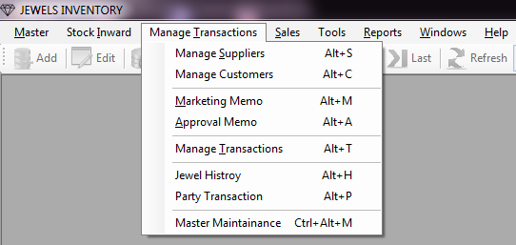**

This menu has option for managing day to day transaction like sending jewels on marketing/ approval basis and taking their return in stock. It also provides all jewel and transaction against the customer or supplier. Master maintenance provides facility to update jewel information.

**Manage Suppliers:**

* Go to Manage Transactions C:\ASP_Practice\ASP\ASP\session9\DataAccessI\images\Next.bmp Manage Suppliers.

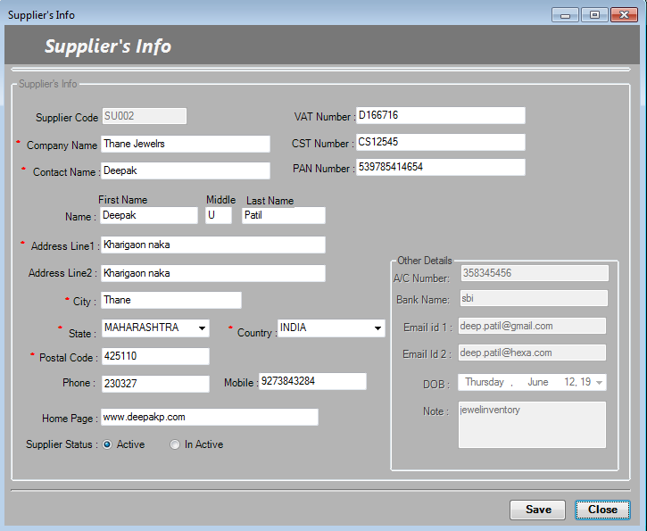

* Enter supplier’s details on respective fields.
* All “\*” marks fields are fields are mandatory.
* Inactive suppliers are not available for doing transactions

**Manage Customers:**

1. Go to Manage Transactions C:\ASP_Practice\ASP\ASP\session9\DataAccessI\images\Next.bmp Manage Customers.

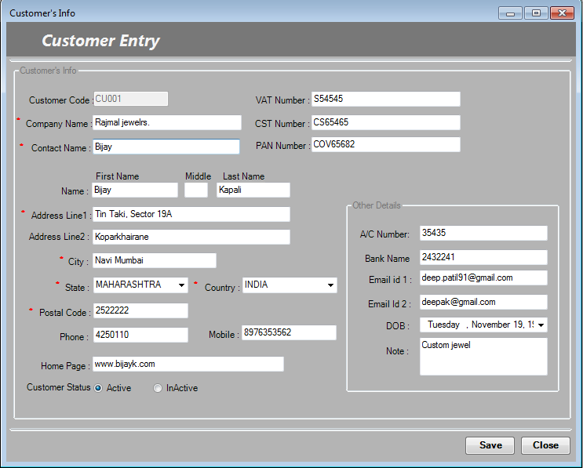

* Enter customer’s details on respective fields.
* All “\*” marks fields are fields are mandatory.
* Inactive customers are not available for doing transactions.

**Marketing/ Approval Memo:**

* Go to Manage Transactions C:\ASP_Practice\ASP\ASP\session9\DataAccessI\images\Next.bmp Marketing Memo.

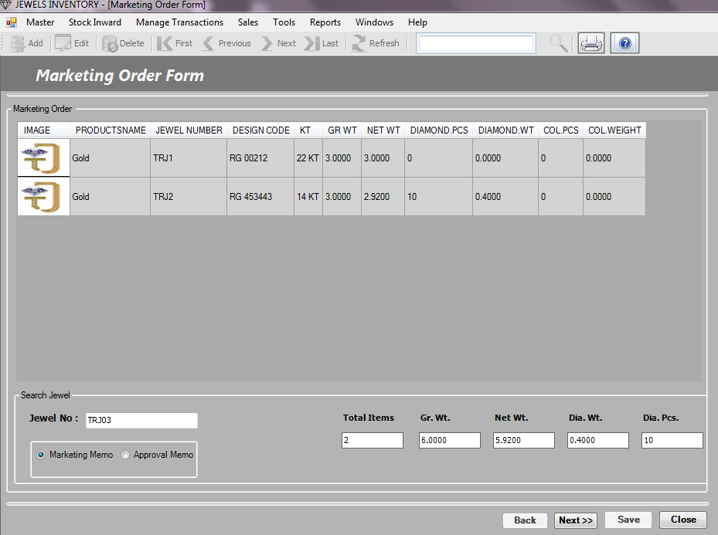

* In Jewel No. block simply trigger the **barcode scanner gun** it fill the **jewel no** in that block or you can **manually enter** the jewel no if remember and **press enter**.
* And you get the whole details of marketing order on the marketing order table and also get the Total items, grass wt, net wt etc.
* And click to **next** button. After that you want to back use **back** button
* Now you get the costing chart for that supplier now you can enter the customer name, contact person name doc/ref no.
* You can change the supplier’s amount with your new decided amount with certificate and stamping charges.
* And click save button to **save** that memo.
* You can take a print of that memo using print option provided in toolbox.

**Approval Memo:**

1. Go to Manage Transactions C:\ASP_Practice\ASP\ASP\session9\DataAccessI\images\Next.bmp ApprovalMemo.
2. In Jewel No. block simply trigger the **barcode scanner gun** it fill the **jewel no** in that block or you can **manually enter** the jewel no if remember and **press enter**.
3. And you get the whole details of marketing order on the marketing order table and also get the Total items, grass wt, net wt etc.
4. And click to **next** button. After that you want to back use **back** button
5. Now you get the costing chart for that supplier now you can enter the customer name, contact person name doc/ref no.
6. You can change the supplier’s amount with your new decided amount with certificate and stamping charges.
7. And click save button to **save** that memo.
8. You can take a print of that memo using print option provided in toolbox.

**Manage Transaction:**

1. Go to Manage Transactions C:\ASP_Practice\ASP\ASP\session9\DataAccessI\images\Next.bmp Manage Transaction.

**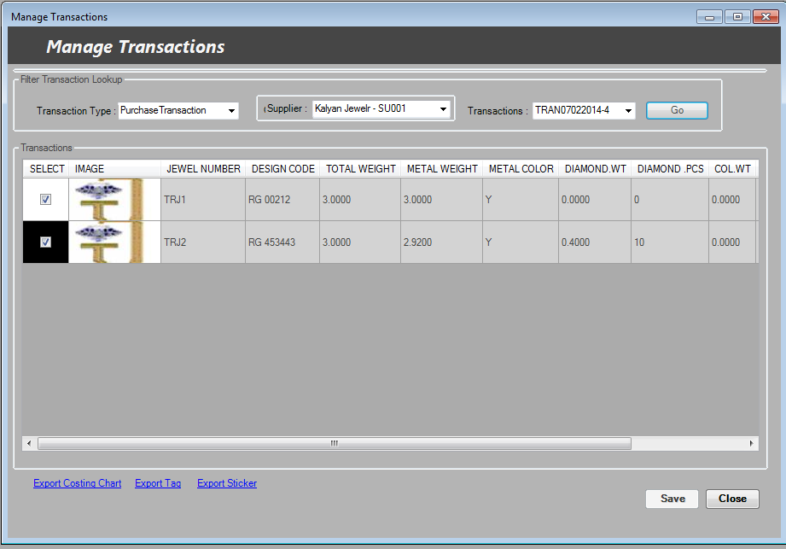**

1. It has a filter with **Transaction Type** drop down select particular type you want.
2. Then select **customer** and then you get all transactions with that customer with some transaction no. in Transaction column and click **Go**.

**Jewel History:**

1. Go to Manage Transactions C:\ASP_Practice\ASP\ASP\session9\DataAccessI\images\Next.bmp Jewel History.

**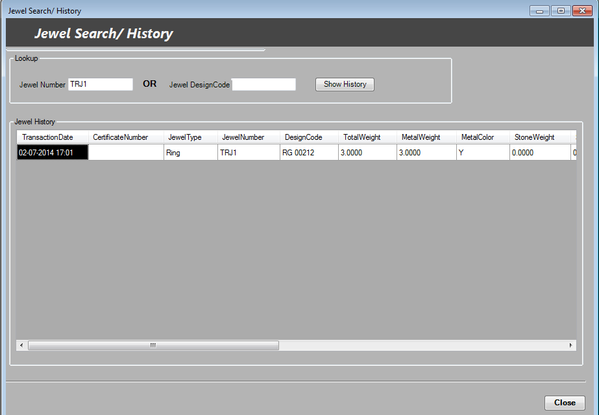**

1. Enter the **jewel no** or **Jewel Design code** and click show button you get the transaction history of that jewel.
2. And press **close** button.

**Party Transaction:**

1. Go to Manage Transactions C:\ASP_Practice\ASP\ASP\session9\DataAccessI\images\Next.bmp Party Transaction.

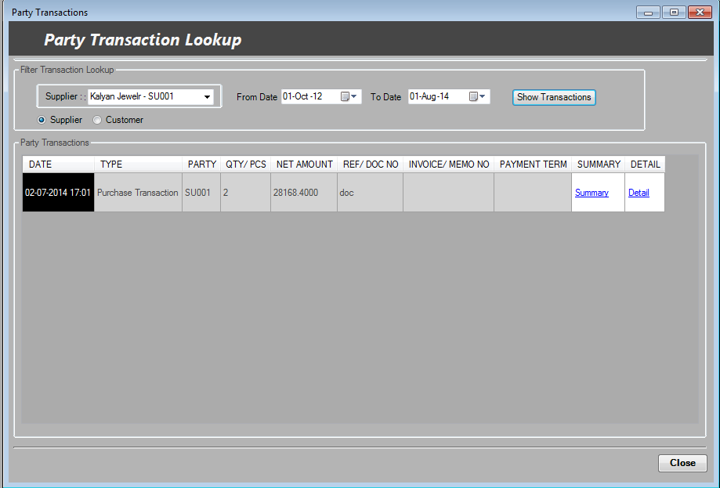

1. It opens lookup form; here we can make a **filter** for particular supplier or customer with specified **time**.
2. Then you click on **show transactions** button it gives you **all** transaction of that supplier or customer for specifying time span.
3. You can also get the summary and details of that transaction by clicking **summary** and **details** links.
4. And finally **close** the form.

**Sales:**

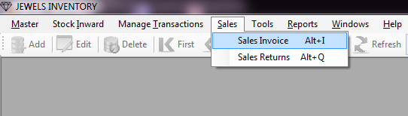

**Sales Invoice:**

1. Go to Sales C:\ASP_Practice\ASP\ASP\session9\DataAccessI\images\Next.bmp Sales Invoice.
2. Then fill the sales information choose the **customer**, **memo no**. and **payment** **term** and click Go.
3. Sales orders are visible on the table and also total jewel are appear at the bottom, you can **generate invoices** or send **email** to that customer.
4. Also you can set net amount, VAT and other charges etc. and click **save** button.

**Tools:**

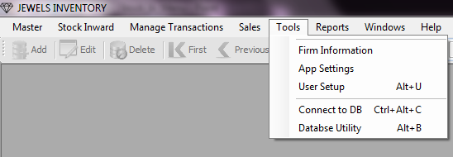

**Firm Information:**

1. Go to Tools C:\ASP_Practice\ASP\ASP\session9\DataAccessI\images\Next.bmp Firm Information.

**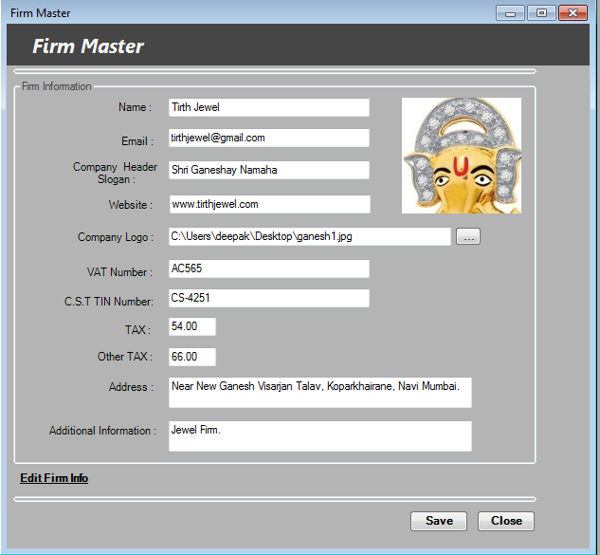**

1. Fill the appropriate blocks with valid values. For company logo click on the side button of that block and browse the image.
2. And save that form.
3. If you want to edit the previous firm record then click to edit firm info link at the bottom and make changes and save it again.

**App Settings:**

1. Go to Tools C:\ASP_Practice\ASP\ASP\session9\DataAccessI\images\Next.bmp App settings.

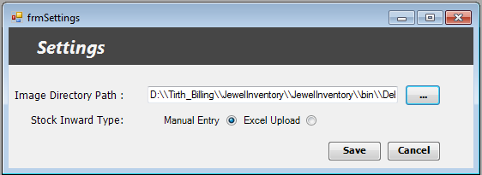

1. Browse the valid **image directory path**.
2. You have addition option **Stock Inward Type**. Using this user can input entries in two ways as follows:

**Manual Entry:** This is a simple manual input entry through the application.

**Excel Upload:** This is input through excel file by uploading it to the application. Using excel upload can be mostly error porn; this option is to be used carefully.

1. And click save button.

**User Setup:**

If you want to add the user rather than system generated Super user then you use following steps to create simple user:

1. Go to Tools C:\ASP_Practice\ASP\ASP\session9\DataAccessI\images\Next.bmp User Setup.

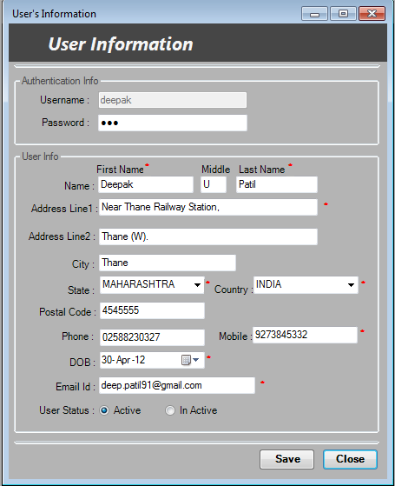

1. Click on **Add** option in the toolbox to add new user.
2. Set the user name and password for the user. All mandatory blocks mark with \* are must have to fill.
3. And finally set the user status to Active if you want to use that user.
4. And click **save** button.
5. If you want to edit the previously create user record then click to **Edit** option on the toolbox and make changes and save it again.

**Reports:**

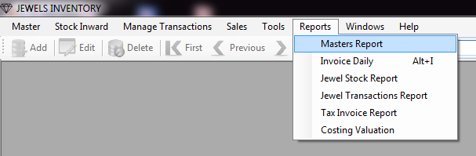

**Master Report:**

1. Go to Reports C:\ASP_Practice\ASP\ASP\session9\DataAccessI\images\Next.bmp Master Report.

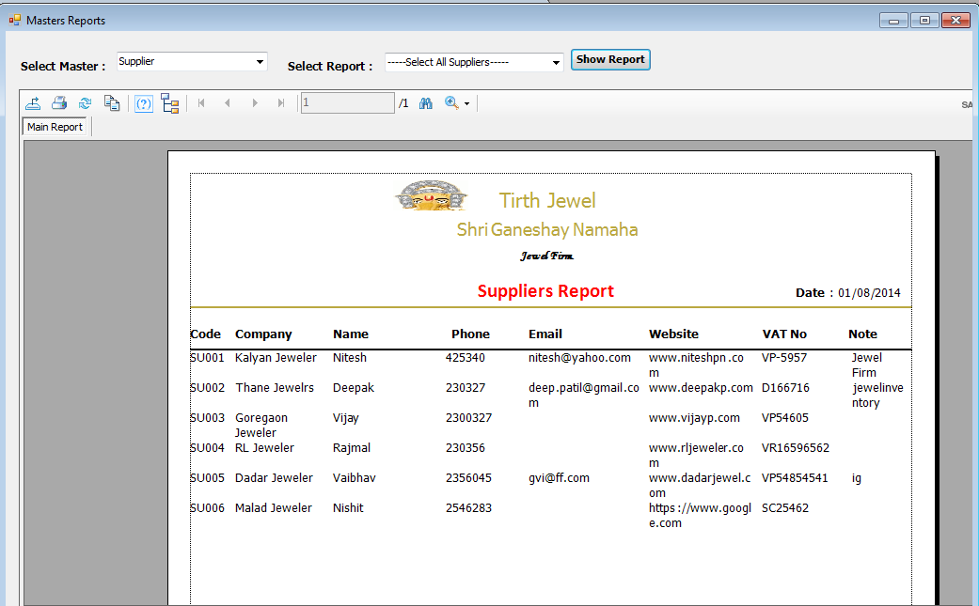

1. Select any one **Master** that you want to generate report like configuration, customer, supplier, and user.
2. Next **Select Report** for any one or all configuration, customer, supplier or user.
3. And click on **Show Report** button.

**Jewel Stock Report:**

1. Go to Reports C:\ASP_Practice\ASP\ASP\session9\DataAccessI\images\Next.bmp Jewel Stock Report.

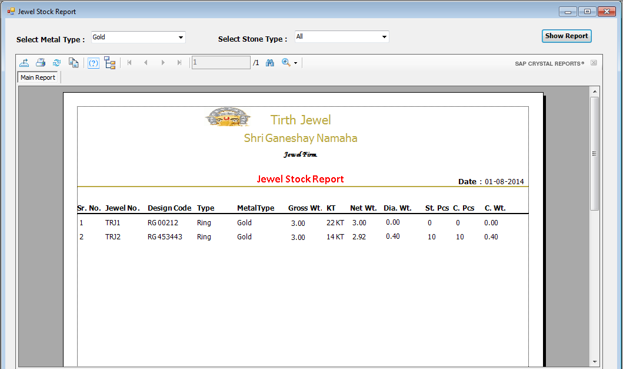

1. Select any one **Metal type** that you want to generate report like Alloy, Silver or Gold.
2. Next select any one or all **Jewel Type** to generate report.
3. And click on **Show Report** button.

**Jewel Transaction Report:**

1. Go to Reports C:\ASP_Practice\ASP\ASP\session9\DataAccessI\images\Next.bmp Jewel Transaction Report.

**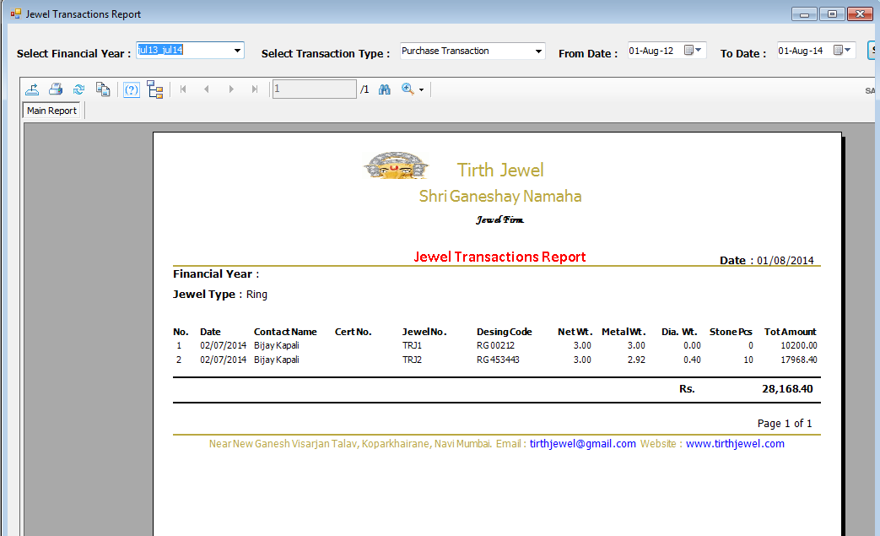**

1. Select any one **Financial Year** for that you want to generate report.
2. Next select any one **Transaction Type** like Purchase, Approval or Marketing Transaction.
3. Select **From Date** and **To Date** for that span you want to get Transaction Report.
4. And click on **Show Report** button.

**Tax Invoice Report:**

1. Go to Reports C:\ASP_Practice\ASP\ASP\session9\DataAccessI\images\Next.bmp Tax Invoice Report.
2. Select any one **Financial Year** for that you want to generate report.
3. Next select any one **Transaction Type** like Purchase, Approval or Marketing Transaction etc.
4. Enter the **Invoice No.** in specified block and choose either **Detail** or **Summary** option for report
5. And click on **Show Report** button.

**Windows:**

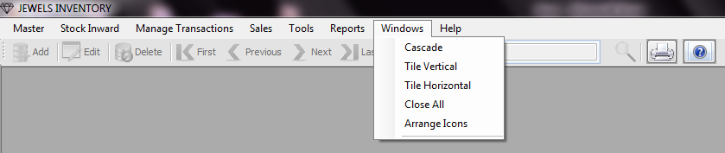

1. Go to Windows C:\ASP_Practice\ASP\ASP\session9\DataAccessI\images\Next.bmp Cascade/Tile Vertical/Tile Horizontal/Close All/Arrange Icons.
2. This use for only viewing your application windows in different styles to make it more users friendly.

**Help:**

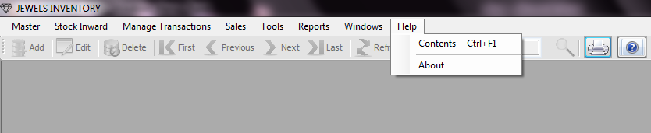

**Content:**

1. Go to Help C:\ASP_Practice\ASP\ASP\session9\DataAccessI\images\Next.bmp Contents.
2. It gives you brief documentation of your application for your convenience.

**About:**

1. Go to Help C:\ASP_Practice\ASP\ASP\session9\DataAccessI\images\Next.bmp About.
2. On clicking this you get the information about our company like website, Email ID etc.

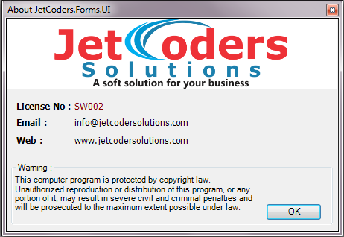

***\*\*\*\*\*\*\*\*\*\*\*\*\*\*End of the Document\*\*\*\*\*\*\*\*\*\*\*\*\****