

***Jewel Catalogue***

**Tools and Technologies Used:**

* Windows Forms, Visual Studio 2010, Crystal Report 2008 VER 13.0, SQL Server 2008 R2 Developer Edition.
* C#.net 4.0, TDD, Microsoft Unity, Domain Driven Architecture, LINQ, Entity Framework 4.0.

**Splash Screen:**

This is only a start up view of the project.

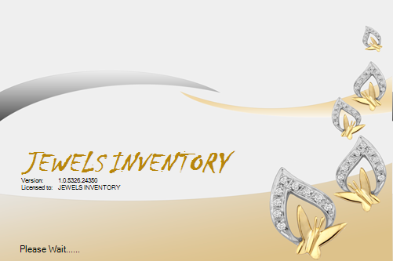

**MDI Mater Form:**

This is the master form for whole application. It has certain menus such as Manage Transactions, Catalogue, Windows and Help. Whole description of those menus is as follows:

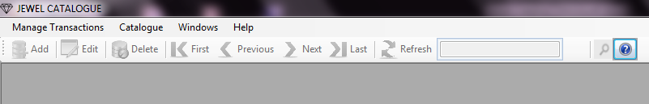

**Manage Transactions:**

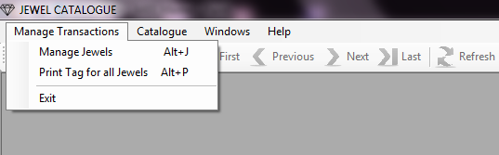

**Manage Jewels:**

This is the form in which you can save number of jewels that you want. Here **Jewel No** is auto generated. But you have to enter the **Style No** which is meaningful like for Necklaces it is NK01.

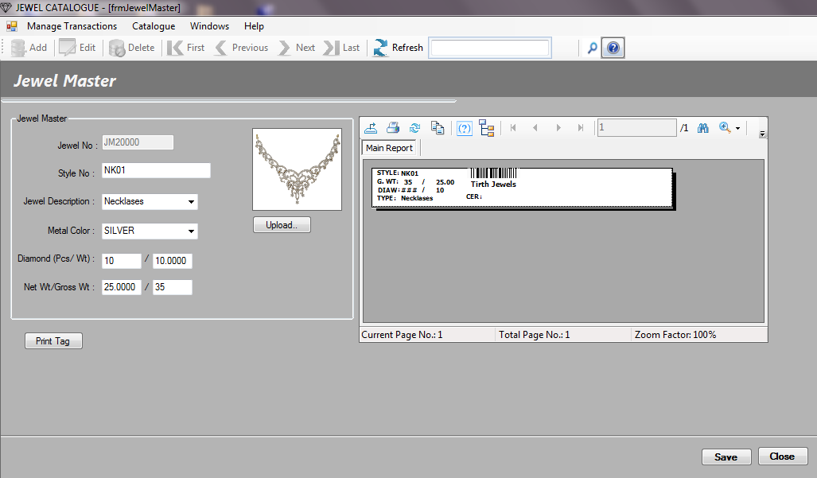

Then, next option is for selecting the jewel description which can be Ring, Necklace, Earring, Bangles etc. Another option is for selecting Metal color which may be silver or yellow. You should have to mention the no of diamond pieces and diamond weight. Then finally, enter net wt ultimately you got gross wt. When you save the content you get the Barcode for that jewel entry. When you want to print tag for that jewel you can click **Print Tag** button.

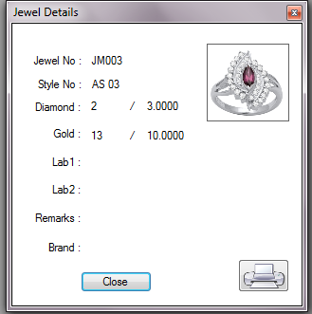

**Print Tag for All Jewels:**

**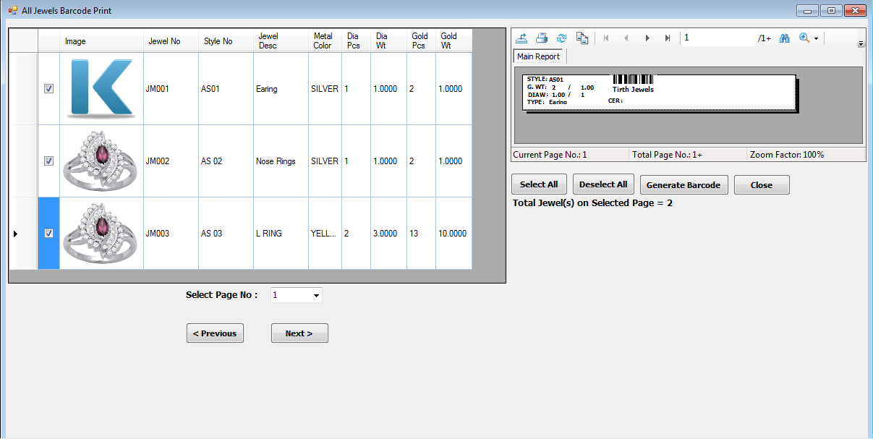**

This is the form for generate the barcode tags for selected jewels. First of all you have to **Select Page No** when there are records more than 10. Then if you want to select all records then click on **Select All** button and to generate tags click on **Generate Barcode** button.

**Catalogue:**

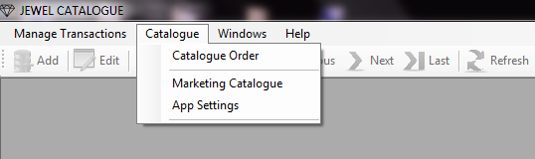

**Catalogue Order:**

This is the form for making a quotation for the customer’s order of jewel. In this you can assign some **Quotation No** for that quotation then enter the **Customer Name** for which you make that quotation. And then enter the appropriate **Jewel No** and press **Enter.** You get the particular jewel with whole description that you entered in Jewel Master form.

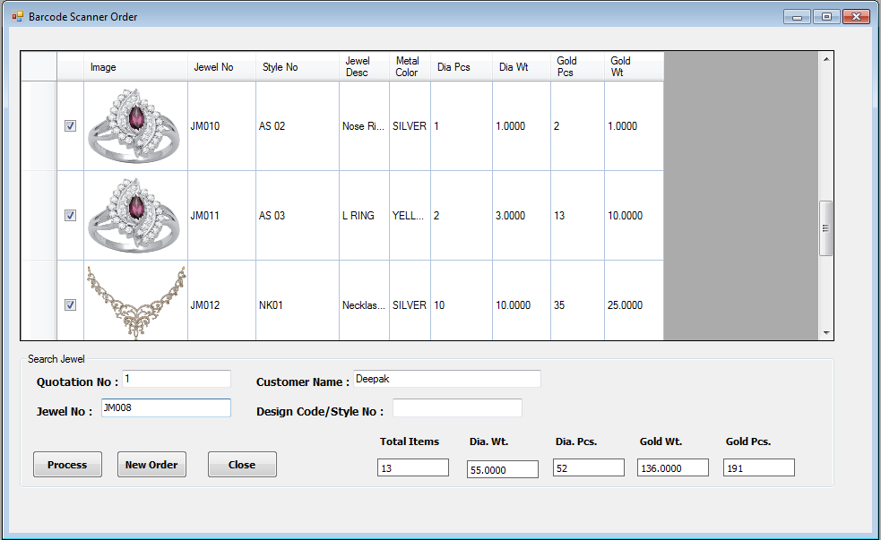

Next you select the no of jewels by clicking check boxes and click on **Process** button to generate report as follows:

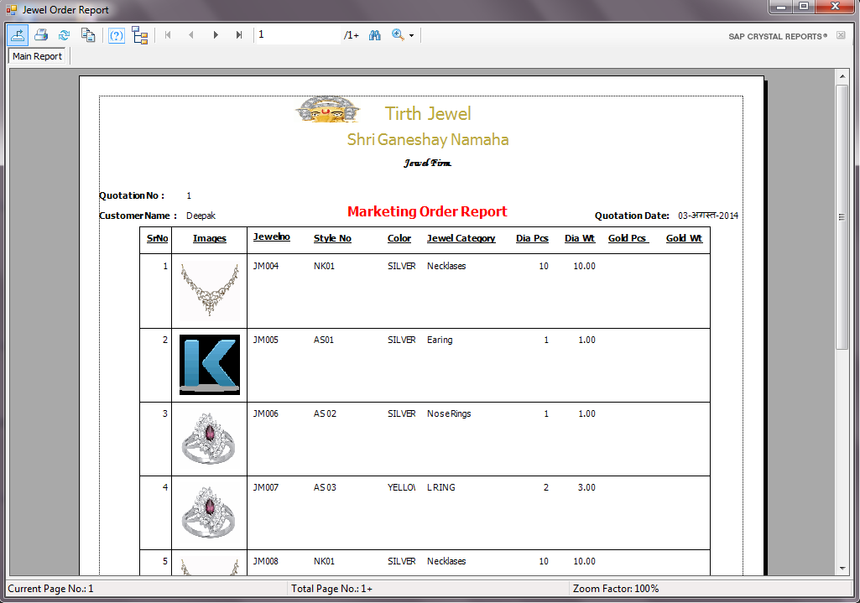

**Marketing Catalogue:**

In this form you select the jewels as per customer’s requirements and criteria. Means customer wants necklace which ranges from 1 to 20 grams its net weight then you feed this values in this form to get the jewels in this range and

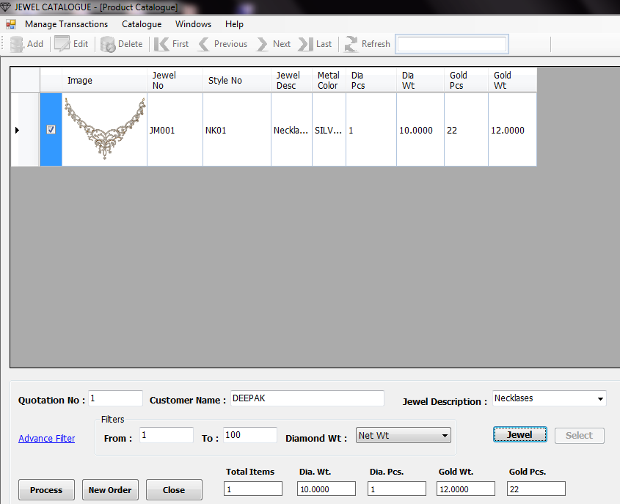

Then click on Jewel button you get the following form. Select the jewels as per customers choice and then click on **Home** button that selected jewels are automatically appears on the marketing order form and finally click on **Process** button to generate marketing report for that customer and then take print when you want.

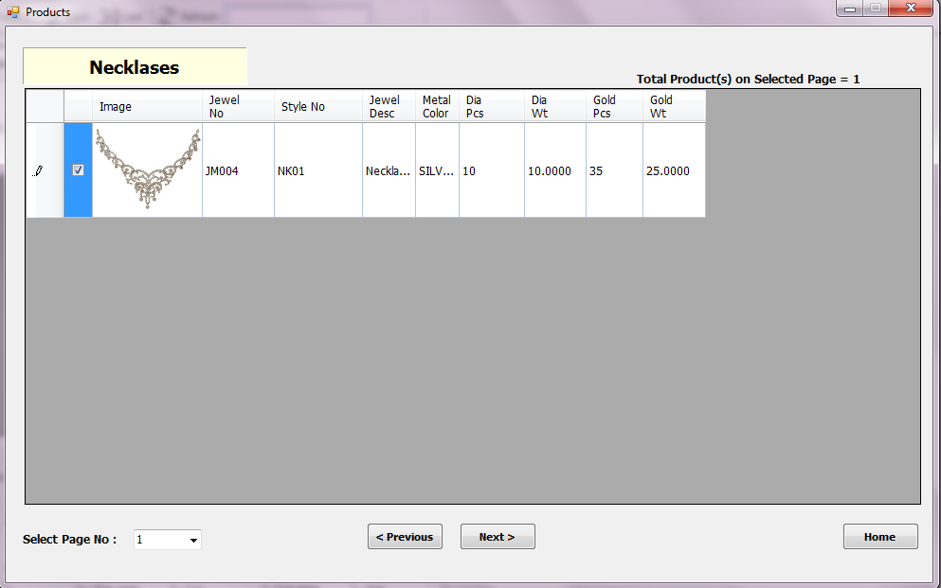

It have some advanced option for filtering the jewels as per customers order so for that you have to click on **Advanced Filter** link then you get following form fill it and click on **Ok** button you get list of jewels as per this filter ranges.

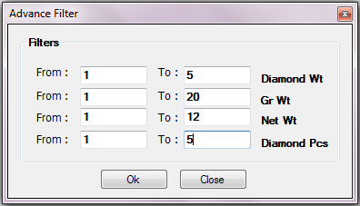

**App Settings:**

This form has an option for browsing and selecting the image directory. This image directory must have all jewels images to be access from application that’s it.

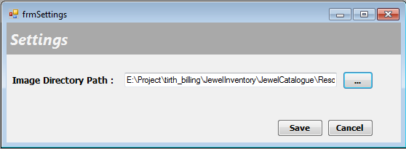

**Windows:**

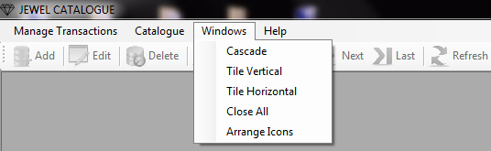

1. Go to Windows C:\ASP_Practice\ASP\ASP\session9\DataAccessI\images\Next.bmp Cascade/Tile Vertical/Tile Horizontal/Close All/Arrange Icons.
2. This use for only viewing your application windows in different styles to make it more users friendly.

**Help:**

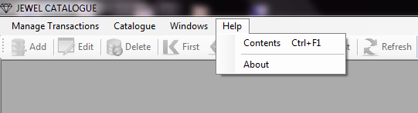

**Content:**

1. Go to Help C:\ASP_Practice\ASP\ASP\session9\DataAccessI\images\Next.bmp Contents.
2. It gives you brief documentation of your application for your convenience.

**About:**

1. Go to Help C:\ASP_Practice\ASP\ASP\session9\DataAccessI\images\Next.bmp About.
2. On clicking this you get the information about our company like website, Email ID etc.

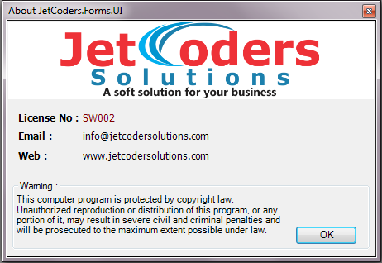

***\*\*\*\*\*\*\*\*\*\*\*\*\*\*End of the Document\*\*\*\*\*\*\*\*\*\*\*\*\****