

***Jewel Inventory System***

**Tools and Technologies Used:**

* Windows Forms, Visual Studio 2010, Crystal Report 2008 VER 13.0, SQL Server 2008 R2 Developer Edition.
* C#.net 4.0, TDD, Microsoft Unity, Domain Driven Architecture, LINQ, Entity Framework 4.0.

**Splash Screen:**

This is only a start up view of the project.

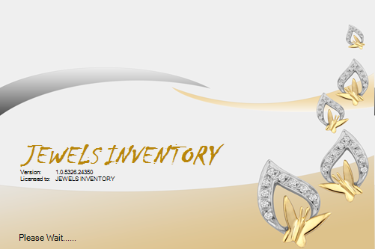

**Login Form:**

Superuser is a system created user and Superuser will have all the rights to the system. All other users will be non admin users.

Non super user is restricted from following access:

* Firm information settings
* DB backup utility
* UserManagement settings (Creating and Editing users)

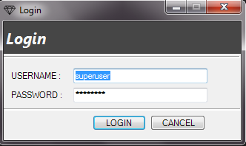

When we run the application the first window is a login form which has already system user known as Superuser. This is for authentication purpose. Then the master form is open firstly it ask for setting the financial year. (Next time we use only FY for Financial Year)

**MDI Mater Form:**

This is the master form for whole application. It has certain menus such as Master, Stock Inward, Manage Transaction, Sales, Tools, Reports, Windows, and Help. The all steps to use those menus are as follows:

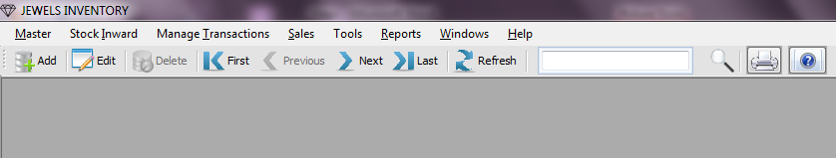

**Mater Menu:**

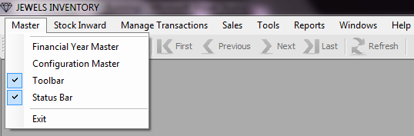

**Financial Year Master:**

1. Go to Master Menu C:\ASP_Practice\ASP\ASP\session9\DataAccessI\images\Next.bmp Financial Year Master C:\ASP_Practice\ASP\ASP\session9\DataAccessI\images\Next.bmp Financial Year Entry.

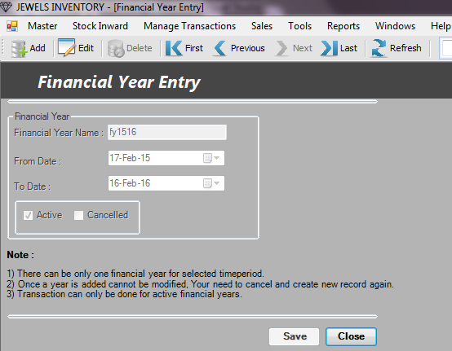

1. Enter the meaningful name for **Financial Year** name box. Eg: FY1314.
2. Then select the **From Date** from which you want to start the FY. In next block, it automatically set with one year span. Eg: Suppose you set FY to 10 Jan 2013 then in next block it is 09 Jan 2014.
3. If you want to use that FY then set it to active mode. In case you enter wrong FY and saved it then doesn’t worry go to that FY and select Edit option in the Master menu’s toolbox and make it **Cancelled** and save it.

**Configuration Master:**

1. Go to Master Menu C:\ASP_Practice\ASP\ASP\session9\DataAccessI\images\Next.bmpConfiguration Master.

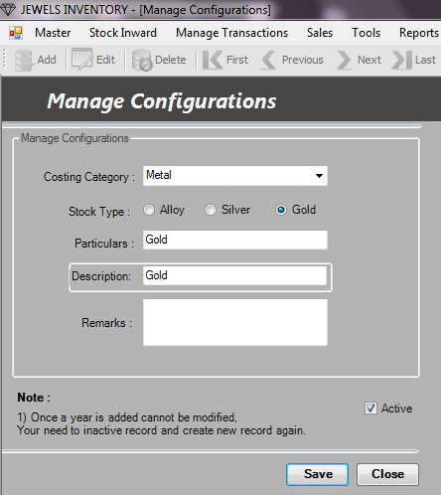

1. If you want to set the configuration for your stock then you can select the **Costing Category** for your configuration like metal, stone, Labor etc.
2. Then choose the **stock type** on which you want to manage configuration eg: Gold, Alloy or silver.
3. And select the **Active** option to use that configuration.
4. And choose **Save** button to save it.

**Stock Inward Menu:**

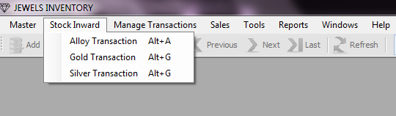

**Alloy Transaction:**

1. Go to Stock Inward C:\ASP_Practice\ASP\ASP\session9\DataAccessI\images\Next.bmp Alloy Transaction

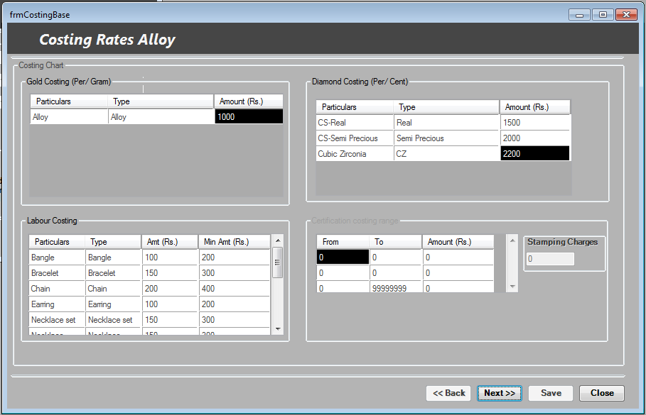

1. Here fill the supplier information from which you purchase your stock, fill date of that purchase, and then select the supplier from drop down list. Then give the suppliers name, doc/ref number and remark.
2. The Costing Rates form will open. In this the first part is to fill supplier information.
3. Here the supplier from which you purchase your stock, fill date of that purchase, then select the supplier from drop down list. Then give the suppliers name, doc/ref number and remark.
4. Then second is a costing chart, in this first table is for alloy per gram costing means at what amount you purchase that Alloy per gram.
5. Then fill the diamond costing table it means at what amount you purchase that Diamond per cent.
6. Next table is for labor costing

**Manage Transactions:**

**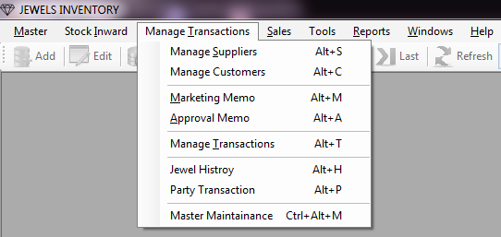**

**Manage Suppliers:**

1. Go to Manage Transactions C:\ASP_Practice\ASP\ASP\session9\DataAccessI\images\Next.bmp Manage Suppliers.

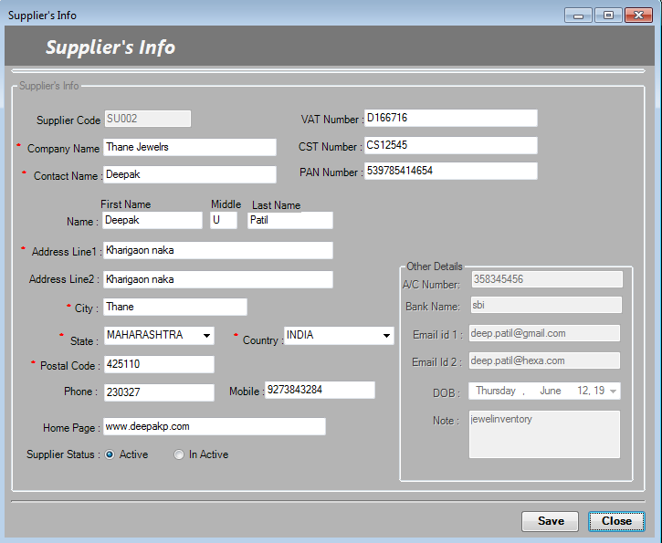

1. Add whole details in the appropriate blocks.
2. There are several block that are mandatory that are highlighted with ’\*’, that you must have to fill.
3. Then at the bottom of the form there is **supplier status** check box button with Active and Inactive mode choose **Active** for use that supplier otherwise make it **Inactive**.
4. And click to **save** button to save that supplier.

**Manage Customers:**

1. Go to Manage Transactions C:\ASP_Practice\ASP\ASP\session9\DataAccessI\images\Next.bmp Manage Customers.

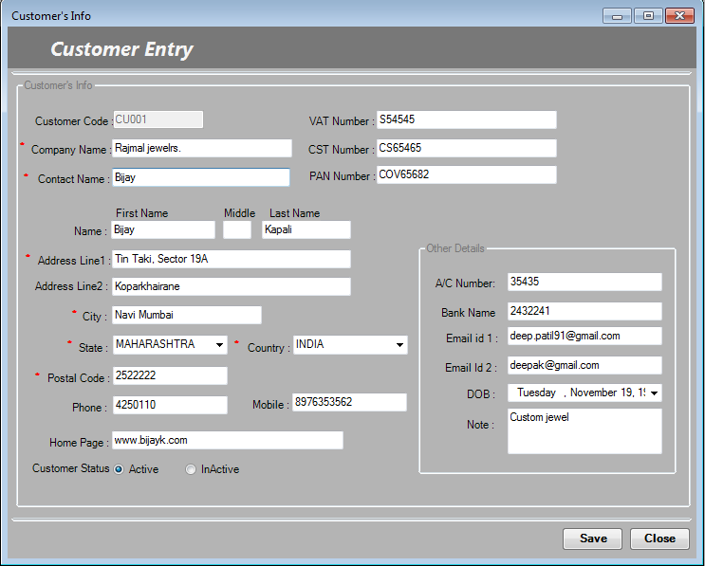

1. Add whole details in the appropriate blocks.
2. There are several block that are mandatory that are highlighted with ’\*’, that you must have to fill.
3. Then at the bottom of the form there is **customer status** check box button with Active and Inactive mode choose **Active** for use that customer otherwise make it **Inactive**.
4. And click to **save** button to save that customer.

**Marketing Memo:**

1. Go to Manage Transactions C:\ASP_Practice\ASP\ASP\session9\DataAccessI\images\Next.bmp Marketing Memo.

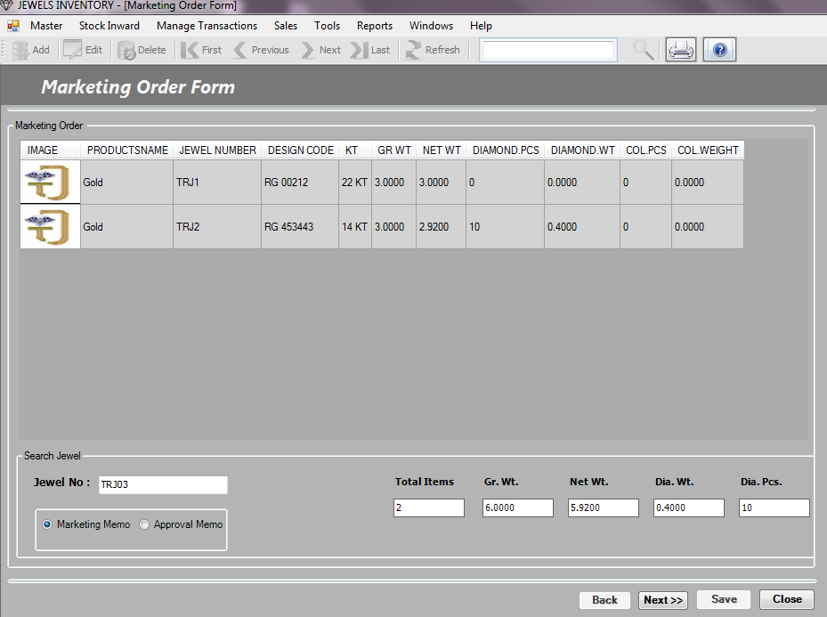

1. In Jewel No. block simply trigger the **barcode scanner gun** it fill the **jewel no** in that block or you can **manually enter** the jewel no if remember and **press enter**.
2. And you get the whole details of marketing order on the marketing order table and also get the Total items, grass wt, net wt etc.
3. And click to **next** button. After that you want to back use **back** button
4. Now you get the costing chart for that supplier now you can enter the customer name, contact person name doc/ref no.
5. You can change the supplier’s amount with your new decided amount with certificate and stamping charges.
6. And click save button to **save** that memo.
7. You can take a print of that memo using print option provided in toolbox.

**Approval Memo:**

1. Go to Manage Transactions C:\ASP_Practice\ASP\ASP\session9\DataAccessI\images\Next.bmp ApprovalMemo.
2. In Jewel No. block simply trigger the **barcode scanner gun** it fill the **jewel no** in that block or you can **manually enter** the jewel no if remember and **press enter**.
3. And you get the whole details of marketing order on the marketing order table and also get the Total items, grass wt, net wt etc.
4. And click to **next** button. After that you want to back use **back** button
5. Now you get the costing chart for that supplier now you can enter the customer name, contact person name doc/ref no.
6. You can change the supplier’s amount with your new decided amount with certificate and stamping charges.
7. And click save button to **save** that memo.
8. You can take a print of that memo using print option provided in toolbox.

**Manage Transaction:**

1. Go to Manage Transactions C:\ASP_Practice\ASP\ASP\session9\DataAccessI\images\Next.bmp Manage Transaction.

**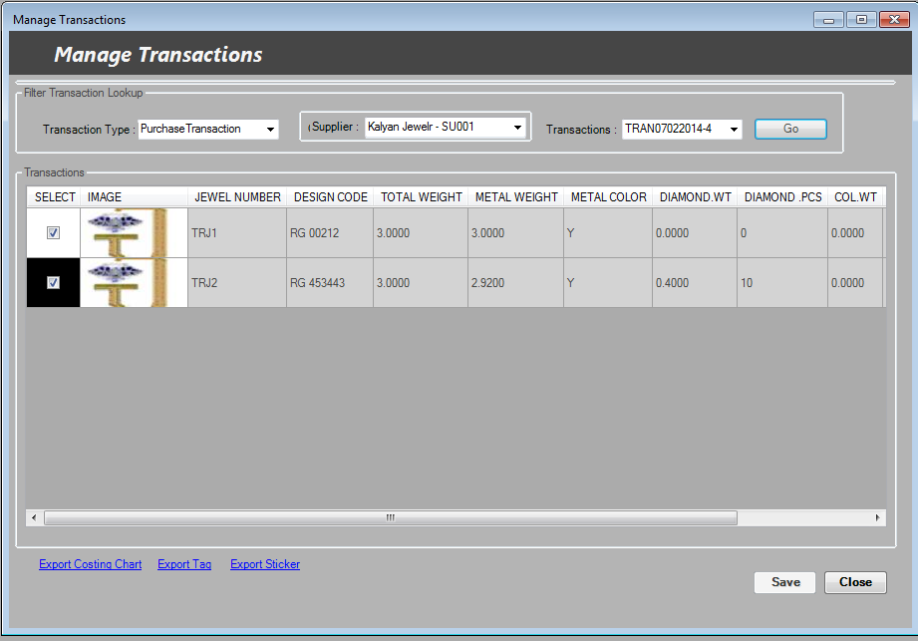**

1. It has a filter with **Transaction Type** drop down select particular type you want.
2. Then select **customer** and then you get all transactions with that customer with some transaction no. in Transaction column and click **Go**.

**Jewel History:**

1. Go to Manage Transactions C:\ASP_Practice\ASP\ASP\session9\DataAccessI\images\Next.bmp Jewel History.

**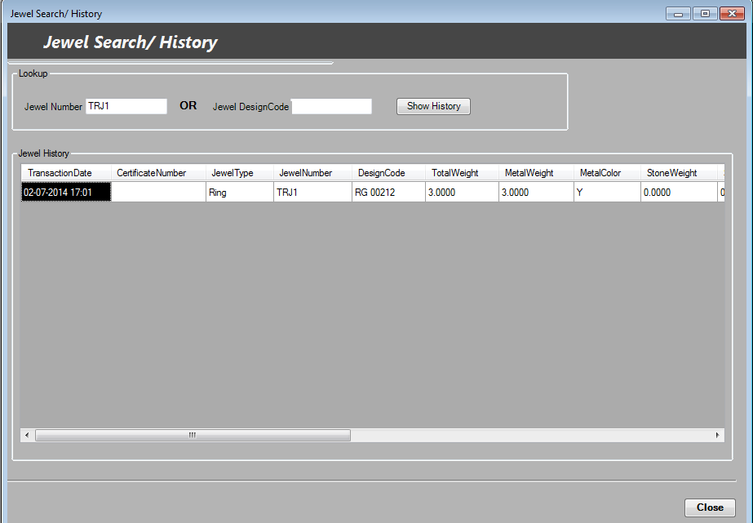**

1. Enter the **jewel no** or **Jewel Design code** and click show button you get the transaction history of that jewel.
2. And press **close** button.

**Party Transaction:**

1. Go to Manage Transactions C:\ASP_Practice\ASP\ASP\session9\DataAccessI\images\Next.bmp Party Transaction.

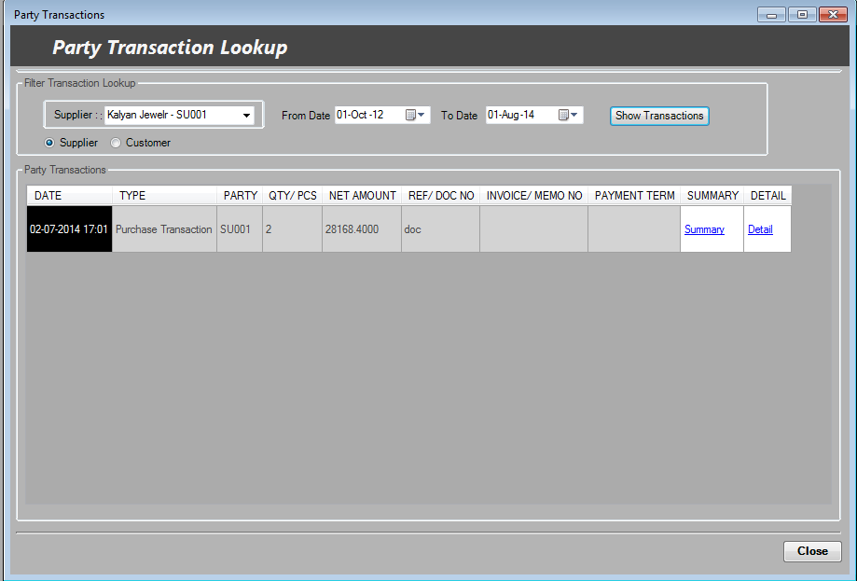

1. It opens lookup form; here we can make a **filter** for particular supplier or customer with specified **time**.
2. Then you click on **show transactions** button it gives you **all** transaction of that supplier or customer for specifying time span.
3. You can also get the summary and details of that transaction by clicking **summary** and **details** links.
4. And finally **close** the form.

**Sales:**

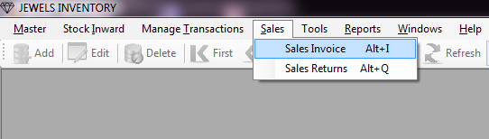

**Sales Invoice:**

1. Go to Sales C:\ASP_Practice\ASP\ASP\session9\DataAccessI\images\Next.bmp Sales Invoice.
2. Then fill the sales information choose the **customer**, **memo no**. and **payment** **term** and click Go.
3. Sales orders are visible on the table and also total jewel are appear at the bottom, you can **generate invoices** or send **email** to that customer.
4. Also you can set net amount, VAT and other charges etc. and click **save** button.

**Tools:**

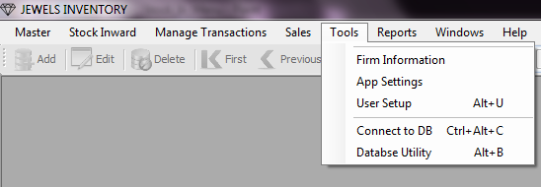

**Firm Information:**

1. Go to Tools C:\ASP_Practice\ASP\ASP\session9\DataAccessI\images\Next.bmp Firm Information.

**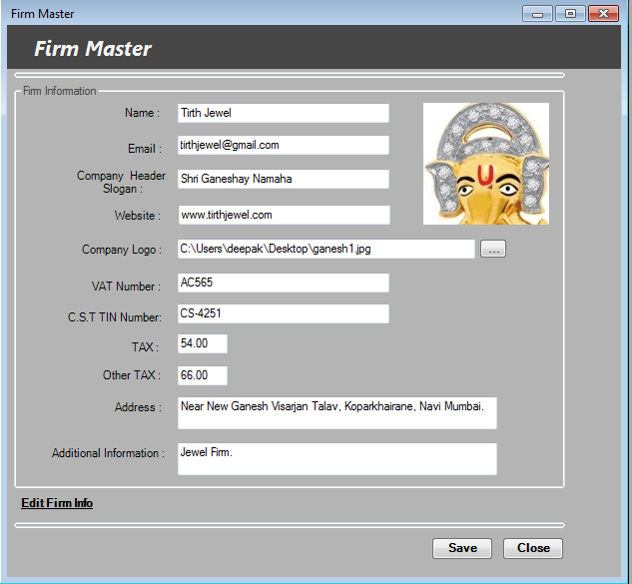**

1. Fill the appropriate blocks with valid values. For company logo click on the side button of that block and browse the image.
2. And save that form.
3. If you want to edit the previous firm record then click to edit firm info link at the bottom and make changes and save it again.

**App Settings:**

1. Go to Tools C:\ASP_Practice\ASP\ASP\session9\DataAccessI\images\Next.bmp App settings.

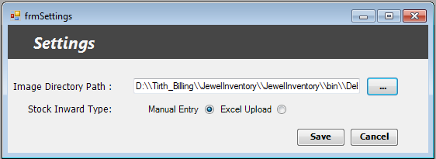

1. Browse the valid **image directory path**.
2. You have addition option **Stock Inward Type**. Using this user can input entries in two ways as follows:

**Manual Entry:** This is a simple manual input entry through the application.

**Excel Upload:** This is input through excel file by uploading it to the application. Using excel upload can be mostly error porn; this option is to be used carefully.

1. And click save button.

**User Setup:**

If you want to add the user rather than system generated Super user then you use following steps to create simple user:

1. Go to Tools C:\ASP_Practice\ASP\ASP\session9\DataAccessI\images\Next.bmp User Setup.

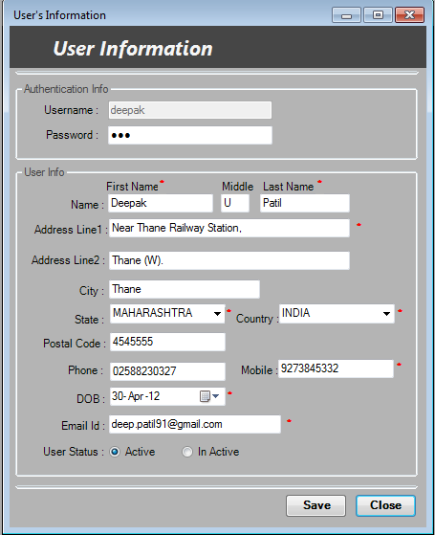

1. Click on **Add** option in the toolbox to add new user.
2. Set the user name and password for the user. All mandatory blocks mark with \* are must have to fill.
3. And finally set the user status to Active if you want to use that user.
4. And click **save** button.
5. If you want to edit the previously create user record then click to **Edit** option on the toolbox and make changes and save it again.

**Reports:**

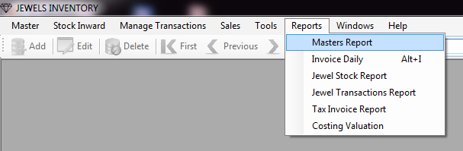

**Master Report:**

1. Go to Reports C:\ASP_Practice\ASP\ASP\session9\DataAccessI\images\Next.bmp Master Report.

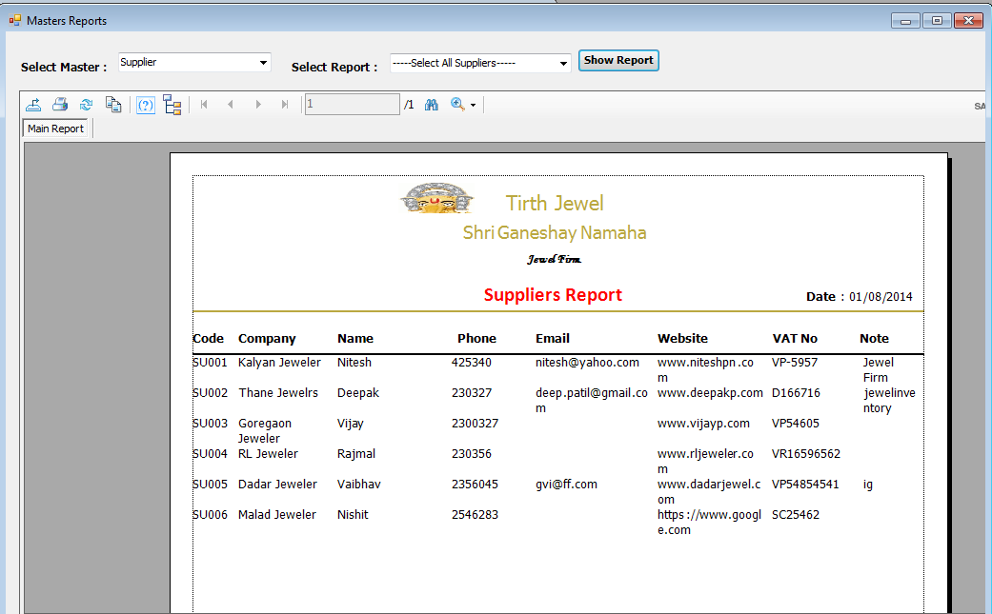

1. Select any one **Master** that you want to generate report like configuration, customer, supplier, and user.
2. Next **Select Report** for any one or all configuration, customer, supplier or user.
3. And click on **Show Report** button.

**Jewel Stock Report:**

1. Go to Reports C:\ASP_Practice\ASP\ASP\session9\DataAccessI\images\Next.bmp Jewel Stock Report.

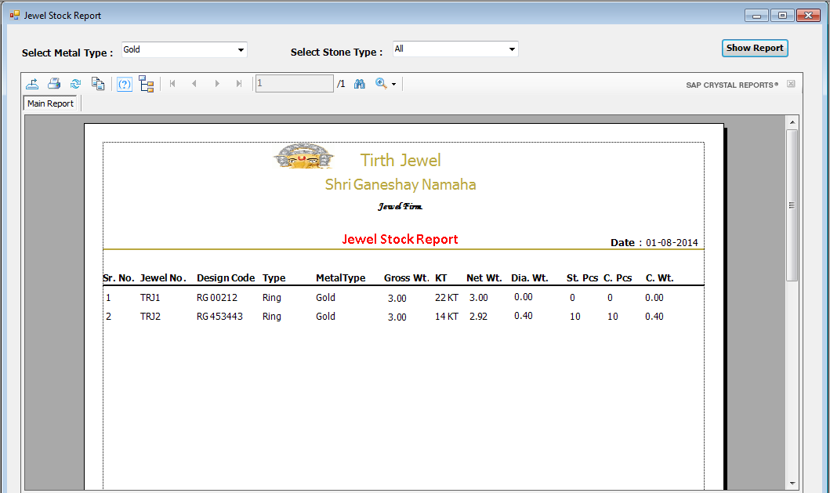

1. Select any one **Metal type** that you want to generate report like Alloy, Silver or Gold.
2. Next select any one or all **Jewel Type** to generate report.
3. And click on **Show Report** button.

**Jewel Transaction Report:**

1. Go to Reports C:\ASP_Practice\ASP\ASP\session9\DataAccessI\images\Next.bmp Jewel Transaction Report.

**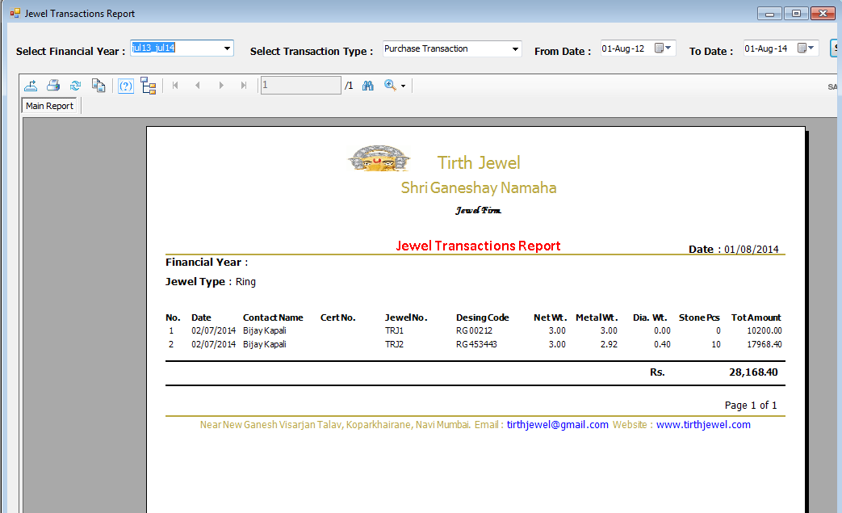**

1. Select any one **Financial Year** for that you want to generate report.
2. Next select any one **Transaction Type** like Purchase, Approval or Marketing Transaction.
3. Select **From Date** and **To Date** for that span you want to get Transaction Report.
4. And click on **Show Report** button.

**Tax Invoice Report:**

1. Go to Reports C:\ASP_Practice\ASP\ASP\session9\DataAccessI\images\Next.bmp Tax Invoice Report.
2. Select any one **Financial Year** for that you want to generate report.
3. Next select any one **Transaction Type** like Purchase, Approval or Marketing Transaction etc.
4. Enter the **Invoice No.** in specified block and choose either **Detail** or **Summary** option for report
5. And click on **Show Report** button.

**Windows:**

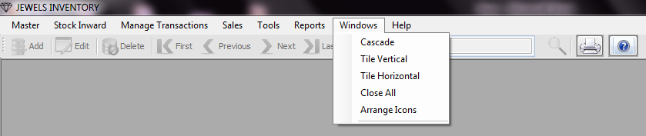

1. Go to Windows C:\ASP_Practice\ASP\ASP\session9\DataAccessI\images\Next.bmp Cascade/Tile Vertical/Tile Horizontal/Close All/Arrange Icons.
2. This use for only viewing your application windows in different styles to make it more users friendly.

**Help:**

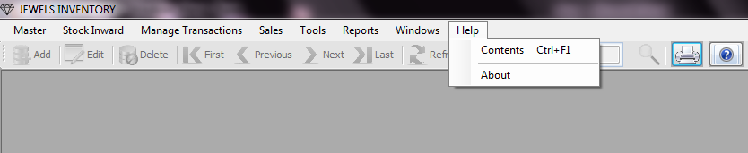

**Content:**

1. Go to Help C:\ASP_Practice\ASP\ASP\session9\DataAccessI\images\Next.bmp Contents.
2. It gives you brief documentation of your application for your convenience.

**About:**

1. Go to Help C:\ASP_Practice\ASP\ASP\session9\DataAccessI\images\Next.bmp About.
2. On clicking this you get the information about our company like website, Email ID etc.

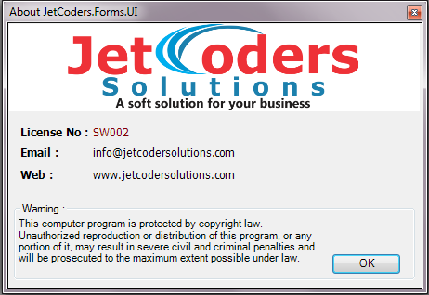

***\*\*\*\*\*\*\*\*\*\*\*\*\*\*End of the Document\*\*\*\*\*\*\*\*\*\*\*\*\****