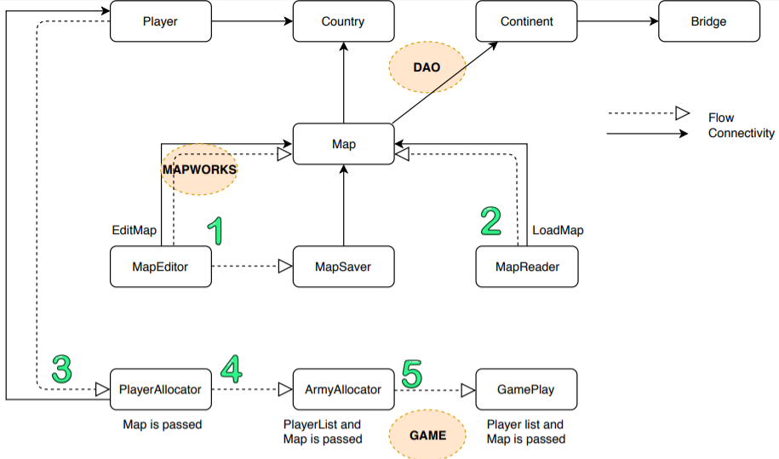

**CONNECTIVITY**

**Data Access Object(dao)** package contains classes- Player, Country, Continent, Bridge and Map.

Player class contains list of country objects, continent contains list of bridges.

Map Contains list of countries and continents.

**mapWorks** package contains classes MapEditor, MapSaver and MapReader.

Classes MapEditor, MapSaver and MapReader have a map object.

**Game** package contains classes PlayerAllocator, ArmyAllocator and GamePlay.

PlayerAllocator has a list of players.

**FLOW**

1.When the user gives command editmap MapEditor is called which creates a map as per the user specifications, validates that map and saves the map through MapSaver class.

2.When the user gives command loadmap, MapReader reads the content of the .map file and fills the map object accordingly.

3.After load map, PlayerAllocator functions are called where user gives commands to add players and the list of players is prepared and countries are allocated to the players using populatecountries. Map object is passed to the functions of this class.

4.ArmyAllocator calculates the no of armies to be assigned to each player and allocates them randomly to the players. It also places these armies using user command. Map object and list of players are passed in all of it’s functions.

5.Gameplay class has functions for reinforcement and fortification. Map object and list of players are passed in all of it’s functions.