Refactoring after Build 1:

**List of refactoring to be made:**

1. Main.java: Merge the editMap commands into a single function so as to reduce the redundant code.
2. Main.java: Merge the code of placeArmies() into gameplayer().
3. Map.java: Separated the map functions (display(), displayAll(), validateMap(), validateContinent(), checkDuplicates()) from MapReader class to Map class.
4. Player.java: Moved reinforcement(), attack(), and fortification() methods from gameplay class to Player class and deleted gameplay class.
5. MapEditor.java: Remove the redundant variables.

**Refactoring Implemented:**

1. Main.java: Merge the editMap commands into a single function so as to reduce the redundant code.

Previous Code:

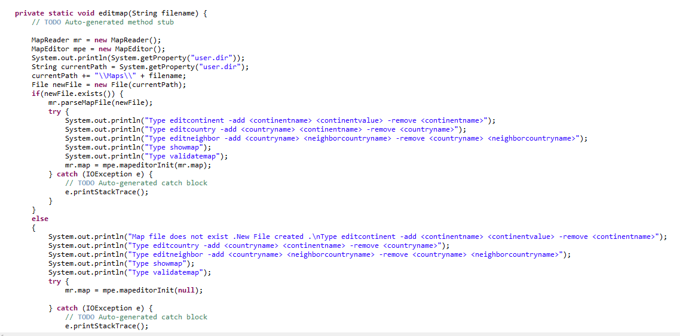

Code after Refactoring:

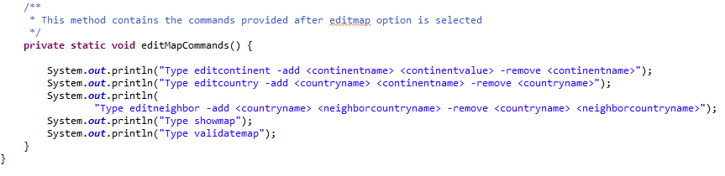

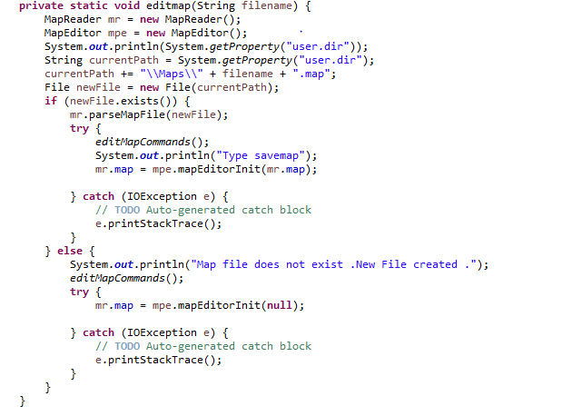

1. Main.java: Merge the code of placeArmies() into gameplayer().

Previous Code:

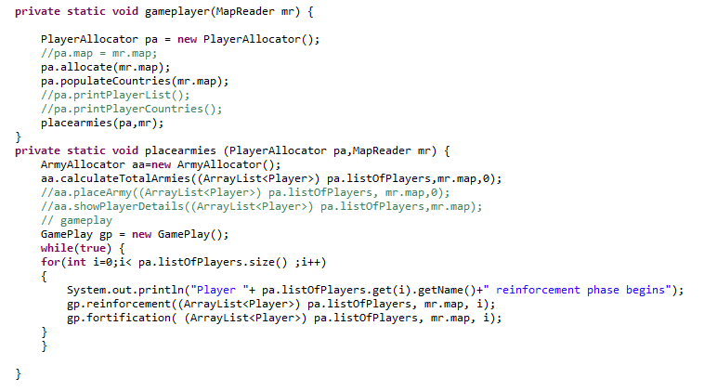

Code after Refactoring:

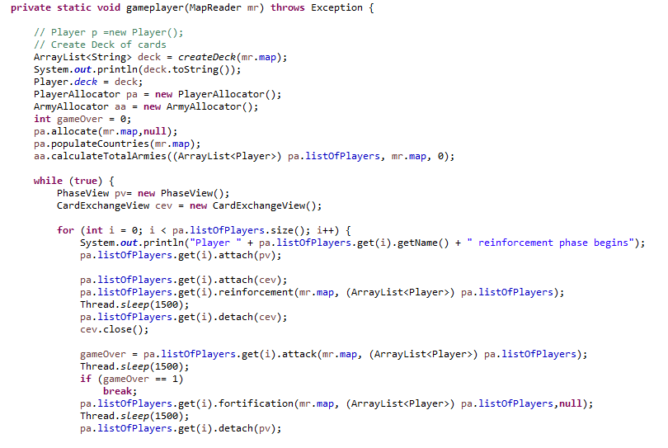

1. Map.java: Separated the map functions from MapReader class to Map class.

Previous Code:

display() in MapReader class:

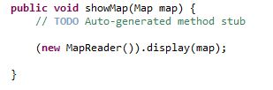

displayAll() in MapReader class:

C:\Users\divya_000\Desktop\Refactor\displayallmr.JPG

validateMap() in MapReader class:

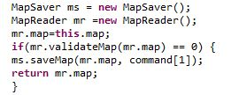

Code after Refactoring:

display() in Map class:

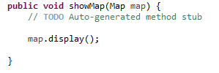

displayAll() in Map class:



validateMap() in Map class:



1. Player.java: Moved reinforcement(), attack(), and fortification() methods from gameplay class to Player class and deleted gameplay class.

Previous Code:

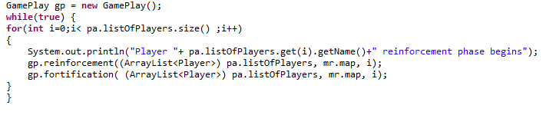

Code after Refactoring:

